AIVORA
Financial Intelligence
Document Extraction, Grounded Analysis & Evidence-Backed Reporting
Technical Documentation
Version 1.0 · 5 October 2026 · Aivora Enterprise FY2025 workspace

Reading note. Every figure, count and measurement in this document is taken from the repository or from this project's own evaluation reports, and each is labelled measured, inferred or unverified. Known limitations are stated in section 12 rather than omitted.

1. Executive Overview
Aivora is a financial intelligence application that reads company filings and answers questions about them. Its defining property is not that it answers, but that it refuses to answer without evidence: no figure is presented to a user unless it can be traced to a span of text in the source document, and no arithmetic is performed by a language model. Values are extracted with their source spans, validated in code, and every calculation is executed in Python.
The system comprises a browser interface of eight product areas, an HTTP API of 99 method-path routes over 82 endpoints, a service layer of routing, extraction, grounding and reporting modules, a document retrieval store, and a tool pipeline that enforces the evidence rules. It runs on CPU with no external service dependency.

1.1 Purpose & Use Cases
- Extraction of financial values from company filings, each bound to the span of source text it was read from.
- Deterministic calculation of financial ratios, performed in Python from extracted operands rather than generated by a model.
- Grounded document question answering, scoped so that a document can only answer for the company it belongs to.
- Explicit refusal when a filing does not contain the information asked for, including forward-looking questions no filing can answer.
- Period-over-period comparison that reports which lines have no prior-year figure instead of leaving them blank.
- Evidence-backed insights and exportable financial reports in which every stated number carries its formula, working and source document.
- Monitoring conditions on financial metrics, evaluated against the filing, with conditions the engine cannot compute refused at creation.

1.2 Technology Stack
Category | Technology / Library
Runtime | Python 3.14, CPU-only deployment
HTTP Server | ThreadingHTTPServer (standard library) - no web framework
Frontend | Single-page HTML, CSS and vanilla JavaScript - no build step
Deep Learning | PyTorch 2.13 (CPU build)
Local Model | DeepSeekV3-architecture model trained in this repository, 101.7M parameters
Optional Model Backend | Hugging Face Transformers 5.x - Qwen2.5-Instruct and SmolLM2 verified
Tokeniser | tiktoken, GPT-2 BPE, 50,257 tokens
Retrieval | TF-IDF chunk index with SQLite persistence
Structured Storage | SQLite (standard library sqlite3) for monitoring rules and saved analyses
Document Parsing | pypdf, python-docx, plain text
Diagrams & Docs | matplotlib, python-docx - figures generated from source
Testing | Standalone Python test scripts, no test framework dependency

1.3 Model Specification
The model trained in this repository, used as the local generation backend. (measured, from models/config.py)
Parameter | Value
Architecture | DeepSeek-V3 inspired - MoE, Multi-head Latent Attention, Multi-Token Prediction
Total parameters | 101.7M
Layers | 8
Hidden size | 512
Attention heads | 8
Context length | 1,024 tokens
Experts | 8, top-2 routing
KV LoRA rank | 128
Query LoRA rank | 192
Vocabulary | 50,257 (GPT-2 BPE)
Training tokens | 120.9M unique, 16.3 epochs
Token / parameter ratio | 1.19 (compute-optimal is approximately 20)

The local model is under-trained by design constraint, not by defect: at 1.19 tokens per parameter it saw about 6% of the data a model this size needs. Section 11 reports what that costs, and why the architecture places no trust in the model's arithmetic.

2. System Architecture
Aivora is a layered pipeline. A request from the browser enters a single-file HTTP layer, is classified by intent, dispatched to the service that can answer it correctly, validated against the source document, and returned with its evidence. The layering exists so that the component least able to be trusted - the language model - is given the smallest possible job.
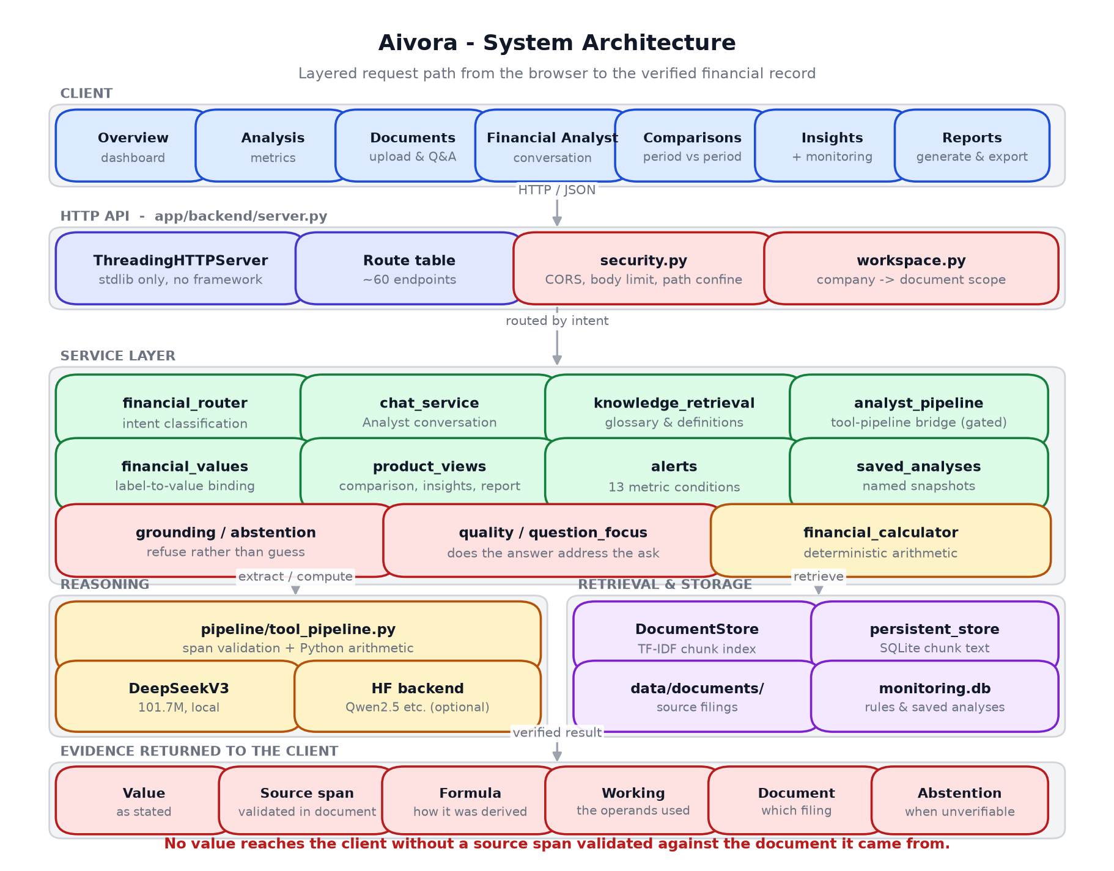
Figure 1. System architecture. The evidence band at the foot of the diagram is what every successful response carries.

2.1 High-Level Component Map
Layer | Module | Responsibility
HTTP API | app/backend/server.py | Route table, request parsing, JSON responses, static file serving
Security | app/backend/security.py | CORS allow-list, body size limit, path confinement, extension allow-list
Workspace | services/workspace.py | Company to document scope; what a question may be answered from
Intent Routing | services/financial_router.py | Classifies a question as calculation, extraction, definition or refusal
Analyst | services/chat_service.py | Conversational analysis, context carry-over, structured responses
Analyst Bridge | services/analyst_pipeline.py | Routes the Analyst through the tool pipeline when a capable model is hosted; refuses rather than degrading
Value Binding | services/financial_values.py | Binds a label to its value with the source span, nearest-label preference
Product Views | services/product_views.py | Comparisons, insights and reports as structured data with sources
Monitoring | services/alerts.py | 13 computable metrics, condition evaluation, state-change detection
Saved Analyses | services/saved_analyses.py | Named snapshots of a view, persisted server-side in SQLite
Grounding | services/grounding.py, services/abstention.py | Determines whether an answer is supported; produces refusals
Answer Quality | services/quality.py, services/question_focus.py | Checks that an answer addresses the question actually asked
Calculation | tools/financial_calculator.py | Deterministic financial arithmetic
Tool Pipeline | pipeline/tool_pipeline.py, pipeline/schema.py | Span validation, operand resolution, Python-only computation
Retrieval | rag/retriever.py, rag/persistent_store.py | TF-IDF chunk index, SQLite-backed chunk persistence
Generation | services/generation.py | Pluggable model backends - local DeepSeekV3 or Hugging Face

2.2 Request Flow
- The browser issues a JSON request to an endpoint on the same origin.
- security.py applies the CORS allow-list, body size limit and, for any path argument, confinement beneath the document root.
- The route table dispatches to a handler; handlers contain no model, scoring or financial logic of their own.
- financial_router.py classifies the question's intent.
- The responsible service answers: calculator for arithmetic, retrieval for document questions, knowledge layer for definitions, refusal rule for questions no filing can answer.
- Workspace scoping discards any retrieval hit from a document outside the company being viewed.
- The grounding layer confirms the answer is supported by its source; if not, an abstention is produced.
- The response is returned with its value, source span, formula, working and source document.
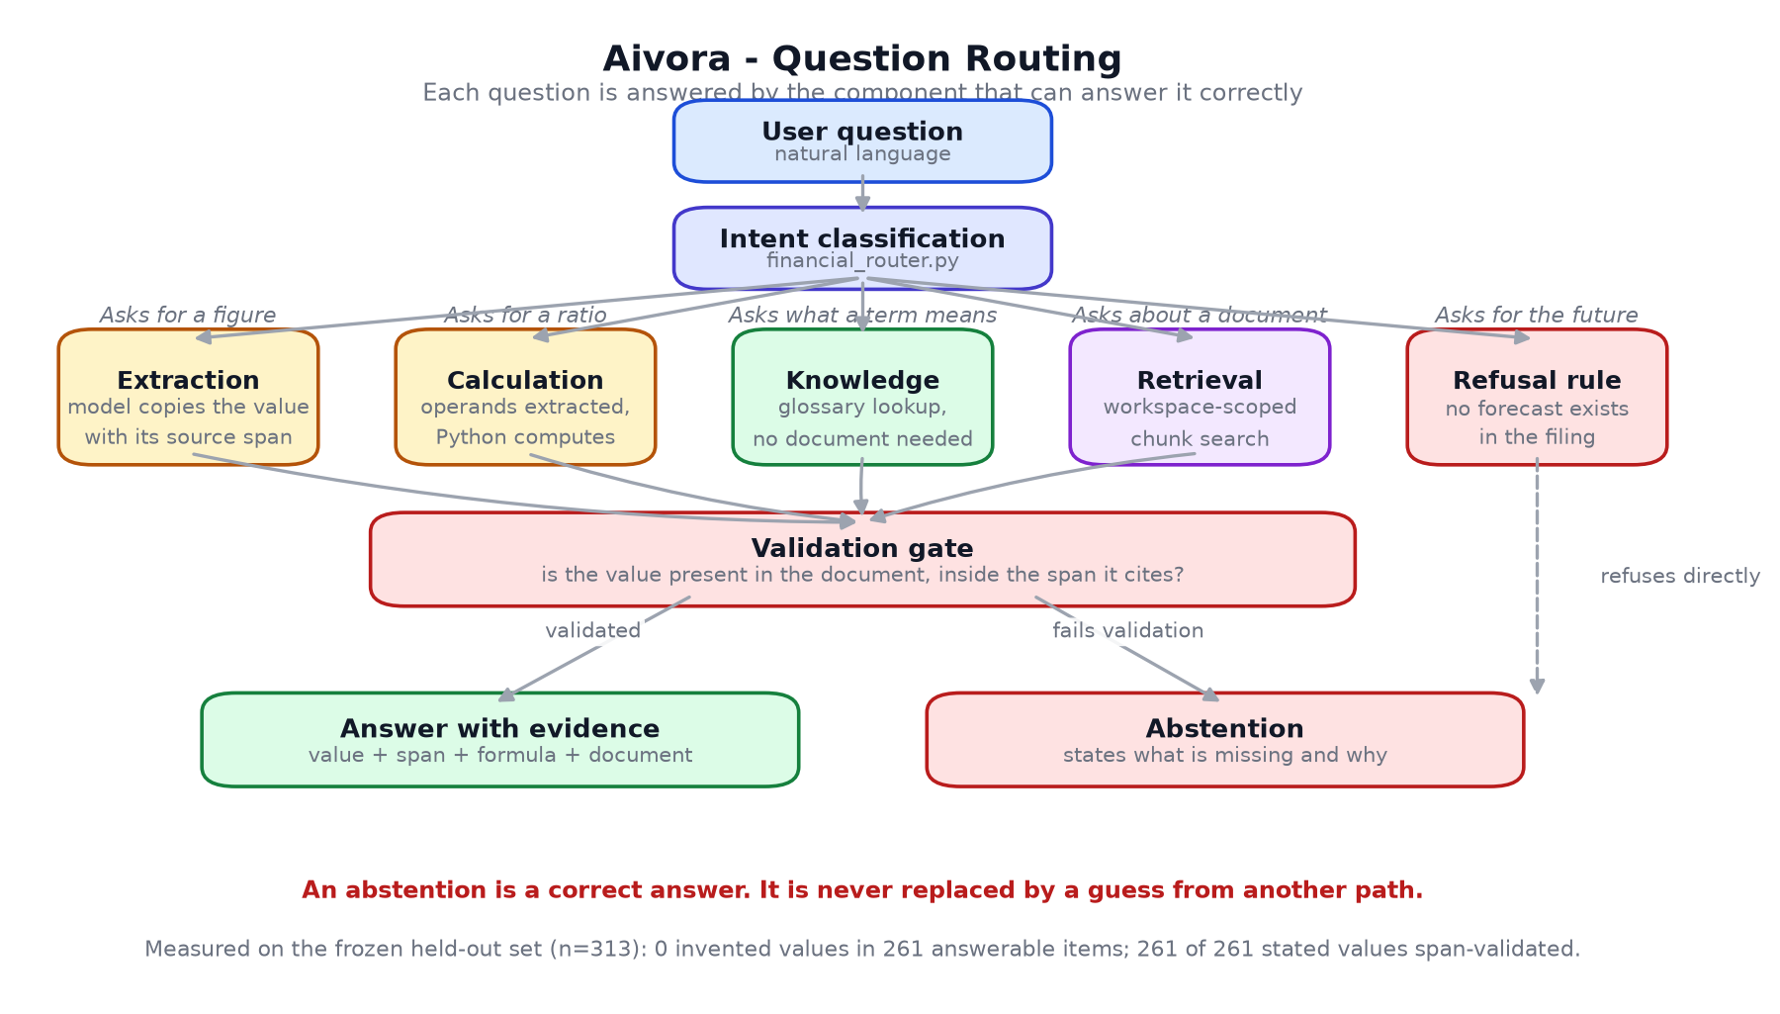
Figure 2. Question routing. Each lane is handled by the component that can answer it correctly; all converge on one validation gate.

3. Module-by-Module Explanation

3.1 Tool Pipeline (pipeline/tool_pipeline.py)
The pipeline divides labour so that correctness does not depend on the model being good. The model reads the context and copies a value with the span it came from. Python validates that span, selects the formula and performs every piece of arithmetic. Rules abstain whenever validation fails or an operand is missing.
Element | Count | Purpose
Formulas | 21 | Question wording to operation and operand list
Operations | 8 | difference, sum, ratio, percentage_of, margin, difference_margin, percentage_change, enterprise_value
Operand fields | 24 | The canonical operands formulas may request
Captions | 147 | Statement wordings mapped to those operands

Operand resolution is the reason the pipeline reaches real filings. A formula asks for "total debt"; a statement says "Borrowings". Python resolves the operand to the caption the document actually uses before the model is asked for it, so the model is only ever asked to copy a label that is verbatim in front of it. Matching is exact or qualified-prefix, never substring, and a caption is assigned to whichever operand matches it most specifically - without that, "total debt" would claim "Debtors and cash". (measured: this raised calculation accuracy from 83.3% to 100% on the frozen evaluation set)

3.2 Validation Schema (pipeline/schema.py)
An extraction is accepted only if all three conditions hold:
- The model reports the value as found.
- The cited source span appears in the context that was supplied.
- The value occurs inside the span that was cited.
Comparison is whitespace- and Unicode-normalised, because models reflow whitespace and substitute quotation marks when copying; the original span is what gets reported. Any condition failing produces an abstention. A fabricated span cannot satisfy condition two, so a value the document does not contain cannot reach a user.
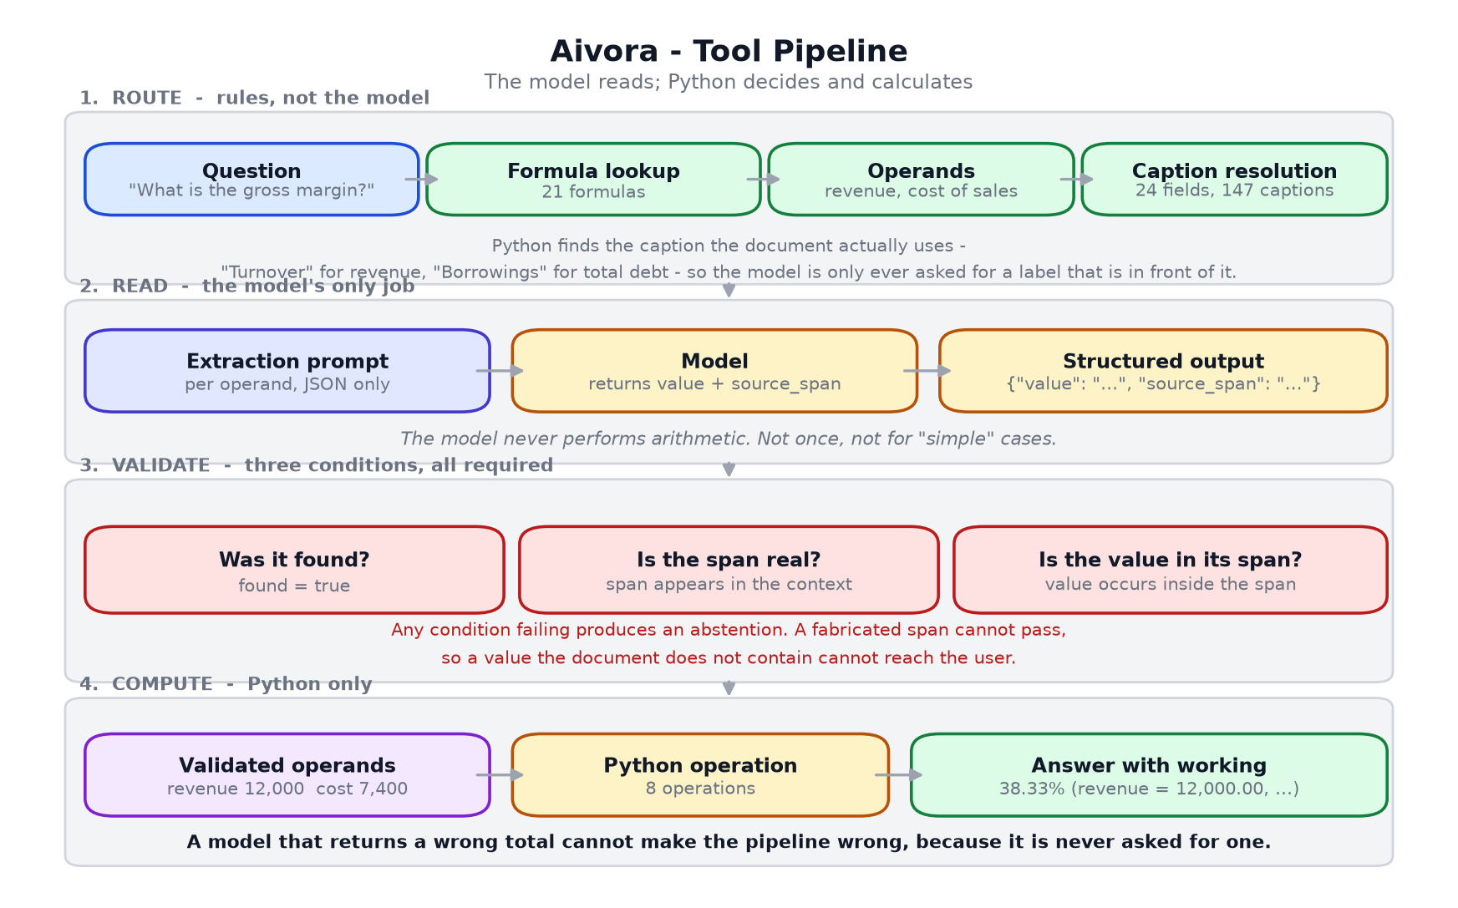
Figure 3. The four stages of the tool pipeline.

3.3 Workspace Scope (services/workspace.py)
A document is answerable only if it belongs to the workspace being viewed. This is a product rule rather than a ranking adjustment: no relevance score should permit one company's filing to answer a question about another's. Uploaded documents join the workspace and become answerable; files present on disk but outside the workspace never answer for it.
This module exists because of a defect found in testing. "What was revenue?" returned Microsoft's quarterly revenue, labelled DOCUMENT GROUNDED with a genuine citation, because the retrieval index held third-party sample excerpts and not the client's filing. A correct-looking citation is not evidence of a correct source.

3.4 Value Binding (services/financial_values.py)
Parses financial values from text into records carrying field, value, unit, currency, scale, source span and confidence. Label-to-value association uses nearest-label binding with a backward preference, so a value is attributed to the label that precedes it rather than to a distant heading. Thousands separators are parsed as whole tokens: a malformed separator is rejected rather than read as its leading digits.

3.5 Monitoring (services/alerts.py)
Conditions on financial metrics, evaluated against the current filing. The API offers exactly the 13 metrics the engine can compute, so a condition that cannot be tested cannot be created. A metric that is computable in general but absent from the filing in hand evaluates to "not evaluable" with a reason, never to "condition not met" - reading an absence as satisfied would be a silent failure.
There is no scheduler. Conditions are evaluated when the view is opened, and the interface states this in place. A genuine threshold crossing between evaluations is detected and reported; nothing is described as a notification.

3.6 Retrieval (rag/)
Documents are loaded, chunked, embedded with TF-IDF and indexed. Chunk text and metadata are persisted to SQLite; embedding vectors are deliberately not persisted, and the vector space is rebuilt in a single reindex on load so it stays internally consistent rather than mixing vectors from an earlier corpus and vocabulary.

3.7 Product Views (services/product_views.py)
Comparisons, insights and reports, returned as data so the interface renders and the export serialises without either re-deriving a figure. Each value carries its source and, where derived, the arithmetic that produced it. A line with no prior-year figure is returned as unavailable with a reason, never as a blank that reads like a zero.

4. Document Lifecycle
A filing passes through seven stages before it can answer a question. Status is reported from the actual stage reached; progress is never simulated.
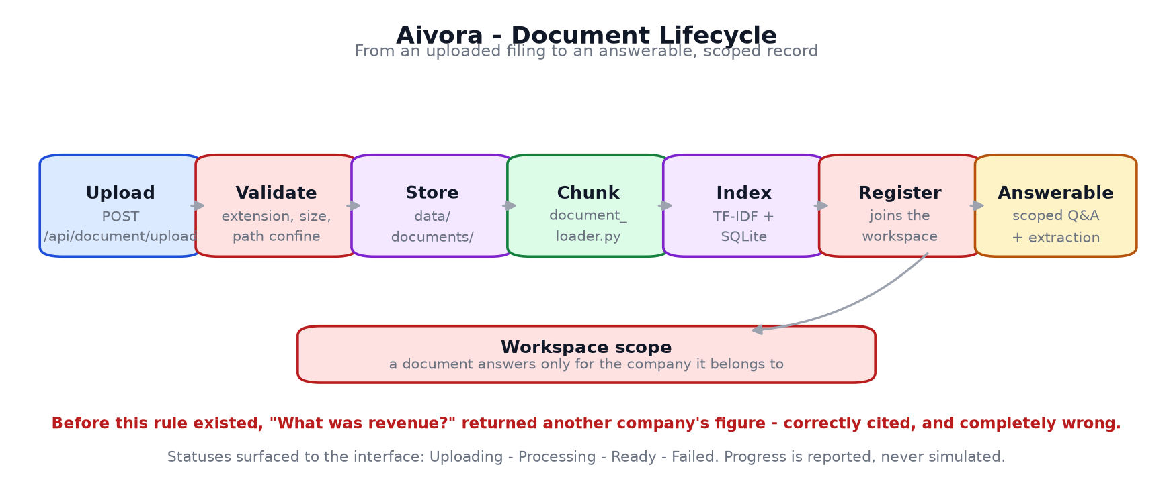
Figure 4. Document lifecycle, from upload to answerable record.
Stage | Module | Outcome
Upload | POST /api/document/upload | File received
Validate | security.py | Extension, size and path confinement checked
Store | data/documents/ | Written beneath the document root
Chunk | rag/document_loader.py | Split into overlapping chunks
Index | rag/retriever.py | TF-IDF vectors built, chunks persisted
Register | services/workspace.py | Added to the workspace manifest
Answerable | - | Available to scoped Q&A and extraction

5. API Reference
Selected endpoints. All accept and return JSON; all are served from the same origin as the interface.
Method | Endpoint | Purpose
GET | /api/health | Service and checkpoint status
GET | /api/company | Verified company profile and headline metrics
POST | /api/financial/calculate | Deterministic metric calculation
POST | /api/financial/full-analysis | Metrics, risks, recommendations, executive summary
POST | /api/document/upload | Upload and index a filing
POST | /api/document/query | Workspace-scoped grounded question answering
POST | /api/copilot/chat | Financial Analyst conversation
POST | /api/risk/analyze | Risk assessment with evidence
GET | /api/comparison | Period comparison with per-line availability
GET | /api/insights | Evidence-backed observations
GET|POST | /api/report/generate | Financial report as structured sections
GET | /api/alerts | Monitoring conditions evaluated against the filing
GET | /api/alerts/metrics | The metrics a condition may name
POST | /api/alerts/create | Create a condition; refuses unknown metrics
GET | /api/analyses | Saved analyses, newest first
POST | /api/analyses/save | Persist a named snapshot of a view
GET | /api/analyst/engine | Which engine serves the Analyst, and why

Example - a grounded answer and its evidence:
POST /api/document/query
{ "query": "What was revenue?" }
{ "grounded": true,
"status": "DOCUMENT GROUNDED",
"answer": "... total consolidated revenue of $10,000,000 (AUD) ...",
"citation": "Aivora_Enterprise_Client_FY2025_Report.txt" }
Example - a refusal, which is a correct answer:
POST /api/document/query
{ "query": "What will revenue be in FY2030?" }
{ "grounded": false,
"status": "INFORMATION NOT AVAILABLE",
"answer": "The provided document does not contain sufficient
information to determine FY2030 revenue.",
"explanation": "Corporate filings do not contain FY2030 forecasts." }

6. Data & Persistence
Store | Technology | Contents
data/documents/ | Filesystem | Source filings
data/workspace.json | JSON | Workspace, company, document scope
data/demo_company.json | JSON | Verified company profile and metrics
Chunk store | SQLite | Document chunk text and metadata
data/monitoring.db | SQLite | Monitoring rules, saved analyses
checkpoints/ | PyTorch | Model checkpoints
data/eval_heldout/ | JSONL | Frozen evaluation set and manifest

Runtime databases are excluded from version control: they hold a user's records, not source. The frozen evaluation set is verified on every scored run against a content hash computed over the parsed items in canonical order, so the check is identical on every platform and still changes if any item changes.

7. Grounding & Hallucination Prevention
Four independent mechanisms, each of which can refuse on its own:
Mechanism | Enforced by | Effect
Source-span validation | pipeline/schema.py | A value with no valid span never reaches the user
Python-only arithmetic | pipeline/tool_pipeline.py | A wrong total from a model cannot become a wrong answer
Workspace scope | services/workspace.py | Another company's filing cannot answer for this one
Refusal rules | services/abstention.py | Forward-looking and unsupported questions are declined explicitly

An abstention is a correct answer. It is never replaced by a guess from another path, because doing so would discard the guarantee that justifies the architecture.

8. Evaluation & Measured Results
Aivora is measured against a frozen held-out set of 313 items across five capability gates, built with 8-gram overlap removal against the training corpus and scored once per configuration by a single shared scorer. Prompts, decoding and scoring are identical across systems. (measured; see reports/phase4/PHASE4_V2_REPORT.md)
Gate | Tool pipeline + Qwen2.5-1.5B | 95% CI
Copy | 68/69 - 98.6% | [92.2, 99.7]
Extraction | 67/69 - 97.1% | [89.9, 99.2]
Wording robustness | 72/75 - 96.0% | [88.9, 98.6]
Calculation | 48/48 - 100% | [92.6, 100]
Abstention | 35/36 - 97.2% | [85.8, 99.5]
Overall | 290/297 - 97.6% | [95.2, 98.8]
Invented values | 0 / 261 answerable items | -
Source-span validation | 273 / 273 stated values | -

8.1 What the Calculation Figure Means
Calculation reads 100%, and that number is conditional in a way the figure alone does not convey. Operand resolution matches a formula's operand to the caption a statement actually uses, from a table of 147 captions. The same capability, measured three ways:
Measurement | Score
Frozen set | 48/48 - 100%
Fresh contexts, captions the vocabulary has | 44/44 - 100%
Fresh contexts, captions the vocabulary lacks | 5/44 - 11.4%

When the table knows the wording the pipeline is exact; when it does not, the model bridges the gap 5 times in 44. Coverage, not arithmetic, is the limit. The failure is the safe one - of 39 misses on unknown captions, 39 were refusals and none was a wrong value, with zero invented values and zero span violations. (measured)
A real filing will use wording outside the table, so it will meet refusals rather than errors. Calculation should be read as coverage multiplied by accuracy-within-coverage, and coverage against real filings has not yet been measured.

8.2 The Pipeline's Contribution, Isolated
The same model, same scorer, same prompts and decoding, answering directly instead of through the pipeline, on the same 297 items:
Gate | Model alone | With the pipeline
Copy | 97.1% | 98.6%
Extraction | 98.5% | 97.1%
Wording robustness | 88.0% | 96.0%
Calculation | 52.1% | 100%
Abstention | 63.9% | 97.2%
Overall | 249/297 - 83.8% | 290/297 - 97.6%
Invented values | 0.77% | 0.00%

Unaided, the model gets roughly half of all arithmetic wrong and answers 13 of the 36 questions it should refuse. Those two gates are what the pipeline buys. Extraction is within a single item of the unaided model. (measured)

8.3 Comparison Against the Local Model
On identical items, with an exact McNemar test for paired observations: the tool pipeline was better on 44 items and worse on none (p < 0.0001). The from-scratch model scores 13.0% on extraction and invents a value on 36.8% of answerable items. (measured)
A parameter-matched comparison settles the cause. SmolLM2-135M - a pre-trained model of 135M parameters against Aivora's 101.7M - beats the from-scratch model on identical items (p = 0.0309). With size approximately held constant the pre-trained model still wins, so the deficit is training data, not capacity. (measured)

8.4 Test Suite
Suite | Checks | Covers
test_product_views.py | 81 | Comparisons, insights, reports, workspace scope
test_alerts_and_analyses.py | 58 | Monitoring conditions, saved analyses
test_tool_pipeline.py | 55 | Span rule, Python arithmetic, operand vocabulary
test_intent_routing.py | 80 | Question classification
test_benchmark.py | 47 | Benchmark construction and scoring
test_analyst_pipeline.py | 28 | Analyst bridge and readiness gate
test_response_pipeline.py | 26 | End-to-end response construction
test_api_security.py | 25 | CORS, body limits, path confinement
test_scorer_regressions.py | 23 | Scorer correctness
test_numbers_in.py | 19 | Numeric parsing and token boundaries
test_knowledge_retrieval.py | 11 | Glossary and definitions

All suites pass as of 5 October 2026. (measured)

9. Installation & Setup

9.1 Prerequisites
- Python 3.11 or later (3.14 verified).
- Approximately 2 GB of disk space for the repository and checkpoints.
- 4 GB RAM minimum for the local model; 8 GB free to host a 1.5B parameter Hugging Face backend.
- No GPU required. No external API key required.

9.2 Installation
git clone https://github.com/Ankushk-aosc/Aivora-AI.git
cd Aivora-AI
python -m venv deepseek_env
deepseek_env\Scripts\activate # Windows
source deepseek_env/bin/activate # macOS / Linux
pip install -r requirements.txt
python -m app.backend.server --port 8001
The interface is then served at http://127.0.0.1:8001/.

9.3 Environment Variables
Variable | Default | Purpose
AIVORA_ANALYST_PIPELINE | 1 | On by default. Set to 0 to use the rule-based engine instead; when on and no capable model can be hosted, the Analyst refuses rather than answering through an unguarded path
AIVORA_ANALYST_MODEL | Qwen/Qwen2.5-1.5B-Instruct | Model backing the Analyst pipeline
AIVORA_CORS_ORIGINS | localhost allow-list | Permitted browser origins
AIVORA_DOCUMENT_ROOT | data/documents | Root beneath which document paths are confined
AIVORA_MAX_BODY_BYTES | built-in limit | Maximum request body size

9.4 Running the Tests
deepseek_env/Scripts/python.exe tests/test_product_views.py
deepseek_env/Scripts/python.exe tests/test_tool_pipeline.py
deepseek_env/Scripts/python.exe tests/test_alerts_and_analyses.py
deepseek_env/Scripts/python.exe tests/test_api_security.py

10. Security
Control | Implementation
Origin control | CORS allow-list; same-origin API calls from the interface
Request size | Body byte limit enforced before parsing
Path confinement | Document paths resolved and confined beneath the document root
Extension allow-list | Only permitted document extensions accepted
Content handling | Uploaded document content is never executed; rendered output is escaped
Secrets | No API keys, credentials or model secrets in frontend code

Limitation. The product endpoints are not individually authenticated. Monitoring rules and saved analyses are therefore per-installation rather than per-user. This is acceptable for a single-workspace deployment and must change before multi-user use.

11. The Analyst Engine and Its Gate
The Analyst can be served either by the existing rule-based engine or by the tool pipeline. The pipeline is the better engine, and it is gated for a measured reason.
Placed behind the local 101.7M model, the pipeline abstained on three of three test questions. The model emitted "Revenue = $5,200,000" for a context stating $10,000,000: it invented a figure, and the span rule stopped it. The guarantee held, but coverage was zero. Switching wholesale would have replaced an engine that answers with one that refuses everything. (measured, 5 October 2026)
The bridge therefore refuses to serve unless the configured model can actually be hosted, and reports the shortfall at /api/analyst/engine. Enabling it on unsuitable hardware is not possible by accident.
Engine | Extraction | Invented values | Hosting
Local 101.7M model | 13.0% | 36.8% | Runs on 4 GB RAM
Qwen2.5-1.5B alone, no pipeline | 98.5% | 0.77% | Needs about 7 GB free
Tool pipeline + Qwen2.5-1.5B | 97.1% | 0.0% | Needs about 7 GB free

12. Known Limitations
- Citations are document-level, not passage-level. Source documents are plain text with no page structure, and page numbers are not invented.
- Period comparison is limited by the source. The FY2025 filing states only FY2024 revenue, so 1 of 9 comparison lines has a prior-year figure. UNDER REVIEW: a change not yet accepted supplies the other eight by applying FY2025 margins to FY2024 revenue. Those figures are modelled, not reported, and must not be presented beside audited ones without being labelled as such.
- Calculation accuracy is conditional on caption coverage: 100% on statement wordings the operand vocabulary holds, 11.4% on wordings it does not. Coverage against real filings is not measured.
- Two misses remain where a valid source span cites the wrong line - goodwill answered from an adjacent intangibles line, cash generated from operations from an adjacent revenue line. Span validation cannot catch this by construction: the span is real, the row is wrong.
- Multi-company and document-versus-document comparison are designed for but not demonstrated: the workspace contains one company and one period.
- Chat history and global search are not implemented. A search box over a single document would be decoration.
- Monitoring is evaluated on view, not watched continuously. There is no scheduler and no change feed.
- The product endpoints are unauthenticated; stores are per-installation.
- The local model is the least reliable component. It is used for generation only, never for arithmetic, and the pipeline is the recommended engine wherever it can be hosted.
- Evaluation set defects found and disclosed: two duplicated question-and-context pairs, and two abstention controls mislabelled answerable. The set is not rebuilt after freezing.

13. Glossary
Term | Definition
Abstention | An explicit refusal to answer, returned when the source does not support an answer. A correct outcome, not a failure.
Source span | The exact passage of document text a value was copied from, validated to appear in the context supplied.
Grounding | Binding every stated figure to the document text that supports it.
Workspace scope | The rule that a document may only answer questions about the company it belongs to.
Operand resolution | Mapping a formula's operand to the caption the statement actually uses, in code, before the model is asked.
Frozen evaluation set | 313 held-out items, never trained on and never used for selection, scored once per configuration.
Selection split | 61 items used to choose a configuration; never reported as a result.
Capability gate | One of copy, extraction, wording, calculation and abstention - measured separately so an average cannot hide a failure.
McNemar test | An exact paired significance test used when two systems are measured on identical items.
Over-refusal | Refusing a question that the source does in fact answer. Tracked separately, because abstention accuracy alone would reward a system that refuses everything.
Invented value | A number presented to the user that does not appear in the source. The metric the architecture exists to drive to zero.
MoE | Mixture of Experts - 8 experts with top-2 routing in this model.
MLA | Multi-head Latent Attention - compresses the key/value cache through a low-rank projection.
MTP | Multi-Token Prediction - an auxiliary objective predicting more than one future token.

