# How to add Blogs

1. Click on Posts>>Add New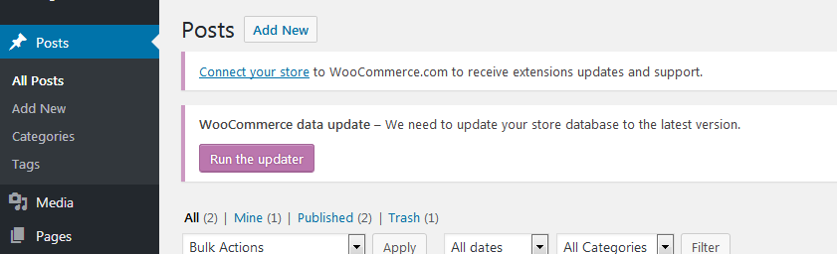
2. Do these steps as shown in screenshot

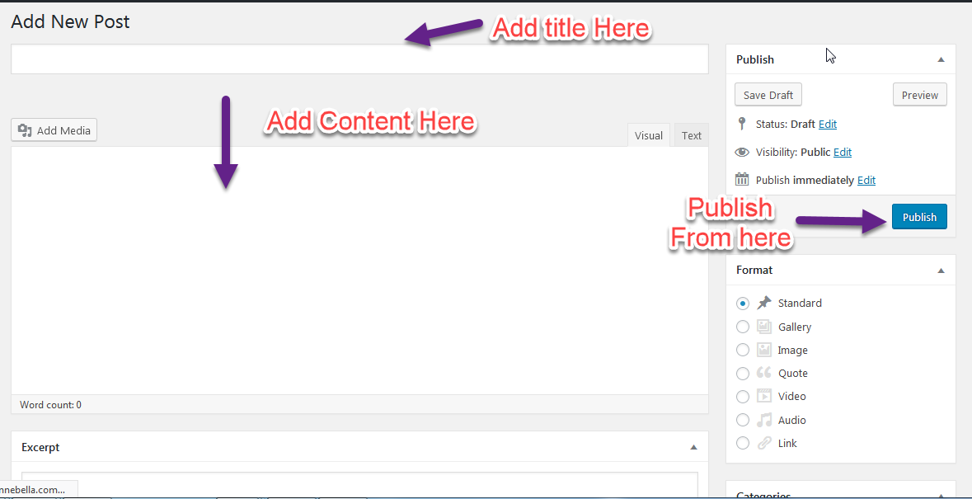

# How to Add FAQ’s

1.Go to Pages>> All Pages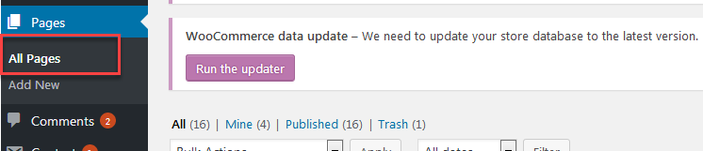

2. Edit Faq page as shown below in screenshot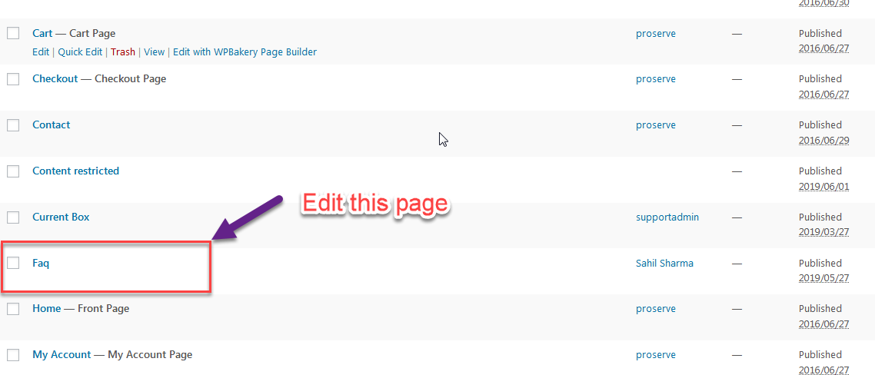

3. Here you have to add text block as new element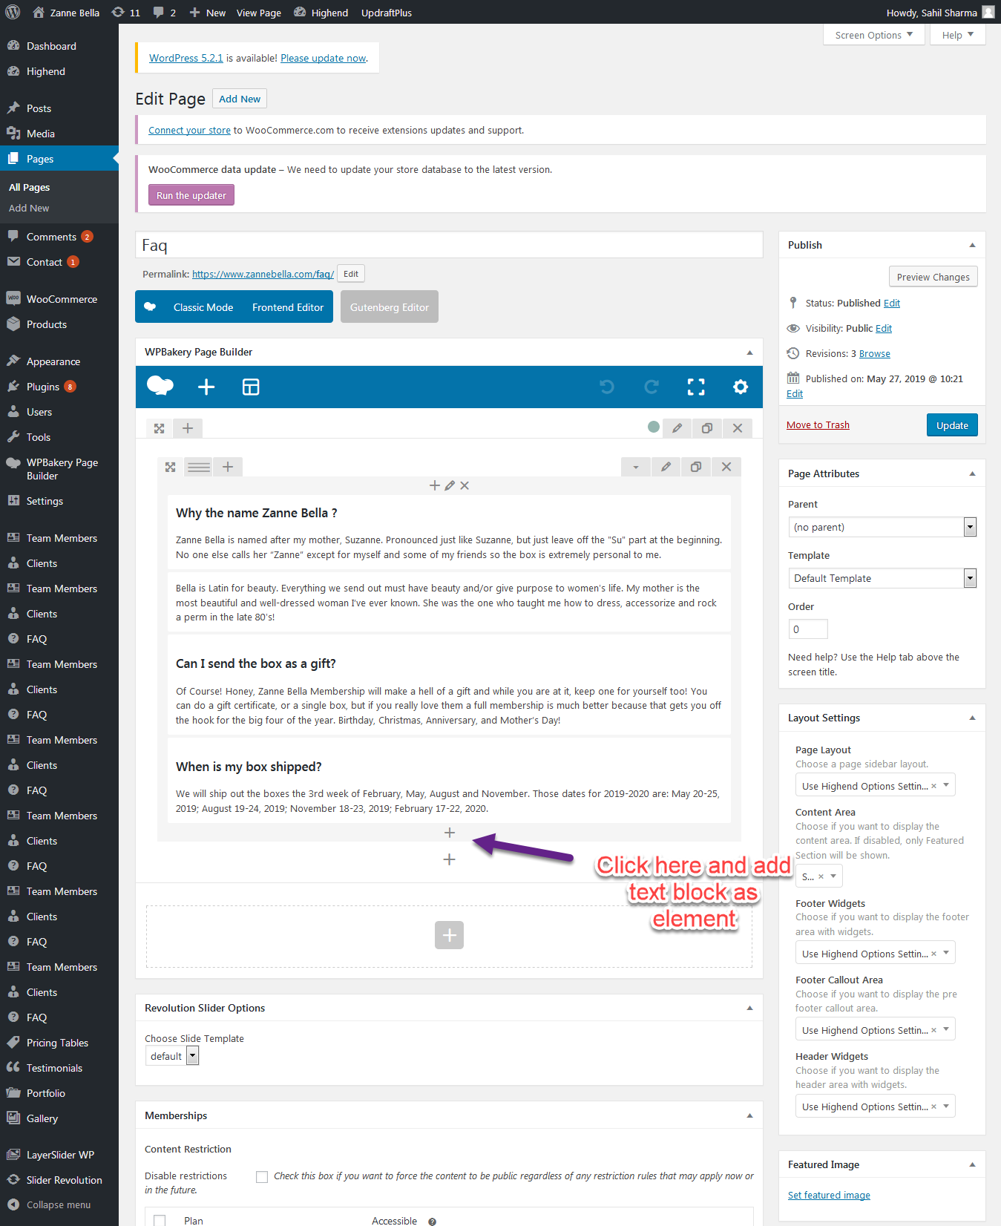

1. Now add new faq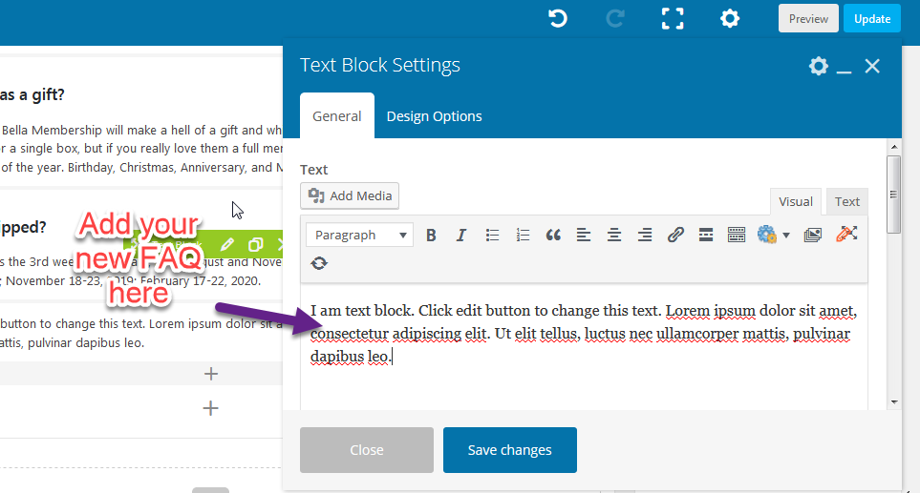

# How To Add Purpose Notes

1. You can add purpose notes in the same way as you have added blog posts. Actually purpose notes are blog posts but don’t forget to select category while creating a new purpose note otherwise it will not be featured on frontend. You can add category as shown in below screenshot

**Recommended Category**: Zannebella

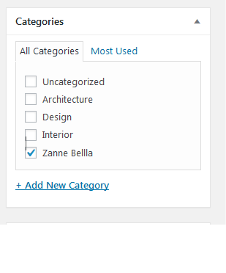

# How to add product in current box.

1. Go to All Pages>> Current Box
2. Edit this page
3. Now after following the both steps 1 and 2 you will see screen as shown below. Now you have to edit this product

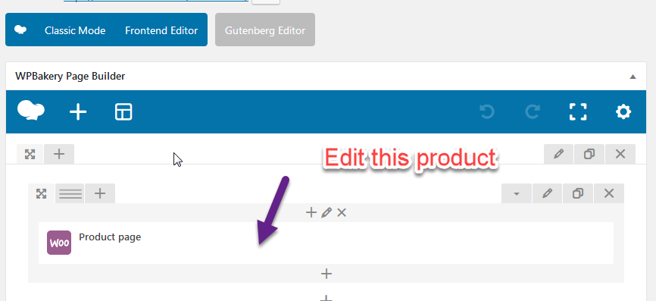

1. After that enter the name of product you want display on Current box page.You can replace the name in the highlighted box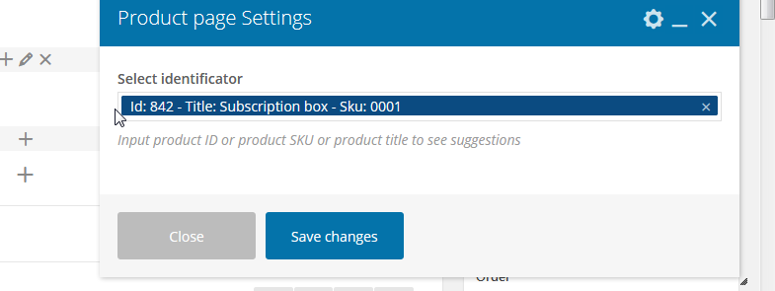

# How to create subscriptions plan

1. Go to Products>>Add New product
2. First of all select Variable Subscription from Dropdown

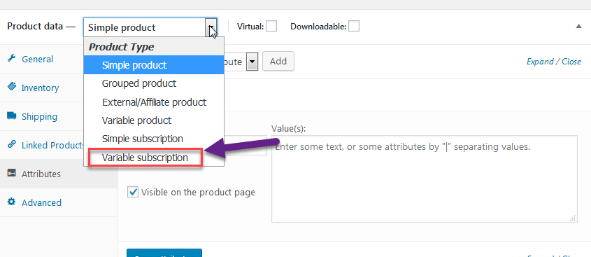

1. Then add custom product attribute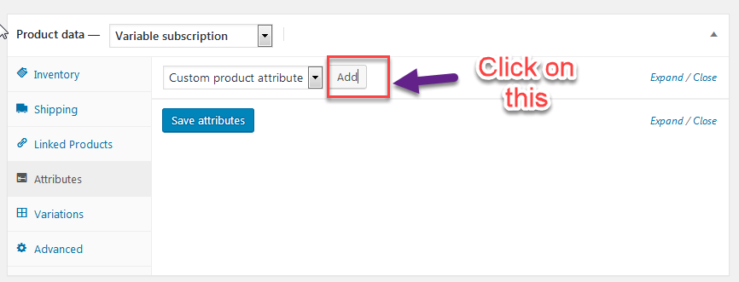
2. Now you have add the values here as described in screenshot and point 2 is mandatory. 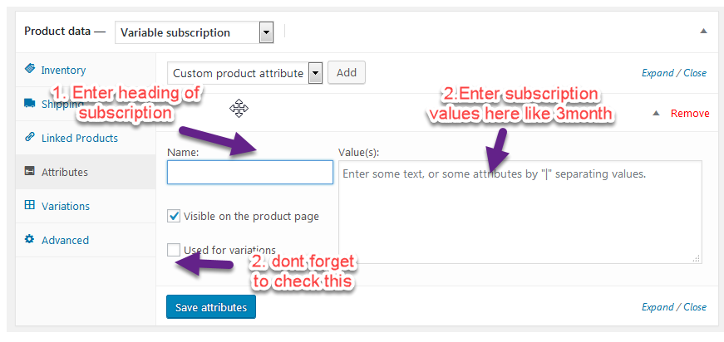
3. Now select “create variation from all attributes”

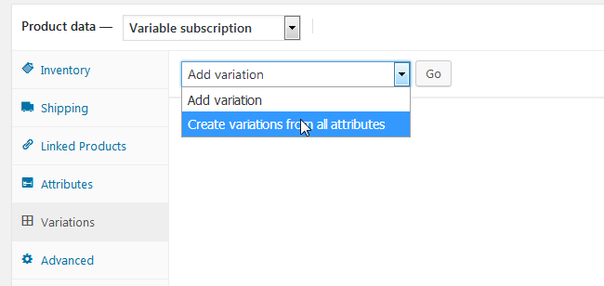

1. Do as shown in below

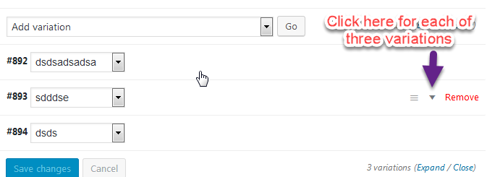

1. Now enter subscription price of each of the attribute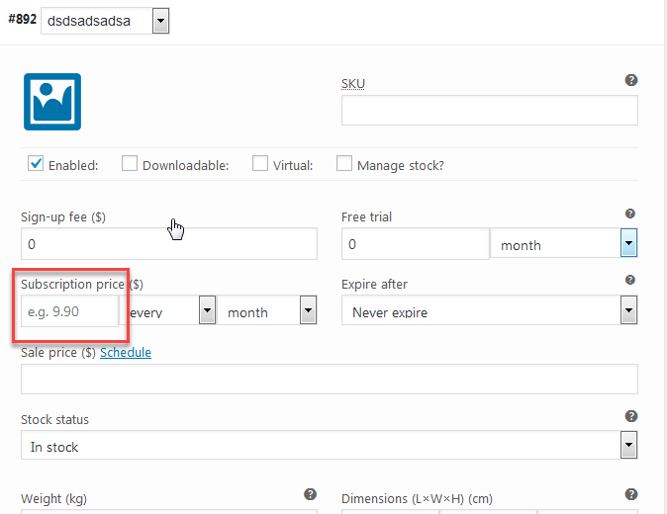
2. And atlast click on update to save the changes.

# How to view registed users

1. Go to Users >> All Users

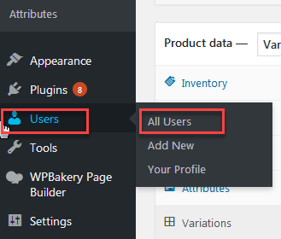

1. Here you can see list of all Registered Users.



