TỔNG LIÊN ĐOÀN LAO ĐỘNG VIỆT NAM

**TRƯỜNG ĐẠI HỌC TÔN ĐỨC THẮNG**

**KHOA CÔNG NGHỆ THÔNG TIN**



**Quá trình 1 môn Công Nghệ Phần Mềm**

*Người hướng dẫn*: **Giảng viên Phạm Thái Kì Trung**

*Người thực hiện*: **NGÔ TRƯỜNG AN-512H0001**

Lớp **: 21H50202**

Khoá  **: 25**

**THÀNH PHỐ HỒ CHÍ MINH, NĂM 2023**

**My work product:**

Functional of Ticket Vendor Machine:

* Show users their select desitnation and the mode of payment, includes: credit card, QR code payment linked with banking system or digital wallet.
* If users use credit card, this machine must issues a paper ticket with a bar code itself and their credit card account be charged.
* The same for digital wallet means that the ticket vendor machine will show a QR Code after the passenger selecting a route for user’s mobile phone payment.
* Must check value of credit card, digital wallet, QR code payment.
* Must check the information of the user.
* Allowing the user to check their ticket and refund if their ticket have one or some problems.
* Make a statistic to count the number of tickets sold in one-day. But not show for the user.
* Send all the information to main server.

Non-functional of Ticket Vendor Machine:

* The service will respond to the user within 5 seconds.
* Have a efficient security for user’s information.
* Have a beatiful form and easy to use

Use case Modelling (Use case diagram):

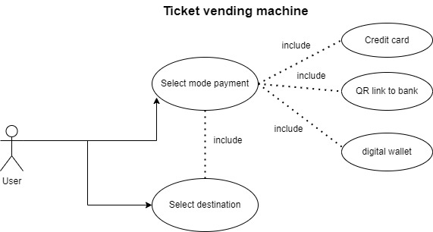

Activity diagram:

Sequence Diagram: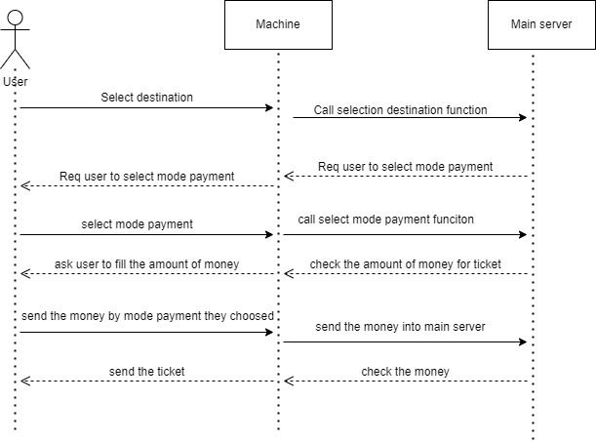

Class Diagram:

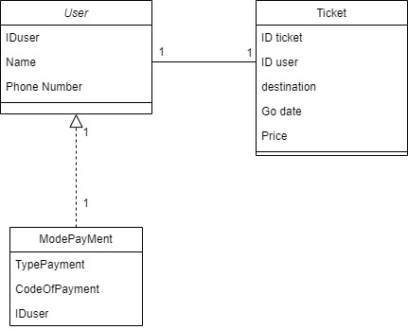

WireFrame for Ticket Vending Machine:

Input:

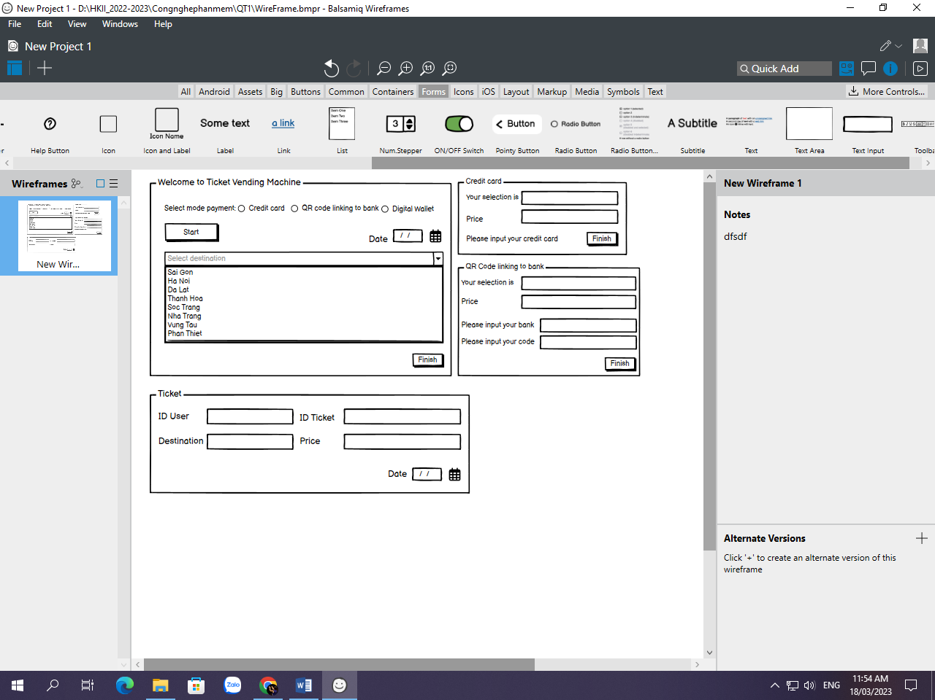

Output:

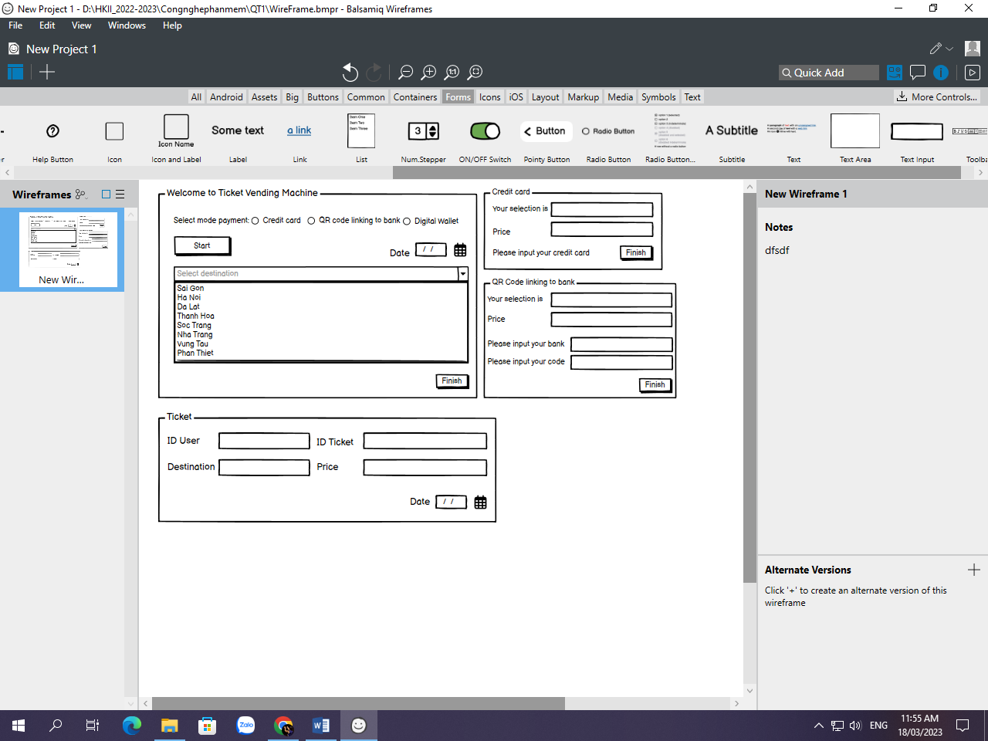

Demo C#:

This is the first interface for user when they start to use this machine. Then if they choose Credit Card or Qr code,..

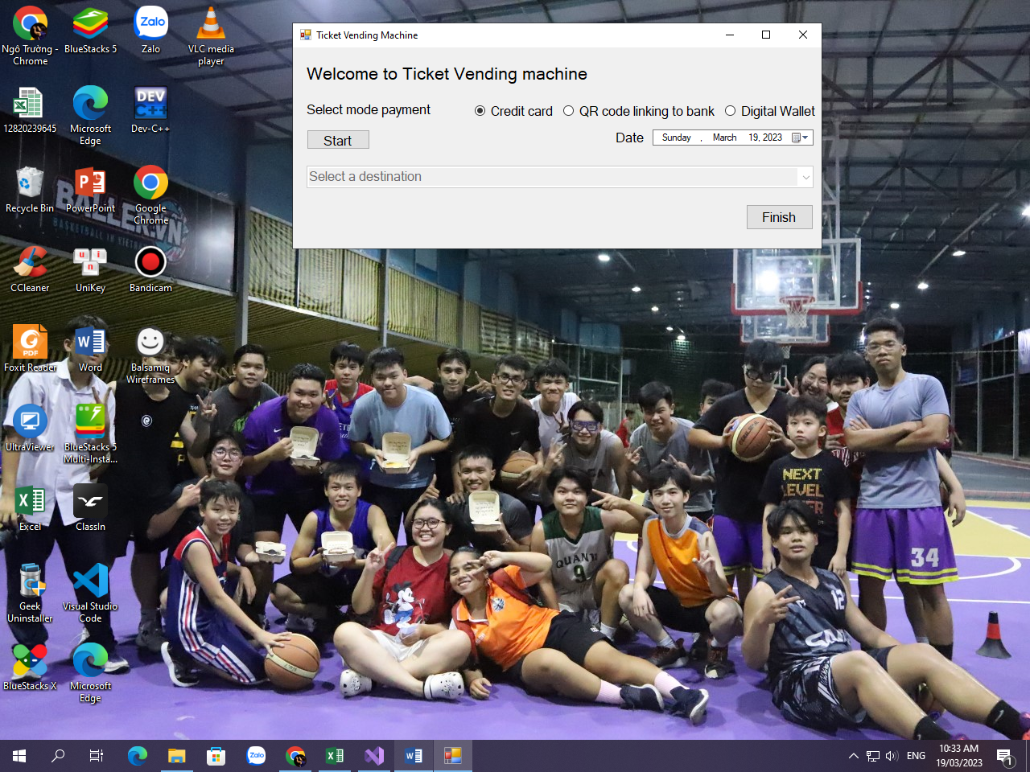

They will show another form depending on what is their choice:

*Credit Card:*

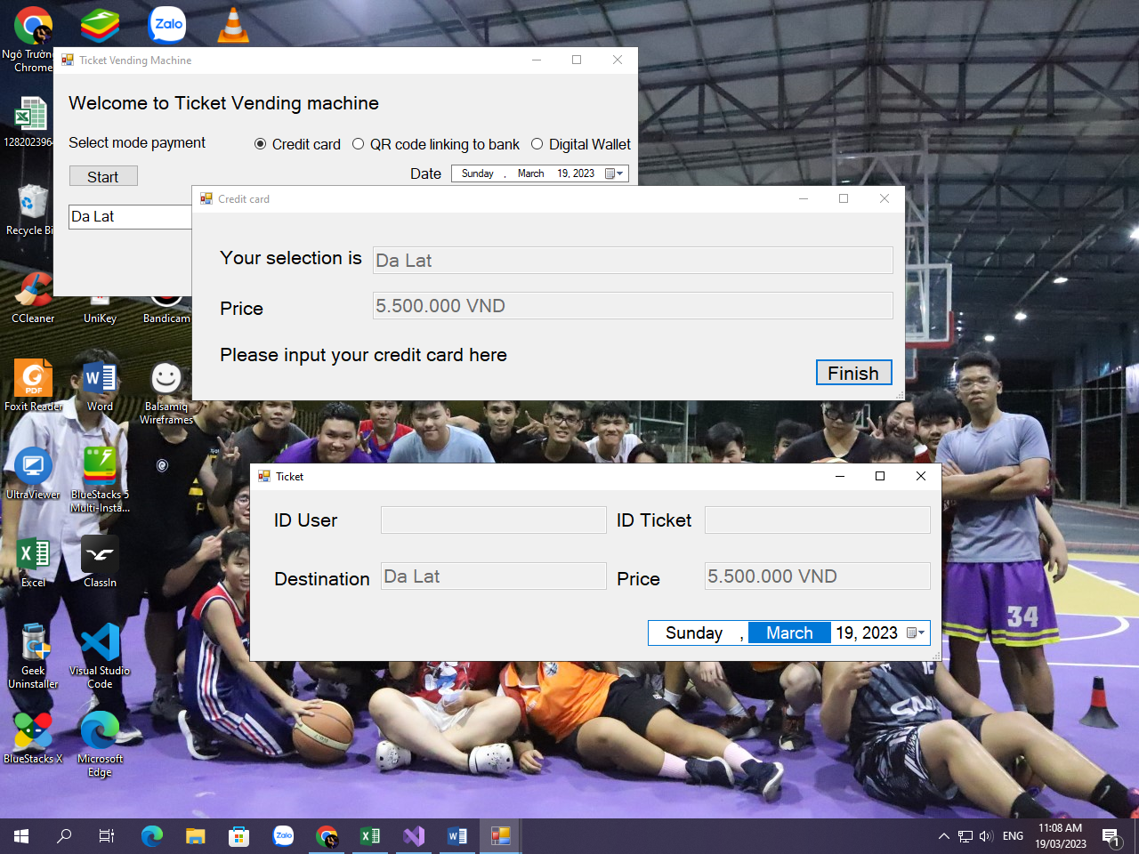

*QR Code or Digital Wallet:*

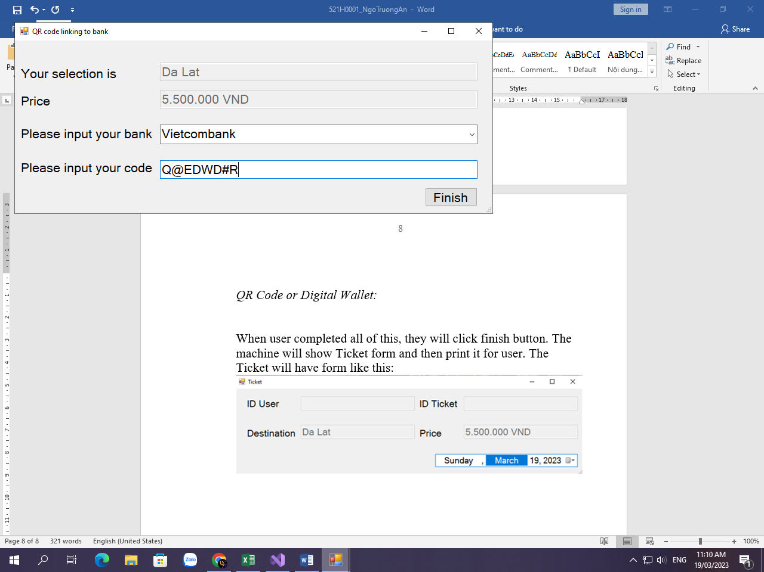

When user completed all of this, they will click finish button. The machine will show Ticket form and then print it for user. The Ticket will have form like this:

