SIMATS ENGINEERING
ASSESSMENT TOOL 2 – CONCEPT MAPPING (Annexure A)
Course Code: CSA1605 | Course Name: Data Warehousing & Data Mining for Cluster Analysis
Course Outcome Covered: CO1: Design data warehouse architectures with appropriate dimensional models for effective decision support systems (BL1, BL2)
Assessment Tool Weightage: 35%
Questions / Total Marks: 5 questions / 50 marks
Name / Reg No: Anlo Melwin.S-192511299
Signature of the student: AnloMelwin.S
Code of Conduct: I Anlo Melwin.S -192511299 certify that this submission is my original work and that I have adhered to the guidelines specified for this assessment. I understand that any violation of academic integrity rules will result in disciplinary action.
Questions answered in this document:
- Q1. Concept Map 6: Advanced OLAP Operations Map
- Q2. Concept Map 7: Data Quality and Preprocessing Map
- Q3. Concept Map 1: DSS and Business Intelligence Integration
- Q4. Concept Map 2: Data Processing Ecosystem (OLTP → OLAP → BI)
- Q5. Concept Map 3: Data Warehouse Components and Data Flow
Colour key: dark box = main concept; light box = sub-concept / example; yellow note = literature source; labelled arrows = linking phrases.

RUBRICS FOR CALCULATION
Criteria | Concept Identification | Linkages | Organization | Integration of Literature | Clarity | Total (50) Marks | Out of 100
Weightage | 25% | 25% | 20% | 20% | 10% | 100%
Q1
Q2
Q3
Q4
Q5
Signature of the Faculty: ________________________ Total Marks Awarded: ____________

RUBRICS FOR CALCULATION: CONCEPT MAPPING
Criteria | Weightage | Level 4 (Exemplary) | Level 3 (Proficient) | Level 2 (Developing) | Level 1 (Beginning)
Concept Identification | 25% | Identifies all key concepts from literature accurately and comprehensively | Identifies most key concepts with minor omissions | Identifies limited concepts; some are irrelevant or missing | Fails to identify essential concepts
Linkages | 25% | Establishes clear, meaningful, and accurate relationships between concepts | Shows correct relationships with minor gaps | Relationships are weak, unclear, or partially incorrect | No meaningful relationships established
Organization | 20% | Concepts are well-structured hierarchically with logical flow and grouping | Mostly organized with minor structural issues | Some organization but lacks clear hierarchy | No logical organization or structure
Integration of Literature | 20% | Integrates multiple studies effectively to show connections and comparisons | Shows some integration of literature | Limited integration; mostly isolated concepts | No integration of literature evidence
Clarity | 10% | Concept map is clear, neat, visually structured, and easy to interpret | Generally clear with minor readability issues | Clarity is reduced; difficult to interpret in parts | Poorly presented and hard to understand

Q1. Concept Map 6: Advanced OLAP Operations Map
Task Description: Develop a concept map explaining advanced OLAP operations and their relationships.
What your map must show: 1. Slice 2. Dice 3. Drill Down 4. Roll Up 5. Pivot 6. Drill Through
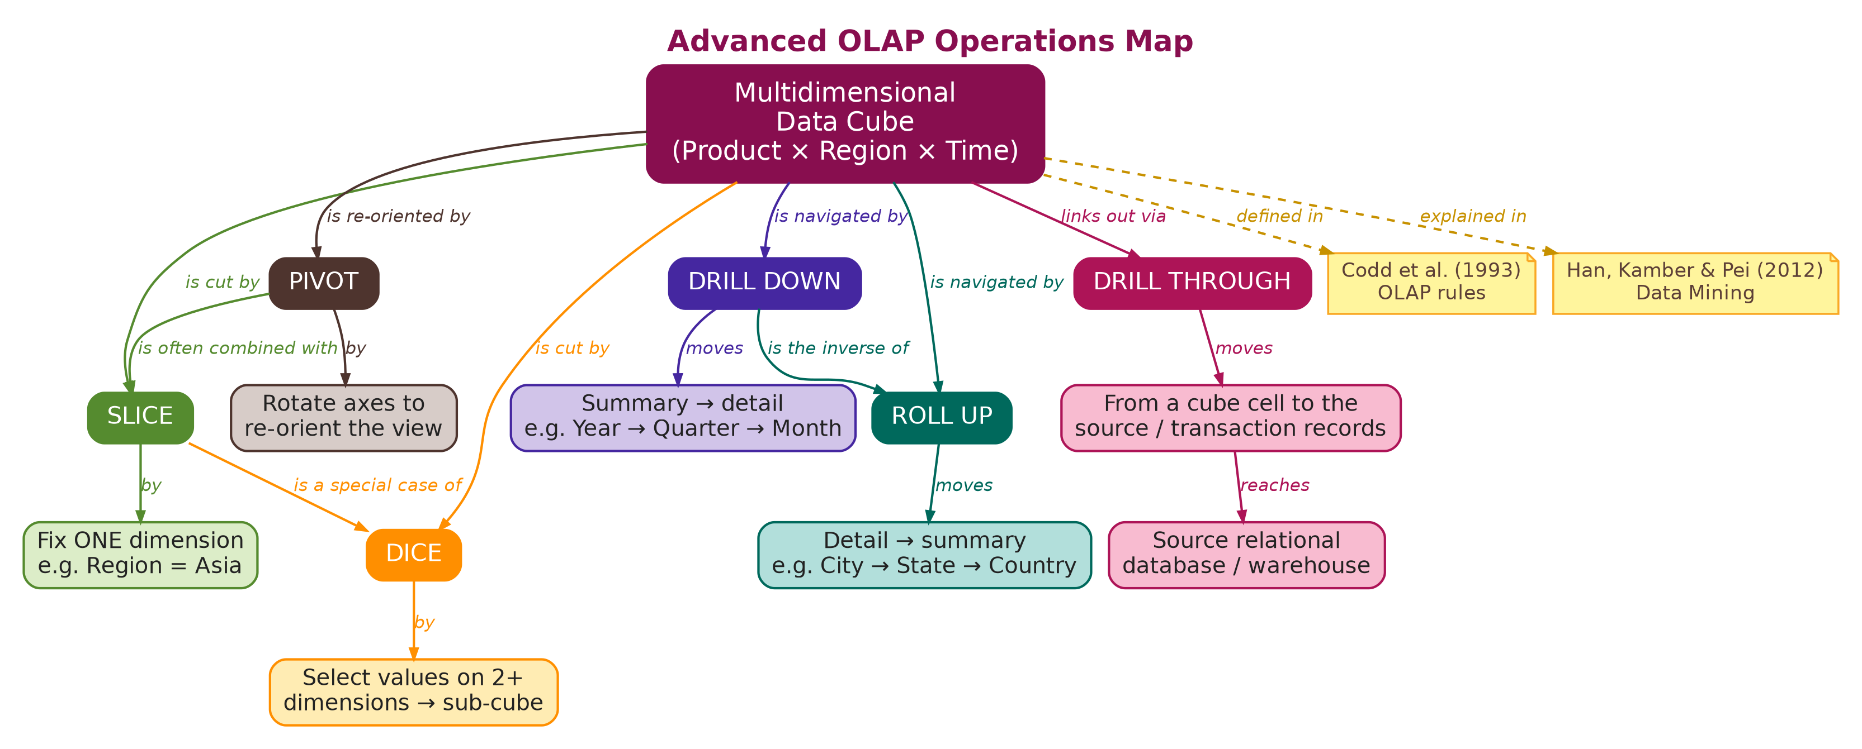

Q2. Concept Map 7: Data Quality and Preprocessing Map
Task Description: Create a concept map explaining the importance of data quality in BI systems.
What your map must show: 1. Missing Data Handling 2. Noise Reduction 3. Data Transformation 4. Data Integration 5. Impact on Decision Making
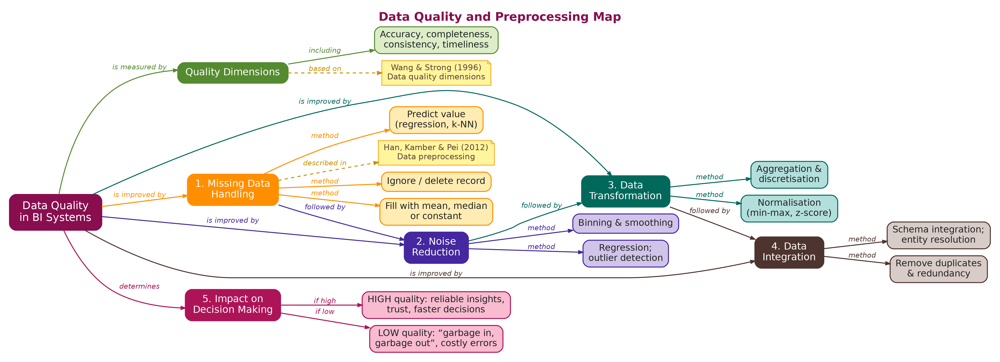

Q3. Concept Map 1: DSS and Business Intelligence Integration
Task Description: Construct a concept map explaining how Decision Support Systems integrate with Business Intelligence for effective decision-making.
What your map must show: 1. DSS and BI relationship 2. Data sources (internal & external) 3. Role of analytics and reporting 4. Decision-making hierarchy 5. Example: Business performance analysis
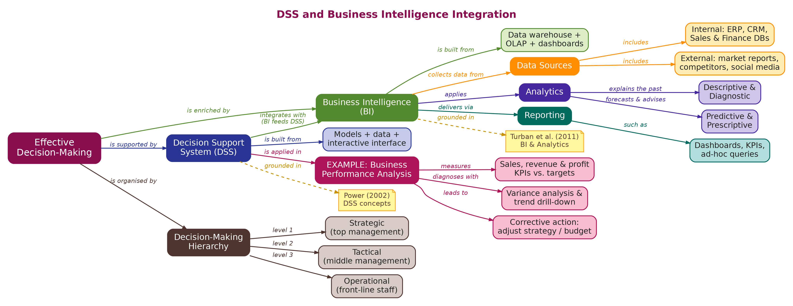

Q4. Concept Map 2: Data Processing Ecosystem (OLTP → OLAP → BI)
Task Description: Create a concept map illustrating the complete data processing ecosystem from transaction systems to analytics.
What your map must show: 1. OLTP systems (data generation) 2. ETL/data integration layer 3. Data warehouse storage 4. OLAP processing 5. BI tools and dashboards 6. Data flow and transformation stages
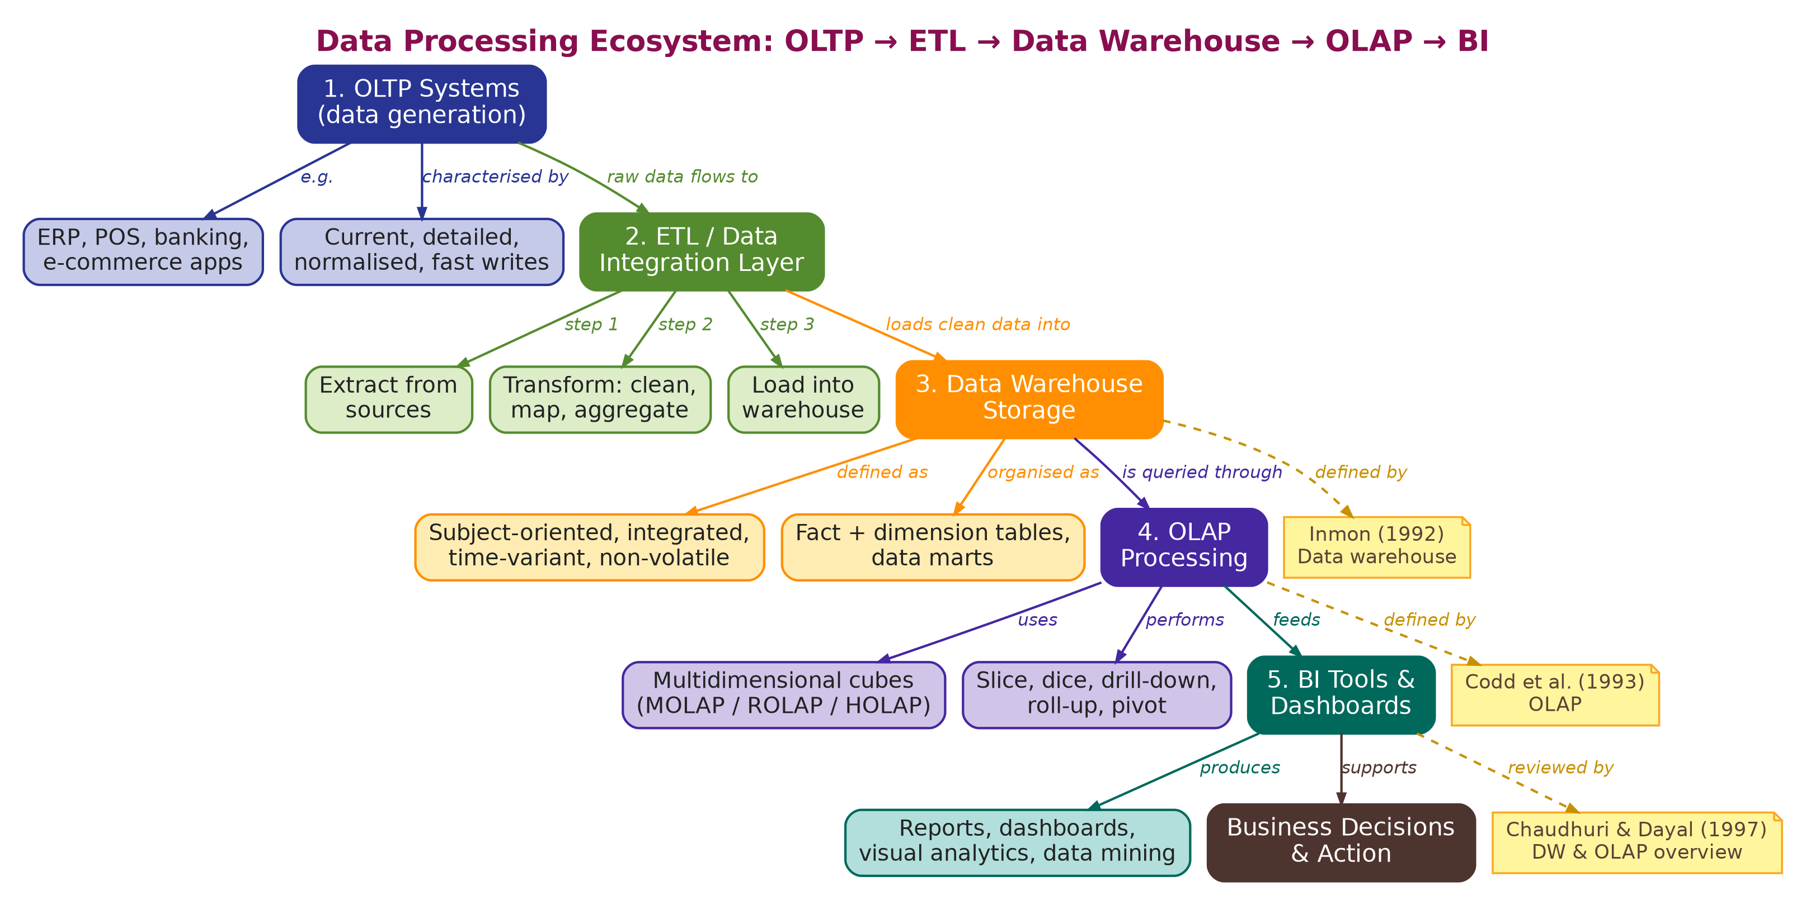

Q5. Concept Map 3: Data Warehouse Components and Data Flow
Task Description: Design a concept map highlighting the internal components of a data warehouse and how data flows through them.
What your map must show: 1. Source systems 2. Data staging area 3. ETL processes 4. Central warehouse 5. Data marts 6. Metadata repository 7. End-user access tools
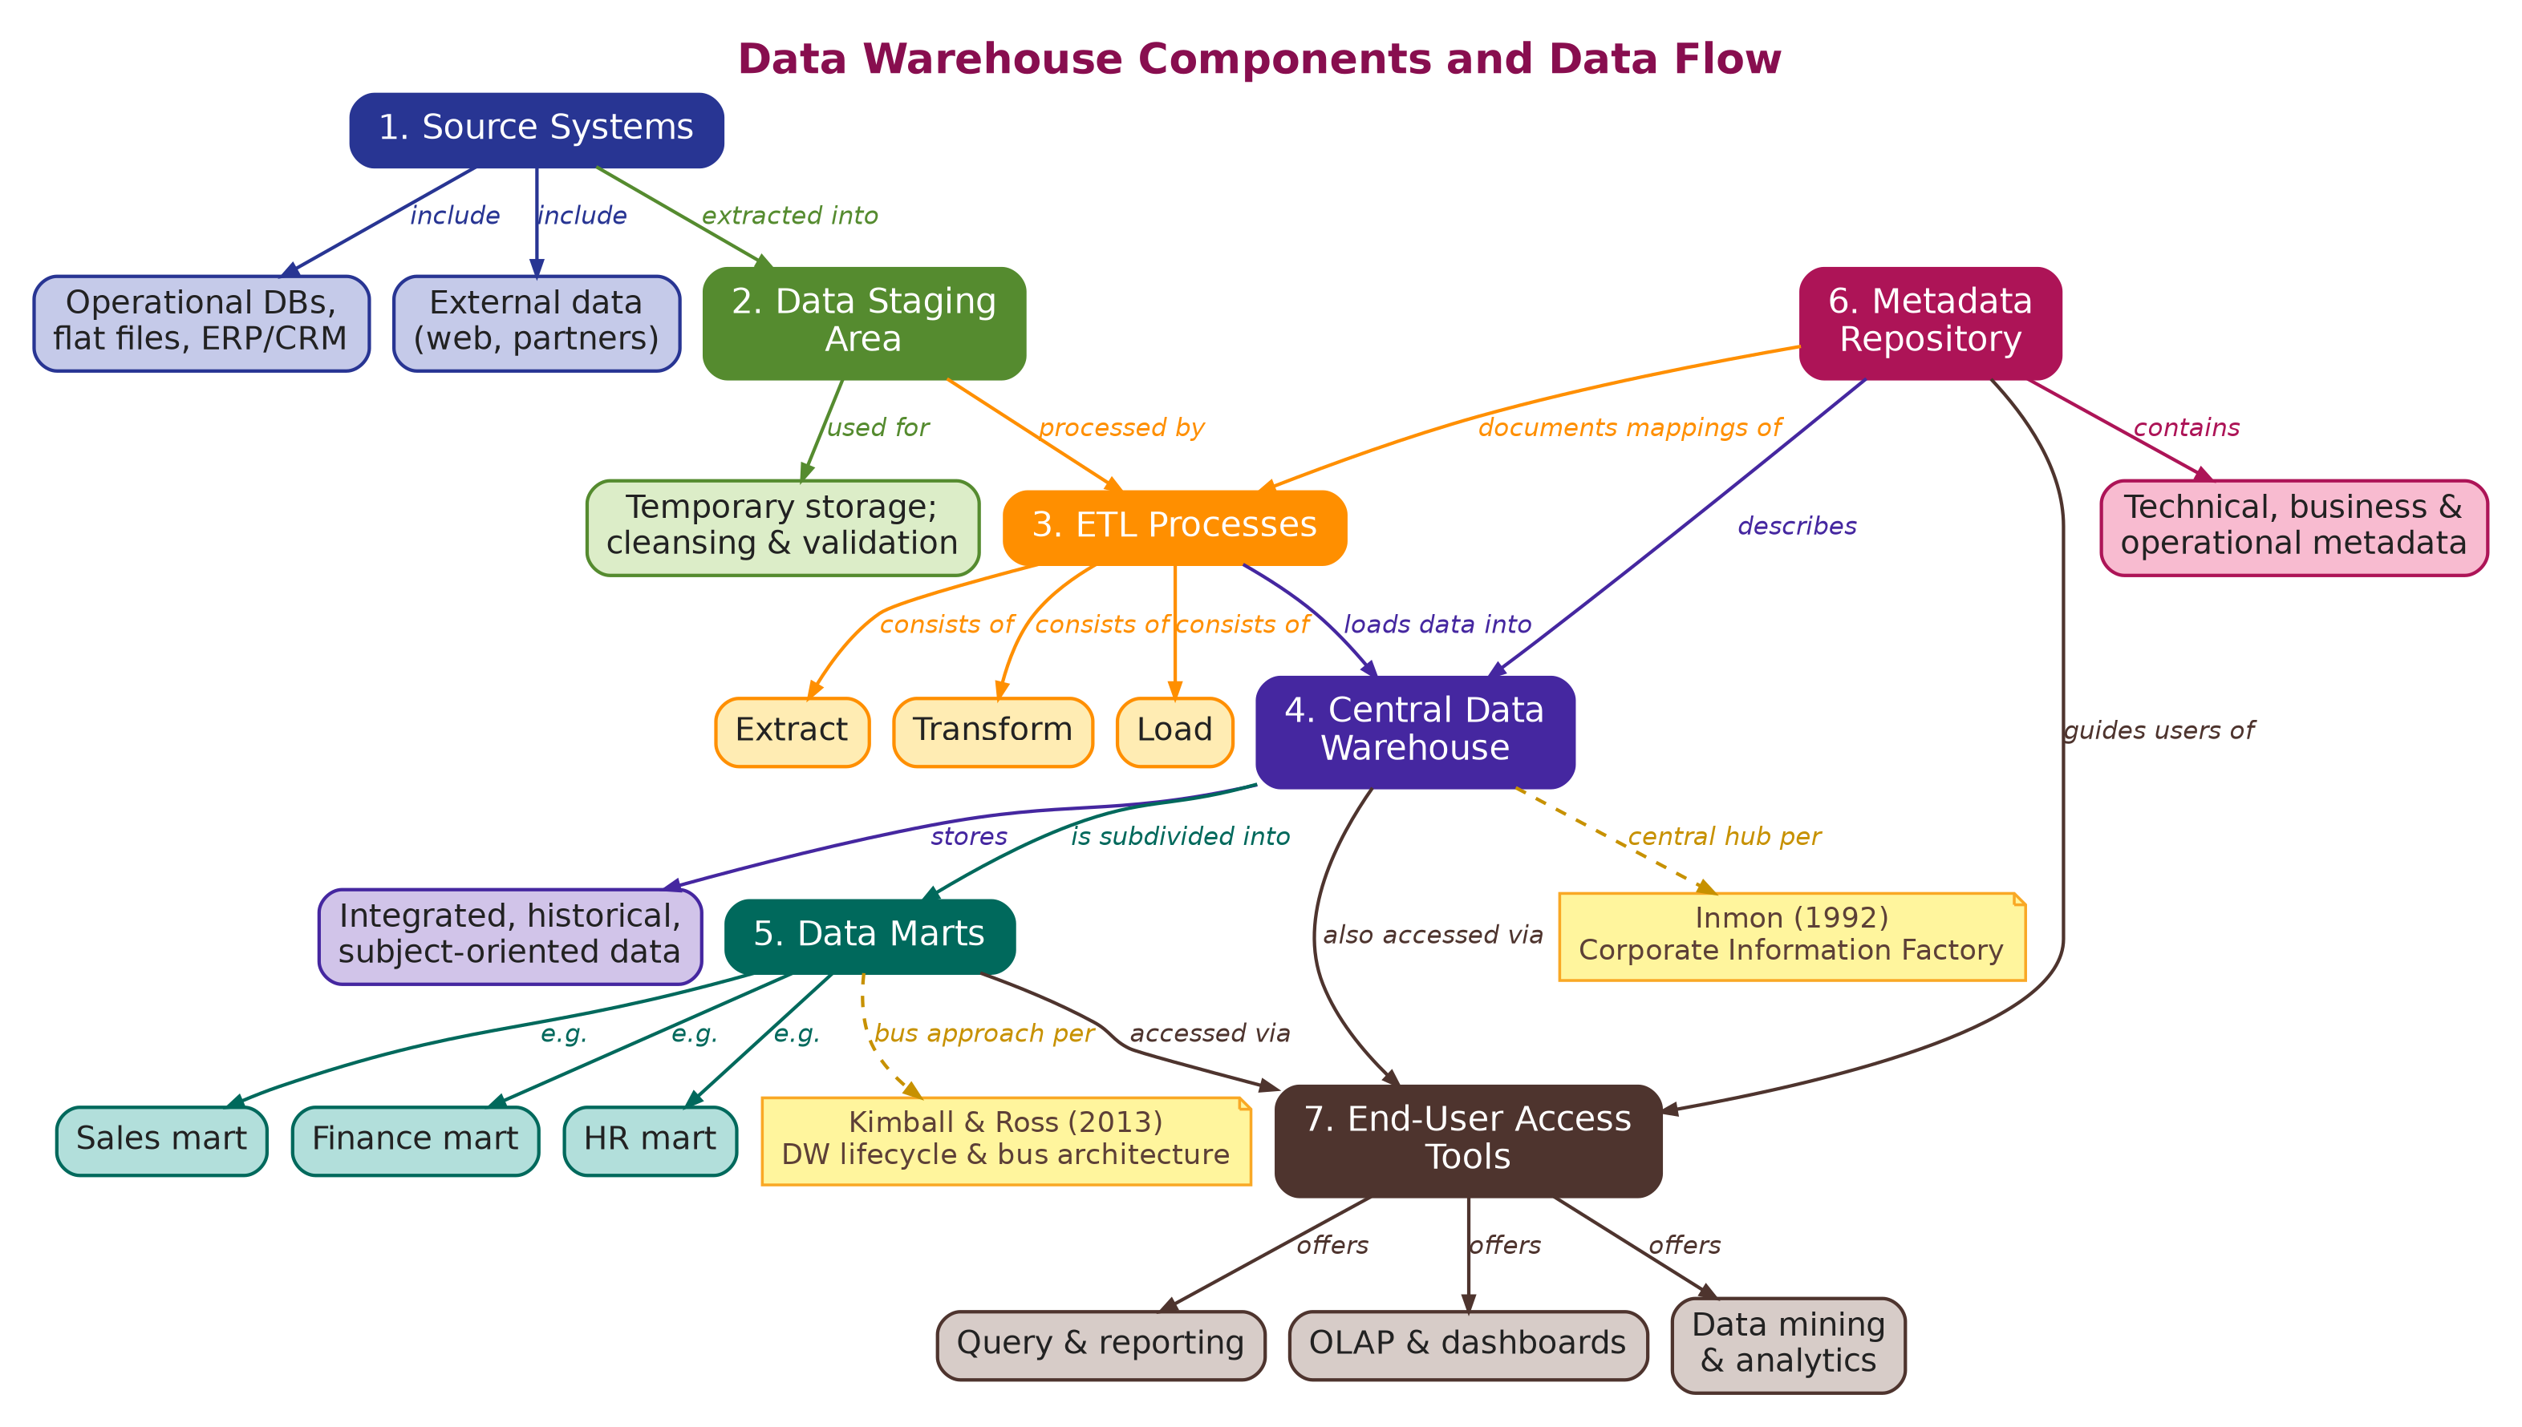

References (Literature Integrated in the Maps)
Chaudhuri, S., & Dayal, U. (1997). An overview of data warehousing and OLAP technology. ACM SIGMOD Record, 26(1), 65–74.
Codd, E. F., Codd, S. B., & Salley, C. T. (1993). Providing OLAP to User-Analysts: An IT Mandate. Codd & Associates.
Han, J., Kamber, M., & Pei, J. (2012). Data Mining: Concepts and Techniques (3rd ed.). Morgan Kaufmann.
Inmon, W. H. (1992). Building the Data Warehouse. Wiley.
Kimball, R., & Ross, M. (2013). The Data Warehouse Toolkit (3rd ed.). Wiley.
Power, D. J. (2002). Decision Support Systems: Concepts and Resources for Managers. Quorum Books.
Turban, E., Sharda, R., & Delen, D. (2011). Decision Support and Business Intelligence Systems (9th ed.). Pearson.
Wang, R. Y., & Strong, D. M. (1996). Beyond accuracy: What data quality means to data consumers. Journal of Management Information Systems, 12(4), 5–34.

