Find the best sushi restaurant in New York City

Capstone Project - The Battle of Neighborhoods

Anmar Arif

**Introduction**

New York City is the is the largest city in the United States and is a large and ethnically diverse metropolis. In 2017, New York City had a population of 8,622,698 people. The diverse culture of NYC makes it a great place for different and high-quality restaurants.

My wife and I are big fans of Japanese cuisine, especially sushi. In every city we go, we must try at least one sushi restaurant. Sadly, my favorite sushi restaurant in NYC has been closed. In this project, I want to find the best sushi restaurant for us to visit on our next trip to NYC.

**Data**

The data used in this project are collected from publicly available sources. The first is data representing the Boroughs and Neighborhoods in NYC, the second is from Foursquare API. We can summarize the data as follows:

1 - Boroughs and Neighborhoods in NYC: https://cocl.us/new_york_dataset

2 - Sushi resturants from Foursquare API

**Methodology**

Since the objective of this project involves venues in NYC, we first collect all venues in the city. Then, the data can be filtered to find the sushi restaurants. That is of course not enough for determining the best restaurant. Therefore, we can analyze the data by processing and visualizing it to determine the best location. The choice of restaurant can be finally made based on the ratings.

The first step is then to download the NYC information. A sample of the data is provided below:

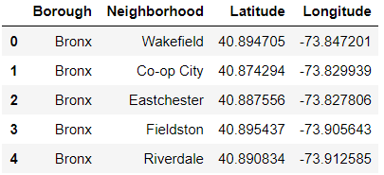

Next, we use geopy library to get the latitude and longitude values of New York City, so we can plot our data on a map. The next part of this project is to collect data from Foursquare. We first the *explore* function in the API to collect all venues in NYC, as shown below:

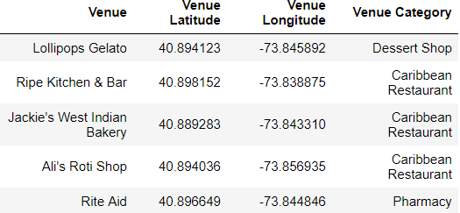

It is important to collect the “id” in the previous so we can later use it when we collect the ratings. Next, the data is filtered so that only sushi restaurants remain.

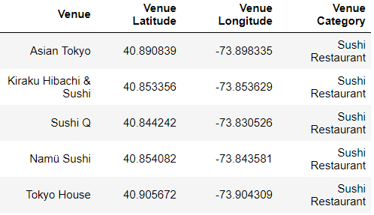

With this data, we have 160 sushi restaurants to choose from.

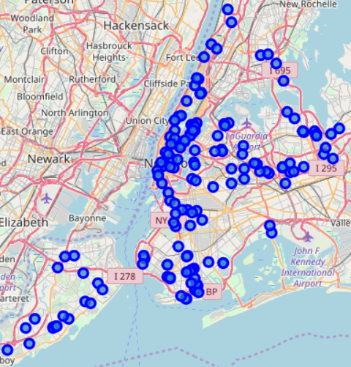

From the previous figure, we can see that there some areas with a large concentration of sushi restaurants. The following figure shows the number of sushi restaurant in each Borough:

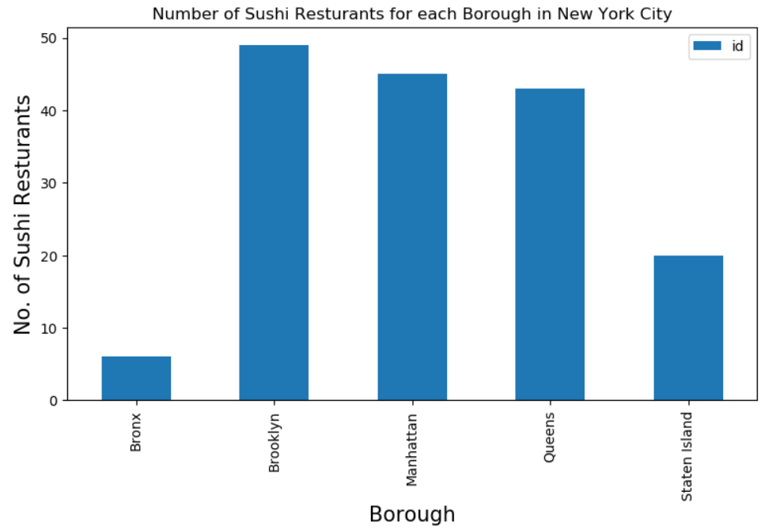

Brooklyn has the highest number of sushi restaurant. Staten Island and Bronx have few sushi restaurants. We still do not have enough information to make a decision, so we collect the ratings, number of reviewers, and number of likes from Foursquare.

**Results and Discussions**

A sample of the data collection is shown below:

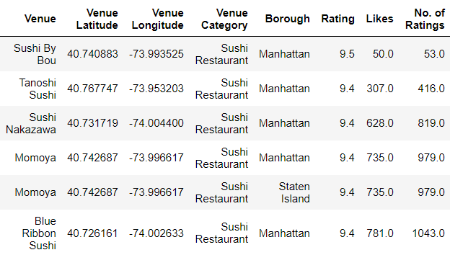

Now let’s filter the data by choosing restaurants the are rated 8 or higher.

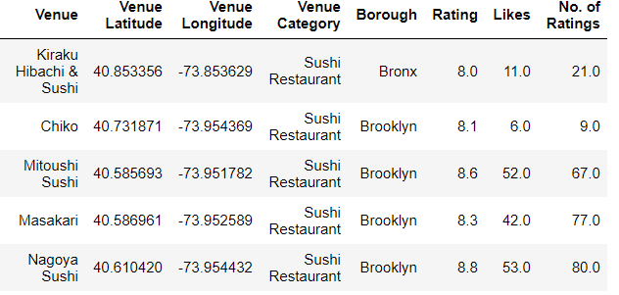

There are 74 restaurants in our list. Since this is a large number, we can conduct further analysis. We noticed that the highest rated restaurants are in Manhattan. Therefore, we grouped the data by Borough:

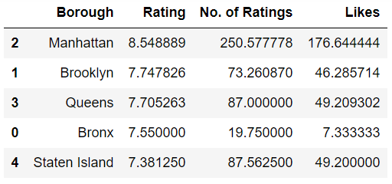

The results clearly show that Manhattan has the best sushi restaurants in NYC. Now let’s see how many are above average:

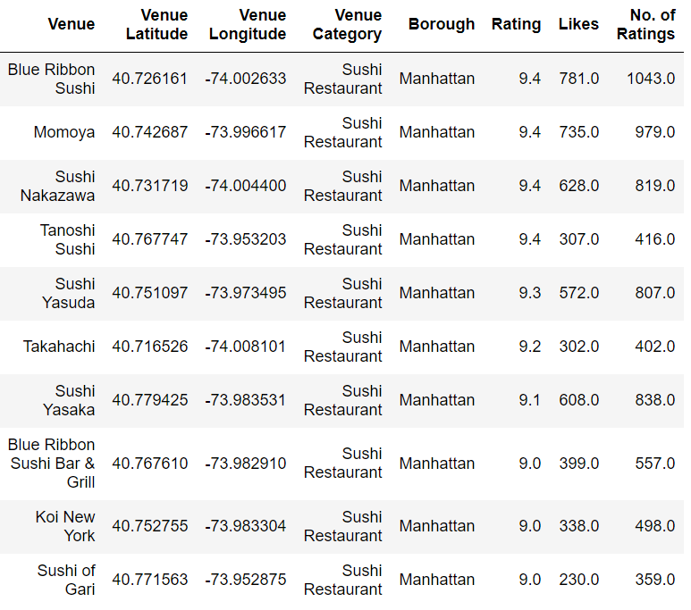

There are 10 restaurants to choose from, with Blue Ribbon Sushi having the highest ratings.

**Conclusion**

* Manhattan has many high-quality sushi restaurants. I chose Blue Ribbon Sushi based on the rating, number of users who rated the restaurant, and number of likes.
* There are also 9 other great choices in case I cannot make it to Blue Ribbon Sushi.
* I will be going to this restaurant in the summer.