## **TABLE OF CONTENTS**

|  |  |  |
| --- | --- | --- |
| **S. NO.** | **TITLE** | **PAGE NO.** |
| 1. | About the Index  1.1. Top constituents by weight  1.2. Sector Representation  1.3. Index Methodology | 1  2  2 |
| 2. | Methodology  2.1. Data Collection  2.2. Calculation of Statistics for all securities and the market (NIFTY PSE)  2.3. Markowitz Efficiency Frontier  2.4. Capital Asset Pricing Model (CAPM)  2.5. Sharpe’s Optimal Portfolio  2.6. Arbitrage Pricing Model (APT) | 4  4  5  7  8  9 |
| 3. | Monthly Returns | 12 |
| 4. | Risk Calculation | 14 |
| 5. | Beta Calculation | 16 |
| 6. | Markowitz Model | 19 |
| 7. | Capital Asset Pricing Model | 23 |
| 8. | Sharpe's Optimal Portfolio | 28 |
| 9. | Arbitrage Pricing Theory | 30 |
| 10. | Performance Evaluation | 33 |
| 11. | Conclusion | 35 |
|  | REFERENCES |  |

**Chapter 1**

**About the Index**

The Nifty PSE Index comprises 20 stocks that are listed on the National Stock Exchange (NSE) where at least 51% of the company's outstanding share capital is held by the Central Government and/or State Government, directly or indirectly.

Nifty PSE Index is computed using the free float market capitalization method, wherein the level of the index reflects the total free float market value of all the stocks in the index relative to a particular base market capitalization value. The Nifty PSE Index can be used for a variety of purposes such as benchmarking fund portfolios, and launching of index funds, ETFs and structured products.

**1.1. Top Constituents by weightage -**

|  |  |
| --- | --- |
| **Company** | **Weightage** |
| NTPC Ltd. | 14.08 |
| Power Grid Corporation of India Ltd. | 11.38 |
| Oil & Natural Gas Corporation Ltd. | 9.11 |
| Coal India Ltd. | 8.79 |
| Bharat Electronics Ltd. | 6.49 |
| Indian Oil Corporation Ltd. | 5.37 |
| Power Finance Corporation Ltd. | 5.14 |
| Hindustan Aeronautics Ltd. | 5.10 |
| Bharat Petroleum Corporation Ltd. | 5.09 |
| REC Ltd. | 4.83 |
| **Total of top 10 constituents** | **75.38%** |

**1.2. Sectoral Representation -**

|  |  |
| --- | --- |
| **Sector** | **Weight (%)** |
| Oil, Gas & Consumable Fuels | 37.30 |
| Power | 27.58 |
| Capital Goods | 14.18 |
| Financial Services | 12.26 |
| Metals & Mining | 3.83 |
| Consumer Services | 2.49 |
| Services | 2.37 |
| **Total** | **100 %** |

**1.3. Index Methodology**

Eligibility Criteria for Selection of Constituent Stocks:

* Companies should form part of the Nifty 500 at the time of review. In case, the number of eligible stocks representing a particular sector within the Nifty 500 falls below 10, then the deficit number of stocks shall be selected from the universe of stocks ranked within the top 800 based on both average daily turnover and average daily full market capitalisation based on previous six months period data used for index rebalancing of Nifty 500.
* Companies must have 51% of their outstanding share capital held by the Central Government and/or State Government, directly or indirectly.
* The company's trading frequency should be at least 90% in the last six months.
* The Company should have a minimum listing history of 1 month as on the cutoff date.
* The final selection of 20 companies shall be done based on the free-float market capitalization of the companies.
* The weightage of each stock in the index is calculated based on its free-float market capitalization such that no single stock shall be more than 33% and the weightage of the top 3 stocks cumulatively shall not be more than 62% at the time of rebalancing.

**Index Re-Balancing:**

Index is re-balanced on semi-annual basis. The cut-off date is January 31 and July 31 of each year, i.e. For semi-annual review of indices, average data for six months ending the cut-off date is considered. Four weeks prior notice is given to market from the date of change.

**Index Governance:**

A professional team manages all NSE indices. There is a three-tier governance structure comprising the Board of Directors of NSE Indices Limited, the Index Advisory Committee (Equity) and the Index Maintenance Sub-Committee.

**Chapter 2**

**Theoretical Foundation and Methodology**

The chapter provides the details of the methodology followed for the project, along with the considerations. It also discusses the theoretical foundations of the various models and works under analysis, for better understanding.

**2.1. Data Collection**

1. Monthly market price data (NIFTY PSE) and the data of the constituent stocks of Index was collected using the Yahoo Finance API with Python, for the duration 1 March 2020 to 1 March 2023. (3 financial years + 1 month as monthly returns need to be calculated).
   1. Any stocks that had an IPO after 1 March 2020 were excluded as it would lead to problems while calculating statistics.
      1. LIC was excluded as it’s IPO was in May 2022
2. The risk-free rate was set to 7.39% per annum (10-year G-Sec yield) from the RBI.

**Data Description**

1. **Open -** Price on the first day of the period. Here, the opening price is the price on the first day of the month.
2. **High -** Highest price during the period. Here, the high price is the highest price during the month.
3. **Low -** Lowest price during the period. Here, the low price is the lowest price during the month.
4. **Close -** Price on the last day of the period. Here, the closing price is the price on the last day of the month.
5. **Volume -** Volume traded during the period.
6. **Dividend -** Dividend distributed during the interval if any.

**2.2. Calculation of Statistics for all securities and the market (NIFTY PSE)**

The theoretical models use various statistical results which are often repeated and common among the models. Thus, the following statistics have been prepared about the market and stocks for efficient analysis.

1. Monthly return = (Closing price - Prev Closing Price + Dividend) / Prev Closing Price

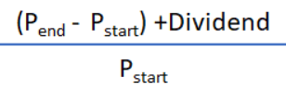

1. Mean monthly return: Arithmetic mean of the monthly returns calculated in point 1
2. Standard deviation of the monthly returns.

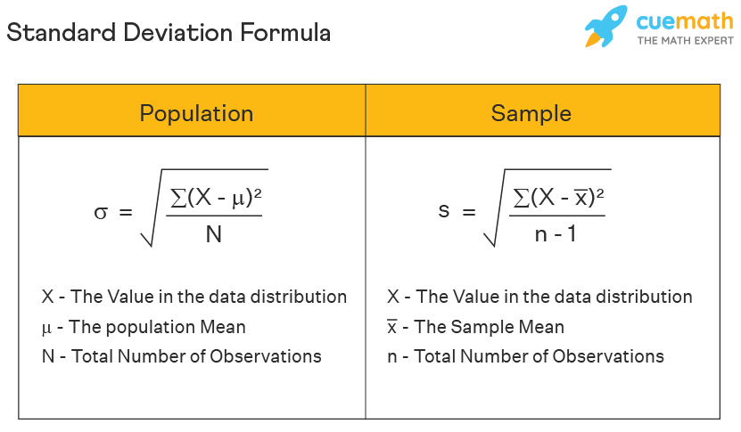

Here n-1 = 35 as we have 3 years data of 12 months each.

1. Beta of security with respect to the market.

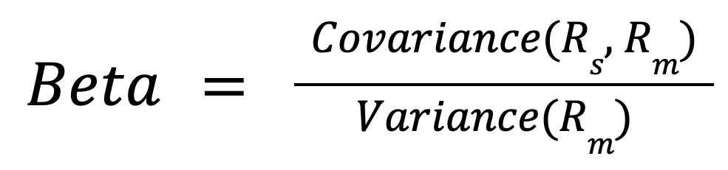

1. Expected Monthly Return of all the securities using CAPM

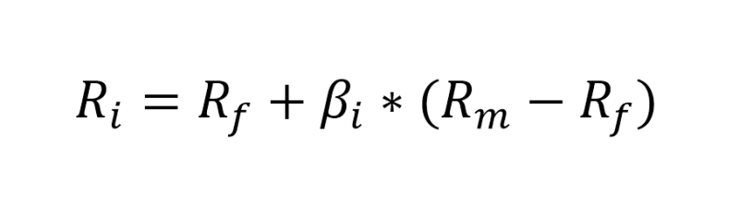

* 1. Rf is fixed = 7.39% / 12 = 0.615833% for monthly Rf.
  2. Rm is the average monthly return of the market data (NIFTY PSE).
  3. Beta taken from point 3.

1. Systematic Risk: (Beta of security wrt market * std dev of market)2
2. Unsystematic Risk - (std dev of security2) - Systematic Risk
3. Excess return to beta (Treynor's Ratio) = (Ri - Rf) / Beta
4. Excess return to Rm
5. Covariance Matrix of all securities

**2.3. Markowitz Efficiency Frontier**

The Markowitz Efficiency Frontier, proposed by Harry Markowitz in 1952, is a graphical representation that illustrates the optimal risk-return trade-offs achievable by combining various assets in a portfolio. It is one of the major foundation stone of the modern portfolio theory, working upon which many other portfolio theories like CAPM have been developed.

It depicts the set of portfolios that offer the highest expected return for a given level of risk or the lowest risk for a given level of return. Portfolios on the frontier are considered efficient because they offer the maximum return for a given level of risk or the minimum risk for a given level of return. Investors aim to construct portfolios that lie on or near the frontier to optimize risk-adjusted returns. The frontier plays a key role in modern portfolio theory and informs asset allocation decisions.

The following methodology has been followed to find the efficient frontier with the index securities and to find the minimum variance portfolio, max variance portfolio, worst portfolios etc.

1. Generated 1000 portfolios with random weights to check if the efficient frontier can be found.
   1. However, due to the high number of securities, leading to a very large sample space, the efficiency frontier cannot be generated using only random portfolio generation.
2. Linear Programming with Constraints was employed to find the efficient frontier and some unique portfolios -
   1. Common constraints were -
      1. The weight of security should be at least 0.01%.
      2. No borrowing or short selling of securities allowed.
      3. The sum of the weights of securities should be 1.
   2. Minimum Variance Portfolio was found by minimising the variance using the constraints.
   3. Maximum Variance Portfolio was found by maximising the variance using the constraints.
   4. Equal weighted portfolio was found wherein the weights were set and the variance and returns were found.
   5. Dominant portfolio was found where the objective was to maximise the Sharpe’s ratio (excess return of port wrt Rf to risk).
   6. A user defined variable called number of steps is set to plot points on the efficient frontier.
      1. Higher the number more the number of points plotted but it comes with computational cost as the algorithm might not be able to find a portfolio for extremely low changes in variance.
   7. Variance jump for the points on the efficiency frontier was calculated using (maximum variance - minimum variance) / no of steps.
   8. At each variance, the portfolio with the maximum return is found by using linear programming, a new constraint has to be added wherein the variance would be equal to the variance jump + variance of the previous step.
   9. At each variance, the portfolio with the minimum return is also found by using linear programming.

**2.4. Capital Asset Pricing Model (CAPM)**

The Capital Asset Pricing Model (CAPM), given by Sharpe et al (1964) is a financial framework used to determine the expected return on an investment based on its systematic risk. It suggests that the expected return of an asset should be proportional to its beta, a measure of its systematic risk relative to the overall market. The formula and methodology followed is as given below.



1. The expected monthly return for securities (calculated ins statistics section 2.3.) is used to compare with the average monthly returns of the securities.
2. Underpriced securities were found, where the mean monthly return was more than the expected return from CAPM.
3. A new covariance matrix of only the underpriced securities was constructed.
4. Linear Programming with Constraints was employed to find the efficient frontier and some unique portfolios -
   1. Common constraints were -
      1. The weight of security should be at least 0.01%.
      2. No borrowing or short selling of securities allowed.
      3. The sum of the weights of securities should be 1.
   2. Minimum Variance Portfolio was found by minimising the variance using the constraints.
   3. Maximum Variance Portfolio was found by maximising the variance using the constraints.
   4. Equal weighted portfolio was found wherein the weights were set and the variance and returns were found.
   5. Dominant portfolio was found where the objective was to maximise the Sharpe’s ratio (excess return of port wrt Rf to risk).
   6. A user defined variable called number of steps is set to plot points on the efficient frontier.
      1. Higher the number more the number of points plotted but it comes with computational cost as the algorithm might not be able to find a portfolio for extremely low changes in variance.
   7. Variance jump for the points on the efficiency frontier was calculated using (maximum variance - minimum variance) / no of steps.
   8. At each variance, the portfolio with the maximum return is found by using linear programming, a new constraint has to be added wherein the variance would be equal to the variance jump + variance of the previous step.
   9. At each variance, the portfolio with the minimum return is also found by using linear programming.

**2.5. Sharpe’s Optimal Portfolio**

Sharpe's Optimal Portfolio, introduced by William Sharpe, is a portfolio constructed to achieve the maximum risk-adjusted return. It represents the point on the efficient frontier with the highest Sharpe ratio, which measures the excess return per unit of risk. Often, it serves as a benchmark for investors seeking to optimize their portfolios and achieve the best possible risk-return trade-off to achieve their investment objectives while managing risk effectively. The methodology followed for the construction of portfolio is as follows:

1. The securities are ordered according to the excess return to beta, calculated in the statistics section 2.6.
2. We find the numerator and denominator of the C* formula.

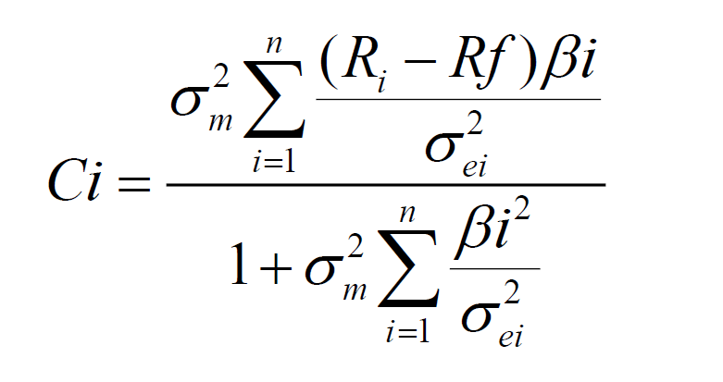

Where, the summations represent cumulative value (Sum) till that security from first security in the ordered list.

1. The set-off point for C* is the last C value till it increases.
2. The z values and weights using the z values are calculated

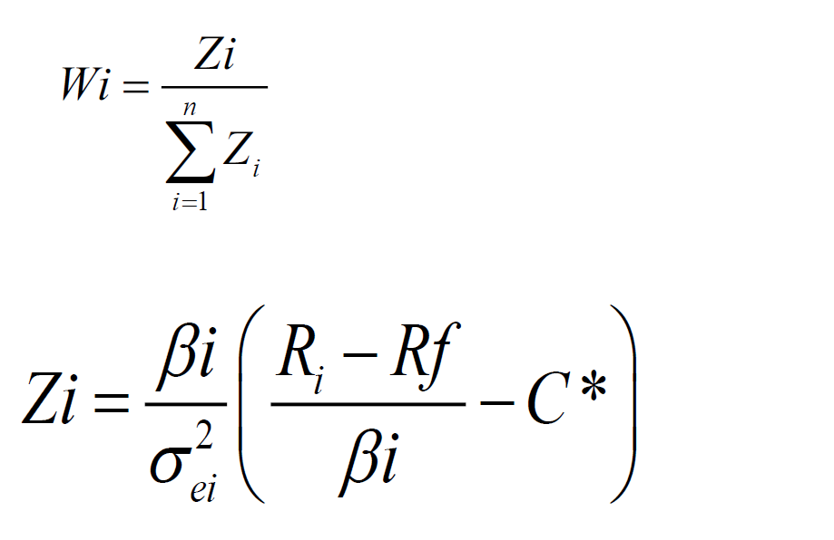

Where



1. Risk and return of the portfolio is found using Sharpe’s single index model formula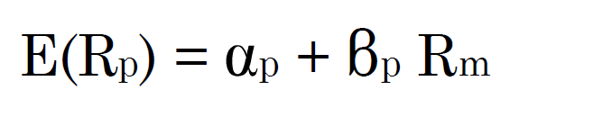

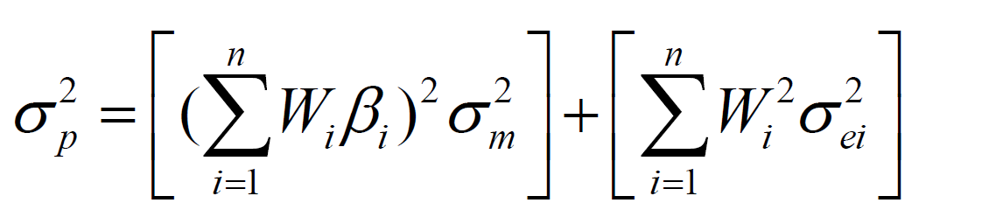

1. Weighted alpha and beta were found using the weights of the Sharpe’s optimal portfolio, and excess return to rm was used as alpha which was calculated for each stock in the basic statistics portion.

**2.6. Arbitrage Pricing Model (APT)**

The Arbitrage Pricing Model, given by Stephen Ross in the 1970s, suggested that the expected return of an investment is not just dependent on the Market only as suggested by the CAPM, but various other macroeconomic factors also affect. These factors add to the systematic risk relating to an investment, thus contributing towards the return expected.

The factors that might be relevant, are not definitive as in CAPM, and can vary according to the nature of the business. Some examples of the factors include GDP, Interest rates, Geopolitical situtations, forex rates, gold prices, oil prices, inflation rates etc. Ross does not specify the factors, only mentions a few that can be considered from a universe. The general equation of the expected return from APT is :



Where, Rf is risk free rate, Betas are sensitivity towards factors and fi are factors.

The APT model acts as an alternative to CAPM with reduced assumptions. However, it is very difficult to perform as identifying factors is an additional task, and multicollinearity might come among the factors, affecting the results.

To identify the factors, following methodology was followed:

1. Quarterly stocks data for the Market (Nifty PSE Index) and 2 PSU mutual funds, named Invesco and SBI PSU MF was collected.
   1. The period considered was Mar 2018 (Q1 Apr-June) to the last quarter of 2022 (Q3 Oct-Dec).
   2. The returns were calculated for the data, resulting to 19 values.
2. Quarterly data for various macroeconomic indicators was collected including gdp, gold prices, inflation, INR_USD forex rate etc.
   1. Derived indicators like gdp_change, gold_change, oil_change, avg_inflation, inflation of 3rd period etc. were also created.
3. SPSS Regression was used, with various factors and mutual funds to identify the relevant factors. This included both stepwise and enter methods of regression.
   1. The results were poor on the MFs, hence a change in methodology was followed. More details of results in the results section.
4. SPSS Regression was used with the market index and various factors, studying the stepwise result and the correlation matrix.
5. Ultimately, 3 factors were finalized, oil_change, inflation_last_month, INR_USD rate. Predictions were created for the index and RMSE was calculated.
6. Sensitivities were calculated by computing covar (stock data, factor data) / var (factor data) for the stocks data of the same period and the above mentioned factors.
7. Predictions were created using the sensitivities and the Rf as used above, adjusted for the time period of a quarter.
   1. RMSE was calculated
8. Pricing strategy was created based on the rules

* If mean return monthly > expected return apt monthly then Underpriced
* Else Overpriced

The APT model also suggests, an opportunity to create arbitrage profit by comparing the expected and actual returns. However, due to poor forecasts estimations by comparing with the actual returns, RMSE and analyst’s opinion, the arbitrage opportunity is created using the CAPM results. The underlying assumption here is that due to poor performance and low significance of the factors, the APT model reduced to the CAPM. For creating the arbitrage opportunity, the following methodology was followed.

1. 6 securities were selected from the list of available securities
   1. Only 2 overpriced securities were present, which were taken as is.
   2. From the 17 underpriced securities, 4 securities with highest Jensen’s Alpha were selected for creating arbitrage
2. Positions were entered for the 6 securities based on the rule:
   1. If underpriced, then enter into long position
   2. If overpriced, short the stock
3. Time frame considered for arbitrage profit is same as that of analysis, i.e. 3 years, which might not be practical in real life, but is an assumption for the current analysis.
   1. t = 0, i.e. time at start of period represents 31st Mar 2020. t = T, i.e. time at the end of period represents 31st Mar 2023.
4. Cash flows from a stock = No of units * Market price on the date
5. The no of units were selected to make net cash flow at time t=0, nearly equal to 0, or negligibily positive, to create arbitrage.
   1. The negligible cash inflow might be considered to be invested in risk free assets for returns.
   2. Assumption - stocks can be partially traded, complete units need to be traded.
6. At the end of period, opposit positions are taken in the same stocks for the same no of units to square off the position, and realize the grain.
   1. Again, the cash flows are calculated and summed to see the profit.

**Chapter 3**

**Monthly Returns**

Monthly returns of all stocks with ticker and company name are present in the below given table.

|  |  |  |
| --- | --- | --- |
| **Ticker** | **Company** | **Mean Monthly Return** |
| BEL | Bharat Electronics Limited | 4.66% |
| BHEL | Bharat Heavy Electricals Limited | 4.46% |
| BPCL | Bharat Petroleum Corporation Limited | 1.73% |
| COALINDIA | Coal India Limited | 3.88% |
| CONCOR | Container Corporation of India Limited | 2.22% |
| GAIL | GAIL (India) Limited | 3.20% |
| HAL | Hindustan Aeronautics Limited | 5.86% |
| HINDPETRO | Hindustan Petroleum Corporation Limited | 2.05% |
| IOC | Indian Oil Corporation Limited | 2.81% |
| IRCTC | Indian Railway Catering & Tourism Corporation Limited | 3.66% |
| NHPC | NHPC Limited | 3.23% |
| NMDC | NMDC Limited | 3.83% |
| NTPC | NTPC Limited | 3.35% |
| ONGC | Oil and Natural Gas Corporation Limited | 4.00% |
| OIL | Oil India Limited | 4.93% |
| PFC | Power Finance Corporation Limited | 3.40% |
| POWERGRID | Power Grid Corporation of India Limited | 3.15% |
| RECLTD | REC Limited | 3.70% |
| SAIL | Steel Authority of India Limited | 5.75% |
| NIFTY PSE | NIFTY PSE Index | 2.15% |

The data presented reveals a period of outstanding success for the Nifty 50 tickers, with all equities demonstrating positive average monthly returns between April 1, 2020 and March 31, 2023. Here's the breakdown:

**Highest Mean Monthly Return:** SAIL (5.75%)

**Lowest Mean Monthly Return:** NIFTY PSE (2.15%)

**Possible Reasons for High Mean Monthly Returns:**

* **Post-COVID Recovery:** The timeframe corresponds to the global economic rebound following the initial COVID-19 lockdowns in 2020. This recovery in economic activity most likely bolstered business earnings and market enthusiasm, resulting in higher stock prices.
* **Low-Interest Rates:**To stimulate the economy during the epidemic, central banks around the world enacted historically low interest rates. This made equities a more appealing investment alternative than low-yielding bonds, driving stock prices higher.
* **Liquidity Injections:** To assist the economy, governments and central banks poured large amounts of liquidity into the financial sector. This additional money supply may have made its way into the stock market, increasing asset prices.
* **Sectoral Performance:** Specific sectors, such as steel (SAIL) and aviation (HAL), may have experienced considerable returns as a result of post-pandemic openings and infrastructure initiatives.

**Chapter 4**

**Risk Calculation**

Std Deviation of all stocks is presented in the below given table.

No. of observations (n) = No. of Years * 12 = 3 * 12 = 36 observations

|  |  |  |  |  |
| --- | --- | --- | --- | --- |
| **Ticker** | **Mean Monthly Return** | **Sum of (X minus Xbar square)** | **Variance**  **Col 3 / (n-1)** | **Risk or Standard Deviation** |
| BEL | 4.66% | 0.287106 | 0.008203 | 9.06% |
| BHEL | 4.46% | 0.783532 | 0.022387 | 14.96% |
| BPCL | 1.73% | 0.240632 | 0.006875 | 8.29% |
| COALINDIA | 3.88% | 0.360847 | 0.01031 | 10.15% |
| CONCOR | 2.22% | 0.300608 | 0.008589 | 9.27% |
| GAIL | 3.20% | 0.307557 | 0.008787 | 9.37% |
| HAL | 5.86% | 0.39633 | 0.011324 | 10.64% |
| HINDPETRO | 2.05% | 0.25359 | 0.007245 | 8.51% |
| IOC | 2.81% | 0.181063 | 0.005173 | 7.19% |
| IRCTC | 3.66% | 0.449986 | 0.012857 | 11.34% |
| NHPC | 3.23% | 0.167354 | 0.004782 | 6.91% |
| NMDC | 3.83% | 0.464934 | 0.013284 | 11.53% |
| NTPC | 3.35% | 0.258776 | 0.007394 | 8.60% |
| ONGC | 4.00% | 0.371899 | 0.010626 | 10.31% |
| OIL | 4.93% | 0.492542 | 0.014073 | 11.86% |
| PFC | 3.40% | 0.297743 | 0.008507 | 9.22% |
| POWERGRID | 3.15% | 0.10479 | 0.002994 | 5.47% |
| RECLTD | 3.70% | 0.262198 | 0.007491 | 8.66% |
| SAIL | 5.75% | 1.146535 | 0.032758 | 18.10% |
| NIFTY PSE | 2.15% | 0.133651 | 0.003818 | 6.18% |

**Highest Standard Deviation:** SAIL (18.10%)

**Lowest Standard Deviation:** POWERGRID (5.47%)

**Possible Reasons for High Standard Deviation:**

* ***SAIL:*** SAIL is a steel firm, and the steel industry is recognised for its cyclicality. Steel prices can fluctuate dramatically depending on economic conditions, resulting in increased volatility in stock returns.
* ***Other High Std Dev Stocks:*** Other equities with a large standard deviation (e.g., IRCTC, NMDC, OIL) may also be vulnerable to sector- or company-specific variables that cause price fluctuations. These factors could include government legislation, commodity price variations, or company-specific events such as mergers and acquisitions.

**Possible Reasons for Low Standard Deviation:**

* ***POWERGRID:*** POWERGRID is a very steady corporation that works in the electricity transmission sector. Electricity demand is usually stable, resulting in less fluctuating stock values for POWERGRID than in cyclical sectors.
* ***Other Low Std Dev Stocks***: Other low-standard deviation stocks (such as BPCL and HINDPETRO) may profit from government regulations or operating in defensive sectors that are less subject to economic cycles.

**Analysis of Standard Deviation of NIFTY PSE**

**NIFTY PSE Standard Deviation:** 6.18%

The NIFTY PSE has a smaller standard deviation than the majority of individual equities in the Nifty 50. This is most likely because it is a market index that measures the average performance of a group of equities. Diversification between industries and companies within the index contributes to lower volatility.

In conclusion, the standard deviation of Nifty 50 tickers varies greatly. Cyclical sectors and company-specific events can cause more volatility, whereas defensive sectors and market indices tend to be less volatile.

**Chapter 5**

**Beta Calculation**

The betas calculated with respect to the market (Nifty PSE) index are given in the below table. Variance of the market (NIFTY PSE) = 0.005326594362555665

|  |  |  |
| --- | --- | --- |
| **Ticker** | **Covariance WRT Index** | **Beta** |
| BEL | 0.00294 | 0.769813 |
| BHEL | 0.006491 | 1.699764 |
| BPCL | 0.003696 | 0.967845 |
| COALINDIA | 0.005107 | 1.337331 |
| CONCOR | 0.003251 | 0.851412 |
| GAIL | 0.004518 | 1.1831 |
| HAL | 0.003186 | 0.834416 |
| HINDPETRO | 0.004026 | 1.054343 |
| IOC | 0.003342 | 0.875081 |
| IRCTC | 0.003957 | 1.03615 |
| NHPC | 0.002323 | 0.60828 |
| NMDC | 0.003496 | 0.915542 |
| NTPC | 0.004194 | 1.098305 |
| ONGC | 0.004965 | 1.300136 |
| OIL | 0.00419 | 1.097161 |
| PFC | 0.004169 | 1.09163 |
| POWERGRID | 0.002455 | 0.642886 |
| RECLTD | 0.003553 | 0.930532 |
| SAIL | 0.006438 | 1.685936 |

**Analysis:** 7 of the 19 stocks have a beta < 1 showing defensive movement and lower volatility with respect to the market, while 12 stocks have beta > 1 indicating the opposite. 6 stocks have beta around 1 (0.9 to 1.1), moving nearly the same as the market. SAIL has the highest beta of 1.66, while beta of BEL, POWERGRID and NHPC are very low.

**Low Beta Stocks (Beta < 1): Defensive Plays**

* **BEL (0.77):** This low beta suggests BEL's stock price fluctuates less than the market. Possible reasons:
  + Steady Government Contracts: BEL is a major defense equipment supplier to the Indian government. These contracts provide a predictable revenue stream, leading to less volatile stock prices.
  + Less Cyclical Industry:Unlike sectors heavily impacted by economic swings, the defense industry tends to be more stable, influencing BEL's beta.
* **CONCOR (0.85):** This container corporation might exhibit lower volatility due to:
  + *Essential Service:* Container movement is crucial for trade and logistics. Even during economic downturns, CONCOR might see consistent demand, leading to a less volatile stock price.
  + Government Backing: Being a central public sector enterprise (CPSE), CONCOR might benefit from government support during economic disturbances, contributing to lower beta.

**High Beta Stocks (Beta > 1): Growth-Oriented but Riskier**

* **SAIL (1.68):** This steel giant has the highest beta, suggesting significant price swings. Potential reasons:
  + Steel Price Volatility: Steel prices are highly cyclical, influenced by global demand, raw material costs, and trade policies. This volatility translates to SAIL's stock price.
  + Government Policies: Government policies like import duties or infrastructure spending can significantly impact steel demand and SAIL's stock price.
* **BHEL (1.70):** Though similar to SAIL in beta, BHEL might have different volatility drivers:
  + Project-Based Business: BHEL secures large power plant construction contracts. Delays or cost overruns in these projects can cause stock price fluctuations.
  + Competition from Private Players: Increased competition from private companies in the power sector can affect BHEL's order book and stock price.

**Beta Around 1 (Relatively Market-Aligned)**

* **NTPC (1.10):** This power generation giant's beta suggests movement similar to the market. Possible explanations:
  + Regulated Industry: The power sector is heavily regulated, with tariffs set by government agencies. This can limit extreme price swings in NTPC's stock.
  + Fuel Price Impact: However, fluctuations in fuel prices (coal, gas) can impact NTPC's profitability and stock price to some extent.

**Chapter 6**

**Markowitz Portfolio Theory**

Markowitz Model Plot -

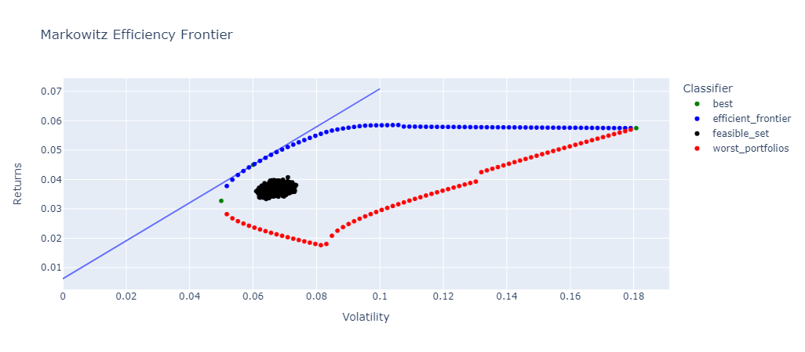

Markowitz Plot without feasible set -

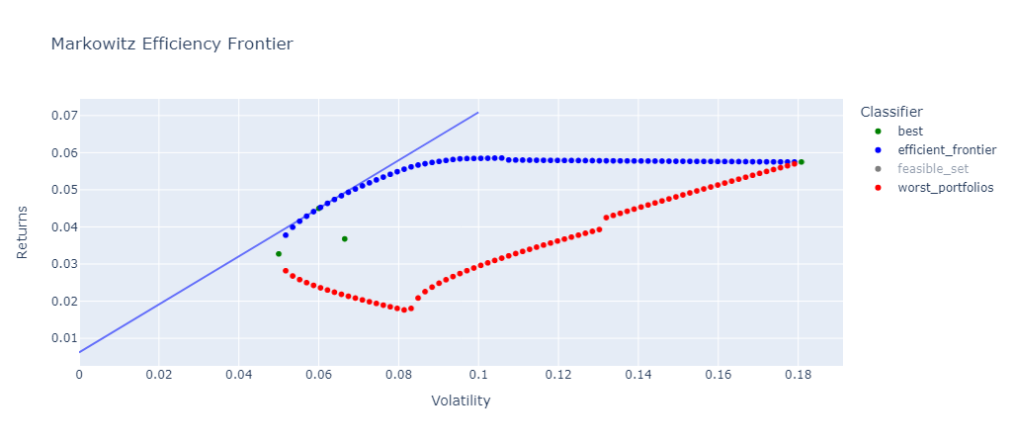

These graphs plot the risk and return of many portfolios.

* Blue points are the portfolios on the efficient frontier
* Red points are the portfolios on the worst frontier
* Green points are unique portfolios given in the table below
* Black points are random portfolio generations in the feasible set.
* Blue line is the CML passing through the dominant portfolio.

We can see that the return increases with risk till a certain point then it starts to decrease eventually meeting the maximum variance portfolio. There are some outliers in the graph that might be due to optimising functions not working for extremely small value changes.

Details about the 4 unique portfolios, including their risk, return and composition are given in the below table.

|  |  |  |  |  |
| --- | --- | --- | --- | --- |
| **Details** | **Minimum Variance Portfolio** | **Maximum Variance Portfolio** | **Dominant Portfolio (Highest Sharpe Ratio)** | **Equal Weighted Portfolio** |
| Returns | 3.27% | 5.75% | 4.50% | 3.68% |
| Volatility (Risk or Std Dev) | 5.00% | 18.07% | 6.00% | 6.65% |
| Beta | 0.702183 | 1.684731 | 0.840469 | 1.051561 |
| Sharpe Ratio | 0.531902 | 0.284001 | 0.647295 | 0.460602 |
| Treynor Ratio | 0.037839 | 0.030466 | 0.046214 | 0.02911 |
| Weight BEL | 8.08% | 0.01% | 10.47% | 5.26% |
| Weight BHEL | 0.01% | 0.01% | 0.01% | 5.26% |
| Weight BPCL | 0.87% | 0.01% | 0.01% | 5.26% |
| Weight COALINDIA | 0.01% | 0.01% | 0.01% | 5.26% |
| Weight CONCOR | 0.01% | 0.01% | 0.01% | 5.26% |
| Weight GAIL | 0.01% | 0.01% | 0.01% | 5.26% |
| Weight HAL | 0.01% | 0.01% | 26.98% | 5.26% |
| Weight HINDPETRO | 0.01% | 0.01% | 0.01% | 5.26% |
| Weight IOC | 12.85% | 0.01% | 0.01% | 5.26% |
| Weight IRCTC | 2.55% | 0.01% | 1.76% | 5.26% |
| Weight NHPC | 18.36% | 0.01% | 18.61% | 5.26% |
| Weight NMDC | 4.14% | 0.01% | 13.21% | 5.26% |
| Weight NTPC | 0.01% | 0.01% | 0.01% | 5.26% |
| Weight ONGC | 0.01% | 0.01% | 0.01% | 5.26% |
| Weight OIL | 0.01% | 0.01% | 16.87% | 5.26% |
| Weight PFC | 0.01% | 0.01% | 0.01% | 5.26% |
| Weight POWERGRID | 52.76% | 0.01% | 10.18% | 5.26% |
| Weight RECLTD | 0.28% | 0.01% | 0.01% | 5.26% |
| Weight SAIL | 0.01% | 99.82% | 1.82% | 5.26% |
| **Weight Sum** | **100.00%** | **100.00%** | **100.00%** | **100.00%** |

**Key observations from the weightings:**

* **Minimum Variance Portfolio:** This portfolio prioritizes low risk by concentrating heavily on NHPC (28.84%) and POWERGRID (47.21%). These are historically stable stocks with low volatility as seen from their low beta.
* **Maximum Variance Portfolio:** This portfolio seems to be heavily concentrated in SAIL (36.57%) and BHEL (63.26%). These are historically high-growth stocks with potentially high returns but also high risk as seen from their beta.
* **Dominant Portfolio (Highest Sharpe Ratio):** This portfolio achieves a balance by taking a larger position in NHPC (16.99%) and OIL (16.48%) for stability, while also including some riskier growth stocks like HAL (10.95%) and NMDC (11.45%).
* **Equal Weighted Portfolio:** This portfolio simply allocates 5.26% to each stock, regardless of its risk-return profile. This approach offers some diversification but is not optimal for maximizing return for a given level of risk as seen from the graph it does not lie on the efficient frontier.

**Diversification Analysis:**

Diversification in portfolio management involves spreading investments across various assets to reduce risk. By investing in different sectors, industries, and geographic regions, investors aim to minimize the impact of any single investment's poor performance on the overall portfolio. This strategy helps to stabilize returns and mitigate the impact of market fluctuations.

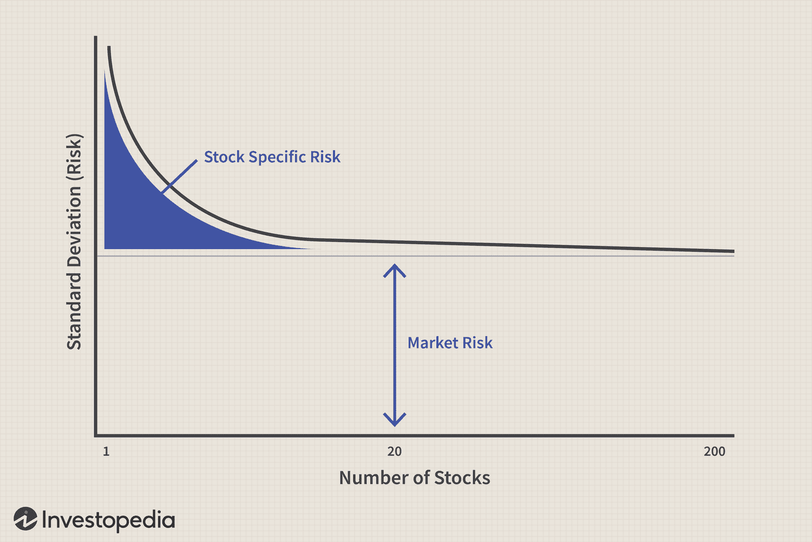

Source: <https://www.investopedia.com/investing/dangers-over-diversifying-your-portfolio/>

The universe in the current analysis, comprises of stocks available in the NIFTY PSE index only, which have a common factor among them - them being Public sector and infrastructure - other than the fact that they operate in same geographic area called India, thus complete diversification is not possible. However, it contains companies from various sub sectors like transportation, oil and gas, energy, capital goods etc. which provides an opportunity for diversification, and a chance to reduce the diversifiable company related risk by adding more stocks.

The weightings clearly indicate how diversification plays out in these portfolios. The Minimum Variance Portfolio and Dominant Portfolio demonstrate how spreading investments across various stocks can reduce overall risk, while the maximum variance portfolio has very high risk with just 2 stocks in the portfolio. Even though the Dominant Portfolio has some higher-risk stocks, it balances them with more stable ones compared to the Maximum Variance Portfolio, which is heavily concentrated in just a few high-risk stocks.

**Risk Return Trade Off**

The risk-return tradeoff is a fundamental concept in finance that links the potential reward of an investment with its associated level of risk. It suggests that investors can achieve or demand greater returns by accepting a higher degree of risk.

Quantitative metrics like the Sharpe ratio, beta coefficient, and alpha are used to assess investment risk. The Sharpe ratio measures the risk-adjusted return of an investment, while beta evaluates the volatility of a security relative to the overall market. These ratios help investors evaluate the risk-return tradeoff of potential investments, enabling informed decision-making regarding portfolio allocation and risk management strategies.

**Sharpe Ratio and Portfolio Choice:**

The Dominant Portfolio has the highest Sharpe Ratio, meaning it offers the best return per unit of risk. This aligns with the concept of efficient frontier portfolios that provide the best risk-return trade-off.

**Chapter 7**

**Capital Asset Pricing Model**

The actual mean monthly returns and expected returns by the model for all the stocks are presented in the below table, along with pricing status.

|  |  |  |  |
| --- | --- | --- | --- |
| **Ticker** | **Mean Return Monthly** | **Expected Return CAPM Monthly** | **Status** |
| BEL | 4.66% | 1.80% | Underpriced |
| BHEL | 4.46% | 3.23% | Underpriced |
| BPCL | 1.73% | 2.10% | Overpriced |
| COALINDIA | 3.88% | 2.67% | Underpriced |
| CONCOR | 2.22% | 1.92% | Underpriced |
| GAIL | 3.20% | 2.43% | Underpriced |
| HAL | 5.86% | 1.90% | Underpriced |
| HINDPETRO | 2.05% | 2.24% | Overpriced |
| IOC | 2.81% | 1.96% | Underpriced |
| IRCTC | 3.66% | 2.21% | Underpriced |
| NHPC | 3.23% | 1.55% | Underpriced |
| NMDC | 3.83% | 2.02% | Underpriced |
| NTPC | 3.35% | 2.30% | Underpriced |
| ONGC | 4.00% | 2.61% | Underpriced |
| OIL | 4.93% | 2.30% | Underpriced |
| PFC | 3.40% | 2.29% | Underpriced |
| POWERGRID | 3.15% | 1.60% | Underpriced |
| RECLTD | 3.70% | 2.05% | Underpriced |
| SAIL | 5.75% | 3.21% | Underpriced |

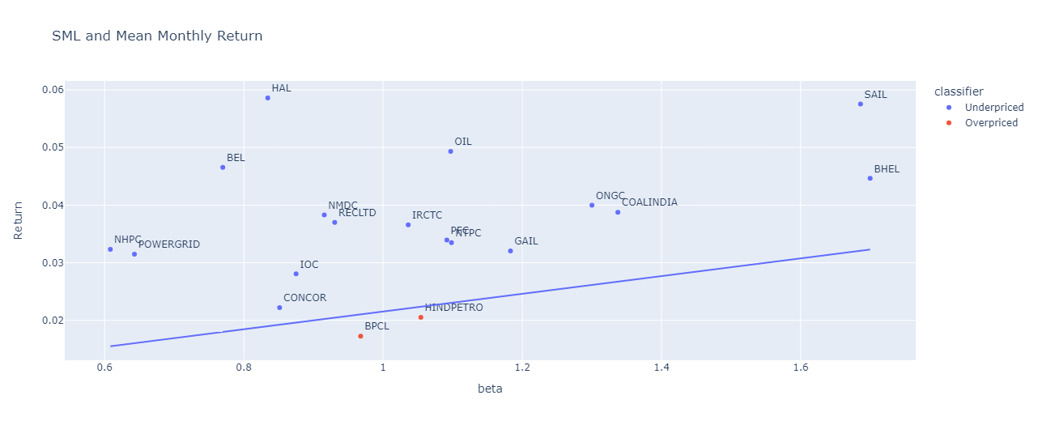

Assumptions -

* Rf = 7.39% the 10 Year G-Sec Bond Yield as given on the RBI Website.
  + <https://www.rbi.org.in/Scripts/BS_NSDPDisplay.aspx?param=4>

Expected CAPM return was calculated using the CAPM formula = Rf + B (Rm - Rf)

Where, Beta was calculated above and Rm is the average monthly return for the index. Substituting the values in the formula, we get the following equation.

E(Ri) = 0.0061583333333333325 + 0.015373498468119338 * beta

The line in the graph represents the SML based on above equation, indicating the expected return at a given level of risk (beta). The points represent the average monthly return as calculated from actual prices.

Pricing of securities according to CAPM as under or overpriced-

* If mean return monthly > expected return CAPM monthly then Underpriced
* Else Overpriced

**Analysis:** Only 2 stocks, BPCL and CONCOR, have performed poorer than the expected return based on their risk. These 2 stocks are overpriced i.e. should be shorted as an investment strategy at the start of the period. Whereas, the remaining 17 stocks are underpriced ar the start of the period, giving a much higher return than expected from CAPM. These should be entered into a long position to make a profit.

In a novel approach to combine the best of CAPM and Markowitz model, the same set of portfolios as Markowitz were generated using the underpriced securities according to CAPM. These include drawing the efficiency frontier, finding the min variance and max variance portfolios, dominant portfolio optimizing sharpe’s ratio, and equally weighted portfolio, along with the worst portfolios. The x-axis, unlike beta in sml, represents std deviation as in Markowitz model.

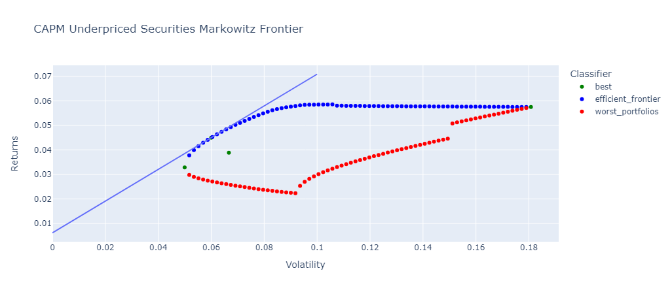

Details about the 4 unique portfolios, including their risk, return and composition are given in the below table.

|  |  |  |  |  |
| --- | --- | --- | --- | --- |
| **Details** | **Minimum Variance Portfolio** | **Maximum Variance Portfolio** | **Dominant Portfolio (Highest Sharpe Ratio)** | **Equal Weighted Portfolio** |
| Returns | 3.28% | 5.75% | 4.50% | 3.89% |
| Volatility | 5.00% | 18.08% | 6.00% | 6.67% |
| Beta | 0.702339 | 1.684866 | 0.840454 | 1.056322 |
| Sharpe_Ratio | 0.534243 | 0.283999 | 0.647371 | 0.490717 |
| Treynor_Ratio | 0.037998 | 0.030468 | 0.046221 | 0.030969 |
| Weight BEL | 8.17% | 0.01% | 10.45% | 5.88% |
| Weight BHEL | 0.01% | 0.01% | 0.01% | 5.88% |
| Weight COALINDIA | 0.01% | 0.01% | 0.01% | 5.88% |
| Weight CONCOR | 0.07% | 0.01% | 0.01% | 5.88% |
| Weight GAIL | 0.01% | 0.01% | 0.01% | 5.88% |
| Weight HAL | 0.01% | 0.01% | 26.99% | 5.88% |
| Weight IOC | 13.62% | 0.01% | 0.01% | 5.88% |
| Weight IRCTC | 2.67% | 0.01% | 1.76% | 5.88% |
| Weight NHPC | 18.12% | 0.01% | 18.62% | 5.88% |
| Weight NMDC | 4.04% | 0.01% | 13.20% | 5.88% |
| Weight NTPC | 0.01% | 0.01% | 0.01% | 5.88% |
| Weight ONGC | 0.01% | 0.01% | 0.01% | 5.88% |
| Weight OIL | 0.01% | 0.01% | 16.87% | 5.88% |
| Weight PFC | 0.01% | 0.01% | 0.01% | 5.88% |
| Weight POWERGRID | 52.69% | 0.01% | 10.20% | 5.88% |
| Weight RECLTD | 0.51% | 0.01% | 0.01% | 5.88% |
| Weight SAIL | 0.01% | 99.84% | 1.83% | 5.88% |
| **Weight Sum** | **100.00%** | **100.00%** | **100.00%** | **100.00%** |

The Capital Asset Pricing Model (CAPM) relies on three key factors to estimate the expected return on an investment: the risk-free rate, market risk premium, and the beta. Each plays a specific and crucial role:

* Risk-Free Rate (Rf):
  + Represents the minimum return an investor expects from an investment with no risk. It can also be considered as the minimum return that an investor demands for blocking its money for time T, i.e. time value of money.
  + Often reflected by the yield on government bonds with minimal default risk.
  + In CAPM, it serves as the baseline return for any investment decision.
* Market Risk Premium (Rm - Rf):
  + Represents the extra return expected by investors for taking on market risk compared to the risk-free rate.
  + Calculated as the difference between the expected return of the market portfolio (Rm) and the risk-free rate (Rf).
  + Essentially, it compensates investors for the inherent volatility associated with the overall market.
* Beta (β):
  + Measures the relative volatility of a specific investment (stock or portfolio) compared to the overall market.
  + A beta of 1 indicates the investment moves exactly in line with the market. A beta greater than 1 suggests the investment is more volatile than the market (amplifies market movements).
  + A beta less than 1 implies the investment is less volatile than the market (dampens market movements).
  + The beta value, which is a measure of risk, is multiplied with market risk premium, which represents the value for risk, to get the excess return over a risk free investment.

**Analysis**

Since, the 2 factors Rf and Market Premium (Rm - Rf) are common for the securities, the expected return for a security depends on the Beta quite a lot. That is why most of the securities have a similar expected return as per CAPM as they follow the index closely since they are its constituents. E(Ri) is high for those with high beta and low for those with low beta.

**Chapter 8**

**Sharpe’s Optimal Portfolio**

|  |  |  |  |  |  |  |  |  |  |  |  |
| --- | --- | --- | --- | --- | --- | --- | --- | --- | --- | --- | --- |
| **Ticker** | **Treynor's Ratio** | **Systematic Risk** | **Unsystematic Risk** | **Excess Return over Rm** | **Excess Return over Rf** | **Beta** | **(Ri - Rf) * B / Unsys Risk** | **B^2 / Unsys Risk** | **Cumulative Numerator** | **Cumulative Denominator** | **C** |
| HAL | 0.0628 | 0.0027 | 0.0087 | 0.0371 | 0.0524 | 0.8344 | 5.0488 | 80.3519 | 5.0488 | 80.3519 | 0.0148 |
| BEL | 0.0525 | 0.0023 | 0.0059 | 0.0250 | 0.0404 | 0.7698 | 5.2362 | 99.7655 | 10.2851 | 180.1174 | 0.0233 |
| NHPC | 0.0430 | 0.0014 | 0.0034 | 0.0108 | 0.0262 | 0.6083 | 4.7254 | 109.8382 | 15.0105 | 289.9556 | 0.0272 |
| POWERGRID | 0.0394 | 0.0016 | 0.0014 | 0.0100 | 0.0253 | 0.6429 | 11.4996 | 291.9326 | 26.5101 | 581.8882 | 0.0314 |
| OIL | 0.0393 | 0.0046 | 0.0095 | 0.0278 | 0.0431 | 1.0972 | 4.9956 | 127.0340 | 31.5057 | 708.9223 | 0.0325 |
| NMDC | 0.0351 | 0.0032 | 0.0101 | 0.0168 | 0.0321 | 0.9155 | 2.9182 | 83.1317 | 34.4239 | 792.0540 | 0.0327 |
| RECLTD | 0.0331 | 0.0033 | 0.0042 | 0.0155 | 0.0308 | 0.9305 | 6.8573 | 206.9104 | 41.2812 | 998.9644 | 0.0327 |
| SAIL | 0.0305 | 0.0109 | 0.0219 | 0.0360 | 0.0514 | 1.6859 | 3.9536 | 129.7644 | 45.2348 | 1128.7290 | 0.0325 |
| IRCTC | 0.0293 | 0.0041 | 0.0088 | 0.0150 | 0.0304 | 1.0362 | 3.5978 | 122.5995 | 48.8326 | 1251.3280 | 0.0323 |
| ONGC | 0.0260 | 0.0065 | 0.0042 | 0.0184 | 0.0338 | 1.3001 | 10.5399 | 405.2757 | 59.3725 | 1656.6040 | 0.0309 |
| PFC | 0.0255 | 0.0046 | 0.0040 | 0.0124 | 0.0278 | 1.0916 | 7.6690 | 301.1933 | 67.0414 | 1957.7970 | 0.0302 |
| IOC | 0.0250 | 0.0029 | 0.0022 | 0.0065 | 0.0219 | 0.8751 | 8.5241 | 340.4853 | 75.5655 | 2298.2830 | 0.0295 |
| NTPC | 0.0249 | 0.0046 | 0.0028 | 0.0120 | 0.0273 | 1.0983 | 10.7742 | 432.7748 | 86.3397 | 2731.0580 | 0.0288 |
| COALINDIA | 0.0244 | 0.0068 | 0.0035 | 0.0172 | 0.0326 | 1.3373 | 12.5273 | 513.8540 | 98.8671 | 3244.9110 | 0.0282 |
| BHEL | 0.0226 | 0.0110 | 0.0114 | 0.0231 | 0.0385 | 1.6998 | 5.7619 | 254.4685 | 104.6290 | 3499.3800 | 0.0278 |
| GAIL | 0.0219 | 0.0053 | 0.0034 | 0.0105 | 0.0259 | 1.1831 | 8.8971 | 406.6218 | 113.5261 | 3906.0020 | 0.0272 |
| CONCOR | 0.0189 | 0.0028 | 0.0058 | 0.0007 | 0.0161 | 0.8514 | 2.3488 | 124.5392 | 115.8748 | 4030.5410 | 0.0270 |
| HINDPETRO | 0.0136 | 0.0042 | 0.0030 | -0.0010 | 0.0144 | 1.0543 | 5.0526 | 370.4868 | 120.9274 | 4401.0280 | 0.0259 |
| BPCL | 0.0115 | 0.0036 | 0.0033 | -0.0043 | 0.0111 | 0.9678 | 3.2637 | 284.0089 | 124.1910 | 4685.0370 | 0.0251 |

The C* as seen above is 0.03 for OIL after which C values start decreasing. So, we take BEL, HAL, NHPC, POWERGRID and OIL in our portfolio. The rest are discarded.

|  |  |  |  |  |  |
| --- | --- | --- | --- | --- | --- |
| **Ticker** | **Beta** | **Treynor’s Ratio** | **C** | **Z** | **Final Weights** |
| HAL | 0.834416 | 0.062834 | 0.014753 | 4.630085 | 28.94% |
| BEL | 0.769813 | 0.052485 | 0.02327 | 3.786229 | 23.66% |
| NHPC | 0.60828 | 0.043022 | 0.027201 | 2.856707 | 17.85% |
| POWERGRID | 0.642886 | 0.039391 | 0.031419 | 3.620247 | 22.63% |
| OIL | 1.097161 | 0.039325 | 0.032453 | 0.79564 | 4.97% |
| NMDC | 0.915542 | 0.035103 | 0.032662 | 0.221634 | 1.39% |
| RECLTD | 0.930532 | 0.033141 | 0.032741 | 0.089005 | 0.56% |

Portfolio details -

|  |  |  |  |  |  |
| --- | --- | --- | --- | --- | --- |
| **Returns** | **Volatility** | **Weighted Alpha** | **Weighted Beta** | **Sharpe’s Ratio** | **Treynor’s Ratio** |
| 4.41% | 5.84% | 0.027905 | 0.750138 | 0.648775 | 0.050523 |

**Chapter 9**

**Arbitrage Pricing Theory**

The results of the various models made with the mutual funds is as given below.

|  |  |  |  |
| --- | --- | --- | --- |
| **Mutual Fund** | **R2** | **Variables** | **Significance of variables** |
| SBI | 0.274 | gdp_change  gold_change | 0.922  0.052 |
| Invesco | 0.146 | gdp_change  gold_change | 0.937  0.180 |
| SBI | 0.295 | gdp_change_lag  gold_change | 0.668  0.027 |
| Invesco | 0.238 | gdp_change_lag  gold_change | 0.234  0.124 |
| SBI | 0.491 | gold_change  inflation_3_change  INR_USD | 0.009  0.125  0.147 |

**Analysis:** The funds are actively managed funds, meaning that the composition and constituent stocks might be different from the PSU industry and the returns depend on the capabilities of the manager as well. For this reason, the factors might not be highly correlated or significant.

3 Models were created using the market index. The details of which, along with the performance are in the below table.

|  |  |  |  |
| --- | --- | --- | --- |
| **Model Method** | **Factors** | **RMSE** | **Adj R2** |
| Enter method | All factors | 0.978097 | 0.597 |
| Stepwise | oil_change | 0.078239 | 0.563 |
| Enter with selected variables based on correlation analysis by analyst | oil_change  Inflation_3 INR_USD | 0.071000 | 0.641 |

**Analysis:** The models for market are able to explain the variability much better with a much higher and significant Adj R2 value. Even from these, shifting the level of significance from 5% to a little higher, the 3 factor model is much better than the other 2 models. However, an adj R2 value of 0.64 is not enough to predict the market, it can still be used for analysis.

The expected return from the final APT model containing the 3 factors, along with average return in the period are in the below table.

|  |  |  |  |
| --- | --- | --- | --- |
| **Ticker** | **Expected Return by APT** | **Mean Actual Return** | **Pricing** |
| BEL | 0.807978 | 0.064837 | Overpriced |
| BHEL | 1.631456 | 0.042531 | Overpriced |
| BPCL | -0.34558 | 0.020089 | Underpriced |
| COALINDIA | 0.854045 | 0.045243 | Overpriced |
| CONCOR | -0.02827 | 0.042486 | Underpriced |
| GAIL | 0.330808 | 0.024181 | Overpriced |
| HINDPETRO | -0.15717 | 0.006421 | Underpriced |
| IOC | -0.04152 | 0.017059 | Underpriced |
| NHPC | 0.837973 | 0.042927 | Overpriced |
| NMDC | 0.168946 | 0.084262 | Overpriced |
| NTPC | 0.586079 | 0.030631 | Overpriced |
| ONGC | 0.172008 | 0.031289 | Overpriced |
| OIL | 0.278112 | 0.04452 | Overpriced |
| PFC | 0.086034 | 0.066485 | Overpriced |
| POWERGRID | -0.12117 | 0.050452 | Underpriced |
| RECLTD | -0.2721 | 0.066142 | Underpriced |
| SAIL | -0.24664 | 0.070747 | Underpriced |

**RMSE:** 0.5563100796287247

**Analysis:** Comparing the estimated returns with the actual mean returns and considering the RMSE value, either the market is very much misplaced and needs a correction or the model is performing poorly on unseen data. The latter is highly likely, thus the APT model is failing for the current analysis, considering the period and the factors. The failure can be contributed to the limited period of study, no of macro economic factors considered, and the form of the factors.

The calculations for the Arbitrage profit generation from mispriced securities are given in the below 2 tables.

|  |  |  |  |  |  |
| --- | --- | --- | --- | --- | --- |
| **Stocks** | **Status** | **At time t=0 (31st Mar 2020)** | | | |
| **Close Price** | **Strategy** | **No of units** | **Cash flow** |
| BPCL | Overpriced | 240.0087 | Short | 2 | 480.0174 |
| HINDPETRO | Overpriced | 154.8721 | Short | 2 | 309.7442 |
| HAL | Underpriced | 223.6443 | Long | 3 | -670.9329 |
| BEL | Underpriced | 22.78674 | Long | 1 | -22.78674 |
| OIL | Underpriced | 65.5955 | Long | 1 | -65.5955 |
| SAIL | Underpriced | 19.96641 | Long | 1 | -19.96641 |
|  | | | | | **10.48005** |

|  |  |  |  |  |
| --- | --- | --- | --- | --- |
| **Stocks** | **At time t=T (31st Mar 2023)** | | | |
| **Close Price** | **Strategy** | **No of units** | **Cash flow** |
| BPCL | 325.1414 | Long | 2 | -650.2828 |
| HINDPETRO | 230.1707 | Long | 2 | -460.3414 |
| HAL | 1340.913 | Short | 3 | 4022.739 |
| BEL | 95.76445 | Short | 1 | 95.76445 |
| OIL | 240.3241 | Short | 1 | 240.3241 |
| SAIL | 80.68114 | Short | 1 | 80.68114 |
|  | | | | **3328.88449** |

**Analysis:** From the implemented strategy, an arbitrage profit of Rs 3328.88 can be generated. An additional Rs 10.48 are available at start of period, which if invested at risk free rate, returns Rs 12.98 at the end of period.

**Chapter 10**

**Performance Evaluation**

The performance of the various portfolios constructed during the analysis has been evaluated with the help of the Sharpe and Treynor Ratio. The results are presented in the below table.

|  |  |  |  |  |  |  |  |
| --- | --- | --- | --- | --- | --- | --- | --- |
| **Portfolios** | **Return** | **Volatility** | **Beta** | **Sharpe Ratio** | **Rank** | **Treynor Ratio** | **Rank** |
| Markowitz Model Minimum Variance Portfolio | 3.27% | 5.00% | 0.702 | 0.532 | 4 | 0.038 | 4 |
| Markowitz Model Maximum Variance Portfolio | 5.75% | 18.07% | 1.685 | 0.284 | 7 | 0.030 | 6 |
| Markowitz Model Dominant Portfolio (Highest Sharpe Ratio) | 4.50% | 6.00% | 0.840 | 0.647 | 2 | 0.046 | 2 |
| Markowitz Model Equal Weightage Portfolio | 3.68% | 6.65% | 1.052 | 0.461 | 6 | 0.029 | 7 |
| CAPM Underpriced Sec Minimum Variance Portfolio | 3.28% | 5.00% | 0.702 | 0.534 | 3 | 0.038 | 3 |
| CAPM Underpriced Sec Maximum Variance Portfolio | 5.75% | 18.08% | 1.685 | 0.284 | 7 | 0.030 | 6 |
| CAPM Underpriced Sec Dominant Portfolio (Highest Sharpe Ratio) | 4.50% | 6.00% | 0.840 | 0.647 | 2 | 0.046 | 2 |
| CAPM Underpriced Sec Equal Weightage Portfolio | 3.89% | 6.67% | 1.056 | 0.491 | 5 | 0.031 | 5 |
| Sharpe Optimal Portfolio | 4.41% | 5.84% | 0.750 | 0.649 | 1 | 0.051 | 1 |
| NSE PSE Index (Market) | 2.15% | 7.30% | 1.000 | 0.211 | 8 | 0.015 | 8 |

**Analysis:** According to the data in the table above, the Sharpe optimum portfolio outperforms the market index. This could be attributed to a lack of payout data during the Yahoo Finance data collection procedure. The dominating portfolio under Markowitz and CAPM performs roughly identically to the best portfolio based on Sharpe ratio, as expected given that it was optimised for that.

According to the treynor's ratio, the Sharpe optimum portfolio outperforms dominating portfolios and the market index. The explanation behind this is the same as above.

Both the evaluation matrices assign roughly identical rankings to the portfolios and the market index.

Portfolio construction and its method has several implications on the risk and return of the portfolio -

* **Risk-Return Tradeoff**: The portfolios have distinct risk-return profiles, demonstrating the basic trade-off between risk and return in investing decision-making. Portfolios with higher projected returns are often more volatile, and vice versa. When selecting portfolios, investors must carefully assess their risk tolerance and investment objectives to ensure that they are in line with their financial goals.
* **Optimization Strategies:** The portfolios built with optimisation techniques, such as the Markowitz Model and CAPM, demonstrate the advantages of adopting quantitative methodologies in portfolio development. These strategies seek to maximise profits for a given level of risk or minimise risk for a desired level of return, allowing investors to allocate capital more effectively based on their risk tolerance.
* **Performance Benchmarking:** Benchmarking against market indexes, such as the NSE PSE Index, can provide useful information on portfolio performance in comparison to the larger market. Portfolios that routinely beat the market index in terms of returns and risk-adjusted metrics such as the Sharpe Ratio demonstrate superior investment performance and portfolio management ability.
* **Investor Preferences and Objectives:** The study emphasises the necessity of taking into account individual investor preferences, risk tolerance, and investing goals when creating portfolios. While some investors prioritise maximising profits regardless of volatility, others prioritise capital preservation and look for lower-risk investing possibilities. Portfolio managers must customise portfolio construction strategies to investors' various needs.
* **Dynamic Market Conditions:** Portfolio development should also consider dynamic market situations and shifting economic environments. Portfolios designed for specific market circumstances may underperform during times of market volatility or unforeseen developments. To adapt to changing market dynamics and maintain appropriate risk-return profiles, portfolio allocations must be monitored and adjusted on a continuous basis.

**Chapter 11**

**Conclusion and Limitations**

**Conclusion**

Portfolio management analysis was performed using the Nifty PSE index and its constituent stocks for the past 3-5 years of data. Markowitz model, CAPM, Sharpe’s Optimal Portfolio and Arbitrage Pricing Theory were implemented on the data, and their performance was compared. Statistical analysis shows the difference between returns and volatility of the stocks, majorly driven by the industry, government policies and macroeconomic factors. Markowitz efficient frontier was drawn, along with the worst portfolios set and a set of unique portfolios like minimum variance and dominant portfolio. The Diversification concept was also discussed and showcased with the analysis. CAPM analysis for identifying mispriced securities, resulted in 2 overpriced and 17 underpriced securities. A novel approach of combining the CAPM and Markowitz was also implemented and the resulting portfolios discussed at the end. Sharpe’s optimal portfolio was also constructed based on the procedure, which comprised of 7 securities. Lastly, Arbitrage Pricing Theory was put to test, with significant factors identified as oil_price_change, last month inflation and the forex rates INR/USD, however the model was not performing as per the requirements and could not be used for predictions. Arbitrage profit was created using mispriced securities from the APT model reduced to CAPM model, making a profit of Rs 3329. To summarize the performance and applicability of the models, performance evaluation was performed with the help of Sharpe ratio and Treynor ratio, which gave similar results, considering the Sharpe Optimal portfolio best in terms of risk return trade off, while proving the index to be the worst. The study is also unique in terms that it automates most of the processing part with Python code, leaving just the analysis part to the analysts. The study performs an in depth analysis of the various portfolio models using the public sector companies in India for the recent times and can prove to be useful for both academia and industry.

**Limitations and Future Recommendations**

* The market data is exclusive of the dividends given by the constituent stocks, thus may not be completely representative of the market, which is specially a limitation as PSU companies tend to give large dividends. Future analysts and researchers can consider it in their analysis or adjust accordingly.
* The factors identified and tested in the APT model are limited by the capacity and capabilities of the analysts. The selection of factors was based on increased significance level, and done by considering only the Nifty PSE Index. Future researchers can work more on this, to get usable model.
* The analysis and expected figures are based on historical data, and may not be indicative of the future movements.
* Constant port revision is a must with changing times and market conditions, an investor or portfolio manager needs an active portfolio management strategy to earn better gains, even after using such models to make an initial portfolio, or to update the weights.
* Limited diversification was there in the portfolios due to the limitation of scope of study. Further diversification can be done by adding securities from other sectors (non PSU) and other geographies.

**REFERENCES**

1. NIFTY Website -
   1. <https://www.niftyindices.com/indices/equity/thematic-indices/nifty-pse>
   2. <https://www.niftyindices.com/Factsheet/ind_nifty_pse.pdf>
   3. <https://www.niftyindices.com/Methodology/Method_NIFTY_Equity_Indices.pdf>
2. Shah, C. A. (2015). Construction of optimal portfolio using sharpe index model & camp for bse top 15 securities. International Journal of Research and Analytical Reviews, 2(2), 168-178.
3. Nawalkha, S. K. (2007). Is the Arbitrage Pricing Theory Dead?. Available at SSRN 984734.
4. Levy, H. (2010). The CAPM is alive and well: A review and synthesis. European Financial Management, 16(1), 43-71. https://doi.org/10.1111/j.1468-036X.2009.00530.x
5. Markowitz, H. (1952). Portfolio selection, Journal of Finance, 7, 77-91
6. Sharpe, W. F. (1964). Capital asset prices: A theory of market equilibrium under conditions of risk. The journal of finance, 19(3), 425-442. <https://onlinelibrary.wiley.com/doi/10.1111/j.1540-6261.1964.tb02865.x>
7. Roll, R., & Ross, S. A. (1984). The Arbitrage Pricing Theory Approach to Strategic Portfolio Planning. Financial Analysts Journal, 40(3), 14–26. <http://www.jstor.org/stable/4478741>
8. Basu, D., & Chawla, D. (2012). An empirical test of the arbitrage pricing theory—The case of Indian stock market. Global Business Review, 13(3), 421-432.