**COIT20256: Data Structures And Algorithms**

**Term 2, 2018**

**Assignment 1: Flight Application**

**Due Date: 28th September 2018**

**Lecturer: Zakiullah Khan**

**Tutorial:** **Zakiullah Khan**

**Submitted by:**

Amit Bhandari: 12080721

Contents

**1. Introduction 3**

**2. Reason for selecting Array List 3**

**3. Reason for Selecting Insertion Sort 4**

**4. Reasons for selecting Binary Search 4**

**5. Time taken to sort data 4**

**6. Time taken to Search data 4**

**7. Screenshot of Test Data(searching and sorting) 5**

**i. Screenshot of Time taken for searching and sorting of 7 flight 5**

**ii. Screenshot of Time taken for searching and sorting of 700 flight 5**

**iii. Screenshot of Time taken for searching and sorting of 7000 flight 6**

# 1. Introduction

Flight Application is the graphical user interface developed in java which allow the user to read the data related to flight departure city, flight arrival city, year and month and flight price from the text file name FlightData.txt. User can also save the file into new file NewData.txt which saves the flight departure city, flight arrival city and flight price. This application sorts all the data and display in the text area in ascending order of departure city.

User can search the flight price to know whether the flight price given by user is present on the file or not. For sorting Insertion sort is used and binary search is used along with various data validation technique for searching purpose here.

# 2. Reason for selecting Array List

I select the array list to store the data of the file in my program. The reason of selecting array list over linked list is due to the following.

The search operation in array list is pretty fast in comparison to linked list. Array list is much faster than linked list doing a binary search on the large list of sorted element. As, I have used binary searching technique in this application .so Array list is the best data structure for my application. Array list is faster to search data than link list as the get (int index) in arraylist gives the performance of O(1) whereas link list gives the performance of O(n).

# 3. Reason for Selecting Insertion Sort

I implement the insertion sort to sort the data in the file according to the flight departure city. The reason of selecting the Insertion sort in my program is due to the following:

It is a simple implementation which is much efficient for small lists. This sorting techniques consumes less memory. As, insertion sort only requires a constant amount O (1) of additional memory space.so , it consumes less memory of the program.

# 4. Reasons for selecting Binary Search

I implement the binary search to search the data from the file according to the flight price. The reason of selecting Binary Search is due to following:

The logarithmic time, with a worst and average case of binary search is O(n log n) whereas for Linear search, there is the linear time which have worst case of O(n) , and an average of O(n/2) for n items. Therefore, Binary search is faster on average than the linear search .so, I used binary search in this application.

# 5. Time taken to Sort data

As I run the application by using 7,700 and 7000 number of flights in the data file and following time in millisecond were obtained for sorting, which is provided in the screenshot below.

|  |  |
| --- | --- |
| Number Of Flights | Time Taken for Execution(milli second) |
| 7 | 0 |
| 700 | 11 |
| 7000 | 173 |

# 6. Time taken to Search data

As I run the application by using 7,700 and 7000 number of flights in the data file and following time in millisecond were obtained for searching, which is provided in the screenshot below.

|  |  |
| --- | --- |
| Number Of Flights | Time Taken for Execution(milli second) |
| 7 | 0 |
| 700 | 14 |
| 7000 | 76 |

# 7. Screenshot of Test Data (searching and sorting)

## Screenshot of Time taken for searching and sorting of 7 flight

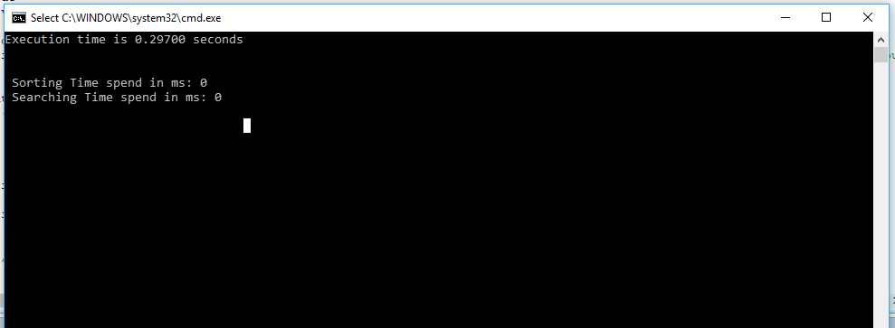

## Screenshot of Time taken for searching and sorting of 700 flight

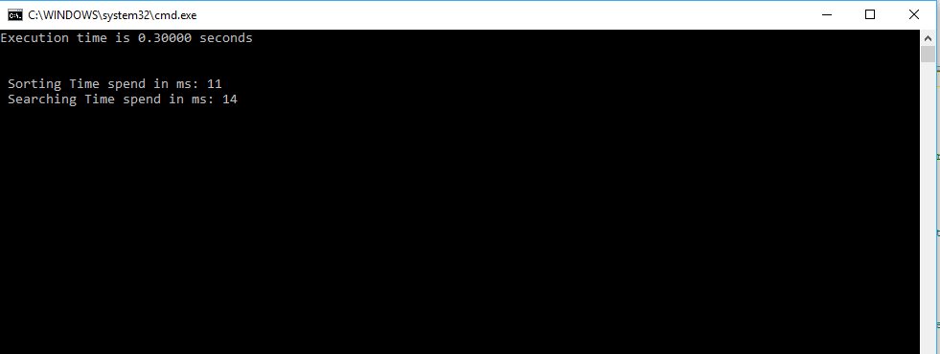

## Screenshot of Time taken for searching and sorting of 7000 flight

