**COIT20256: Data Structures And Algorithms**

**Term 2, 2018**

**Assignment 1: Vending Machine**

**Due Date: 23th Aug 2018**

**Lecturer: Zakiullah Khan**

**Tutorial:** **Zakiullah Khan**

**Submitted by:**

Amit Bhandari: 12080721

**1. Introduction**

Vending machine is the graphical user interface developed in java which allows the user to buy items from this machine. This machine has 3 drop down list to select the items, calculated the cost of selected items, display the total cost, pay the cost and release the item.

**Test Results**

2. **Screenshots of Application Test Cases**

# 2.1 The figure given below is the screenshot of the main program which shows the title label, combo box and the button as given below. It also asks the user to select the value of candy, gum and chips. There are also buttons which shows the total cost, pay cost, release item and exit from the program.

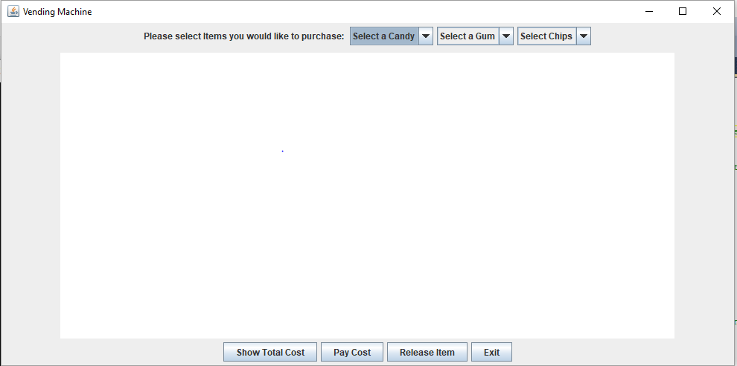

2.2 The below screenshot shows the figure in which user can select items whether it is candy, gums, or chips.

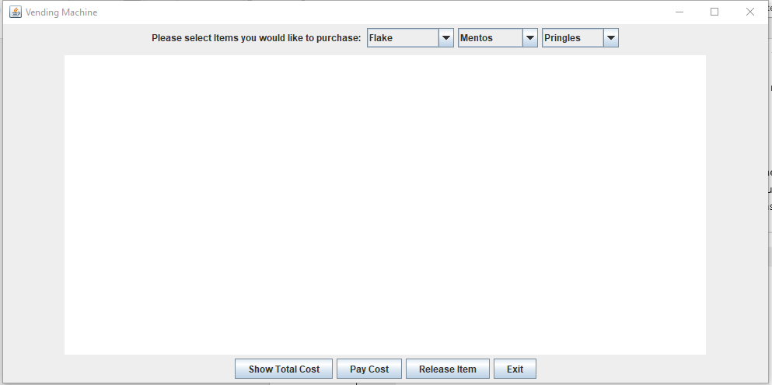

Fig: 1

2.2 The below screenshot shows the total cost that have to be paid by the customer after purchasing the fries, gums and chips. The total cost is displayed on the text field as given below.

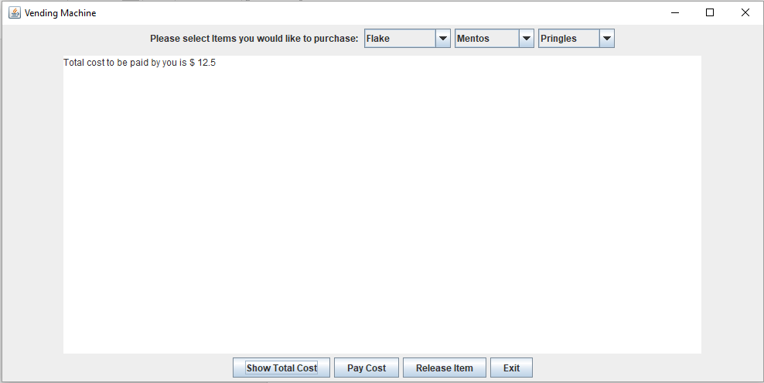

2.3 The following screenshot shows the response when the user pressed the pay cost button. After user pressed the press button then the system ask the user how much amount they want to pay which is shown in the screenshot below.

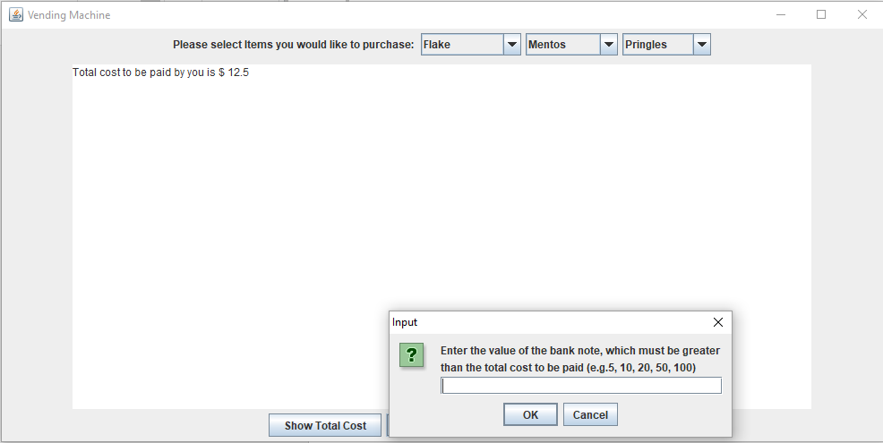

2.4 The following screenshot is displayed if the user enter less amount than the bill amount.

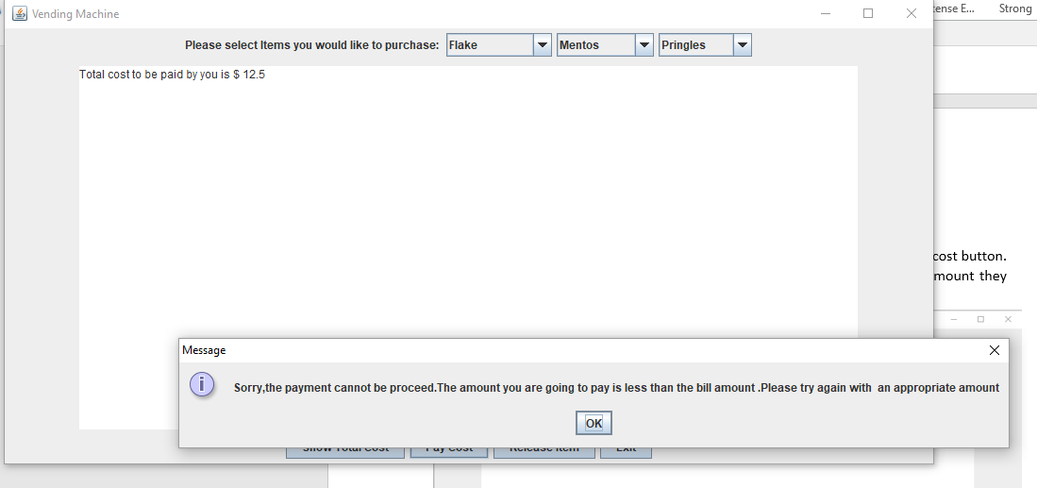

2.5 The following screenshot shows the overall summary of his transaction after paying for his item.

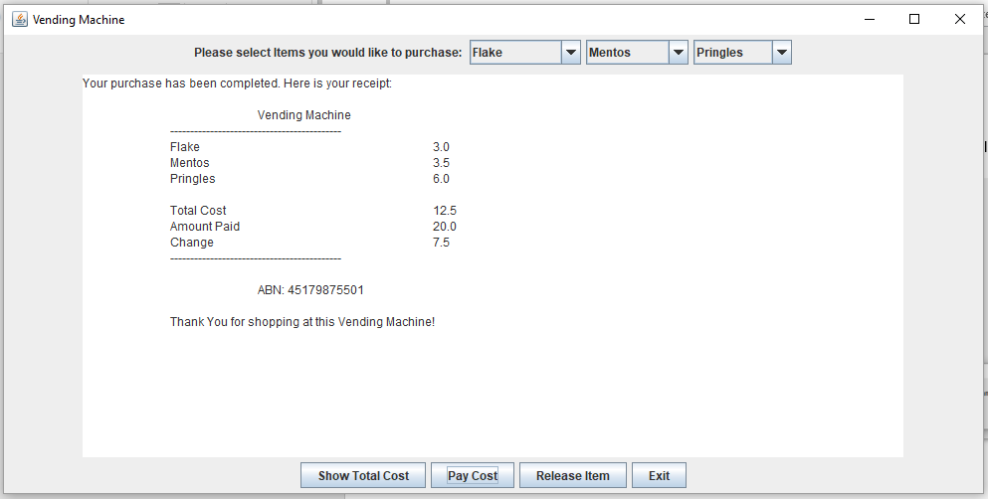

2.6 The following response is seen when user or customer press release item button.

