Data Shortfalls on Vascular Epiphytes in the Neotropics
Maria Judith Carmona-Higuita^{1*}, Andreas Mehl¹, Derio Antonio Jiménez-López², Flavio Nunes Ramos³, Michael Kessler⁴, Talitha Mayumi Francisco⁵, Adriano Quaresma⁶, Nayely Martínez-Meléndez⁷, André Luís de Gasper⁸, Ana Maria Benavides⁹, Glenda Mendieta-Leiva^{1†}, Alexander Zizka^{1†}

¹ Department of Biology, Philipps-Universität Marburg, Karl-von-Frisch-Straße 8, 35032, Marburg, Germany.
² Departamento de Conservación de la Biodiversidad, El Colegio de la Frontera Sur, periférico sur s/n, María Auxiliadora, 29290, San Cristóbal de las Casas, México.
³ Instituto de Ciências Naturais, Universidade Federal de Alfenas, Rua Gabriel Monteiro da Silva, 700, 37130-001, Centro, Alfenas, MG, Brasil.
⁴ Systematic and Evolutionary Botany, University of Zurich, Zollikerstrasse 107, 8008 Zurich, Switzerland.
⁵ Instituto Nacional da Mata Atlântica, Avenida José Ruschi, 4, 29650-000, Santa Teresa, ES, Brazil.
⁶ Ecology, Monitoring and Sustainable Use of Wetlands Research Group (MAUA), National
Institute for Amazonian Research (INPA), Manaus, Brazil
⁷ Eizia Asociación Civil. Calle C2 310, Colonia Vida Mejor, 29045, Tuxtla Gutiérrez, Chiapas, México.
⁸ Universidade Regional de Blumenau, Herbário Dr. Roberto Miguel Klein, Rua Antônio da Veiga, 140, Itoupava Seca, Blumenau, Santa Catarina, Brazil
^{9.} Jardin Botanico de Medellin, Medellin, Colombia
† Those authors contributed equally.
* Corresponding author: maria.carmonahiguita@biologie.uni-marburg.de

Received: ; Revised: (optional); Accepted:_______
Abstract
Biased shortfalls in biodiversity data availability limit our understanding of ecology, evolution, and conservation of tropical ecosystems. Vascular epiphytes (VE) represent nearly 10% of global vascular flora and up to 39% in the Neotropics. About 20% of VE species in this region are threatened with extinction, yet VE remains among the least studied plant groups. This study assesses the extent of taxonomic and geographic biases in data availability for the five species-richest VE families (Araceae, Bromeliaceae, Orchidaceae, Piperaceae, and Polypodiaceae) based on over 500,000 occurrence records. We evaluated the Wallacean shortfall at a 30-arc-minute resolution across biogeographic provinces using species accumulation curves and survey completeness. Our results show that 51.8% of Neotropical grid cells contain VE occurrence data, yet only 40.6% of species have more than 10 records. Based on the slope of species accumulation curves, 15.4% of grid cells were well-sampled; based on completeness and R/S ratio, only 0.05% were well-sampled. Hotspots of biodiversity shortfalls are in the mountainous region of Mexico, Central America, several regions in the Amazonia, the southeastern Brazil and the South American Southern Cone. Among families, Bromeliaceae and Araceae show the greatest sampling deficiency (slope-based proxy), while Orchidaceae had the lowest completeness and R/S ratio, particularly in the Andes and Amazon. Our findings highlight major knowledge gaps in VE biodiversity data, affecting our understanding of species distributions and conservation planning. We recommend improving herbarium data curation, targeted field surveys, and strengthening collaborations with local institutions to enhance biodiversity data coverage in the Neotropics.
Keywords: bias, biodiversity data, distribution, sampling biases, scientific ignorance, tropical plants, uncertainty

INTRODUCTION

The biased availability of biodiversity data limits the understanding of the ecology and evolution of tropical plants and their conservation (Luján et al., 2023; Ondo et al., 2024). Two types of bias are particularly common: taxonomic bias, which arises from the uneven availability of species descriptions, systematic treatments, and distribution records across different taxa, and geographic bias, which results from the unequal availability of data across geographic regions (Antonelli et al., 2018; Feeley, 2015; ter Steege et al., 2016). Taxonomic and geographic bias are problematic for two reasons: first, undersampled regions or taxa —diversity dark spots— may harbor undescribed species and hold crucial conservation value (Ondo et al., 2024; Carmona-Higuita et al., 2023; Ramos et al., 2021). Second, systematic biases lead to misinterpretations of species distributions and skew large-scale analyses (Meyer et al., 2015; Oliveira et al., 2016, Araujo et al., 2022). Integrating multiple data sources, such as national biodiversity platforms, herbarium collections, and citizen science records, has been suggested as a key strategy to mitigate these biases (Amano et al., 2016; Araujo et al., 2022; Jiménez-López, Carmona-Higuita, et al., 2023; Stropp et al., 2016). However, since the extent and strength of these biases often remain unknown, it is difficult to design targeted efforts to correct them or account for their effects in analyses. These data deficits can be framed as knowledge shortfalls—measurable gaps in our understanding of biodiversity (Hortal et al., 2015). The most tractable for quantitative assessment are the Linnean shortfall (species not yet formally described) and the Wallacean shortfall (insufficient geo-referenced occurrence data to characterize known species distributions). While the Linnean shortfall constrains the universe of species that can be recorded, the Wallacean shortfall is directly quantifiable through occurrence databases and inventory completeness metrics, and is thus the primary shortfall addressed in this study.
The Neotropics house nearly 40% of the global plant diversity in 13% of the terrestrial surface area (Raven et al., 2020). A particular contribution to this diversity comes from vascular epiphytes (VE), which contribute up to 39% of species in some regions (Taylor et al., 2021) and as much as 50% of species in some locations (Kelly et al., 2004). VE diversity and distribution have historically served as a model for biogeographic and macroecological patterns in the Neotropics, providing a tractable system for exploring biogeographic and macroecological processes that shape Neotropical plant diversity broadly (Gentry & Dodson, 1987; Benzing, 1990; Freitas et al., 2016; Taylor et al., 2023). Forinstance, analyzing VE diversity patterns in the Neotropics has confirmed that biogeographic provinces such as the Páramo, Cauca, and Atlantic Forest exhibit high richness and endemism in plants and animals (Carmona‐Higuita et al., 2025). Furthermore, epiphytes' sensitivity to climatic gradients, habitat heterogeneity, and disturbances makes them indicators of ecosystem function and environmental change (Cardelus et al., 2006). Their reliance on atmospheric moisture and their often restricted distributions (Kreft et al. 2004), make them particularly sensitive to changes in climate or disturbance regime, helpful as an early-warning system for ecosystems reaction to environmental changes (Benavides et al., 2005). Additionally, VE are essential parts of ecosystems in their own right, playing an important role in nutrient cycling and providing microhabitats for other organisms (Benzing, 1990; Woods et al., 2015).
Despite recent advancements in data mobilization for VE in the Neotropics (Guzmán-Jacob et al., 2021; Mendieta-Leiva et al., 2020; Quaresma et al., 2022; Ramos et al., 2019, 2024), critical knowledge gaps remain. Vast areas of the Neotropics are poorly documented (Araujo & Ramos, 2021; Carmona‐Higuita et al., 2025; Vargas et al., 2022), but with unclear differences among taxa and regions. Understanding and addressing these gaps is crucial to improve the reliability of biodiversity assessments and make better informed decisions about conservation strategies, ensuring that efforts are focused on areas and species most at risk (Hortal et al., 2015; Mendieta-Leiva & Zotz, 2015). While previous studies have assessed inventory completeness of Neotropical plants at regional scales (Araujo et al., 2022; Ramírez-Barahona et al., 2023) or focused on endemism patterns (Carmona-Higuita et al., 2025), a continent-wide quantification of Wallacean shortfalls for VE across biogeographic provinces and families remains lacking. In this study, we quantify the geographic sampling incompleteness of VE occurrence data—specifically the Wallacean shortfall (Hortal et al., 2015). Specifically, we:
(1) identify biogeographic provinces and grid cells with significant geographic (Wallacean) shortfalls in inventory completeness (spatial patterns).
(2) determine which families show the greatest inventory incompleteness (Wallacean shortfall), and compare VE completeness with tree inventories (Chanachai et al., 2024; Ramírez-Barahona et al., 2023) to contextualize the relative magnitude of VE data gaps
(3) describe areas of high and low concentration of biodiversity shortfalls, identifying clusters of high inventory incompleteness (hotspots of Wallacean shortfall) as priorities for future sampling, and clusters of high completeness (coldspots) as well-documented reference areas

METHODS

1. Dataset
As a basis for all analyses, we used an existing database including more than 500,000 geo-referenced occurrence records of species of the five most species-rich families of vascular epiphytes (VE): Araceae, Bromeliaceae, Orchidaceae, Piperaceae, and Polypodiaceae (Carmona‐Higuita et al., 2023). This database to our knowledge is the most complete representation of VE distribution to date and integrates data from the Global biodiversity Information Facility (www.gbif.org), and a dedicated non-public epiphyte databases (Epiphyte Inventory Group EPIG-DB v1 database; Mendieta-Leiva et al., 2020), enriched with data from the literature on Atlantic epiphytes (Ramos et al., 2019), Amazonian epiphytes (Araujo et al., 2022), South American Dry Diagonal Forest Epiphytes database (Ramos et al., 2024), Epiphytes of the Sierra Madre of Chiapas (Jiménez-López, Carmona-Higuita, et al., 2023), Usumacinta River basin flora (Jiménez-López, Gallardo-Cruz, et al., 2023), Biovera-Epi (Guzmán-Jacob et al., 2021), as well as unpublished data of Neotropical Araceae (Alejandro Zuluaga, unpublished data), Polypodiaceae of America (Michael Kessler, unpublished data), Marie Selby Botanical Gardens herbarium (Bruce Holst, unpublished data) and records in 700 papers and theses (see complete list of 700 references in TS3.2, Carmona-Higuita et al., 2023). Geographic and taxonomic errors were already addressed in this dataset, and all data was cropped to the Neotropics (Morrone et al., 2022). For the detailed process, see Carmona-Higuita et al. (2023). To enhance taxonomic consistency, we resolved species names to a curated taxonomic backbone (Epiphyte Inventory Group, 2025), which includes the worldwide epiphyte list, EpiList v.1.0 (Zotz et al., 2021), and additional data from EpIG-DB v.1.0 (Mendieta-Leiva et al., 2020). We also eliminated geographic duplicate entries within the same grid cell.

2. Biodiversity shortfalls
To evaluate biodiversity shortfalls, we focused on the Wallacean shortfall at the level of grid cells at 30 arc-minute resolution (ca. 55 km at the equator). We estimated the degree of completeness of each grid cell using the KnowBR package (Lobo et al. 2018; Guisande and Lobo 2019), which examines species accumulation by adding occurrence records. These accumulation curves were performed simultaneously for all the cells in the Neotropics applying the exact estimator proposed by Ugland et al. (2003). KnowBR estimates the three parameters: the final slope of the accumulation curve, the completeness, and the ratio between the number of database records and the number of species. Completeness values (i.e. the percentage of species that have been documented over the total predicted) were calculated after adjusting the accumulation curves to a ran exponential model (Lobo et al. 2018).
To assess the Wallacean shortfall, we used three metrics derived from KnowBR: the slope of the species accumulation curve, the completeness of each cell inventory, and the ratio between the number of database records and the number of species (R/S ratio; Lobo et al., 2018). The slope reflects the current rate of species discovery; completeness estimates the proportion of the predicted species pool already documented; and the R/S ratio measures sampling intensity relative to species diversity (Ugland et al., 2003). Grid cells were classified as well-sampled (slope < 0.02), fairly sampled (0.02 ≤ slope ≤ 0.3), or poorly sampled (slope > 0.3).
Cells were additionally classified using completeness and R/S ratio: well-sampled (completeness > 90% and R/S ratio > 15), poorly sampled (completeness < 50% and R/S ratio < 3), and fairly sampled otherwise. Although the three KnowBR metrics are theoretically distinct, they produced highly concordant cell rankings across all five families studied (Spearman ρ = 0.86–0.99 for all pairwise combinations; Supplementary Table SX), confirming that they capture the same underlying signal of distributional knowledge gaps. We therefore treat the three metrics as convergent evidence of the Wallacean shortfall rather than independent measures.
All analyses were performed using a Lambert azimuthal equal-area projection, while visualization was reprojected to Behrman equal-area projection to avoid distortion far from the tropics. We removed poorly sampled grid cells containing less than 10 records overall for all analyses.

3. Spatial and family patterns of biodiversity shortfalls
We first examined the spatial distribution of occurrence records to identify potential biases in data availability across biogeographic provinces (as defined in Morrone et al., 2022). We quantified the density of records per province and assessed whether data collection was skewed toward specific areas, for instance related to greater accessibility or higher research investment. We assessed spatial patterns of shortfalls by examining how the Wallacean shortfall vary across different biogeographic provinces. We also describe which families were most affected by the Wallacean shortfall.

4. Hotspots and coldspots of biodiversity shortfalls
We defined hotspots as spatial clustering of the biodiversity shortfall using the Getis-Ord Gi* statistic (Getis & Ord, 1992, sensu Ramírez‐Barahona et al. 2023), which allows the detection of a local concentration of high and low values ​​in neighboring grids, using a focal neighbourhood size of 75 km, as implemented in the SPDEP package (Bivand & Wong, 2018). Prior to computing the Gi* statistic, completeness values were transformed to incompleteness (100 − completeness) and slope values were inverted (1 − slope), such that high Gi* values identify spatial clusters of greatest sampling deficiency. We classified the grids clustered as hotspots (Gi* > 1.96) or coldspots (Gi* < -1.96), with statistical significance at the 95% confidence level (based on the threshold suggested by Rossi & Becker, 2019).

5. Resolution and data processing
While our analyses provide insights at the biogeographic province and continental level, finer-scale resolution (15 arc-minutes or 0.25°) is necessary for practical conservation decisions (Antonelli et al., 2023). Therefore, we also present the results at this finer resolution for more detailed insights (see Supplementary Information A1).
We performed all analyses in R v.4.3.1 (R. Core Team, 2024), using the tidyverse package (Wickham et al., 2019) for data wrangling, sf (Pebesma, 2018), rgdal (Bivand et al., 2021), and raster (Hijmans, 2021) for spatial analyses, and ggplot2 for visualizations (Wickham, 2009).

RESULTS

1. Spatial patterns of biodiversity shortfalls
We found that 51.8% of the Neotropical grid cells (n = 8,520) contain georeferenced information on VE occurrence, and 40.6% of VE species in the dataset have more than 10 records. The number of records per grid cell averaged 131 (sd = 725), with a median of 14, while each cell contained an average of 125 species (sd = 747), with a median of 46 species. Provinces with the highest average number of occurrences per grid cell were in Central America (Puntarenas-Chiriqui and Guatuso-Talamanca provinces with 539 and 507), followed by the south of Mexico (Trans-Mexican Volcanic Belt and Chiapas Highlands provinces with 280 and 156), the Andean region (Cauca and Paramo provinces with 279 and 215) and the Atlantic province (194). Conversely, provinces with low data availability include the Xingu-Tapajós (11) and Cerrado (15) in northwestern Brazil. Additionally, the Savanna province (Los Llanos, Venezuela, and Colombia) and the Southern Neotropics (Atacama, Cuyan, and Monte) had the lower average number of occurrences per grid cell (< 10).
The areas with the highest species numbers generally overlapped with regions containing more occurrence records (Figure 1) yet, high species richness did not always correlate with high data availability (Table TS1). Based on the slope-based proxy, 15.4% of grid cells were well-sampled, 76.2% were fairly sampled, and 8.3% were poorly sampled (Figure 2). The greatest sampling deficiencies were found in Mexico, with the Sierra Madre Oriental (26.7%) and Transmexican Volcanic Belt (33.1%) provinces exhibiting moderate shortfalls; as well as in the Caribbean and Central America, with Puerto Rico (56.5%), Guatuso-Talamanca (42.9%) and Puntarenas-Chiriqui (37.5%) provinces showing the most significant gaps. In South America, especially in Brazil, provinces such as Comechingones (50.0%), Chapada Diamantina (48.4%), Southern Espinhaco (25.8%), and Caatinga (22.9%) showed lower sampling deficiencies. We also found high sampling deficiencies in the Cauca province, located at the southern border with Colombia (22.8%) and in the Galápagos Islands (33.3%).
Based on the completeness and R/S ratio proxy, Wallacean shortfalls were similarly widespread (Figure 3), with 14 % of the grid cells categorized as poorly sampled and only 0.05% as well-sampled. Provinces such as Venezuelan, Puntarenas-Chiriqui, Cauca, Western Ecuador and Lesser Antilles provinces exhibited the largest deficits (over 20% poorly sampled grid cells). Provinces with the lowest values of poorly sampled grid cells for this proxy were Southern Espinhaco, Cerrado, Transmexican Volcanic Belt, Sierra Madre Oriental and Caatinga provinces (< 4%). Again provinces with the lowest number of species and records had 0% poorly sampled grid cells (Chapada Diamantina, Puerto Rico, Comechingones, Galapagos Islands and Atacama provinces).

2. Comparison of biodiversity shortfalls among families
On average, the Orchidaceae family had an average of 140 species recorded per cell, while Bromeliaceae, Araceae, Piperaceae, and Polypodiaceae had much lower species numbers on average, ranging between 24 and 34 species per grid cell. Sampling completeness (slope-based proxy) varied among families. Bromeliaceae (16.7%) and Araceae (16.6%) had the highest percentages of poorly sampled cells, while Orchidaceae (3.8%) had the lowest, followed by Piperaceae (9.8%) and Polypodiaceae (12.4%). For well-sampled grid-cells (slope-based proxy), Orchidaceae had the highest percentage (19.5%), followed by Polypodiaceae (8.7%), Piperaceae (6.2%), Bromeliaceae (5.7%), and Araceae (3.5%). Most grid cells across families remain in the fairly sampled category, ranging from 76.6% in Orchidaceae to 84% in Piperaceae, indicating moderate species discovery potential (Figure 2).
Based on the completeness and R/S ratio proxy, well-sampled cells were rare among families. Poorly-sampled grid cells were most frequent for Orchidaceae (17.6%) and least frequent for Araceae (2.4%), while Araceae and Bromeliaceae had the highest proportion of well-sampled grid cells (0.13%), while Orchidaceae had the lowest (0.03%). The proportion of fairly-sampled cells was generally high across all families, ranging from 82.4% for Orchidaceae to 97.5% for Araceae (Figures 3).

3. Hot- and Coldspots of biodiversity shortfalls
Biodiversity shortfall hotspots are concentrated in several key regions, including the Mountainous Region of Mexico (with the Trans-Mexican Volcanic Belt, Balsas Basin, Veracruz, Sierra Madre del Sur, and Chiapas Highlands provinces), hotspots are found across diverse ecosystems such as the volcanic zones, semi-arid areas, and mountain ranges. In the Central American region (including the Pacific Lowlands, Guatuso-Talamanca, and Puntarenas-Chiriquí provinces), hotspots are located along the Pacific coastal strip and in mountainous regions of Costa Rica and western Panama. The Amazonian and surrounding region (including the Napo and Rondonia provinces) contains biodiversity-rich areas of the Ecuadorian Amazon, Colombia, Peru, Brazil, and Bolivia. In the Atlantic region of South America (including the Atlantic, Caatinga, Cerrado, and Chapada Diamantina provinces), hotspots span coastal ecosystems, semi-arid ecoregions, tropical savannas, and mountainous areas within the Cerrado. Finally, in the Southern Cone (including the Puna, Araucaria Forest, Chaco, Paranaense Forest, and Iberá Wetlands provinces), hotspots are found in high Andean regions, dry areas, Atlantic Forests, and wetlands stretching across Argentina, Bolivia, Brazil, Paraguay, and Chile (Figure 4).

DISCUSSION
This study documented the gaps in the available occurrence information of vascular epiphytes (VE) across the Neotropics, with widespread distributional knowledge gaps (Wallacean shortfall). WE found 51.8% of grid cells to contain georeferenced records, and 40.6% of species with more than 10 records in total, highlighting the need for data collection and mobilization. The results indicate the lowest number of records in key biodiversity regions, particularly in the Xingu-Tapajós and Cerrado provinces of Brazil, as well as in the Savanna province (Los Llanos) and the Southern Neotropics (Atacama, Cuyan, and Monte). Sampling deficiency (slope-based proxy) was most pronounced in Mexico (Sierra Madre Oriental and Transmexican Volcanic Belt), the Caribbean and Central America (Puerto Rico, Guatuso-Talamanca, Puntarenas-Chiriquí), and parts of South America, including Comechingones, Chapada Diamantina, and the Cauca province in Colombia. Wallacean shortfalls based on completeness and R/S ratio were widespread, with the largest deficits in Venezuelan, Puntarenas-Chiriquí, Cauca, Western Ecuador, and Lesser Antilles provinces. Additionally, Caatinga, Atlantic Forest, and Araucaria Forest provinces emerged as hotspots of biodiversity shortfalls, showing significant data deficiencies despite their high species richness.
A limitation of the data is its incomplete representation of the true biodiversity, as only about 25% of the records from Carmona-Higuita et al. (2023) passed the cleaning process, with many lacking geographic coordinates, which limits their use in spatial analyses. Moreover, 40% of the data comes from GBIF, a source known to contain inaccuracies (Zizka et al., 2020) that may result in overestimated species richness (Maldonado et al., 2015). While we made efforts to access as much unpublished data and grey literature as possible, digital accessibility remains a critical barrier, with over two-fifths of botanical resources remaining digitally undiscoverable (Nicolson et al., 2023), often due to structural inequalities in scientific research (de Lima et al., 2022). Additionally, explorations in undersampled regions are increasingly difficult due to high deforestation rates, which outpace the description of new species (Gasper et al., 2016). This situation underscores the need for data mobilization from regional and smaller herbaria, which often contain locally collected specimens absent from larger international collections (Delves et al., 2024; Haque et al., 2020). Investment in the curation and mobilization of herbarium specimens has proven more efficient than fieldwork in generating new data (Vargas et al., 2024). Enhancing the role of regional herbaria, botanical gardens, and local communities in conservation is a promising approach (Perez et al., 2019; Vitt et al., 2023). Collaborative initiatives, such as the Rede Brasileira de Herbários and the Colombian National Herbarium, have demonstrated how decentralized collections, when integrated into global databases like GBIF, can significantly expand our understanding of biodiversity (Heberling et al., 2021; Soberón & Peterson, 2009).
Regions with the highest occurrence of epiphytes, such as the Mexican Transition Zone, Cauca, Paramo, and Atlantic Forest provinces together with the Mesoamerican Dominion, overlap with areas historically prioritized for botanical surveys. These regions have been better sampled and have higher species richness, as noted by previous studies (Araujo et al., 2022; Araujo & Ramos, 2021; Ramírez‐Barahona et al., 2023). This pattern highlights how historical research priorities and accessibility have skewed the knowledge of species distributions. While tree and shrub inventories tend to be biased toward areas with greater accessibility, such as near roads, research stations, and protected areas (Feeley & Silman, 2011; Tobler et al., 2007, Zizka et al., 2021), epiphyte data are further constrained by their canopy-dependent habit, and their three-dimensional distribution in the tree (Zotz, 2016), which makes their collection inherently more challenging than terrestrial species.
Although most grid cells had moderate to good sampling completeness, these were often the ones with fewer records. This is likely due to the overall scarcity of data. Gaps in data persist in particular in regions where fragmented habitats and limited infrastructure impede data collection (Roy et al., 2017; Sobral-Souza et al., 2021), such as the Xingu-Tapajós and Cerrado in northwestern Brazil, the Savanna province (Los Llanos, Venezuela and Colombia), and the Southern Neotropics (Atacama, Cuyan, and Monte). Similarly, the ruggedness of some regions limits sampling, as, for instance in the Madeira, Xingu, and Tapajós basins within Amazonia, which have been pointed out as difficult for data collection before (Oliveira et al., 2016; Quaresma et al., 2022; Stropp et al., 2016). This area, part of Brazil's "Arc of Deforestation," has experienced extensive deforestation, rendering prior records obsolete and exacerbating knowledge gaps (Escribano et al., 2016). In addition, the impact of deforestation has discouraged further botanical expeditions (Stropp et al., 2020) and contributed to the loss of species. Similarly, regions such as the Cerrado, Caatinga, and Imeri exhibit both types of distributional knowledge gaps, underscoring the logistical challenges and uneven resource allocation that have been documented in previous studies on other plant groups (Hopkins, 2019). This lack of comprehensive data not only affects biodiversity modelling but also undermines conservation efforts, as regions with high potential richness but low documentation are less likely to be prioritized for protection (Feeley, 2015).
In terms of sampling quality among the studied epiphyte families, Araceae and Bromeliaceae had the highest sampling deficiency (slope-based proxy) and Orchidaceae had the highest proportion of poorly-sampled grid cells for the completeness and R/S ratio proxy, indicating a marked difference in how well these families are represented across the studied grid cells. This suggests that less represented families appear to be well sampled on average, but the overall taxonomic information available for Orchidaceae is broader, which could be advantageous for understanding its distribution and diversity across a larger spatial extent. The amount of information is particularly high in the charismatic and better represented families such as Orchidaceae and Bromeliaceae, largely due to focused collections (Garcillán & Ezcurra, 2011; ter Steege et al., 2016) and the higher rate of description of new species (Cheek et al., 2020; Luján et al., 2023), nevertheless it frequently has a complex taxonomy (e.g., new name combinations; Schellenberger Costa et al., 2023). Although some epiphyte species grow to large sizes, many are very small and go unnoticed in un-directed sampling campaigns (Zotz, 2016). This pattern is especially pronounced in the Neotropics, where high species richness and complex taxonomy contribute to prolonged time lags in species description. For instance, the central Andes (southern Ecuador, Peru, western Bolivia, and northern and central Argentina and Chile) exhibit the longest time lags, while Chocó (western Colombia) has the shortest (Luján et al., 2023). In comparison with other life forms, trees for example also experience taxonomic shortfalls, nevertheless, these are particularly pronounced in epiphytes (Araujo et al., 2022; Araujo & Ramos, 2021) due to the prevalence of cryptic species, high phenotypic plasticity, and reliance on specialists for accurate identification (Lees et al., 2020; Leite et al., 2013; Marin et al., 2008; Zotz, 2016). While trees and shrubs also suffer taxonomic uncertainties, especially in diverse families like Lauraceae and Myrtaceae (Meyer et al., 2016), epiphytes—particularly Orchidaceae—experience some of the highest rates of misidentifications and synonymization due to their intricate floral morphology and complex reproductive strategies (Freudenstein & Chase, 2015).
Furthermore, epiphytes are disproportionately underrepresented in large repositories, as many collections prioritize more accessible growth forms (Gentry & Dodson, 1987; Prance et al., 2000). These patterns underscore the need for more accurate representation and targeted surveys to ensure a more comprehensive understanding of Neotropical plant diversity. The persistent knowledge gaps in epiphyte diversity and distribution, exacerbated by a lack of trained taxonomists and local researchers, underscore the urgent need for investments in botanical education, capacity building, and collaborations between taxonomists, field botanists, and conservationists while emphasizing the importance of broadening sampling efforts to other epiphyte families and integrating phylogenetic diversity (as it is more evenly distributed across space and biomes than species richness alone; Tietje et al., 2023) into conservation planning across global biodiversity hotspots.
Hotspots can draw the attention of managers and decision-makers to areas of both high conservation importance and high vulnerability (Schröter et al., 2017). In the current study, the Wallacean shortfall in hotspot and coldspot analyses resulted in a scattered distribution across the studied families in the Neotropics, complicating the interpretation of general diversity and distribution patterns of VE. This issue has conservation implications, as species with small ranges and/or population sizes are less likely to be encountered in the wild (and thus less likely to be described) and are more likely to be threatened (Brown et al., 2023; Gaston, 2003). VE, in particular, has been described as having a high number of endemics (approximately 21%) and a high extinction risk (1 out of 6 species; Carmona-Higuita et al., 2023, 2025). However, insufficient records and low species completeness may lead to misclassification, where taxa with limited data might be erroneously considered as either widely distributed or highly restricted.
Effective biodiversity conservation relies on the availability of high-quality, comprehensive biodiversity data. Our study provides a quantitative assessment of the Wallacean shortfall in epiphytic vascular plants, identifying priority areas and families that require further sampling efforts. We found severe under-sampling within key biodiversity regions either with a low number of records (Amazonia, Savannas and Southern Arid Zones), or for the biodiversity shortfalls (Mesoamerica and the Caribbean, Andes and Sub-Andean Regions and Eastern South American Forests), which limits our ability to accurately assess epiphyte diversity. Addressing these shortfalls is essential for improving biodiversity databases and ensuring that conservation strategies are based on accurate and representative data. Expanding targeted field explorations in under-sampled regions, including and describing shortfalls in other families, alongside the curation and mobilization of herbarium specimens, will be crucial to enhancing data completeness. Moreover, strengthening collaborative efforts among herbaria and research institutions will provide a more spatially balanced and taxonomically comprehensive picture of Neotropical epiphyte diversity. Such proactive approaches will enable better-informed conservation assessments and facilitate long-term studies on biodiversity responses to anthropogenic pressures.

Figures
Figure 1. Geographic distribution of epiphyte species records for the five most diverse epiphyte families in the Neotropics at a grid cell resolution of ≈ 55 km at the equator. The bivariate map shows species richness (x-axis) and number of occurrence records (y-axis) per grid cell, with values categorized into quartiles. Data were compiled from Carmona-Higuita et al., 2023 and mapped using the Behrmann projection. White cells indicate areas with no recorded occurrences. Areas with high record density generally coincide with high species richness, particularly in the Andes, Central America, and the Atlantic Forest, while some regions (e.g., the Amazon Basin) show relatively high species numbers with fewer records, suggesting potential under-sampling.
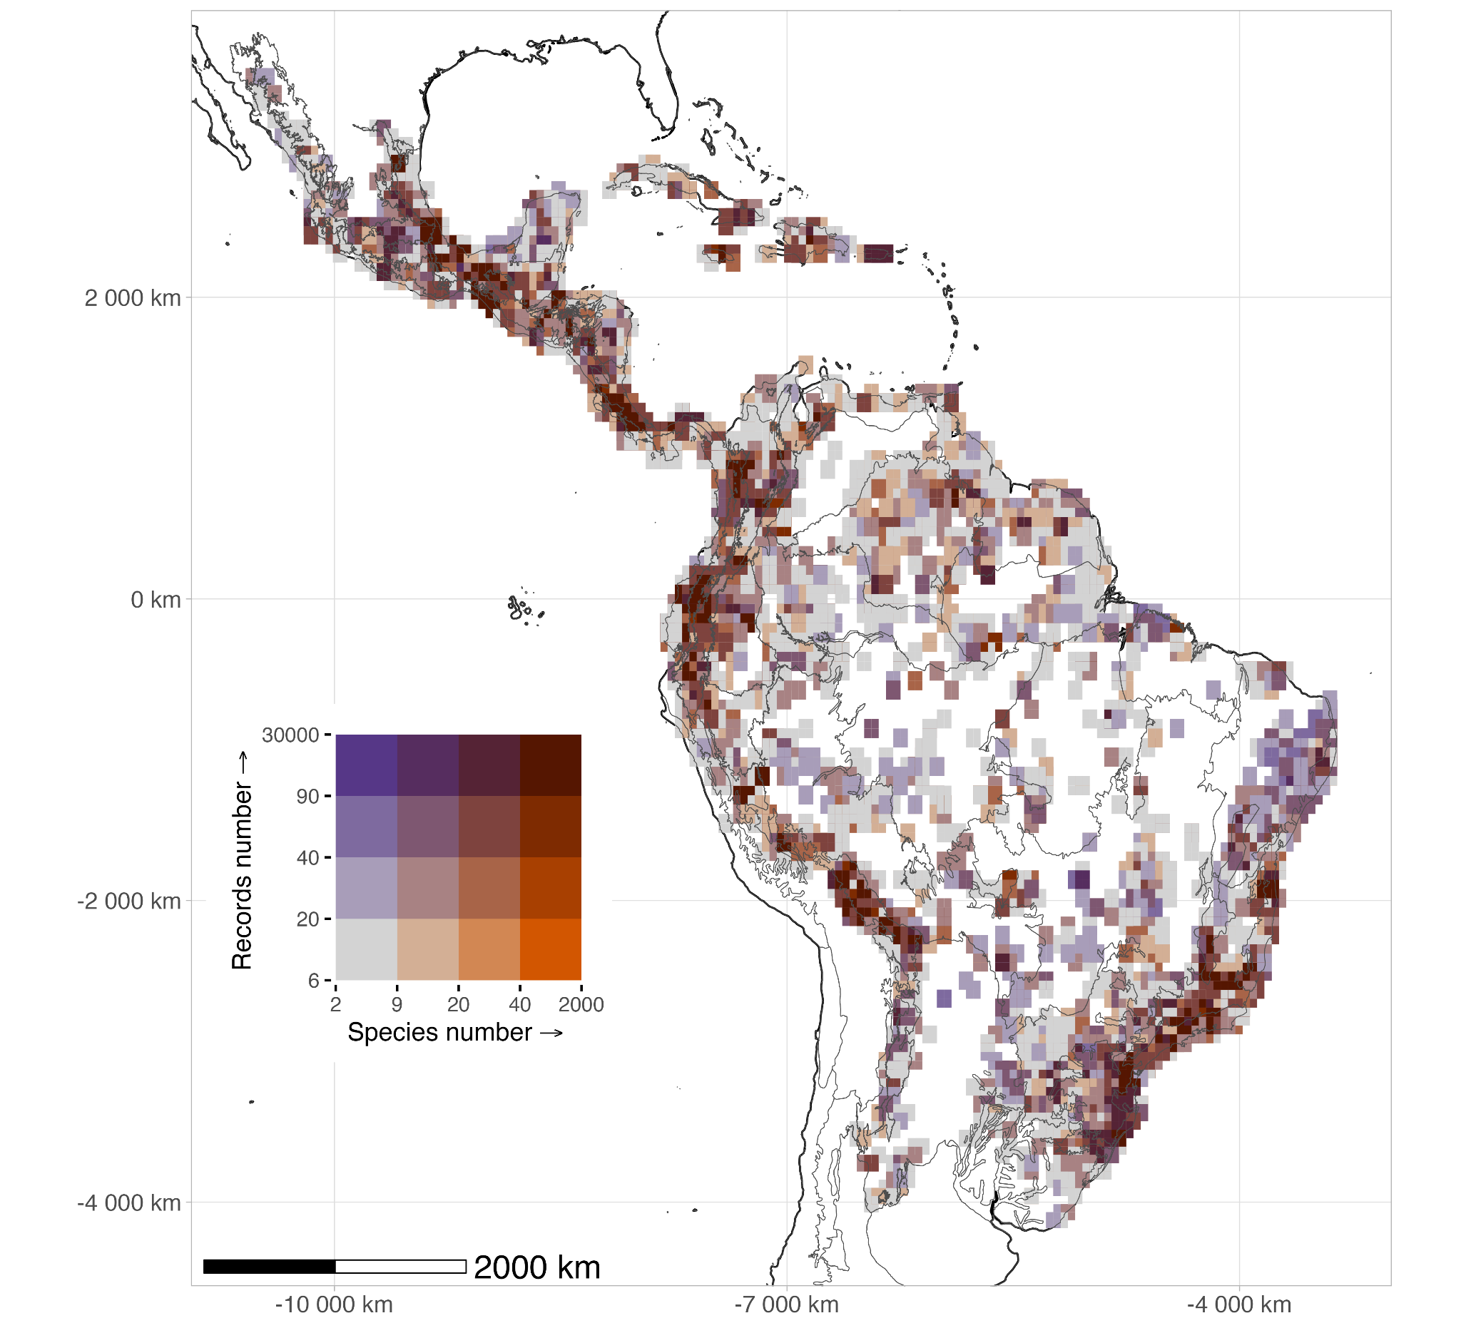
Figure 2. Sampling deficiency (slope-based proxy) for the five most diverse epiphyte families in the Neotropics. The maps show the geographic distribution of sampling deficiency, calculated using the slope estimated with KnowBR, at a grid cell resolution of ≈ 55 km at the equator. Colors represent the degree sampling completeness, categorized into quartiles: low (red, 2.1 – 53.6), middle low (light orange, 53.7 – 77.1), middle high (light green, 77.2 – 92.9), and high (light blue, 93 – 116 ). Slope was mapped using the Behrmann projection, and smaller islands were excluded for visualization purposes. The total map includes all five families (Araceae, Bromeliaceae, Orchidaceae, Piperaceae, and Polypodiaceae), while individual panels show their specific sampling patterns. Well-sampled regions were rare located mainly in in Central America (Mexico: particularly in the states of Veracruz and Chiapas), Costa Rica, some Caribbean islands, and the Brazilian Atlantic region; whereas most areas in the Neotropics remain poorly sampled, suggesting gaps in taxonomic knowledge.
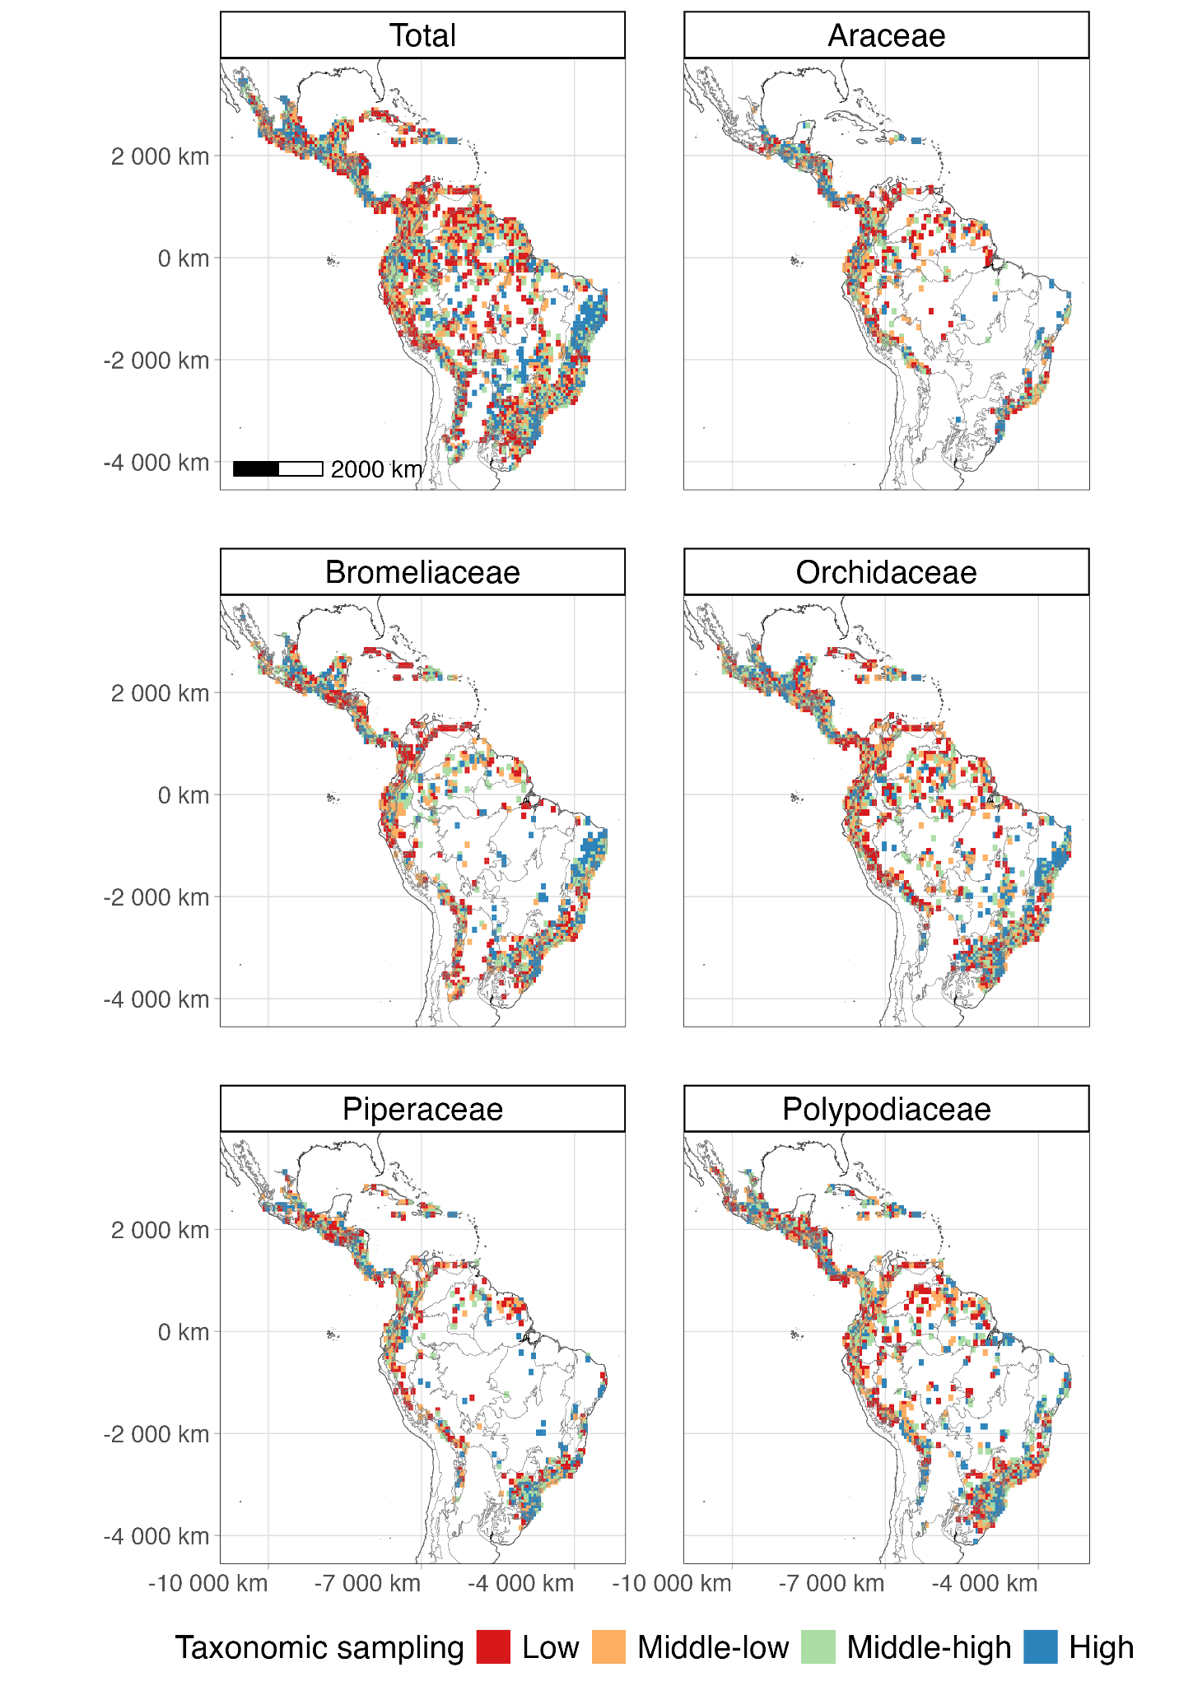
Figure 3. Wallacean shortfalls (completeness and R/S ratio proxy) for the five most diverse epiphyte families in the Neotropics. The maps display the geographic distribution of Wallacean shortfalls for epiphytes, assessed using KnowBR at a grid cell resolution of ≈ 55 km at the equator. Colors indicate the level of distributional sampling: well-sampled (cyan, slope < 0.02, completeness > 90%, R/S ratio > 15), fairly sampled (light green, intermediate values), and poorly sampled (red, slope > 0.3, completeness < 50%, R/S ratio < 3). The total map represents all families combined, while individual panels show patterns for Araceae, Bromeliaceae, Orchidaceae, Piperaceae, and Polypodiaceae. The Behrmann projection was used, and smaller islands were excluded for visualization. The results highlight that most areas in the Neotropics remain poorly sampled.
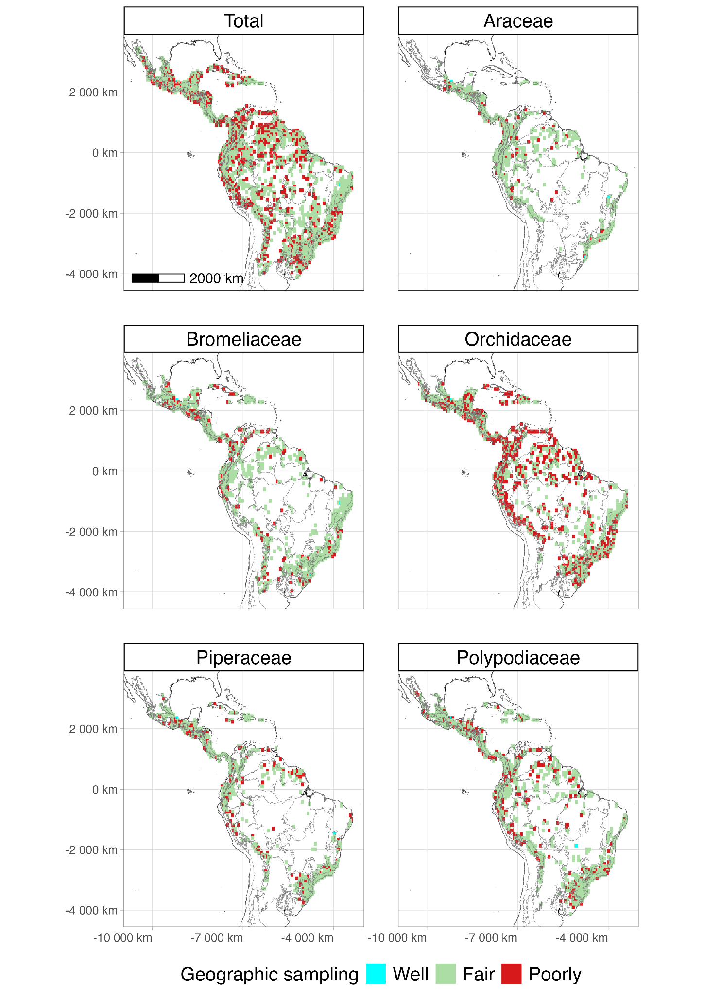
Figure 4. Hotspots and coldspots for the Wallacean shortfall of the five most diverse epiphyte families in the Neotropics. The map shows spatial clustering patterns of the Wallacean shortfall for Araceae, Bromeliaceae, Orchidaceae, Piperaceae, and Polypodiaceae. Analyses were conducted using presence records compiled by Carmona-Higuita et al. (2023), aggregated into a grid cell resolution of ≈ 55 km at the equator (Bergman projection) using the Getis-Ord Gi* statistic for local clustering. Grid cells were classified as hotspots (red: Gi* > 1.96) or coldspots (blue: Gi* < -1.96), with statistical significance at the 95% confidence level.
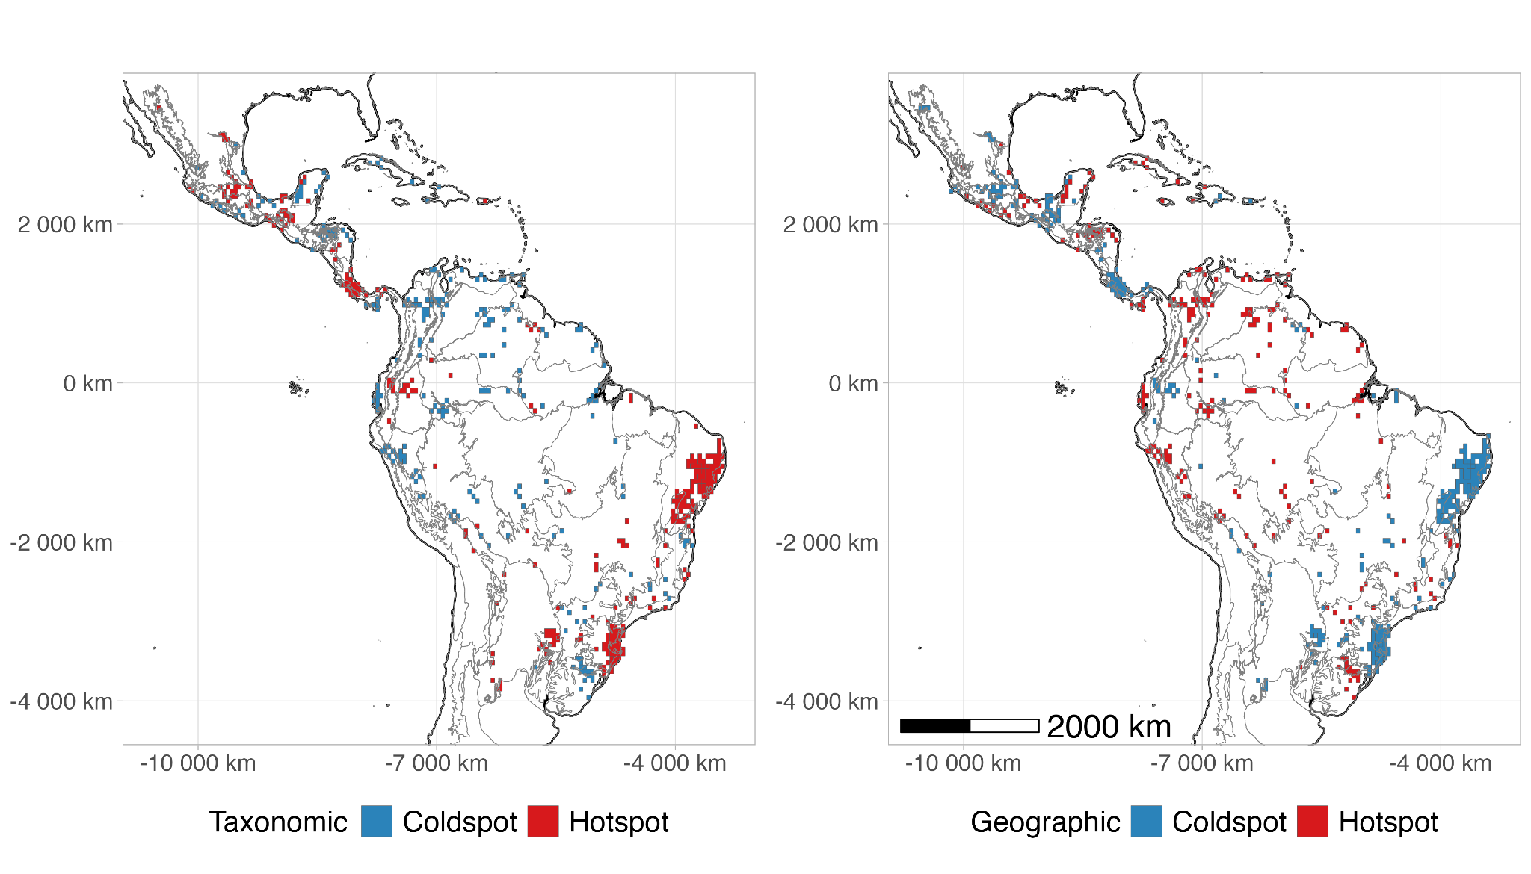

ACKNOWLEDGEMENTS
We acknowledge the support provided to GML by the DFG for the project CONTINENT (ME 5087/1-1).
Author Contribution Statement
AM, GML, AZ and DJL contributed to the conceptualization. AM led the investigation and GML supervised the work. MJCH, AM and GML performed material preparation, data curation, and formal analysis. DJL contributed with visualization. The first draft of the manuscript was written by MJCH with AM contributions. All authors commented on previous versions of the manuscript. All authors read and approved the final manuscript.
Conflict of Interest
The corresponding author confirms on behalf of all authors that there have been no involvements that might raise the question of bias in the work reported or in the conclusions, implications, or opinions stated.
Data availability statement
The data supporting the findings of this study are provided in the Supporting Information of Carmona-Higuita et al., (2023). All scripts used for data processing and analysis are openly available on GitHub at Epiphyte-Shortfalls and have been archived in Zenodo with the DOI https://doi.org/10.5281/zenodo.15001563.

REFERENCES
Amano, T., Lamming, J. D. L., & Sutherland, W. J. (2016). Spatial Gaps in Global Biodiversity Information and the Role of Citizen Science. BioScience, 66(5), 393–400. https://doi.org/10.1093/biosci/biw022
Araujo, M. L., Quaresma, A. C., & Ramos, F. N. (2022). GBIF information is not enough: National database improves the inventory completeness of Amazonian epiphytes. Biodiversity and Conservation. https://doi.org/10.1007/s10531-022-02458-x
Araujo, M. L., & Ramos, F. N. (2021). Targeting the survey efforts: Gaps and biases in epiphyte sampling at a biodiversity hotspot. Forest Ecology and Management, 498, 119544. https://doi.org/10.1016/j.foreco.2021.119544
Benavides, A. M., Duque M., A. J., Duivenvoorden, J. F., Vasco, A., & Callejas, R. (2005). A First Quantitative Census of Vascular Epiphytes in Rain forests of Colombian Amazonia. Biodiversity and Conservation, 14(3), 739–758. https://doi.org/10.1007/s10531-004-3920-9
Benzing, D. H. (1990). Vascular epiphytes. In Forest canopies (pp. 175–211). Cambridge University Press.
Bivand, R. S., Keitt, T. H., & Rowlingson, B. (2021). RGDAL: bindings for the ’geospatial’ data abstraction library. R package v.1.5-23. https://CRAN.R-project.org/package=rgdal
Bivand, R. S., & Wong, D. W. S. (2018). Comparing implementations of global and local indicators of spatial association. TEST, 27(3), 716–748. https://doi.org/10.1007/s11749-018-0599-x
Brown, M. J. M., Bachman, S. P., & Nic Lughadha, E. (2023). Three in four undescribed plant species are threatened with extinction. New Phytologist, 240(4), 1340–1344. https://doi.org/10.1111/nph.19214
Cardelus, C. L., Colwell, R. K., & Watkins, J. E. (2006). Vascular epiphyte distribution patterns: Explaining the mid-elevation richness peak. Journal of Ecology, 94(1), 144–156. https://doi.org/10.1111/j.1365-2745.2005.01052.x
Carmona-Higuita, M. J., Mendieta-Leiva, G., Gómez-Díaz, J. A., Villalobos, F., Ramos, F. N., Elias, J. P. C., Jiménez-López, D. A., Zuluaga, A., Holst, B., Kessler, M., Mathieu, G., Zizka, A., Zotz, G., & Krömer, T. (2023). Conservation status of vascular epiphytes in the Neotropics [Preprint]. In Review. https://doi.org/10.21203/rs.3.rs-2773328/v1
Carmona‐Higuita, M. J., Mendieta‐Leiva, G., Gómez‐Díaz, J. A., Villalobos, F., Ramos, F. N., Elias, J. P. C., Jiménez‐López, D. A., Zuluaga, A., Holst, B., Kessler, M., Mathieu, G., Zizka, A., Zotz, G., & Krömer, T. (2025). Endemism Centres of the Five Richest Vascular Epiphyte Families in the Neotropics. Journal of Biogeography, 52(1), 80–91. https://doi.org/10.1111/jbi.15016
Cheek, M., Nic Lughadha, E., Kirk, P., Lindon, H., Carretero, J., Looney, B., Douglas, B., Haelewaters, D., Gaya, E., Llewellyn, T., Ainsworth, A. M., Gafforov, Y., Hyde, K., Crous, P., Hughes, M., Walker, B. E., Campostrini Forzza, R., Wong, K. M., & Niskanen, T. (2020). New scientific discoveries: Plants and fungi. PLANTS, PEOPLE, PLANET, 2(5), 371–388. https://doi.org/10.1002/ppp3.10148
de Lima, R. A. F., Phillips, O. L., Duque, A., Tello, J. S., Davies, S. J., De Oliveira, A. A., Muller, S., Honorio Coronado, E. N., Vilanova, E., Cuni-Sanchez, A., Baker, T. R., Ryan, C. M., Malizia, A., Lewis, S. L., Ter Steege, H., Ferreira, J., Marimon, B. S., Luu, H. T., Imani, G., … Vásquez, R. (2022). Making forest data fair and open. Nature Ecology & Evolution, 6(6), 656–658. https://doi.org/10.1038/s41559-022-01738-7
Delves, J., Albán‐Castillo, J., Cano, A., Fernández Aviles, C., Gagnon, E., Gonzáles, P., Knapp, S., León, B., Marcelo‐Peña, J. L., Reynel, C., Rojas Gonzáles, R. D. P., Rodríguez Rodríguez, E. F., Särkinen, T., Vásquez Martínez, R., & Moonlight, P. W. (2024). Small and in‐country herbaria are vital for accurate plant threat assessments: A case study from Peru. PLANTS, PEOPLE, PLANET, 6(1), 174–185. https://doi.org/10.1002/ppp3.10425
Epiphyte Inventory Group. (2025). EpIG: Epiphyte Invent​ory Group​​. A global initiative to bring together epiphyte inventory data from across the world. https://www.epigdatabase.org/
Escribano, N., Ariño, A. H., & Galicia, D. (2016). Biodiversity data obsolescence and land uses changes. PeerJ, 4, e2743. https://doi.org/10.7717/peerj.2743
Feeley, K. (2015). Are We Filling the Data Void? An Assessment of the Amount and Extent of Plant Collection Records and Census Data Available for Tropical South America. PLOS ONE, 10(4), e0125629. https://doi.org/10.1371/journal.pone.0125629
Foster, P. (2001). The potential negative impacts of global climate change on tropical montane cloud forests. Earth-Science Reviews, 55(1–2), 73–106. https://doi.org/10.1016/S0012-8252(01)00056-3
Freitas, L., Salino, A., Neto, L. M., Almeida, T. E., Mortara, S. R., Stehmann, J. R., Amorim, A. M., Guimarães, E. F., Coelho, M. N., Zanin, A., & Forzza, R. C. (2016). A comprehensive checklist of vascular epiphytes of the Atlantic Forest reveals outstanding endemic rates. PhytoKeys, 58(1), 65–79. https://doi.org/10.3897/phytokeys.58.5643
Freudenstein, J. V., & Chase, M. W. (2015). Phylogenetic relationships in Epidendroideae (Orchidaceae), one of the great flowering plant radiations: Progressive specialization and diversification. Annals of Botany, 115(4), 665–681. https://doi.org/10.1093/aob/mcu253
Garcillán, P. P., & Ezcurra, E. (2011). Sampling procedures and species estimation: Testing the effectiveness of herbarium data against vegetation sampling in an oceanic island: Testing herbarium data against vegetation sampling. Journal of Vegetation Science, 22(2), 273–280. https://doi.org/10.1111/j.1654-1103.2010.01247.x
Gasper, A. L. D., Eisenlohr, P. V., & Salino, A. (2016). Improving collection efforts to avoid loss of biodiversity: Lessons from comprehensive sampling of lycophytes and ferns in the subtropical Atlantic Forest. Acta Botanica Brasilica, 30(2), 166–175. https://doi.org/10.1590/0102-33062015abb0292
Gaston, K. J. (2003). The structure and dynamics of geographic ranges. Oxford University Press.
Gentry, A., & Dodson, C. (1987). Diversity and biogeography of Neotropical vascular epiphytes. Annals of the Missouri Botanical Garden, 74(2), 205–233.
Getis, A., & Ord, J. K. (1992). The Analysis of Spatial Association by Use of Distance Statistics. Geographical Analysis, 24(3), 189–206. https://doi.org/10.1111/j.1538-4632.1992.tb00261.x
Guedes, T. B., Sawaya, R. J., Zizka, A., Laffan, S., Faurby, S., Pyron, R. A., Bérnils, R. S., Jansen, M., Passos, P., Prudente, A. L. C., Cisneros‐Heredia, D. F., Braz, H. B., Nogueira, C. D. C., & Antonelli, A. (2018). Patterns, biases and prospects in the distribution and diversity of Neotropical snakes. Global Ecology and Biogeography, 27(1), 14–21. https://doi.org/10.1111/geb.12679
Guisande, C., & Lobo, J. M. (2019). Discriminating well surveyed spatial units from exhaustive biodiversity databases (Version R package version 2.0) [Computer software]. http://cran. r-project. org/web/packages/KnowBR
Guzmán-Jacob, V., Weigelt, P., Craven, D., Zotz, G., Krömer, T., & Kreft, H. (2021). Biovera-Epi: A new database on species diversity, community composition and leaf functional traits of vascular epiphytes along gradients of elevation and forest-use intensity in Mexico. Biodiversity Data Journal, 9, e71974. https://doi.org/10.3897/BDJ.9.e71974
Haque, Md. M., Beaumont, L. J., & Nipperess, D. A. (2020). Taxonomic shortfalls in digitised collections of Australia’s flora. Biodiversity and Conservation, 29(1), 333–343. https://doi.org/10.1007/s10531-019-01885-7
Heberling, J. M., Miller, J. T., Noesgaard, D., Weingart, S. B., & Schigel, D. (2021). Data integration enables global biodiversity synthesis. Proceedings of the National Academy of Sciences, 118(6), e2018093118. https://doi.org/10.1073/pnas.2018093118
Hijmans, R. J. (2021). RASTER: geographic data analysis and modeling. R package v.3.4- 13. URL https://CRAN.R-project.org/package=raster
Hopkins, M. J. G. (2019). Are we close to knowing the plant diversity of the Amazon? Anais Da Academia Brasileira de Ciências, 91(suppl 3), e20190396. https://doi.org/10.1590/0001-3765201920190396
Hortal, J., De Bello, F., Diniz-Filho, J. A. F., Lewinsohn, T. M., Lobo, J. M., & Ladle, R. J. (2015). Seven Shortfalls that Beset Large-Scale Knowledge of Biodiversity. Annual Review of Ecology, Evolution, and Systematics, 46(1), 523–549. https://doi.org/10.1146/annurev-ecolsys-112414-054400
Jiménez-López, D. A., Carmona-Higuita, M. J., Mendieta-Leiva, G., Martínez-Camilo, R., Espejo-Serna, A., Krömer, T., Martínez-Meléndez, N., & Ramírez-Marcial, N. (2023). Linking different resources to recognize vascular epiphyte richness and distribution in a mountain system in southeastern Mexico. Flora, 152261. https://doi.org/10.1016/j.flora.2023.152261
Jiménez-López, D. A., Gallardo-Cruz, J. A., Véliz, M. E., Martínez-Camilo, R., Méndez, C., Solórzano, J. V., Velázquez-Méndez, L., Carabias, J., García-Hidalgo, G., Peralta-Carreta, C., Sánchez-González, M., Castillo-Acosta, O., Luna-Kamyshev, N. M., Villaseñor, J. L., & Meave, J. A. (2023). High vascular plant species richness in the Usumacinta River Basin: A comprehensive floristic checklist for a natural region in the Mesoamerican biodiversity hotspot. Botanical Sciences, 101(3), 1–62. https://doi.org/doi.org/10.17129/botsci.3253
Kelly, D. L., O’Donovan, G., Feehan, J., Murphy, S., Drangeid, S. O., & Marcano-Berti, L. (2004). The epiphyte communities of a montane rain forest in the Andes of Venezuela: Patterns in the distribution of the flora. Journal of Tropical Ecology, 20(6), 643–666. https://doi.org/10.1017/S0266467404001671
Köster, N., Friedrich, K., Nieder, J., & Barthlott, W. (2009). Conservation of epiphyte diversity in an Andean landscape transformed by human land use. Conservation Biology : The Journal of the Society for Conservation Biology, 23(4), 911–919. https://doi.org/10.1111/j.1523-1739.2008.01164.x
Kreft, H., Köster, N., Küper, W., Nieder, J., & Barthlott, W. (2004). Diversity and biogeography of vascular epiphytes in Western Amazonia, Yasuní, Ecuador. Journal of Biogeography, 31(9), 1463–1476. https://doi.org/10.1111/j.1365-2699.2004.01083.x
Lees, A. C., Rosenberg, K. V., Ruiz-Gutierrez, V., Marsden, S., Schulenberg, T. S., & Rodewald, A. D. (2020). A roadmap to identifying and filling shortfalls in Neotropical ornithology. The Auk, 137(4), ukaa048. https://doi.org/10.1093/auk/ukaa048
Leite, G. A., Pinheiro, R. T., Marcelino, D. G., Figueira, J. E. C., & Delabie, J. H. C. (2013). Foraging Behavior of Kaempfer’s Woodpecker ( Celeus obrieni ), a Bamboo Specialist. The Condor, 115(2), 221–229. https://doi.org/10.1525/cond.2013.120062
Lobo, J. M., Hortal, J., Yela, J. L., Millán, A., Sánchez-Fernández, D., García-Roselló, E., González-Dacosta, J., Heine, J., González-Vilas, L., & Guisande, C. (2018). KnowBR: An application to map the geographical variation of survey effort and identify well-surveyed areas from biodiversity databases. Ecological Indicators, 91, 241–248. https://doi.org/10.1016/j.ecolind.2018.03.077
Lomolino, M. V. (2004). Conservation biogeography. In Lomolino, L. R. Heaney. 2004. Frontiers of Biogeography: New Directions in the Geography of Nature. (p. 293). Sinauer Associates, Inc.
Luján, M., Lemos, R. M., Lucas, E., Michelangeli, F. A., Prance, G., Pennington, T. D., Rzedowski, J., Santamaría-Aguilar, D., Serpell, E., Sothers, C., & Zuntini, A. R. (2023). Trials and tribulations of Neotropical plant taxonomy: Pace of tree species description. Plant Biology. https://doi.org/10.1101/2023.09.05.556231
Maldonado, C., Molina, C. I., Zizka, A., Persson, C., Taylor, C. M., Albán, J., Chilquillo, E., Rønsted, N., & Antonelli, A. (2015). Estimating species diversity and distribution in the era of Big Data: To what extent can we trust public databases? Global Ecology and Biogeography, 24(8), 973–984. https://doi.org/10.1111/geb.12326
Marin, A. C., Wolf, J. H. D., Oostermeijer, J. G. B., & den Nijs, J. C. M. (2008). Establishment of Epiphytic Bromeliads in Successional Tropical Premontane Forests in Costa Rica. Biotropica, 40(4), 441–448.
Mendieta-Leiva, G., Ramos, F. N., Elias, J. P. C., Zotz, G., Acuña-Tarazona, M., Alvim, F. S., Barbosa, D. E. F., Basílio, G. A., Batke, S. P., Benavides, A. M., Blum, C. T., Boelter, C. R., Brancalion, P. H. S., Carmona, M. J., Carvalho, L. P., de la Rosa-Manzano, E., Einzmann, H. J. R., Fernández, M., Furtado, S. G., … Jiménez-Alfaro, B. (2020). EpIG-DB: A database of vascular epiphyte assemblages in the Neotropics. Journal of Vegetation Science, 31(3), 1–11. https://doi.org/10.1111/jvs.12867
Mendieta-Leiva, G., & Zotz, G. (2015). A conceptual framework for the analysis of vascular epiphyte assemblages. Perspectives in Plant Ecology, Evolution and Systematics, 17(6), 510–521. https://doi.org/10.1016/j.ppees.2015.09.003
Meyer, C., Kreft, H., Guralnick, R., & Jetz, W. (2015). Global priorities for an effective information basis of biodiversity distributions. Nature Communications, 6(1), 8221. https://doi.org/10.1038/ncomms9221
Meyer, C., Weigelt, P., & Kreft, H. (2016). Multidimensional biases, gaps and uncertainties in global plant occurrence information. Ecology Letters, 19(8), 992–1006. https://doi.org/10.1111/ele.12624
Morrone, J. J., Escalante, T., Rodríguez-Tapia, G., Carmona, A., Arana, M., & Mercado-Gómez, J. D. (2022). Biogeographic regionalization of the Neotropical region: New map and shapefile. Anais Da Academia Brasileira de Ciências, 94(1), e20211167. https://doi.org/10.1590/0001-3765202220211167
Nicolson, N., Trekels, M., Groom, Q. J., Knapp, S., & Paton, A. J. (2023). Global access to nomenclatural botanical resources: Evaluating open access availability. PLANTS, PEOPLE, PLANET, 5(6), 899–907. https://doi.org/10.1002/ppp3.10438
Nieder, J., Prosperi, J., & Michaloud, G. (2001). Epiphytes and their contribution to canopy diversity. Plant Ecology, 153, 51–63.
Oliveira, U., Paglia, A. P., Brescovit, A. D., De Carvalho, C. J. B., Silva, D. P., Rezende, D. T., Leite, F. S. F., Batista, J. A. N., Barbosa, J. P. P. P., Stehmann, J. R., Ascher, J. S., De Vasconcelos, M. F., De Marco, P., Löwenberg‐Neto, P., Dias, P. G., Ferro, V. G., & Santos, A. J. (2016). The strong influence of collection bias on biodiversity knowledge shortfalls of B razilian terrestrial biodiversity. Diversity and Distributions, 22(12), 1232–1244. https://doi.org/10.1111/ddi.12489
Ondo, I., Dhanjal‐Adams, K. L., Pironon, S., Silvestro, D., Colli‐Silva, M., Deklerck, V., Grace, O. M., Monro, A. K., Nicolson, N., Walker, B., & Antonelli, A. (2024). Plant diversity darkspots for global collection priorities. New Phytologist, 244(2), 719–733. https://doi.org/10.1111/nph.20024
Pebesma, E. (2018). Simple Features for R: Standardized Support for Spatial Vector Data. The R Journal, 10(1), 439. https://doi.org/10.32614/RJ-2018-009
Perez, T. M., Valverde-Barrantes, O., Bravo, C., Taylor, T. C., Fadrique, B., Hogan, J. A., Pardo, C. J., Stroud, J. T., Baraloto, C., & Feeley, K. J. (2019). Botanic gardens are an untapped resource for studying the functional ecology of tropical plants. Philosophical Transactions of the Royal Society B: Biological Sciences, 374(1763), 20170390. https://doi.org/10.1098/rstb.2017.0390
Prance, G. T., Beentje, H., Dransfield, J., & Johns, R. (2000). The Tropical Flora Remains Undercollected. Annals of the Missouri Botanical Garden, 87(1), 67. https://doi.org/10.2307/2666209
Quaresma, A., Zartman, C. E., Piedade, M. T. F., Wittmann, F., Jardim, M. A. G., Irume, M. V., Benavides, A. M., Freitas, L., Toledo, J. J., Boelter, C. R., Obermüller, F., Duque, A. J., Klein, V. P., Mari, M. L. G., Schöngart, J., Arenas, E., Pos, E. T., Vasco, A., Ek, R., … Ter Steege, H. (2022). The Amazon Epiphyte Network: A First Glimpse Into Continental-Scale Patterns of Amazonian Vascular Epiphyte Assemblages. Frontiers in Forests and Global Change, 5, 828759. https://doi.org/10.3389/ffgc.2022.828759
R. Core Team. (2024). _R: A Language and Environment for Statistical Computing_ [Computer software]. R Foundation for Statistical Computing. <https://www.R-project.org/>
Ramírez‐Barahona, S., Cuervo‐Robayo, A. P., & Magallón, S. (2023). Assessing digital accessible botanical knowledge and priorities for exploration and discovery of plant diversity across Mesoamerica. New Phytologist, 240(4), 1659–1672. https://doi.org/10.1111/nph.19190
Ramos, F. N., De Araujo, M. L., Da Silva Assis, I., Basilio, G. A., Barbosa, D. E. F., Correa, T. A., Delgado, C. N., Furtado, S. G., Marquez, G., Soares, J. S., Yañez, A., Silva, S. M., Neto, L. M., & Elias, J. P. C. (2024). Vascular epiphytes of the South America Dry Diagonal: Characterising their occurrence and richness in this neglected region. New Zealand Journal of Botany, 1–18. https://doi.org/10.1080/0028825X.2024.2387188
Ramos, F. N., Mortara, S. R., & Elias, J. P. C. (2021). Vascular Epiphytes of the Atlantic Forest: Diversity and Community Ecology. In M. C. M. Marques & C. E. V. Grelle (Eds.), The Atlantic Forest (pp. 133–149). Springer International Publishing. https://doi.org/10.1007/978-3-030-55322-7_7
Ramos, F. N., Mortara, S. R., Monalisa‐Francisco, N., Elias, J. P. C., Neto, L. M., Freitas, L., Kersten, R., Amorim, A. M., Matos, F. B., Nunes‐Freitas, A. F., Alcantara, S., Alexandre, M. H. N., Almeida‐Scabbia, R. J., Almeida, O. J. G., Alves, F. E., Oliveira Alves, R. M., Alvim, F. S., Andrade, A. C. S., Andrade, S., … Ribeiro, M. C. (2019). ATLANTIC EPIPHYTES: A data set of vascular and non‐vascular epiphyte plants and lichens from the Atlantic Forest. Ecology, 100(2), e02541. https://doi.org/10.1002/ecy.2541
Raven, P. H., Gereau, R. E., Phillipson, P. B., Chatelain, C., Jenkins, C. N., & Ulloa Ulloa, C. (2020). The distribution of biodiversity richness in the tropics. Science Advances, 6(37), eabc6228. https://doi.org/10.1126/sciadv.abc6228
Rossi, F., & Becker, G. (2019). Creating forest management units with Hot Spot Analysis (Getis-Ord Gi*) over a forest affected by mixed-severity fires. Australian Forestry, 82(4), 166–175. https://doi.org/10.1080/00049158.2019.1678714

Roy, M., Vasco‐Palacios, A., Geml, J., Buyck, B., Delgat, L., Giachini, A., Grebenc, T., Harrower, E., Kuhar, F., Magnago, A., Rinaldi, A. C., Schimann, H., Selosse, M., Sulzbacher, M. A., Wartchow, F., & Neves, M. (2017). The (re)discovery of ectomycorrhizal symbioses in Neotropical ecosystems sketched in Florianópolis. New Phytologist, 214(3), 920–923. https://doi.org/10.1111/nph.14531
Sabatini, F. M., Jiménez-Alfaro, B., Jandt, U., Chytrý, M., Field, R., Kessler, M., Lenoir, J., Schrodt, F., Wiser, S. K., Arfin Khan, M. A. S., Attorre, F., Cayuela, L., De Sanctis, M., Dengler, J., Haider, S., Hatim, M. Z., Indreica, A., Jansen, F., Pauchard, A., … Bruelheide, H. (2022). Global patterns of vascular plant alpha diversity. Nature Communications, 13(1), 4683. https://doi.org/10.1038/s41467-022-32063-z
Schellenberger Costa, D., Boehnisch, G., Freiberg, M., Govaerts, R., Grenié, M., Hassler, M., Kattge, J., Muellner‐Riehl, A. N., Rojas Andrés, B. M., Winter, M., Watson, M., Zizka, A., & Wirth, C. (2023). The big four of plant taxonomy – a comparison of global checklists of vascular plant names. New Phytologist, 240(4), 1687–1702. https://doi.org/10.1111/nph.18961
Schröter, M., Kraemer, R., Ceauşu, S., & Rusch, G. M. (2017). Incorporating threat in hotspots and coldspots of biodiversity and ecosystem services. Ambio, 46(7), 756–768. https://doi.org/10.1007/s13280-017-0922-x
Soberón, J., & Peterson, A. T. (2009). Monitoring Biodiversity Loss with Primary Species-occurrence Data: Toward National-level Indicators for the 2010 Target of the Convention on Biological Diversity. AMBIO: A Journal of the Human Environment, 38(1), 29–34. https://doi.org/10.1579/0044-7447-38.1.29
Sobral-Souza, T., Stropp, J., Santos, J. P., Prasniewski, V. M., Szinwelski, N., Vilela, B., Freitas, A. V. L., Ribeiro, M. C., & Hortal, J. (2021). Knowledge gaps hamper understanding the relationship between fragmentation and biodiversity loss: The case of Atlantic Forest fruit-feeding butterflies. PeerJ, 9, e11673. https://doi.org/10.7717/peerj.11673
Stropp, J., Ladle, R. J., M. Malhado, A. C., Hortal, J., Gaffuri, J., H. Temperley, W., Olav Skøien, J., & Mayaux, P. (2016). Mapping ignorance: 300 years of collecting flowering plants in Africa. Global Ecology and Biogeography, 25(9), 1085–1096. https://doi.org/10.1111/geb.12468
Stropp, J., Umbelino, B., Correia, R. A., Campos‐Silva, J. V., Ladle, R. J., & Malhado, A. C. M. (2020). The ghosts of forests past and future: Deforestation and botanical sampling in the Brazilian Amazon. Ecography, 43(7), 979–989. https://doi.org/10.1111/ecog.05026
Taylor, A., Weigelt, P., Denelle, P., Cai, L., & Kreft, H. (2023). The contribution of plant life and growth forms to global gradients of vascular plant diversity. New Phytologist, nph.19011. https://doi.org/10.1111/nph.19011
Taylor, A., Zotz, G., Weigelt, P., Cai, L., Karger, D. N., König, C., & Kreft, H. (2021). Vascular epiphytes contribute disproportionately to global centres of plant diversity. Global Ecology and Biogeography, 31(1), 62–74. https://doi.org/10.1111/geb.13411
ter Steege, H., Vaessen, R. W., Cárdenas-López, D., Sabatier, D., Antonelli, A., De Oliveira, S. M., Pitman, N. C. A., Jørgensen, P. M., & Salomão, R. P. (2016). The discovery of the Amazonian tree flora with an updated checklist of all known tree taxa. Scientific Reports, 6(1), 29549. https://doi.org/10.1038/srep29549
Tietje, M., Antonelli, A., Forest, F., Govaerts, R., Smith, S. A., Sun, M., Baker, W. J., & Eiserhardt, W. L. (2023). Global hotspots of plant phylogenetic diversity. New Phytologist, 240(4), 1636–1646. https://doi.org/10.1111/nph.19151
Ugland, K. I., Gray, J. S., & Ellingsen, K. E. (2003). The species-accumulation curve and estimation of species richness. Journal of Animal Ecology, 72(5), 888–897.
Vargas, C. A., Bottin, M., Sarkinen, T., Richardson, J. E., Celis, M., Villanueva, B., & Sanchez, A. (2024). How to fill the biodiversity data gap: Is it better to invest in fieldwork or curation? Plant Diversity, 46(1), 39–48. https://doi.org/10.1016/j.pld.2023.06.003
Vargas, C. A., Bottin, M., Särkinen, T., Richardson, J. E., Raz, L., Garzon-Lopez, C. X., & Sanchez, A. (2022). Environmental and geographical biases in plant specimen data from the Colombian Andes. Botanical Journal of the Linnean Society, 200(4), 451–464. https://doi.org/10.1093/botlinnean/boac035
Vitt, P., Taylor, A., Rakosy, D., Kreft, H., Meyer, A., Weigelt, P., & Knight, T. M. (2023). Global conservation prioritization for the Orchidaceae. Scientific Reports, 13(1), 6718. https://doi.org/10.1038/s41598-023-30177-y
Wickham, H. (2009). ggplot2: Elegant Graphics for Data Analysis. Springer New York. https://doi.org/10.1007/978-0-387-98141-3
Wickham, H., Hester, J., & Chang, W. (2019). Devtools: Tools to Make Developing R Packages Easier. R package version 2.0.2. https://cran.r-project.org/package=devtools
Woods, C. L., Cardelús, C. L., & DeWalt, S. J. (2015). Microhabitat associations of vascular epiphytes in a wet tropical forest canopy. Journal of Ecology, 103(2), 421–430.
Zizka, A., Antunes Carvalho, F., Calvente, A., Rocio Baez-Lizarazo, M., Cabral, A., Coelho, J. F. R., Colli-Silva, M., Fantinati, M. R., Fernandes, M. F., Ferreira-Araújo, T., Gondim Lambert Moreira, F., Santos, N. M. C., Santos, T. A. B., dos Santos-Costa, R. C., Serrano, F. C., Alves da Silva, A. P., de Souza Soares, A., Cavalcante de Souza, P. G., Calisto Tomaz, E., … Antonelli, A. (2020). No one-size-fits-all solution to clean GBIF. PeerJ, 8, e9916. https://doi.org/10.7717/peerj.9916
Zizka, A., Antonelli, A., & Silvestro, D. (2021). Sampbias , a method for quantifying geographic sampling biases in species distribution data. Ecography, 44(1), 25–32. https://doi.org/10.1111/ecog.05102

Zotz, G. (2016). Plants on plants – the biology of vascular epiphytes. Springer. https://doi.org/10.1007/978-3-319-39237-0_1
Zotz, G., Weigelt, P., Kessler, M., Kreft, H., & Taylor, A. (2021). EpiList 1.0: A global checklist of vascular epiphytes. Ecology, 102(6), e03326. https://doi.org/10.1002/ecy.3326

