Supporting Information
Data Shortfalls on Vascular Epiphytes in the Neotropics
Diversity and Distributions
APPENDICES S1–S3: TABLES

Appendix S1, Table S1.1. Spearman rank correlations (ρ) between the three KnowBR inventory completeness metrics (slope, completeness %, and R/S ratio) across all five vascular epiphyte families (Araceae, Bromeliaceae, Orchidaceae, Piperaceae, and Polypodiaceae) and for all families combined. All pairwise correlations were highly concordant (ρ = 0.86–0.99, all p < 0.001; n = number of grid cells with ≥ 10 records per family), supporting the use of the three metrics as convergent evidence of the Wallacean shortfall rather than independent measures.

Appendix S2, Table S2.1. Sensitivity analysis of the minimum-records threshold used to include grid cells in KnowBR analyses. Spearman rank correlations (ρ) between slope-based completeness rankings obtained with thresholds of 5, 10, 15, 20, 25, and 30 records per cell, for all families combined and for each family individually. All pairwise correlations were ρ = 1.00 (p < 0.001), indicating that the threshold of 10 records used in this study produces results that are robust across the full range of thresholds tested. The threshold of 10 records retains 94.3% of grid cells with any occurrence data.

Appendix S3, Table S3.1. Summary of inventory completeness metrics by biogeographic province (Morrone et al., 2022) for all five vascular epiphyte families combined. Columns report the mean number of records per cell (Records), mean species richness (SR), and the percentage of grid cells classified as well-sampled (WS), fairly-sampled (FS), and poorly-sampled (PS) based on the slope proxy (Slope < 0.02, 0.02–0.3, > 0.3, respectively) and the combined completeness + R/S ratio proxy (GS_WS, GS_FS, GS_PS). Provinces are listed alphabetically.
 | Provinces | mean_n | mean_sr | TS_WS | TS_FS | TS_PS | GS_WS | GS_FS | GS_PS
1 | Araucaria Forest province | 85 | 28 | 11.9 | 65.6 | 22.5 | 0.0 | 89.8 | 10.2
2 | Atacama province | 3 | 1 | 0.0 | 100.0 | 0.0 | 0.0 | 100.0 | 0.0
3 | Atlantic province | 195 | 61 | 7.4 | 58.8 | 33.8 | 0.4 | 93.3 | 6.3
4 | Bahama province | 4 | 3 | 9.1 | 90.9 | 0.0 | 0.0 | 90.9 | 9.1
5 | Balsas Basin province | 32 | 10 | 14.2 | 71.7 | 14.2 | 0.0 | 86.7 | 13.3
6 | Caatinga province | 32 | 9 | 1.6 | 75.5 | 22.9 | 0.3 | 98.7 | 1.0
7 | Cauca province | 279 | 104 | 21.9 | 55.3 | 22.8 | 0.0 | 78.9 | 21.1
8 | Cerrado province | 16 | 7 | 3.6 | 89.7 | 6.8 | 0.1 | 97.2 | 2.7
9 | Chaco province | 11 | 5 | 5.3 | 88.6 | 6.1 | 0.0 | 95.4 | 4.6
10 | Chapada Diamantina province | 101 | 21 | 1.1 | 50.5 | 48.4 | 2.2 | 97.8 | 0.0
11 | Chiapas Highlands province | 156 | 53 | 20.7 | 61.3 | 18.0 | 0.0 | 82.4 | 17.6
12 | Choco-Darien province | 75 | 27 | 18.3 | 69.3 | 12.4 | 0.0 | 85.6 | 14.4
13 | Comechingones province | 50 | 14 | 0.0 | 50.0 | 50.0 | 0.0 | 100.0 | 0.0
14 | Cuban province | 20 | 12 | 19.0 | 78.5 | 2.5 | 0.0 | 82.3 | 17.7
15 | Cuyan High Andean province | 5 | 4 | 36.4 | 63.6 | 0.0 | 0.0 | 90.9 | 9.1
16 | Desert province | 4 | 3 | 7.2 | 92.8 | 0.0 | 0.0 | 94.0 | 6.0
17 | Ecuadorian province | 9 | 6 | 19.1 | 78.7 | 2.1 | 0.0 | 83.0 | 17.0
18 | Esteros del Ibera province | 7 | 3 | 6.6 | 87.6 | 5.8 | 0.0 | 93.4 | 6.6
19 | Galapagos Islands province | 17 | 5 | 0.0 | 66.7 | 33.3 | 0.0 | 100.0 | 0.0
20 | Guajira province | 20 | 11 | 19.3 | 80.2 | 0.5 | 0.0 | 83.6 | 16.4
21 | Guatuso-Talamanca province | 508 | 116 | 8.4 | 48.7 | 42.9 | 0.0 | 93.5 | 6.5
22 | Guianan Lowlands province | 18 | 10 | 13.7 | 80.4 | 5.8 | 0.0 | 88.9 | 11.1
23 | Guianan province | 20 | 10 | 11.9 | 82.2 | 5.9 | 0.0 | 89.9 | 10.1
24 | Hispaniola province | 46 | 18 | 11.0 | 74.7 | 14.4 | 0.0 | 91.1 | 8.9
25 | Imeri province | 17 | 8 | 10.8 | 82.1 | 7.1 | 0.0 | 91.0 | 9.0
26 | Jamaica province | 92 | 31 | 15.4 | 69.2 | 15.4 | 0.0 | 84.6 | 15.4
27 | Lesser Antilles province | 16 | 12 | 20.0 | 80.0 | 0.0 | 0.0 | 80.0 | 20.0
28 | Madeira province | 9 | 5 | 7.0 | 90.0 | 3.0 | 0.0 | 94.1 | 5.9
29 | Magdalena province | 73 | 32 | 18.6 | 74.8 | 6.6 | 0.0 | 83.4 | 16.6
30 | Monte province | 7 | 4 | 7.8 | 90.3 | 1.9 | 0.0 | 93.2 | 6.8
31 | Mosquito province | 61 | 22 | 22.2 | 62.8 | 15.0 | 0.0 | 81.2 | 18.8
32 | Napo province | 68 | 27 | 8.9 | 74.9 | 16.2 | 0.0 | 92.4 | 7.6
33 | Pacific Lowlands province | 79 | 28 | 15.7 | 71.6 | 12.6 | 0.0 | 87.1 | 12.9
34 | Pampean province | 14 | 7 | 10.4 | 86.0 | 3.6 | 0.0 | 91.0 | 9.0
35 | Para province | 10 | 5 | 4.6 | 89.9 | 5.5 | 0.0 | 95.9 | 4.1
36 | Paramo province | 216 | 79 | 16.5 | 67.3 | 16.2 | 0.0 | 85.0 | 15.0
37 | Parana Forest province | 61 | 24 | 17.4 | 71.5 | 11.1 | 0.0 | 86.0 | 14.0
38 | Puerto Rico province | 115 | 27 | 0.0 | 43.5 | 56.5 | 0.0 | 100.0 | 0.0
39 | Puna province | 24 | 12 | 8.4 | 87.8 | 3.8 | 0.0 | 92.3 | 7.7
40 | Puntarenas-Chiriqui province | 540 | 119 | 25.0 | 37.5 | 37.5 | 0.0 | 77.8 | 22.2
41 | Rondonia province | 14 | 8 | 6.0 | 89.7 | 4.3 | 0.0 | 94.9 | 5.1
42 | Roraima province | 14 | 7 | 9.1 | 84.8 | 6.1 | 0.0 | 92.0 | 8.0
43 | Sabana province | 13 | 11 | 7.5 | 91.8 | 0.7 | 0.0 | 93.2 | 6.8
44 | Sierra Madre Occidental province | 9 | 5 | 5.0 | 92.5 | 2.5 | 0.0 | 95.7 | 4.3
45 | Sierra Madre Oriental province | 102 | 38 | 4.4 | 68.9 | 26.7 | 0.0 | 97.8 | 2.2
46 | Sierra Madre del Sur province | 84 | 40 | 20.6 | 70.3 | 9.1 | 0.0 | 83.4 | 16.6
47 | Southern Espinhaco province | 103 | 31 | 3.1 | 71.1 | 25.8 | 0.0 | 96.9 | 3.1
48 | Transmexican Volcanic Belt province | 281 | 50 | 5.2 | 61.7 | 33.1 | 0.0 | 97.4 | 2.6
49 | Trinidad province | 33 | 23 | 16.7 | 83.3 | 0.0 | 0.0 | 83.3 | 16.7
50 | Ucayali province | 55 | 27 | 17.5 | 75.2 | 7.3 | 0.0 | 84.1 | 15.9
51 | Venezuelan province | 20 | 13 | 30.1 | 68.9 | 1.0 | 0.0 | 75.7 | 24.3
52 | Veracruzan province | 155 | 50 | 14.8 | 65.5 | 19.7 | 0.2 | 86.4 | 13.4
53 | Western Ecuador province | 60 | 30 | 23.6 | 72.4 | 4.1 | 0.0 | 79.7 | 20.3
54 | Xingu-Tapajos province | 11 | 6 | 5.2 | 91.8 | 3.0 | 0.0 | 95.2 | 4.8
55 | Yucatan Peninsula Province | 20 | 9 | 12.0 | 77.9 | 10.1 | 0.0 | 89.9 | 10.1
56 | Yungas province | 94 | 36 | 18.2 | 65.1 | 16.7 | 0.0 | 84.3 | 15.7

APPENDICES S4–S9: FIGURES

Appendix S4, Figure S4.1. Sensitivity analysis of inventory completeness rankings to the minimum-records threshold. Maps show the slope-based completeness classification (well-sampled: slope < 0.02, cyan; fairly-sampled: 0.02 ≤ slope ≤ 0.3, light green; poorly-sampled: slope > 0.3, red) for all vascular epiphyte families combined, using thresholds of 5, 10, 15, 20, 25, and 30 minimum records per grid cell. The spatial pattern of completeness is virtually identical across all thresholds (Spearman ρ = 1.00; see Appendix S2, Table S2.1), confirming that the threshold of 10 records produces robust results. The Behrmann equal-area projection is used; grid cell resolution ≈ 55 km at the equator. Scale bar: 1,000 km.

Appendix S5, Figure S5.1. Geographic distribution of occurrence records for each of the five most species-rich vascular epiphyte families (Araceae, Bromeliaceae, Orchidaceae, Piperaceae, and Polypodiaceae) in the Neotropics. Colour intensity indicates the number of georeferenced records per 30 arc-minute grid cell (~55 km at the equator). The Behrmann equal-area projection is used. White cells indicate no available occurrence data. Scale bar: 1,000 km.
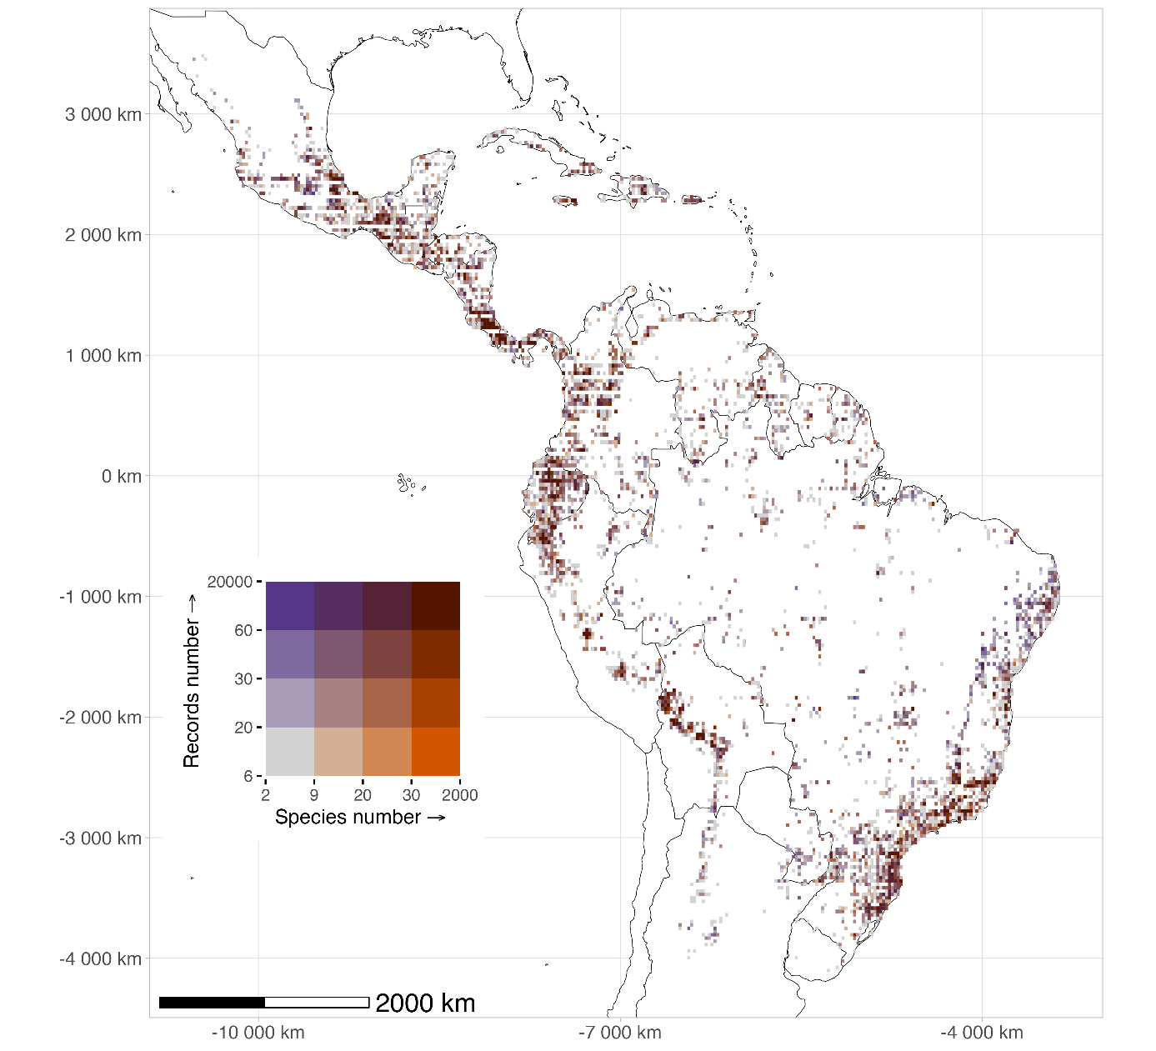

Appendix S6, Figure S6.1. Sampling completeness (slope-based proxy) for each of the five most species-rich vascular epiphyte families (Araceae, Bromeliaceae, Orchidaceae, Piperaceae, and Polypodiaceae) in the Neotropics. Grid cells are classified as well-sampled (slope < 0.02, cyan), fairly-sampled (0.02 ≤ slope ≤ 0.3, light green), or poorly-sampled (slope > 0.3, red), reflecting the slope of the species accumulation curve estimated with KnowBR. The Behrmann equal-area projection is used; grid cell resolution ≈ 55 km at the equator. Scale bar: 1,000 km.
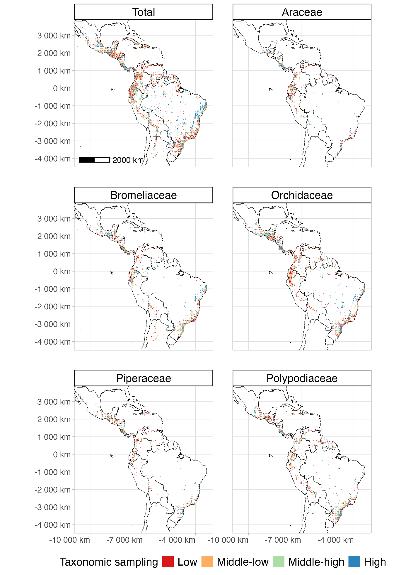

Appendix S7, Figure S7.1. Distributional knowledge gaps (Wallacean shortfall) quantified by the combined completeness and R/S ratio proxy for each of the five most species-rich vascular epiphyte families (Araceae, Bromeliaceae, Orchidaceae, Piperaceae, and Polypodiaceae) in the Neotropics. Grid cells are classified as well-sampled (completeness > 90% and R/S > 15), fairly-sampled, or poorly-sampled (completeness < 50% and R/S < 3). The Behrmann equal-area projection is used; grid cell resolution ≈ 55 km at the equator. Scale bar: 1,000 km.
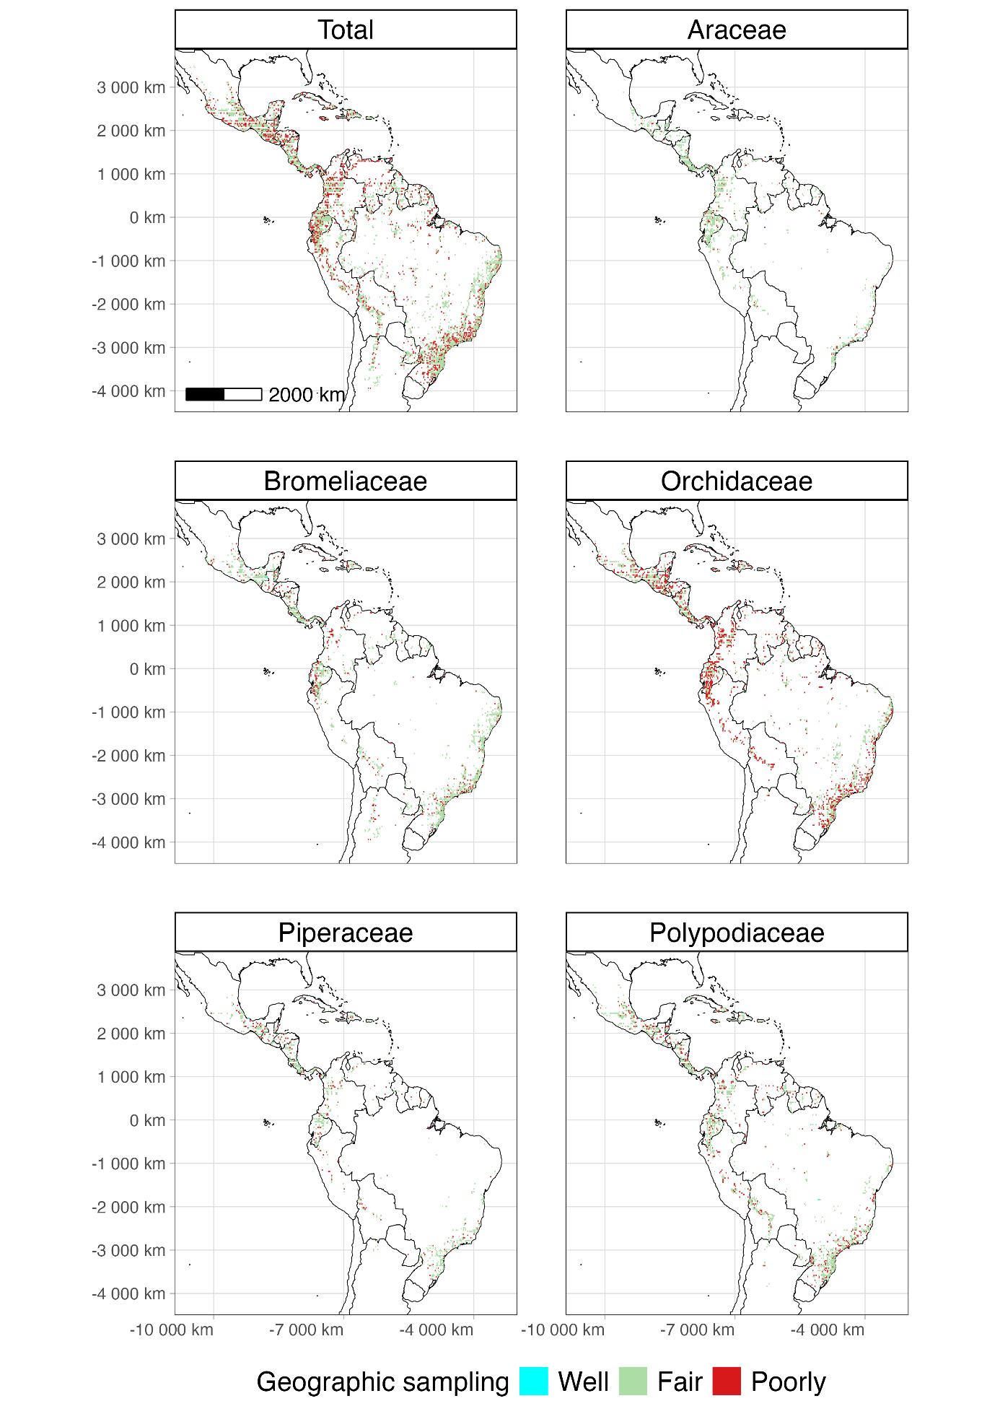

Appendix S8, Figure S8.1. Spatial clustering of inventory completeness for the five most diverse vascular epiphyte families in the Neotropics, assessed using the Getis-Ord Gi* statistic (Getis & Ord, 1992; Ramírez-Barahona et al., 2023) implemented in the spdep package (Bivand & Wong, 2018). Grid cells with statistically significant clustering of high completeness values are shown in red (Gi* > 1.96) and those with clustering of low completeness in blue (Gi* < −1.96; 95% confidence level). Prior to computing Gi*, completeness values were transformed to incompleteness (100 − completeness) and slope values were inverted (1 − slope), so that high Gi* values identify clusters of greatest sampling deficiency. The clusters in red reflect historical concentration of botanical survey effort in accessible and well-resourced regions; they do not represent priority areas for future sampling. True sampling priorities correspond to grid cells with no occurrence data (white cells in Figures 1 and 2 of the main text). Data: Carmona-Higuita et al. (2023); Behrmann projection; resolution ≈ 55 km at equator. Scale bar: 1,000 km.
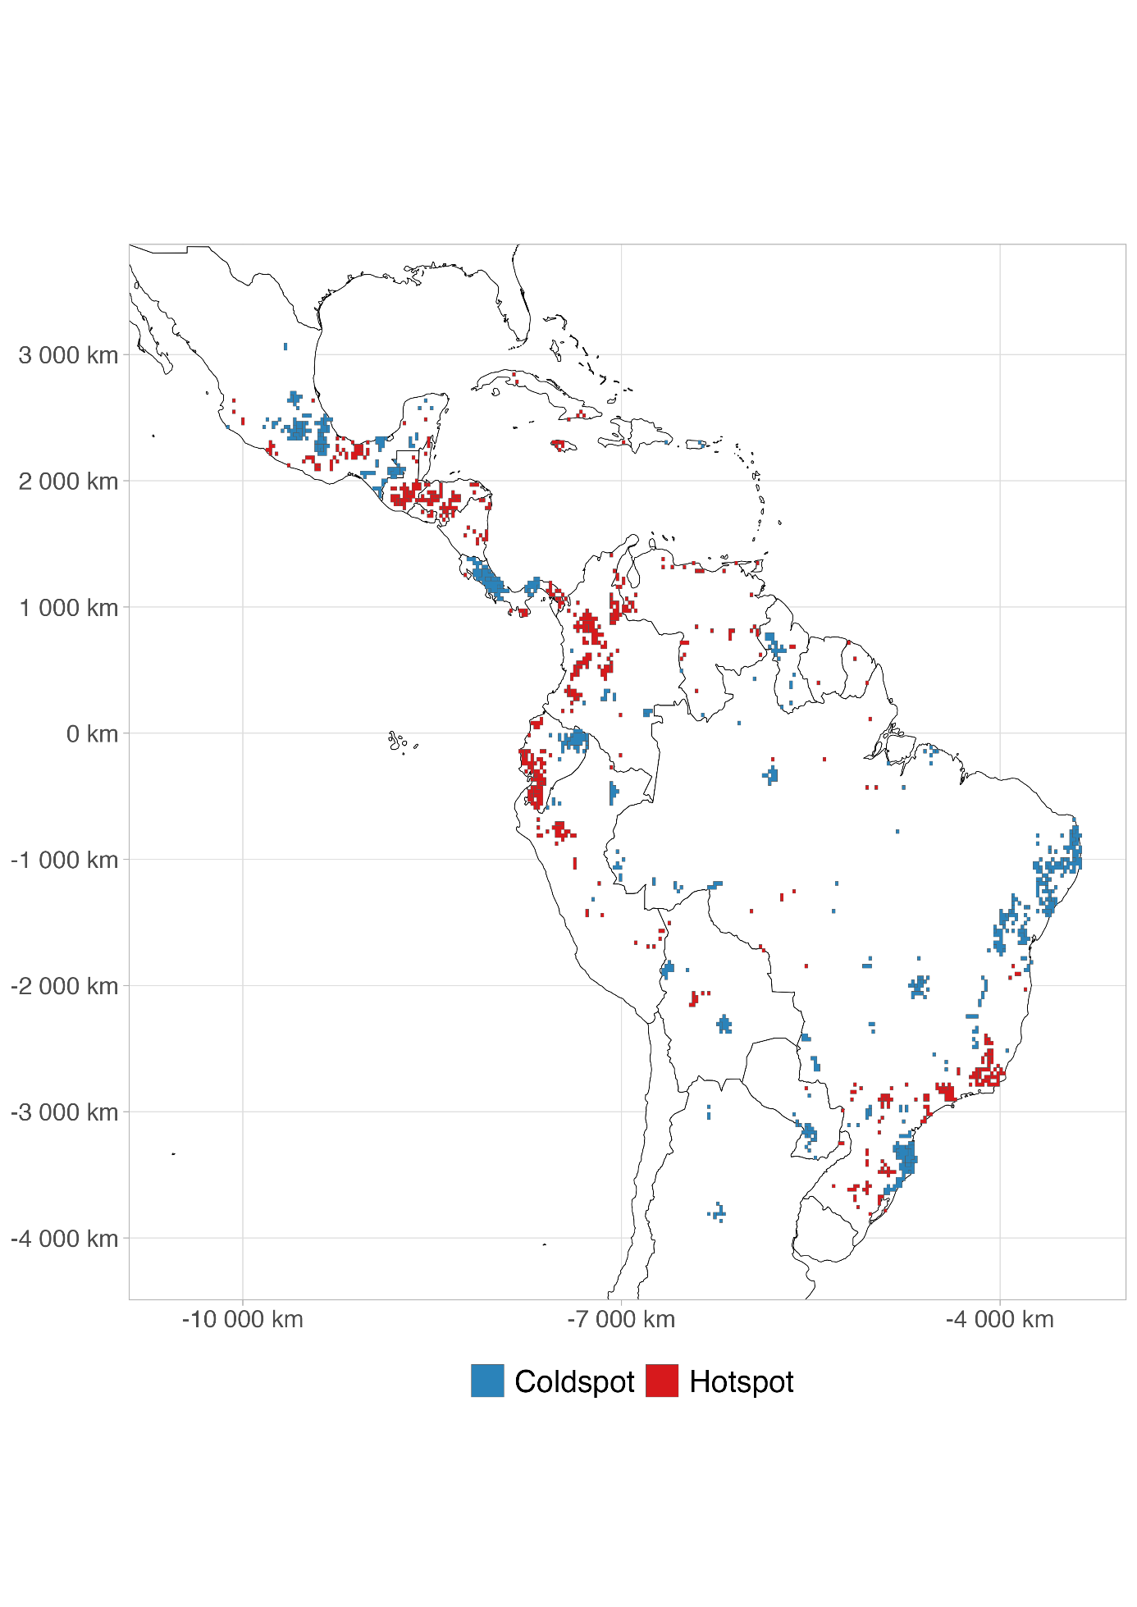

Appendix S9, Figure S9.1. Biogeographic provinces of the Neotropics following Morrone et al. (2022). Provinces are coloured by subregion: Brazilian (green), Chacoan (ochre), Antillean (blue), Mexican Transition Zone (terracotta), and South American Transition Zone (purple). Labels indicate the provinces most frequently referenced in this study. The map uses the Mollweide equal-area projection (central meridian 75°W). Province boundaries were sourced from the shapefile accompanying Morrone et al. (2022).
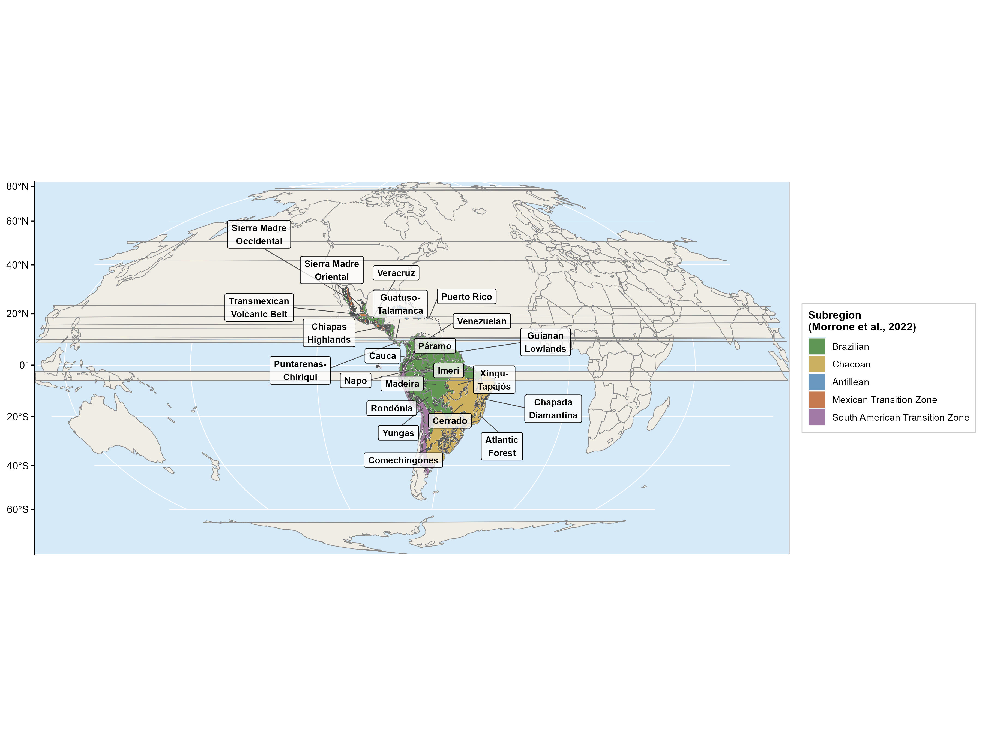

Note on figure numbering: Per Diversity and Distributions author guidelines, figures and tables in the Supporting Information are numbered by Appendix (e.g., Figure S4.1 = first figure in Appendix S4). The nine appendices above are referred to in the main text as "Appendix S1" through "Appendix S9 (Supporting Information)".

