Data Shortfalls on Vascular Epiphytes in the Neotropics
Maria Judith Carmona-Higuita^{1*}, Andreas Mehl¹, Derio Antonio Jiménez-López², Flavio Nunes Ramos³, Michael Kessler⁴, Talitha Mayumi Francisco⁵, Adriano Quaresma⁶, Nayely Martínez-Meléndez⁷, André Luís de Gasper⁸, Ana Maria Benavides⁹, Glenda Mendieta-Leiva^{1†}, Alexander Zizka^{1†}
¹ Department of Biology, Philipps-Universität Marburg, Karl-von-Frisch-Straße 8, 35032, Marburg, Germany.
² Departamento de Conservación de la Biodiversidad, El Colegio de la Frontera Sur, periférico sur s/n, María Auxiliadora, 29290, San Cristóbal de las Casas, México.
³ Instituto de Ciências Naturais, Universidade Federal de Alfenas, Rua Gabriel Monteiro da Silva, 700, 37130-001, Centro, Alfenas, MG, Brasil.
⁴ Systematic and Evolutionary Botany, University of Zurich, Zollikerstrasse 107, 8008 Zurich, Switzerland.
⁵ Instituto Nacional da Mata Atlântica, Avenida José Ruschi, 4, 29650-000, Santa Teresa, ES, Brazil.
⁶ Ecology, Monitoring and Sustainable Use of Wetlands Research Group (MAUA), National
Institute for Amazonian Research (INPA), Manaus, Brazil
⁷ Eizia Asociación Civil. Calle C2 310, Colonia Vida Mejor, 29045, Tuxtla Gutiérrez, Chiapas, México.
⁸ Universidade Regional de Blumenau, Herbário Dr. Roberto Miguel Klein, Rua Antônio da Veiga, 140, Itoupava Seca, Blumenau, Santa Catarina, Brazil
^{9.} Jardin Botanico de Medellin, Medellin, Colombia
† Those authors contributed equally.
* Corresponding author: maria.carmonahiguita@biologie.uni-marburg.de
Abstract

Aim: We quantified the Wallacean shortfall—the gap between known species distributions and available georeferenced occurrence data—for the five most species-rich vascular epiphyte families across the Neotropics. Specifically, we mapped spatial patterns of sampling completeness, examined temporal trends in occurrence record accumulation, and compared shortfall severity among families. Vascular epiphytes represent nearly 10% of global vascular flora and up to 39% of plant species in the Neotropics, yet their distributional knowledge gaps remain poorly characterized.
Location: Neotropics.
Methods: We used over 500,000 georeferenced occurrence records for Araceae, Bromeliaceae, Orchidaceae, Piperaceae, and Polypodiaceae from an existing curated database integrating GBIF and dedicated epiphyte datasets. We evaluated the Wallacean shortfall at 30 arc-minute resolution using three complementary metrics derived from the KnowBR framework: the slope of species accumulation curves, inventory completeness, and the ratio between recorded and estimated species richness.
Results: Of Neotropical grid cells, 51.8% contain at least one georeferenced VE record, but only 1.1% are adequately sampled (accumulation curve slope < 0.1), and 0.05% meet stringent completeness thresholds (completeness ≥ 5%, R/S ratio ≥ 0.5). Wallacean shortfalls are most severe in the Caribbean, parts of Central America, and several South American provinces. Orchidaceae shows the highest proportional sampling deficiency, followed by Araceae and Bromeliaceae. Occurrence record accumulation peaked in the 1980s and has since declined, suggesting that data mobilization efforts have not kept pace with biodiversity documentation needs.
Main conclusions: Vascular epiphytes remain severely under-sampled across the Neotropics, with the most critical gaps concentrated in the Caribbean and parts of Central America. Orchidaceae exhibits the greatest data deficiency among the families studied. The decline in occurrence record accumulation since the 1990s underscores the urgent need for coordinated, targeted data collection efforts in data-poor regions to support informed conservation planning.
Keywords: biodiversity shortfall, epiphytes, inventory completeness, Neotropics, occurrence records, sampling bias, species distributions, Wallacean shortfall

INTRODUCTION
The biased availability of biodiversity data limits the understanding of the ecology and evolution of tropical plants and their conservation (Luján et al., 2023; Ondo et al., 2024). Two types of bias are particularly common: taxonomic bias, which arises from the uneven availability of species descriptions, systematic treatments, and data for different taxonomic groups—with some groups far better represented in global biodiversity databases than others, regardless of their geographic range, and geographic bias, which results from the unequal availability of data across geographic regions (Antonelli et al., 2018; Feeley, 2015; ter Steege et al., 2016). Taxonomic and geographic biases are problematic for two reasons: first, undersampled regions or taxa —diversity dark spots— may harbor undescribed species and hold crucial conservation value (Ondo et al., 2024; Carmona-Higuita et al., 2023; Ramos et al., 2021). Second, systematic biases lead to misinterpretations of species distribution patterns and skew large-scale analyses (Meyer et al., 2015; Oliveira et al., 2016, Araujo et al., 2022). Integrating multiple data sources, such as national biodiversity platforms, herbarium collections, and citizen science records, has been suggested as a key strategy to mitigate these biases (Amano et al., 2016; Araujo et al., 2022; Jiménez-López, Carmona-Higuita, et al., 2023; Stropp et al., 2016). However, since the extent and strength of these biases often remain unknown, it is difficult to design targeted efforts to correct them or account for their effects in analyses. These data deficits can be framed as knowledge shortfalls—measurable gaps in our understanding of biodiversity (Hortal et al., 2015). Hortal et al. (2015) identified seven such shortfalls, spanning gaps in species identities (Linnean shortfall), distributions (Wallacean shortfall), functional traits (Raunkiæran shortfall), evolutionary history (Darwinian shortfall), physiological tolerances (Hutchinsonian shortfall), abundance data (Prestonian shortfall), and ecological interactions (Eltonian shortfall). Of these, the Wallacean shortfall is among the most tractable for quantitative assessment, as it is directly measurable through occurrence databases and inventory completeness metrics, and is thus the primary shortfall addressed in this study.
The Neotropics house nearly 40% of the global plant diversity in 13% of the terrestrial surface area (Raven et al., 2020). A particular contribution to this diversity comes from vascular epiphytes (VE), which contribute up to 39% of species in some regions (Taylor et al., 2021) and as much as 50% of species in some locations (Kelly et al., 2004). VE diversity and distribution have historically served as a model system for studying plant diversity patterns, biogeographical processes, and data collection biases in the Neotropics, providing a tractable model system for exploring processes that shape Neotropical plant diversity broadly—owing to their distinct vertical distribution across forest strata, predictable responses to environmental gradients, and amenability to standardized field inventories (Gentry & Dodson, 1987; Benzing, 1990; Freitas et al., 2016; Taylor et al., 2023). For instance, analyzing VE diversity patterns in the Neotropics has confirmed that biogeographic provinces such as the Páramo, Cauca, and Atlantic Forest exhibit high richness and endemism in plants(Carmona‐Higuita et al., 2025). Beyond their biogeographic importance, epiphytes' sensitivity to climatic gradients, habitat heterogeneity, and disturbances makes them indicators of ecosystem function and environmental change (Cardelus et al., 2006). Their reliance on atmospheric moisture and their often restricted distributions (Kreft et al. 2004), make them particularly sensitive to changes in climate or disturbance regime, useful as early-warning indicators of ecosystem responses to environmental change (Benavides et al., 2005). Indeed, global analyses indicate that approximately half of angiosperm epiphyte species have small range sizes and qualify as rare (Svahnström et al., 2025), a pattern that amplifies both their ecological sensitivity and their underrepresentation in biodiversity databases. Additionally, VE are essential parts of functionally important components of tropical ecosystems, playing an important role in nutrient cycling and providing microhabitats for other organisms (Benzing, 1990; Woods et al., 2015).
Despite recent advancements in data mobilization for VE in the Neotropics (Guzmán-Jacob et al., 2021; Mendieta-Leiva et al., 2020; Quaresma et al., 2022; Ramos et al., 2019, 2024), critical knowledge gaps remain. Vast areas of the Neotropics are poorly documented (Araujo & Ramos, 2021; Carmona‐Higuita et al., 2025; Vargas et al., 2022), yet the extent of these gaps varies among taxa and regions. Understanding and addressing these gaps is crucial to improve the reliability of biodiversity assessments and make better-informed decisions about conservation strategies, ensuring that efforts are focused on areas and species most at risk (Hortal et al., 2015; Mendieta-Leiva & Zotz, 2015). While previous studies have assessed inventory completeness of Neotropical plants at regional scales (Araujo et al., 2022; Ramírez-Barahona et al., 2023) or focused on endemism patterns (Carmona-Higuita et al., 2025), a continent-wide quantification of Wallacean shortfalls for VE across biogeographic provinces and families remains lacking. In this study, we quantify the geographic sampling incompleteness of VE occurrence data—specifically the Wallacean shortfall (Hortal et al., 2015). Specifically, we:
(1) quantify and map the spatial extent and geographic patterns of the Wallacean shortfall for the five most species-rich VE families across the Neotropics, at both grid-cell and biogeographic-province scales.
(2) characterize temporal trends in occurrence record accumulation across regions and families to evaluate whether data gaps are being addressed over time.
(3) compare shortfall patterns among the five VE families to identify which groups present the greatest data deficiencies and explore potential correlates of differential sampling completeness.

METHODS

1. Dataset
As a basis for all analyses, we used an existing database including more than 500,000 geo-referenced occurrence records of species of the five most species-rich families of vascular epiphytes (VE): Araceae, Bromeliaceae, Orchidaceae, Piperaceae, and Polypodiaceae (Carmona‐Higuita et al., 2023). This database, to our knowledge, is the most complete representation of VE distribution to date and integrates data from the Global biodiversity Information Facility (www.gbif.org), and a dedicated non-public epiphyte database (Epiphyte Inventory Group EPIG-DB v1 database; Mendieta-Leiva et al., 2020), enriched with data from the literature on Atlantic epiphytes (Ramos et al., 2019), Amazonian epiphytes (Araujo et al., 2022), South American Dry Diagonal Forest Epiphytes database (Ramos et al., 2024), Epiphytes of the Sierra Madre of Chiapas (Jiménez-López, Carmona-Higuita, et al., 2023), Usumacinta River basin flora (Jiménez-López, Gallardo-Cruz, et al., 2023), Biovera-Epi (Guzmán-Jacob et al., 2021), as well as unpublished data of Neotropical Araceae (Alejandro Zuluaga, unpublished data), Polypodiaceae of America (Michael Kessler, unpublished data), Marie Selby Botanical Gardens herbarium (Bruce Holst, unpublished data) and records in 700 papers and theses (see complete list of 700 references in TS3.2, Carmona-Higuita et al., 2023). Geographic and taxonomic errors were already addressed in this dataset, and all data were cropped to the Neotropics (Morrone et al., 2022). Key quality-control steps included coordinate validation, removal of records with geographic uncertainty exceeding cell size, and exclusion of cultivated or naturalized occurrences; the complete filtering protocol is detailed in Carmona-Higuita et al. (2023). To enhance taxonomic consistency, we resolved species names to a curated taxonomic backbone (Epiphyte Inventory Group, 2025), which includes the worldwide epiphyte list, EpiList v.1.0 (Zotz et al., 2021), and additional data from EpIG-DB v.1.0 (Mendieta-Leiva et al., 2020). We also eliminated within-cell spatial duplicate entries: records of the same species occurring at identical coordinates were consolidated to a single record per unique coordinate pair regardless of collection year, as KnowBR operates on species-by-occurrence matrices at the grid cell level. Records from the same species at different coordinates within the same cell, including those from different collection years, were retained as distinct sampling events, consistent with standard KnowBR protocol (Lobo et al., 2018).

2. Biodiversity shortfalls
To evaluate biodiversity shortfalls, we focused on the Wallacean shortfall at the level of grid cells at 30 arc-minute resolution (ca. 55 km at the equator) — a scale standard in Neotropical macroecological analyses (Ramírez-Barahona et al., 2023) that balances spatial detail with data availability, ensuring sufficient records per cell for KnowBR estimation (see also Appendix S4 for 15 arc-minute sensitivity results). We estimated the degree of completeness of each grid cell using the KnowBR package (Lobo et al. 2018; Guisande and Lobo 2019), which examines species accumulation by adding occurrence records. These accumulation curves were computed simultaneously for all the cells in the Neotropics, applying the exact analytical estimator proposed by Ugland et al. (2003). This estimator provides an exact solution for the expected species richness as a function of the number of samples, requiring no permutation tests or randomisation; each grid cell's accumulation curve is thus fully determined by the observed species-by-record matrix. KnowBR estimates three parameters: the final slope of the accumulation curve, the completeness, and the ratio between the number of database records and the number of species. Completeness values (i.e. the percentage of species that have been documented over the total predicted) were calculated after adjusting the accumulation curves toa rational model (Lobo et al. 2018).
To assess the Wallacean shortfall, we used three metrics derived from KnowBR: the slope of the species accumulation curve, the completeness of each cell inventory, and the ratio between the number of database records and the number of species (R/S ratio; Lobo et al., 2018). The slope reflects the current rate of species discovery; completeness estimates the proportion of the predicted species pool already documented; and the R/S ratio measures sampling intensity relative to species diversity (Ugland et al., 2003). Grid cells were classified as well-sampled (slope < 0.02), fairly sampled (0.02 ≤ slope ≤ 0.3), or poorly sampled (slope > 0.3). These slope thresholds follow the benchmarks established by Lobo et al. (2018), who validated them against inventories of well-studied European taxa (birds and butterflies): a slope < 0.02 indicates the accumulation curve has effectively reached an asymptote—meaning that additional records are unlikely to yield new species in that cell—while slopes > 0.3 indicate that the inventory is far from complete. Intermediate values (0.02–0.3) represent grids where inventorying effort is ongoing but species discovery has decelerated.
Cells were additionally classified using completeness and R/S ratio: well-sampled (completeness &gt; 90% and R/S ratio &gt; 15), poorly sampled (completeness &lt; 50% and R/S ratio &lt; 3), and fairly sampled otherwise. Although the three KnowBR metrics are theoretically distinct, they produced highly concordant cell rankings across all five families studied (Spearman ρ = 0.86–0.99 for all pairwise combinations; Supplementary Table S1), confirming that they capture the same underlying signal of distributional knowledge gaps. We therefore treat the three metrics as convergent evidence of the Wallacean shortfall rather than independent measures.
All analyses were performed using a Lambert azimuthal equal-area projection, while visualization was reprojected to Behrman equal-area projection to avoid distortion far from the tropics. We removed poorly sampled grid cells containing less than 10 records overall for all analyses. To assess the robustness of this threshold, we repeated the completeness categorisation across thresholds of 5 to 30 records per cell; the spatial rankings of cells were identical across all tested thresholds (Spearman ρ = 1.00), and the threshold of n ≥ 10 retained 94.3% of cells with KnowBR estimators (n = 2,389 cells; Appendix S2, Table S2.1) and covered the spatial extent of sampled regions across the Neotropics (Appendix S4, Fig. S4.1).

3. Spatial and family patterns of biodiversity shortfalls
We first examined the spatial distribution of occurrence records to identify potential biases in data availability across biogeographic provinces (Morrone et al., 2022; Figure 4), following the approach of Oliveira et al. (2016). We quantified record density as the number of georeferenced occurrence records per 10,000 km² within each biogeographic province (with province areas derived from the spatial layer of Morrone et al., 2022) and assessed whether data collection was skewed toward specific areas, for instance related to greater accessibility or higher research investment. We assessed spatial patterns of shortfalls by examining how the Wallacean shortfall varies across different biogeographic provinces. We also described which families were most affected by the Wallacean shortfall.

4. Temporal trends in record accumulation
We analysed temporal trends in occurrence record accumulation using all records in the occurrence database. Records were aggregated by decade based on the year of collection (1880–2020), and cumulative accumulation curves were computed for the total dataset and separately for each of the five focal VE families (Araceae, Bromeliaceae, Orchidaceae, Piperaceae, and Polypodiaceae). Decades with fewer than 10 records per family were excluded from family-level analyses. This approach allowed us to assess whether data gaps have been decreasing over time and to identify periods of intensified or reduced sampling effort across regions and taxonomic groups (see Appendix S10 in Supporting Information).

5. Spatial clustering of sampling effort (Appendix S8)
Prior to computing the Gi* statistic, completeness values were transformed to incompleteness (100 − completeness) and slope values were inverted (1 − slope), such that high Gi* values identify spatial clusters of greatest sampling deficiency. Spatial clustering of inventory completeness was assessed using the Getis-Ord Gi* statistic (Getis & Ord, 1992; Ramirez-Barahona et al., 2023), implemented in the spdep package (Bivand & Wong, 2018). Full methodology and results are presented in Appendix S5 (Supporting Information).

While our analyses characterize patterns at the biogeographic province and continental scale, finer-scale resolution (15 arc-minutes, ca. 27 km at the equator) is more appropriate for country-level and priority-area conservation decisions (Antonelli et al., 2023). We used 30 arc-minutes as the primary resolution because it maximises the number of grid cells with sufficient occurrence records for reliable KnowBR estimation across the entire Neotropics; at 15 arc-minutes, the proportion of cells with ≥10 records drops substantially, reducing spatial coverage. The 15 arc-minute analysis is therefore presented as a sensitivity check confirming that spatial patterns are consistent across scales. Therefore, we also present the results at this finer resolution for more detailed insights (see Appendix S1, Supporting Information).
We performed all analyses in R v.4.3.1 (R. Core Team, 2024), using the tidyverse package (Wickham et al., 2019) for data wrangling, sf (Pebesma, 2018), and raster (Hijmans, 2021) for spatial analyses, and ggplot2 for visualizations (Wickham, 2009).

RESULTS

1. Spatial patterns of biodiversity shortfalls
We found that 51.8% of the Neotropical grid cells (n = 8,520) contain georeferenced information on VE occurrence, and 40.6% of VE species in the dataset have more than 10 records. The number of records per grid cell averaged 131 (sd = 725), with a median of 14, while each cell contained an average of 125 species (sd = 747), with a median of 46 species. Both distributions were strongly right-skewed (Figure S9.1), supporting the use of median rather than mean as central tendency measure. Records per grid cell and species richness were positively correlated (Pearson r = 0.70, p < 0.001; Spearman ρ = 0.95), indicating a strong influence of sampling effort on observed species richness (Oliveira et al., 2017). Provinces with the highest median number of occurrences per grid cell were Guatuso-Talamanca (958), Cauca (481), Atlantic Forest (362), and Páramo (233) provinces. Conversely, provinces with the lowest median number of occurrences per grid cell included the Cuyan High Andean (10), Bahama (14), and Desert (14) provinces..
The areas with the highest species numbers generally overlapped with regions containing more occurrence records (Figure 1), yet high species richness did not always correlate with high data availability (Table S3). Note that provinces with the highest species richness and record counts—such as Guatuso-Talamanca and Cauca—may simultaneously show high proportions of poorly sampled cells because the shortfall is evaluated relative to the estimated species pool: species-rich provinces require proportionally more records to achieve comparable coverage. Based on the slope-based proxy, 15.4% of grid cells were well-sampled, 76.2% were fairly sampled, and 8.3% were poorly sampled (Figure 2). The greatest sampling deficiencies were found in Mexico, with the Sierra Madre Oriental (26.7%) and Transmexican Volcanic Belt (33.1%) provinces exhibiting moderate shortfalls; as well as in the Caribbean and Central America, with Puerto Rico (56.5%), Guatuso-Talamanca (42.9%) and Puntarenas-Chiriqui (37.5%) provinces showing the most severe sampling deficiencies. In South America, especially in Brazil, provinces such as Comechingones (50.0%), Chapada Diamantina (48.4%), Southern Espinhaco (25.8%), and Caatinga (22.9%) showed lower sampling deficiencies in the Cauca province, located at the southern border with Colombia (22.8%) and in the Galápagos Islands (33.3%).
Using the completeness and R/S ratio as proxies, the Wallacean shortfall was similarly extensive: 14% of grid cells were poorly sampled and only 0.05% were well-sampled (Figures 3 and 4). The provinces with the greatest Wallacean shortfall—those with the highest proportion of poorly sampled cells—were Venezuelan, Puntarenas-Chiriqui, Cauca, Western Ecuador, and Lesser Antilles (each with >20% of cells classified as poorly sampled). By contrast, Southern Espinhaco, Cerrado, Transmexican Volcanic Belt, Sierra Madre Oriental, and Caatinga provinces showed few poorly sampled cells (<4%). Provinces with the fewest records and lowest estimated species richness—Chapada Diamantina, Puerto Rico, Comechingones, Galápagos Islands, and Atacama—showed 0% poorly sampled cells, reflecting that sparse sampling can appear adequate when the estimated species pool is small.

2. Comparison of biodiversity shortfalls among families
Under the slope-based proxy, Orchidaceae had the highest proportion of well-sampled cells (19.5%), consistent with its status as the most species-rich VE family (~140 species per grid cell on average). In contrast, Bromeliaceae (16.7%) and Araceae (16.6%) showed the highest proportions of poorly sampled cells. Across all families, the majority of grid cells were classified as fairly sampled (76.6–84%; Figure 2).
Under the completeness and R/S ratio proxy (Figure 3), Orchidaceae showed the highest proportion of poorly sampled cells (17.6%), while Araceae had the lowest (2.4%). Well-sampled cells were rare across all families (<0.15%), and the fairly sampled category accounted for >80% of cells in each family. These values differ from the slope-based results (Figure 2) because the two proxies capture different dimensions of sampling sufficiency: the slope reflects the ongoing rate of species discovery relative to effort, while completeness and R/S ratio measure the absolute fraction of the estimated species pool that has been documented. Under these stricter criteria, Orchidaceae—despite having the most occurrence records—is most poorly sampled because its high species richness demands proportionally more records to approach full coverage. The categories (poorly, fairly, well-sampled) are mutually exclusive and sum to 100% for each proxy independently; the low proportion of well-sampled cells (<0.15%) is therefore not contradicted by the 2.4% poorly sampled proportion for Araceae, as the remaining >97% are classified as fairly sampled.

Spatial clustering of sampling effort (Gi* statistic) is presented in Appendix S5 (Supporting Information).
The spatial distribution of inventory completeness across the Neotropics, assessed using the Getis-Ord Gi* statistic (Getis & Ord, 1992; Ramírez-Barahona et al., 2023), is presented in full in Appendix S8 (Supporting Information, Figure S8.1).

DISCUSSION
Together, these findings reveal that the Wallacean shortfall for Neotropical vascular epiphytes is both extensive and geographically structured. The majority of grid cells either lack occurrence records entirely or contain records insufficient for reliable completeness estimation, placing VE among the most poorly documented major plant groups in global biodiversity databases. Critically, data deficits are not randomly distributed: they are most severe in provinces where high endemism, ongoing habitat loss, and logistical barriers to sampling converge—including Mexico's volcanic highlands, the Caribbean archipelago, the Colombian Andes, and parts of eastern Brazil. This spatial structuring of knowledge gaps has direct implications for biodiversity modelling, red-list assessments, and conservation prioritization, all of which depend on occurrence data that, for Neotropical VE, remain too sparse and too spatially biased to support reliable inference across most of the region.

Regions with the highest occurrence of epiphytes, such as the Mexican Transition Zone, Cauca, Paramo, and Atlantic Forest provinces (Figure 4) together with the Mesoamerican Dominion, overlap with areas historically prioritized for botanical surveys. These regions have been better sampled and have higher species richness, as noted by previous studies (Araujo et al., 2022; Araujo & Ramos, 2021; Ramírez‐Barahona et al., 2023). This pattern highlights how historical research priorities have shaped VE distributional knowledge: the Mexican Transition Zone and Mesoamerica were intensively surveyed during 19th- and 20th-century botanical expeditions linked to major herbaria (e.g., Kew, Smithsonian, Missouri Botanical Garden), while the Atlantic Forest and Paramo benefited from longstanding research networks and their status as globally recognised biodiversity hotspots (Myers et al., 2000). Accessibility also played a key role—provinces with road networks, universities, and biological stations accumulated records at higher rates than remote or politically restricted regions, a pattern documented for plants broadly (Gentry & Dodson, 1987; Meyer et al., 2016; Zizka et al., 2021). While tree and shrub inventories tend to be biased toward areas with greater accessibility, such as near roads, research stations, and protected areas (Feeley & Silman, 2011; Tobler et al., 2007, Zizka et al., 2021), epiphyte data are further constrained by their canopy-dependent habit, and their three-dimensional distribution in the tree (Zotz, 2016), which makes their collection inherently more challenging than terrestrial species. Additionally, many epiphyte species are inherently rare, with restricted geographic distributions (Svahnström et al., 2025), so even intensive surveys may systematically fail to detect them within standard sampling protocols.
Although most grid cells had moderate to good sampling completeness, these were often the ones with fewer records. This is likely due to the overall scarcity of data. This apparent paradox—that cells with fewer records can show moderate completeness—reflects how KnowBR estimates completeness relative to the cell-specific estimated species pool, not in absolute terms: cells in low-diversity arid or montane regions can achieve high completeness with few records if their estimated pool is correspondingly small. Data gaps persist particularly in regions where multiple limiting factors compound one another: (i) fragmented habitats and deforestation render prior records obsolete and discourage new expeditions (Stropp et al., 2020); (ii) limited transport infrastructure makes localities logistically inaccessible (Roy et al., 2017; Sobral-Souza et al., 2021); (iii) few trained local specialists are available in many tropical countries (Cheek et al., 2020); and (iv) funding asymmetries concentrate research effort near institutions in wealthier regions (de Lima et al., 2022). Such provinces include the Xingu-Tapajós and Cerrado in northwestern Brazil, the Savanna province (Los Llanos), and the Southern Neotropics. where fragmented habitats and limited infrastructure impede data collection (Roy et al., 2017; Sobral-Souza et al., 2021), such as the Xingu-Tapajós and Cerrado in northwestern Brazil, the Savanna province (Los Llanos, Venezuela and Colombia), and the Southern Neotropics (Atacama, Cuyan, and Monte). Similarly, the ruggedness of some regions limits sampling, as in the Madeira, Xingu, and Tapajós basins within Amazonia, which have been pointed out as difficult for data collection before (Oliveira et al., 2016; Quaresma et al., 2022; Stropp et al., 2016). This area, part of Brazil's "Arc of Deforestation," has experienced extensive deforestation, rendering prior records obsolete and exacerbating knowledge gaps (Escribano et al., 2016). In addition, the impact of deforestation has discouraged further botanical expeditions (Stropp et al., 2020) and contributed to the loss of species. Similarly, regions such as the Cerrado, Caatinga, and Imeri exhibit both types of distributional knowledge gaps, underscoring the logistical challenges and uneven resource allocation that have been documented in previous studies on other plant groups (Hopkins, 2019). This lack of comprehensive data not only affects biodiversity modelling but also undermines conservation efforts, as regions with high potential richness but low documentation are less likely to be prioritized for protection (Feeley, 2015).
Among the focal families, sampling deficiency under the slope-based proxy was greatest for Araceae and Bromeliaceae, while under the completeness and R/S ratio proxy, Orchidaceae showed the highest proportion of poorly sampled cells. These contrasting patterns reflect different sampling dynamics among families. Araceae and Bromeliaceae deficits likely reflect the concentration of their diversity in habitats with limited field access—many Araceae occur in flooded or riparian environments difficult to survey systematically, while Bromeliaceae exhibit extensive habitat specialization across altitudinal gradients requiring multi-elevation campaigns (Benzing, 2000; Zotz, 2016). The Orchidaceae pattern—that the family with the most occurrence records in absolute terms shows the worst completeness—arises from its extraordinary species richness: with an estimated 26,000+ species globally, Orchidaceae harbours more species than any other angiosperm family (Chase et al., 2015), many with highly restricted ranges and low local abundance that make them systematically harder to detect at the grid-cell scale (Svahnström et al., 2025; Vitt et al., 2023). Furthermore, Orchidaceae nomenclature is particularly unstable due to frequent synonymizations, new species descriptions, and reinterpretations of floral morphology (Cheek et al., 2020; Freudenstein & Chase, 2015), meaning that existing records may be assigned to names that are later split, lumped, or invalidated—reducing their effective information content. Across all families, epiphytes are systematically under-collected relative to terrestrial life forms because they require canopy access techniques absent from standard vegetation surveys and because morphological similarity among congeners requires specialist confirmation for accurate identification (Gentry & Dodson, 1987; Mendieta-Leiva & Zotz, 2015).
To contextualise the magnitude of epiphyte data deficits, our results can be compared with recent assessments of tree inventory completeness, which represent a better-sampled plant growth form. Chanachai et al. (2024) assessed global tree species inventory completeness using the Chao1 estimator (C = observed/estimated species richness) for 100 × 100 km sampling units, finding that globally only 18% of sampling units are well-surveyed (C ≥ 0.80), with the lowest completeness concentrated in South America, central Africa and Southeast Asia, and the highest number of unrecorded tree species estimated for tropical South America. Despite methodological differences in spatial resolution and estimators that preclude direct quantitative comparison, the pattern is consistent with our findings: the Neotropics represent one of the most severely under-documented regions globally even for trees, and our results indicate that vascular epiphytes face even greater data deficits — with only 1.1% of 30 arc-minute cells well-sampled using the slope-based proxy, compared to 18% of 100 km cells for trees globally. This gap is consistent with the known under-representation of epiphytes in botanical collections: epiphytic plants are systematically less collected than trees because they require specialised techniques, are absent from standard vegetation plots, and remain taxonomically challenging across most families (Gentry & Dodson, 1987; Mendieta-Leiva et al., 2020; Ramos et al., 2019, 2024). These converging lines of evidence underscore the urgency of targeted epiphyte surveys across tropical South America, where high species diversity, low sampling completeness, and accelerating habitat loss create conditions of both high discovery potential and diminishing sampling opportunity (Chanachai et al., 2024). These shortfalls are further compounded by the biology of epiphytes themselves: approximately half of angiosperm epiphyte species globally have small range sizes and are classified as rare (Svahnström et al., 2025), meaning that data incompleteness reflects not only sampling effort but also the inherent detectability constraints of the organisms. Global conservation prioritization frameworks for epiphytes, such as that developed for Orchidaceae (Vitt et al., 2023), may therefore be biased toward better-documented, widespread species — underscoring the need for targeted surveys before reliable conservation priorities can be established.
Epiphytes present specific data-mobilization challenges that distinguish them from other plant life forms. Because they are absent from standard ground-based vegetation plots and require canopy access, they are excluded from most large-scale survey programs—including RAINFOR, ATDN, and TEAM network plots (Anderson-Teixeira et al., 2015; Phillips et al., 2009)—meaning that even the most comprehensive tropical forest monitoring programs generate little to no epiphyte occurrence data. Life-form-focused survey programs that target epiphytes specifically across altitudinal and forest-type gradients have been shown to yield substantially more records per unit effort than general botanical surveys (Mendieta-Leiva et al., 2020; Ramos et al., 2019, 2024), and represent the most tractable path toward closing the data gaps identified here. Complementarily, digitization and georeferencing of herbarium specimens—particularly from regional institutions in tropical countries—has been shown to be more cost-effective than new fieldwork for generating records of rare and restricted-range species (Heberling et al., 2021; Vargas et al., 2024). Investment in taxonomic capacity, including training local specialists and expanding phylogenetically diverse taxonomic backbones, is a prerequisite for translating raw occurrence data into reliable distributional knowledge (Delves et al., 2024; Nicolson et al., 2023).
The Gi* analysis revealed that well-sampled cells cluster in southern Mexico and Central America, parts of Amazonia, and the Atlantic Forest of Brazil. These clusters emerge from the geography of botanical infrastructure: well-sampled zones correspond closely to the catchment areas of major herbaria, research universities, and biological stations with longstanding epiphyte programs (e.g., Instituto de Biología UNAM; INPA in Amazonia; research networks associated with the Brazilian Atlantic Forest PELD sites). This 'hub-and-spoke' pattern of sampling effort—in which records accumulate near institutions and decay with distance from them—has been documented for plants globally (Daru et al., 2017; Stropp et al., 2016) and is particularly pronounced for specialist-dependent groups like epiphytes. The well-sampled clusters therefore reflect historical accumulation of institutional capacity rather than areas of greatest biodiversity importance—a critical distinction for conservation planning (Feeley & Silman, 2011). The true priorities for future sampling are the unsampled white zones in Figures 1 and 2, representing areas invisible to current distribution models and conservation assessments. Even well-sampled provinces such as the Atlantic Forest contain many narrow-ranged epiphytes that remain under-represented in databases (Leão et al., 2023), illustrating that grid-cell-level completeness does not guarantee adequate representation of rare species.
Several limitations of this study warrant acknowledgement. First, our analyses rely on data accessed primarily through large online repositories (GBIF and EpIG-DB), which are known to contain georeferencing errors and taxonomic inconsistencies (Maldonado et al., 2015; Zizka et al., 2020); we addressed these through the taxonomic backbone and duplicate removal described in the Methods, but residual error cannot be excluded. Second, the 30 arc-minute resolution (~55 km at equator) represents a necessary trade-off between data availability and spatial detail; finer-scale analyses, while desirable, would leave most grid cells with insufficient records for KnowBR estimation. Third, our focus on the five most species-rich families, while providing broad taxonomic coverage, excludes other epiphyte lineages (e.g., many fern families, Cactaceae, Gesneriaceae) that may have distinct sampling patterns. Finally, our analyses quantify the Wallacean shortfall specifically; the Linnean shortfall — unknown species yet to be described — remains unaddressed and may be particularly severe in poorly sampled regions of Amazonia and the Andes (Cheek et al., 2020).
A limitation of the data is its incomplete representation of the true biodiversity, as only about 25% of the records from Carmona-Higuita et al. (2023) passed the cleaning process, with many lacking geographic coordinates, which limits their use in spatial analyses. Moreover, 40% of the data comes from GBIF, a source known to contain inaccuracies (Zizka et al., 2020) that may result in overestimated species richness (Maldonado et al., 2015). While we made efforts to access as much unpublished data and grey literature as possible, digital accessibility remains a critical barrier, with over two-fifths of botanical resources remaining digitally undiscoverable (Nicolson et al., 2023), often due to structural inequalities in scientific research (de Lima et al., 2022). Additionally, explorations in undersampled regions are increasingly difficult due to high deforestation rates, which outpace the description of new species (Gasper et al., 2016). This situation underscores the need for data mobilization from regional and smaller herbaria, which often contain locally collected specimens absent from larger international collections (Delves et al., 2024; Haque et al., 2020). Investment in the curation and mobilization of herbarium specimens has proven more efficient than fieldwork in generating new data (Vargas et al., 2024). Enhancing the role of regional herbaria, botanical gardens, and local communities in conservation is a promising approach (Perez et al., 2019; Vitt et al., 2023). Collaborative initiatives, such as the Rede Brasileira de Herbários and the Colombian National Herbarium, have demonstrated how decentralized collections, when integrated into global databases like GBIF, can significantly expand our understanding of biodiversity (Heberling et al., 2021; Soberón & Peterson, 2009).
The Wallacean shortfall documented here has practical consequences that extend beyond database completeness. Species distribution models, range size estimates, and extinction risk assessments for Neotropical epiphytes depend on occurrence data quality; when records are sparse and spatially biased, these applications systematically underestimate the ranges of rare species and overestimate those of common ones (Feeley, 2015; Maldonado et al., 2015). Conservation prioritization under global frameworks—including the Kunming-Montreal Global Biodiversity Framework's 30×30 target—will inherit these biases, potentially undervaluing high-shortfall provinces such as the Lesser Antilles and the Colombian Andes, where endemism is high but documentation is sparse (Myers et al., 2000; Vitt et al., 2023). Addressing these shortfalls will require coordinated action: targeted field surveys in the high-shortfall provinces identified here, digitization of regional herbarium specimens (Heberling et al., 2021; Vargas et al., 2024), development of epiphyte-specific sampling standards for integration into GBIF and similar platforms, and sustained investment in taxonomic training and regional capacity (Cheek et al., 2020; Nicolson et al., 2023). Given that approximately half of angiosperm epiphyte species globally are rare, with small range sizes (Svahnström et al., 2025), and that conservation prioritization for this group is nascent (Vitt et al., 2023), closing these data gaps is not merely a scientific priority—it is a prerequisite for effective conservation action before accelerating habitat loss permanently forecloses the opportunity for survey-based discovery (Gasper et al., 2016).

Figures
Figure 1. Geographic distribution of epiphyte species records for the five most diverse epiphyte families in the Neotropics at a grid cell resolution of ≈ 55 km at the equator. The bivariate map shows species richness (x-axis) and number of occurrence records (y-axis) per grid cell, with each axis divided into four equal-frequency classes for visualization. Data were compiled from Carmona-Higuita et al., 2023 and mapped using the Behrmann projection. White cells indicate areas with no recorded occurrences. Areas with high record density generally coincide with high species richness, particularly in the Andes, Central America, and the Atlantic Forest, while some regions (e.g., the Amazon Basin) show relatively high species numbers with fewer records, suggesting potential under-sampling.
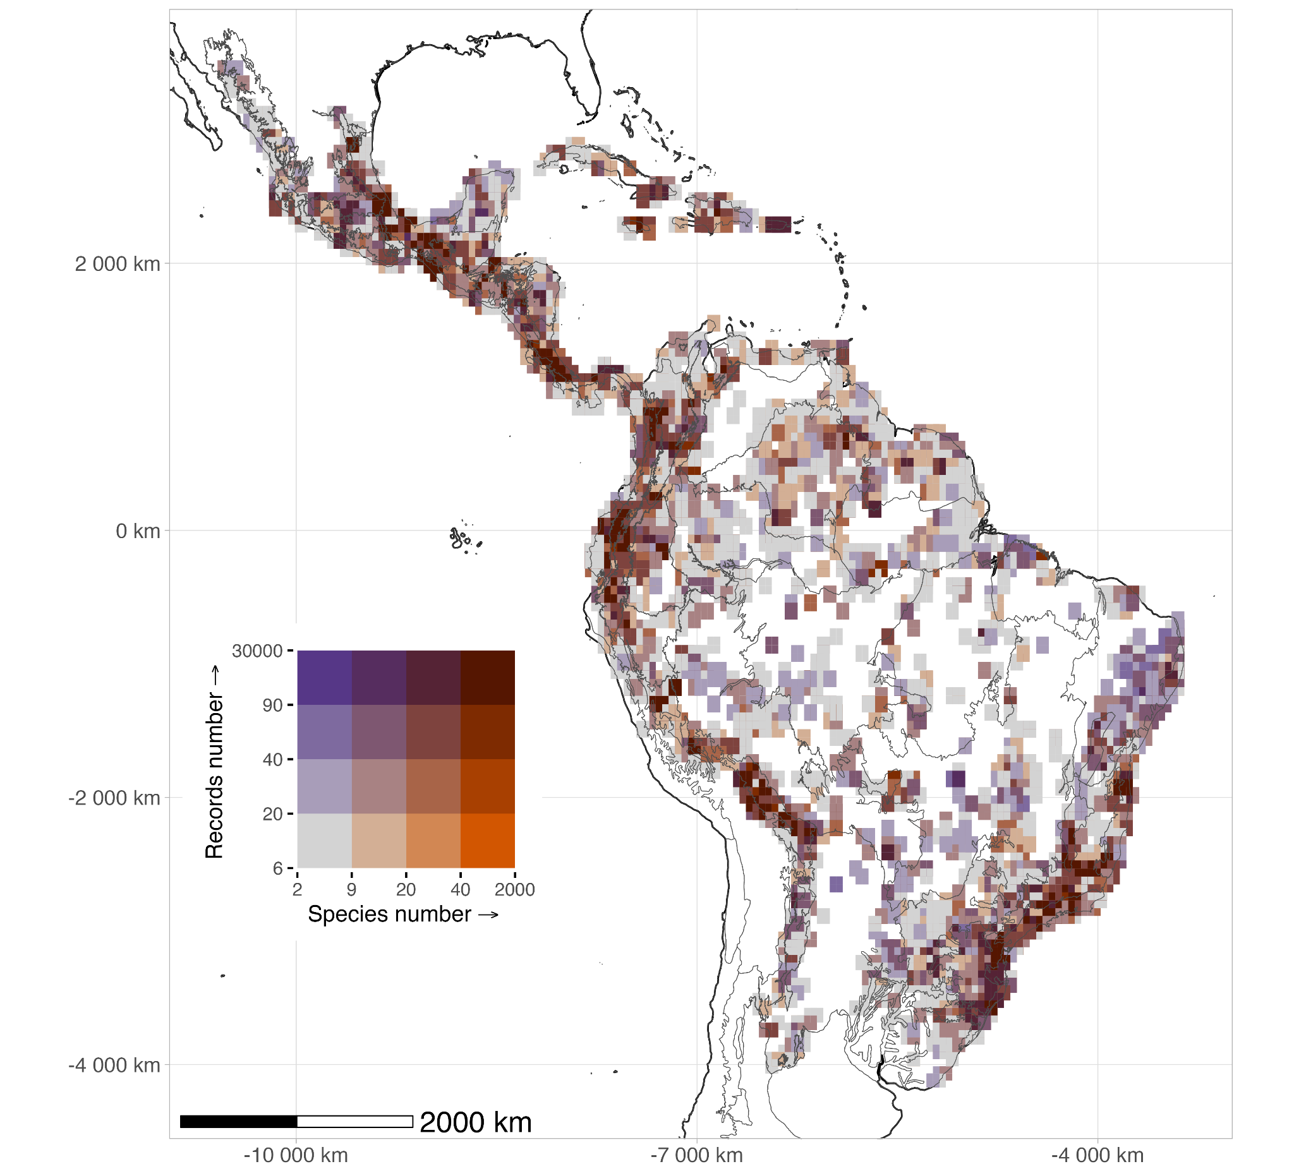
Figure 2. Sampling deficiency (slope-based proxy) for the five most diverse epiphyte families in the Neotropics. The maps show the geographic distribution of sampling deficiency, calculated using the slope estimated with KnowBR, at a grid cell resolution of ≈ 55 km at the equator. Colors represent the degree of sampling completeness, categorized using three classes: well-sampled (red, slope < 0.02), fairly-sampled (light green, 0.02 ≤ slope ≤ 0.3), and poorly-sampled (blue, slope > 0.3). Grid cell borders have been removed for visual clarity. Slope was mapped using the Behrmann projection, and smaller islands were excluded for visualization purposes. The total map includes all five families (Araceae, Bromeliaceae, Orchidaceae, Piperaceae, and Polypodiaceae), while individual panels show their specific sampling patterns. Well-sampled regions were rare, located mainly in Central America (Mexico: particularly in the states of Veracruz and Chiapas), Costa Rica, some Caribbean islands, and the Brazilian Atlantic region; whereas most areas in the Neotropics remain poorly sampled, suggesting important gaps in distributional knowledge.
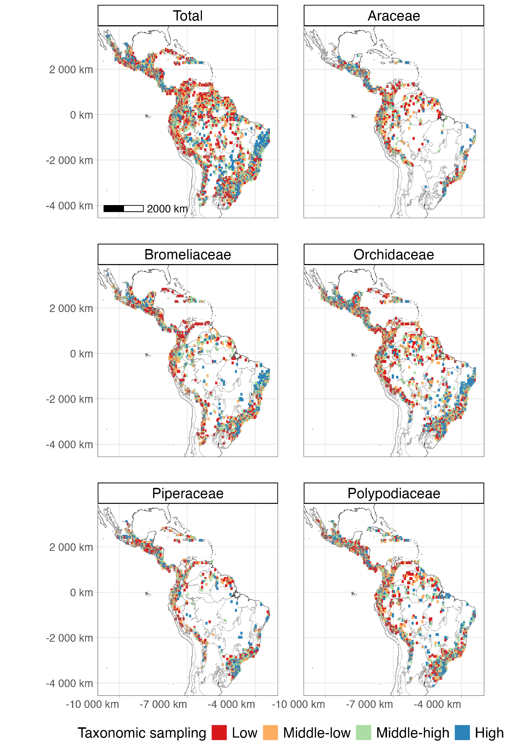
Figure 3. Wallacean shortfalls (completeness and R/S ratio proxy) for the five most diverse epiphyte families in the Neotropics. The maps display the geographic distribution of Wallacean shortfalls for epiphytes, assessed using KnowBR at a grid cell resolution of ≈ 55 km at the equator. Colors indicate the level of distributional sampling: well-sampled (red, slope < 0.02, completeness > 90%, R/S ratio > 15), fairly sampled (light green, intermediate values), and poorly sampled (blue, slope > 0.3, completeness < 50%, R/S ratio < 3). Grid cell borders have been removed for visual clarity. The total map represents all families combined, while individual panels show patterns for Araceae, Bromeliaceae, Orchidaceae, Piperaceae, and Polypodiaceae. The Behrmann projection was used, and smaller islands were excluded for visualization. The results highlight that most areas in the Neotropics remain poorly sampled.
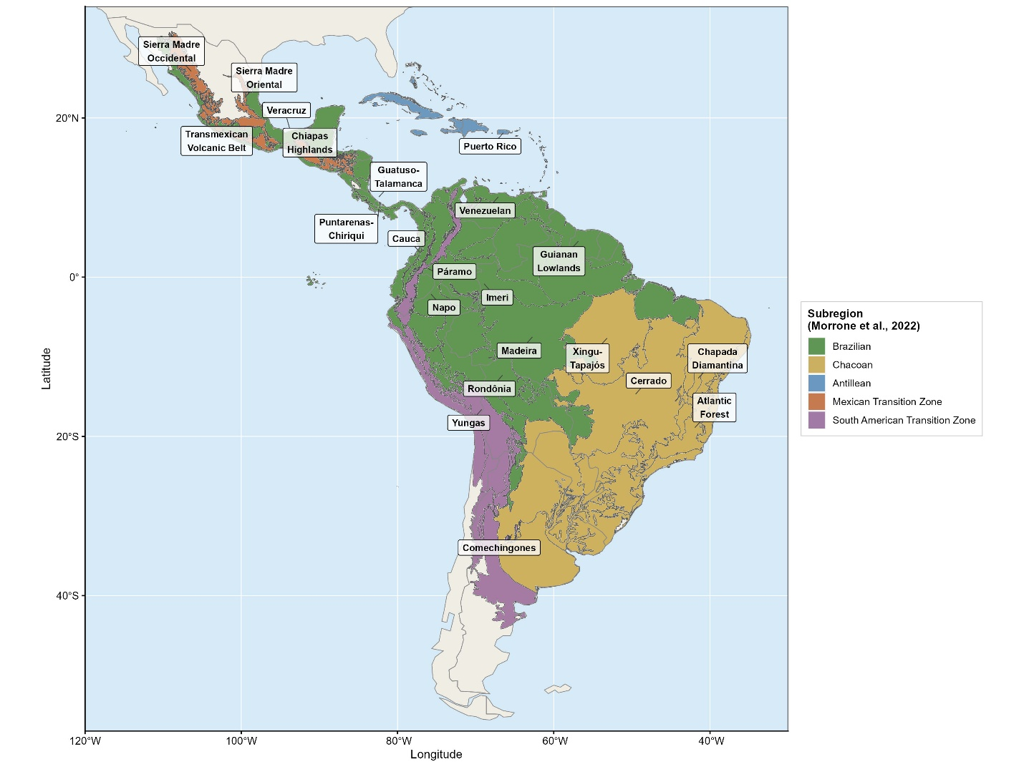
Figure 4. Biogeographic provinces of the Neotropics as defined by Morrone et al. (2022), used as the spatial framework for regional comparisons of Wallacean shortfall patterns. Province boundaries were used to summarize the distribution of well-sampled, fairly sampled, and poorly sampled grid cells across regions. Maps are displayed in Mollweide equal-area projection.
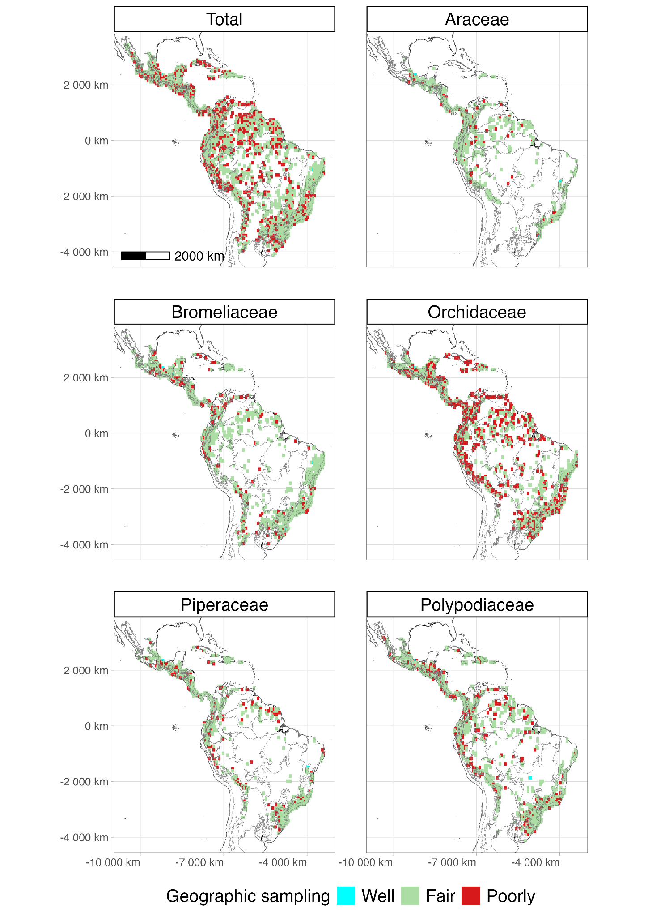
Appendix S8, Figure S8.1. Spatial clustering of inventory completeness for the five most diverse vascular epiphyte families in the Neotropics. Grid cells were classified using the Getis-Ord Gi* statistic as areas of high sampling concentration (red: Gi* > 1.96) or low sampling concentration (blue: Gi* < -1.96; 95% confidence level). Analyses used presence records from Carmona-Higuita et al. (2023) at 30 arc-minute resolution (~55 km at equator; Behrmann projection). These clusters reflect historical concentration of botanical survey effort, not priority areas for future sampling; the latter are the completely unsampled cells (white in Figures 1 and 2 of the main text).

Appendix S9, Figure S9.1. Frequency distributions of (A) occurrence records per grid cell and (B) observed species richness per grid cell, for all Neotropical grid cells with ≥ 10 records at 30 arc-minute resolution (~ 55 km at the equator). Both distributions are strongly right-skewed; vertical lines show the mean (dashed, red) and median (solid, black), justifying the use of median as the central tendency measure throughout the manuscript (Reviewer 1, comment on ln 196).

ACKNOWLEDGEMENTS
We acknowledge the support provided to GML by the DFG for the project CONTINENT (ME 5087/1-1).
Author Contribution Statement
AM, GML, AZ and DJL contributed to the conceptualization. AM led the investigation and GML supervised the work. MJCH, AM and GML performed material preparation, data curation, and formal analysis. DJL contributed with visualization. The first draft of the manuscript was written by MJCH with AM contributions. All authors commented on previous versions of the manuscript. All authors read and approved the final manuscript.
Conflict of Interest
The corresponding author confirms on behalf of all authors that there have been no involvements that might raise the question of bias in the work reported or in the conclusions, implications, or opinions stated.
Data availability statement
The data supporting the findings of this study are provided in the Supporting Information of Carmona-Higuita et al., (2023). All scripts used for data processing and analysis are openly available on GitHub at Epiphyte-Shortfalls and have been archived in Zenodo with the DOI https://doi.org/10.5281/zenodo.15001563.

REFERENCES
Amano, T., Lamming, J. D. L., & Sutherland, W. J. (2016). Spatial Gaps in Global Biodiversity Information and the Role of Citizen Science. BioScience, 66(5), 393–400. https://doi.org/10.1093/biosci/biw022
Araujo, M. L., Quaresma, A. C., & Ramos, F. N. (2022). GBIF information is not enough: National database improves the inventory completeness of Amazonian epiphytes. Biodiversity and Conservation. https://doi.org/10.1007/s10531-022-02458-x
Araujo, M. L., & Ramos, F. N. (2021). Targeting the survey efforts: Gaps and biases in epiphyte sampling at a biodiversity hotspot. Forest Ecology and Management, 498, 119544. https://doi.org/10.1016/j.foreco.2021.119544
Benavides, A. M., Duque M., A. J., Duivenvoorden, J. F., Vasco, A., & Callejas, R. (2005). A First Quantitative Census of Vascular Epiphytes in Rain forests of Colombian Amazonia. Biodiversity and Conservation, 14(3), 739–758. https://doi.org/10.1007/s10531-004-3920-9
Benzing, D. H. (1990). Vascular epiphytes. In Forest canopies (pp. 175–211). Cambridge University Press.
Bivand, R. S., Keitt, T. H., & Rowlingson, B. (2021). RGDAL: bindings for the ’geospatial’ data abstraction library. R package v.1.5-23. https://CRAN.R-project.org/package=rgdal
Bivand, R. S., & Wong, D. W. S. (2018). Comparing implementations of global and local indicators of spatial association. TEST, 27(3), 716–748. https://doi.org/10.1007/s11749-018-0599-x
Brown, M. J. M., Bachman, S. P., & Nic Lughadha, E. (2023). Three in four undescribed plant species are threatened with extinction. New Phytologist, 240(4), 1340–1344. https://doi.org/10.1111/nph.19214
Cardelus, C. L., Colwell, R. K., & Watkins, J. E. (2006). Vascular epiphyte distribution patterns: Explaining the mid-elevation richness peak. Journal of Ecology, 94(1), 144–156. https://doi.org/10.1111/j.1365-2745.2005.01052.x
Carmona-Higuita, M. J., Mendieta-Leiva, G., Gómez-Díaz, J. A., Villalobos, F., Ramos, F. N., Elias, J. P. C., Jiménez-López, D. A., Zuluaga, A., Holst, B., Kessler, M., Mathieu, G., Zizka, A., Zotz, G., & Krömer, T. (2023). Conservation status of vascular epiphytes in the Neotropics [Preprint]. In Review. https://doi.org/10.21203/rs.3.rs-2773328/v1
Carmona‐Higuita, M. J., Mendieta‐Leiva, G., Gómez‐Díaz, J. A., Villalobos, F., Ramos, F. N., Elias, J. P. C., Jiménez‐López, D. A., Zuluaga, A., Holst, B., Kessler, M., Mathieu, G., Zizka, A., Zotz, G., & Krömer, T. (2025). Endemism Centres of the Five Richest Vascular Epiphyte Families in the Neotropics. Journal of Biogeography, 52(1), 80–91. https://doi.org/10.1111/jbi.15016
Cheek, M., Nic Lughadha, E., Kirk, P., Lindon, H., Carretero, J., Looney, B., Douglas, B., Haelewaters, D., Gaya, E., Llewellyn, T., Ainsworth, A. M., Gafforov, Y., Hyde, K., Crous, P., Hughes, M., Walker, B. E., Campostrini Forzza, R., Wong, K. M., & Niskanen, T. (2020). New scientific discoveries: Plants and fungi. PLANTS, PEOPLE, PLANET, 2(5), 371–388. https://doi.org/10.1002/ppp3.10148
de Lima, R. A. F., Phillips, O. L., Duque, A., Tello, J. S., Davies, S. J., De Oliveira, A. A., Muller, S., Honorio Coronado, E. N., Vilanova, E., Cuni-Sanchez, A., Baker, T. R., Ryan, C. M., Malizia, A., Lewis, S. L., Ter Steege, H., Ferreira, J., Marimon, B. S., Luu, H. T., Imani, G., … Vásquez, R. (2022). Making forest data fair and open. Nature Ecology & Evolution, 6(6), 656–658. https://doi.org/10.1038/s41559-022-01738-7
Delves, J., Albán‐Castillo, J., Cano, A., Fernández Aviles, C., Gagnon, E., Gonzáles, P., Knapp, S., León, B., Marcelo‐Peña, J. L., Reynel, C., Rojas Gonzáles, R. D. P., Rodríguez Rodríguez, E. F., Särkinen, T., Vásquez Martínez, R., & Moonlight, P. W. (2024). Small and in‐country herbaria are vital for accurate plant threat assessments: A case study from Peru. PLANTS, PEOPLE, PLANET, 6(1), 174–185. https://doi.org/10.1002/ppp3.10425
Epiphyte Inventory Group. (2025). EpIG: Epiphyte Invent​ory Group​​. A global initiative to bring together epiphyte inventory data from across the world. https://www.epigdatabase.org/
Escribano, N., Ariño, A. H., & Galicia, D. (2016). Biodiversity data obsolescence and land uses changes. PeerJ, 4, e2743. https://doi.org/10.7717/peerj.2743
Feeley, K. (2015). Are We Filling the Data Void? An Assessment of the Amount and Extent of Plant Collection Records and Census Data Available for Tropical South America. PLOS ONE, 10(4), e0125629. https://doi.org/10.1371/journal.pone.0125629
Foster, P. (2001). The potential negative impacts of global climate change on tropical montane cloud forests. Earth-Science Reviews, 55(1–2), 73–106. https://doi.org/10.1016/S0012-8252(01)00056-3
Freitas, L., Salino, A., Neto, L. M., Almeida, T. E., Mortara, S. R., Stehmann, J. R., Amorim, A. M., Guimarães, E. F., Coelho, M. N., Zanin, A., & Forzza, R. C. (2016). A comprehensive checklist of vascular epiphytes of the Atlantic Forest reveals outstanding endemic rates. PhytoKeys, 58(1), 65–79. https://doi.org/10.3897/phytokeys.58.5643
Freudenstein, J. V., & Chase, M. W. (2015). Phylogenetic relationships in Epidendroideae (Orchidaceae), one of the great flowering plant radiations: Progressive specialization and diversification. Annals of Botany, 115(4), 665–681. https://doi.org/10.1093/aob/mcu253
Garcillán, P. P., & Ezcurra, E. (2011). Sampling procedures and species estimation: Testing the effectiveness of herbarium data against vegetation sampling in an oceanic island: Testing herbarium data against vegetation sampling. Journal of Vegetation Science, 22(2), 273–280. https://doi.org/10.1111/j.1654-1103.2010.01247.x
Gasper, A. L. D., Eisenlohr, P. V., & Salino, A. (2016). Improving collection efforts to avoid loss of biodiversity: Lessons from comprehensive sampling of lycophytes and ferns in the subtropical Atlantic Forest. Acta Botanica Brasilica, 30(2), 166–175. https://doi.org/10.1590/0102-33062015abb0292
Gaston, K. J. (2003). The structure and dynamics of geographic ranges. Oxford University Press.
Gentry, A., & Dodson, C. (1987). Diversity and biogeography of Neotropical vascular epiphytes. Annals of the Missouri Botanical Garden, 74(2), 205–233.
Getis, A., & Ord, J. K. (1992). The Analysis of Spatial Association by Use of Distance Statistics. Geographical Analysis, 24(3), 189–206. https://doi.org/10.1111/j.1538-4632.1992.tb00261.x
Guedes, T. B., Sawaya, R. J., Zizka, A., Laffan, S., Faurby, S., Pyron, R. A., Bérnils, R. S., Jansen, M., Passos, P., Prudente, A. L. C., Cisneros‐Heredia, D. F., Braz, H. B., Nogueira, C. D. C., & Antonelli, A. (2018). Patterns, biases and prospects in the distribution and diversity of Neotropical snakes. Global Ecology and Biogeography, 27(1), 14–21. https://doi.org/10.1111/geb.12679
Guisande, C., & Lobo, J. M. (2019). Discriminating well surveyed spatial units from exhaustive biodiversity databases (Version R package version 2.0) [Computer software]. http://cran. r-project. org/web/packages/KnowBR
Guzmán-Jacob, V., Weigelt, P., Craven, D., Zotz, G., Krömer, T., & Kreft, H. (2021). Biovera-Epi: A new database on species diversity, community composition and leaf functional traits of vascular epiphytes along gradients of elevation and forest-use intensity in Mexico. Biodiversity Data Journal, 9, e71974. https://doi.org/10.3897/BDJ.9.e71974
Haque, Md. M., Beaumont, L. J., & Nipperess, D. A. (2020). Taxonomic shortfalls in digitised collections of Australia’s flora. Biodiversity and Conservation, 29(1), 333–343. https://doi.org/10.1007/s10531-019-01885-7
Heberling, J. M., Miller, J. T., Noesgaard, D., Weingart, S. B., & Schigel, D. (2021). Data integration enables global biodiversity synthesis. Proceedings of the National Academy of Sciences, 118(6), e2018093118. https://doi.org/10.1073/pnas.2018093118
Hijmans, R. J. (2021). RASTER: geographic data analysis and modeling. R package v.3.4- 13. URL https://CRAN.R-project.org/package=raster
Hopkins, M. J. G. (2019). Are we close to knowing the plant diversity of the Amazon? Anais Da Academia Brasileira de Ciências, 91(suppl 3), e20190396. https://doi.org/10.1590/0001-3765201920190396
Hortal, J., De Bello, F., Diniz-Filho, J. A. F., Lewinsohn, T. M., Lobo, J. M., & Ladle, R. J. (2015). Seven Shortfalls that Beset Large-Scale Knowledge of Biodiversity. Annual Review of Ecology, Evolution, and Systematics, 46(1), 523–549. https://doi.org/10.1146/annurev-ecolsys-112414-054400
Jiménez-López, D. A., Carmona-Higuita, M. J., Mendieta-Leiva, G., Martínez-Camilo, R., Espejo-Serna, A., Krömer, T., Martínez-Meléndez, N., & Ramírez-Marcial, N. (2023). Linking different resources to recognize vascular epiphyte richness and distribution in a mountain system in southeastern Mexico. Flora, 152261. https://doi.org/10.1016/j.flora.2023.152261
Jiménez-López, D. A., Gallardo-Cruz, J. A., Véliz, M. E., Martínez-Camilo, R., Méndez, C., Solórzano, J. V., Velázquez-Méndez, L., Carabias, J., García-Hidalgo, G., Peralta-Carreta, C., Sánchez-González, M., Castillo-Acosta, O., Luna-Kamyshev, N. M., Villaseñor, J. L., & Meave, J. A. (2023). High vascular plant species richness in the Usumacinta River Basin: A comprehensive floristic checklist for a natural region in the Mesoamerican biodiversity hotspot. Botanical Sciences, 101(3), 1–62. https://doi.org/doi.org/10.17129/botsci.3253
Kelly, D. L., O’Donovan, G., Feehan, J., Murphy, S., Drangeid, S. O., & Marcano-Berti, L. (2004). The epiphyte communities of a montane rain forest in the Andes of Venezuela: Patterns in the distribution of the flora. Journal of Tropical Ecology, 20(6), 643–666. https://doi.org/10.1017/S0266467404001671
Köster, N., Friedrich, K., Nieder, J., & Barthlott, W. (2009). Conservation of epiphyte diversity in an Andean landscape transformed by human land use. Conservation Biology : The Journal of the Society for Conservation Biology, 23(4), 911–919. https://doi.org/10.1111/j.1523-1739.2008.01164.x
Kreft, H., Köster, N., Küper, W., Nieder, J., & Barthlott, W. (2004). Diversity and biogeography of vascular epiphytes in Western Amazonia, Yasuní, Ecuador. Journal of Biogeography, 31(9), 1463–1476. https://doi.org/10.1111/j.1365-2699.2004.01083.x
Lees, A. C., Rosenberg, K. V., Ruiz-Gutierrez, V., Marsden, S., Schulenberg, T. S., & Rodewald, A. D. (2020). A roadmap to identifying and filling shortfalls in Neotropical ornithology. The Auk, 137(4), ukaa048. https://doi.org/10.1093/auk/ukaa048
Leão, T. C. C., Reich, P. B., & Nic Lughadha, E. (2023). The geographic range size and vulnerability to extinction of angiosperm epiphytes in the Atlantic Forest of Brazil. Global Ecology and Biogeography, 32, 1607–1617. https://doi.org/10.1111/geb.13718
Leite, G. A., Pinheiro, R. T., Marcelino, D. G., Figueira, J. E. C., & Delabie, J. H. C. (2013). Foraging Behavior of Kaempfer’s Woodpecker ( Celeus obrieni ), a Bamboo Specialist. The Condor, 115(2), 221–229. https://doi.org/10.1525/cond.2013.120062
Lobo, J. M., Hortal, J., Yela, J. L., Millán, A., Sánchez-Fernández, D., García-Roselló, E., González-Dacosta, J., Heine, J., González-Vilas, L., & Guisande, C. (2018). KnowBR: An application to map the geographical variation of survey effort and identify well-surveyed areas from biodiversity databases. Ecological Indicators, 91, 241–248. https://doi.org/10.1016/j.ecolind.2018.03.077
Lomolino, M. V. (2004). Conservation biogeography. In Lomolino, L. R. Heaney. 2004. Frontiers of Biogeography: New Directions in the Geography of Nature. (p. 293). Sinauer Associates, Inc.
Luján, M., Lemos, R. M., Lucas, E., Michelangeli, F. A., Prance, G., Pennington, T. D., Rzedowski, J., Santamaría-Aguilar, D., Serpell, E., Sothers, C., & Zuntini, A. R. (2023). Trials and tribulations of Neotropical plant taxonomy: Pace of tree species description. Plant Biology. https://doi.org/10.1101/2023.09.05.556231
Maldonado, C., Molina, C. I., Zizka, A., Persson, C., Taylor, C. M., Albán, J., Chilquillo, E., Rønsted, N., & Antonelli, A. (2015). Estimating species diversity and distribution in the era of Big Data: To what extent can we trust public databases? Global Ecology and Biogeography, 24(8), 973–984. https://doi.org/10.1111/geb.12326
Marin, A. C., Wolf, J. H. D., Oostermeijer, J. G. B., & den Nijs, J. C. M. (2008). Establishment of Epiphytic Bromeliads in Successional Tropical Premontane Forests in Costa Rica. Biotropica, 40(4), 441–448.
Mendieta-Leiva, G., Ramos, F. N., Elias, J. P. C., Zotz, G., Acuña-Tarazona, M., Alvim, F. S., Barbosa, D. E. F., Basílio, G. A., Batke, S. P., Benavides, A. M., Blum, C. T., Boelter, C. R., Brancalion, P. H. S., Carmona, M. J., Carvalho, L. P., de la Rosa-Manzano, E., Einzmann, H. J. R., Fernández, M., Furtado, S. G., … Jiménez-Alfaro, B. (2020). EpIG-DB: A database of vascular epiphyte assemblages in the Neotropics. Journal of Vegetation Science, 31(3), 1–11. https://doi.org/10.1111/jvs.12867
Mendieta-Leiva, G., & Zotz, G. (2015). A conceptual framework for the analysis of vascular epiphyte assemblages. Perspectives in Plant Ecology, Evolution and Systematics, 17(6), 510–521. https://doi.org/10.1016/j.ppees.2015.09.003
Meyer, C., Kreft, H., Guralnick, R., & Jetz, W. (2015). Global priorities for an effective information basis of biodiversity distributions. Nature Communications, 6(1), 8221. https://doi.org/10.1038/ncomms9221
Meyer, C., Weigelt, P., & Kreft, H. (2016). Multidimensional biases, gaps and uncertainties in global plant occurrence information. Ecology Letters, 19(8), 992–1006. https://doi.org/10.1111/ele.12624
Morrone, J. J., Escalante, T., Rodríguez-Tapia, G., Carmona, A., Arana, M., & Mercado-Gómez, J. D. (2022). Biogeographic regionalization of the Neotropical region: New map and shapefile. Anais Da Academia Brasileira de Ciências, 94(1), e20211167. https://doi.org/10.1590/0001-3765202220211167
Nicolson, N., Trekels, M., Groom, Q. J., Knapp, S., & Paton, A. J. (2023). Global access to nomenclatural botanical resources: Evaluating open access availability. PLANTS, PEOPLE, PLANET, 5(6), 899–907. https://doi.org/10.1002/ppp3.10438
Nieder, J., Prosperi, J., & Michaloud, G. (2001). Epiphytes and their contribution to canopy diversity. Plant Ecology, 153, 51–63.
Oliveira, U., Paglia, A. P., Brescovit, A. D., De Carvalho, C. J. B., Silva, D. P., Rezende, D. T., Leite, F. S. F., Batista, J. A. N., Barbosa, J. P. P. P., Stehmann, J. R., Ascher, J. S., De Vasconcelos, M. F., De Marco, P., Löwenberg‐Neto, P., Dias, P. G., Ferro, V. G., & Santos, A. J. (2016). The strong influence of collection bias on biodiversity knowledge shortfalls of B razilian terrestrial biodiversity. Diversity and Distributions, 22(12), 1232–1244. https://doi.org/10.1111/ddi.12489
Ondo, I., Dhanjal‐Adams, K. L., Pironon, S., Silvestro, D., Colli‐Silva, M., Deklerck, V., Grace, O. M., Monro, A. K., Nicolson, N., Walker, B., & Antonelli, A. (2024). Plant diversity darkspots for global collection priorities. New Phytologist, 244(2), 719–733. https://doi.org/10.1111/nph.20024
Pebesma, E. (2018). Simple Features for R: Standardized Support for Spatial Vector Data. The R Journal, 10(1), 439. https://doi.org/10.32614/RJ-2018-009
Perez, T. M., Valverde-Barrantes, O., Bravo, C., Taylor, T. C., Fadrique, B., Hogan, J. A., Pardo, C. J., Stroud, J. T., Baraloto, C., & Feeley, K. J. (2019). Botanic gardens are an untapped resource for studying the functional ecology of tropical plants. Philosophical Transactions of the Royal Society B: Biological Sciences, 374(1763), 20170390. https://doi.org/10.1098/rstb.2017.0390
Prance, G. T., Beentje, H., Dransfield, J., & Johns, R. (2000). The Tropical Flora Remains Undercollected. Annals of the Missouri Botanical Garden, 87(1), 67. https://doi.org/10.2307/2666209
Quaresma, A., Zartman, C. E., Piedade, M. T. F., Wittmann, F., Jardim, M. A. G., Irume, M. V., Benavides, A. M., Freitas, L., Toledo, J. J., Boelter, C. R., Obermüller, F., Duque, A. J., Klein, V. P., Mari, M. L. G., Schöngart, J., Arenas, E., Pos, E. T., Vasco, A., Ek, R., … Ter Steege, H. (2022). The Amazon Epiphyte Network: A First Glimpse Into Continental-Scale Patterns of Amazonian Vascular Epiphyte Assemblages. Frontiers in Forests and Global Change, 5, 828759. https://doi.org/10.3389/ffgc.2022.828759
R. Core Team. (2024). _R: A Language and Environment for Statistical Computing_ [Computer software]. R Foundation for Statistical Computing. <https://www.R-project.org/>
Ramírez‐Barahona, S., Cuervo‐Robayo, A. P., & Magallón, S. (2023). Assessing digital accessible botanical knowledge and priorities for exploration and discovery of plant diversity across Mesoamerica. New Phytologist, 240(4), 1659–1672. https://doi.org/10.1111/nph.19190
Ramos, F. N., De Araujo, M. L., Da Silva Assis, I., Basilio, G. A., Barbosa, D. E. F., Correa, T. A., Delgado, C. N., Furtado, S. G., Marquez, G., Soares, J. S., Yañez, A., Silva, S. M., Neto, L. M., & Elias, J. P. C. (2024). Vascular epiphytes of the South America Dry Diagonal: Characterising their occurrence and richness in this neglected region. New Zealand Journal of Botany, 1–18. https://doi.org/10.1080/0028825X.2024.2387188
Ramos, F. N., Mortara, S. R., & Elias, J. P. C. (2021). Vascular Epiphytes of the Atlantic Forest: Diversity and Community Ecology. In M. C. M. Marques & C. E. V. Grelle (Eds.), The Atlantic Forest (pp. 133–149). Springer International Publishing. https://doi.org/10.1007/978-3-030-55322-7_7
Ramos, F. N., Mortara, S. R., Monalisa‐Francisco, N., Elias, J. P. C., Neto, L. M., Freitas, L., Kersten, R., Amorim, A. M., Matos, F. B., Nunes‐Freitas, A. F., Alcantara, S., Alexandre, M. H. N., Almeida‐Scabbia, R. J., Almeida, O. J. G., Alves, F. E., Oliveira Alves, R. M., Alvim, F. S., Andrade, A. C. S., Andrade, S., … Ribeiro, M. C. (2019). ATLANTIC EPIPHYTES: A data set of vascular and non‐vascular epiphyte plants and lichens from the Atlantic Forest. Ecology, 100(2), e02541. https://doi.org/10.1002/ecy.2541
Raven, P. H., Gereau, R. E., Phillipson, P. B., Chatelain, C., Jenkins, C. N., & Ulloa Ulloa, C. (2020). The distribution of biodiversity richness in the tropics. Science Advances, 6(37), eabc6228. https://doi.org/10.1126/sciadv.abc6228
Rossi, F., & Becker, G. (2019). Creating forest management units with Hot Spot Analysis (Getis-Ord Gi*) over a forest affected by mixed-severity fires. Australian Forestry, 82(4), 166–175. https://doi.org/10.1080/00049158.2019.1678714

Roy, M., Vasco‐Palacios, A., Geml, J., Buyck, B., Delgat, L., Giachini, A., Grebenc, T., Harrower, E., Kuhar, F., Magnago, A., Rinaldi, A. C., Schimann, H., Selosse, M., Sulzbacher, M. A., Wartchow, F., & Neves, M. (2017). The (re)discovery of ectomycorrhizal symbioses in Neotropical ecosystems sketched in Florianópolis. New Phytologist, 214(3), 920–923. https://doi.org/10.1111/nph.14531
Sabatini, F. M., Jiménez-Alfaro, B., Jandt, U., Chytrý, M., Field, R., Kessler, M., Lenoir, J., Schrodt, F., Wiser, S. K., Arfin Khan, M. A. S., Attorre, F., Cayuela, L., De Sanctis, M., Dengler, J., Haider, S., Hatim, M. Z., Indreica, A., Jansen, F., Pauchard, A., … Bruelheide, H. (2022). Global patterns of vascular plant alpha diversity. Nature Communications, 13(1), 4683. https://doi.org/10.1038/s41467-022-32063-z
Schellenberger Costa, D., Boehnisch, G., Freiberg, M., Govaerts, R., Grenié, M., Hassler, M., Kattge, J., Muellner‐Riehl, A. N., Rojas Andrés, B. M., Winter, M., Watson, M., Zizka, A., & Wirth, C. (2023). The big four of plant taxonomy – a comparison of global checklists of vascular plant names. New Phytologist, 240(4), 1687–1702. https://doi.org/10.1111/nph.18961
Schröter, M., Kraemer, R., Ceauşu, S., & Rusch, G. M. (2017). Incorporating threat in hotspots and coldspots of biodiversity and ecosystem services. Ambio, 46(7), 756–768. https://doi.org/10.1007/s13280-017-0922-x
Soberón, J., & Peterson, A. T. (2009). Monitoring Biodiversity Loss with Primary Species-occurrence Data: Toward National-level Indicators for the 2010 Target of the Convention on Biological Diversity. AMBIO: A Journal of the Human Environment, 38(1), 29–34. https://doi.org/10.1579/0044-7447-38.1.29
Sobral-Souza, T., Stropp, J., Santos, J. P., Prasniewski, V. M., Szinwelski, N., Vilela, B., Freitas, A. V. L., Ribeiro, M. C., & Hortal, J. (2021). Knowledge gaps hamper understanding the relationship between fragmentation and biodiversity loss: The case of Atlantic Forest fruit-feeding butterflies. PeerJ, 9, e11673. https://doi.org/10.7717/peerj.11673
Stropp, J., Ladle, R. J., M. Malhado, A. C., Hortal, J., Gaffuri, J., H. Temperley, W., Olav Skøien, J., & Mayaux, P. (2016). Mapping ignorance: 300 years of collecting flowering plants in Africa. Global Ecology and Biogeography, 25(9), 1085–1096. https://doi.org/10.1111/geb.12468
Stropp, J., Umbelino, B., Correia, R. A., Campos‐Silva, J. V., Ladle, R. J., & Malhado, A. C. M. (2020). The ghosts of forests past and future: Deforestation and botanical sampling in the Brazilian Amazon. Ecography, 43(7), 979–989. https://doi.org/10.1111/ecog.05026
Svahnström, V. J., Nic Lughadha, E., Forest, F., & Leão, T. C. C. (2025). Geographic range size and rarity of epiphytic flowering plants. Nature Plants. https://doi.org/10.1038/s41477-025-02022-9
Taylor, A., Weigelt, P., Denelle, P., Cai, L., & Kreft, H. (2023). The contribution of plant life and growth forms to global gradients of vascular plant diversity. New Phytologist, nph.19011. https://doi.org/10.1111/nph.19011
Taylor, A., Zotz, G., Weigelt, P., Cai, L., Karger, D. N., König, C., & Kreft, H. (2021). Vascular epiphytes contribute disproportionately to global centres of plant diversity. Global Ecology and Biogeography, 31(1), 62–74. https://doi.org/10.1111/geb.13411
ter Steege, H., Vaessen, R. W., Cárdenas-López, D., Sabatier, D., Antonelli, A., De Oliveira, S. M., Pitman, N. C. A., Jørgensen, P. M., & Salomão, R. P. (2016). The discovery of the Amazonian tree flora with an updated checklist of all known tree taxa. Scientific Reports, 6(1), 29549. https://doi.org/10.1038/srep29549
Tietje, M., Antonelli, A., Forest, F., Govaerts, R., Smith, S. A., Sun, M., Baker, W. J., & Eiserhardt, W. L. (2023). Global hotspots of plant phylogenetic diversity. New Phytologist, 240(4), 1636–1646. https://doi.org/10.1111/nph.19151
Ugland, K. I., Gray, J. S., & Ellingsen, K. E. (2003). The species-accumulation curve and estimation of species richness. Journal of Animal Ecology, 72(5), 888–897.
Vargas, C. A., Bottin, M., Sarkinen, T., Richardson, J. E., Celis, M., Villanueva, B., & Sanchez, A. (2024). How to fill the biodiversity data gap: Is it better to invest in fieldwork or curation? Plant Diversity, 46(1), 39–48. https://doi.org/10.1016/j.pld.2023.06.003
Vargas, C. A., Bottin, M., Särkinen, T., Richardson, J. E., Raz, L., Garzon-Lopez, C. X., & Sanchez, A. (2022). Environmental and geographical biases in plant specimen data from the Colombian Andes. Botanical Journal of the Linnean Society, 200(4), 451–464. https://doi.org/10.1093/botlinnean/boac035
Vitt, P., Taylor, A., Rakosy, D., Kreft, H., Meyer, A., Weigelt, P., & Knight, T. M. (2023). Global conservation prioritization for the Orchidaceae. Scientific Reports, 13(1), 6718. https://doi.org/10.1038/s41598-023-30177-y
Wickham, H. (2009). ggplot2: Elegant Graphics for Data Analysis. Springer New York. https://doi.org/10.1007/978-0-387-98141-3
Wickham, H., Hester, J., & Chang, W. (2019). Devtools: Tools to Make Developing R Packages Easier. R package version 2.0.2. https://cran.r-project.org/package=devtools
Woods, C. L., Cardelús, C. L., & DeWalt, S. J. (2015). Microhabitat associations of vascular epiphytes in a wet tropical forest canopy. Journal of Ecology, 103(2), 421–430.
Zizka, A., Antunes Carvalho, F., Calvente, A., Rocio Baez-Lizarazo, M., Cabral, A., Coelho, J. F. R., Colli-Silva, M., Fantinati, M. R., Fernandes, M. F., Ferreira-Araújo, T., Gondim Lambert Moreira, F., Santos, N. M. C., Santos, T. A. B., dos Santos-Costa, R. C., Serrano, F. C., Alves da Silva, A. P., de Souza Soares, A., Cavalcante de Souza, P. G., Calisto Tomaz, E., … Antonelli, A. (2020). No one-size-fits-all solution to clean GBIF. PeerJ, 8, e9916. https://doi.org/10.7717/peerj.9916
Zizka, A., Antonelli, A., & Silvestro, D. (2021). Sampbias , a method for quantifying geographic sampling biases in species distribution data. Ecography, 44(1), 25–32. https://doi.org/10.1111/ecog.05102

Zotz, G. (2016). Plants on plants – the biology of vascular epiphytes. Springer. https://doi.org/10.1007/978-3-319-39237-0_1
Zotz, G., Weigelt, P., Kessler, M., Kreft, H., & Taylor, A. (2021). EpiList 1.0: A global checklist of vascular epiphytes. Ecology, 102(6), e03326. https://doi.org/10.1002/ecy.3326

