Game Design Document

Fill up the following document

1. Write the title of your project.

MazeCo19

1. What is the goal of the game?

To get all masks and reach 100 points

1. Write a brief story of your game.

The Player has to reach 100 points by collecting masks.

Each mask gives 25 poins which means 4 maks = 100 poins = WIN!

And there is NPC which are people who are not wearing mask and roaming around the maze there is also powermask that if a PC takes it and touches a NPC, the NPC get back to its starting place also PC has 1 life.

1. Which are the playing characters of this game?

* Playing characters are the ones who respond to the user based on the input from the user.
* Cars, monkeys, dinos, wizards, etc., are the playing characters in the game.

|  |  |  |
| --- | --- | --- |
| Number | Character Name | What can this character do? |
| 1 | Nic(People) | Collects masks and move around the maze |

1. Which are the Non-Playing Characters of this game?

* Non-Playing characters are the ones that don't have an action or behavior when the user interacts with the game.
* Hurdles, stones, bananas, coins, etc., are non-playing characters in the game.

|  |  |  |
| --- | --- | --- |
| Number | Character Name | What can this character do? |
| 1 | Nace(People) | Drop virus pattles and move around |
| 2 | Grove(People) | Drop virus pattles and move around |
|  |  |  |
|  |  |  |
|  |  |  |
|  |  |  |
|  |  |  |
|  |  |  |

Draw your imagination of this game. What does this game look like?

* Draw the game either on your computer or on paper.
* Add images of the game scenes to show each of the playing and non-playing characters at least once.

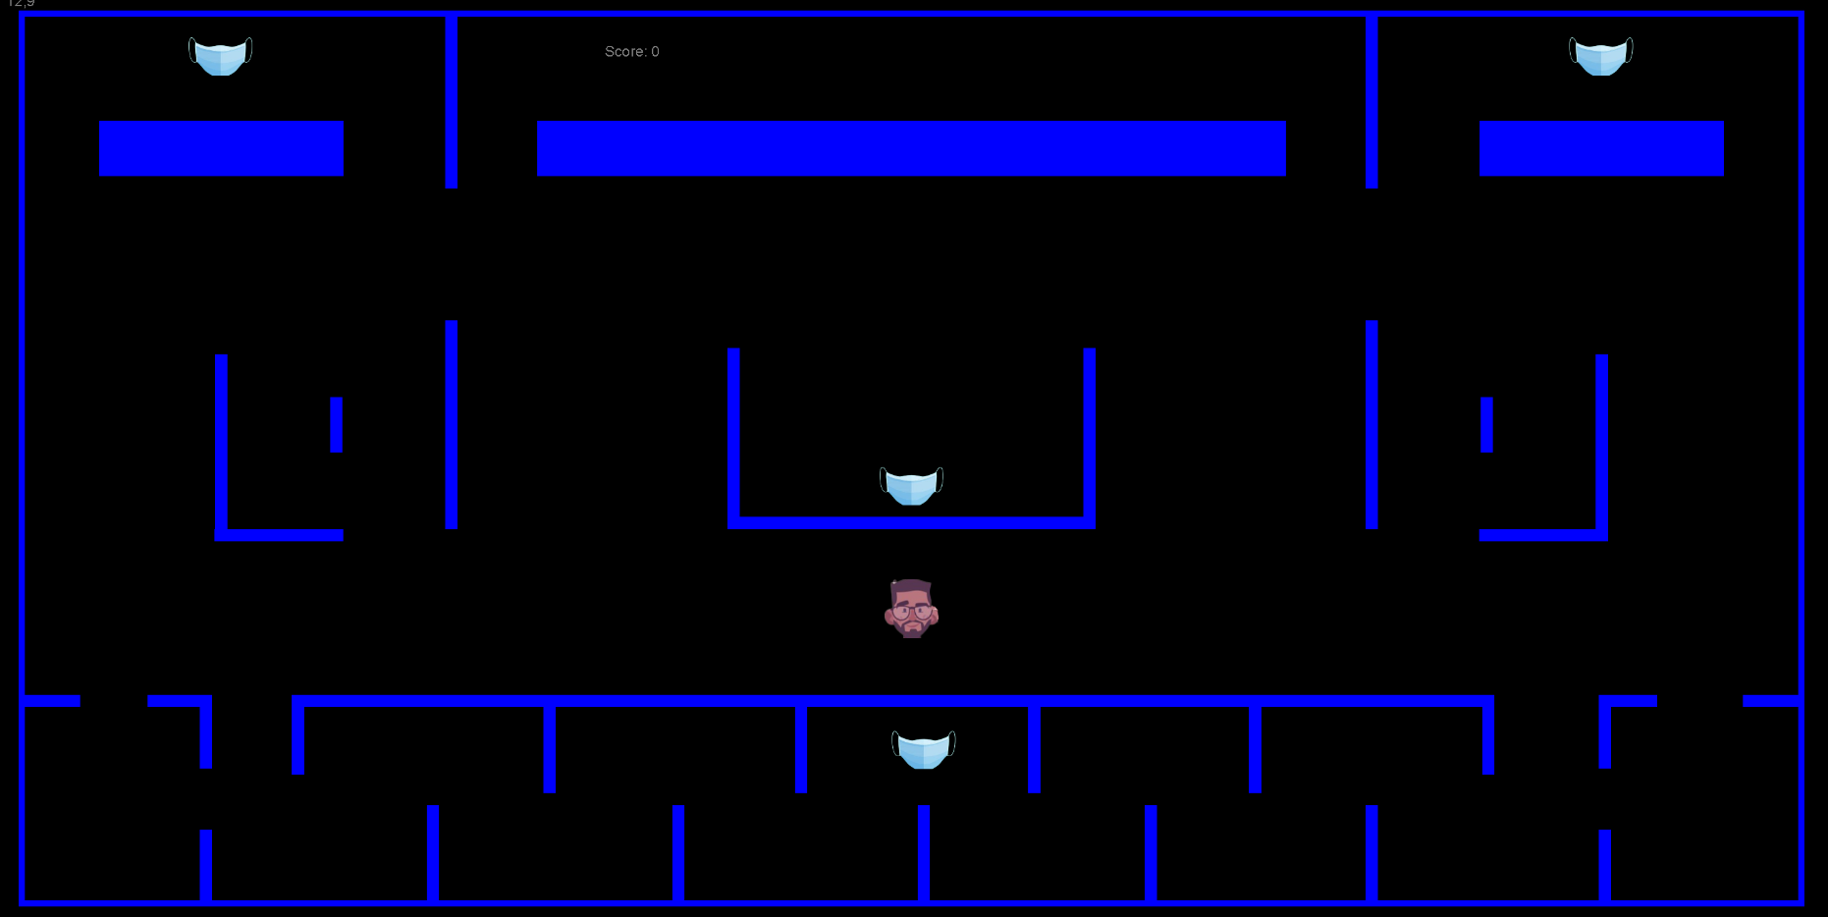

How do you plan to make your game engaging?

By adding PC and NPC and make a score system so it feels like pac-man v2 also collecting masks…