

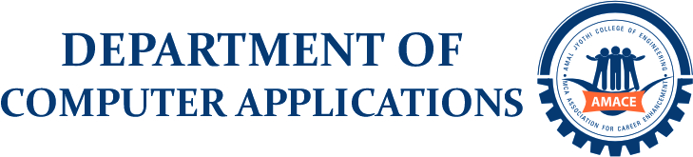

AQUA MOTUS: WATERMETRO

20INMCA509 - Mini Project 2

Scrum Master

MR. JINSON DEVIS

Assistant Professor  
Department of Computer Applications

ANMIGHA N M

AJC20MCA-I014

INMCA2020-25 S9

Git url - https://github.com/AnmighaNM/WATERMETRO.git

E Mail – anmighanm2025@mca.ajce.in

ABSTRACT

**Topic: WATERMETRO MANAGEMENT SYSTEM**

The Mini - project entitled **“*AQUA MOTUS*”** is a dynamic web application for managing Ticket and Facilities Management System that significantly elevates user experience through streamlined online ticket booking processes and seamless access to comprehensive information regarding available facilities.

In the proposed system, users can register online to book tickets for boat transportation services and can browse available boat schedules, select routes, and book tickets accordingly. The Station Master manages boats and services, ensuring smooth operations, scheduling, and maintenance. The admin registers boats, station master, updates services, and oversees overall system functionality.

*Modules Description:*

The modules of the system are:

• Admin

• Station Master

• User

*ADMIN*

* Admin can log in using a username and password.
* Register new Station Masters.
* Add new events.
* Register boat details.
* Add new stations.

*STATION MASTER*

* Station Master can log in using a username and password.
* Manage various services available for boat transportation.
* Assign boats to specific routes and schedules.
* View tickets booked by users.
* Generate and view reports related to boat operations and services.

*USER*

* User can log in using a username and password.
* Browse available boat schedules and select desired routes and book tickets.
* View booked tickets and option to cancel ticket requests and payment option.

*Technologies Employed:*

* *Python:* Backend logic.
* *Django:* Web framework implementation.
* *SQLite:* Database management.
* *Machine Learning:* Enhances system capabilities with weather forecasting for safe travel planning, boat safety and security measures, and route optimization for efficient service delivery.