USER INTERFACE DESIGN USING FIGMA

1. Login page

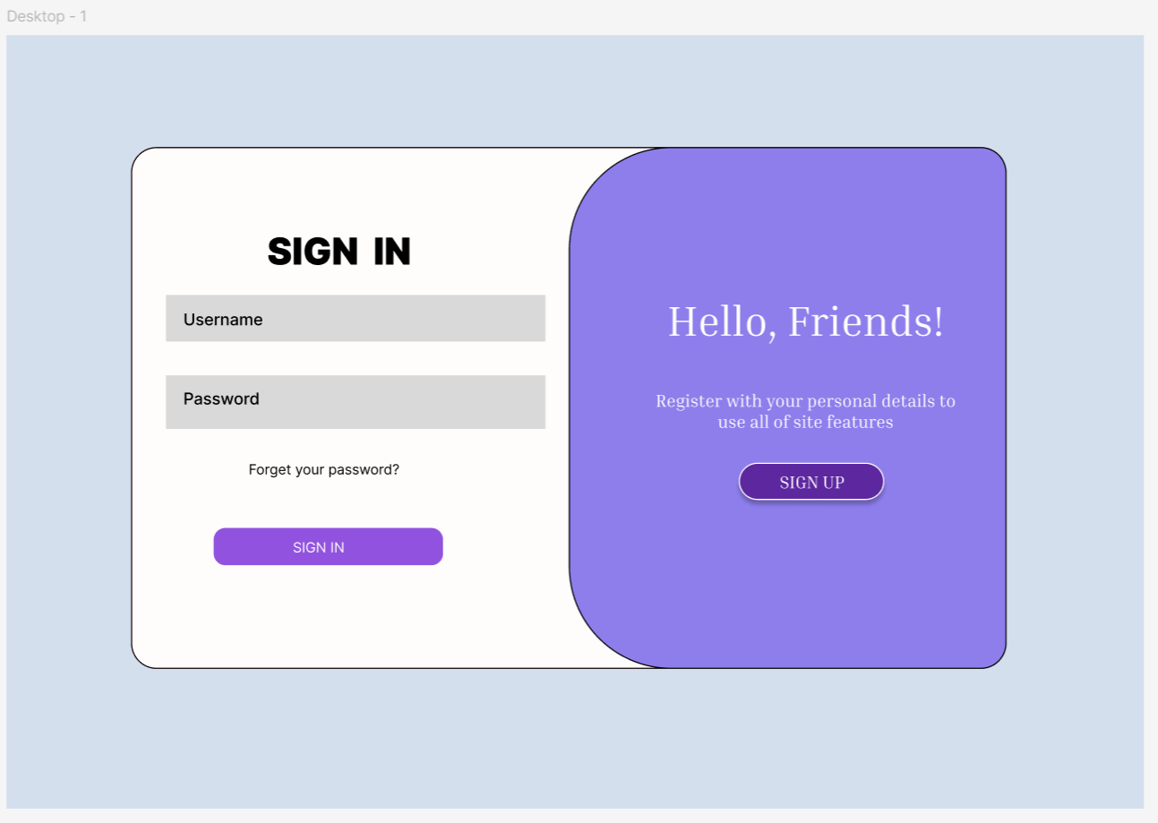

1. Station Master Registration – Admin Module

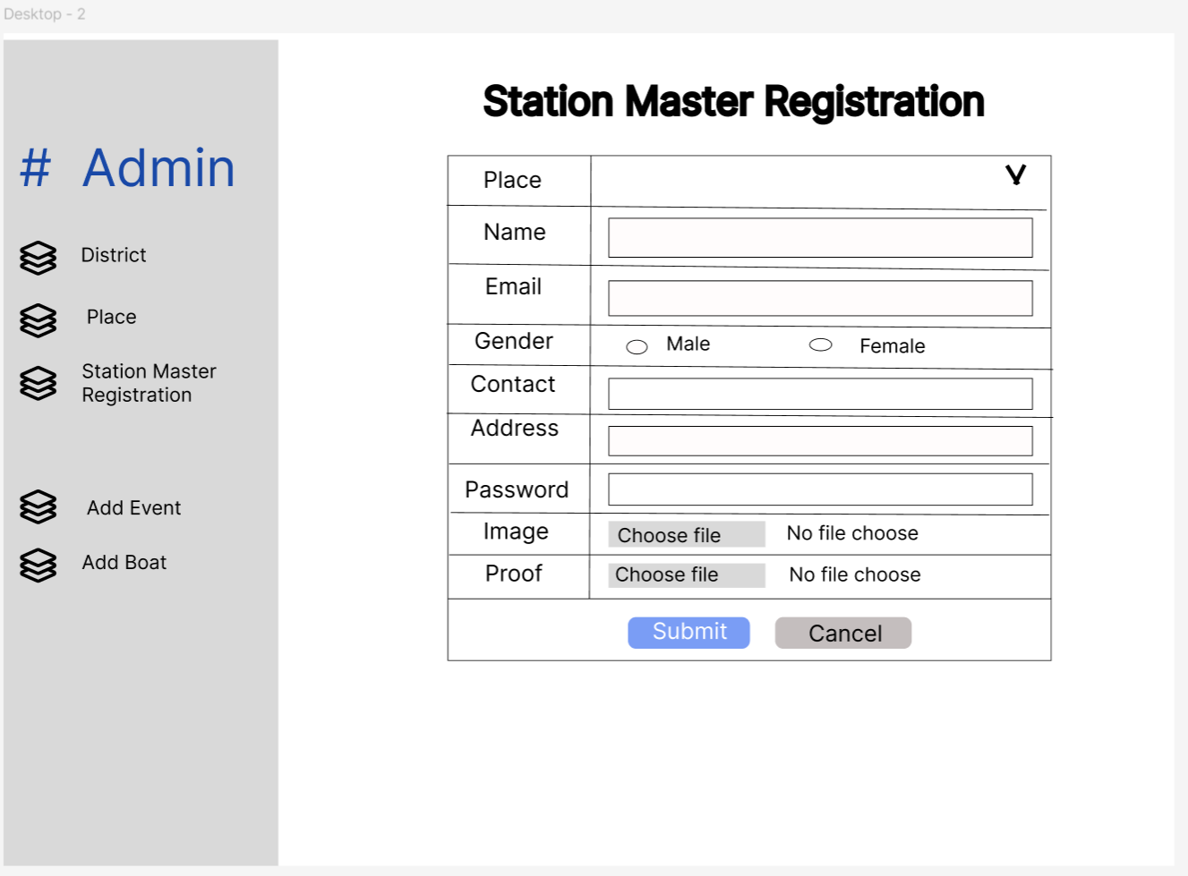

1. Assign Boat – Station Master Module

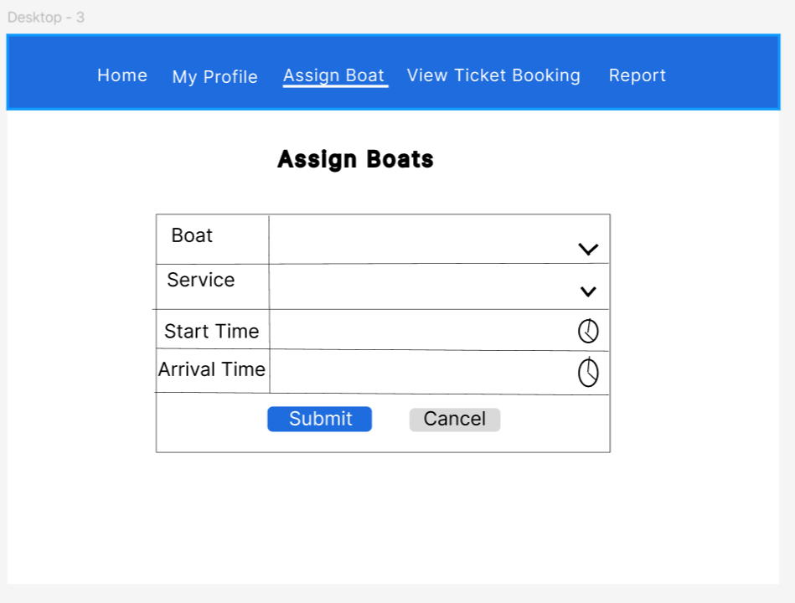

1. Ticket Booking – User Module

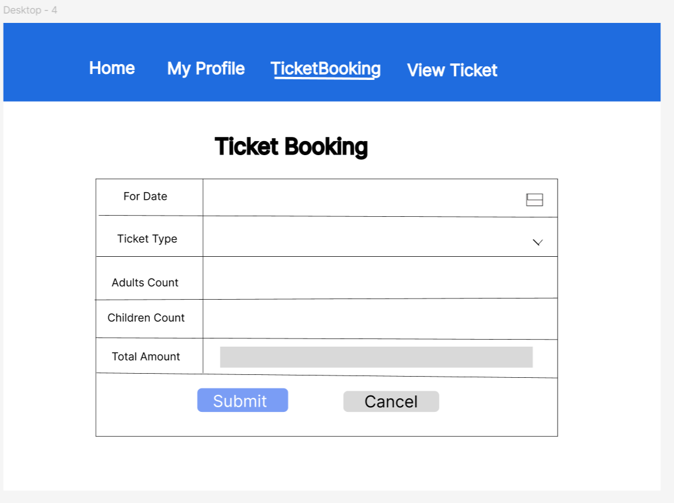

1. Registration

