UML DIAGRAM

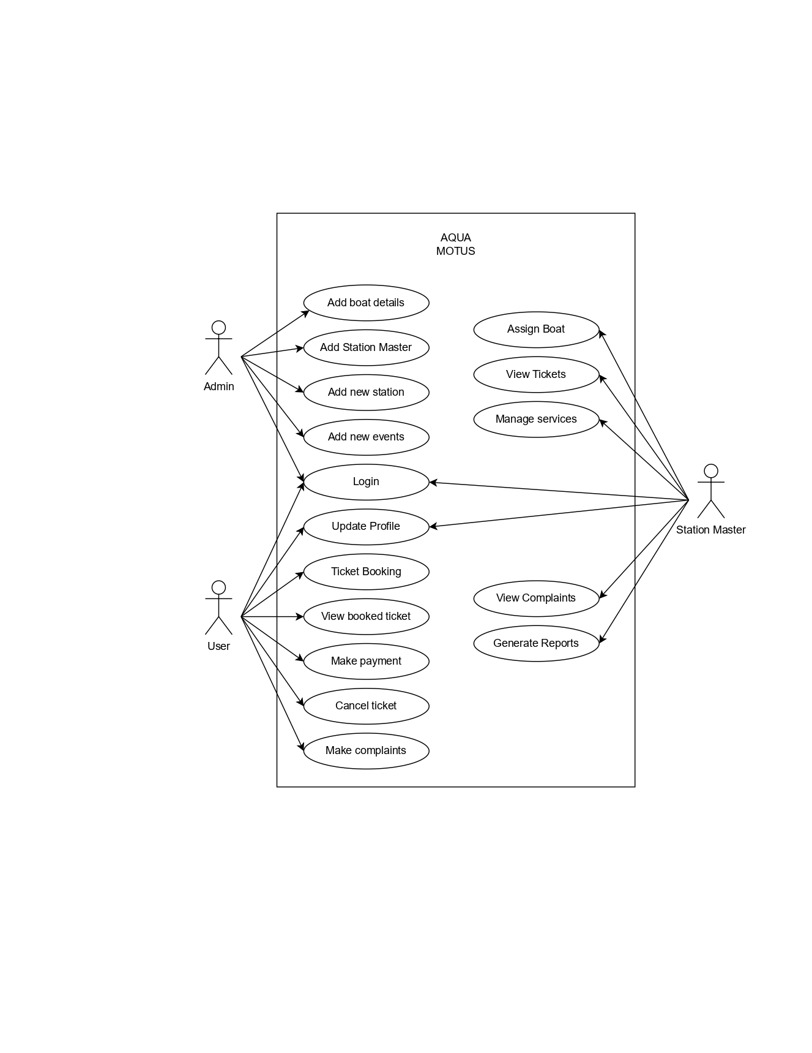**•** **Use case diagram**

**• Sequence diagram**

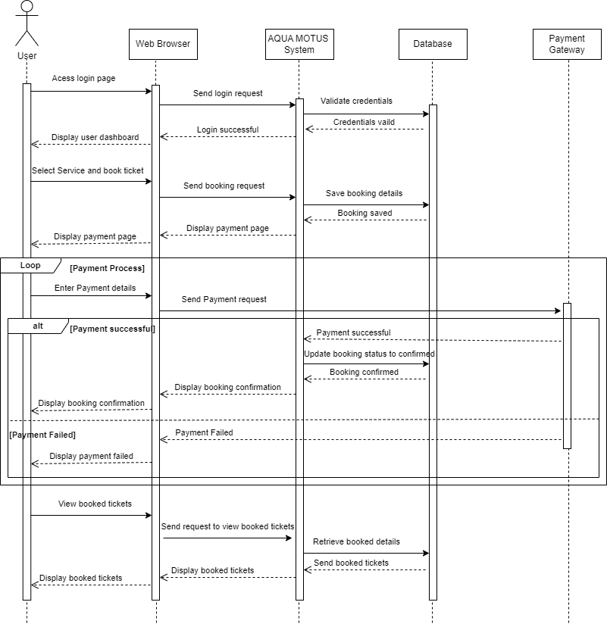

**• Class diagram**

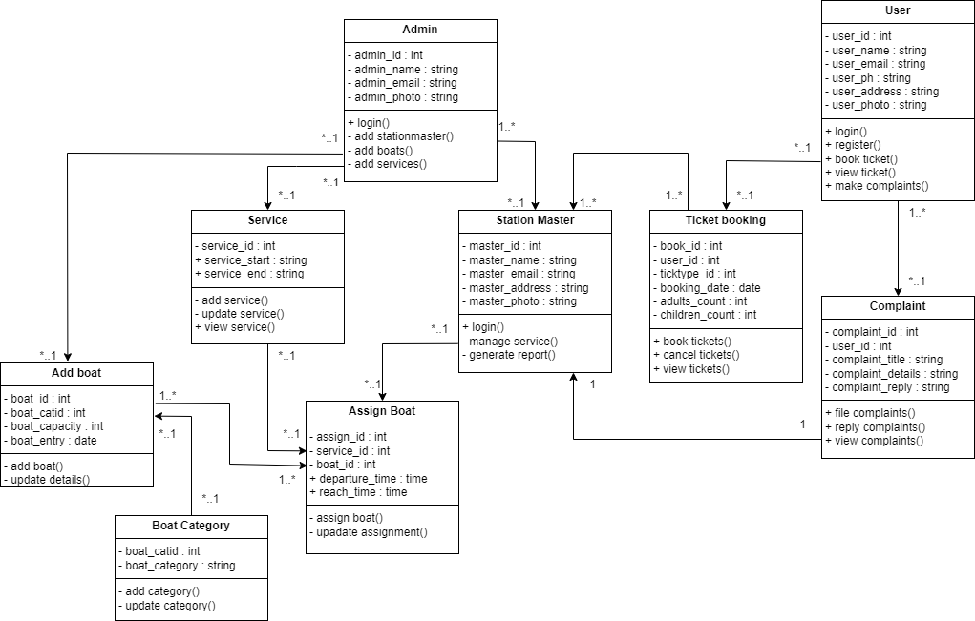

**• Object diagram**

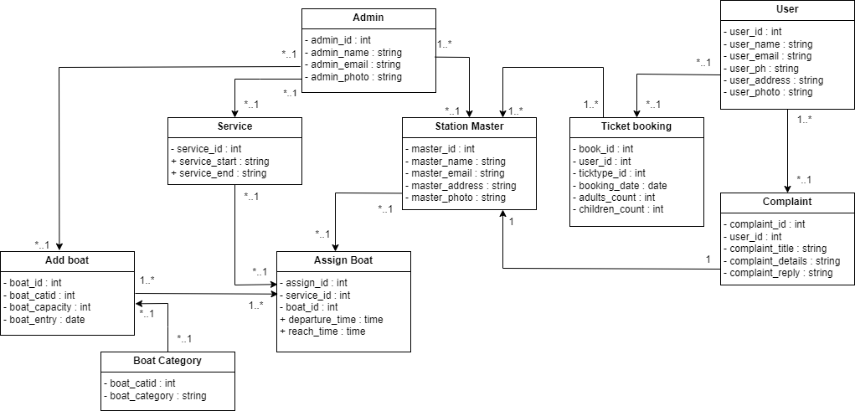

**• Activity diagram**

* User

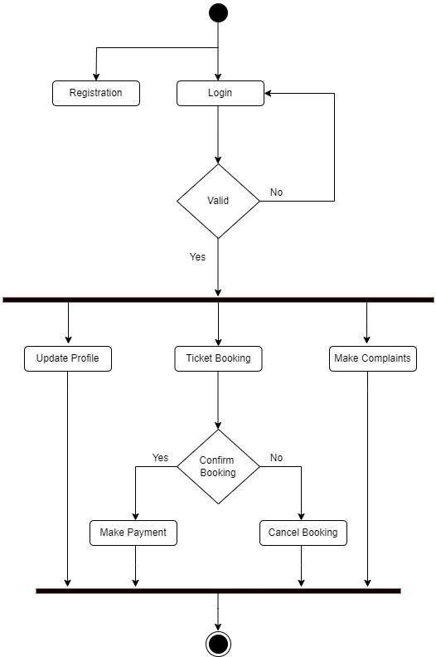

* Station Master

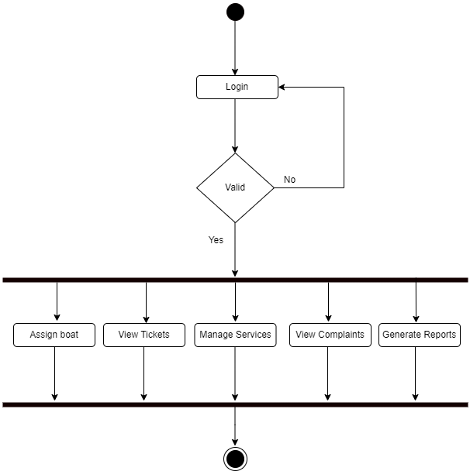

* Admin

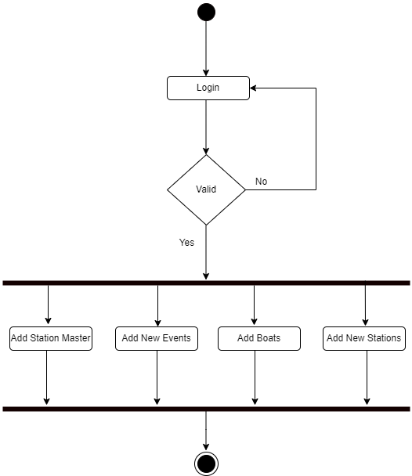

**• Collaboration diagram**

**• State chart diagram**

**• Deployment diagram**

**• Component diagram**