1
Ex. No: 10 | ADD ANDROID AS A BUILD TARGET
Date of Exercise | 22.09.2026
Git-hub Host Link | https://urk23cs1203.github.io/Flutter-Lap-Ex10/

Aim:
To configure and build a Flutter application for the Android platform.

Description:
This experiment demonstrates how to configure Flutter for Android development, check connected Android devices, accept Android SDK licenses, run the application on an Android device or emulator, and generate an APK file.

Procedure:
Step 1: Check the Flutter installation and Android toolchain using:

flutter doctor
Step 2: Check the available devices using:

flutter devices
Step 3: Accept the Android SDK licenses using:

flutter doctor --android-licenses
Accept all the required licenses by entering y.
Step 4: Create a new Flutter application using:
flutter create android_app
Step 5: Navigate to the application directory: cd android_app
Step 6: Start the Android emulator and run the application:
flutter emulators --launch Medium_Phone_API_36.1
flutter run
Step 7: Build the Flutter application as an Android APK:

flutter build apk
Step 8: Locate the generated APK in:

build/app/outputs/flutter-apk/app-release.apk
Step 9: Install the generated APK on an Android device or emulator and test the application.

2

Program:

import 'package:flutter/material.dart';
void main() {
runApp(const MyApp()); }
class MyApp extends StatelessWidget {
const MyApp({super.key});
@override
Widget build(BuildContext context) {
return MaterialApp(
debugShowCheckedModeBanner: false,
title: 'Experiment 10',
theme: ThemeData(
colorScheme: ColorScheme.fromSeed(seedColor: Colors.deepPurple), ),
home: const MyHomePage(), ); } }
class MyHomePage extends StatefulWidget {
const MyHomePage({super.key});
@override
State<MyHomePage> createState() => _MyHomePageState(); }
class _MyHomePageState extends State<MyHomePage> {
int _counter = 0;
void _incrementCounter() {
setState(() {
_counter++; }); }
@override
Widget build(BuildContext context) {
return Scaffold(
appBar: AppBar(
title: const Text('Experiment 10'), ),
body: Center(
child: Column(
mainAxisAlignment: MainAxisAlignment.center,
children: [
const Text(
'You have pushed the button this many times:', ),
Text(
'$_counter',
style: const TextStyle(fontSize: 30), ), ], ), ),
floatingActionButton: FloatingActionButton(
onPressed: _incrementCounter,
tooltip: 'Increment',
child: const Icon(Icons.add), ), ); } }

3

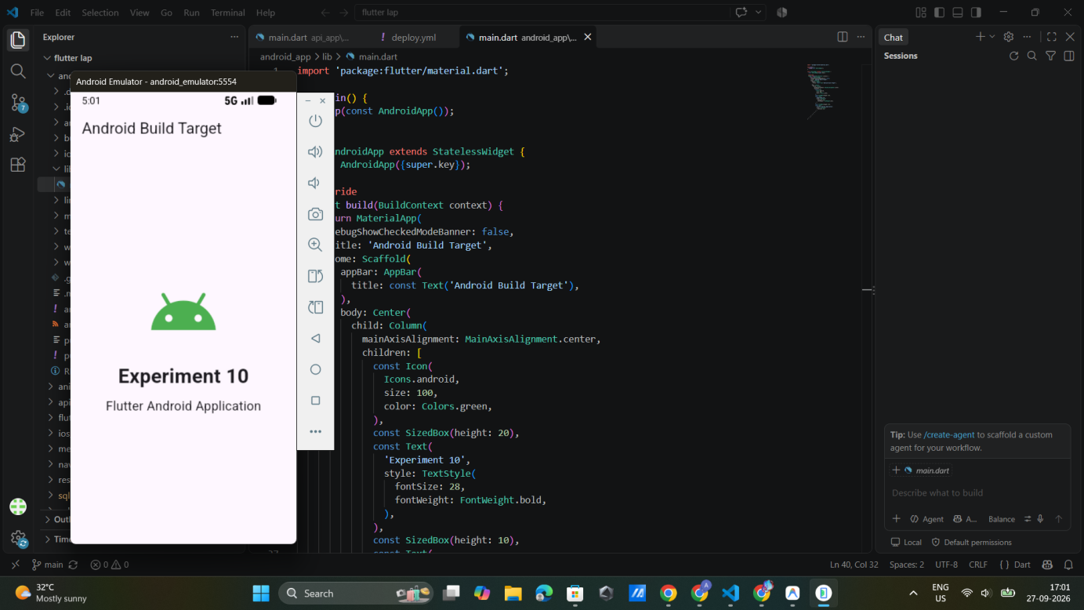
Output:

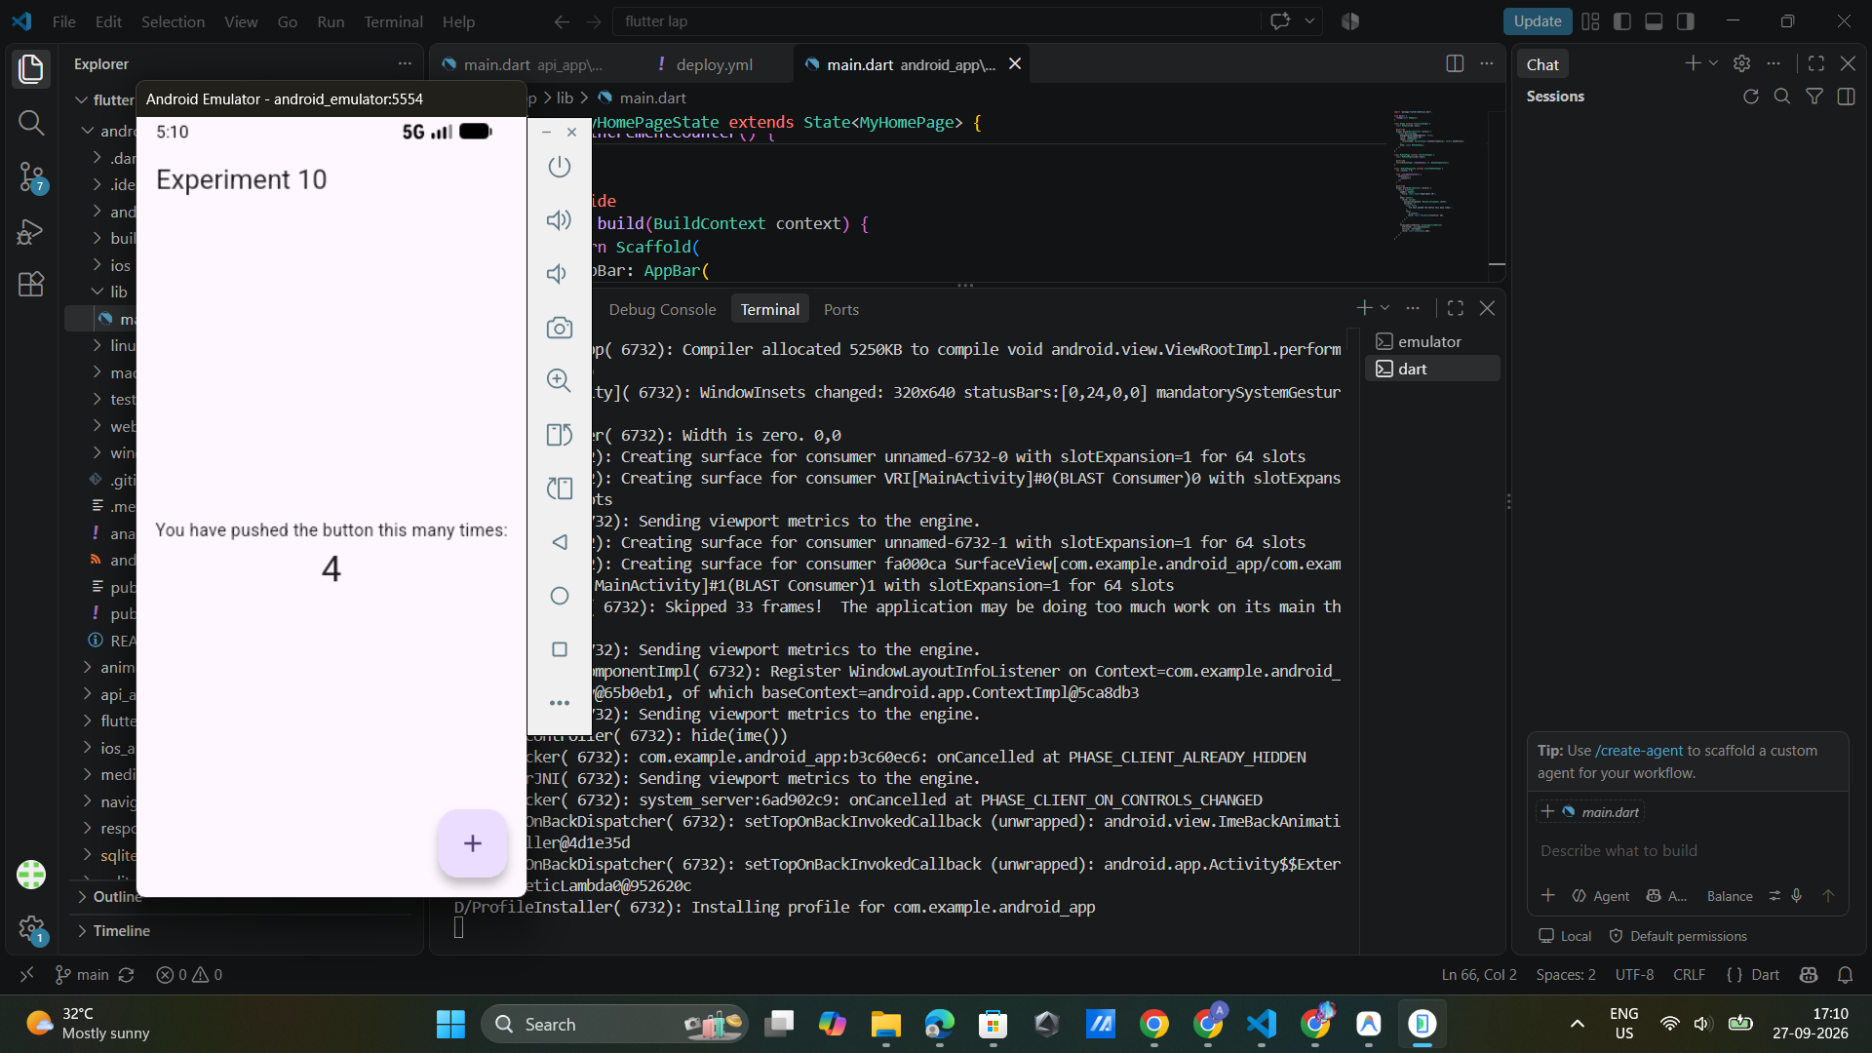

4

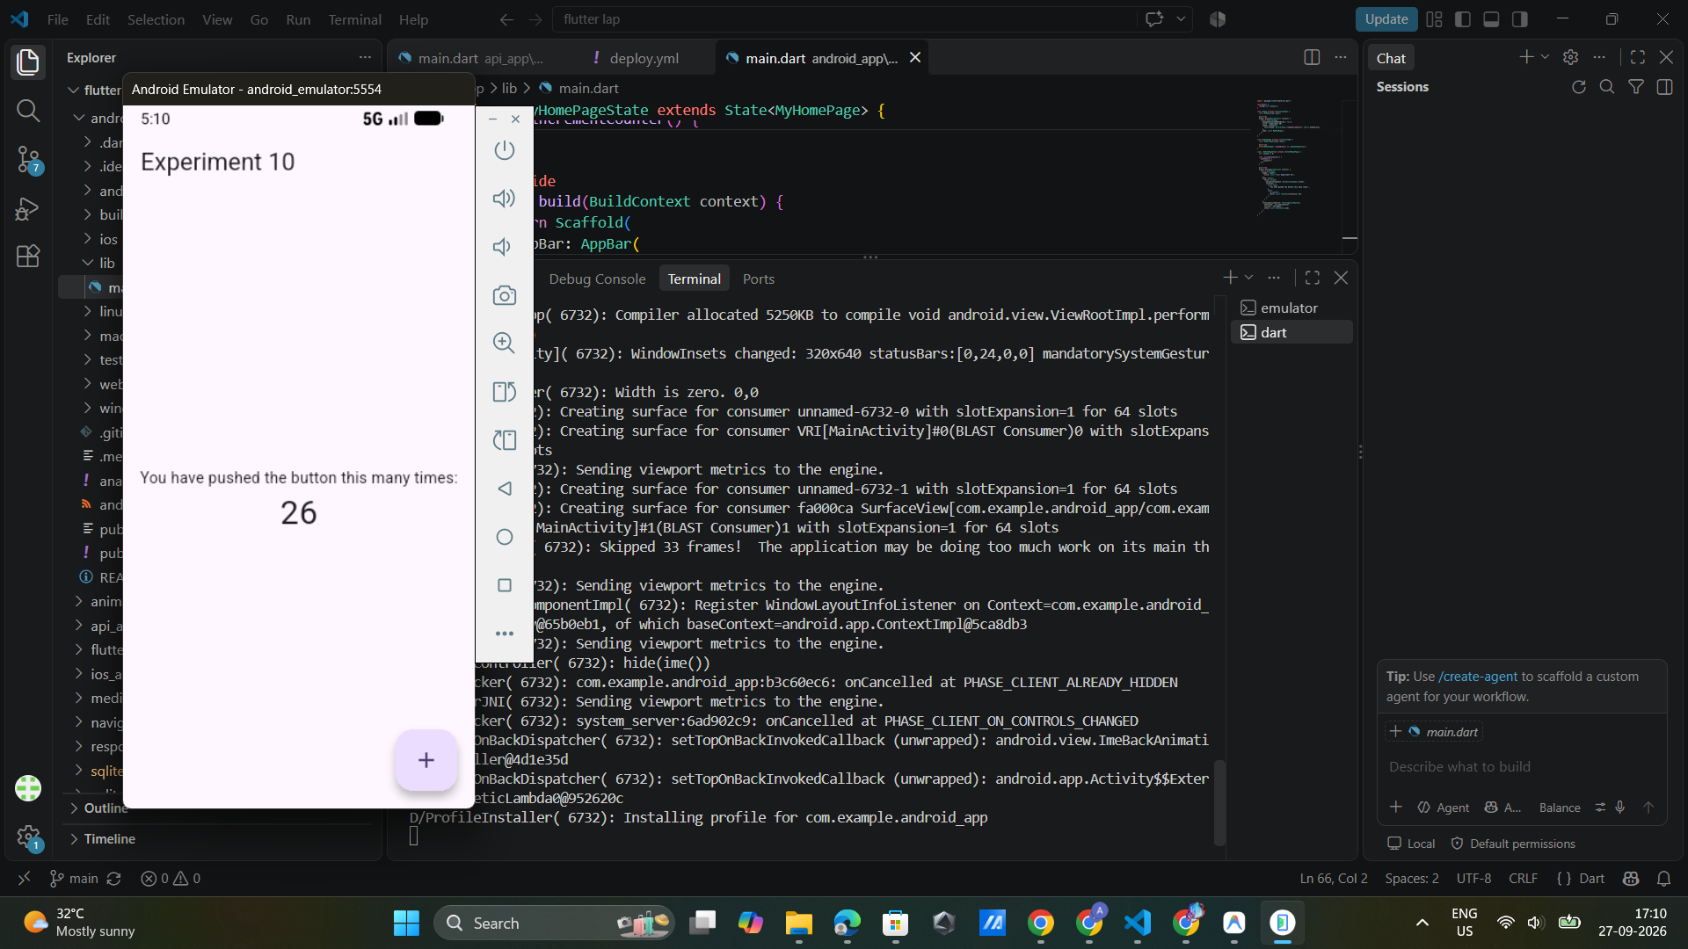

RESULT
The Flutter application was successfully configured, built, and executed as an Android application. The APK file was generated successfully and can be installed on an Android device.

