Ex. No. 03 | ADD INTERACTIVITY TO APP – INPUT AND FORMS
Date of Exercise | 25.08.2026
Git-hub Host Link | https://github.com/dasariobulesh/FLUTTEREXPS-3.git

Aim:
To create an interactive Flutter student registration form with input fields and validation for Student Name, Email, and Password, along with a Submit button.

Description:
This experiment demonstrates how to add interactivity to a Flutter application using input fields and forms.
A Form is used to group the input fields. TextFormField is used to accept user input such as Student Name, Email, and Password. GlobalKey<FormState> is used to identify and validate the form. The validator function checks whether the required Student Name field is empty. obscureText is used to hide the password input. An ElevatedButton is used as the Submit button. When the form is submitted successfully, a SnackBar displays a success message.

Procedure:
- Open Visual Studio Code and open the terminal.
- Create a new Flutter project using flutter create student_form.
- Navigate into the project using cd student_form.
- Open the project in Visual Studio Code using code ..
- Open the lib/main.dart file.
- Create a GlobalKey<FormState> for form validation.
- Create a Form widget and assign the form key.
- Add a TextFormField for entering the Student Name.
- Add validation to the Student Name field to display an error when it is empty.
- Add a TextFormField for Email input.
- Set the keyboard type of the Email field to TextInputType.emailAddress.
- Add a TextFormField for Password input.
- Set obscureText to true for the Password field.
- Add an ElevatedButton with the text Submit.
- Validate the form when the Submit button is pressed.
- Display Form submitted successfully using a SnackBar when the form is valid.
- Run the Flutter application.
- Click Submit without entering the Student Name and verify the validation message.
- Enter the student details and click Submit to verify the success message.
- Take screenshots of the output for the record.
- Initialize Git, commit the project, create a GitHub repository, and push the project to GitHub.
1


Ex. 3 |ADD INTERACTIVITY TO APP – INPUT AND FORMS

Program:
import 'package:flutter/material.dart'; void main() {
runApp(const StudentFormApp());
}

class StudentFormApp extends StatelessWidget { const StudentFormApp({super.key});

@override
Widget build(BuildContext context) { return MaterialApp( debugShowCheckedModeBanner: false, title: 'Student Registration',
theme: ThemeData(useMaterial3: true, colorSchemeSeed: Colors.blue), home: const StudentForm(),
);
}
}

class StudentForm extends StatefulWidget { const StudentForm({super.key});

@override
State<StudentForm> createState() => _StudentFormState();
}

class _StudentFormState extends State<StudentForm> { final _formKey = GlobalKey<FormState>();

@override
Widget build(BuildContext context) { return Scaffold(
appBar: AppBar( title: const Text(
'Student Registration',
style: TextStyle(fontWeight: FontWeight.bold),
),
centerTitle: true,
),

body: Center(
child: SingleChildScrollView( padding: const EdgeInsets.all(24), child: Card(
elevation: 6, child: Padding(
padding: const EdgeInsets.all(24), child: Form(
key: _formKey, child: Column(
mainAxisSize: MainAxisSize.min, children: [
const Icon(Icons.school, size: 60), const SizedBox(height: 15),
const Text(
'Create Student Account', style: TextStyle( fontSize: 24,
fontWeight: FontWeight.bold,
),
),
const SizedBox(height: 25), TextFormField(
decoration: const InputDecoration( labelText: 'Student Name', prefixIcon: Icon(Icons.person), border: OutlineInputBorder(),
),
validator: (value) {
if (value == null || value.isEmpty) { return 'Enter student name';
}
return null;
},
),
const SizedBox(height: 18), TextFormField(
decoration: const InputDecoration( labelText: 'Email',

prefixIcon: Icon(Icons.email), border: OutlineInputBorder(),
),
keyboardType: TextInputType.emailAddress,
),

const SizedBox(height: 18),

TextFormField( obscureText: true,
decoration: const InputDecoration( labelText: 'Password',
prefixIcon: Icon(Icons.lock), border: OutlineInputBorder(),
),
),
const SizedBox(height: 25), SizedBox(
width: double.infinity, child: ElevatedButton( onPressed: () {
if (_formKey.currentState!.validate()) { ScaffoldMessenger.of(context).showSnackBar( const SnackBar(
content: Text('Form submitted successfully'),
),
);
}
},
child: const Text('Submit'),
),
),
],
),
),
),
),
),
),
);
}
}
2

Ex. 3 | ADD INTERACTIVITY TO APP – INPUT AND FORMS

Output:

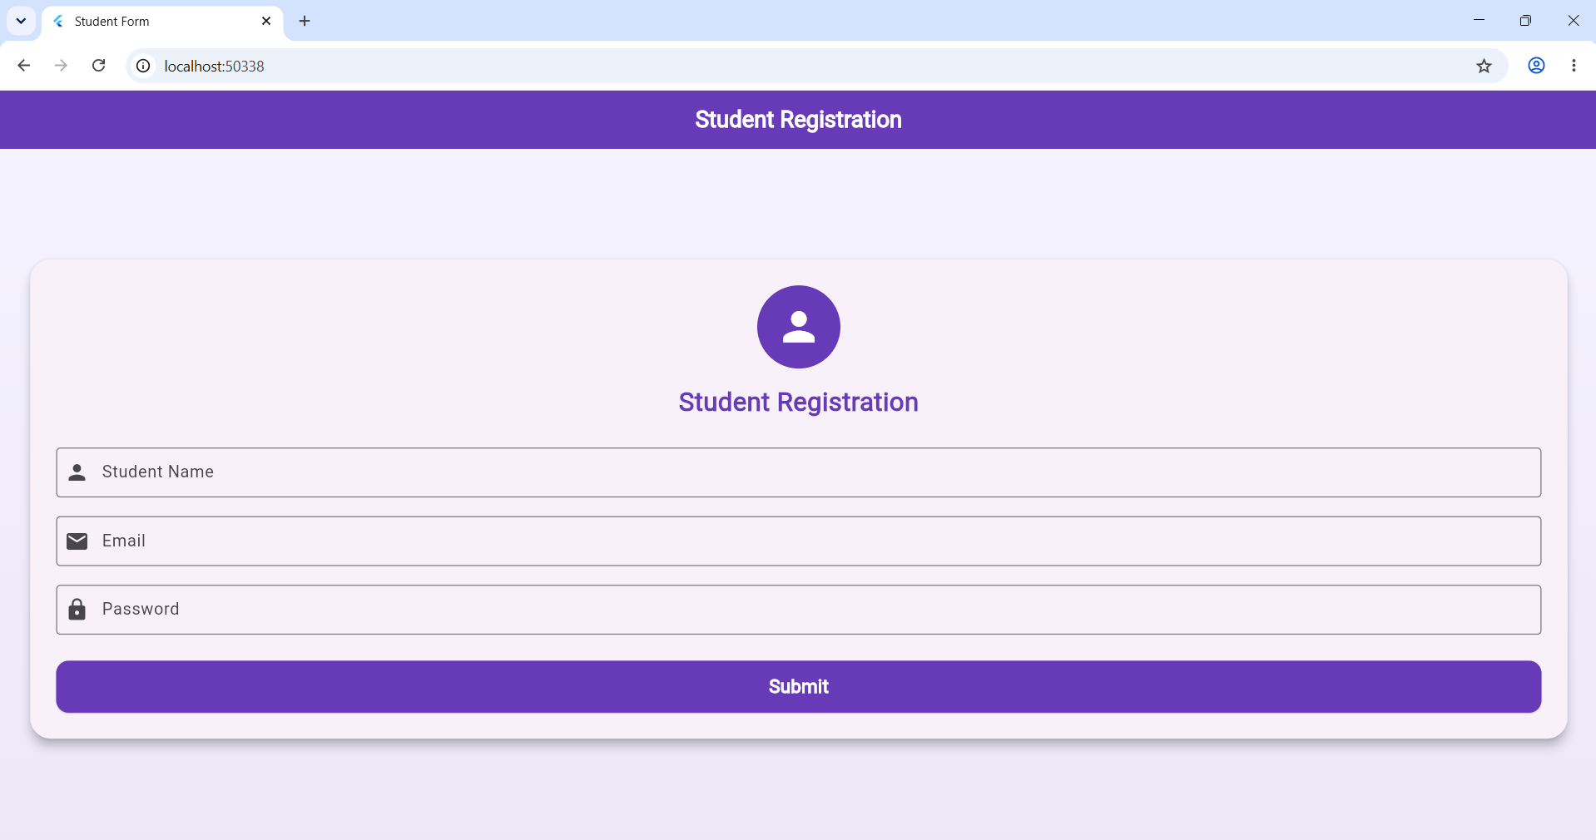

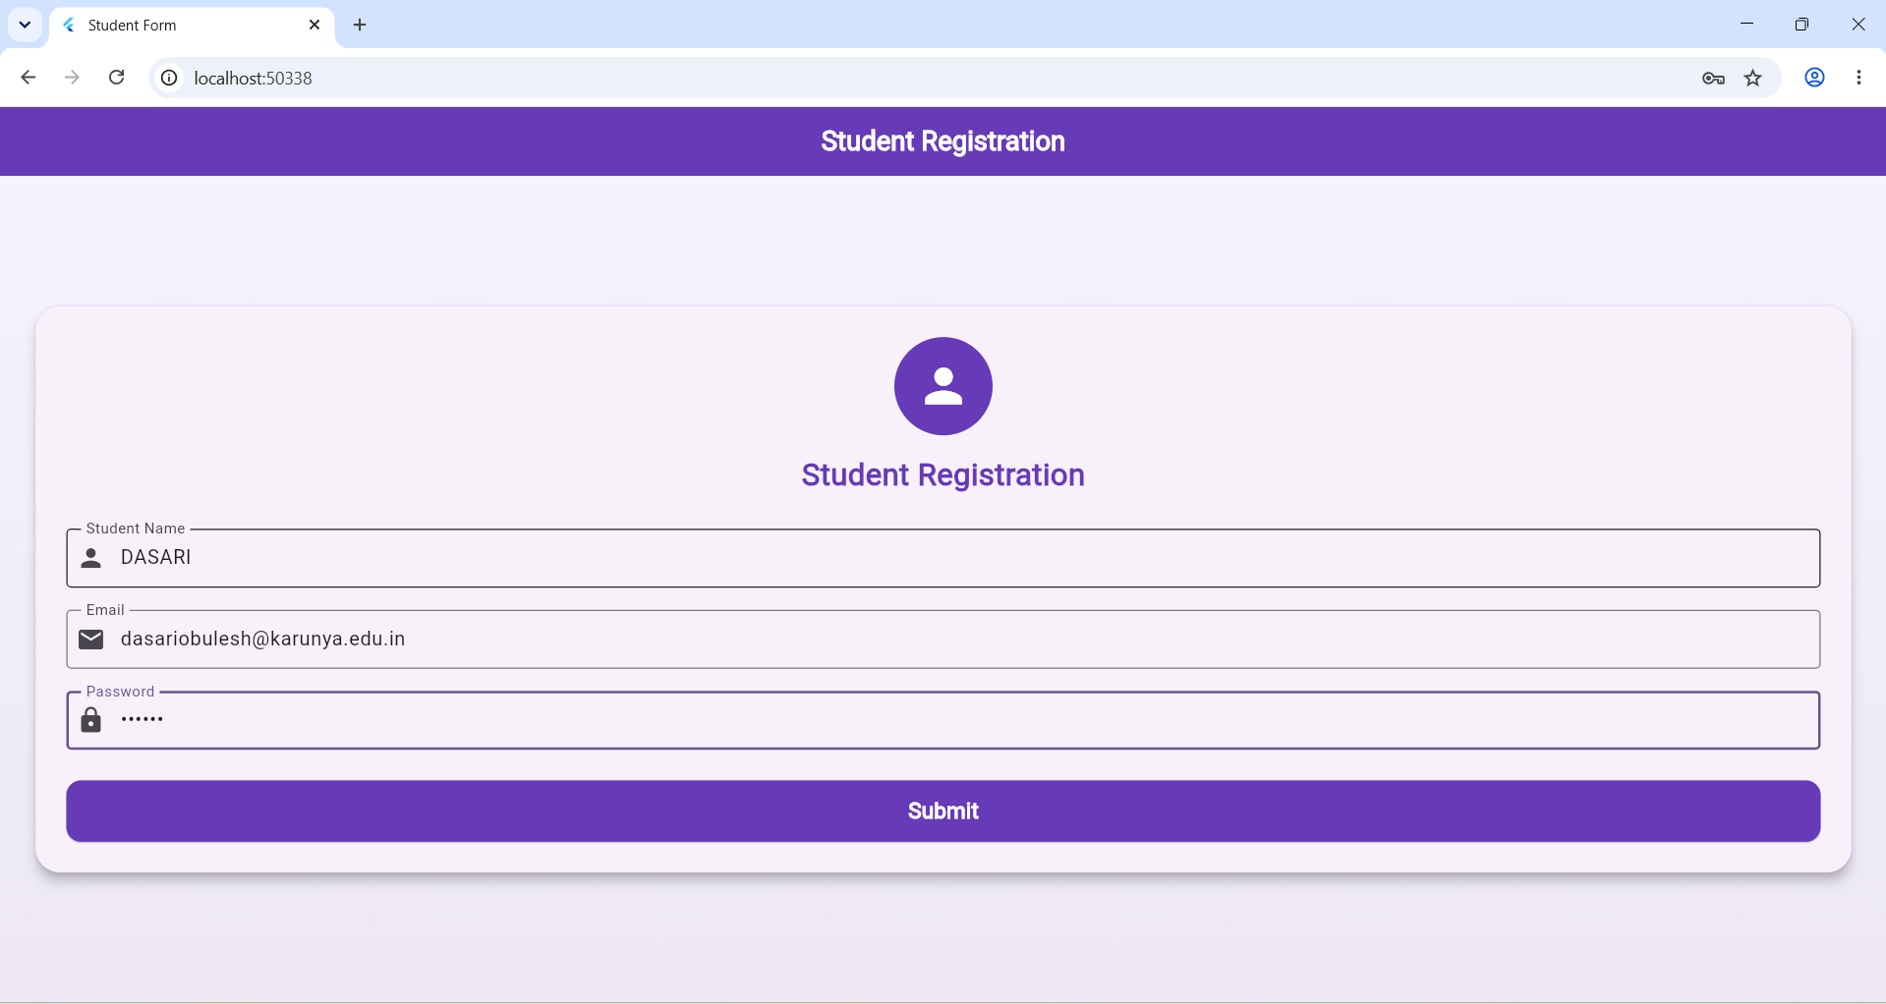

Result:
Thus, a working interactive Flutter student registration form was successfully created with Name, Email, Password, validation, and Submit button functionality.

3
Ex. 3 | ADD INTERACTIVITY TO APP – INPUT AND FORMS

