**TRASH TROOPERS**

**GAME DESIGN DOCUMENTS**

**Project overview**

This game design document describes a casual catcher game with touch controls, unique characters and gameplay.

**Version History**

|  |  |  |  |  |  |
| --- | --- | --- | --- | --- | --- |
| **Version #** | **Implemented**  **By** | **Revision**  **Date** | **Approved**  **By** | **Approval**  **Date** | **Reason** |
| 0.0.0.1 | *Kavyansh* | *03/08/2023* | *Lead* | *03/08/2023* | *Player movement* |
| 0.0.0.2 | Anmol | 04/08/2023 |  | *04/08/2023* | Trash Spawner |
| 0.0.0.3 | Kavyansh | 04/08/2023 |  | *04/08/2023* | Trash disposal system |
| 0.0.0.4 | Faizal | 05/08/2023 |  | *05/08/2023* | Updated GDD [Upgrade system, no of level, tutorial levels added] |

1. ***Characters***
2. ***Story***
   1. ***Theme***
3. ***Gameplay***
   1. ***Goal***
   2. ***User Skills***
   3. ***Game Mechanics***
      1. ***Core Mechanics***
      2. ***Core Loop***
   4. ***Items & powerups***
      1. ***Items***
      2. ***Powerups***
      3. ***Upgrades***
   5. ***Progression & Challenge***
   6. ***Losing***
4. ***World and Environment Design***
5. ***User Interface [UI]***
6. ***Art style***
7. ***Music & Sounds***
8. ***Technical description***
9. ***Marketing & Funding***
   1. ***Demographics***
   2. ***Platforms & Monetization***
   3. ***Localization***
10. ***Other ideas***
11. **Characters**

The **player** is a trash cleaner who collects falling trash from building(s) and sorts the dry & wet waste in separate trash bins.

**NPC(s):** The people that are throwing trash from their respective floor(s).

**Aunty [BOSS]:** The final boss of the game who throws a lot of trash and is to be defeated to win the game.

1. **Story**

The game is set in an Indian street, people are throwing trash on the street and making the environment dirty.

We are a trash cleaner guy who is cleans the city by picking, sorting all that trash that these people are throwing, in separate trash bins.

* 1. **Theme**

This game is about spreading awareness about climate change and the cleanliness of our environment.

* 1. **Genre**

Casual | 2.5D

1. **GamePlay**
   1. **Goals**

Short term goals:

* Pick up trash
* Sorting of trash

Overall goal:

* Defeat the final boss “Evil aunty”
  1. **User Skills**
* Joystick movement [left & right]
* Catch falling objects
* Clean the trash piled up on the ground by just touching it.
  1. **Game Mechanics**

Here game mechanics are described by a **walkthrough** of just 1 level of the game:

* Player is spawned in the environment.
* Player can move Left & Right with a joystick.
* NPCs are throwing dry & wet waste from their respective floor of the building(s).
* There are two trash bins, one for dry waste only, other one for dry waste only.
* Player has to catch all the trash.
  + Player has a trash bag which can hold trash.
    - Condition of catching the trash
      * If player picks up dry waste first:
        + Then he/she will have to collect only the dry waste.
        + And dispose all the dry waste in dry trash bin before player can catch wet waste. [vice versa]
* There are 5-10 levels in the game ad there is a final boss fight.
* BOSS FIGHT
  + There is an evil aunty who doesn’t care about environment even a bit, throws a lot of trash on streets and must be taught a lesson.
    1. **Core Mechanics**
* Lest & Right Movement
* Catch the trash
* Sort the trash.
  + 1. **Core loop**

**Spawn trash**

**Catch trash**

**Sort & Dispose trash**

* 1. **Items and powerups**
     1. **Items**
* Trash
  + Wet
    - Fruit peels
    - Chicken/Fish bones
    - Egg shells
    - Sanitary napkins or diapers
    - Food waste/leftovers
  + Dry
    - Empty bottle
    - Soft drink cans
    - Cardboard boxes
    - Newspaper
    - Chips wrapper
* Trash bins for both type of trash.
  + 1. **Powerups**
* **Gloves:** These gloves automatically separates both type of trash into their respective trash bins.
* **Eco-Bin-Bomb:** Clears all the waste currently on the screen and puts it into respective bins.
* **Time Slow:** Slows down the time for a particular time so player can strategize itself.[not in short version]
* **Time Fast:** Increases the speed of falling waste (can work as a negative powerup) [not in short version]
  + 1. **Upgrades**
* **Capacity:** Player can be upgraded to hold more than 1 waste item at a time to multiple items.
* **Speed:** Walking speed of the player can be upgraded.
* **Cleaning power:** Time taken to clean the waste piled up on ground can be reduced by upgrading this power up. [not in short version]
* **Magnet:** Player will be able to attract the trash towards it.
  1. **Progression and Challenge**

There will initially be 5 levels 5th being boss level.

|  |  |
| --- | --- |
| **Name** | Description |
| **Tutorial Level 1** | Introduction of UI controls and trash. Player will just have to catch the trash and dispose it in any of the dustbins. Sorting not introduced yet. |
| **Tutorial Level 2** | Introduction to a powerup and sorting of trash into two separate dustbins. |

**What is locked, unlocked and where?**

|  |  |  |  |  |  |  |  |
| --- | --- | --- | --- | --- | --- | --- | --- |
| **NAME** | **GOAL**  **OF THE**  **LEVEL** | **UN-LOCKED** | **SPAWNING OF POWERUPS** | **LOCKD** | **START TIME OF INSTANCIATING OF TRASH** | **INCREASE OF RATE OF INSTANCIATING OF TRASH** | **END POINT OF RATE** |
| **Level 1** | Time based. Player has to survive through the given time [ex: 5 min] and maintain the cleanliness meter above 60 to win level. | P1:Gloves | Every 10 seconds | Others | One trash every **4** seconds | -0.5s with every spawn | 2s |
| **Level 2** |  | P1: [Gloves, Eco-Bin-Bomb], U1: [Capacity unlocked] | 1.5s |
| **Level 3** |  |  | 1s |
| **Level 4** |  |  | 0.5s |
| **Level 5: [BOSS]** |  | All powerups & upgrades unlocked |  | Boss throws trash very frequently | N/A |  |

**\*These values are for reference\***

**3.5.1. BOSS**

The Evil Aunty is the final boss of trash troopers, she hates trash collector guys and doesn’t care about environment. Although the boss fight will have two phases but we’ll limit it to just one for now [for IGDC].

Boss fight will be time bases survival [for IGDC].

**Phase one:**

|  |  |  |  |  |  |
| --- | --- | --- | --- | --- | --- |
| **Name** | **Base Attack**  **[Sane]** | **Attack 1** | **Attack 2** | **Attack 3** | **Attack 4**  **[Insane]** |
| **Evil Aunty** | 1 trash/2 seconds |  |  |  |  |
| **Lasts** | 15 seconds |  |  |  |  |

* 1. **Losing**

|  |  |  |  |  |
| --- | --- | --- | --- | --- |
| **Criteria of losing** | **Initial value** | **[80 – 100]** | **[60 - 80)** | **Below 60** |
| **Cleanliness meter** | 100 | Perfect | Fair | Fail |
| **Effect** | No dust on screen. | Very little dust on screen. | Large amount of dust on screen. | Huge amount of dust on screen. |
| **Reward** | Economy will be added in the full version of the game. | | | |

1. **World and Environment Design**

The game’s world environment is set in the Indian style street.

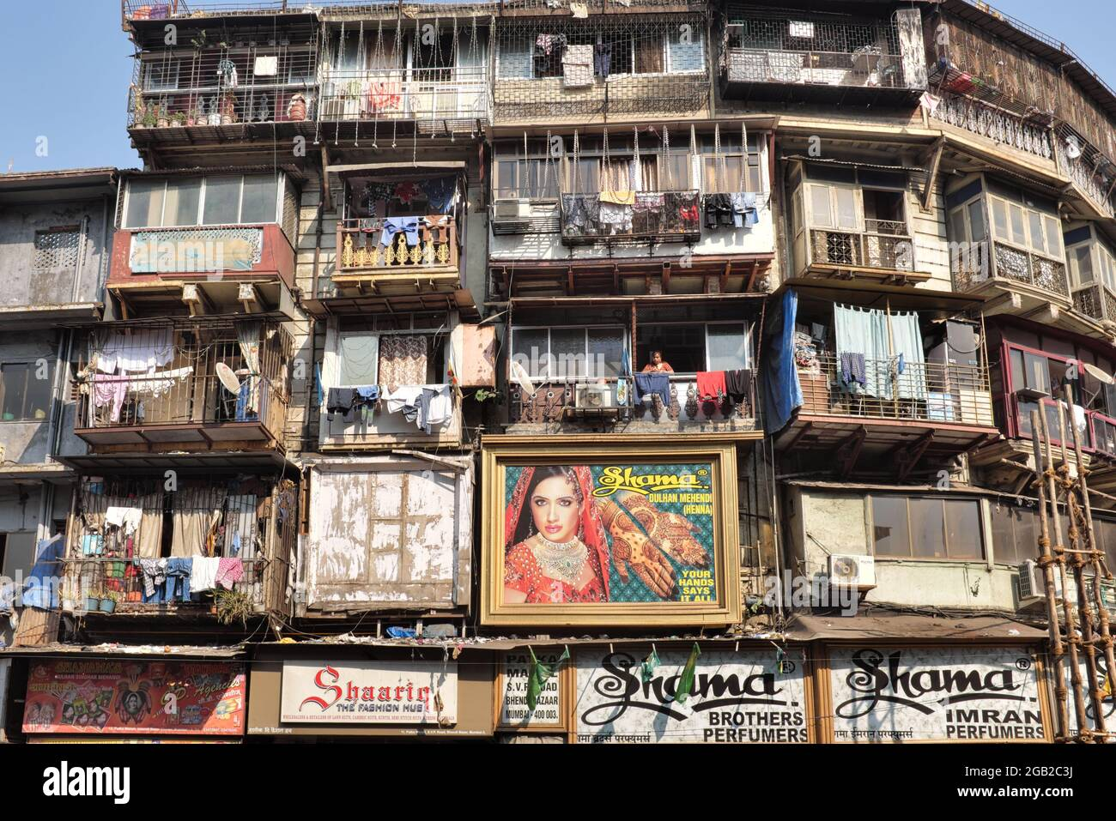

* - - - - - - - - - - -

Dry

Wet

C Meter

1. ***User Interface [UI]***
   1. **Mock ups**

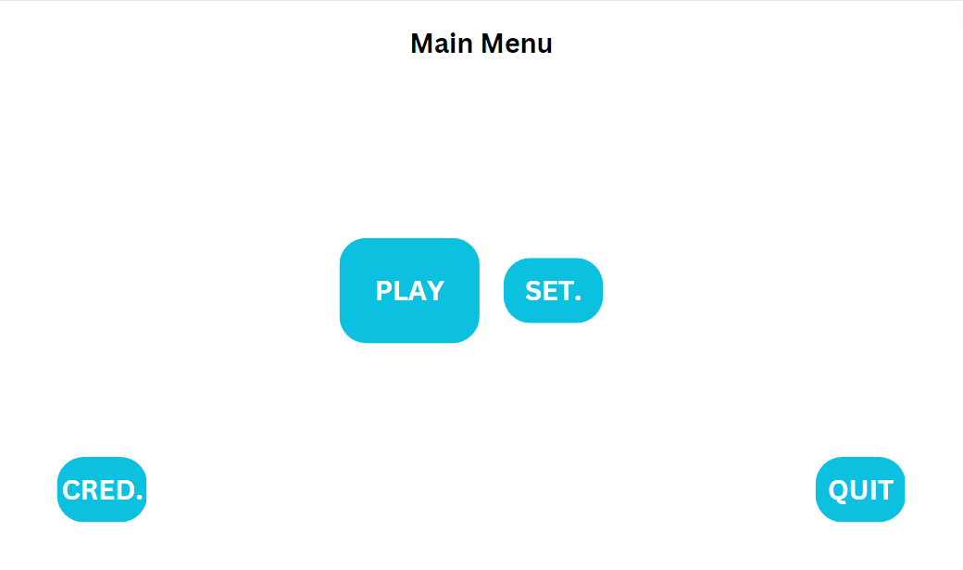

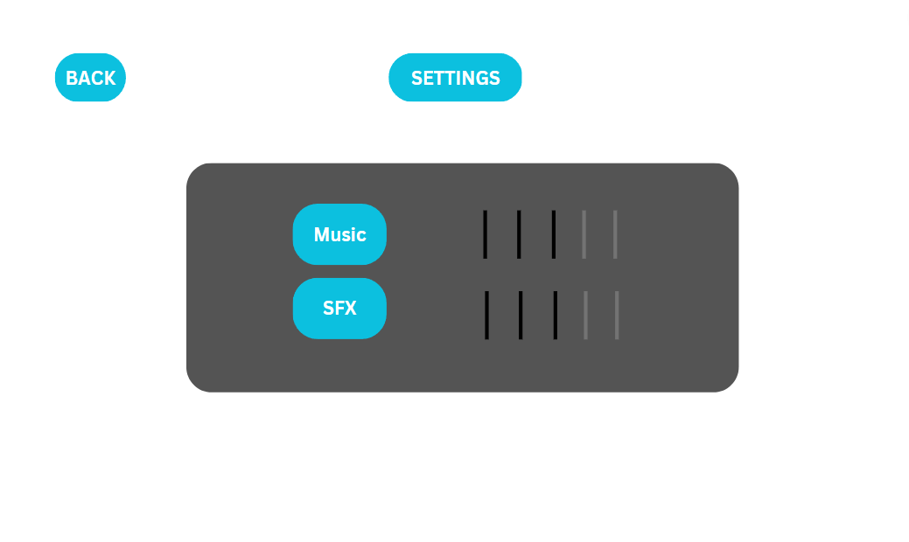

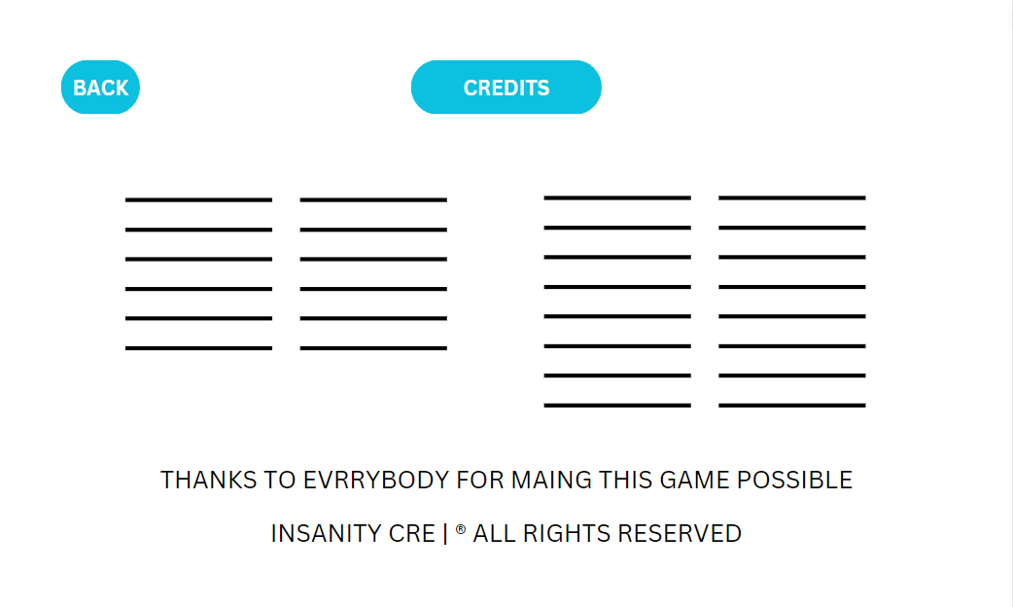

INSANITY CREW

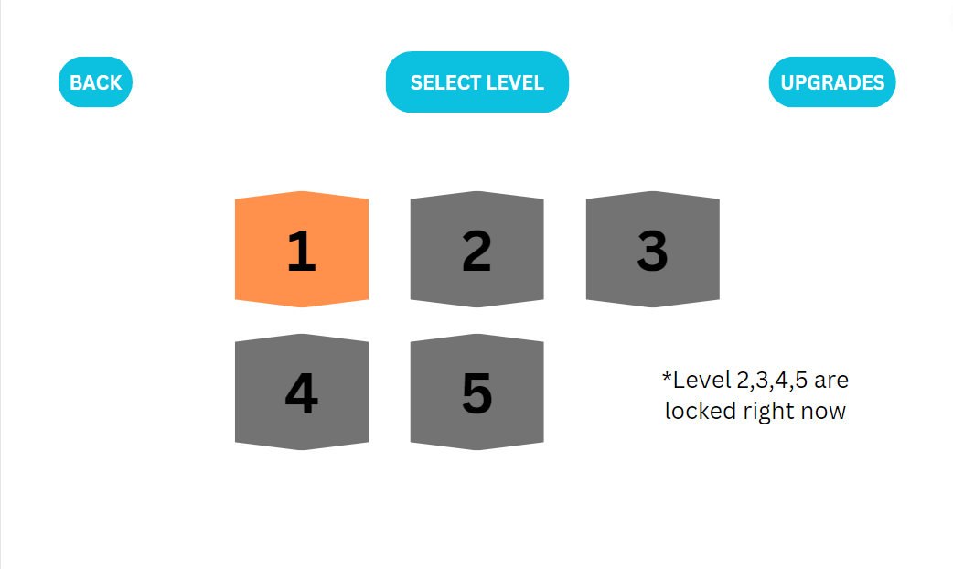

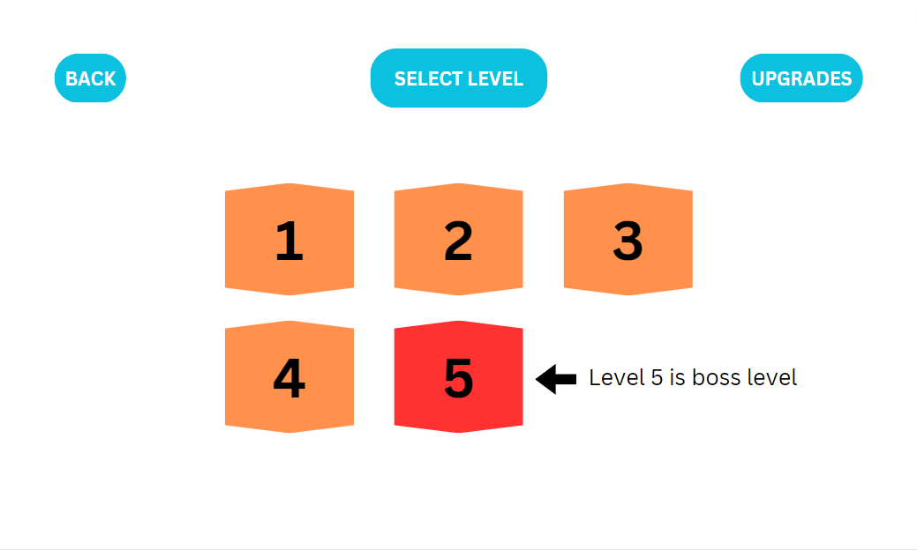

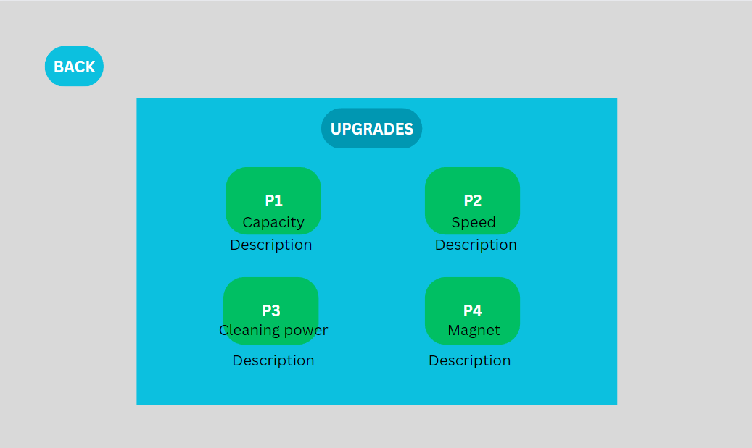

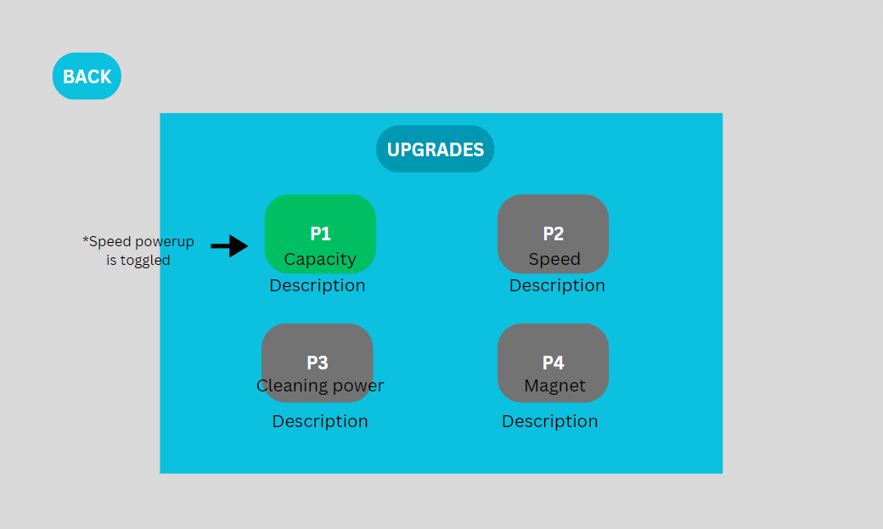

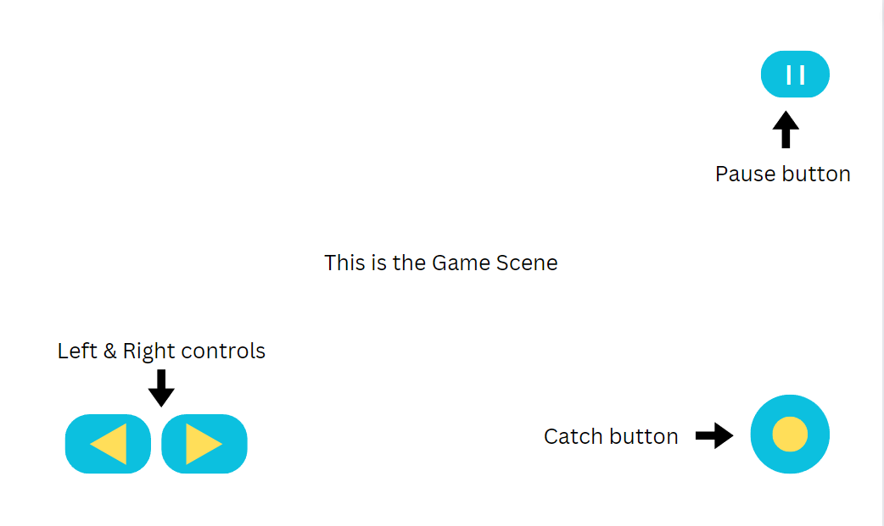

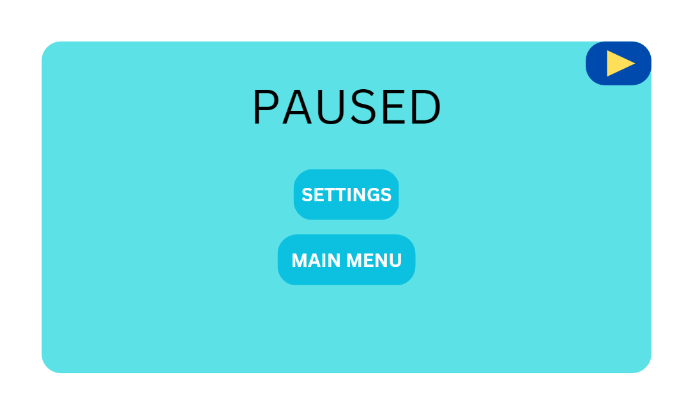

1. ***Art style***

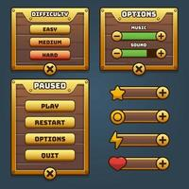

1. ***Music & Sounds***

The game will have the following music and sound effects

* 1. **Music**
* Main menu music
  + Variation of theme song
* Level selector music
  + 4 layer music [1st layer will be the 4th] and subtle[ build up music, not loud]
* In game music
  + Theme song
  1. **Sound Effects [SFX]**
* Button touch
* When trash is caught
* When trash is disposed
* When trash is disposed in wrong bin
* When trash is disposed in right bin
* When trash hits the ground
* When a powerup is caught
* When Cleanliness meter goes down & up

1. ***Technical description***
2. ***Marketing & Funding***
   1. ***Demographics***
   2. ***Platforms & Monetization***

***Localization***