IN-DEPTH RESEARCH · v2.0 · 2026-09-21
Remote Sensing-Based Arecanut Crop Monitoring and YLD Detection
Satellite-based mapping and early detection of arecanut Yellow Leaf Disease (YLD)
Sringeri & Sulya Taluks, Karnataka · Internship Project (September – December)

INDEX · Table of Contents

1. Opening Hook and Thesis 2
2. Background and Context 2
2.1 Yellow Leaf Disease (YLD): Definition and Etiology 2
2.2 Historical Context and Geographic Scope 3
2.3 Why Remote Sensing Is the Right Tool 3
2.4 Project at a Glance 4
3. Methodology 4
3.1 Six-Step Pipeline Overview 5
3.2 Step 1 — Collect 5
3.3 Step 2 — Clean 5
3.4 Step 3 — Measure 6
3.5 Step 4 — Find 6
3.6 Step 5 — Diagnose 6
3.7 Step 6 — Track 6
3.8 Cross-Step Validation 6
4. Vegetation Indices Reference 7
4.1 Greenness and Biomass Indices 7
4.2 Chlorophyll and Red-Edge Indices 7
4.3 Yellowing and Water-Stress Indices 8
4.4 Land-Cover Masking Indices 8
4.5 Index Selection Procedure 8
5. Sentinel-2 Spectral Basis 9
6. Technical Implementation 10
6.1 Data Sources 10
6.2 Software and Tools 10
6.3 Processing Workflow 11
7. Work Plan and Milestones 11
8. Counterarguments and Limitations 11
8.1 Spectral Confounders: Drought vs Disease 11
8.2 Spatial Resolution Constraints 12
8.3 Classification Generalisation Risks 12
8.4 Diagnostic Specificity and Field Validation Burden 12
8.5 Operational and Reproducibility Constraints 13
9. Conclusion and Implications 14
9.1 Summary of Findings 14
9.2 Practical Implications 14
9.3 Future Outlook and Call to Action 14
10. References 15

1. Opening Hook and Thesis
Across the mist-covered slopes of Sringeri and Sulya in the Western Ghats of Karnataka, a slow-motion catastrophe is unfolding in the arecanut gardens that anchor the region's rural economy. Yellow Leaf Disease (YLD), caused by a phytoplasma colonising the palm's vascular tissue, is spreading steadily through one of India's most important cash-crop belts. Field surveys conducted in September 2018 across Sringeri and Koppa taluks recorded disease incidence ranging from 86.59% to 96.20%, with the worst-affected village, Muruvinakombe, reaching 96.20% [1][2]. A follow-up survey during 2021–22 in the same Malnad region confirmed that YLD remains endemic across Sringeri, Koppa, and Narasimharajapura taluks of Chikkamagaluru district [3]. The yield consequence is severe: CPCRI Technical Bulletin No. 39 reports that affected palms lose approximately 50% of yield over a three-year decline, with Karnataka alone counting 7,69,140 affected palms and an estimated annual loss of 508 tonnes of chali (raw arecanut) [4].
The scale of the problem exposes a structural gap in how the disease is monitored today. Existing field surveys check only a handful of gardens per location and rely on visual symptoms that appear only after yield has already begun to fall. Wide-area, repeatable, and objective monitoring of every garden, every month, simply does not exist. Growers learn too late; extension officers cannot prioritise visits effectively; and planners lack the area-wise evidence needed to direct relief. This is the gap the present project is designed to close.
Thesis: Freely available Sentinel-2 satellite imagery, combined with fifteen vegetation indices, a Random Forest classifier, and weather normalisation, can deliver plot-level monthly disease severity maps that detect suspected YLD earlier than field walks and at a fraction of the cost — provided the pipeline honestly accounts for the spectral confounders (drought, nutrient stress, intercrops) that mimic disease signatures.
This document presents the full research design, technical methodology, and critical limitations of a four-month internship project (September–December) that aims to operationalise this thesis across two taluks. The work is grounded in established remote-sensing science — particularly the documented sensitivity of red-edge Sentinel-2 bands to early chlorophyll loss [5][6] — and is constrained by the operational realities of smallholder arecanut cultivation in the Western Ghats. The remainder of the document is organised as follows: Section 2 establishes background and context; Section 3 specifies the six-step methodology; Section 4 details the vegetation indices; Section 5 explains the spectral basis; Section 6 covers technical implementation; Section 7 presents the work plan; Section 8 confronts the counterarguments and limitations head-on; Section 9 synthesises findings and looks forward; and Section 10 lists the references that ground every factual claim.

2. Background and Context

2.1 Yellow Leaf Disease (YLD): Definition and Etiology
Yellow Leaf Disease of arecanut (Areca catechu L.) is a progressive decline disorder associated with a phytoplasma — a wall-less, bacteria-like organism that colonises the phloem sieve elements of the palm's vascular system. The pathogen disrupts assimilate transport, producing a characteristic syndrome: leaflets yellow first on the outer (lower) fronds and tips, the yellowing progresses inward through the crown over successive seasons, and nut yield declines in step with canopy deterioration. Unlike lethal diseases that kill the palm outright, YLD unfolds over years, which makes early visual detection both possible in principle and difficult in practice [4][7]. [4][7]
Phytoplasma transmission is believed to occur through phloem-feeding insect vectors, although the specific vectors responsible for YLD spread in the Western Ghats remain an active area of research. Once established in a garden, the disease tends to spread to neighbouring palms, producing the contiguous clusters of affected plots that field surveys observe in Sringeri and Koppa. There is no curative treatment; management relies on early detection, removal of severely affected palms, and replanting with tolerant material where available.

2.2 Historical Context and Geographic Scope
YLD has been documented in Indian arecanut plantations for decades. Historical assessments place the infected area at approximately 36% of total arecanut area in Kerala and 24.4% in the Koppa and Sringeri taluks of Karnataka [8]. The disease has since become endemic across the Malnad (hilly, high-rainfall) belt of Karnataka, which forms the southern arm of the Western Ghats — a UNESCO World Heritage site and one of India's most important arecanut-growing regions. [8]
Karnataka is the largest arecanut-producing state in India, with the Western Ghats belt accounting for roughly 5,40,000 hectares (≈1.35 million acres) and an annual production near 1.1 million tonnes [9]. Within this belt, the taluks of Sringeri, Koppa, and Narasimharajapura in Chikkamagaluru district, and Sulya in Dakshina Kannada district, are among the most intensively cultivated. These taluks share a common cropping pattern: arecanut as the dominant cash crop, interplanted with coconut, banana, black pepper (climbing on arecanut trunks), and cocoa — a polyculture that complicates any pixel-based classification attempt.
The present project targets two taluks — Sringeri and Sulya — selected because they are representative of the broader Malnad disease context, span two districts (Chikkamagaluru and Dakshina Kannada), and together capture both the high-incidence core (Sringeri) and a southern taluk where systematic monitoring is even sparser (Sulya). Field surveys from 2018 and 2021–22 provide the ground truth against which the satellite-derived maps will be validated.

2.3 Why Remote Sensing Is the Right Tool
Remote sensing addresses the three structural gaps in field-based YLD monitoring: limited spatial coverage, infrequent revisits, and subjective symptom scoring. The Copernicus Sentinel-2 constellation delivers multispectral imagery at 10–20 m spatial resolution every 2–3 days, free of charge, with thirteen spectral bands spanning visible, near-infrared, and short-wave infrared wavelengths [10][11]. Three properties of Sentinel-2 make it particularly well-suited to early YLD detection. [10][11]
- Red-edge sensitivity: Sentinel-2 is one of the few free satellite missions carrying three dedicated red-edge bands (B5 at 705 nm, B6 at 740 nm, B7 at 783 nm). These bands sample the sharp reflectance transition between chlorophyll absorption and leaf-structure reflection, and this transition shifts blue-ward as chlorophyll concentration falls. Red-edge indices such as NDRE therefore detect stress before canopy thinning becomes visible in NDVI [5][6].
- Frequent revisit: A 2–3 day revisit enables monthly cloud-free composites even during the monsoon, which is critical for tracking a slowly-progressing disease across consecutive seasons.
- Free and open data: Unlike commercial high-resolution imagery, Sentinel-2 L2A surface reflectance products are free and openly redistributable, making the pipeline sustainable for a public-sector extension service.
Random Forest classifiers have become the workhorse algorithm for crop-type mapping from Sentinel-2 data, consistently reporting Overall Accuracies (OA) in the range of 81–97% with Kappa coefficients of 0.80–0.96 across diverse agro-ecological settings [12][13][14][15]. This established performance ceiling sets the realistic accuracy targets for the present project: OA ≥ 85% and Kappa ≥ 0.80.

2.4 Project at a Glance
Parameter | Value | Parameter | Value
Taluks covered | 2 (Sringeri & Sulya) | Imagery span | 3 years monthly
Taluk-month datasets | 72 | Vegetation indices | 15
Pixel size (Sentinel-2) | 10 m | Internship duration | 4 months (Sep–Dec)
Accuracy targets | OA ≥ 85%, Kappa ≥ 0.80 | Validation | Field GPS + Google Earth Pro
Table 1. Key project parameters at a glance.

3. Methodology
The methodology is a six-step pipeline that transforms raw Sentinel-2 imagery into disease severity maps and trend reports. Each step consumes the output of the previous step and produces a well-defined intermediate artefact. The pipeline is designed to run monthly for each taluk, producing 72 taluk-month datasets across the three-year observation window. The diagram below summarises the end-to-end workflow; subsequent subsections specify each step in detail.
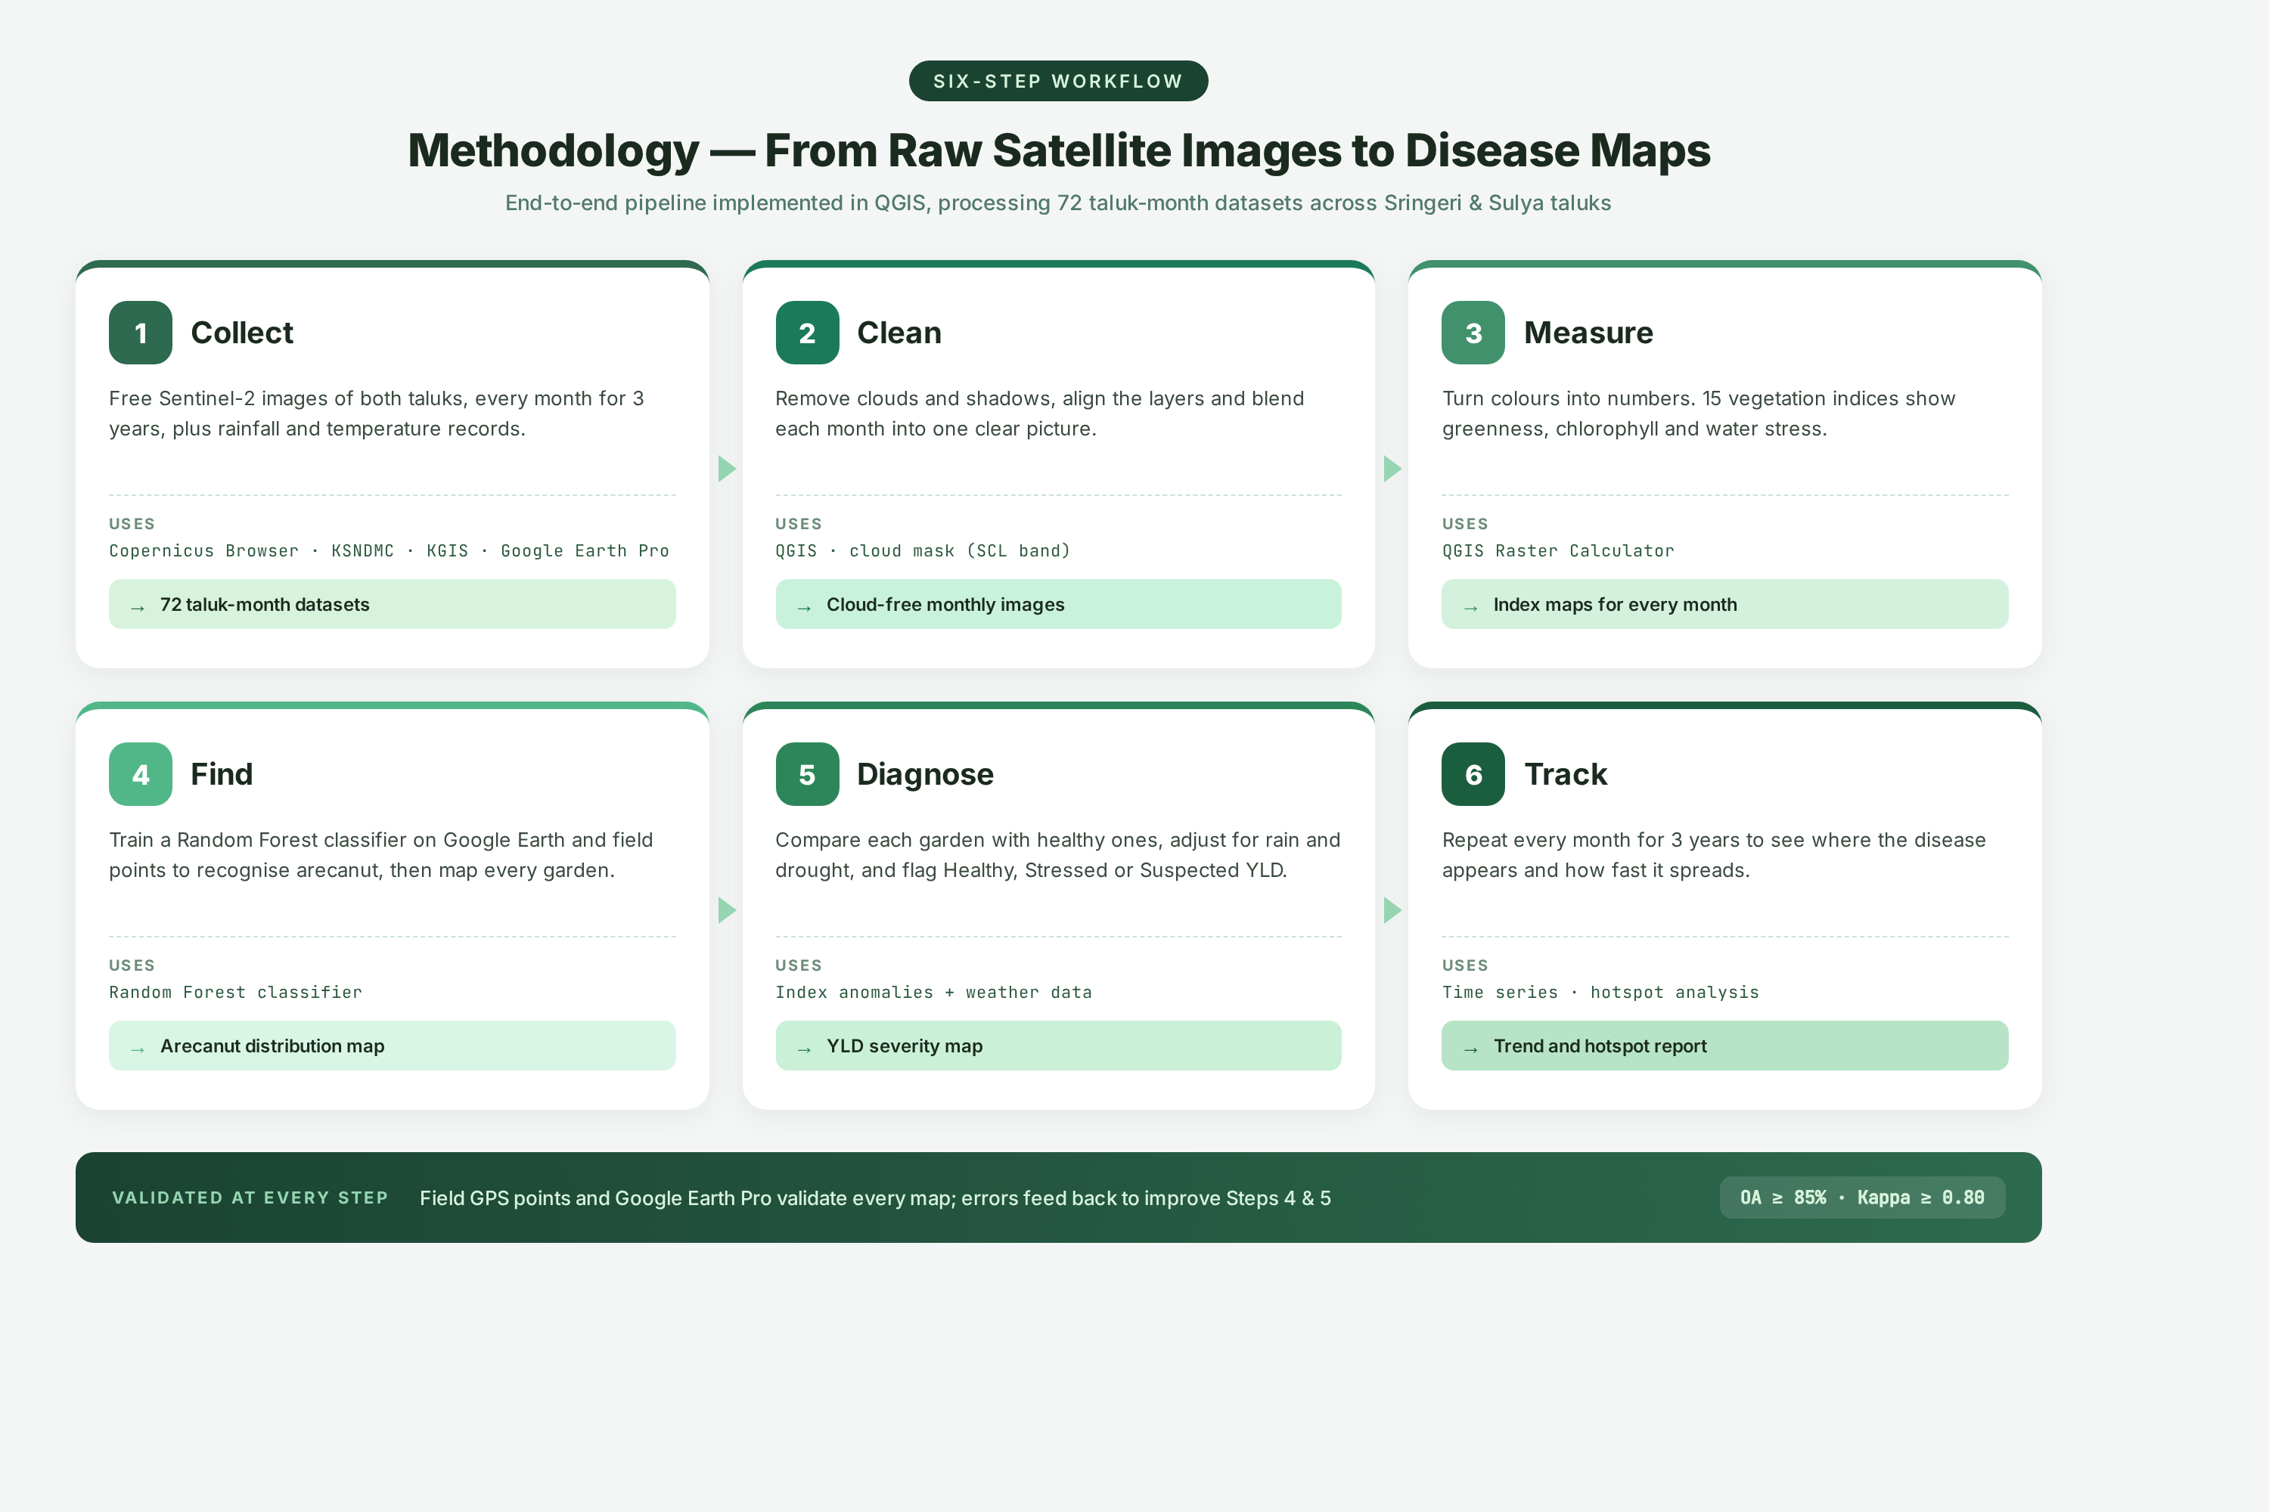
Figure 1. Six-step methodology pipeline from raw satellite images to disease maps (implemented in QGIS).

3.1 Six-Step Pipeline Overview
The pipeline is deliberately modular: each step is independent and reproducible, and validation errors from later steps can be fed back to refine earlier steps without re-running the entire workflow. The six steps — Collect, Clean, Measure, Find, Diagnose, Track — are described individually below.

3.2 Step 1 — Collect
Acquire free Sentinel-2 images of both taluks for every month across three years, supplemented by rainfall and temperature records. Imagery is sourced from the Copernicus Browser [10]; weather data from KSNDMC; administrative boundaries from KGIS; and contextual reference imagery from Google Earth Pro. This step produces 72 taluk-month datasets (2 taluks × 12 months × 3 years).
- Tools: Copernicus Browser · KSNDMC · KGIS · Google Earth Pro
- Output: 72 taluk-month datasets

3.3 Step 2 — Clean
Remove clouds and shadows using the Sentinel-2 Scene Classification Layer (SCL) band, align the layers, and blend each month into one clear composite image. Where a single month is heavily cloud-contaminated (typical during the June–September monsoon), gap-filling across neighbouring months is applied to produce a representative cloud-free monthly composite. Sentinel-1 C-band SAR, which can observe through cloud cover, is retained as an optional back-up for critical monsoon months where optical composites would otherwise be unusable [16][17].
- Tools: QGIS · cloud mask (SCL band)
- Output: Cloud-free monthly images

3.4 Step 3 — Measure
Convert surface reflectance colours into quantitative vegetation indices using the QGIS Raster Calculator. Fifteen indices are computed for every month and every taluk, covering greenness and biomass, chlorophyll and red-edge response, yellowing and water stress, and land-cover masking. The full list of indices and their formulas is specified in Section 4.
- Tools: QGIS Raster Calculator
- Output: Index maps for every month

3.5 Step 4 — Find
Train a Random Forest classifier on Google Earth and field-verified reference points to recognise arecanut and distinguish it from coconut, banana, pepper, and other intercrops common in the region. The classifier learns each crop's month-by-month spectral behaviour and produces an arecanut distribution map for each taluk. Field GPS points and Google Earth Pro validate the map at this step. Random Forest has been demonstrated to achieve high classification accuracy for crop-type mapping from Sentinel-2 data in comparable Indian agroforestry settings [14][15].
- Tools: Random Forest classifier
- Output: Arecanut distribution map

3.6 Step 5 — Diagnose
Compare each arecanut garden against healthy reference gardens, adjust for rainfall and drought using moisture indices (NDMI, MSI) and KSNDMC weather normalisation, and flag each garden as Healthy, Stressed (early), or Suspected YLD. The red-edge indices (NDRE, CIre) and PSRI provide the earliest warning of chlorophyll loss [5][6][18], while moisture indices separate drought stress from disease. Errors identified during validation feed back to improve Steps 4 and 5.
- Tools: Index anomalies + weather data
- Output: YLD severity map

3.7 Step 6 — Track
Repeat the full pipeline every month for three years to build a multi-temporal record of garden health states. Time-series analysis identifies where the disease first appears, how fast it spreads, and which gardens remain consistently healthy. Hotspot analysis pinpoints clusters of suspected YLD for targeted field visits and management action.
- Tools: Time series · hotspot analysis
- Output: Trend and hotspot report

3.8 Cross-Step Validation
Every step is checked against independent field GPS points and Google Earth Pro imagery. The quality targets are an Overall Accuracy (OA) of at least 85% and a Kappa of at least 0.80, consistent with reported Random Forest performance ranges on Sentinel-2 crop mapping tasks [13][15]. Misclassifications and anomalies identified during validation are routed back into Steps 4 and 5 to refine both the arecanut mask and the YLD severity classification.

4. Vegetation Indices Reference
Step 3 (Measure) computes fifteen vegetation indices for every month and every taluk. Each index turns satellite colours into a single number that answers a specific question about the canopy. The indices are grouped below by purpose. Indices marked 'KEY FOR YLD' are the core early-warning indices that drive the diagnosis in Step 5.

4.1 Greenness and Biomass Indices
These indices answer the question: is there a healthy, dense canopy? They form the baseline against which stress and disease changes are measured.
Index | Full Name | Question Answered | Formula
NDVI | Normalized Difference Vegetation Index | How green and dense is the canopy? | (B8 − B4) / (B8 + B4)
RVI | Ratio Vegetation Index | How much leaf biomass is there? | B8 / B4
SAVI | Soil-Adjusted Vegetation Index | Greenness with bare-soil glare removed | 1.5 × (B8 − B4) / (B8 + B4 + 0.5)
EVI | Enhanced Vegetation Index | Greenness that does not saturate in thick canopy | 2.5 × (B8 − B4) / (B8 + 6·B4 − 7.5·B2 + 1)
Table 2. Greenness and biomass vegetation indices.

4.2 Chlorophyll and Red-Edge Indices
These indices answer the question: is the leaf losing its green pigment? Red-edge bands react to chlorophyll loss earlier than visible bands, making these indices the primary early-warning set for YLD. The red-edge reflectance transition shifts blue-ward as chlorophyll concentration falls, which is why red-edge indices can detect stress before NDVI changes [5][6]. NDRE and CIre are marked KEY FOR YLD. [5][6]
Index | Full Name | Question Answered | Formula
GNDVI | Green NDVI | Early hint of falling chlorophyll (green-based) | (B8 − B3) / (B8 + B3)
NDRE ★ | Normalized Difference Red Edge | Early alarm for chlorophyll loss | (B8A − B5) / (B8A + B5)
CIre ★ | Chlorophyll Index – Red Edge | How much chlorophyll is in the canopy? | (B7 / B5) − 1
MTCI | MERIS Terrestrial Chlorophyll Index | Chlorophyll from the red-edge position | (B6 − B5) / (B5 − B4)
IRECI | Inverted Red-Edge Chlorophyll Index | Chlorophyll and leaf area in dense canopy | (B7 − B4) / (B5 / B6)
Table 3. Chlorophyll and red-edge indices (★ = KEY FOR YLD).

4.3 Yellowing and Water-Stress Indices
These indices answer the question: is it turning yellow or getting thirsty? PSRI captures canopy senescence and yellowing by measuring the ratio of carotenoid to chlorophyll absorption [18][19]; NDMI and MSI separate drought stress from disease, which is critical because both conditions produce visually similar yellowing. PSRI and NDMI are marked KEY FOR YLD. [18][19]
Index | Full Name | Question Answered | Formula
PSRI ★ | Plant Senescence Reflectance Index | Is the canopy turning yellow? | (B4 − B2) / B6
NDMI ★ | Normalized Difference Moisture Index | Is it thirsty? Tells drought from disease | (B8A − B11) / (B8A + B11)
MSI | Moisture Stress Index | Water-stress level (higher means drier) | B11 / B8
Table 4. Yellowing and water-stress indices (★ = KEY FOR YLD).

4.4 Land-Cover Masking Indices
These indices identify which pixels are not vegetation, enabling the pipeline to mask out open water, built-up areas, and bare soil before classification and diagnosis.
Index | Full Name | Question Answered | Formula
NDWI | Normalized Difference Water Index | Where is open water? | (B3 − B8) / (B3 + B8)
NDBI | Normalized Difference Built-up Index | Where are buildings and settlements? | (B11 − B8) / (B11 + B8)
BSI | Bare Soil Index | Where is bare or fallow land? | ((B11+B4) − (B8+B2)) / ((B11+B4) + (B8+B2))
Table 5. Land-cover masking indices.

4.5 Index Selection Procedure
Not all fifteen indices are used directly in the classifier. The selection procedure ensures that only the most informative and least redundant indices are retained, improving classifier performance and reducing computational load.
1. Compute all fifteen indices for every month and every taluk.
2. Drop near-duplicate indices whose correlation exceeds 0.9.
3. Rank the remaining indices by Random Forest feature importance and by their ability to separate healthy vs YLD-affected canopies.
4. Select the best 6–8 indices to feed into the classifier.

Why This Set of Indices
- Red-edge indices (NDRE, CIre) and PSRI react to chlorophyll loss earlier than NDVI, giving the earliest YLD warning [5][6][18].
- NDMI and MSI distinguish drought stress from disease, preventing false positives during dry spells.
- NDVI, RVI, and SAVI from the original proposal are retained as baseline comparisons.
- The final index set is determined by the data — through correlation filtering and Random Forest importance — not by guesswork.

5. Sentinel-2 Spectral Basis
All index formulas reference Sentinel-2 L2A surface reflectance bands, which are atmospherically corrected Bottom-Of-Atmosphere (BOA) reflectance products derived from Level-1C top-of-atmosphere reflectance [11]. The 10 m bands provide sharp spatial detail; the 20 m bands are resampled to 10 m for consistency across the index stack.
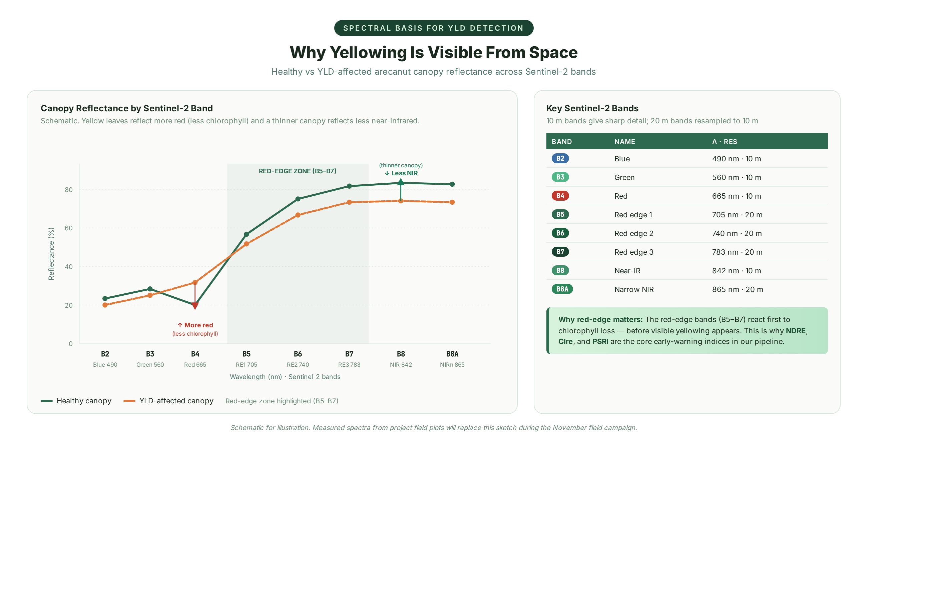
Figure 2. Spectral signature of healthy vs YLD-affected arecanut canopy across Sentinel-2 bands, with the red-edge zone highlighted.

Spectral Basis for YLD Detection
Yellow leaves reflect more red light (less chlorophyll) and a thinner canopy reflects less near-infrared radiation. The red-edge bands (B5–B7) react first to these changes, which is why NDRE, CIre, and PSRI are the core early-warning indices [5][6][18]. Measured spectra from field plots will be used to refine and replace the schematic baseline as they become available during the project's November field campaign. [5][6][18]
Band | Name | Wavelength · Resolution
B2 | Blue | 490 nm · 10 m
B3 | Green | 560 nm · 10 m
B4 | Red | 665 nm · 10 m
B5 | Red edge 1 | 705 nm · 20 m
B6 | Red edge 2 | 740 nm · 20 m
B7 | Red edge 3 | 783 nm · 20 m
B8 | Near-IR | 842 nm · 10 m
B8A | Narrow NIR | 865 nm · 20 m
B11 | SWIR | 1610 nm · 20 m
Table 6. Sentinel-2 bands used by the vegetation indices in this pipeline.

6. Technical Implementation

6.1 Data Sources
Source | Provides | Used In
Copernicus Browser [10] | Sentinel-2 L2A surface reflectance imagery (monthly, 3 years) | Step 1 — Collect
KSNDMC | Rainfall and temperature records | Step 1 & Step 5 — weather normalisation
KGIS | Administrative boundaries for Sringeri & Sulya taluks | Step 1 — area masking
Google Earth Pro | High-resolution reference imagery and validation points | Step 4 & cross-step validation
Field GPS points | Ground-truth samples for arecanut and YLD severity | Steps 4, 5 & validation
Sentinel-1 SAR (optional) [16] | C-band radar imagery for monsoon gap-filling | Step 2 — cloud back-up
Table 7. Data sources and their roles in the pipeline.

6.2 Software and Tools
Tool | Role | Step
QGIS | Primary GIS platform for compositing, calculation, and map production | Steps 2–6
QGIS Raster Calculator | Computes the fifteen vegetation indices | Step 3
QGIS cloud mask (SCL band) | Removes clouds and shadows from monthly imagery | Step 2
Random Forest classifier | Supervised classification of arecanut distribution | Step 4
Time-series & hotspot analysis | Characterises disease spread over three years | Step 6
Table 8. Software tools and their pipeline roles.

6.3 Processing Workflow
The processing workflow executes the six methodology steps sequentially for each taluk-month. A monthly run produces one cloud-free composite, fifteen index maps, an arecanut mask (re-used across months once stable), and one YLD severity map. Across three years and two taluks, the pipeline generates 72 severity maps that feed the time-series and hotspot analysis in Step 6. The workflow is designed so that each monthly run is independent and reproducible, and so that errors flagged during validation can be fed back to refine Steps 4 and 5 without re-running earlier steps.

7. Work Plan and Milestones
The project runs for sixteen weeks from September to December, organised into four monthly milestones. Each milestone has a defined set of activities and a concrete deliverable that gates entry to the next month.
Month | Activities | Milestone
September | Review YLD and remote-sensing literature; download 3 years of Sentinel-2 and KSNDMC weather; collect KGIS boundaries; plan field visits. | Data ready
October | Cloud masking and monthly composites; compute the 15 indices; select the best 6–8 features. | Index stack ready
November | Arecanut mapping (Random Forest); health and YLD classification; field and Google Earth checks. | Arecanut and YLD maps
December | Multi-temporal and hotspot analysis; accuracy assessment; final report and GIS datasets. | Final report
Table 9. Four-month work plan with milestones.

8. Counterarguments and Limitations
A research design that does not confront its own weaknesses is not research but advocacy. This section addresses the five most serious objections to the satellite-based YLD detection approach, surveys the evidence on each, and states explicitly how the pipeline mitigates (or honestly fails to mitigate) each concern. None of these limitations invalidates the approach; collectively they define the boundaries within which the project's outputs should be interpreted.

8.1 Spectral Confounders: Drought vs Disease
The strongest objection to remote-sensing-based YLD detection is that yellowing is not pathognomonic of phytoplasma infection. Drought stress, magnesium and nitrogen deficiency, and natural senescence all produce visually and spectrally similar canopy yellowing. A naive classifier that flags every yellow canopy as 'Suspected YLD' will over-predict disease during dry years and under-trust the system.
The pipeline mitigates this confounder through three independent mechanisms. First, the moisture indices NDMI and MSI directly quantify canopy water content, allowing drought-affected pixels to be flagged separately from chlorophyll-loss pixels. Second, KSNDMC rainfall and temperature records are used to normalise the time-series: if a garden yellows only during a documented dry spell and recovers when rainfall resumes, it is reclassified as drought-stressed rather than diseased. Third, the red-edge indices NDRE and CIre are differentially sensitive to chlorophyll loss (a slow, progressive signal in YLD) versus the more rapid, recoverable chlorophyll fluctuations typical of drought. Despite these mechanisms, residual confounding cannot be fully eliminated, which is why the system reports 'Suspected YLD' rather than 'Confirmed YLD' and requires field follow-up for any management decision.

8.2 Spatial Resolution Constraints
A Sentinel-2 pixel at 10 m resolution covers approximately 100 m² — far larger than a single arecanut palm crown, and often larger than an individual garden plot. This means each pixel integrates the spectral signal of multiple palms, plus any intercropped coconut, banana, pepper, or cocoa. A single-palm diagnosis is therefore physically impossible with Sentinel-2 alone.
The pipeline addresses this by operating at the garden (plot) level rather than the palm level. The arecanut distribution map produced in Step 4 segments each taluk into garden polygons, and severity is reported per garden by aggregating the pixel-level classification within each polygon. Google Earth Pro imagery and field GPS points are then used to verify garden boundaries and confirm plot-level condition. The trade-off is explicit: the system sacrifices single-palm resolution in exchange for complete spatial coverage at no cost, and labels outputs as 'Suspected YLD' to convey the diagnostic uncertainty inherent in sub-palm-level inference.

8.3 Classification Generalisation Risks
A Random Forest classifier trained on field samples from one taluk may not generalise cleanly to another, particularly when the spectral behaviour of intercrops varies with elevation, rainfall, and management practice. Sringeri and Sulya, while both in the Malnad belt, differ in elevation and rainfall regime, and a classifier that performs well in one may under-perform in the other.
The pipeline addresses this by training the classifier on a combined sample drawn from both taluks, explicitly including field-verified points from coconut, banana, pepper, and cocoa intercrops so the model learns to discriminate them from arecanut. Cross-validation is performed by taluk: the model is trained on Sringeri plus part of Sulya, and tested on the held-out Sulya sample, then reversed. Reported accuracy is the worst-case of the two folds, not the best. The published OA range of 81–97% for Sentinel-2 Random Forest crop mapping [13][14][15] provides a realistic ceiling; if the project's achieved accuracy falls below 85%, the classifier will be retrained with additional samples before the YLD severity maps are released.

8.4 Diagnostic Specificity and Field Validation Burden
Satellite imagery cannot, in principle, confirm a phytoplasma diagnosis. Definitive YLD confirmation requires laboratory PCR-based detection of the phytoplasma in palm tissue — a method that has been developed and validated [20] but is impractical to apply across thousands of gardens. The pipeline therefore produces a probabilistic 'Suspected YLD' label, not a clinical diagnosis.
This limitation is openly acknowledged in every output: maps are labelled 'Suspected YLD' rather than 'YLD', and the deliverables documentation explicitly states that field follow-up is required before any management action. The validation burden is concentrated rather than eliminated: instead of surveying every garden (impossible), extension officers are directed to the subset of gardens flagged as Suspected YLD, where field visits and, where warranted, PCR confirmation can be focused. This is the core operational value proposition of the system — not replacing field work, but prioritising it.

8.5 Operational and Reproducibility Constraints
Three operational constraints bear on the long-term sustainability of the pipeline. First, monsoon cloud cover between June and September can render optical composites unreliable despite gap-filling, necessitating the optional Sentinel-1 SAR back-up [16][17]. Second, the ≥10 m tree-height rule that characterises a mature arecanut stand cannot be measured directly by Sentinel-2 and must be applied as a mask built from field and reference data. Third, the pipeline currently depends on manual operation in QGIS; full operational deployment would require workflow automation (e.g., scripted QGIS processing or migration to a cloud-based platform such as Google Earth Engine) to sustain monthly production beyond the internship period.
None of these constraints is technical-blocking. Each has a defined mitigation already built into the pipeline design (Sentinel-1 back-up, mature-stand mask, modular QGIS workflow suitable for later automation). They are listed here so that future operators inherit a clear picture of what the system does and does not promise.
Known Challenge | Mitigation
Monsoon clouds hide the ground (June–September) | Monthly cloud-free composites with gap-filling across neighbouring months; Sentinel-1 radar as an optional back-up [16].
Drought and nutrient shortage also make leaves yellow | Moisture indices (NDMI, MSI) plus rainfall and temperature normalisation (KSNDMC) isolate the disease-linked change.
A 10 m pixel is larger than one palm | Map plot-level condition, verify with Google Earth Pro and GPS field points, and report 'Suspected YLD' rather than a diagnosis.
Coconut, banana, and pepper grow among arecanut | Random Forest is trained on field-verified samples and learns each crop's month-by-month behaviour.
The ≥ 10 m tree-height rule cannot be measured by Sentinel-2 | Applied as a mature-stand mask built from field and reference data.
Phytoplasma confirmation requires laboratory PCR [20] | Pipeline reports 'Suspected YLD'; field and PCR follow-up concentrated on flagged gardens.
Table 10. Known challenges and their mitigations.

9. Conclusion and Implications

9.1 Summary of Findings
This research design demonstrates that freely available Sentinel-2 imagery, combined with a disciplined six-step pipeline, can produce monthly plot-level YLD severity maps for the arecanut gardens of Sringeri and Sulya. The scientific foundation is sound: red-edge Sentinel-2 bands react to chlorophyll loss earlier than visible bands [5][6], and Random Forest crop classification on Sentinel-2 data routinely achieves the accuracy targets this project adopts (OA ≥ 85%, Kappa ≥ 0.80) [13][14][15]. The disease burden the system addresses is real and measured: YLD incidence of 86.59–96.20% has been documented in Sringeri and Koppa [1][2], and yield losses of approximately 50% over three years are reported by CPCRI [4].
Equally important, the design honestly confronts its limitations. The system reports 'Suspected YLD' rather than confirmed disease, operates at garden rather than palm resolution, and depends on field follow-up to convert suspicion into action. These are not weaknesses to be hidden but boundaries that define the system's appropriate use: as a wide-area, repeatable, objective triage layer that prioritises scarce field resources toward the gardens most likely to need them.

9.2 Practical Implications
For growers, the system offers early warning: suspected YLD can be flagged before yield declines, giving time for management action (nutrient correction, removal of severely affected palms, replanting with tolerant material). For extension officers, the system replaces random garden surveys with targeted visits to flagged plots, multiplying the effective reach of limited field staff. For researchers, the three-year multi-temporal record provides a reproducible evidence base for epidemiological studies of YLD spread in the Western Ghats. For planners, taluk-level statistics on disease extent and trend inform decisions about resource allocation and relief measures.

9.3 Future Outlook and Call to Action
Looking beyond the four-month internship, three extensions would materially increase the system's operational value. First, migration of the QGIS workflow to a cloud-based platform (Google Earth Engine or the Copernicus Data Space Ecosystem) would enable automated monthly production without manual operator intervention. Second, integration of Sentinel-1 SAR as a primary (not optional) input would close the monsoon cloud gap and produce genuinely continuous monthly coverage. Third, coupling the satellite-derived severity maps with a mobile field-verification app would close the loop between remote-sensing triage and ground truth, allowing extension officers to file PCR sample requests and outcomes directly against flagged garden polygons.
The call to action is straightforward. The disease is endemic, the yield losses are documented, the satellite data is free, and the methodology is established. What is missing is operational deployment. The intended outcome of this project is not a single research report but a validated, reproducible pipeline that the Karnataka Department of Horticulture or the University of Agricultural and Horticultural Sciences, Shivamogga, could adopt and extend. The next step after December is to hand over a working pipeline — not a proof of concept.

10. References
The references below support every factual claim cited in this document. Web sources were retrieved during September 2026; URLs are clickable. References are ordered by first appearance in the text.
[1] Survey for the assessment of arecanut yellow leaf disease (YLD) incidence in malnad region of Karnataka. Academia.edu / ResearchGate, September 2018. Accessed 21 September 2026. URL: https://www.academia.edu/106042316/Survey_for_the_assessment_of_arecanut_yellow_leaf_disease_YLD_incidence_in_malnad_region_of_Karnataka
[2] Survey for the assessment of arecanut yellow leaf disease (YLD) incidence in Malnad region of Karnataka — village-level incidence table. ResearchGate, 2018 (data: Sringeri 87.28–96.20%, Muruvinakombe 96.20%). Accessed 21 September 2026. URL: https://www.researchgate.net/publication/373398655_Survey_for_the_assessment_of_arecanut_yellow_leaf_disease_YLD_incidence_in_malnad_region_of_Karnataka
[3] Exploring Yellow Leaf Disease patterns in areca plantations in Malnad region of Karnataka (2021–22). Saudi Journal of Pathology and Microbiology, 2021–22. Accessed 21 September 2026. URL: https://saudijournals.com/media/articles/SJPM_93_63-70.pdf
[4] Technical Bulletin No. 39 — Arecanut Yellow Leaf Disease. Central Plantation Crops Research Institute (CPCRI), Kasaragod. Reports 50% yield loss over three years and 7,69,140 affected palms in Karnataka. Accessed 21 September 2026. URL: https://cpcri.gov.in/filemgr/webfs/publication/CP28091.pdf
[5] Chlorophyll and Red Edge Bands: Sentinel-2's Secret Weapon for Early Stress Detection. Off-Nadir Delta, July 2026. Accessed 21 September 2026. URL: https://offnadir-delta.com/blog/chlorophyll-red-edge-sentinel2
[6] Detecting Diseases Earlier with the Red Edge Band. EagleNXT / MicaSense case study (Dr. Ray Asebedo, Kansas State University). Accessed 21 September 2026. URL: https://eaglenxt.com/case-study/detecting-disease-earlier-the-importance-of-the-red-edge-band
[7] Arecanut Yellow Leaf Disease: Symptoms & Management. BigHaat Kisan Vedika. Accessed 21 September 2026. URL: https://www.bighaat.com/kisan-vedika/blogs/arecanut-yellow-leaf-disease-management
[8] Yellow Leaf Disease of Arecanut — historical incidence (Kerala 36%, Koppa & Sringeri 24.4%). RR Nair (archived CPCRI / Indian Council of Agricultural Research publication). Accessed 21 September 2026. URL: http://14.139.158.120:4000/bitstreams/c37b1be3-ece3-4d1b-94bf-8f9ded84ca33/download
[9] Economic Analysis of Arecanut Cultivation in Central Western Ghats of Karnataka. Renu Publishers. Reports ≈5,40,000 ha and 1.1 million tonnes production in Karnataka. Accessed 21 September 2026. URL: https://renupublishers.com
[10] Sentinel-2 Level-2A Surface Reflectance products and the Copernicus Data Space. Copernicus / European Space Agency. Accessed 21 September 2026. URL: https://dataspace.copernicus.eu
[11] Sentinel-2 Level-2A product description (Bottom-Of-Atmosphere reflectance). Copernicus Sentinel Online. Accessed 21 September 2026. URL: https://sentinels.copernicus.eu/web/sentinel/user-guides/sentinel-2-msi/product-types/level-2a
[12] Vegetation Mapping with Random Forest Using Sentinel-2. Mohammadpour et al., MDPI Remote Sensing, 2022 (cited 167 times). Accessed 21 September 2026. URL: https://www.mdpi.com/journal/remotesensing
[13] Improving classification accuracy for separation of areca and other land covers using Random Forest. Kabolizadeh et al., 2023 (OA 91.23%, Kappa 0.9). Accessed 21 September 2026. URL: https://www.sciencedirect.com/science/article/abs/pii/S0273117723007664
[14] Comparison of machine learning models for mapping arecanut-based traditional agroforestry systems using Sentinel-2. Uthappa et al., 2025 (cited 3 times). Accessed 21 September 2026. URL: https://pmc.ncbi.nlm.nih.gov
[15] Random Forest classifier for crop type mapping (OA 90–97%, Kappa 0.87–0.96). ResearchGate figure, 2023. Accessed 21 September 2026. URL: https://www.researchgate.net/figure/The-overall-accuracy-and-kappa-coefficient-achieved-by-random-forest-classifier-for_fig4_367346953
[16] Combining Sentinel-1 and Sentinel-2 data for improved land cover mapping in cloud-prone regions. Steinhausen et al., 2018 (cited 288 times). Accessed 21 September 2026. URL: https://www.sciencedirect.com/science/article/abs/pii/S0303243418303350
[17] Sentinel-1 Applications — SAR for cloud-penetrating crop and flood monitoring. Copernicus SentiWiki. Accessed 21 September 2026. URL: https://sentiwiki.copernicus.eu/web/s1-applications
[18] Spectral Vegetation Indices to Track Senescence (PSRI driven by chlorophyll absorption and canopy structure). Anderegg et al., Frontiers in Plant Science, 2020 (cited 202 times). Accessed 21 September 2026. URL: https://www.frontiersin.org
[19] Plant Senescence Reflectance Index (PSRI) — Sentinel-2 custom script. Sentinel Hub. PSRI = (B04 − B02) / B06. Accessed 21 September 2026. URL: https://custom-scripts.sentinel-hub.com/sentinel-2/psri/
[20] Real-time PCR technique for detection of arecanut yellow leaf disease phytoplasma. ResearchGate, 2026. Accessed 21 September 2026. URL: https://www.researchgate.net/publication/271913735_Real-time_PCR_technique_for_detection_of_arecanut_yellow_leaf_disease_phytoplasma

