

C Programming
Project
SEMESTER-I
2025-2026

SUBMITTED BY: SUBMITTED TO:
Name: Anmol Malhotra Mr. Virender Kadyan
BATCH: B33
SAP ID: 590023097

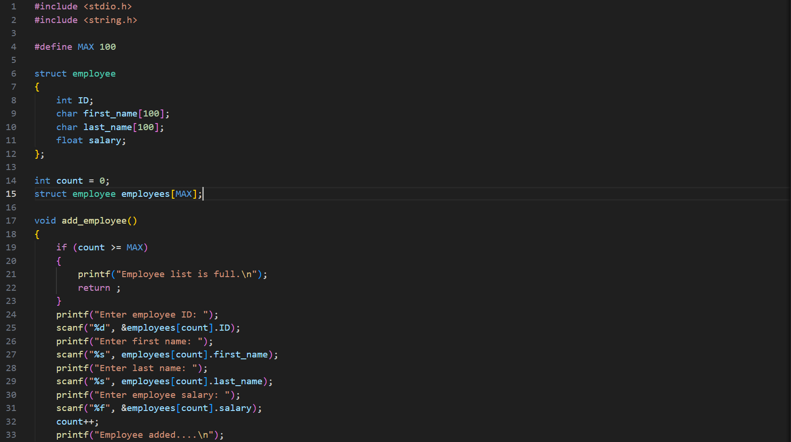
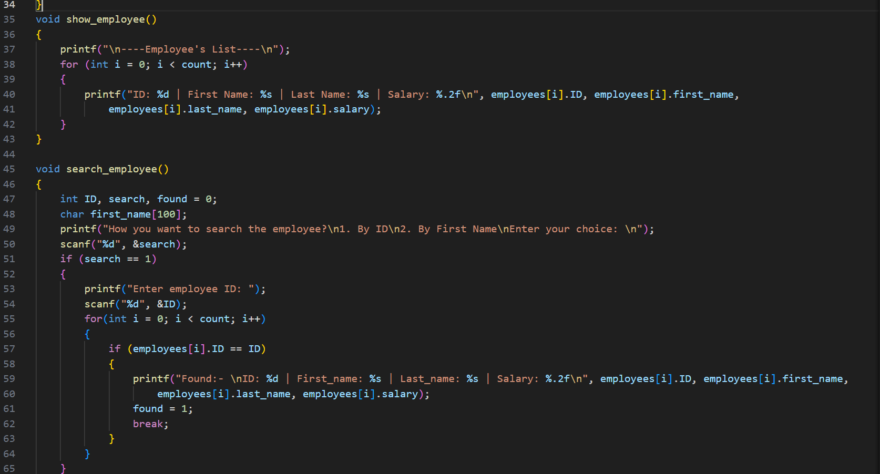
CODE TESTING

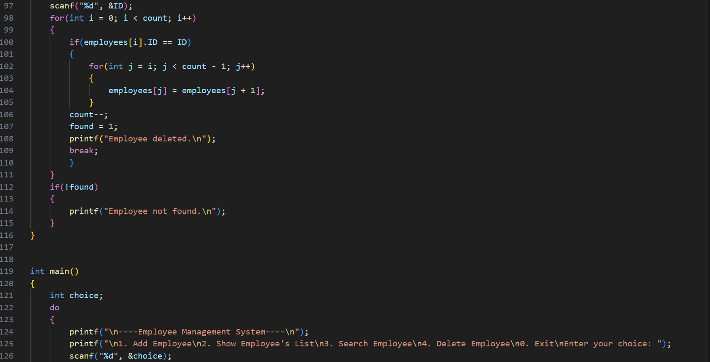
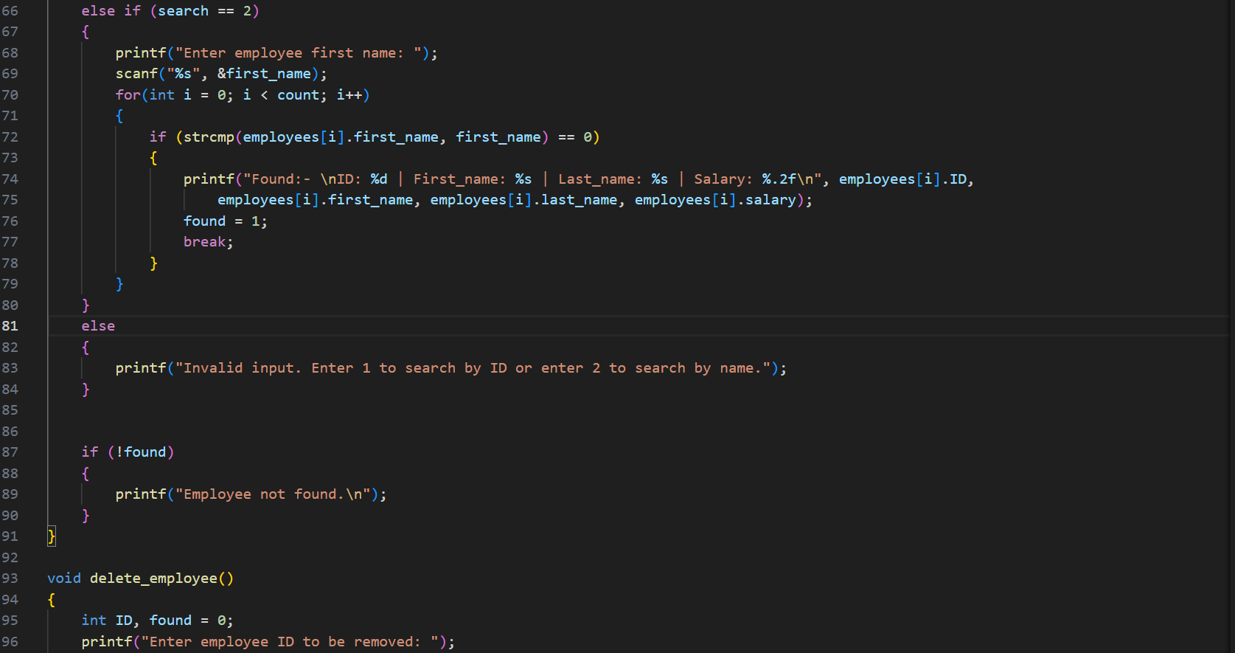
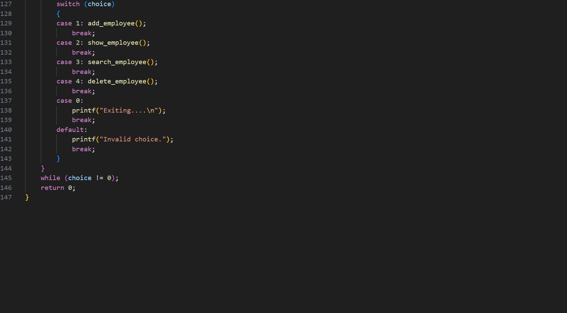

This project is a console-based Employee Management System implemented in C. It demonstrates the use of structures, arrays, and basic file operations to manage employee records. The program allows users to:
- Add Employee → Store employee details (ID, first name, last name, salary) in a structured array.
- Show Employee List → Display all employees currently stored.
- Search Employee → Find employees either by their ID or first name using linear search.
- Delete Employee → Remove an employee record by ID and shift remaining records to maintain the list.

- Exit → Quit the program safely.

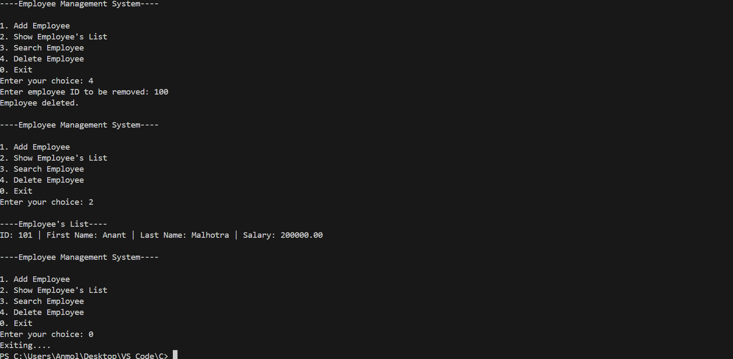
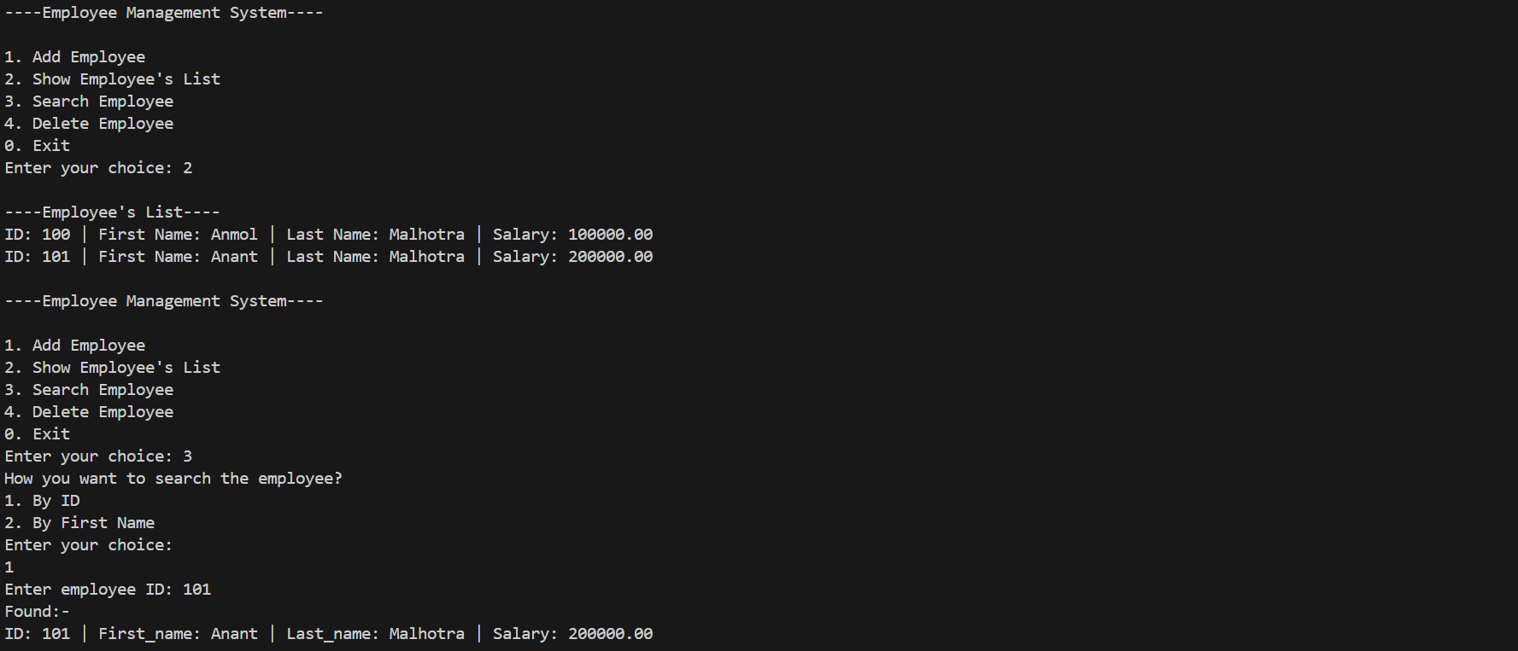
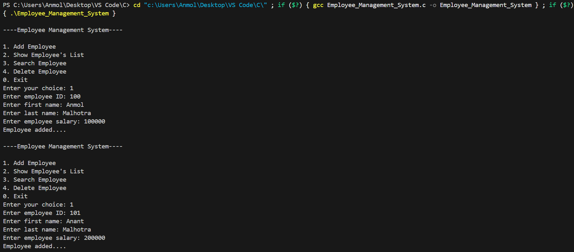
OUTPUT
Employee Management System Documentation

- Purpose of the Program:
The program is a basic Employee Management System written in C.
It allows the user to:
- Add new employees with details (ID, first name, last name, salary).
- Display the list of all employees.
- Search for employees by ID or first name.
- Delete employees by ID.
- Exit the system when finished.
This is a menu-driven program that runs in a loop until the user chooses to exit.

- Logic Implemented:
1. Data Structure
- A struct employee is defined with fields:
  - ID → Unique identifier for each employee.
  - first_name → Employee’s first name.
  - last_name → Employee’s last name.
  - salary → Employee’s salary.
- An array employees[MAX] stores up to 100 employees.
- A global variable count tracks the number of employees currently stored.
2. Adding an Employee
- Function: add_employee()
- Logic:
  - Checks if the list is full (count >= MAX).
  - Prompts user for ID, first name, last name, and salary.
  - Stores the data in the employees array at index count.
  - Increments count by 1.
- Rule: Prevents adding more than 100 employees.
3. Showing Employees
- Function: show_employee()
- Logic:
  - Iterates through the employees array up to count.
  - Prints each employee’s details in a formatted way.
- Rule: Displays only the employees that have been added.

4. Searching Employees
- Function: search_employee()
- Logic:
  - User chooses search type:
    - By ID → Compares input ID with stored employee IDs.
    - By First Name → Uses strcmp to compare input name with stored first names.
  - If found, prints employee details.
  - If not found, prints "Employee not found."
- Rule: Search stops at the first match (no multiple results shown).

5. Deleting Employees
- Function: delete_employee()
- Logic:
  - User enters employee ID to delete.
  - Searches for matching ID.
  - If found:
    - Shifts all subsequent employees one position left to overwrite the deleted entry.
    - Decrements count.
    - Prints "Employee deleted."
  - If not found, prints "Employee not found."
- Rule: Maintains array integrity by shifting elements.

6. Main Menu
- Function: main()
- Logic:
  - Runs a do-while loop until user chooses 0 (Exit).
  - Displays menu options:
    - Add Employee
    - Show Employee’s List
    - Search Employee
    - Delete Employee
    - Exit
  - Executes corresponding function based on user choice.
- Rule: Invalid choices are handled with an error message.

- Additions Made
- Structured Menu System: Added a loop with switch-case for user-friendly navigation.
- Search Options: Implemented two search methods (by ID and by first name).
- Delete Functionality: Added logic to remove employees and shift array elements.
- Validation:
- Prevents adding employees beyond the maximum limit.
- Handles invalid menu choices.
- Ensures proper feedback when employees are not found.

Summary Report: Employee Management System
1. Challenges Faced
- Data Storage Limitation:
The program uses a fixed-size array (MAX = 100). This restricts scalability and requires manual adjustment if more employees are needed.
- Deletion Complexity:
Deleting an employee requires shifting all subsequent records in the array. This is inefficient for large datasets.
- Search Limitations:
  - Search is only possible by ID or first name.
  - No support for searching by last name, salary, or partial matches.
  - Only the first match is returned, even if multiple employees share the same name.
- Input Validation:
  - No checks for duplicate IDs.
  - No validation for salary values (e.g., negative or unrealistic amounts).
  - User input errors (like entering strings for numeric fields) may cause unexpected behavior.
- Data Persistence:
Currently, all employee data is lost once the program exits since it only stores data in memory.

2. Observations Made
- The program is menu-driven, making it user-friendly and easy to navigate.
- Functions are modularized (add_employee, show_employee, search_employee, delete_employee), which improves readability and maintainability.
- The use of struct is appropriate for grouping employee-related data.
- The program demonstrates basic CRUD operations (Create, Read, Search, Delete), which are fundamental in database management systems.
- The logic for deletion and searching is straightforward but could be optimized for larger datasets.

  - Conclusion:
The program successfully demonstrates a foundational Employee Management System. While functional, it can be significantly improved by enhancing search capabilities, adding update functionality, ensuring data persistence, and adopting more efficient data structures. These improvements would make the system more robust, scalable, and practical for real-world use.

