The Tesla Coil

Introduction:

Nikola Tesla is an unsung hero of all times. His contributions to the world are unparalleled. He could foresee the future in manners of wireless transmission energy. His research today helps in wireless charging, radar etc. This project is tribute to his efforts and passion towards making our life easy.

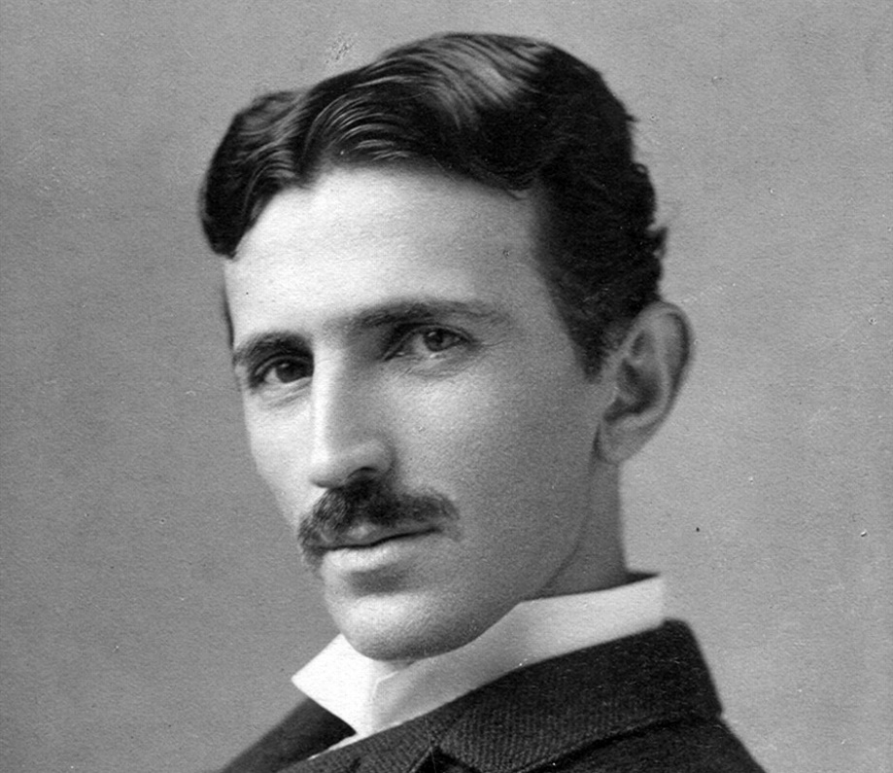

Description:

It is device that uses air as a medium of transmission of electricity and can

light up devices several feet away from it. We are going to make a mini

version of it.

Working:

The Tesla coil consists of two parts: primary coil and secondary coil, each

with its own capacitor. (Capacitors store electrical energy just like

batteries.) The two capacitors are connected to the spark gap - the air gap

between the two electrodes that generate the spark of electricity.An

external source is required to the entire system power adapter.Essentially,

the Tesla coil is two open electric circuits connected to the spark gap.

The power source is connected to the primary coil. The primary coil

capacitor absorbs charge. The base coil itself must be able to withstand a

huge charge and massive surges of current, so the coil is usually made of

copper, a good conductor. Ultimately, the capacitor builds up a lot of

charge that breaks the air resistance in the spark gap. Then, similar to

pressing a soaked sponge, the current flows out of the capacitor down the

primary coil and creates a magnetic field.

A huge amount of energy makes the magnetic field collapse rapidly and

generates an electrical current in the secondary coil. The voltage through

the air creates sparks in the spark gap. The energy steps back and forth

between the coils several hundred times per second and accumulates in

secondary coils and capacitor. Eventually, the charge in the secondary

capacitor gets so high that it breaks free in a spectacular burst of power

supply.

Procedure:

* We open the insect zapper racquet and use it to power our tesla coil.
* We use our own capacitors instead of the circuits for better quality.
* We use the 2 Duracell batteries (i.e. 3 volts) as a power source.
* We circulate the copper wire around a PVC pipe to make a secondary coil and wound the primary coil just below it for best flux linkage.
* We attach the secondary coil to the door knob to discharge the stored electricity.

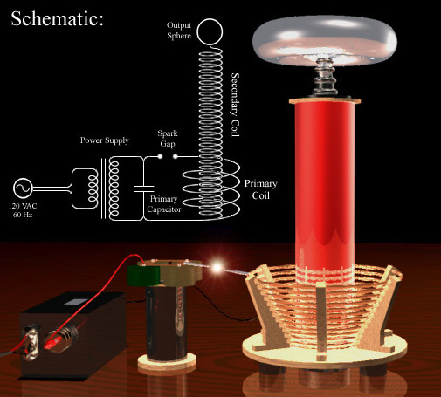

Comfort:

It can provide wireless electricity to everywhere which can reduce a lot of

labor and material cost.

- Anmol Tripathi