<https://replit.com/join/xfjbkzvnka-luxinran048>

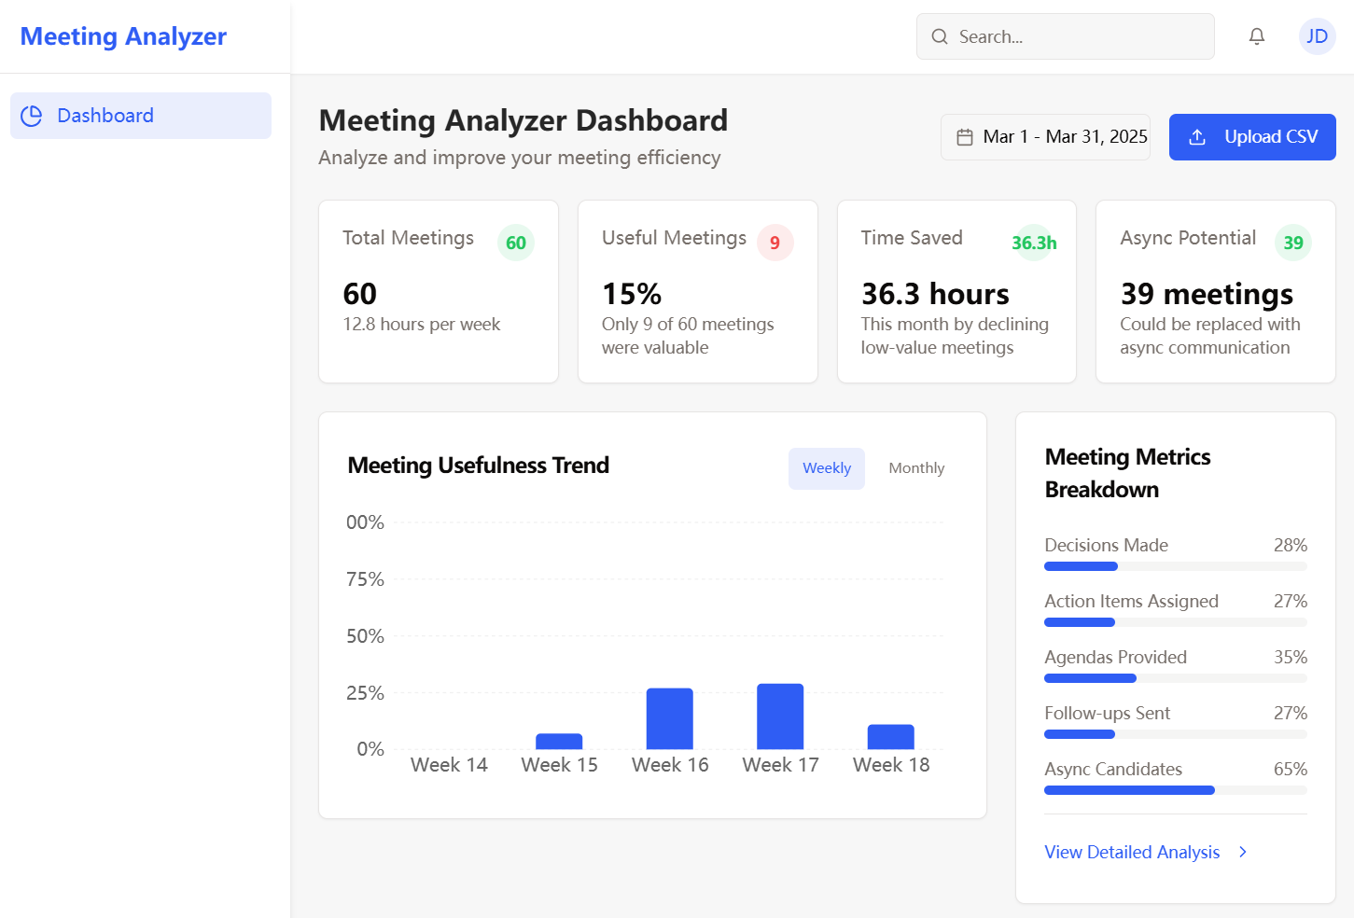

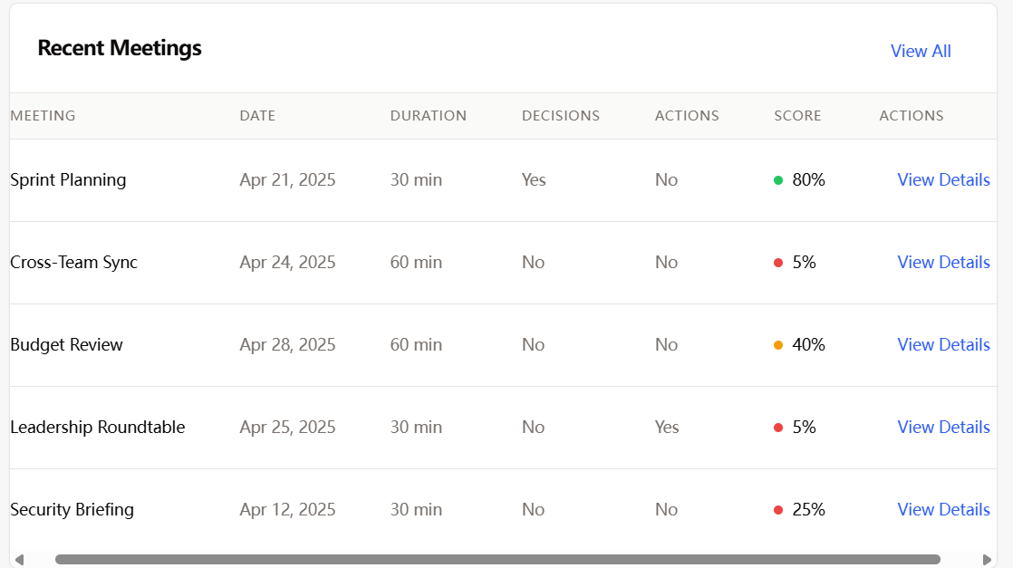

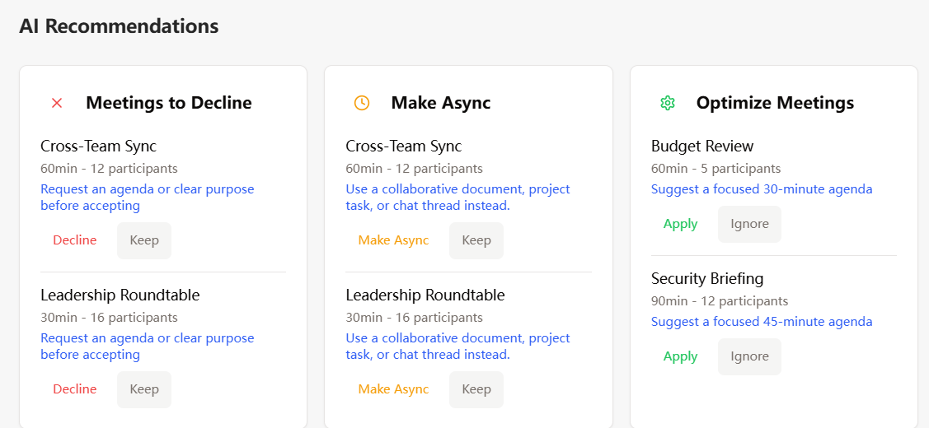

The MeetingInsightAI is an AI-powered tool designed to evaluate meeting effectiveness. Here's a breakdown of its main functions:

1. Dashboard Analytics

* **Summary Cards**: Displays key metrics including total meetings analyzed, percentage of useful meetings, time saved, and meetings that could be async alternatives
* **Progress Charts**: Shows visual metrics for decision-making rates, action assignment, agenda usage, and follow-up activities
* **Usefulness Trend**: Tracks meeting effectiveness over time with weekly trend analysis
* **Recommendations**: Provides AI-generated suggestions for improving or eliminating low-value meetings

2. CSV Data Upload

* **File Upload**: Allows users to upload meeting data in CSV format
* **Format Validation**: Validates CSV data against required fields (Meeting_Title, Duration_Minutes, Participants, etc.)
* **Data Processing**: Analyzes the uploaded meeting data and calculates usefulness scores
* **Option to Replace/Append**: Users can choose to replace existing data or append new data

3. Data Storage

* **Database Integration**: Stores meeting data in a PostgreSQL database
* **Data Persistence**: Saves meeting analysis between sessions
* **Data Retrieval**: Efficiently loads meeting data for display and analysis

4. Meeting Evaluation Logic

* **Scoring Algorithm**: Evaluates meetings using factors like:
  + Decision-making outcomes
  + Speaker participation ratios
  + Presence of agendas
  + Follow-up actions
  + Potential for async alternatives
* **Usefulness Classification**: Categorizes meetings as high/medium/low value

5. User Interface

* **Responsive Design**: Adapts to different screen sizes (desktop, tablet, mobile)
* **Clean Navigation**: Simple dashboard-focused interface with minimal navigation
* **Interactive Elements**: Hover effects on charts and data visualizations
* **Accessibility Features**: Proper contrast, semantic HTML, and keyboard navigation support

6. User Experience

* **Real-time Feedback**: Shows upload progress and success/error messages
* **Data Visualization**: Presents complex meeting data in easy-to-understand charts and metrics
* **Actionable Insights**: Provides specific recommendations for meeting improvements