Survival Analysis of Colorectal and Stomach Cancers
A Comparative Study Using TCGA Clinical Data
Anmol Singh
Student ID: 3068804
MSc Health Data Science
University of Birmingham
Supervisor: Dr Sudip Mondal
July 2026
Word count: approximately 4,950

Abstract
Gastrointestinal cancers account for a large share of global cancer mortality, yet the extent to which the same clinical factors govern survival across different gastrointestinal sites is not always clear. This study applies a survival analysis pipeline to clinical data from three cancer cohorts in The Cancer Genome Atlas (TCGA): colon (COAD), rectal (READ) and stomach (STAD) adenocarcinoma. After deduplicating the Genomic Data Commons clinical files to one record per patient, 437 colon, 161 rectal and 412 stomach patients were analysed. Kaplan-Meier estimation, penalised Cox regression, a random survival forest and SHAP explainability were applied to each cohort independently using an eleven-variable clinical feature set, and the cohorts were compared by the direction and size of covariate effects rather than by absolute survival. Stage was the dominant and most consistent predictor of survival across all three cancers, with residual disease after surgery the next most consistent signal, while demographic variables were not prognostic after adjustment. Stomach cancer showed substantially poorer survival than either colorectal site, a difference that is not attributable to age. The forest did not materially outperform the regularised Cox model out of sample, and SHAP corroborated the Cox findings, supporting a parsimonious, interpretable model. Comparing the cancers directly, every clinical predictor kept the same relationship with survival across colorectal and stomach cancer, so a model trained only on colorectal patients ranked stomach patients almost as well as a stomach-trained one, yet after adjustment stomach remained about three times worse stage-for-stage. The ordering of risk is shared across these cancers; the absolute level of risk is not.

Contents
1. Introduction 5
1.1 Background and Motivation 5
1.2 Aims 5
1.3 Data Source 6
2. Literature Review 6
3. Data and Preprocessing 7
3.1 Cohorts and Deduplication 7
3.2 Clinical Variables 8
4. Methods 10
4.1 Analytical Pipeline 10
4.2 Cross-Cohort Comparison Strategy 10
4.3 Kaplan-Meier and Log-Rank Tests 11
4.4 Cox Proportional Hazards Regression 11
4.5 Random Survival Forest and SHAP 12
4.6 Adjusted between-cancer comparison 13
4.7 Transfer from colorectal to stomach 13
4.8 Invariance of predictors across cancers 13
5. Exploratory Data Analysis 14
6. Kaplan-Meier Results 15
7. Cox Regression Results 18
8. Random Survival Forest and SHAP Results 21
9. Cross-Cancer Analysis 24
9.1 Adjusted comparison of colon and stomach 24
9.2 Transfer from colorectal to stomach 24
9.3 Which predictors are invariant across the cancers 26
10. Discussion 27
11. Limitations 28
12. Conclusion 29
13. Code Availability 30
14. References 30
Appendix 32
Statement on the Use of Generative AI 34

1. Introduction

1.1 Background and Motivation
Colorectal cancer, comprising cancers of the colon and rectum, is one of the most prevalent malignancies worldwide and a leading cause of cancer-related mortality (Zhou et al., 2023). Stomach (gastric) cancer carries a similarly heavy burden, with high incidence in East Asia. The two groups share adenocarcinomatous histology and overlapping risk factors such as age, diet and family history, which makes a comparative survival analysis clinically meaningful.
Large public clinical datasets such as TCGA make computational survival analysis feasible at scale, and machine-learning methods are increasingly applied to gastrointestinal disease (Hodgkiss and Acharjee, 2025), including prognostic models for colorectal cancer (Jiang et al., 2020). Survival analysis, the framework for time-to-event data, suits cancer research, where the outcomes of interest are time to death and recurrence (Mondal et al., 2021a).
This project applies such a pipeline to TCGA clinical data for colorectal (COAD and READ) and stomach (STAD) cancers. A central challenge, addressed in Section 4, is comparing survival across cohorts collected under different protocols.

1.2 Aims
This project aims to:
- characterise and compare survival outcomes in colorectal cancer (COAD and READ) and stomach cancer (STAD) using TCGA clinical data;
- apply a sequential pipeline of Kaplan-Meier estimation, Cox proportional hazards regression, and a random survival forest with SHAP explainability;
- identify the clinical predictors of survival that are consistent across colorectal and gastric cohorts, using a broad clinical feature set rather than a small fixed set of covariates;
- address the methodological challenge of cross-cohort comparison, given that COAD, READ and STAD are distinct patient populations with different baseline characteristics.

1.3 Data Source
All clinical data were obtained from TCGA via the National Cancer Institute Genomic Data Commons (GDC) portal (portal.gdc.cancer.gov). TCGA has molecularly characterised over 20,000 primary tumour and matched normal samples across 33 cancer types. Only clinical data are used here, on the supervisor's recommendation to establish results on interpretable variables before molecular data.

2. Literature Review
Machine learning is increasingly applied to prognosis in gastrointestinal disease (Hodgkiss and Acharjee, 2025). In colorectal cancer, Jiang et al. (2020) built a machine-learning prognostic predictor for stage III colon cancer, and Zhou et al. (2023) showed that an integrative deep-learning model improved risk stratification in colon adenocarcinoma and carried over to a rectal cohort. Mondal et al. (2021a, 2021b) compared statistical approaches for survivability prediction and tuned random survival forest parameters. These studies establish that clinical features carry prognostic signal, but each treats a single cancer, and none tests whether the same predictors act in the same way across cancers.
Methodologically the field rests on Kaplan-Meier estimation (Kaplan and Meier, 1958) and Cox regression (Cox, 1972), with the random survival forest (Ishwaran et al., 2008) as a non-linear alternative and SHAP (Lundberg and Lee, 2017) supplying post-hoc explanation, as applied to colorectal markers by Radhakrishnan et al. (2024). A recurring weakness is that flexible models are often reported without an out-of-sample comparison against a well-specified linear baseline, leaving their added value unclear.
Transfer learning offers a way to borrow strength across cohorts. Li et al. (2016) regularised Cox regression for transfer, Bellot and van der Schaar (2019) boosted survival models across heterogeneous domains, and both Sabbatini et al. (2026) and Wen and Li (2025) report that transfer improves survival prediction when target data are scarce. Saegusa et al. (2021), however, caution that heterogeneous populations with differing censoring complicate pooled inference, which is the central difficulty in comparing separate cancer cohorts.
Three gaps follow, and this project addresses each: whether prognostic structure is genuinely shared across gastrointestinal sites, whether a model learned on one site transfers to another using clinical variables alone, and whether the flexibility of a forest is justified against a penalised Cox baseline.

3. Data and Preprocessing

3.1 Cohorts and Deduplication
Three TCGA clinical datasets were used: TCGA-COAD (colon), TCGA-READ (rectum) and TCGA-STAD (stomach). All three share an identical structure of 201 clinical columns, so one preprocessing pipeline serves all of them.
The GDC clinical file stores one row per diagnosis-and-follow-up combination, not per patient, so a single patient can occupy many rows (up to 32 in the colon file). Treating rows as patients would inflate each cohort roughly threefold, so records were collapsed to one per patient, keyed on cases.case_id. Vital status, age and sex are constant within a patient and taken directly; censoring time is the latest follow-up; and stage and the other diagnosis-level variables (Section 3.2) come from the primary-diagnosis record. After deduplication the cohorts comprise 461 colon, 172 rectal and 443 stomach patients, derived from 1,801, 642 and 1,595 raw rows respectively, matching the known TCGA cohort sizes.
Patients with no valid survival time, from both date fields missing or a zero or negative time, were excluded, since the outcome cannot be imputed without fabricating data. The excluded patients represent 5.2% (colon), 6.4% (rectum) and 7.0% (stomach) of the deduplicated cohorts, and this is noted as a limitation in Section 11. The final analysable cohorts are 437 colon, 161 rectal and 412 stomach patients, summarised in Table 1.
Cohort | Patients | Deaths (%) | Median obs. time | Median age | % male
COAD (colon) | 437 | 95 (21.7%) | 672 days | 68 | 54%
READ (rectum) | 161 | 27 (16.8%) | 638 days | 65 | 56%
STAD (stomach) | 412 | 168 (40.8%) | 450 days | 67 | 65%
Table 1. Analysable cohorts after deduplication and exclusion of records with missing survival time. Observed time is the time to death for patients who died and the time to last follow-up for those censored.

3.2 Clinical Variables
Survival time was built from two TCGA fields, days_to_death for patients who died and days_to_last_follow_up for those alive at last visit, with the latter treated as censored. A binary event indicator was set to 1 for death and 0 for censoring; excluding censored patients would introduce survivorship bias and discard information that Kaplan-Meier and Cox regression are designed to use (Mondal et al., 2021a).
An early version used only stage, age and sex; on the supervisor's direction this was expanded to eleven clinical variables (Table 2): age, sex, overall AJCC stage, T, N and M stage, prior malignancy, residual disease after surgery, whether treatment was received, race and ethnicity. Detailed AJCC sub-stages (for example IIA, IIIC) were collapsed to the four groups I to IV, and T, N and M to their principal levels; unresolved codes (TX, NX, MX) were grouped as 'Unknown' so patients were retained rather than dropped. Diagnosis-level variables came from the primary-diagnosis record, and the treatment indicator was aggregated across a patient's records.
Two further variables were dropped after inspection. Classification of tumour is constant at the primary-diagnosis record, varying only in post-baseline metastasis and recurrence records that would leak outcome information. Prior treatment is 'No' for over 99% of patients in every cohort, and all stomach patients, leaving no usable variation. Both are kept in the clean dataset but not modelled.
Variable | Role | Notes
Vital status | Event indicator | Complete in all cohorts
Days to death / follow-up | Survival time | Combined into one time variable
Age at diagnosis | Covariate | Under 1% to 2% missing
Sex | Covariate | Complete
Overall stage (I to IV) | Covariate | 2.5% to 5% missing
T, N, M stage | Covariate (forest only) | Collinear with overall stage
Prior malignancy | Covariate | Yes / No / Unknown
Residual disease | Covariate | R0 / R+ / Unknown
Treatment received | Covariate | Aggregated across records
Race, ethnicity | Covariate | Sparse categories grouped
Table 2. Clinical variables used in the analysis. T, N and M stage are used only in the random survival forest, for the reasons given in Section 4.4.

4. Methods

4.1 Analytical Pipeline
The analysis follows a sequential pipeline, informed by Mondal et al. (2021a, 2021b). Each cancer is analysed independently first: exploratory data analysis; Kaplan-Meier estimation with log-rank tests; penalised Cox regression; a random survival forest with permutation importance; and SHAP explanation of the forest. A set of cross-cancer analyses (Section 9) then compares the cancers directly: an adjusted comparison, transfer of a colorectal-trained model to stomach, and a test of which predictors are invariant.

4.2 Cross-Cohort Comparison Strategy
COAD, READ and STAD are distinct cohorts with no shared patients, so any between-cancer comparison could reflect true aggressiveness, demographics, staging protocols, or censoring and follow-up (maximum follow-up is 3,720 days in stomach against 4,502 in colon).
Four principles address this, informed by Saegusa et al. (2021). First, each cancer is modelled separately, so every result is internally valid before comparison. Second, the comparison focuses on the direction and size of covariate effects, such as the Stage IV against Stage I hazard ratio, rather than absolute median survival, which is cohort-specific. Third, Section 5 shows the cohorts have near-identical age distributions, so age does not confound the comparison, while the sex difference is controlled for in the Cox model. Fourth, the limitations, including the differing censoring distributions, are stated in Section 11.

4.3 Kaplan-Meier and Log-Rank Tests
Kaplan-Meier survival functions (Kaplan and Meier, 1958) were estimated for each cohort using lifelines, overall and stratified by stage, sex and age group (under 50, 50 to 59, 60 to 69, 70 or over), with a log-rank test per stratification. Medians are in days and significance is a log-rank p below 0.05. These unadjusted tests are descriptive and motivate the multivariable models that follow.

4.4 Cox Proportional Hazards Regression
A multivariable Cox proportional hazards model (Cox, 1972) was fitted to each cohort using the eight-variable subset of the clinical features that is appropriate for a linear model: age, sex, overall stage, prior malignancy, residual disease, treatment received, race and ethnicity. The T, N and M variables were excluded here because they are collinear with overall stage, which they jointly determine. Categorical variables were one-hot encoded against a reference, and missing categories kept as an explicit 'Unknown' level, so the complete-case requirement fell only on age and overall stage. This gave complete-case cohorts of 426 colon, 153 rectal and 393 stomach patients.
The design is wide relative to the number of deaths, especially in rectum, where about 24 events support roughly fifteen coefficients, below the usual ten-events-per-coefficient guideline. A ridge penalty was therefore applied, escalated automatically on non-convergence; a mild penalty sufficed everywhere. Coefficients constant within a cohort were dropped before fitting, removing the Hispanic-ethnicity term in rectum and the unknown-prior-malignancy term in stomach. Discrimination is Harrell's concordance index.

4.5 Random Survival Forest and SHAP
A random survival forest (Ishwaran et al., 2008) was fitted to each cohort using scikit-survival, in a separate environment from the Cox analysis due to a dependency conflict. It used the full eleven-variable set, including T, N and M, since a tree ensemble is unaffected by the collinearity that excludes them from Cox and can exploit the granular staging. Each variable was a single ordinal column, so the forest returns one importance value per variable rather than indicator terms.
Because a single split on cohorts this small produces variable estimates, discrimination was estimated by five-fold cross-validation stratified on the event, with the fold spread reported. For a fair comparison, a Cox model was scored on the same folds, so both are evaluated out of sample on identical patients; the in-sample Cox concordance from Section 7 is shown alongside. Importance was estimated by permutation, the mean drop in concordance when a variable is shuffled, averaged across folds.
The forest was then explained with SHAP (Lundberg and Lee, 2017), an approach also used to surface prognostic markers in colorectal cancer (Radhakrishnan et al., 2024). SHAP's exact tree explainer does not support scikit-survival's forest, so a model-agnostic permutation explainer was applied to the risk score. This gave a global importance ranking (mean absolute SHAP value per variable) and, per cohort, a per-patient summary of how each variable moves predicted risk.

4.6 Adjusted between-cancer comparison
To test whether the survival difference survives adjustment, colon and stomach were pooled in one Cox model with a cancer-type indicator, adjusting for age, stage and sex. Because 'colon' may mean colon alone or colorectal, both were run. The pooled design has ample events per coefficient, so no penalty was needed.

4.7 Transfer from colorectal to stomach
A random survival forest was trained on the pooled colorectal cohorts and evaluated, without refitting, on stomach, a direct form of transfer learning for survival models (Li et al., 2016; Bellot and van der Schaar, 2019). Discrimination was the concordance index, calibration the integrated Brier score, and time-resolved discrimination the time-dependent AUC, with the grid restricted to event times shared by both cohorts so the censoring weights stay estimable. Stomach patients were also split into three groups by colorectal-predicted risk and their survival compared, testing whether high predicted risk identifies high-risk stomach patients.

4.8 Invariance of predictors across cancers
Following invariant causal prediction, each covariate's effect was fitted separately in colorectal and stomach, and a likelihood-ratio test on a covariate-by-cancer interaction tested whether it differs; a non-significant interaction indicates an invariant effect. The two environments were colorectal and stomach, and the covariates tested were age, sex, stage and residual disease.

5. Exploratory Data Analysis
Figure 1a shows observed-time distributions (time to death for those who died, time to last follow-up otherwise). Colon and rectum are similarly right-skewed, with median observed times of 672 and 638 days and tails beyond 3,900 days. Stomach differs: a sharp peak at 300 to 500 days, a shorter median of 450 days and a steeper early decline.
The age-at-diagnosis distributions are broadly similar (Figure 1b), peaking at 60 to 70 years, with median ages 68 (colon), 65 (rectum) and 67 (stomach) and means 66.3, 64.0 and 65.1. This near-identical profile matters, because survival differences between the cancers cannot then be attributed to age.
Sex distributions are similar in colon and rectum (54% and 56% male) but more skewed in stomach (65% male), consistent with gastric epidemiology; sex is carried as a covariate and potential confounder. Stage is well recorded (only 2.5% to 5% missing). Stomach is predominantly Stage III, colon Stage II, and rectum split between Stages II and III (Figure 1c); stomach has the smallest Stage IV share, 10% of the staged cohort against 14% in colon and 16% in rectum. Death rates differ sharply: 40.8% in stomach against 21.7% in colon and 16.8% in rectum. As the cohorts are age-matched, this reflects the poorer prognosis of gastric cancer rather than demographics (Mondal et al., 2021a; Zhou et al., 2023).
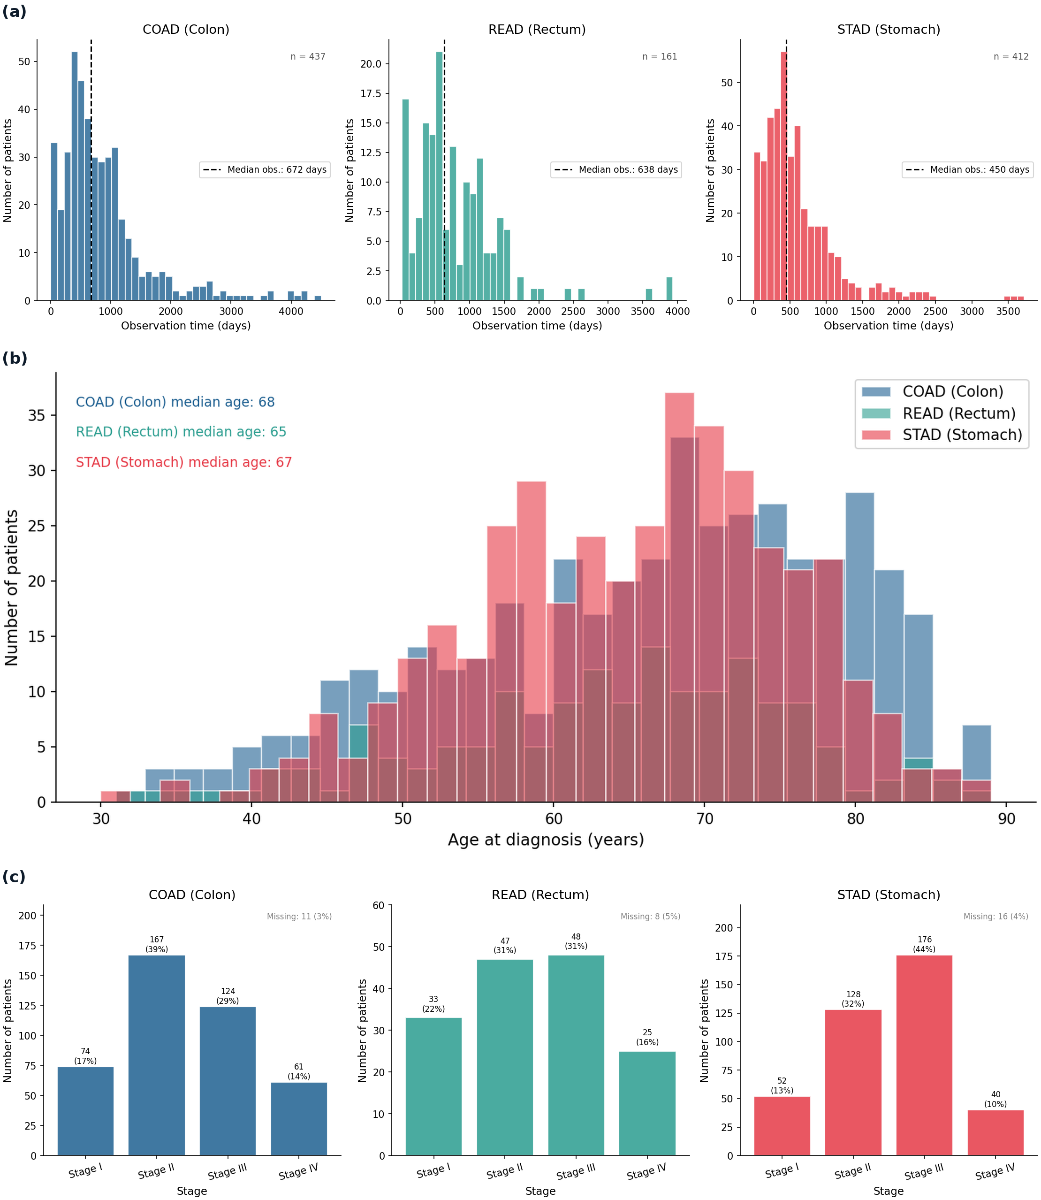
Figure 1. Exploratory characteristics of the three cohorts. (a) Observed-time distributions by cancer, with the median marked; observed time mixes deaths and censored follow-up. (b) Age-at-diagnosis distributions by cancer, showing near-identical age profiles across the three cohorts. (c) Stage distribution by cancer, with the percentage missing annotated; stomach is predominantly Stage III and has the smallest Stage IV share.

6. Kaplan-Meier Results
Kaplan-Meier median survival was 2,821 days for colon, 1,741 for rectum and 881 for stomach (Figure 2a). The ordering confirms the exploratory finding: stomach survival is substantially poorer, its curve declining fastest and plateauing lowest at around 30% in the long tail. These medians exceed the observed times in Section 5 because the estimator accounts for censoring. The rectal curve flattens beyond about 1,750 days into a wide confidence interval, reflecting few patients at risk rather than a true plateau, as in all three long tails.
Survival by stage separates cleanly in the expected order in every cancer (Figure 2b), with the log-rank test highly significant throughout (colon p < 0.0001, rectum p < 0.001, stomach p < 0.0001), making stage the strongest single predictor in this phase. Two caveats: in rectum the Stage I and II groups have very few deaths (two and four), so their exact curve positions are unstable; and in stomach the lower-stage curves wobble in the sparse long tail, which should not be read as reversals of prognosis.
No sex difference in survival was found in any cancer (colon p = 0.55, rectum p = 0.68, stomach p = 0.64), the male and female curves tracking closely (Figure 2c). This is notable for stomach, whose cohort is markedly male-skewed: the composition imbalance does not translate into a survival difference. As these tests are unadjusted, sex is still carried into the Cox model.
Survival by age group is significant in rectum (p = 0.001) but not colon (p = 0.075) or stomach (p = 0.28) (Figure 2d). Older groups fare worse in rectum, and the same non-significant gradient appears in colon. This refines rather than contradicts the earlier point: the cohorts are age-matched so age does not distort the between-cancer comparison, but within a cohort it can still predict survival, which is why it is retained.
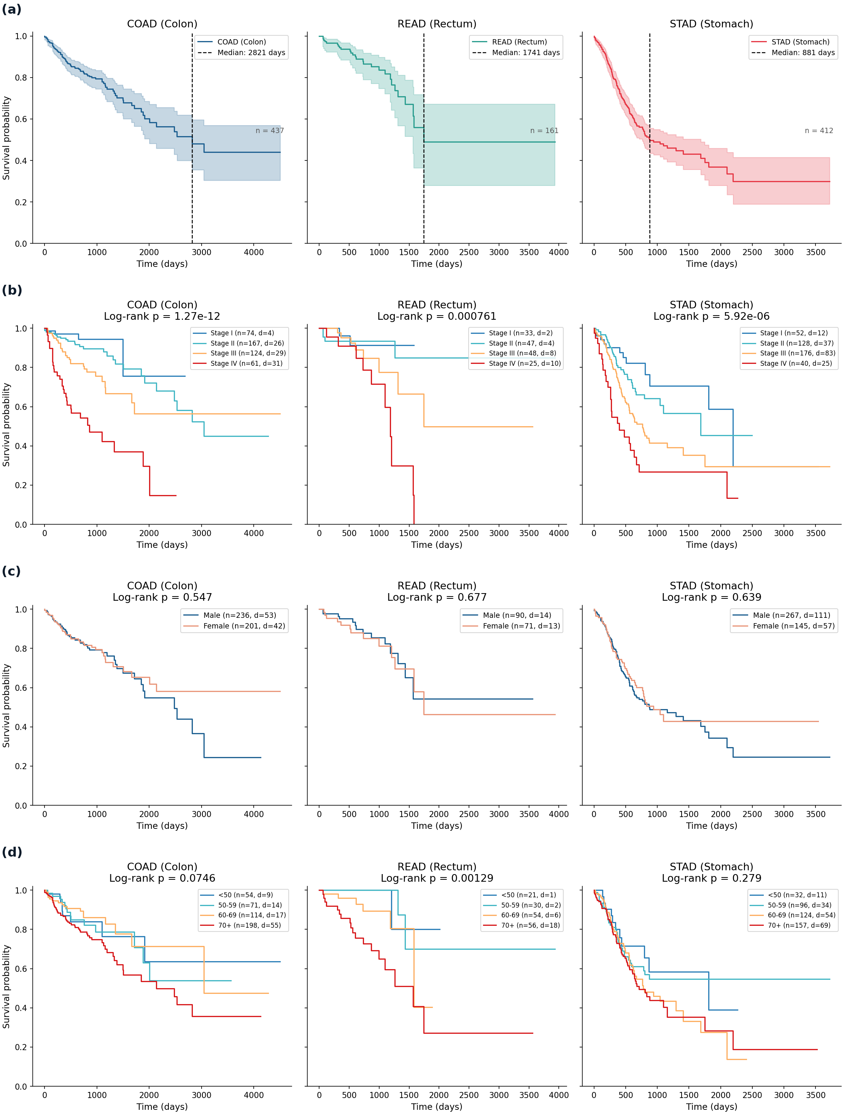
Figure 2. Kaplan-Meier survival, each cohort fitted independently. (a) Overall survival by cancer; the dashed line marks median survival and the shaded band is the 95% confidence interval. (b) Survival stratified by stage, with the log-rank p-value above each panel; the legend reports group size (n) and deaths (d). (c) Survival stratified by sex, with the log-rank p-value above each panel. (d) Survival stratified by age group, with the log-rank p-value above each panel.
Table 3 summarises the log-rank results: stage is significant in every cohort, age in rectum only, sex in none. These define the covariates carried into the Cox model.
Stratification | COAD | READ | STAD
Stage (I to IV) | p < 0.0001 | p < 0.001 | p < 0.0001
Sex | p = 0.55 | p = 0.68 | p = 0.64
Age group | p = 0.075 | p = 0.001 | p = 0.28
Table 3. Kaplan-Meier log-rank tests by stratification and cancer. Exact stage p-values: COAD 1.3e-12, READ 7.6e-4, STAD 5.9e-6.

7. Cox Regression Results
The multivariable Cox models confirm and refine the Kaplan-Meier findings, with concordance indices 0.76 (colon), 0.83 (rectum) and 0.70 (stomach). The rectal value is highest but most optimistic: an in-sample figure from only 24 deaths under a heavy penalty, with a considerably lower cross-validated estimate in Section 8.
Stage remains the dominant predictor in all three cancers. The hazard ratio for Stage IV against Stage I is 3.2 in colon (p < 0.0001), 2.6 in rectum (p = 0.04) and 2.8 in stomach (p < 0.0001), with risk rising steeply from Stage III to Stage IV in each cohort (Figure 3a, Figure 3b). These hazard ratios are smaller than in the earlier three-covariate model, the expected effect of the ridge penalty and added adjustment. The slight Stage II dip in Figure 3b reflects the small Stage I reference group under penalisation, not a protective effect.
Residual disease after surgery is the second most consistent signal, with a hazard ratio of about 1.9 in colon (p = 0.04) and 2.0 in stomach (p = 0.004), both significant, and the same direction in rectum though not significant. Age is significant in colon (p = 0.045) and rectum (p = 0.04) but not stomach (p = 0.08), matching the Kaplan-Meier results, and sex is significant nowhere.
In stomach, treatment is associated with lower risk (hazard ratio 0.67, p = 0.014), most likely confounding by indication since fitter patients are treated, not a causal effect; the same caution applies to the SHAP results. Several coefficients rest on tiny subgroups and are not interpreted: the Hispanic-ethnicity term in colon and stomach covers four and five patients, and the Asian-race term in rectum one, so their intervals are very wide. The apparently protective stomach ethnicity term is a five-patient artefact, not a finding.
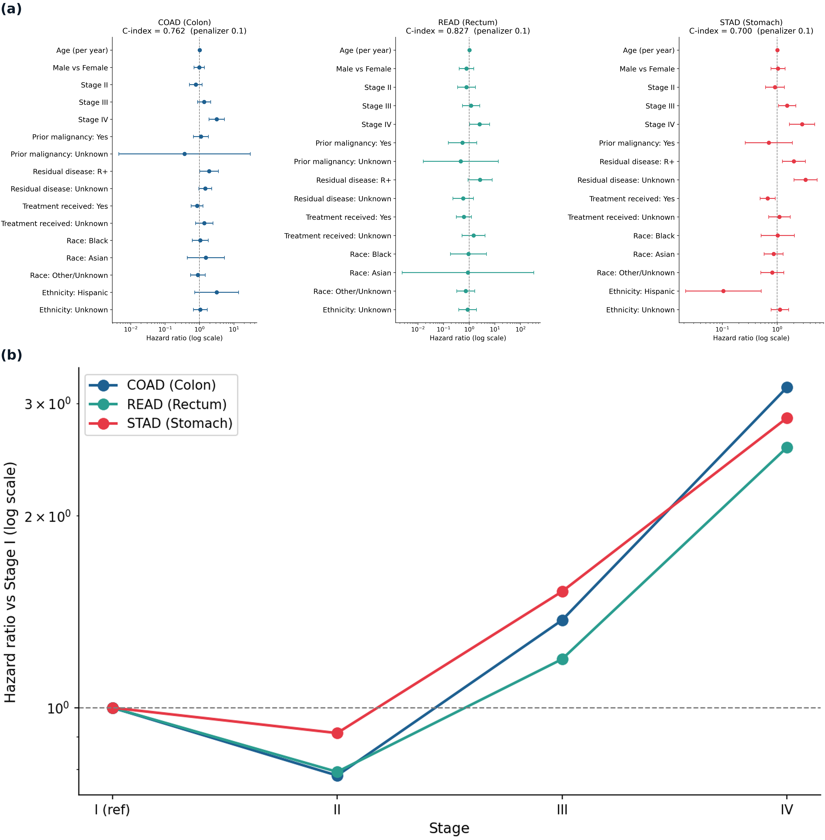
Figure 3. Cox proportional hazards results for the expanded clinical model. (a) Hazard ratios by cancer on a log scale; points are hazard ratios and bars are 95% confidence intervals. (b) Stage hazard-ratio gradient across cancers, relative to Stage I; the comparison of interest is the shape of the gradient, not the absolute values.
Selected covariate | COAD | READ | STAD
Stage IV vs I (HR) | 3.18 | 2.56 | 2.85
Age, per year (HR) | 1.02 | 1.03 | 1.01
Residual disease present (HR) | 1.91 | 2.68 | 2.02
Treatment received (HR) | 0.86 | 0.71 | 0.67
Concordance index | 0.76 | 0.83 | 0.70
Table 4. Selected Cox hazard ratios (HR) and apparent concordance. Full estimates with confidence intervals are shown in Figure 3a. Concordance is in-sample; cross-validated values are in Section 8.

8. Random Survival Forest and SHAP Results
Under five-fold cross-validation the forest achieved concordance indices 0.76 (colon), 0.66 (rectum) and 0.65 (stomach); the Cox model on the same folds achieved 0.73, 0.72 and 0.69 (Figure 4a). The forest slightly beats Cox in colon, the largest and cleanest cohort, but Cox is competitive or better in rectum and stomach. There is thus no substantial gain from the flexible model, consistent with largely monotonic clinical predictors, so Cox is retained as the primary interpretable model. Figure 4a also shows the in-sample optimism: apparent rectal Cox concordance of 0.83 falls to about 0.72 under cross-validation, driven by the few deaths there.
Permutation importance and SHAP agree closely and both corroborate the Cox model. Staging drives risk in all three cancers, and age is prominent, the single strongest variable in rectum (Figure 4b and 4c). Residual disease matters in colon and stomach, and treatment ranks among the top stomach variables, mirroring its Cox effect with the same caveat. Race, ethnicity and sex are negligible. Because overall stage and T, N and M are correlated, their importance is shared, so staging is read as a group; the rectal permutation estimates are noisy below age, so the more stable SHAP ranking is preferred there.
The per-patient SHAP summary for stomach (Figure 4d) shows each effect's direction: later stage, residual disease and older age raise predicted risk, treatment lowers it, consistent with the Cox model. The colon and rectal summaries show the same pattern (Appendix, Figure A1).
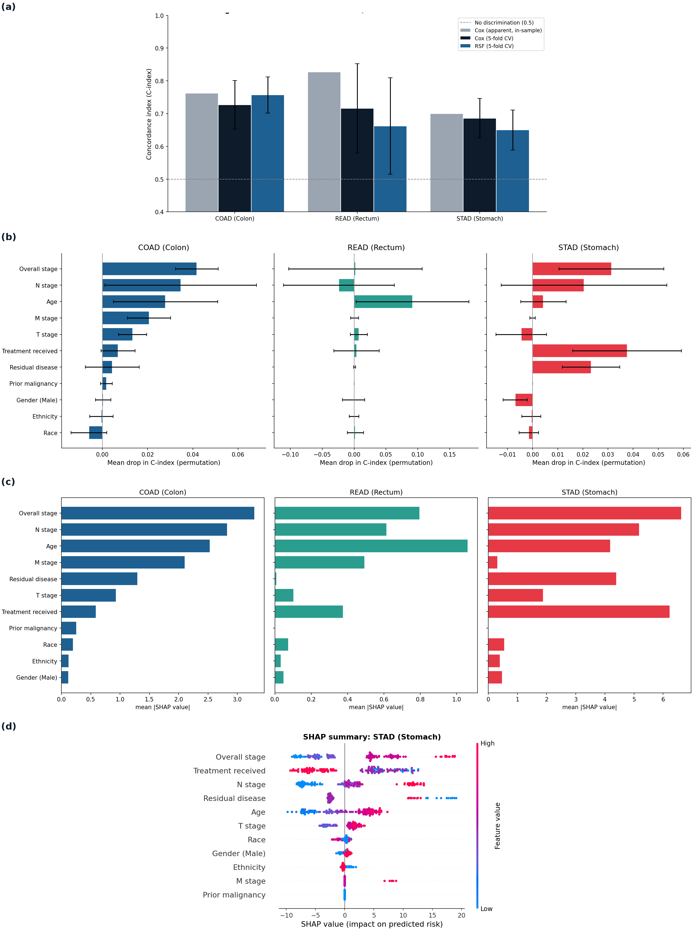
Figure 4. Random survival forest performance and variable importance. (a) Predictive performance, Cox versus random survival forest; the two cross-validated bars are the fair comparison, while the apparent in-sample Cox bar shows the optimism of the in-sample estimate. (b) Random survival forest permutation importance (mean drop in concordance when a variable is shuffled), with the spread across folds. (c) Global SHAP importance (mean absolute SHAP value per variable) for each cancer. (d) SHAP summary for the stomach cohort; each point is a patient, coloured by feature value, and position shows the effect on predicted risk.

9. Cross-Cancer Analysis

9.1 Adjusted comparison of colon and stomach
Pooling colon and stomach and adjusting for age, stage and sex, colon has a hazard ratio of 0.36 relative to stomach (95% CI 0.27 to 0.47, p < 0.0001); colorectal against stomach gives 0.33 (0.26 to 0.42, p < 0.0001). Colon therefore does not fare worse than stomach; stomach is roughly three times worse. Since the model holds stage constant, this is stage-for-stage: at any given stage a stomach patient fares far worse, so its poor prognosis is intrinsic rather than a consequence of later diagnosis. The stage gradient is steep, with a Stage IV hazard ratio of about 7.8 relative to Stage I, larger than the penalised per-cohort estimates because the pooled model needs no penalty; age is significant, sex is not.

9.2 Transfer from colorectal to stomach
A forest trained only on colorectal patients, never shown a stomach patient, achieved a concordance index of 0.646 on stomach. A forest trained on stomach itself reaches 0.650 under cross-validation (Section 8), so the colorectal-trained model ranks stomach patients almost as well. Splitting stomach into three groups by colorectal-predicted risk separates survival sharply (log-rank p = 1.5 x 10 to the power minus seven; Figure 5a), the high-risk third faring far worse than the low-risk third. The integrated Brier score was 0.192 and mean time-dependent AUC 0.671, the latter stable across follow-up (Figure 5b). Colorectal patterns therefore transfer to stomach, identifying its high-risk patients. Discrimination transfers almost perfectly but calibration less so, the Brier score reflecting a model optimistic about absolute stomach survival even when ranking correctly. This is what Section 9.1 predicts, since risk ordering is shared but its absolute level is not. Three checks support this (Appendix, Figure A2): a Cox transfer performs almost identically (0.649 against 0.646); time-dependent ROC gives AUCs of 0.658 to 0.678 from one to three years; and the transfer is symmetric, a stomach-trained forest reaching 0.763 on colorectal against a 0.760 ceiling, meeting the within-cohort ceiling in both directions.
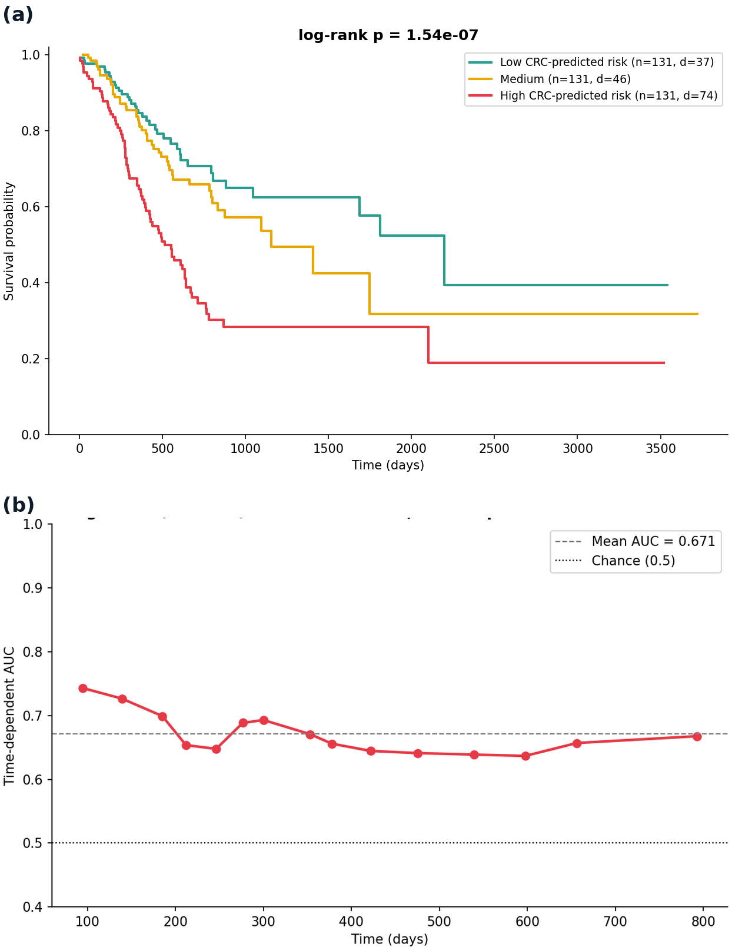
Figure 5. Cross-cancer transfer from colorectal to stomach. (a) Stomach survival by colorectal-predicted risk: the stomach patients are split into three equal groups by the risk score of a colorectal-trained forest, and the clean separation shows that colorectal risk transfers to stomach. (b) Time-dependent AUC of the colorectal-trained forest evaluated on stomach, stable above chance across follow-up.

9.3 Which predictors are invariant across the cancers
Testing each predictor for a difference in effect between colorectal and stomach, none showed a significant interaction with cancer type (Figure 6). Age raises risk similarly in both (hazard ratio 1.04 against 1.02, interaction p = 0.46), residual disease similarly (1.60 against 1.74, p = 0.48), and sex is invariantly null (0.88 against 1.01, p = 0.81). Stage is invariant as well (p = 0.10), although its per-level effect is somewhat steeper in colorectal (2.23) than stomach (1.66); this does not reach significance but points the same way as the adjusted comparison, since stomach is already poor at early stages and stage therefore differentiates survival slightly less. Every predictor tested thus keeps the same relationship across the two cancers, which is the mechanism behind the transfer: because the prognostic relationships are invariant, a colorectal model generalises to stomach.
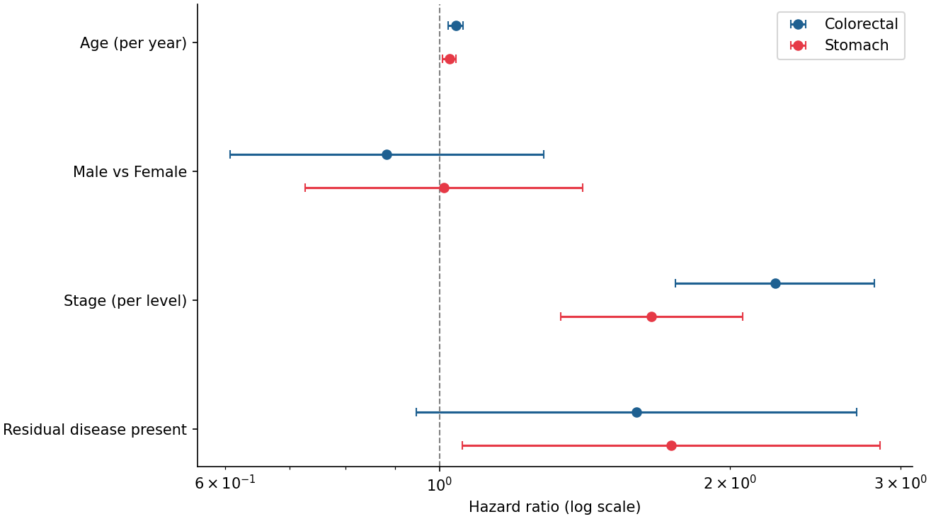
Figure 6. Each covariate's hazard ratio in colorectal and in stomach. Overlapping estimates, and non-significant interaction tests, indicate that the effect is invariant across the two cancers.

10. Discussion
The most consistent result of this study is that stage is the dominant predictor of survival across all three gastrointestinal cancers. This holds at every level of the pipeline: log-rank tests, Cox hazard ratios, permutation importance and SHAP all place stage first or joint-first. Residual disease after surgery is the second most consistent signal, significant in the colon and stomach Cox models and prominent in the corresponding SHAP rankings. In contrast, the demographic variables, sex, race and ethnicity, carry no reliable prognostic information once stage and the other clinical variables are accounted for. Age occupies an intermediate position: it predicts survival within cohorts, most clearly in the rectal cohort, but because the three cohorts are closely matched on age it does not distort the comparison between cancers.
The defensible finding is not absolute survival but that the same factors predict survival in the same direction across colorectal and gastric cancer: later stage and residual disease raise risk in each, with similarly shaped stage gradients (Figure 3b). Against this, stomach stands out for poorer survival, a death rate of 40.8% and median survival of 881 days against 16.8% to 21.7% and 1,741 to 2,821 days in colorectal. As the cohorts are age-matched and sex-adjusted, this reflects the recognised aggressiveness of gastric cancer rather than demographics (Mondal et al., 2021a; Zhou et al., 2023).
The Section 9 analyses make this precise. The invariance analysis shows every predictor keeps the same relationship with survival in both cancers, so the prognostic structure is genuinely shared. This is why the transfer succeeds: a forest trained only on colorectal patients ranks stomach patients almost as well as a stomach-trained model, in line with reports that cross-cancer transfer helps when target data are limited (Sabbatini et al., 2026; Wen and Li, 2025). What does not transfer is the absolute level of risk, since stomach is about three times worse stage-for-stage, an excess reflecting intrinsic aggressiveness rather than later diagnosis. Ranking is shared; baseline risk is not, visible in the transfer as strong discrimination alongside weaker calibration.
The Cox-versus-forest comparison is informative in itself. The forest, despite modelling non-linear effects and using the granular T, N and M staging that Cox must exclude, does not materially outperform the regularised Cox model out of sample, and is marginally better only in colon. Its value here is thus explanation rather than prediction: the close agreement between its SHAP explanations and the Cox coefficients corroborates the prognostic structure and supports a parsimonious, interpretable model (Mondal et al., 2021b).
The protective treatment association in stomach, in both Cox and SHAP, is best read as confounding by indication, not evidence that treatment works: fitter patients are more likely to be treated, so a naive model credits the treatment for their better outcomes. It is therefore reported descriptively, not causally.
Two choices proved important with a broad feature set: excluding the leaking and the near-constant variables kept both out of the models, and the ridge penalty was necessary for the rectal Cox model to be estimable at all.

11. Limitations
Several limitations qualify these findings. The between-cancer comparison is between-cohort, so the safe interpretation is of the direction and shape of covariate effects, not absolute survival. The rectal cohort is small, with only 24 deaths, so its Cox model is heavily regularised, its cross-validated forest estimate is unstable, and its results should be read as indicative. Between 5% and 7% of patients were excluded for missing survival time, which could introduce bias if those patients differ systematically from the rest. It uses clinical variables only, not the molecular data in TCGA, so it cannot capture prognostic genomic subtypes. TCGA is a research rather than population-representative cohort, and the cohorts differ in follow-up and censoring, which the strategy mitigates but cannot remove. Finally, several demographic categories are represented by very few patients and were not interpreted.

12. Conclusion
This study applied a full survival pipeline, combining Kaplan-Meier estimation, penalised Cox regression, a random survival forest and SHAP explainability, to three TCGA gastrointestinal cohorts, using an expanded eleven-variable feature set and analyses designed to compare the cancers directly. Stage was the dominant and most consistent predictor of survival across colon, rectal and gastric cancer, with residual disease after surgery the next most consistent signal, while demographic variables were not prognostic after adjustment. Every predictor tested keeps the same relationship across colorectal and stomach cancer, so a model trained only on colorectal patients transfers to stomach, ranking its patients almost as well as a stomach-trained model and separating survival sharply by predicted risk. What does not transfer is the absolute level of risk: after adjusting for age, stage and sex, stomach remains about three times worse stage-for-stage, intrinsic aggressiveness rather than later diagnosis. The forest did not improve materially on the regularised Cox model, and its SHAP explanations corroborated the Cox findings, together supporting a parsimonious and interpretable prognostic model. Natural extensions are a dedicated small-sample transfer method, such as a transfer survival forest, and incorporating TCGA molecular data to relate these predictors to genomic subtype.

13. Code Availability
All code, cleaned data and results supporting this analysis are available at https://github.com/Anmol-singh57/survival-analysis-gi-cancers. The repository contains the two analysis notebooks, the conda environment files needed to reproduce them, and the figures and result tables reported here. Raw TCGA clinical files are not redistributed; they are open-access and can be downloaded from the NCI Genomic Data Commons.

14. References
Bellot, A. and van der Schaar, M. (2019). Boosting transfer learning with survival data from heterogeneous domains. In Proceedings of the 22nd International Conference on Artificial Intelligence and Statistics (AISTATS). Proceedings of Machine Learning Research, 89.
Cox, D.R. (1972). Regression models and life-tables. Journal of the Royal Statistical Society: Series B, 34(2), 187-220.
Hodgkiss, R. and Acharjee, A. (2025). Unravelling metabolite-microbiome interactions in inflammatory bowel disease through AI and interaction-based modelling. BBA - Molecular Basis of Disease, 1871, 167618.
Ishwaran, H., Kogalur, U.B., Blackstone, E.H. and Lauer, M.S. (2008). Random survival forests. The Annals of Applied Statistics, 2(3), 841-860.
Jiang, D. et al. (2020). A machine learning-based prognostic predictor for stage III colon cancer. Scientific Reports, 10, 10333.
Kaplan, E.L. and Meier, P. (1958). Nonparametric estimation from incomplete observations. Journal of the American Statistical Association, 53(282), 457-481.
Li, Y. et al. (2016). Transfer learning for survival analysis via efficient L2,1-norm regularized Cox regression. In 2016 IEEE 16th International Conference on Data Mining (ICDM). IEEE.
Lundberg, S.M. and Lee, S.-I. (2017). A unified approach to interpreting model predictions. Advances in Neural Information Processing Systems, 30, 4765-4774.
Mondal, S. et al. (2021a). Implication of statistical methods on patient data: an approach for cancer survivability prediction. In Intelligent Healthcare. Springer, pp. 57-80.
Mondal, S. et al. (2021b). Parameter optimization on random survival forest increases the efficiency of survival prediction models. SSRN Electronic Journal. Available at: https://ssrn.com/abstract=3994212.
Radhakrishnan, S.K. et al. (2024). Machine learning-based identification of proteomic markers in colorectal cancer using UK Biobank data. Frontiers in Oncology, 14, 1505675.
Sabbatini, G. et al. (2026). Deep learning with limited data: a transfer learning approach for transcriptomic survival prediction. Computers in Biology and Medicine, 206, 111618.
Saegusa, T. et al. (2021). Detecting survival-associated biomarkers from heterogeneous populations. Scientific Reports, 11, 3203.
Wen, G. and Li, L. (2025). Federated transfer learning with differential privacy for multi-omics survival analysis. Briefings in Bioinformatics, 26(2), bbaf166.
Zhou, J. et al. (2023). Integrative deep learning analysis improves colon adenocarcinoma patient stratification at risk for mortality. eBioMedicine, 94, 104726.

Appendix
SHAP was computed for all three cohorts. The stomach summary is shown in the main text (Figure 4d); the colon and rectal summaries are given here.
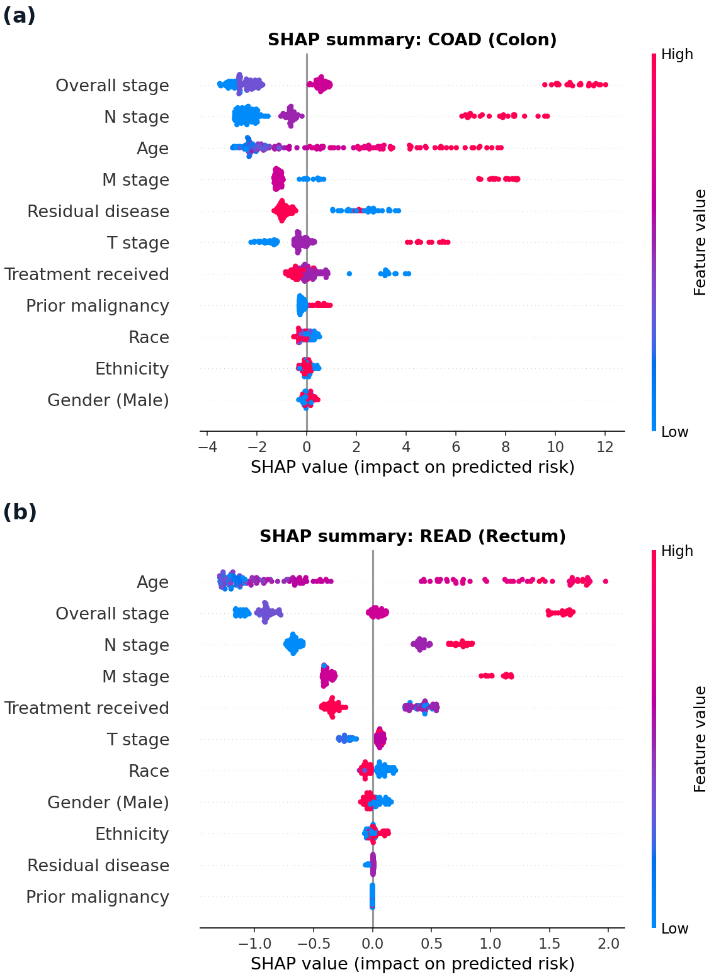
Figure A1. SHAP summaries for the two remaining cohorts. (a) Colon and (b) rectum. Each point is a patient, coloured by feature value, and position shows the effect on predicted risk. Every effect runs in the same direction as stomach (Figure 4d): later stage, residual disease and older age raise predicted risk. Age is the strongest single feature in rectum, matching the Cox model and the permutation importance.
The following supports the transfer analysis in Section 9.2: the ROC-AUC of the transferred model, a comparison of methods, and the comparison against each cohort's within-cohort ceiling in both directions.
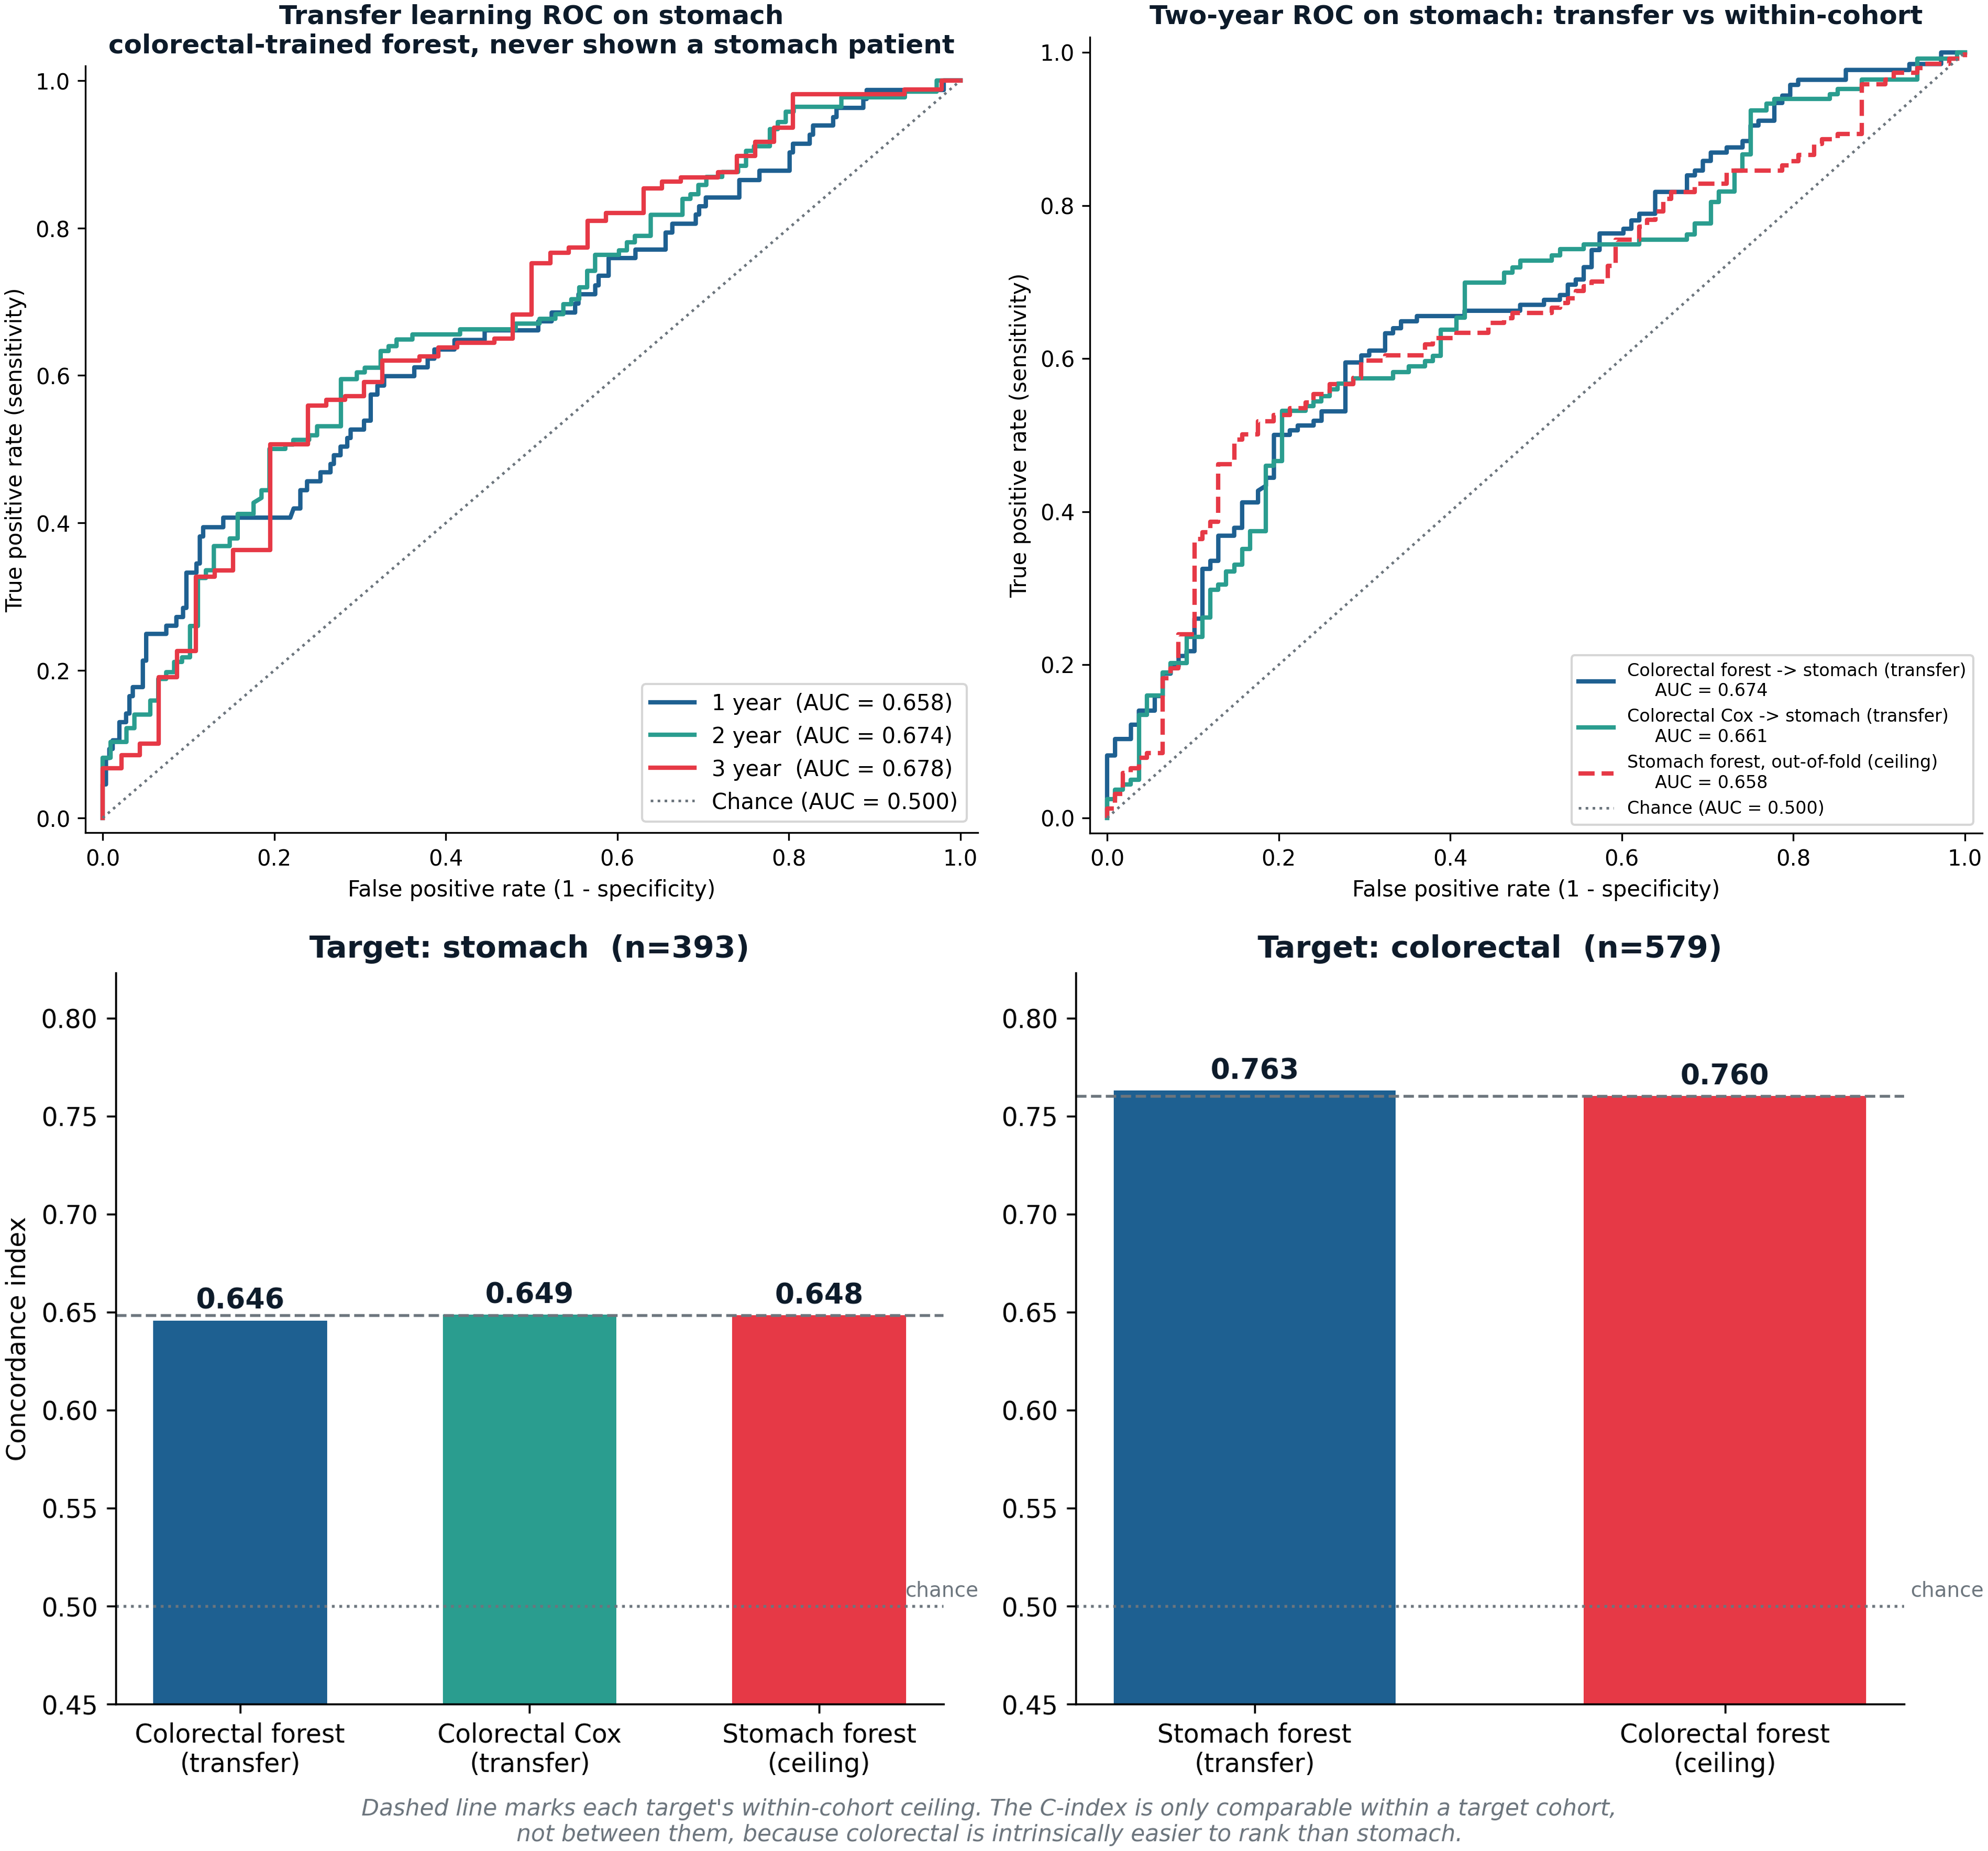
Figure A2. Supporting analyses for the colorectal-to-stomach transfer. Top left: time-dependent ROC of the colorectal-trained forest on stomach at one, two and three years, censoring-weighted. Top right: two-year ROC comparing the forest transfer, a Cox transfer, and a stomach-trained forest, which lie almost on top of one another. Bottom: concordance against each target cohort's own within-cohort ceiling; transfer reaches the ceiling on stomach (0.646 against 0.648) and on colorectal (0.763 against 0.760). The concordance index is only comparable within a target cohort, not between them.

Statement on the Use of Generative AI
Generative AI tools (Anthropic's Claude and OpenAI's ChatGPT) were used in a supporting role during this project, within the limits permitted by the module guidelines. They were used to help debug and troubleshoot Python code for the analysis pipeline, including software environment and dependency issues and an error in a SHAP wrapper function; to help locate relevant literature, which I then read and verified against the original papers; to suggest ways of structuring and organising the report; to draft and revise passages of text for clarity and concision, which I then reviewed and edited; to check spelling and grammar; to assist with presentation, including combining figure panels and formatting the reference list; to help write the code for the supplementary transfer analyses in the Appendix (time-dependent ROC and the reverse-direction comparison), which I then ran and checked; and to check citation consistency.
All research questions, the study design, the choice and implementation of the statistical and machine-learning methods, the analyses, and every numerical result reported here are my own work, produced and verified by me from the TCGA data. No result was generated, altered or interpreted by an AI tool. I reviewed and edited all AI-assisted text, and I take full responsibility for the final content of this dissertation.

