Name : Anmol Raj  
 Roll no : 001811001069



***IRIS DATASET***

# Importing modules

In [2]:

import numpy as np import pandas as pd

from sklearn import datasets

from sklearn.metrics import accuracy_score, classification_report, confusion_matrix from sklearn.model_selection import train_test_split

from sklearn.svm import SVC import seaborn as sns

from sklearn.neural_network import MLPClassifier from sklearn.ensemble import RandomForestClassifier

# Load Dataset

In [3]:

iris = datasets.load_iris() # it's source is same as : https://archive.ics.uci.edu/ml/dat asets/Iris/

In [4]:

dir(iris) Out[4]:

['DESCR', 'data', 'feature_names', 'filename', 'target', 'target_names']

In [5]:

iris.data Out[5]:

|  |  |  |  |
| --- | --- | --- | --- |
| array([[5.1, | 3.5, | 1.4, | 0.2], |
| [4.9, | 3. , | 1.4, | 0.2], |
| [4.7, | 3.2, | 1.3, | 0.2], |
| [4.6, | 3.1, | 1.5, | 0.2], |
| [5. , | 3.6, | 1.4, | 0.2], |
| [5.4, | 3.9, | 1.7, | 0.4], |
| [4.6, | 3.4, | 1.4, | 0.3], |
| [5. , | 3.4, | 1.5, | 0.2], |
| [4.4, | 2.9, | 1.4, | 0.2], |
| [4.9, | 3.1, | 1.5, | 0.1], |
| [5.4, | 3.7, | 1.5, | 0.2], |
| [4.8, | 3.4, | 1.6, | 0.2], |
| [4.8, | 3. , | 1.4, | 0.1], |
| [4.3, | 3. , | 1.1, | 0.1], |
| [5.8, | 4. , | 1.2, | 0.2], |
| [5.7, | 4.4, | 1.5, | 0.4], |
| [5.4, | 3.9, | 1.3, | 0.4], |
| [5.1, | 3.5, | 1.4, | 0.3], |
| [5.7, | 3.8, | 1.7, | 0.3], |
| [5.1, | 3.8, | 1.5, | 0.3], |
| [5.4, | 3.4, | 1.7, | 0.2], |
| [5.1, | 3.7, | 1.5, | 0.4], |
| [4.6, | 3.6, | 1. , | 0.2], |
| [5.1, | 3.3, | 1.7, | 0.5], |
| [4.8, | 3.4, | 1.9, | 0.2], |
| [5. , | 3. , | 1.6, | 0.2], |

 

|  |  |  |  |
| --- | --- | --- | --- |
| [5. , | 3.4, | 1.6, | 0.4], |
| [5.2, | 3.5, | 1.5, | 0.2], |
| [5.2, | 3.4, | 1.4, | 0.2], |
| [4.7, | 3.2, | 1.6, | 0.2], |
| [4.8, | 3.1, | 1.6, | 0.2], |
| [5.4, | 3.4, | 1.5, | 0.4], |
| [5.2, | 4.1, | 1.5, | 0.1], |
| [5.5, | 4.2, | 1.4, | 0.2], |
| [4.9, | 3.1, | 1.5, | 0.2], |
| [5. , | 3.2, | 1.2, | 0.2], |
| [5.5, | 3.5, | 1.3, | 0.2], |
| [4.9, | 3.6, | 1.4, | 0.1], |
| [4.4, | 3. , | 1.3, | 0.2], |
| [5.1, | 3.4, | 1.5, | 0.2], |
| [5. , | 3.5, | 1.3, | 0.3], |
| [4.5, | 2.3, | 1.3, | 0.3], |
| [4.4, | 3.2, | 1.3, | 0.2], |
| [5. , | 3.5, | 1.6, | 0.6], |
| [5.1, | 3.8, | 1.9, | 0.4], |
| [4.8, | 3. , | 1.4, | 0.3], |
| [5.1, | 3.8, | 1.6, | 0.2], |
| [4.6, | 3.2, | 1.4, | 0.2], |
| [5.3, | 3.7, | 1.5, | 0.2], |
| [5. , | 3.3, | 1.4, | 0.2], |
| [7. , | 3.2, | 4.7, | 1.4], |
| [6.4, | 3.2, | 4.5, | 1.5], |
| [6.9, | 3.1, | 4.9, | 1.5], |
| [5.5, | 2.3, | 4. , | 1.3], |
| [6.5, | 2.8, | 4.6, | 1.5], |
| [5.7, | 2.8, | 4.5, | 1.3], |
| [6.3, | 3.3, | 4.7, | 1.6], |
| [4.9, | 2.4, | 3.3, | 1. ], |
| [6.6, | 2.9, | 4.6, | 1.3], |
| [5.2, | 2.7, | 3.9, | 1.4], |
| [5. , | 2. , | 3.5, | 1. ], |
| [5.9, | 3. , | 4.2, | 1.5], |
| [6. , | 2.2, | 4. , | 1. ], |
| [6.1, | 2.9, | 4.7, | 1.4], |
| [5.6, | 2.9, | 3.6, | 1.3], |
| [6.7, | 3.1, | 4.4, | 1.4], |
| [5.6, | 3. , | 4.5, | 1.5], |
| [5.8, | 2.7, | 4.1, | 1. ], |
| [6.2, | 2.2, | 4.5, | 1.5], |
| [5.6, | 2.5, | 3.9, | 1.1], |
| [5.9, | 3.2, | 4.8, | 1.8], |
| [6.1, | 2.8, | 4. , | 1.3], |
| [6.3, | 2.5, | 4.9, | 1.5], |
| [6.1, | 2.8, | 4.7, | 1.2], |
| [6.4, | 2.9, | 4.3, | 1.3], |
| [6.6, | 3. , | 4.4, | 1.4], |
| [6.8, | 2.8, | 4.8, | 1.4], |
| [6.7, | 3. , | 5. , | 1.7], |
| [6. , | 2.9, | 4.5, | 1.5], |
| [5.7, | 2.6, | 3.5, | 1. ], |
| [5.5, | 2.4, | 3.8, | 1.1], |
| [5.5, | 2.4, | 3.7, | 1. ], |
| [5.8, | 2.7, | 3.9, | 1.2], |
| [6. , | 2.7, | 5.1, | 1.6], |
| [5.4, | 3. , | 4.5, | 1.5], |
| [6. , | 3.4, | 4.5, | 1.6], |
| [6.7, | 3.1, | 4.7, | 1.5], |
| [6.3, | 2.3, | 4.4, | 1.3], |
| [5.6, | 3. , | 4.1, | 1.3], |
| [5.5, | 2.5, | 4. , | 1.3], |
| [5.5, | 2.6, | 4.4, | 1.2], |
| [6.1, | 3. , | 4.6, | 1.4], |
| [5.8, | 2.6, | 4. , | 1.2], |
| [5. , | 2.3, | 3.3, | 1. ], |
| [5.6, | 2.7, | 4.2, | 1.3], |
| [5.7, | 3. , | 4.2, | 1.2], |
| [5.7, | 2.9, | 4.2, | 1.3], |
| [6.2, | 2.9, | 4.3, | 1.3], |

|  |  |  |  |
| --- | --- | --- | --- |
| [5.1, | 2.5, | 3. , | 1.1], |
| [5.7, | 2.8, | 4.1, | 1.3], |
| [6.3, | 3.3, | 6. , | 2.5], |
| [5.8, | 2.7, | 5.1, | 1.9], |
| [7.1, | 3. , | 5.9, | 2.1], |
| [6.3, | 2.9, | 5.6, | 1.8], |
| [6.5, | 3. , | 5.8, | 2.2], |
| [7.6, | 3. , | 6.6, | 2.1], |
| [4.9, | 2.5, | 4.5, | 1.7], |
| [7.3, | 2.9, | 6.3, | 1.8], |
| [6.7, | 2.5, | 5.8, | 1.8], |
| [7.2, | 3.6, | 6.1, | 2.5], |
| [6.5, | 3.2, | 5.1, | 2. ], |
| [6.4, | 2.7, | 5.3, | 1.9], |
| [6.8, | 3. , | 5.5, | 2.1], |
| [5.7, | 2.5, | 5. , | 2. ], |
| [5.8, | 2.8, | 5.1, | 2.4], |
| [6.4, | 3.2, | 5.3, | 2.3], |
| [6.5, | 3. , | 5.5, | 1.8], |
| [7.7, | 3.8, | 6.7, | 2.2], |
| [7.7, | 2.6, | 6.9, | 2.3], |
| [6. , | 2.2, | 5. , | 1.5], |
| [6.9, | 3.2, | 5.7, | 2.3], |
| [5.6, | 2.8, | 4.9, | 2. ], |
| [7.7, | 2.8, | 6.7, | 2. ], |
| [6.3, | 2.7, | 4.9, | 1.8], |
| [6.7, | 3.3, | 5.7, | 2.1], |
| [7.2, | 3.2, | 6. , | 1.8], |
| [6.2, | 2.8, | 4.8, | 1.8], |
| [6.1, | 3. , | 4.9, | 1.8], |
| [6.4, | 2.8, | 5.6, | 2.1], |
| [7.2, | 3. , | 5.8, | 1.6], |
| [7.4, | 2.8, | 6.1, | 1.9], |
| [7.9, | 3.8, | 6.4, | 2. ], |
| [6.4, | 2.8, | 5.6, | 2.2], |
| [6.3, | 2.8, | 5.1, | 1.5], |
| [6.1, | 2.6, | 5.6, | 1.4], |
| [7.7, | 3. , | 6.1, | 2.3], |
| [6.3, | 3.4, | 5.6, | 2.4], |
| [6.4, | 3.1, | 5.5, | 1.8], |
| [6. , | 3. , | 4.8, | 1.8], |
| [6.9, | 3.1, | 5.4, | 2.1], |
| [6.7, | 3.1, | 5.6, | 2.4], |
| [6.9, | 3.1, | 5.1, | 2.3], |
| [5.8, | 2.7, | 5.1, | 1.9], |
| [6.8, | 3.2, | 5.9, | 2.3], |
| [6.7, | 3.3, | 5.7, | 2.5], |
| [6.7, | 3. , | 5.2, | 2.3], |
| [6.3, | 2.5, | 5. , | 1.9], |
| [6.5, | 3. , | 5.2, | 2. ], |
| [6.2, | 3.4, | 5.4, | 2.3], |
| [5.9, | 3. , | 5.1, | 1.8]]) |



In [6]:

df = pd.DataFrame(data=iris.data, columns=iris.feature_names) df.head()

Out[6]:

|  |  |  |  |
| --- | --- | --- | --- |
| **sepal length (cm)** | **sepal width (cm)** | **petal length (cm)** | **petal width (cm)** |
| **0** 5.1 | 3.5 | 1.4 | 0.2 |
| **1** 4.9 | 3.0 | 1.4 | 0.2 |
| **2** 4.7 | 3.2 | 1.3 | 0.2 |
| **3** 4.6 | 3.1 | 1.5 | 0.2 |
| **4** 5.0 | 3.6 | 1.4 | 0.2 |

In [7]:



df["target"] = iris.target df.head()

Out[7]:

|  |  |  |  |  |
| --- | --- | --- | --- | --- |
| **sepal length (cm)** | **sepal width (cm)** | **petal length (cm)** | **petal width (cm)** | **target** |
| **0** 5.1 | 3.5 | 1.4 | 0.2 | 0 |
| **1** 4.9 | 3.0 | 1.4 | 0.2 | 0 |
| **2** 4.7 | 3.2 | 1.3 | 0.2 | 0 |
| **3** 4.6 | 3.1 | 1.5 | 0.2 | 0 |
| **4** 5.0 | 3.6 | 1.4 | 0.2 | 0 |

In [8]:

iris.target_names Out[8]:

array(['setosa', 'versicolor', 'virginica'], dtype='<U10')

# DataFrame ready to perform

In [9]:

df["flower_names"] = df.target.apply(lambda x: iris.target_names[x]) df.head()

Out[9]:

|  |  |  |  |  |  |
| --- | --- | --- | --- | --- | --- |
| **sepal length (cm)** | **sepal width (cm)** | **petal length (cm)** | **petal width (cm)** | **target** | **flower_names** |
| **0** 5.1 | 3.5 | 1.4 | 0.2 | 0 | setosa |
| **1** 4.9 | 3.0 | 1.4 | 0.2 | 0 | setosa |
| **2** 4.7 | 3.2 | 1.3 | 0.2 | 0 | setosa |
| **3** 4.6 | 3.1 | 1.5 | 0.2 | 0 | setosa |
| **4** 5.0 | 3.6 | 1.4 | 0.2 | 0 | setosa |

In [10]:

len(df) Out[10]: 150

In [11]:

X = df.drop(["target", "flower_names"], axis="columns") y = df.target

print(X.head())

print(y.head())

sepal length (cm) sepal width (cm) petal length (cm) petal width (cm)

|  |  |  |  |  |  |
| --- | --- | --- | --- | --- | --- |
| 0 |  | 5.1 | 3.5 | 1.4 | 0.2 |
| 1 |  | 4.9 | 3.0 | 1.4 | 0.2 |
| 2 |  | 4.7 | 3.2 | 1.3 | 0.2 |
| 3 |  | 4.6 | 3.1 | 1.5 | 0.2 |
| 4 |  | 5.0 | 3.6 | 1.4 | 0.2 |
| 0 | 0 |  | | | |
| 1 | 0 |
| 2 | 0 |
| 3 | 0 |
| 4 | 0 |

Name: target, dtype: int64



# SVC Classfier

## Linear SVC Classifier

In [12]:

linear_SVC_classifier = SVC(kernel='linear') linear_SVC_classifier

Out[12]:

SVC(C=1.0, break_ties=False, cache_size=200, class_weight=None, coef0=0.0, decision_function_shape='ovr', degree=3, gamma='scale', kernel='linear', max_iter=-1, probability=False, random_state=None, shrinking=True, tol=0.001, verbose=False)

### train size : test size = 70% : 30%

In [13]:

X_train, X_test, y_train, y_test = train_test_split(X, y, test_size=0.3, random_state=0)

#### # 70% training data, 30% testing data

In [15]:

print(len(X_train)) print(len(y_test))

105

45

In [17]:

linear_SVC_classifier.fit(X_train, y_train) Out[17]:

SVC(C=1.0, break_ties=False, cache_size=200, class_weight=None, coef0=0.0, decision_function_shape='ovr', degree=3, gamma='scale', kernel='linear', max_iter=-1, probability=False, random_state=None, shrinking=True, tol=0.001, verbose=False)

In [19]:

y_pred = linear_SVC_classifier.predict(X_test) print(f"Accuracy: {100 * accuracy_score(y_test,y_pred)}%\n") cf_matrix = confusion_matrix(y_test,y_pred) print("Confusion Matrix:\n")

print(cf_matrix) print("\nClassification Report:\n")

print(classification_report(y_test,y_pred)) Accuracy: 97.77777777777777%

Confusion Matrix:

|  |  |
| --- | --- |
| [[16 | 0 0] |
| [ 0 | 17 1] |
| [ 0 | 0 11]] |

Classification Report:

precision recall f1-score support

|  |  |  |  |  |
| --- | --- | --- | --- | --- |
| 0 | 1.00 | 1.00 | 1.00 | 16 |
| 1 | 1.00 | 0.94 | 0.97 | 18 |

|  |  |  |  |  |
| --- | --- | --- | --- | --- |
| 2 | 0.92 | 1.00 | 0.96 | 11 |
| accuracy |  |  | 0.98 | 45 |
| macro avg | 0.97 | 0.98 | 0.98 | 45 |
| weighted avg | 0.98 | 0.98 | 0.98 | 45 |

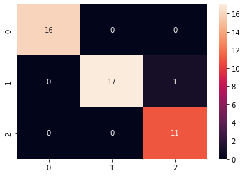

In [20]:

sns.heatmap(cf_matrix, annot=True) Out[20]:

<matplotlib.axes._subplots.AxesSubplot at 0x7fd1a8258590>

### train size : test size = 60% : 40%

In [21]:

X_train, X_test, y_train, y_test = train_test_split(X, y, test_size=0.4, random_state=0)

#### # 60% training data, 40% testing data

In [22]:

print(len(X_train)) print(len(y_test))

90

60

In [23]:

linear_SVC_classifier.fit(X_train, y_train) Out[23]:

SVC(C=1.0, break_ties=False, cache_size=200, class_weight=None, coef0=0.0, decision_function_shape='ovr', degree=3, gamma='scale', kernel='linear', max_iter=-1, probability=False, random_state=None, shrinking=True, tol=0.001, verbose=False)

In [24]:

y_pred = linear_SVC_classifier.predict(X_test) print(f"Accuracy: {100 * accuracy_score(y_test,y_pred)}%\n") cf_matrix = confusion_matrix(y_test,y_pred) print("Confusion Matrix:")

print(cf_matrix) print("\nClassification Report:\n")

print(classification_report(y_test,y_pred)) Accuracy: 96.66666666666667%

Confusion Matrix: [[16 0 0]

[ 0 22 1]

[ 0 1 20]]

Classification Report:

|  |  |  |  |  |
| --- | --- | --- | --- | --- |
|  | precision | recall | f1-score | support |
| 0 | 1.00 | 1.00 | 1.00 | 16 |
| 1 | 0.96 | 0.96 | 0.96 | 23 |
| 2 | 0.95 | 0.95 | 0.95 | 21 |
| accuracy |  |  | 0.97 | 60 |
| macro avg | 0.97 | 0.97 | 0.97 | 60 |
| weighted avg | 0.97 | 0.97 | 0.97 | 60 |

In [25]:



sns.heatmap(cf_matrix, annot=True)

Out[25]:

<matplotlib.axes._subplots.AxesSubplot at 0x7fd1a80c9510>

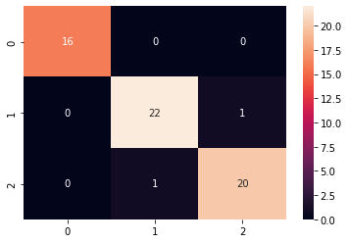

### train size : test size = 50% : 50%

In [ ]:



X_train, X_test, y_train, y_test = train_test_split(X, y, test_size=0.5, random_state=0)

# 50% training data, 50% testing data

In [26]:



print(len(X_train)) print(len(y_test))

90

60

In [27]:



linear_SVC_classifier.fit(X_train, y_train)

Out[27]:

SVC(C=1.0, break_ties=False, cache_size=200, class_weight=None, coef0=0.0, decision_function_shape='ovr', degree=3, gamma='scale', kernel='linear', max_iter=-1, probability=False, random_state=None, shrinking=True, tol=0.001, verbose=False)

In [28]:



y_pred = linear_SVC_classifier.predict(X_test) print(f"Accuracy: {100 * accuracy_score(y_test,y_pred)}%\n") cf_matrix = confusion_matrix(y_test,y_pred)





print("Confusion Matrix:") print(cf_matrix) print("\nClassification Report:\n")

print(classification_report(y_test,y_pred))

Accuracy: 96.66666666666667%

Confusion Matrix:

[[16 0 0]

[ 0 22 1]

[ 0 1 20]]

Classification Report:

|  |  |  |  |  |
| --- | --- | --- | --- | --- |
|  | precision | recall | f1-score | support |
| 0 | 1.00 | 1.00 | 1.00 | 16 |
| 1 | 0.96 | 0.96 | 0.96 | 23 |
| 2 | 0.95 | 0.95 | 0.95 | 21 |
| accuracy |  |  | 0.97 | 60 |
| macro avg | 0.97 | 0.97 | 0.97 | 60 |
| weighted avg | 0.97 | 0.97 | 0.97 | 60 |

In [29]:



sns.heatmap(cf_matrix, annot=True)

Out[29]:

<matplotlib.axes._subplots.AxesSubplot at 0x7fd19fad3c50>



### train size : test size = 40% : 60%

In [30]:



X_train, X_test, y_train, y_test = train_test_split(X, y, test_size=0.6, random_state=0)

In [31]:



print(len(X_train)) print(len(y_test))

60

90

In [32]:



linear_SVC_classifier.fit(X_train, y_train)

Out[32]:

SVC(C=1.0, break_ties=False, cache_size=200, class_weight=None, coef0=0.0, decision_function_shape='ovr', degree=3, gamma='scale', kernel='linear', max_iter=-1, probability=False, random_state=None, shrinking=True,

tol=0.001, verbose=False)

In [33]:



y_pred = linear_SVC_classifier.predict(X_test) print(f"Accuracy: {100 * accuracy_score(y_test,y_pred)}%\n") cf_matrix = confusion_matrix(y_test,y_pred) print("Confusion Matrix:\n")

print(cf_matrix) print("\nClassification Report:\n")

print(classification_report(y_test,y_pred))

Accuracy: 96.66666666666667%

Confusion Matrix:

[[26 0 0]

[ 0 32 1]

[ 0 2 29]]

Classification Report:

|  |  |  |  |  |
| --- | --- | --- | --- | --- |
|  | precision | recall | f1-score | support |
| 0 | 1.00 | 1.00 | 1.00 | 26 |
| 1 | 0.94 | 0.97 | 0.96 | 33 |
| 2 | 0.97 | 0.94 | 0.95 | 31 |
| accuracy |  |  | 0.97 | 90 |
| macro avg | 0.97 | 0.97 | 0.97 | 90 |
| weighted avg | 0.97 | 0.97 | 0.97 | 90 |

In [34]:



sns.heatmap(cf_matrix, annot=True)

Out[34]:

<matplotlib.axes._subplots.AxesSubplot at 0x7fd1a81b4890>

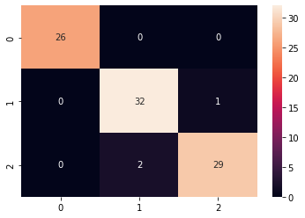

### train size : test size = 30% : 70%

In [35]:



X_train, X_test, y_train, y_test = train_test_split(X, y, test_size=0.7, random_state=0)

In [36]:



print(len(X_train)) print(len(y_test))

45

105

In [37]:

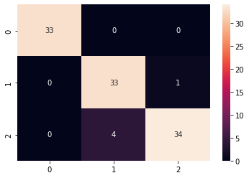

linear_SVC_classifier.fit(X_train, y_train) Out[37]:

SVC(C=1.0, break_ties=False, cache_size=200, class_weight=None, coef0=0.0, decision_function_shape='ovr', degree=3, gamma='scale', kernel='linear', max_iter=-1, probability=False, random_state=None, shrinking=True, tol=0.001, verbose=False)

In [38]:

y_pred = linear_SVC_classifier.predict(X_test) print(f"Accuracy: {100 * accuracy_score(y_test,y_pred)}%\n") cf_matrix = confusion_matrix(y_test,y_pred) print("Confusion Matrix:\n")

print(cf_matrix) print("\nClassification Report:\n")

print(classification_report(y_test,y_pred)) Accuracy: 95.23809523809523%

Confusion Matrix:

[[33 0 0]

[ 0 33 1]

[ 0 4 34]]

Classification Report:

|  |  |  |  |  |
| --- | --- | --- | --- | --- |
|  | precision | recall | f1-score | support |
| 0 | 1.00 | 1.00 | 1.00 | 33 |
| 1 | 0.89 | 0.97 | 0.93 | 34 |
| 2 | 0.97 | 0.89 | 0.93 | 38 |
| accuracy |  |  | 0.95 | 105 |
| macro avg | 0.95 | 0.96 | 0.95 | 105 |
| weighted avg | 0.95 | 0.95 | 0.95 | 105 |

In [39]:

sns.heatmap(cf_matrix, annot=True) Out[39]:

<matplotlib.axes._subplots.AxesSubplot at 0x7fd19f953750>

## Polynomial SVC Classifier

In [40]:

poly_SVC_classifier = SVC(kernel='poly')





poly_SVC_classifier

Out[40]:

SVC(C=1.0, break_ties=False, cache_size=200, class_weight=None, coef0=0.0, decision_function_shape='ovr', degree=3, gamma='scale', kernel='poly', max_iter=-1, probability=False, random_state=None, shrinking=True, tol=0.001, verbose=False)

### train size : test size = 70% : 30%

In [41]:



X_train, X_test, y_train, y_test = train_test_split(X, y, test_size=0.3, random_state=0)

In [42]:



print(len(X_train)) print(len(y_test))

105

45

In [43]:



poly_SVC_classifier.fit(X_train, y_train)

Out[43]:

SVC(C=1.0, break_ties=False, cache_size=200, class_weight=None, coef0=0.0, decision_function_shape='ovr', degree=3, gamma='scale', kernel='poly', max_iter=-1, probability=False, random_state=None, shrinking=True, tol=0.001, verbose=False)

In [44]:



y_pred = poly_SVC_classifier.predict(X_test) print(f"Accuracy: {100 * accuracy_score(y_test,y_pred)}%\n") cf_matrix = confusion_matrix(y_test,y_pred) print("Confusion Matrix:\n", cf_matrix) print("\nClassification Report:\n") print(classification_report(y_test,y_pred))

Accuracy: 97.77777777777777%

Confusion Matrix:

[[16 0 0]

[ 0 17 1]

[ 0 0 11]]

Classification Report:

|  |  |  |  |  |
| --- | --- | --- | --- | --- |
|  | precision | recall | f1-score | support |
| 0 | 1.00 | 1.00 | 1.00 | 16 |
| 1 | 1.00 | 0.94 | 0.97 | 18 |
| 2 | 0.92 | 1.00 | 0.96 | 11 |
| accuracy |  |  | 0.98 | 45 |
| macro avg | 0.97 | 0.98 | 0.98 | 45 |
| weighted avg | 0.98 | 0.98 | 0.98 | 45 |

In [45]:



sns.heatmap(cf_matrix, annot=True)

Out[45]:

<matplotlib.axes._subplots.AxesSubplot at 0x7fd19f88f390>



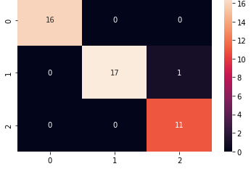

### train size : test size = 60% : 40%

In [46]:

X_train, X_test, y_train, y_test = train_test_split(X, y, test_size=0.4, random_state=0)

In [47]:

print(len(X_train)) print(len(y_test))

90

60

In [48]:

poly_SVC_classifier.fit(X_train, y_train) Out[48]:

SVC(C=1.0, break_ties=False, cache_size=200, class_weight=None, coef0=0.0, decision_function_shape='ovr', degree=3, gamma='scale', kernel='poly', max_iter=-1, probability=False, random_state=None, shrinking=True, tol=0.001, verbose=False)

In [49]:

y_pred = poly_SVC_classifier.predict(X_test) print(f"Accuracy: {100 * accuracy_score(y_test,y_pred)}%\n") cf_matrix = confusion_matrix(y_test,y_pred) print("Confusion Matrix:\n", cf_matrix) print("\nClassification Report:\n") print(classification_report(y_test,y_pred))

Accuracy: 90.0%

Confusion Matrix: [[16 0 0]

[ 0 22 1]

[ 0 5 16]]

Classification Report:

|  |  |  |  |  |
| --- | --- | --- | --- | --- |
|  | precision | recall | f1-score | support |
| 0 | 1.00 | 1.00 | 1.00 | 16 |
| 1 | 0.81 | 0.96 | 0.88 | 23 |
| 2 | 0.94 | 0.76 | 0.84 | 21 |
| accuracy |  |  | 0.90 | 60 |
| macro avg | 0.92 | 0.91 | 0.91 | 60 |
| weighted avg | 0.91 | 0.90 | 0.90 | 60 |

In [50]:

sns.heatmap(cf_matrix, annot=True) Out[50]:

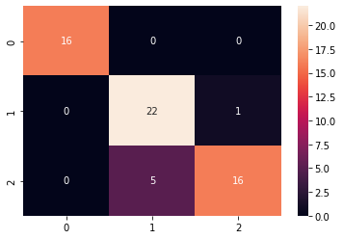

<matplotlib.axes._subplots.AxesSubplot at 0x7fd19f7b5b90>

### train size : test size = 50% : 50%

In [51]:

X_train, X_test, y_train, y_test = train_test_split(X, y, test_size=0.5, random_state=0)

In [52]:

print(len(X_train)) print(len(y_test))

75

75

In [53]:

poly_SVC_classifier.fit(X_train, y_train) Out[53]:

SVC(C=1.0, break_ties=False, cache_size=200, class_weight=None, coef0=0.0, decision_function_shape='ovr', degree=3, gamma='scale', kernel='poly', max_iter=-1, probability=False, random_state=None, shrinking=True, tol=0.001, verbose=False)

In [54]:

y_pred = poly_SVC_classifier.predict(X_test) print(f"Accuracy: {100 * accuracy_score(y_test,y_pred)}%\n") cf_matrix = confusion_matrix(y_test,y_pred) print("Confusion Matrix:\n", cf_matrix) print("\nClassification Report:\n") print(classification_report(y_test,y_pred))

Accuracy: 92.0%

Confusion Matrix: [[21 0 0]

[ 0 29 1]

[ 0 5 19]]

Classification Report:

|  |  |  |  |  |
| --- | --- | --- | --- | --- |
|  | precision | recall | f1-score | support |
| 0 | 1.00 | 1.00 | 1.00 | 21 |
| 1 | 0.85 | 0.97 | 0.91 | 30 |
| 2 | 0.95 | 0.79 | 0.86 | 24 |
| accuracy |  |  | 0.92 | 75 |

|  |  |  |  |  |
| --- | --- | --- | --- | --- |
| macro avg | 0.93 | 0.92 | 0.92 | 75 |
| weighted avg | 0.93 | 0.92 | 0.92 | 75 |

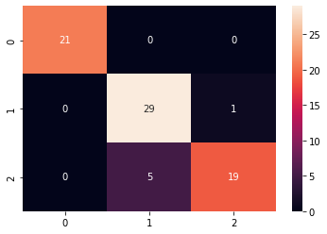

In [55]:

sns.heatmap(cf_matrix, annot=True) Out[55]:

<matplotlib.axes._subplots.AxesSubplot at 0x7fd19f709150>

### train size : test size = 40% : 60%

In [66]:

X_train, X_test, y_train, y_test = train_test_split(X, y, test_size=0.6, random_state=0)

In [67]:

print(len(X_train)) print(len(y_test))

60

90

In [68]:

poly_SVC_classifier.fit(X_train, y_train) Out[68]:

SVC(C=1.0, break_ties=False, cache_size=200, class_weight=None, coef0=0.0, decision_function_shape='ovr', degree=3, gamma='scale', kernel='poly', max_iter=-1, probability=False, random_state=None, shrinking=True, tol=0.001, verbose=False)

In [59]:

y_pred = poly_SVC_classifier.predict(X_test) print(f"Accuracy: {100 * accuracy_score(y_test,y_pred)}%\n") cf_matrix = confusion_matrix(y_test,y_pred) print("Confusion Matrix:\n", cf_matrix) print("\nClassification Report:\n") print(classification_report(y_test,y_pred))

Accuracy: 93.33333333333333%

Confusion Matrix: [[26 0 0]

[ 0 32 1]

[ 0 5 26]]

Classification Report:

|  |  |  |  |  |
| --- | --- | --- | --- | --- |
|  | precision | recall | f1-score | support |
| 0 | 1.00 | 1.00 | 1.00 | 26 |
| 1 | 0.86 | 0.97 | 0.91 | 33 |
| 2 | 0.96 | 0.84 | 0.90 | 31 |
| accuracy |  |  | 0.93 | 90 |
| macro avg | 0.94 | 0.94 | 0.94 | 90 |
| weighted avg | 0.94 | 0.93 | 0.93 | 90 |

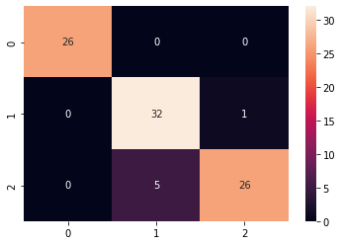

In [60]:

sns.heatmap(cf_matrix, annot=True) Out[60]:

<matplotlib.axes._subplots.AxesSubplot at 0x7fd19f62e450>

### train size : test size = 30% : 70%

In [61]:

X_train, X_test, y_train, y_test = train_test_split(X, y, test_size=0.7, random_state=0)

In [62]:

print(len(X_train)) print(len(y_test))

45

105

In [63]:

poly_SVC_classifier.fit(X_train, y_train) Out[63]:

SVC(C=1.0, break_ties=False, cache_size=200, class_weight=None, coef0=0.0, decision_function_shape='ovr', degree=3, gamma='scale', kernel='poly', max_iter=-1, probability=False, random_state=None, shrinking=True, tol=0.001, verbose=False)

In [64]:

y_pred = poly_SVC_classifier.predict(X_test) print(f"Accuracy: {100 * accuracy_score(y_test,y_pred)}%\n") cf_matrix = confusion_matrix(y_test,y_pred) print("Confusion Matrix:\n", cf_matrix) print("\nClassification Report:\n") print(classification_report(y_test,y_pred))

Accuracy: 94.28571428571428%

Confusion Matrix:

[[33 0 0]

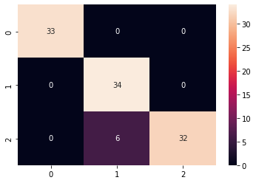

[ 0 34 0]

[ 0 6 32]]

Classification Report:

|  |  |  |  |  |
| --- | --- | --- | --- | --- |
|  | precision | recall | f1-score | support |
| 0 | 1.00 | 1.00 | 1.00 | 33 |
| 1 | 0.85 | 1.00 | 0.92 | 34 |
| 2 | 1.00 | 0.84 | 0.91 | 38 |
| accuracy |  |  | 0.94 | 105 |
| macro avg | 0.95 | 0.95 | 0.94 | 105 |
| weighted avg | 0.95 | 0.94 | 0.94 | 105 |

In [65]:

sns.heatmap(cf_matrix, annot=True) Out[65]:

<matplotlib.axes._subplots.AxesSubplot at 0x7fd19f571150>

## Gaussain SVC Classifier

In [69]:

gaussain_SVC_classifier = SVC(kernel='rbf') gaussain_SVC_classifier

Out[69]:

SVC(C=1.0, break_ties=False, cache_size=200, class_weight=None, coef0=0.0, decision_function_shape='ovr', degree=3, gamma='scale', kernel='rbf', max_iter=-1, probability=False, random_state=None, shrinking=True, tol=0.001, verbose=False)

### train size : test size = 70% : 30%

In [70]:

X_train, X_test, y_train, y_test = train_test_split(X, y, test_size=0.3, random_state=0)

In [71]:

print(len(X_train)) print(len(y_test))

105

45

In [72]:

gaussain_SVC_classifier.fit(X_train, y_train) Out[72]:



SVC(C=1.0, break_ties=False, cache_size=200, class_weight=None, coef0=0.0, decision_function_shape='ovr', degree=3, gamma='scale', kernel='rbf', max_iter=-1, probability=False, random_state=None, shrinking=True, tol=0.001, verbose=False)

In [73]:

y_pred = gaussain_SVC_classifier.predict(X_test) print(f"Accuracy: {100 * accuracy_score(y_test,y_pred)}%\n") cf_matrix = confusion_matrix(y_test,y_pred) print("Confusion Matrix:\n", cf_matrix) print("\nClassification Report:\n") print(classification_report(y_test,y_pred))

Accuracy: 97.77777777777777%

Confusion Matrix:

[[16 0 0]

[ 0 17 1]

[ 0 0 11]]

Classification Report:

|  |  |  |  |  |
| --- | --- | --- | --- | --- |
|  | precision | recall | f1-score | support |
| 0 | 1.00 | 1.00 | 1.00 | 16 |
| 1 | 1.00 | 0.94 | 0.97 | 18 |
| 2 | 0.92 | 1.00 | 0.96 | 11 |
| accuracy |  |  | 0.98 | 45 |
| macro avg | 0.97 | 0.98 | 0.98 | 45 |
| weighted avg | 0.98 | 0.98 | 0.98 | 45 |

In [74]:

sns.heatmap(cf_matrix, annot=True) Out[74]:

<matplotlib.axes._subplots.AxesSubplot at 0x7fd19f7adfd0>

### train size : test size = 60% : 40%

In [80]:

X_train, X_test, y_train, y_test = train_test_split(X, y, test_size=0.4, random_state=0)

In [81]:

print(len(X_train)) print(len(y_test))

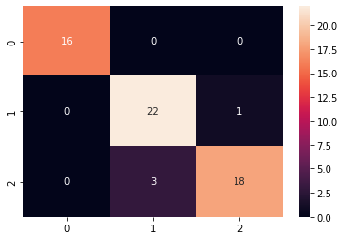

90

60

In [82]:

gaussain_SVC_classifier.fit(X_train, y_train) Out[82]:

SVC(C=1.0, break_ties=False, cache_size=200, class_weight=None, coef0=0.0, decision_function_shape='ovr', degree=3, gamma='scale', kernel='rbf', max_iter=-1, probability=False, random_state=None, shrinking=True, tol=0.001, verbose=False)

In [83]:

y_pred = gaussain_SVC_classifier.predict(X_test) print(f"Accuracy: {100 * accuracy_score(y_test,y_pred)}%\n") cf_matrix = confusion_matrix(y_test,y_pred) print("Confusion Matrix:\n", cf_matrix) print("\nClassification Report:\n") print(classification_report(y_test,y_pred))

Accuracy: 93.33333333333333%

Confusion Matrix:

[[16 0 0]

[ 0 22 1]

[ 0 3 18]]

Classification Report:

|  |  |  |  |  |
| --- | --- | --- | --- | --- |
|  | precision | recall | f1-score | support |
| 0 | 1.00 | 1.00 | 1.00 | 16 |
| 1 | 0.88 | 0.96 | 0.92 | 23 |
| 2 | 0.95 | 0.86 | 0.90 | 21 |
| accuracy |  |  | 0.93 | 60 |
| macro avg | 0.94 | 0.94 | 0.94 | 60 |
| weighted avg | 0.94 | 0.93 | 0.93 | 60 |

In [84]:

sns.heatmap(cf_matrix, annot=True) Out[84]:

<matplotlib.axes._subplots.AxesSubplot at 0x7fd19f325a10>

### train size : test size = 50% : 50%

In [85]:

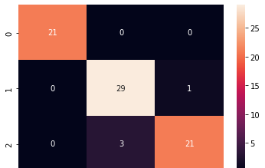

X_train, X_test, y_train, y_test = train_test_split(X, y, test_size=0.5, random_state=0)

In [86]:

print(len(X_train)) print(len(y_test))

75

75

In [87]:

gaussain_SVC_classifier.fit(X_train, y_train) Out[87]:

SVC(C=1.0, break_ties=False, cache_size=200, class_weight=None, coef0=0.0, decision_function_shape='ovr', degree=3, gamma='scale', kernel='rbf', max_iter=-1, probability=False, random_state=None, shrinking=True, tol=0.001, verbose=False)

In [88]:

y_pred = gaussain_SVC_classifier.predict(X_test) print(f"Accuracy: {100 * accuracy_score(y_test,y_pred)}%\n") cf_matrix = confusion_matrix(y_test,y_pred) print("Confusion Matrix:\n", cf_matrix) print("\nClassification Report:\n") print(classification_report(y_test,y_pred))

Accuracy: 94.66666666666667%

Confusion Matrix:

[[21 0 0]

[ 0 29 1]

[ 0 3 21]]

Classification Report:

|  |  |  |  |  |
| --- | --- | --- | --- | --- |
|  | precision | recall | f1-score | support |
| 0 | 1.00 | 1.00 | 1.00 | 21 |
| 1 | 0.91 | 0.97 | 0.94 | 30 |
| 2 | 0.95 | 0.88 | 0.91 | 24 |
| accuracy |  |  | 0.95 | 75 |
| macro avg | 0.95 | 0.95 | 0.95 | 75 |
| weighted avg | 0.95 | 0.95 | 0.95 | 75 |

In [89]:

sns.heatmap(cf_matrix, annot=True) Out[89]:

<matplotlib.axes._subplots.AxesSubplot at 0x7fd19f7ba610>



### train size : test size = 40% : 60%

In [90]:



X_train, X_test, y_train, y_test = train_test_split(X, y, test_size=0.6, random_state=0)

In [91]:



print(len(X_train)) print(len(y_test))

60

90

In [92]:



gaussain_SVC_classifier.fit(X_train, y_train)

Out[92]:

SVC(C=1.0, break_ties=False, cache_size=200, class_weight=None, coef0=0.0, decision_function_shape='ovr', degree=3, gamma='scale', kernel='rbf', max_iter=-1, probability=False, random_state=None, shrinking=True, tol=0.001, verbose=False)

In [93]:



y_pred = gaussain_SVC_classifier.predict(X_test) print(f"Accuracy: {100 * accuracy_score(y_test,y_pred)}%\n") cf_matrix = confusion_matrix(y_test,y_pred) print("Confusion Matrix:\n", cf_matrix) print("\nClassification Report:\n") print(classification_report(y_test,y_pred))

Accuracy: 93.33333333333333%

Confusion Matrix:

[[26 0 0]

[ 0 32 1]

[ 0 5 26]]

Classification Report:

|  |  |  |  |  |
| --- | --- | --- | --- | --- |
|  | precision | recall | f1-score | support |
| 0 | 1.00 | 1.00 | 1.00 | 26 |
| 1 | 0.86 | 0.97 | 0.91 | 33 |
| 2 | 0.96 | 0.84 | 0.90 | 31 |
| accuracy |  |  | 0.93 | 90 |
| macro avg | 0.94 | 0.94 | 0.94 | 90 |
| weighted avg | 0.94 | 0.93 | 0.93 | 90 |

In [94]:



sns.heatmap(cf_matrix, annot=True)

Out[94]:

<matplotlib.axes._subplots.AxesSubplot at 0x7fd19f1e38d0>

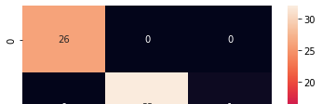

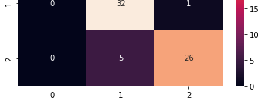

### train size : test size = 30% : 70%

In [95]:



X_train, X_test, y_train, y_test = train_test_split(X, y, test_size=0.7, random_state=0)

In [96]:



print(len(X_train)) print(len(y_test))

45

105

In [97]:



gaussain_SVC_classifier.fit(X_train, y_train)

Out[97]:

SVC(C=1.0, break_ties=False, cache_size=200, class_weight=None, coef0=0.0, decision_function_shape='ovr', degree=3, gamma='scale', kernel='rbf', max_iter=-1, probability=False, random_state=None, shrinking=True, tol=0.001, verbose=False)

In [98]:



y_pred = gaussain_SVC_classifier.predict(X_test) print(f"Accuracy: {100 * accuracy_score(y_test,y_pred)}%\n") cf_matrix = confusion_matrix(y_test,y_pred) print("Confusion Matrix:\n", cf_matrix) print("\nClassification Report:\n") print(classification_report(y_test,y_pred))

Accuracy: 88.57142857142857%

Confusion Matrix:

[[33 0 0]

[ 0 34 0]

[ 0 12 26]]

Classification Report:

|  |  |  |  |  |
| --- | --- | --- | --- | --- |
|  | precision | recall | f1-score | support |
| 0 | 1.00 | 1.00 | 1.00 | 33 |
| 1 | 0.74 | 1.00 | 0.85 | 34 |
| 2 | 1.00 | 0.68 | 0.81 | 38 |
| accuracy |  |  | 0.89 | 105 |
| macro avg | 0.91 | 0.89 | 0.89 | 105 |
| weighted avg | 0.92 | 0.89 | 0.88 | 105 |

In [99]:



sns.heatmap(cf_matrix, annot=True)

Out[99]:

<matplotlib.axes._subplots.AxesSubplot at 0x7fd19f1982d0>



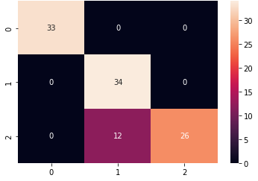

## Sigmoid SVC Classifier

In [100]:



sigmoid_SVC_classifier = SVC(kernel='sigmoid') sigmoid_SVC_classifier

Out[100]:

SVC(C=1.0, break_ties=False, cache_size=200, class_weight=None, coef0=0.0, decision_function_shape='ovr', degree=3, gamma='scale', kernel='sigmoid', max_iter=-1, probability=False, random_state=None, shrinking=True, tol=0.001, verbose=False)

### train size : test size = 70% : 30%

In [101]:



X_train, X_test, y_train, y_test = train_test_split(X, y, test_size=0.3, random_state=0)

In [102]:



print(len(X_train)) print(len(y_test))

105

45

In [103]:



sigmoid_SVC_classifier.fit(X_train, y_train)

Out[103]:

SVC(C=1.0, break_ties=False, cache_size=200, class_weight=None, coef0=0.0, decision_function_shape='ovr', degree=3, gamma='scale', kernel='sigmoid', max_iter=-1, probability=False, random_state=None, shrinking=True, tol=0.001, verbose=False)

In [104]:



y_pred = sigmoid_SVC_classifier.predict(X_test) print(f"Accuracy: {100 * accuracy_score(y_test,y_pred)}%\n") cf_matrix = confusion_matrix(y_test,y_pred) print("Confusion Matrix:\n", cf_matrix) print("\nClassification Report:\n") print(classification_report(y_test,y_pred))

Accuracy: 24.444444444444443%

Confusion Matrix: [[ 0 0 16]

[ 0 0 18]

[ 0 0 11]]



Classification Report:

|  |  |  |  |  |
| --- | --- | --- | --- | --- |
|  | precision | recall | f1-score | support |
| 0 | 0.00 | 0.00 | 0.00 | 16 |
| 1 | 0.00 | 0.00 | 0.00 | 18 |
| 2 | 0.24 | 1.00 | 0.39 | 11 |
| accuracy |  |  | 0.24 | 45 |
| macro avg | 0.08 | 0.33 | 0.13 | 45 |
| weighted avg | 0.06 | 0.24 | 0.10 | 45 |

/usr/local/lib/python3.7/dist-packages/sklearn/metrics/_classification.py:1272: Undefined MetricWarning: Precision and F-score are ill-defined and being set to 0.0 in labels with no predicted samples. Use `zero_division` parameter to control this behavior.

_warn_prf(average, modifier, msg_start, len(result))

In [105]:



sns.heatmap(cf_matrix, annot=True)

Out[105]:

<matplotlib.axes._subplots.AxesSubplot at 0x7fd19f0d9290>

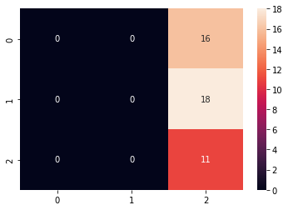

### train size : test size = 60% : 40%

In [106]:



X_train, X_test, y_train, y_test = train_test_split(X, y, test_size=0.4, random_state=0)

In [107]:



print(len(X_train)) print(len(y_test))

90

60

In [108]:



sigmoid_SVC_classifier.fit(X_train, y_train)

Out[108]:

SVC(C=1.0, break_ties=False, cache_size=200, class_weight=None, coef0=0.0, decision_function_shape='ovr', degree=3, gamma='scale', kernel='sigmoid', max_iter=-1, probability=False, random_state=None, shrinking=True, tol=0.001, verbose=False)

In [109]:



y_pred = sigmoid_SVC_classifier.predict(X_test)





print(f"Accuracy: {100 * accuracy_score(y_test,y_pred)}%\n") cf_matrix = confusion_matrix(y_test,y_pred) print("Confusion Matrix:\n", cf_matrix) print("\nClassification Report:\n") print(classification_report(y_test,y_pred))

Accuracy: 26.666666666666668%

Confusion Matrix:

|  |  |  |
| --- | --- | --- |
| [[16 | 0 | 0] |
| [23 | 0 | 0] |
| [21 | 0 | 0]] |

Classification Report:

|  |  |  |  |  |
| --- | --- | --- | --- | --- |
|  | precision | recall | f1-score | support |
| 0 | 0.27 | 1.00 | 0.42 | 16 |
| 1 | 0.00 | 0.00 | 0.00 | 23 |
| 2 | 0.00 | 0.00 | 0.00 | 21 |
| accuracy |  |  | 0.27 | 60 |
| macro avg | 0.09 | 0.33 | 0.14 | 60 |
| weighted avg | 0.07 | 0.27 | 0.11 | 60 |

/usr/local/lib/python3.7/dist-packages/sklearn/metrics/_classification.py:1272: Undefined MetricWarning: Precision and F-score are ill-defined and being set to 0.0 in labels with no predicted samples. Use `zero_division` parameter to control this behavior.

_warn_prf(average, modifier, msg_start, len(result))

In [110]:



sns.heatmap(cf_matrix, annot=True)

Out[110]:

<matplotlib.axes._subplots.AxesSubplot at 0x7fd19f015a90>

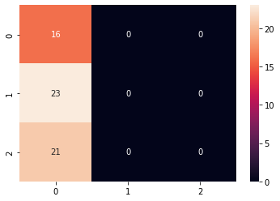

### train size : test size = 50% : 50%

In [111]:



X_train, X_test, y_train, y_test = train_test_split(X, y, test_size=0.5, random_state=0)

In [112]:



print(len(X_train)) print(len(y_test))

75

75

In [113]:





sigmoid_SVC_classifier.fit(X_train, y_train)

Out[113]:

SVC(C=1.0, break_ties=False, cache_size=200, class_weight=None, coef0=0.0, decision_function_shape='ovr', degree=3, gamma='scale', kernel='sigmoid', max_iter=-1, probability=False, random_state=None, shrinking=True, tol=0.001, verbose=False)

In [114]:



y_pred = sigmoid_SVC_classifier.predict(X_test) print(f"Accuracy: {100 * accuracy_score(y_test,y_pred)}%\n") cf_matrix = confusion_matrix(y_test,y_pred) print("Confusion Matrix:\n", cf_matrix) print("\nClassification Report:\n") print(classification_report(y_test,y_pred))

Accuracy: 28.000000000000004%

Confusion Matrix:

[[21 0 0]

[30 0 0]

[24 0 0]]

Classification Report:

|  |  |  |  |  |
| --- | --- | --- | --- | --- |
|  | precision | recall | f1-score | support |
| 0 | 0.28 | 1.00 | 0.44 | 21 |
| 1 | 0.00 | 0.00 | 0.00 | 30 |
| 2 | 0.00 | 0.00 | 0.00 | 24 |
| accuracy |  |  | 0.28 | 75 |
| macro avg | 0.09 | 0.33 | 0.15 | 75 |
| weighted avg | 0.08 | 0.28 | 0.12 | 75 |

/usr/local/lib/python3.7/dist-packages/sklearn/metrics/_classification.py:1272: Undefined MetricWarning: Precision and F-score are ill-defined and being set to 0.0 in labels with no predicted samples. Use `zero_division` parameter to control this behavior.

_warn_prf(average, modifier, msg_start, len(result))

In [115]:



sns.heatmap(cf_matrix, annot=True)

Out[115]:

<matplotlib.axes._subplots.AxesSubplot at 0x7fd19ef44d50>

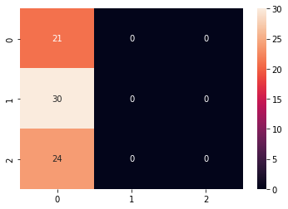

### train size : test size = 40% : 60%

In [116]:



X_train, X_test, y_train, y_test = train_test_split(X, y, test_size=0.6, random_state=0)



In [117]:



print(len(X_train)) print(len(y_test))

60

90

In [118]:



sigmoid_SVC_classifier.fit(X_train, y_train)

Out[118]:

SVC(C=1.0, break_ties=False, cache_size=200, class_weight=None, coef0=0.0, decision_function_shape='ovr', degree=3, gamma='scale', kernel='sigmoid', max_iter=-1, probability=False, random_state=None, shrinking=True, tol=0.001, verbose=False)

In [119]:



y_pred = sigmoid_SVC_classifier.predict(X_test) print(f"Accuracy: {100 * accuracy_score(y_test,y_pred)}%\n") cf_matrix = confusion_matrix(y_test,y_pred) print("Confusion Matrix:\n", cf_matrix) print("\nClassification Report:\n") print(classification_report(y_test,y_pred))

Accuracy: 28.888888888888886%

Confusion Matrix:

[[26 0 0]

[33 0 0]

[31 0 0]]

Classification Report:

|  |  |  |  |  |
| --- | --- | --- | --- | --- |
|  | precision | recall | f1-score | support |
| 0 | 0.29 | 1.00 | 0.45 | 26 |
| 1 | 0.00 | 0.00 | 0.00 | 33 |
| 2 | 0.00 | 0.00 | 0.00 | 31 |
| accuracy |  |  | 0.29 | 90 |
| macro avg | 0.10 | 0.33 | 0.15 | 90 |
| weighted avg | 0.08 | 0.29 | 0.13 | 90 |

/usr/local/lib/python3.7/dist-packages/sklearn/metrics/_classification.py:1272: Undefined MetricWarning: Precision and F-score are ill-defined and being set to 0.0 in labels with no predicted samples. Use `zero_division` parameter to control this behavior.

_warn_prf(average, modifier, msg_start, len(result))

In [120]:



sns.heatmap(cf_matrix, annot=True)

Out[120]:

<matplotlib.axes._subplots.AxesSubplot at 0x7fd19ee78cd0>

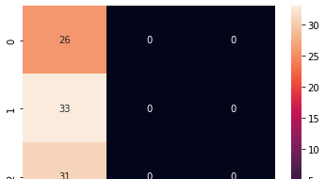



### train size : test size = 30% : 70%

In [121]:



X_train, X_test, y_train, y_test = train_test_split(X, y, test_size=0.7, random_state=0)

In [122]:



print(len(X_train)) print(len(y_test))

45

105

In [123]:



sigmoid_SVC_classifier.fit(X_train, y_train)

Out[123]:

SVC(C=1.0, break_ties=False, cache_size=200, class_weight=None, coef0=0.0, decision_function_shape='ovr', degree=3, gamma='scale', kernel='sigmoid', max_iter=-1, probability=False, random_state=None, shrinking=True, tol=0.001, verbose=False)

In [124]:



y_pred = sigmoid_SVC_classifier.predict(X_test) print(f"Accuracy: {100 * accuracy_score(y_test,y_pred)}%\n") cf_matrix = confusion_matrix(y_test,y_pred) print("Confusion Matrix:\n", cf_matrix) print("\nClassification Report:\n") print(classification_report(y_test,y_pred))

Accuracy: 31.428571428571427%

Confusion Matrix:

[[33 0 0]

[34 0 0]

[38 0 0]]

Classification Report:

|  |  |  |  |  |
| --- | --- | --- | --- | --- |
|  | precision | recall | f1-score | support |
| 0 | 0.31 | 1.00 | 0.48 | 33 |
| 1 | 0.00 | 0.00 | 0.00 | 34 |
| 2 | 0.00 | 0.00 | 0.00 | 38 |
| accuracy |  |  | 0.31 | 105 |
| macro avg | 0.10 | 0.33 | 0.16 | 105 |
| weighted avg | 0.10 | 0.31 | 0.15 | 105 |

/usr/local/lib/python3.7/dist-packages/sklearn/metrics/_classification.py:1272: Undefined MetricWarning: Precision and F-score are ill-defined and being set to 0.0 in labels with no predicted samples. Use `zero_division` parameter to control this behavior.

_warn_prf(average, modifier, msg_start, len(result))

In [125]:



sns.heatmap(cf_matrix, annot=True)

Out[125]:

<matplotlib.axes._subplots.AxesSubplot at 0x7fd19ee1a650>



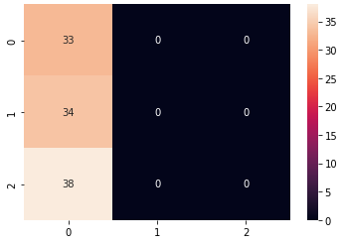

# MLP Classifier

In [126]:



mlp_classifier = MLPClassifier(learning_rate='constant', max_iter=600) mlp_classifier

Out[126]:

MLPClassifier(activation='relu', alpha=0.0001, batch_size='auto', beta_1=0.9, beta_2=0.999, early_stopping=False, epsilon=1e-08, hidden_layer_sizes=(100,), learning_rate='constant', learning_rate_init=0.001, max_fun=15000, max_iter=600, momentum=0.9, n_iter_no_change=10, nesterovs_momentum=True, power_t=0.5, random_state=None, shuffle=True, solver='adam', tol=0.0001, validation_fraction=0.1, verbose=False, warm_start=False)

### train size : test size = 70% : 30%

In [152]:



X_train, X_test, y_train, y_test = train_test_split(X, y, test_size=0.3, random_state=0)

# 70% training data, 30% testing data

In [153]:



print(len(X_train)) print(len(y_test))

105

45

In [154]:



mlp_classifier.fit(X_train, y_train)

Out[154]:

MLPClassifier(activation='relu', alpha=0.0001, batch_size='auto', beta_1=0.9, beta_2=0.999, early_stopping=False, epsilon=1e-08, hidden_layer_sizes=(100,), learning_rate='constant', learning_rate_init=0.001, max_fun=15000, max_iter=600, momentum=0.9, n_iter_no_change=10, nesterovs_momentum=True, power_t=0.5, random_state=None, shuffle=True, solver='adam', tol=0.0001, validation_fraction=0.1, verbose=False, warm_start=False)

In [155]:



y_pred = mlp_classifier.predict(X_test)

print(f"Accuracy: {100 * accuracy_score(y_test,y_pred)}%\n") cf_matrix = confusion_matrix(y_test,y_pred)





print("Confusion Matrix:\n") print(cf_matrix) print("\nClassification Report:\n")

print(classification_report(y_test,y_pred))

Accuracy: 97.77777777777777%

Confusion Matrix:

|  |  |
| --- | --- |
| [[16 | 0 0] |
| [ 0 | 17 1] |
| [ 0 | 0 11]] |

Classification Report:

|  |  |  |  |  |
| --- | --- | --- | --- | --- |
|  | precision | recall | f1-score | support |
| 0 | 1.00 | 1.00 | 1.00 | 16 |
| 1 | 1.00 | 0.94 | 0.97 | 18 |
| 2 | 0.92 | 1.00 | 0.96 | 11 |
| accuracy |  |  | 0.98 | 45 |
| macro avg | 0.97 | 0.98 | 0.98 | 45 |
| weighted avg | 0.98 | 0.98 | 0.98 | 45 |

In [156]:



sns.heatmap(cf_matrix, annot=True)

Out[156]:

<matplotlib.axes._subplots.AxesSubplot at 0x7fd19e9ba750>



### train size : test size = 60% : 40%

In [157]:



X_train, X_test, y_train, y_test = train_test_split(X, y, test_size=0.4, random_state=0)

# 60% training data, 40% testing data

In [158]:



print(len(X_train)) print(len(y_test))

90

60

In [159]:



mlp_classifier.fit(X_train, y_train)

Out[159]:

MLPClassifier(activation='relu', alpha=0.0001, batch_size='auto', beta_1=0.9,

In [160]:

beta_2=0.999, early_stopping=False, epsilon=1e-08, hidden_layer_sizes=(100,), learning_rate='constant', learning_rate_init=0.001, max_fun=15000, max_iter=600, momentum=0.9, n_iter_no_change=10, nesterovs_momentum=True, power_t=0.5, random_state=None, shuffle=True, solver='adam', tol=0.0001, validation_fraction=0.1, verbose=False, warm_start=False)





y_pred = mlp_classifier.predict(X_test)

print(f"Accuracy: {100 * accuracy_score(y_test,y_pred)}%\n") cf_matrix = confusion_matrix(y_test,y_pred) print("Confusion Matrix:")

print(cf_matrix) print("\nClassification Report:\n")

print(classification_report(y_test,y_pred))

Accuracy: 96.66666666666667%

Confusion Matrix:

[[16 0 0]

[ 0 22 1]

[ 0 1 20]]

Classification Report:

|  |  |  |  |  |
| --- | --- | --- | --- | --- |
|  | precision | recall | f1-score | support |
| 0 | 1.00 | 1.00 | 1.00 | 16 |
| 1 | 0.96 | 0.96 | 0.96 | 23 |
| 2 | 0.95 | 0.95 | 0.95 | 21 |
| accuracy |  |  | 0.97 | 60 |
| macro avg | 0.97 | 0.97 | 0.97 | 60 |
| weighted avg | 0.97 | 0.97 | 0.97 | 60 |

In [161]:



sns.heatmap(cf_matrix, annot=True)

Out[161]:

<matplotlib.axes._subplots.AxesSubplot at 0x7fd19e8b5ad0>



### train size : test size = 50% : 50%

In [162]:



X_train, X_test, y_train, y_test = train_test_split(X, y, test_size=0.5, random_state=0)

# 50% training data, 50% testing data

In [163]:





print(len(X_train)) print(len(y_test))

75

75

In [164]:



mlp_classifier.fit(X_train, y_train)

Out[164]:

MLPClassifier(activation='relu', alpha=0.0001, batch_size='auto', beta_1=0.9, beta_2=0.999, early_stopping=False, epsilon=1e-08, hidden_layer_sizes=(100,), learning_rate='constant', learning_rate_init=0.001, max_fun=15000, max_iter=600, momentum=0.9, n_iter_no_change=10, nesterovs_momentum=True, power_t=0.5, random_state=None, shuffle=True, solver='adam', tol=0.0001, validation_fraction=0.1, verbose=False, warm_start=False)

In [165]:



y_pred = mlp_classifier.predict(X_test)

print(f"Accuracy: {100 * accuracy_score(y_test,y_pred)}%\n") cf_matrix = confusion_matrix(y_test,y_pred) print("Confusion Matrix:")

print(cf_matrix) print("\nClassification Report:\n")

print(classification_report(y_test,y_pred))

Accuracy: 97.33333333333334%

Confusion Matrix:

[[21 0 0]

[ 0 29 1]

[ 0 1 23]]

Classification Report:

|  |  |  |  |  |
| --- | --- | --- | --- | --- |
|  | precision | recall | f1-score | support |
| 0 | 1.00 | 1.00 | 1.00 | 21 |
| 1 | 0.97 | 0.97 | 0.97 | 30 |
| 2 | 0.96 | 0.96 | 0.96 | 24 |
| accuracy |  |  | 0.97 | 75 |
| macro avg | 0.98 | 0.98 | 0.98 | 75 |
| weighted avg | 0.97 | 0.97 | 0.97 | 75 |

In [166]:



sns.heatmap(cf_matrix, annot=True)

Out[166]:

<matplotlib.axes._subplots.AxesSubplot at 0x7fd19e808690>

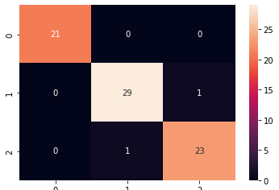



### train size : test size = 40% : 60%

In [167]:



X_train, X_test, y_train, y_test = train_test_split(X, y, test_size=0.6, random_state=0)

In [168]:



print(len(X_train)) print(len(y_test))

60

90

In [169]:



mlp_classifier.fit(X_train, y_train)

/usr/local/lib/python3.7/dist-packages/sklearn/neural_network/_multilayer_perceptron.py:5 71: ConvergenceWarning: Stochastic Optimizer: Maximum iterations (600) reached and the op timization hasn't converged yet.

% self.max_iter, ConvergenceWarning)

Out[169]:

MLPClassifier(activation='relu', alpha=0.0001, batch_size='auto', beta_1=0.9, beta_2=0.999, early_stopping=False, epsilon=1e-08, hidden_layer_sizes=(100,), learning_rate='constant', learning_rate_init=0.001, max_fun=15000, max_iter=600, momentum=0.9, n_iter_no_change=10, nesterovs_momentum=True, power_t=0.5, random_state=None, shuffle=True, solver='adam', tol=0.0001, validation_fraction=0.1, verbose=False, warm_start=False)

In [170]:



y_pred = mlp_classifier.predict(X_test)

print(f"Accuracy: {100 * accuracy_score(y_test,y_pred)}%\n") cf_matrix = confusion_matrix(y_test,y_pred) print("Confusion Matrix:\n")

print(cf_matrix) print("\nClassification Report:\n")

print(classification_report(y_test,y_pred))

Accuracy: 97.77777777777777%

Confusion Matrix: [[26 0 0]

[ 0 32 1]

[ 0 1 30]]

Classification Report:

|  |  |  |  |  |
| --- | --- | --- | --- | --- |
|  | precision | recall | f1-score | support |
| 0 | 1.00 | 1.00 | 1.00 | 26 |
| 1 | 0.97 | 0.97 | 0.97 | 33 |
| 2 | 0.97 | 0.97 | 0.97 | 31 |
| accuracy |  |  | 0.98 | 90 |
| macro avg | 0.98 | 0.98 | 0.98 | 90 |
| weighted avg | 0.98 | 0.98 | 0.98 | 90 |

In [171]:



sns.heatmap(cf_matrix, annot=True)

Out[171]:

<matplotlib.axes._subplots.AxesSubplot at 0x7fd19e7391d0>

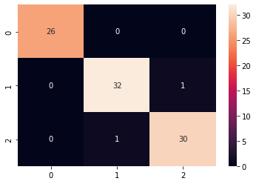

### train size : test size = 30% : 70%

In [172]:



X_train, X_test, y_train, y_test = train_test_split(X, y, test_size=0.7, random_state=0)

In [173]:



print(len(X_train)) print(len(y_test))

45

105

In [174]:



mlp_classifier.fit(X_train, y_train)

Out[174]:

MLPClassifier(activation='relu', alpha=0.0001, batch_size='auto', beta_1=0.9, beta_2=0.999, early_stopping=False, epsilon=1e-08, hidden_layer_sizes=(100,), learning_rate='constant', learning_rate_init=0.001, max_fun=15000, max_iter=600, momentum=0.9, n_iter_no_change=10, nesterovs_momentum=True, power_t=0.5, random_state=None, shuffle=True, solver='adam', tol=0.0001, validation_fraction=0.1, verbose=False, warm_start=False)

In [175]:



y_pred = mlp_classifier.predict(X_test)

print(f"Accuracy: {100 * accuracy_score(y_test,y_pred)}%\n") cf_matrix = confusion_matrix(y_test,y_pred) print("Confusion Matrix:\n")

print(cf_matrix) print("\nClassification Report:\n")

print(classification_report(y_test,y_pred))

Accuracy: 97.14285714285714%

Confusion Matrix:

[[33 0 0]

[ 0 33 1]

[ 0 2 36]]

Classification Report:

precision recall f1-score support 0 1.00 1.00 1.00 33

|  |  |  |  |  |
| --- | --- | --- | --- | --- |
| 1 | 0.94 | 0.97 | 0.96 | 34 |
| 2 | 0.97 | 0.95 | 0.96 | 38 |
| accuracy |  |  | 0.97 | 105 |
| macro avg | 0.97 | 0.97 | 0.97 | 105 |
| weighted avg | 0.97 | 0.97 | 0.97 | 105 |



In [176]:



sns.heatmap(cf_matrix, annot=True)

Out[176]:

<matplotlib.axes._subplots.AxesSubplot at 0x7fd19e66ff50>

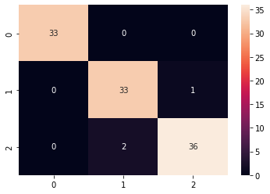

# Random Forest Classifier

In [177]:



rfc_classifier = RandomForestClassifier(n_estimators=20) rfc_classifier

Out[177]:

RandomForestClassifier(bootstrap=True, ccp_alpha=0.0, class_weight=None,

criterion='gini', max_depth=None, max_features='auto', max_leaf_nodes=None, max_samples=None, min_impurity_decrease=0.0, min_impurity_split=None, min_samples_leaf=1, min_samples_split=2, min_weight_fraction_leaf=0.0, n_estimators=20, n_jobs=None, oob_score=False, random_state=None, verbose=0, warm_start=False)

### train size : test size = 70% : 30%

In [178]:



X_train, X_test, y_train, y_test = train_test_split(X, y, test_size=0.3, random_state=0)

# 70% training data, 30% testing data

In [179]:



print(len(X_train)) print(len(y_test))

105

45

In [180]:



rfc_classifier.fit(X_train, y_train)

Out[180]:



RandomForestClassifier(bootstrap=True, ccp_alpha=0.0, class_weight=None,

criterion='gini', max_depth=None, max_features='auto', max_leaf_nodes=None, max_samples=None, min_impurity_decrease=0.0, min_impurity_split=None, min_samples_leaf=1, min_samples_split=2, min_weight_fraction_leaf=0.0, n_estimators=20, n_jobs=None, oob_score=False, random_state=None, verbose=0, warm_start=False)

In [181]:



y_pred = rfc_classifier.predict(X_test)

print(f"Accuracy: {100 * accuracy_score(y_test,y_pred)}%\n") cf_matrix = confusion_matrix(y_test,y_pred) print("Confusion Matrix:\n")

print(cf_matrix) print("\nClassification Report:\n")

print(classification_report(y_test,y_pred))

Accuracy: 97.77777777777777%

Confusion Matrix:

|  |  |
| --- | --- |
| [[16 0 | 0] |
| [ 0 17 | 1] |
| [ 0 0 | 11]] |

Classification Report:

|  |  |  |  |  |
| --- | --- | --- | --- | --- |
|  | precision | recall | f1-score | support |
| 0 | 1.00 | 1.00 | 1.00 | 16 |
| 1 | 1.00 | 0.94 | 0.97 | 18 |
| 2 | 0.92 | 1.00 | 0.96 | 11 |
| accuracy |  |  | 0.98 | 45 |
| macro avg | 0.97 | 0.98 | 0.98 | 45 |
| weighted avg | 0.98 | 0.98 | 0.98 | 45 |

In [182]:



sns.heatmap(cf_matrix, annot=True)

Out[182]:

<matplotlib.axes._subplots.AxesSubplot at 0x7fd19e5a8410>



### train size : test size = 60% : 40%

In [183]:



X_train, X_test, y_train, y_test = train_test_split(X, y, test_size=0.4, random_state=0)

# 60% training data, 40% testing data



In [184]:



print(len(X_train)) print(len(y_test))

90

60

In [185]:



rfc_classifier.fit(X_train, y_train)

Out[185]:

RandomForestClassifier(bootstrap=True, ccp_alpha=0.0, class_weight=None,

criterion='gini', max_depth=None, max_features='auto', max_leaf_nodes=None, max_samples=None, min_impurity_decrease=0.0, min_impurity_split=None, min_samples_leaf=1, min_samples_split=2, min_weight_fraction_leaf=0.0, n_estimators=20, n_jobs=None, oob_score=False, random_state=None, verbose=0, warm_start=False)

In [186]:



y_pred = rfc_classifier.predict(X_test)

print(f"Accuracy: {100 * accuracy_score(y_test,y_pred)}%\n") cf_matrix = confusion_matrix(y_test,y_pred) print("Confusion Matrix:")

print(cf_matrix) print("\nClassification Report:\n")

print(classification_report(y_test,y_pred))

Accuracy: 93.33333333333333%

Confusion Matrix:

[[16 0 0]

[ 0 23 0]

[ 0 4 17]]

Classification Report:

|  |  |  |  |  |
| --- | --- | --- | --- | --- |
|  | precision | recall | f1-score | support |
| 0 | 1.00 | 1.00 | 1.00 | 16 |
| 1 | 0.85 | 1.00 | 0.92 | 23 |
| 2 | 1.00 | 0.81 | 0.89 | 21 |
| accuracy |  |  | 0.93 | 60 |
| macro avg | 0.95 | 0.94 | 0.94 | 60 |
| weighted avg | 0.94 | 0.93 | 0.93 | 60 |

In [187]:



sns.heatmap(cf_matrix, annot=True)

Out[187]:

<matplotlib.axes._subplots.AxesSubplot at 0x7fd19e558ad0>

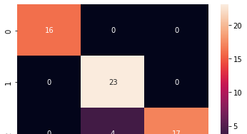



### train size : test size = 50% : 50%

In [188]:



X_train, X_test, y_train, y_test = train_test_split(X, y, test_size=0.5, random_state=0)

# 50% training data, 50% testing data

In [189]:



print(len(X_train)) print(len(y_test))

75

75

In [190]:



rfc_classifier.fit(X_train, y_train)

Out[190]:

RandomForestClassifier(bootstrap=True, ccp_alpha=0.0, class_weight=None,

criterion='gini', max_depth=None, max_features='auto', max_leaf_nodes=None, max_samples=None, min_impurity_decrease=0.0, min_impurity_split=None, min_samples_leaf=1, min_samples_split=2, min_weight_fraction_leaf=0.0, n_estimators=20, n_jobs=None, oob_score=False, random_state=None, verbose=0, warm_start=False)

In [191]:



y_pred = rfc_classifier.predict(X_test)

print(f"Accuracy: {100 * accuracy_score(y_test,y_pred)}%\n") cf_matrix = confusion_matrix(y_test,y_pred) print("Confusion Matrix:")

print(cf_matrix) print("\nClassification Report:\n")

print(classification_report(y_test,y_pred))

Accuracy: 94.66666666666667%

Confusion Matrix:

[[21 0 0]

[ 0 29 1]

[ 0 3 21]]

Classification Report:

|  |  |  |  |  |
| --- | --- | --- | --- | --- |
|  | precision | recall | f1-score | support |
| 0 | 1.00 | 1.00 | 1.00 | 21 |
| 1 | 0.91 | 0.97 | 0.94 | 30 |
| 2 | 0.95 | 0.88 | 0.91 | 24 |
| accuracy |  |  | 0.95 | 75 |
| macro avg | 0.95 | 0.95 | 0.95 | 75 |
| weighted avg | 0.95 | 0.95 | 0.95 | 75 |

In [192]:



sns.heatmap(cf_matrix, annot=True)

Out[192]:

<matplotlib.axes._subplots.AxesSubplot at 0x7fd19e494d90>



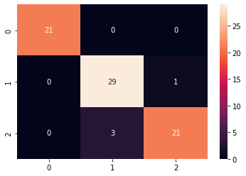

### train size : test size = 40% : 60%

In [193]:



X_train, X_test, y_train, y_test = train_test_split(X, y, test_size=0.6, random_state=0)

In [194]:



print(len(X_train)) print(len(y_test))

60

90

In [195]:



rfc_classifier.fit(X_train, y_train)

Out[195]:

RandomForestClassifier(bootstrap=True, ccp_alpha=0.0, class_weight=None,

criterion='gini', max_depth=None, max_features='auto', max_leaf_nodes=None, max_samples=None, min_impurity_decrease=0.0, min_impurity_split=None, min_samples_leaf=1, min_samples_split=2, min_weight_fraction_leaf=0.0, n_estimators=20, n_jobs=None, oob_score=False, random_state=None, verbose=0, warm_start=False)

In [196]:



y_pred = rfc_classifier.predict(X_test)

print(f"Accuracy: {100 * accuracy_score(y_test,y_pred)}%\n") cf_matrix = confusion_matrix(y_test,y_pred) print("Confusion Matrix:\n")

print(cf_matrix) print("\nClassification Report:\n")

print(classification_report(y_test,y_pred))

Accuracy: 94.44444444444444%

Confusion Matrix:

|  |  |
| --- | --- |
| [[26 0 | 0] |
| [ 0 33 | 0] |
| [ 0 5 | 26]] |

Classification Report:

precision recall f1-score support

|  |  |  |  |  |
| --- | --- | --- | --- | --- |
| 0 | 1.00 | 1.00 | 1.00 | 26 |
| 1 | 0.87 | 1.00 | 0.93 | 33 |
| 2 | 1.00 | 0.84 | 0.91 | 31 |



|  |  |  |  |  |
| --- | --- | --- | --- | --- |
| accuracy |  |  | 0.94 | 90 |
| macro avg | 0.96 | 0.95 | 0.95 | 90 |
| weighted avg | 0.95 | 0.94 | 0.94 | 90 |

In [197]:



sns.heatmap(cf_matrix, annot=True)

Out[197]:

<matplotlib.axes._subplots.AxesSubplot at 0x7fd19e3a37d0>

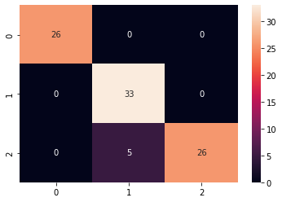

### train size : test size = 30% : 70%

In [198]:



X_train, X_test, y_train, y_test = train_test_split(X, y, test_size=0.7, random_state=0)

In [199]:



print(len(X_train)) print(len(y_test))

45

105

In [200]:



rfc_classifier.fit(X_train, y_train)

Out[200]:

RandomForestClassifier(bootstrap=True, ccp_alpha=0.0, class_weight=None,

criterion='gini', max_depth=None, max_features='auto', max_leaf_nodes=None, max_samples=None, min_impurity_decrease=0.0, min_impurity_split=None, min_samples_leaf=1, min_samples_split=2, min_weight_fraction_leaf=0.0, n_estimators=20, n_jobs=None, oob_score=False, random_state=None, verbose=0, warm_start=False)

In [201]:



y_pred = rfc_classifier.predict(X_test)

print(f"Accuracy: {100 * accuracy_score(y_test,y_pred)}%\n") cf_matrix = confusion_matrix(y_test,y_pred) print("Confusion Matrix:\n")

print(cf_matrix) print("\nClassification Report:\n")

print(classification_report(y_test,y_pred))

Accuracy: 94.28571428571428%

Confusion Matrix:



[[33 0 0]

[ 0 34 0]

[ 0 6 32]]

Classification Report:

|  |  |  |  |  |
| --- | --- | --- | --- | --- |
|  | precision | recall | f1-score | support |
| 0 | 1.00 | 1.00 | 1.00 | 33 |
| 1 | 0.85 | 1.00 | 0.92 | 34 |
| 2 | 1.00 | 0.84 | 0.91 | 38 |
| accuracy |  |  | 0.94 | 105 |
| macro avg | 0.95 | 0.95 | 0.94 | 105 |
| weighted avg | 0.95 | 0.94 | 0.94 | 105 |

In [202]:

sns.heatmap(cf_matrix, annot=True) Out[202]:

<matplotlib.axes._subplots.AxesSubplot at 0x7fd19e300c90>

Name : Anmol Raj



Roll no : 001811001069

***CANCER-DATA***

# Import required modules

In [1]:

import numpy as np import pandas as pd

from sklearn import datasets

from sklearn.metrics import accuracy_score, classification_report, confusion_matrix from sklearn.model_selection import train_test_split

from sklearn.svm import SVC import seaborn as sns

from sklearn.neural_network import MLPClassifier from sklearn.ensemble import RandomForestClassifier

# Load Dataset

In [2]:

b_cancer = datasets.load_breast_cancer() # it's source is same as : https://archive.ics.u ci.edu/ml/datasets/wine

In [3]:

dir(b_cancer) Out[3]:

['DESCR', 'data', 'feature_names', 'filename', 'target', 'target_names']

|  |  |  |  |  |
| --- | --- | --- | --- | --- |
| In [4]: |  | | | |
| b_cancer.data |
| Out[4]: |
| array([[1.799e+01, 1.038e+01, | 1.228e+02, | ..., | 2.654e-01, | 4.601e-01, |
| 1.189e-01], |  |  |  |  |
| [2.057e+01, 1.777e+01, | 1.329e+02, | ..., | 1.860e-01, | 2.750e-01, |
| 8.902e-02], |  |  |  |  |
| [1.969e+01, 2.125e+01, | 1.300e+02, | ..., | 2.430e-01, | 3.613e-01, |
| 8.758e-02], |  |  |  |  |
| ..., |  |  |  |  |
| [1.660e+01, 2.808e+01, | 1.083e+02, | ..., | 1.418e-01, | 2.218e-01, |
| 7.820e-02], |  |  |  |  |
| [2.060e+01, 2.933e+01, | 1.401e+02, | ..., | 2.650e-01, | 4.087e-01, |
| 1.240e-01], |  |  |  |  |
| [7.760e+00, 2.454e+01, | 4.792e+01, | ..., | 0.000e+00, | 2.871e-01, |
| 7.039e-02]]) |  |  |  |  |

In [5]:

print(b_cancer.feature_names) print(b_cancer.target_names) print(b_cancer.target)

['mean radius' 'mean texture' 'mean perimeter' 'mean area' 'mean smoothness' 'mean compactness' 'mean concavity'

'mean concave points' 'mean symmetry' 'mean fractal dimension' 'radius error' 'texture error' 'perimeter error' 'area error' 'smoothness error' 'compactness error' 'concavity error' 'concave points error' 'symmetry error' 'fractal dimension error'

'worst radius' 'worst texture' 'worst perimeter' 'worst area' 'worst smoothness' 'worst compactness' 'worst concavity'

'worst concave points' 'worst symmetry' 'worst fractal dimension'] ['malignant' 'benign']

|  |  |  |  |  |  |  |  |  |  |  |  |  |  |  |  |  |  |  |  |  |  |  |  |  |  |  |  |  |  |  |  |  |  |  |  |  |
| --- | --- | --- | --- | --- | --- | --- | --- | --- | --- | --- | --- | --- | --- | --- | --- | --- | --- | --- | --- | --- | --- | --- | --- | --- | --- | --- | --- | --- | --- | --- | --- | --- | --- | --- | --- | --- |
| [0 | 0 | 0 | 0 | 0 | 0 | 0 | 0 | 0 | 0 | 0 | 0 | 0 | 0 | 0 | 0 | 0 | 0 | 0 | 1 | 1 | 1 | 0 | 0 | 0 | 0 | 0 | 0 | 0 | 0 | 0 | 0 | 0 | 0 | 0 | 0 | 0 |
| 1 | 0 | 0 | 0 | 0 | 0 | 0 | 0 | 0 | 1 | 0 | 1 | 1 | 1 | 1 | 1 | 0 | 0 | 1 | 0 | 0 | 1 | 1 | 1 | 1 | 0 | 1 | 0 | 0 | 1 | 1 | 1 | 1 | 0 | 1 | 0 | 0 |
| 1 | 0 | 1 | 0 | 0 | 1 | 1 | 1 | 0 | 0 | 1 | 0 | 0 | 0 | 1 | 1 | 1 | 0 | 1 | 1 | 0 | 0 | 1 | 1 | 1 | 0 | 0 | 1 | 1 | 1 | 1 | 0 | 1 | 1 | 0 | 1 | 1 |
| 1 | 1 | 1 | 1 | 1 | 1 | 0 | 0 | 0 | 1 | 0 | 0 | 1 | 1 | 1 | 0 | 0 | 1 | 0 | 1 | 0 | 0 | 1 | 0 | 0 | 1 | 1 | 0 | 1 | 1 | 0 | 1 | 1 | 1 | 1 | 0 | 1 |
| 1 | 1 | 1 | 1 | 1 | 1 | 1 | 1 | 0 | 1 | 1 | 1 | 1 | 0 | 0 | 1 | 0 | 1 | 1 | 0 | 0 | 1 | 1 | 0 | 0 | 1 | 1 | 1 | 1 | 0 | 1 | 1 | 0 | 0 | 0 | 1 | 0 |
| 1 | 0 | 1 | 1 | 1 | 0 | 1 | 1 | 0 | 0 | 1 | 0 | 0 | 0 | 0 | 1 | 0 | 0 | 0 | 1 | 0 | 1 | 0 | 1 | 1 | 0 | 1 | 0 | 0 | 0 | 0 | 1 | 1 | 0 | 0 | 1 | 1 |
| 1 | 0 | 1 | 1 | 1 | 1 | 1 | 0 | 0 | 1 | 1 | 0 | 1 | 1 | 0 | 0 | 1 | 0 | 1 | 1 | 1 | 1 | 0 | 1 | 1 | 1 | 1 | 1 | 0 | 1 | 0 | 0 | 0 | 0 | 0 | 0 | 0 |
| 0 | 0 | 0 | 0 | 0 | 0 | 0 | 1 | 1 | 1 | 1 | 1 | 1 | 0 | 1 | 0 | 1 | 1 | 0 | 1 | 1 | 0 | 1 | 0 | 0 | 1 | 1 | 1 | 1 | 1 | 1 | 1 | 1 | 1 | 1 | 1 | 1 |
| 1 | 0 | 1 | 1 | 0 | 1 | 0 | 1 | 1 | 1 | 1 | 1 | 1 | 1 | 1 | 1 | 1 | 1 | 1 | 1 | 1 | 0 | 1 | 1 | 1 | 0 | 1 | 0 | 1 | 1 | 1 | 1 | 0 | 0 | 0 | 1 | 1 |
| 1 | 1 | 0 | 1 | 0 | 1 | 0 | 1 | 1 | 1 | 0 | 1 | 1 | 1 | 1 | 1 | 1 | 1 | 0 | 0 | 0 | 1 | 1 | 1 | 1 | 1 | 1 | 1 | 1 | 1 | 1 | 1 | 0 | 0 | 1 | 0 | 0 |
| 0 | 1 | 0 | 0 | 1 | 1 | 1 | 1 | 1 | 0 | 1 | 1 | 1 | 1 | 1 | 0 | 1 | 1 | 1 | 0 | 1 | 1 | 0 | 0 | 1 | 1 | 1 | 1 | 1 | 1 | 0 | 1 | 1 | 1 | 1 | 1 | 1 |
| 1 | 0 | 1 | 1 | 1 | 1 | 1 | 0 | 1 | 1 | 0 | 1 | 1 | 1 | 1 | 1 | 1 | 1 | 1 | 1 | 1 | 1 | 1 | 0 | 1 | 0 | 0 | 1 | 0 | 1 | 1 | 1 | 1 | 1 | 0 | 1 | 1 |
| 0 | 1 | 0 | 1 | 1 | 0 | 1 | 0 | 1 | 1 | 1 | 1 | 1 | 1 | 1 | 1 | 0 | 0 | 1 | 1 | 1 | 1 | 1 | 1 | 0 | 1 | 1 | 1 | 1 | 1 | 1 | 1 | 1 | 1 | 1 | 0 | 1 |
| 1 | 1 | 1 | 1 | 1 | 1 | 0 | 1 | 0 | 1 | 1 | 0 | 1 | 1 | 1 | 1 | 1 | 0 | 0 | 1 | 0 | 1 | 0 | 1 | 1 | 1 | 1 | 1 | 0 | 1 | 1 | 0 | 1 | 0 | 1 | 0 | 0 |
| 1 | 1 | 1 | 0 | 1 | 1 | 1 | 1 | 1 | 1 | 1 | 1 | 1 | 1 | 1 | 0 | 1 | 0 | 0 | 1 | 1 | 1 | 1 | 1 | 1 | 1 | 1 | 1 | 1 | 1 | 1 | 1 | 1 | 1 | 1 | 1 | 1 |
| 1 | 1 | 1 | 1 | 1 | 1 | 1 | 0 | 0 | 0 | 0 | 0 | 0 | 1] |  |  |  |  |  |  |  |  |  |  |  |  |  |  |  |  |  |  |  |  |  |  |  |

In [6]:



df = pd.DataFrame(data=b_cancer.data, columns=b_cancer.feature_names) df.head()

Out[6]:

**mean radius**

**mean texture**

**mean perimeter**

**mean area**

**mean smoothness**

**mean compactness**

**mean concavity**

**mean concave points**

**mean symmetry**

**mean fractal dimension**

**radius error**

**texture error**

|  |  |  |  |  |  |  |  |  |  |  |  |  |
| --- | --- | --- | --- | --- | --- | --- | --- | --- | --- | --- | --- | --- |
| **0** | 17.99 | 10.38 | 122.80 | 1001.0 | 0.11840 | 0.27760 | 0.3001 | 0.14710 | 0.2419 | 0.07871 | 1.0950 | 0.9053 |
| **1** | 20.57 | 17.77 | 132.90 | 1326.0 | 0.08474 | 0.07864 | 0.0869 | 0.07017 | 0.1812 | 0.05667 | 0.5435 | 0.7339 |
| **2** | 19.69 | 21.25 | 130.00 | 1203.0 | 0.10960 | 0.15990 | 0.1974 | 0.12790 | 0.2069 | 0.05999 | 0.7456 | 0.7869 |
| **3** | 11.42 | 20.38 | 77.58 | 386.1 | 0.14250 | 0.28390 | 0.2414 | 0.10520 | 0.2597 | 0.09744 | 0.4956 | 1.1560 |
| **4** | 20.29 | 14.34 | 135.10 | 1297.0 | 0.10030 | 0.13280 | 0.1980 | 0.10430 | 0.1809 | 0.05883 | 0.7572 | 0.7813 |

|  |  |  |
| --- | --- | --- |
|  |  |  |

In [7]:



df["target"] = b_cancer.target df.head()

Out[7]:

**mean radius**

**mean texture**

**mean perimeter**

**mean area**

**mean smoothness**

**mean compactness**

**mean concavity**

**mean concave points**

**mean symmetry**

**mean fractal dimension**

**radius error**

**texture error**



**0** 17.99 10.38

122.80 1001.0

0.11840

0.27760

0.3001 0.14710

0.2419 0.07871 1.0950 0.9053

**1** 20.57 17.77 132.90 1326.0 0.08474 0.07864 0.0869 0.07017 0.1812 0.05667 0.5435 0.7339

**2** 19.69 21.25

130.00 1203.0

0.10960

0.15990

0.1974 0.12790

0.2069 0.05999 0.7456 0.7869

**3** 11.42 20.38 77.58 386.1 0.14250 0.28390 0.2414 0.10520 0.2597 0.09744 0.4956 1.1560

**4** 20.29 14.34

135.10 1297.0

0.10030

0.13280

0.1980 0.10430

0.1809 0.05883 0.7572 0.7813

|  |  |  |
| --- | --- | --- |
|  |  |  |

In [8]:



df.target.value_counts()

Out[8]:

1 357

0 212

Name: target, dtype: int64



# DataFrame ready to perform

In [9]:



len(df)

Out[9]:

569

In [10]:



X = df.drop(["target"], axis="columns") y = df.target

print(X.head())

print(y.head())

mean radius mean texture ... worst symmetry worst fractal dimension 0 17.99 10.38 ... 0.4601 0.11890

1 20.57 17.77 ... 0.2750 0.08902

2 19.69 21.25 ... 0.3613 0.08758

3 11.42 20.38 ... 0.6638 0.17300

4 20.29 14.34 ... 0.2364 0.07678

|  |  |  |
| --- | --- | --- |
| [5 | rows | x 30 columns] |
| 0 | 0 |  |
| 1 | 0 |  |
| 2 | 0 |  |
| 3 | 0 |  |
| 4 | 0 |  |

Name: target, dtype: int64

# SVC Classfier

## Linear SVC Classifier

In [37]:



linear_SVC_classifier = SVC(kernel='linear') linear_SVC_classifier

Out[37]:

SVC(C=1.0, break_ties=False, cache_size=200, class_weight=None, coef0=0.0, decision_function_shape='ovr', degree=3, gamma='scale', kernel='linear', max_iter=-1, probability=False, random_state=None, shrinking=True, tol=0.001, verbose=False)

### train size : test size = 70% : 30%

In [38]:



X_train, X_test, y_train, y_test = train_test_split(X, y, test_size=0.3, random_state=0)

# 70% training data, 30% testing data

In [39]:



print(len(X_train)) print(len(y_test))

398

171

In [40]:

linear_SVC_classifier.fit(X_train, y_train) Out[40]:

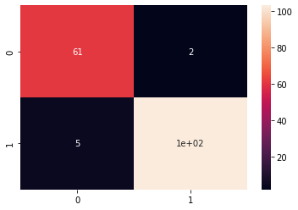

SVC(C=1.0, break_ties=False, cache_size=200, class_weight=None, coef0=0.0, decision_function_shape='ovr', degree=3, gamma='scale', kernel='linear', max_iter=-1, probability=False, random_state=None, shrinking=True, tol=0.001, verbose=False)

In [41]:

y_pred = linear_SVC_classifier.predict(X_test) print(f"Accuracy: {100 * accuracy_score(y_test,y_pred)}%\n") cf_matrix = confusion_matrix(y_test,y_pred) print("Confusion Matrix:\n")

print(cf_matrix) print("\nClassification Report:\n")

print(classification_report(y_test,y_pred)) Accuracy: 95.90643274853801%

Confusion Matrix:

[[ 61 2]

[ 5 103]]

Classification Report:

|  |  |  |  |  |
| --- | --- | --- | --- | --- |
|  | precision | recall | f1-score | support |
| 0 | 0.92 | 0.97 | 0.95 | 63 |
| 1 | 0.98 | 0.95 | 0.97 | 108 |
| accuracy |  |  | 0.96 | 171 |
| macro avg | 0.95 | 0.96 | 0.96 | 171 |
| weighted avg | 0.96 | 0.96 | 0.96 | 171 |

In [42]:

sns.heatmap(cf_matrix, annot=True) Out[42]:

<matplotlib.axes._subplots.AxesSubplot at 0x7fa14a2c9390>

### train size : test size = 60% : 40%

In [43]:

X_train, X_test, y_train, y_test = train_test_split(X, y, test_size=0.4, random_state=0)

#### # 60% training data, 40% testing data

In [44]:

print(len(X_train))

print(len(y_test))

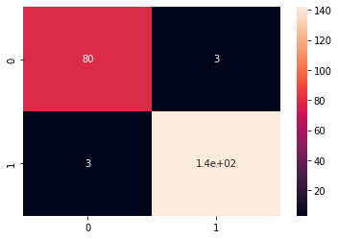

341

228

In [45]:

linear_SVC_classifier.fit(X_train, y_train) Out[45]:

SVC(C=1.0, break_ties=False, cache_size=200, class_weight=None, coef0=0.0, decision_function_shape='ovr', degree=3, gamma='scale', kernel='linear', max_iter=-1, probability=False, random_state=None, shrinking=True, tol=0.001, verbose=False)

In [46]:

y_pred = linear_SVC_classifier.predict(X_test) print(f"Accuracy: {100 * accuracy_score(y_test,y_pred)}%\n") cf_matrix = confusion_matrix(y_test,y_pred) print("Confusion Matrix:")

print(cf_matrix) print("\nClassification Report:\n")

print(classification_report(y_test,y_pred)) Accuracy: 97.36842105263158%

Confusion Matrix:

[[ 80 3]

[ 3 142]]

Classification Report:

|  |  |  |  |  |
| --- | --- | --- | --- | --- |
|  | precision | recall | f1-score | support |
| 0 | 0.96 | 0.96 | 0.96 | 83 |
| 1 | 0.98 | 0.98 | 0.98 | 145 |
| accuracy |  |  | 0.97 | 228 |
| macro avg | 0.97 | 0.97 | 0.97 | 228 |
| weighted avg | 0.97 | 0.97 | 0.97 | 228 |

In [47]:

sns.heatmap(cf_matrix, annot=True) Out[47]:

<matplotlib.axes._subplots.AxesSubplot at 0x7fa14a11d290>

### train size : test size = 50% : 50%

In [48]:

X_train, X_test, y_train, y_test = train_test_split(X, y, test_size=0.5, random_state=0)

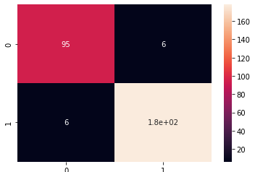

#### # 50% training data, 50% testing data

In [49]:

print(len(X_train)) print(len(y_test))

284

285

In [50]:

linear_SVC_classifier.fit(X_train, y_train) Out[50]:

SVC(C=1.0, break_ties=False, cache_size=200, class_weight=None, coef0=0.0, decision_function_shape='ovr', degree=3, gamma='scale', kernel='linear', max_iter=-1, probability=False, random_state=None, shrinking=True, tol=0.001, verbose=False)

In [51]:

y_pred = linear_SVC_classifier.predict(X_test) print(f"Accuracy: {100 * accuracy_score(y_test,y_pred)}%\n") cf_matrix = confusion_matrix(y_test,y_pred) print("Confusion Matrix:")

print(cf_matrix) print("\nClassification Report:\n")

print(classification_report(y_test,y_pred)) Accuracy: 95.78947368421052%

Confusion Matrix:

[[ 95 6]

[ 6 178]]

Classification Report:

|  |  |  |  |  |
| --- | --- | --- | --- | --- |
|  | precision | recall | f1-score | support |
| 0 | 0.94 | 0.94 | 0.94 | 101 |
| 1 | 0.97 | 0.97 | 0.97 | 184 |
| accuracy |  |  | 0.96 | 285 |
| macro avg | 0.95 | 0.95 | 0.95 | 285 |
| weighted avg | 0.96 | 0.96 | 0.96 | 285 |

In [52]:

sns.heatmap(cf_matrix, annot=True) Out[52]:

<matplotlib.axes._subplots.AxesSubplot at 0x7fa1529a0690>

### train size : test size = 40% : 60%

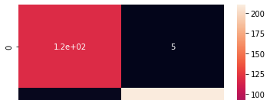

In [53]:

X_train, X_test, y_train, y_test = train_test_split(X, y, test_size=0.6, random_state=0)

In [54]:

print(len(X_train)) print(len(y_test))

227

342

In [55]:

linear_SVC_classifier.fit(X_train, y_train) Out[55]:

SVC(C=1.0, break_ties=False, cache_size=200, class_weight=None, coef0=0.0, decision_function_shape='ovr', degree=3, gamma='scale', kernel='linear', max_iter=-1, probability=False, random_state=None, shrinking=True, tol=0.001, verbose=False)

In [56]:

y_pred = linear_SVC_classifier.predict(X_test) print(f"Accuracy: {100 * accuracy_score(y_test,y_pred)}%\n") cf_matrix = confusion_matrix(y_test,y_pred) print("Confusion Matrix:\n")

print(cf_matrix) print("\nClassification Report:\n")

print(classification_report(y_test,y_pred)) Accuracy: 95.90643274853801%

Confusion Matrix:

[[118 5]

[ 9 210]]

Classification Report:

|  |  |  |  |  |
| --- | --- | --- | --- | --- |
|  | precision | recall | f1-score | support |
| 0 | 0.93 | 0.96 | 0.94 | 123 |
| 1 | 0.98 | 0.96 | 0.97 | 219 |
| accuracy |  |  | 0.96 | 342 |
| macro avg | 0.95 | 0.96 | 0.96 | 342 |
| weighted avg | 0.96 | 0.96 | 0.96 | 342 |

In [57]:

sns.heatmap(cf_matrix, annot=True) Out[57]:

<matplotlib.axes._subplots.AxesSubplot at 0x7fa149fecad0>

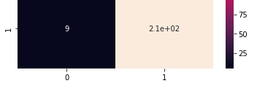

### train size : test size = 30% : 70%

In [58]:

X_train, X_test, y_train, y_test = train_test_split(X, y, test_size=0.7, random_state=0)

In [59]:

print(len(X_train)) print(len(y_test))

170

399

In [60]:

linear_SVC_classifier.fit(X_train, y_train) Out[60]:

SVC(C=1.0, break_ties=False, cache_size=200, class_weight=None, coef0=0.0, decision_function_shape='ovr', degree=3, gamma='scale', kernel='linear', max_iter=-1, probability=False, random_state=None, shrinking=True, tol=0.001, verbose=False)

In [61]:

y_pred = linear_SVC_classifier.predict(X_test) print(f"Accuracy: {100 * accuracy_score(y_test,y_pred)}%\n") cf_matrix = confusion_matrix(y_test,y_pred) print("Confusion Matrix:\n")

print(cf_matrix) print("\nClassification Report:\n")

print(classification_report(y_test,y_pred)) Accuracy: 95.48872180451127%

Confusion Matrix:

[[137 9]

[ 9 244]]

Classification Report:

|  |  |  |  |  |
| --- | --- | --- | --- | --- |
|  | precision | recall | f1-score | support |
| 0 | 0.94 | 0.94 | 0.94 | 146 |
| 1 | 0.96 | 0.96 | 0.96 | 253 |
| accuracy |  |  | 0.95 | 399 |
| macro avg | 0.95 | 0.95 | 0.95 | 399 |
| weighted avg | 0.95 | 0.95 | 0.95 | 399 |

In [62]:

sns.heatmap(cf_matrix, annot=True) Out[62]:

<matplotlib.axes._subplots.AxesSubplot at 0x7fa14a04fdd0>

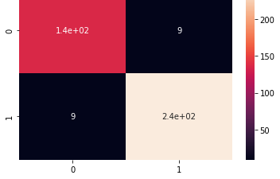

## Polynomial SVC Classifier

In [63]:



poly_SVC_classifier = SVC(kernel='poly') poly_SVC_classifier

Out[63]:

SVC(C=1.0, break_ties=False, cache_size=200, class_weight=None, coef0=0.0, decision_function_shape='ovr', degree=3, gamma='scale', kernel='poly', max_iter=-1, probability=False, random_state=None, shrinking=True, tol=0.001, verbose=False)

### train size : test size = 70% : 30%

In [64]:



X_train, X_test, y_train, y_test = train_test_split(X, y, test_size=0.3, random_state=0)

In [65]:



print(len(X_train)) print(len(y_test))

398

171

In [66]:



poly_SVC_classifier.fit(X_train, y_train)

Out[66]:

SVC(C=1.0, break_ties=False, cache_size=200, class_weight=None, coef0=0.0, decision_function_shape='ovr', degree=3, gamma='scale', kernel='poly', max_iter=-1, probability=False, random_state=None, shrinking=True, tol=0.001, verbose=False)

In [67]:



y_pred = poly_SVC_classifier.predict(X_test) print(f"Accuracy: {100 * accuracy_score(y_test,y_pred)}%\n") cf_matrix = confusion_matrix(y_test,y_pred) print("Confusion Matrix:\n", cf_matrix) print("\nClassification Report:\n") print(classification_report(y_test,y_pred))

Accuracy: 91.81286549707602%

Confusion Matrix: [[ 51 12]

[ 2 106]]

Classification Report:



|  |  |  |  |  |
| --- | --- | --- | --- | --- |
|  | precision | recall | f1-score | support |
| 0 | 0.96 | 0.81 | 0.88 | 63 |
| 1 | 0.90 | 0.98 | 0.94 | 108 |
| accuracy |  |  | 0.92 | 171 |
| macro avg | 0.93 | 0.90 | 0.91 | 171 |
| weighted avg | 0.92 | 0.92 | 0.92 | 171 |

In [68]:



sns.heatmap(cf_matrix, annot=True)

Out[68]:

<matplotlib.axes._subplots.AxesSubplot at 0x7fa155d5c110>

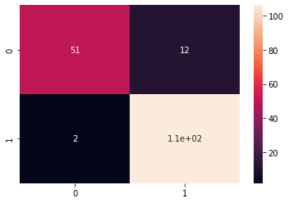

### train size : test size = 60% : 40%

In [69]:



X_train, X_test, y_train, y_test = train_test_split(X, y, test_size=0.4, random_state=0)

In [70]:



print(len(X_train)) print(len(y_test))

341

228

In [71]:



poly_SVC_classifier.fit(X_train, y_train)

Out[71]:

SVC(C=1.0, break_ties=False, cache_size=200, class_weight=None, coef0=0.0, decision_function_shape='ovr', degree=3, gamma='scale', kernel='poly', max_iter=-1, probability=False, random_state=None, shrinking=True, tol=0.001, verbose=False)

In [72]:



y_pred = poly_SVC_classifier.predict(X_test) print(f"Accuracy: {100 * accuracy_score(y_test,y_pred)}%\n") cf_matrix = confusion_matrix(y_test,y_pred) print("Confusion Matrix:\n", cf_matrix) print("\nClassification Report:\n") print(classification_report(y_test,y_pred))

Accuracy: 91.66666666666666%

Confusion Matrix:

[[ 65 18]

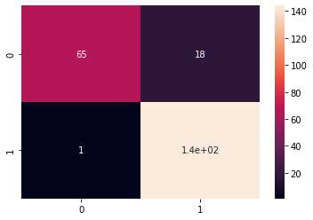

[ 1 144]]

Classification Report:

|  |  |  |  |  |
| --- | --- | --- | --- | --- |
|  | precision | recall | f1-score | support |
| 0 | 0.98 | 0.78 | 0.87 | 83 |
| 1 | 0.89 | 0.99 | 0.94 | 145 |
| accuracy |  |  | 0.92 | 228 |
| macro avg | 0.94 | 0.89 | 0.91 | 228 |
| weighted avg | 0.92 | 0.92 | 0.91 | 228 |

In [73]:

sns.heatmap(cf_matrix, annot=True) Out[73]:

<matplotlib.axes._subplots.AxesSubplot at 0x7fa149ddd550>

### train size : test size = 50% : 50%

In [74]:

X_train, X_test, y_train, y_test = train_test_split(X, y, test_size=0.5, random_state=0)

In [75]:

print(len(X_train)) print(len(y_test))

284

285

In [76]:

poly_SVC_classifier.fit(X_train, y_train) Out[76]:

SVC(C=1.0, break_ties=False, cache_size=200, class_weight=None, coef0=0.0, decision_function_shape='ovr', degree=3, gamma='scale', kernel='poly', max_iter=-1, probability=False, random_state=None, shrinking=True, tol=0.001, verbose=False)

In [77]:

y_pred = poly_SVC_classifier.predict(X_test) print(f"Accuracy: {100 * accuracy_score(y_test,y_pred)}%\n") cf_matrix = confusion_matrix(y_test,y_pred) print("Confusion Matrix:\n", cf_matrix) print("\nClassification Report:\n")





print(classification_report(y_test,y_pred))

Accuracy: 90.87719298245615%

Confusion Matrix:

[[ 77 24]

[ 2 182]]

Classification Report:

|  |  |  |  |  |
| --- | --- | --- | --- | --- |
|  | precision | recall | f1-score | support |
| 0 | 0.97 | 0.76 | 0.86 | 101 |
| 1 | 0.88 | 0.99 | 0.93 | 184 |
| accuracy |  |  | 0.91 | 285 |
| macro avg | 0.93 | 0.88 | 0.89 | 285 |
| weighted avg | 0.92 | 0.91 | 0.91 | 285 |

In [78]:



sns.heatmap(cf_matrix, annot=True)

Out[78]:

<matplotlib.axes._subplots.AxesSubplot at 0x7fa149d7e310>

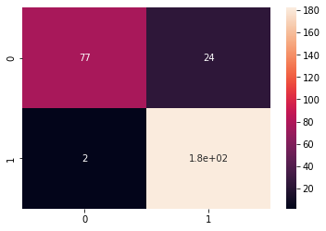

### train size : test size = 40% : 60%

In [79]:



X_train, X_test, y_train, y_test = train_test_split(X, y, test_size=0.6, random_state=0)

In [80]:



print(len(X_train)) print(len(y_test))

227

342

In [81]:



poly_SVC_classifier.fit(X_train, y_train)

Out[81]:

SVC(C=1.0, break_ties=False, cache_size=200, class_weight=None, coef0=0.0, decision_function_shape='ovr', degree=3, gamma='scale', kernel='poly', max_iter=-1, probability=False, random_state=None, shrinking=True, tol=0.001, verbose=False)

In [82]:

y_pred = poly_SVC_classifier.predict(X_test) print(f"Accuracy: {100 * accuracy_score(y_test,y_pred)}%\n") cf_matrix = confusion_matrix(y_test,y_pred) print("Confusion Matrix:\n", cf_matrix) print("\nClassification Report:\n") print(classification_report(y_test,y_pred))

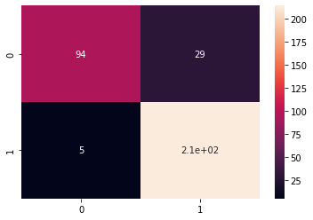

Accuracy: 90.05847953216374%

Confusion Matrix:

[[ 94 29]

[ 5 214]]

Classification Report:

|  |  |  |  |  |
| --- | --- | --- | --- | --- |
|  | precision | recall | f1-score | support |
| 0 | 0.95 | 0.76 | 0.85 | 123 |
| 1 | 0.88 | 0.98 | 0.93 | 219 |
| accuracy |  |  | 0.90 | 342 |
| macro avg | 0.92 | 0.87 | 0.89 | 342 |
| weighted avg | 0.91 | 0.90 | 0.90 | 342 |

In [83]:

sns.heatmap(cf_matrix, annot=True) Out[83]:

<matplotlib.axes._subplots.AxesSubplot at 0x7fa14a1c5150>

### train size : test size = 30% : 70%

In [84]:

X_train, X_test, y_train, y_test = train_test_split(X, y, test_size=0.7, random_state=0)

In [85]:

print(len(X_train)) print(len(y_test))

170

399

In [86]:

poly_SVC_classifier.fit(X_train, y_train) Out[86]:

SVC(C=1.0, break_ties=False, cache_size=200, class_weight=None, coef0=0.0, decision_function_shape='ovr', degree=3, gamma='scale', kernel='poly', max_iter=-1, probability=False, random_state=None, shrinking=True,

tol=0.001, verbose=False)

In [87]:



y_pred = poly_SVC_classifier.predict(X_test) print(f"Accuracy: {100 * accuracy_score(y_test,y_pred)}%\n") cf_matrix = confusion_matrix(y_test,y_pred) print("Confusion Matrix:\n", cf_matrix) print("\nClassification Report:\n") print(classification_report(y_test,y_pred))

Accuracy: 89.72431077694235%

Confusion Matrix:

[[108 38]

[ 3 250]]

Classification Report:

|  |  |  |  |  |
| --- | --- | --- | --- | --- |
|  | precision | recall | f1-score | support |
| 0 | 0.97 | 0.74 | 0.84 | 146 |
| 1 | 0.87 | 0.99 | 0.92 | 253 |
| accuracy |  |  | 0.90 | 399 |
| macro avg | 0.92 | 0.86 | 0.88 | 399 |
| weighted avg | 0.91 | 0.90 | 0.89 | 399 |

In [88]:



sns.heatmap(cf_matrix, annot=True)

Out[88]:

<matplotlib.axes._subplots.AxesSubplot at 0x7fa149c2af10>

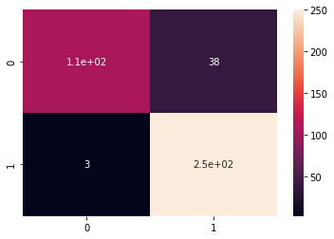

## Gaussain SVC Classifier

In [89]:



gaussain_SVC_classifier = SVC(kernel='rbf') gaussain_SVC_classifier

Out[89]:

SVC(C=1.0, break_ties=False, cache_size=200, class_weight=None, coef0=0.0, decision_function_shape='ovr', degree=3, gamma='scale', kernel='rbf', max_iter=-1, probability=False, random_state=None, shrinking=True, tol=0.001, verbose=False)

### train size : test size = 70% : 30%

In [90]:

X_train, X_test, y_train, y_test = train_test_split(X, y, test_size=0.3, random_state=0)

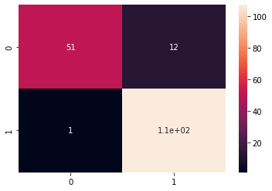

In [91]:

print(len(X_train)) print(len(y_test))

398

171

In [92]:

gaussain_SVC_classifier.fit(X_train, y_train) Out[92]:

SVC(C=1.0, break_ties=False, cache_size=200, class_weight=None, coef0=0.0, decision_function_shape='ovr', degree=3, gamma='scale', kernel='rbf', max_iter=-1, probability=False, random_state=None, shrinking=True, tol=0.001, verbose=False)

In [93]:

y_pred = gaussain_SVC_classifier.predict(X_test) print(f"Accuracy: {100 * accuracy_score(y_test,y_pred)}%\n") cf_matrix = confusion_matrix(y_test,y_pred) print("Confusion Matrix:\n", cf_matrix) print("\nClassification Report:\n") print(classification_report(y_test,y_pred))

Accuracy: 92.39766081871345%

Confusion Matrix:

[[ 51 12]

[ 1 107]]

Classification Report:

|  |  |  |  |  |
| --- | --- | --- | --- | --- |
|  | precision | recall | f1-score | support |
| 0 | 0.98 | 0.81 | 0.89 | 63 |
| 1 | 0.90 | 0.99 | 0.94 | 108 |
| accuracy |  |  | 0.92 | 171 |
| macro avg | 0.94 | 0.90 | 0.91 | 171 |
| weighted avg | 0.93 | 0.92 | 0.92 | 171 |

In [94]:

sns.heatmap(cf_matrix, annot=True) Out[94]:

<matplotlib.axes._subplots.AxesSubplot at 0x7fa149b5bb90>

### train size : test size = 60% : 40%

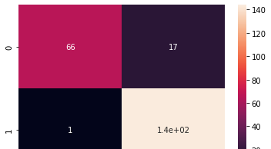

In [95]:

X_train, X_test, y_train, y_test = train_test_split(X, y, test_size=0.4, random_state=0)

In [96]:

print(len(X_train)) print(len(y_test))

341

228

In [97]:

gaussain_SVC_classifier.fit(X_train, y_train) Out[97]:

SVC(C=1.0, break_ties=False, cache_size=200, class_weight=None, coef0=0.0, decision_function_shape='ovr', degree=3, gamma='scale', kernel='rbf', max_iter=-1, probability=False, random_state=None, shrinking=True, tol=0.001, verbose=False)

In [98]:

y_pred = gaussain_SVC_classifier.predict(X_test) print(f"Accuracy: {100 * accuracy_score(y_test,y_pred)}%\n") cf_matrix = confusion_matrix(y_test,y_pred) print("Confusion Matrix:\n", cf_matrix) print("\nClassification Report:\n") print(classification_report(y_test,y_pred))

Accuracy: 92.10526315789474%

Confusion Matrix:

[[ 66 17]

[ 1 144]]

Classification Report:

|  |  |  |  |  |
| --- | --- | --- | --- | --- |
|  | precision | recall | f1-score | support |
| 0 | 0.99 | 0.80 | 0.88 | 83 |
| 1 | 0.89 | 0.99 | 0.94 | 145 |
| accuracy |  |  | 0.92 | 228 |
| macro avg | 0.94 | 0.89 | 0.91 | 228 |
| weighted avg | 0.93 | 0.92 | 0.92 | 228 |

In [99]:

sns.heatmap(cf_matrix, annot=True) Out[99]:

<matplotlib.axes._subplots.AxesSubplot at 0x7fa149aef090>

### train size : test size = 50% : 50%

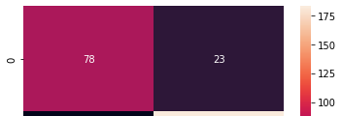

In [100]:

X_train, X_test, y_train, y_test = train_test_split(X, y, test_size=0.5, random_state=0)

In [101]:

print(len(X_train)) print(len(y_test))

284

285

In [102]:

gaussain_SVC_classifier.fit(X_train, y_train) Out[102]:

SVC(C=1.0, break_ties=False, cache_size=200, class_weight=None, coef0=0.0, decision_function_shape='ovr', degree=3, gamma='scale', kernel='rbf', max_iter=-1, probability=False, random_state=None, shrinking=True, tol=0.001, verbose=False)

In [103]:

y_pred = gaussain_SVC_classifier.predict(X_test) print(f"Accuracy: {100 * accuracy_score(y_test,y_pred)}%\n") cf_matrix = confusion_matrix(y_test,y_pred) print("Confusion Matrix:\n", cf_matrix) print("\nClassification Report:\n") print(classification_report(y_test,y_pred))

Accuracy: 91.57894736842105%

Confusion Matrix:

[[ 78 23]

[ 1 183]]

Classification Report:

|  |  |  |  |  |
| --- | --- | --- | --- | --- |
|  | precision | recall | f1-score | support |
| 0 | 0.99 | 0.77 | 0.87 | 101 |
| 1 | 0.89 | 0.99 | 0.94 | 184 |
| accuracy |  |  | 0.92 | 285 |
| macro avg | 0.94 | 0.88 | 0.90 | 285 |
| weighted avg | 0.92 | 0.92 | 0.91 | 285 |

In [104]:

sns.heatmap(cf_matrix, annot=True) Out[104]:

<matplotlib.axes._subplots.AxesSubplot at 0x7fa149af1890>

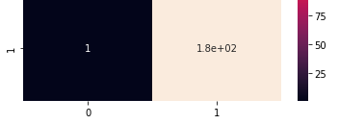

### train size : test size = 40% : 60%

In [105]:



X_train, X_test, y_train, y_test = train_test_split(X, y, test_size=0.6, random_state=0)

In [106]:



print(len(X_train)) print(len(y_test))

227

342

In [107]:



gaussain_SVC_classifier.fit(X_train, y_train)

Out[107]:

SVC(C=1.0, break_ties=False, cache_size=200, class_weight=None, coef0=0.0, decision_function_shape='ovr', degree=3, gamma='scale', kernel='rbf', max_iter=-1, probability=False, random_state=None, shrinking=True, tol=0.001, verbose=False)

In [108]:



y_pred = gaussain_SVC_classifier.predict(X_test) print(f"Accuracy: {100 * accuracy_score(y_test,y_pred)}%\n") cf_matrix = confusion_matrix(y_test,y_pred) print("Confusion Matrix:\n", cf_matrix) print("\nClassification Report:\n") print(classification_report(y_test,y_pred))

Accuracy: 90.64327485380117%

Confusion Matrix:

[[ 94 29]

[ 3 216]]

Classification Report:

|  |  |  |  |  |
| --- | --- | --- | --- | --- |
|  | precision | recall | f1-score | support |
| 0 | 0.97 | 0.76 | 0.85 | 123 |
| 1 | 0.88 | 0.99 | 0.93 | 219 |
| accuracy |  |  | 0.91 | 342 |
| macro avg | 0.93 | 0.88 | 0.89 | 342 |
| weighted avg | 0.91 | 0.91 | 0.90 | 342 |

In [109]:



sns.heatmap(cf_matrix, annot=True)

Out[109]:

<matplotlib.axes._subplots.AxesSubplot at 0x7fa1499c92d0>



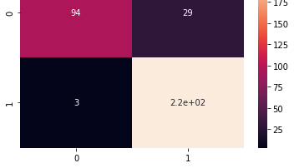

### train size : test size = 30% : 70%

In [110]:



X_train, X_test, y_train, y_test = train_test_split(X, y, test_size=0.7, random_state=0)

In [111]:



print(len(X_train)) print(len(y_test))

170

399

In [112]:



gaussain_SVC_classifier.fit(X_train, y_train)

Out[112]:

SVC(C=1.0, break_ties=False, cache_size=200, class_weight=None, coef0=0.0, decision_function_shape='ovr', degree=3, gamma='scale', kernel='rbf', max_iter=-1, probability=False, random_state=None, shrinking=True, tol=0.001, verbose=False)

In [113]:



y_pred = gaussain_SVC_classifier.predict(X_test) print(f"Accuracy: {100 * accuracy_score(y_test,y_pred)}%\n") cf_matrix = confusion_matrix(y_test,y_pred) print("Confusion Matrix:\n", cf_matrix) print("\nClassification Report:\n") print(classification_report(y_test,y_pred))

Accuracy: 90.47619047619048%

Confusion Matrix: [[110 36]

[ 2 251]]

Classification Report:

|  |  |  |  |  |
| --- | --- | --- | --- | --- |
|  | precision | recall | f1-score | support |
| 0 | 0.98 | 0.75 | 0.85 | 146 |
| 1 | 0.87 | 0.99 | 0.93 | 253 |
| accuracy |  |  | 0.90 | 399 |
| macro avg | 0.93 | 0.87 | 0.89 | 399 |
| weighted avg | 0.91 | 0.90 | 0.90 | 399 |

In [114]:



sns.heatmap(cf_matrix, annot=True)

Out[114]:

<matplotlib.axes._subplots.AxesSubplot at 0x7fa1498fd910>

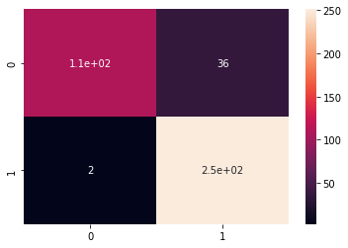

## Sigmoid SVC Classifier

In [115]:

sigmoid_SVC_classifier = SVC(kernel='sigmoid', C=0.9) sigmoid_SVC_classifier

Out[115]:

SVC(C=0.9, break_ties=False, cache_size=200, class_weight=None, coef0=0.0, decision_function_shape='ovr', degree=3, gamma='scale', kernel='sigmoid', max_iter=-1, probability=False, random_state=None, shrinking=True, tol=0.001, verbose=False)

### train size : test size = 70% : 30%

In [116]:

X_train, X_test, y_train, y_test = train_test_split(X, y, test_size=0.3, random_state=0)

In [117]:

print(len(X_train)) print(len(y_test))

398

171

In [118]:

sigmoid_SVC_classifier.fit(X_train, y_train) Out[118]:

SVC(C=0.9, break_ties=False, cache_size=200, class_weight=None, coef0=0.0, decision_function_shape='ovr', degree=3, gamma='scale', kernel='sigmoid', max_iter=-1, probability=False, random_state=None, shrinking=True, tol=0.001, verbose=False)

In [119]:

y_pred = sigmoid_SVC_classifier.predict(X_test) print(f"Accuracy: {100 * accuracy_score(y_test,y_pred)}%\n") cf_matrix = confusion_matrix(y_test,y_pred) print("Confusion Matrix:\n", cf_matrix) print("\nClassification Report:\n") print(classification_report(y_test,y_pred))

Accuracy: 46.198830409356724%

Confusion Matrix: [[10 53]

[39 69]]



Classification Report:

|  |  |  |  |  |
| --- | --- | --- | --- | --- |
|  | precision | recall | f1-score | support |
| 0 | 0.20 | 0.16 | 0.18 | 63 |
| 1 | 0.57 | 0.64 | 0.60 | 108 |
| accuracy |  |  | 0.46 | 171 |
| macro avg | 0.38 | 0.40 | 0.39 | 171 |
| weighted avg | 0.43 | 0.46 | 0.44 | 171 |

In [120]:

from sklearn.model_selection import GridSearchCV

In [124]:

param_grid = {'C': [0.1,1, 10, 100], 'gamma': [1,0.1,0.01,0.001],'kernel': ['sigmoid']}

In [126]:

grid = GridSearchCV(SVC(),param_grid,refit=True,verbose=2) grid.fit(X_train,y_train)

Fitting 5 folds for each of 16 candidates, totalling 80 fits

[CV] C=0.1, gamma=1, kernel=sigmoid ..................................

[CV] ................... C=0.1, gamma=1, kernel=sigmoid, total= 0.0s [CV] C=0.1, gamma=1, kernel=sigmoid ..................................

[CV] ................... C=0.1, gamma=1, kernel=sigmoid, total= 0.0s [CV] C=0.1, gamma=1, kernel=sigmoid ..................................

[CV] ................... C=0.1, gamma=1, kernel=sigmoid, total= 0.0s [CV] C=0.1, gamma=1, kernel=sigmoid ..................................

[CV] ................... C=0.1, gamma=1, kernel=sigmoid, total= 0.0s [CV] C=0.1, gamma=1, kernel=sigmoid ..................................

[CV] ................... C=0.1, gamma=1, kernel=sigmoid, total= 0.0s [CV] C=0.1, gamma=0.1, kernel=sigmoid ................................

[CV] ................. C=0.1, gamma=0.1, kernel=sigmoid, total= 0.0s [CV] C=0.1, gamma=0.1, kernel=sigmoid ................................

[CV] ................. C=0.1, gamma=0.1, kernel=sigmoid, total= 0.0s [CV] C=0.1, gamma=0.1, kernel=sigmoid ................................

[CV] ................. C=0.1, gamma=0.1, kernel=sigmoid, total= 0.0s [CV] C=0.1, gamma=0.1, kernel=sigmoid ................................

[CV] ................. C=0.1, gamma=0.1, kernel=sigmoid, total= 0.0s [CV] C=0.1, gamma=0.1, kernel=sigmoid ................................

[CV] ................. C=0.1, gamma=0.1, kernel=sigmoid, total= 0.0s [CV] C=0.1, gamma=0.01, kernel=sigmoid ...............................

[CV] ................ C=0.1, gamma=0.01, kernel=sigmoid, total= 0.0s [CV] C=0.1, gamma=0.01, kernel=sigmoid ...............................

[CV] ................ C=0.1, gamma=0.01, kernel=sigmoid, total= 0.0s [CV] C=0.1, gamma=0.01, kernel=sigmoid ...............................

[CV] ................ C=0.1, gamma=0.01, kernel=sigmoid, total= 0.0s [CV] C=0.1, gamma=0.01, kernel=sigmoid ...............................

[CV] ................ C=0.1, gamma=0.01, kernel=sigmoid, total= 0.0s [CV] C=0.1, gamma=0.01, kernel=sigmoid ...............................

[CV] ................ C=0.1, gamma=0.01, kernel=sigmoid, total= 0.0s [CV] C=0.1, gamma=0.001, kernel=sigmoid ..............................

[CV] ............... C=0.1, gamma=0.001, kernel=sigmoid, total= 0.0s [CV] C=0.1, gamma=0.001, kernel=sigmoid ..............................

[CV] ............... C=0.1, gamma=0.001, kernel=sigmoid, total= 0.0s [CV] C=0.1, gamma=0.001, kernel=sigmoid ..............................

[CV] ............... C=0.1, gamma=0.001, kernel=sigmoid, total= 0.0s [CV] C=0.1, gamma=0.001, kernel=sigmoid ..............................

[CV] ............... C=0.1, gamma=0.001, kernel=sigmoid, total= 0.0s [CV] C=0.1, gamma=0.001, kernel=sigmoid ..............................

[CV] ............... C=0.1, gamma=0.001, kernel=sigmoid, total= 0.0s [CV] C=1, gamma=1, kernel=sigmoid ....................................

[CV] ..................... C=1, gamma=1, kernel=sigmoid, total= 0.0s [CV] C=1, gamma=1, kernel=sigmoid ....................................



[Parallel(n_jobs=1)]: Using backend SequentialBackend with 1 concurrent workers. [Parallel(n_jobs=1)]: Done 1 out of 1 | elapsed: 0.0s remaining: 0.0s

[CV] ..................... C=1, gamma=1, kernel=sigmoid, total= 0.0s [CV] C=1, gamma=1, kernel=sigmoid ....................................

[CV] ..................... C=1, gamma=1, kernel=sigmoid, total= 0.0s [CV] C=1, gamma=1, kernel=sigmoid ....................................

[CV] ..................... C=1, gamma=1, kernel=sigmoid, total= 0.0s [CV] C=1, gamma=1, kernel=sigmoid ....................................

[CV] ..................... C=1, gamma=1, kernel=sigmoid, total= 0.0s [CV] C=1, gamma=0.1, kernel=sigmoid ..................................

[CV] ................... C=1, gamma=0.1, kernel=sigmoid, total= 0.0s [CV] C=1, gamma=0.1, kernel=sigmoid ..................................

[CV] ................... C=1, gamma=0.1, kernel=sigmoid, total= 0.0s [CV] C=1, gamma=0.1, kernel=sigmoid ..................................

[CV] ................... C=1, gamma=0.1, kernel=sigmoid, total= 0.0s [CV] C=1, gamma=0.1, kernel=sigmoid ..................................

[CV] ................... C=1, gamma=0.1, kernel=sigmoid, total= 0.0s [CV] C=1, gamma=0.1, kernel=sigmoid ..................................

[CV] ................... C=1, gamma=0.1, kernel=sigmoid, total= 0.0s [CV] C=1, gamma=0.01, kernel=sigmoid .................................

[CV] .................. C=1, gamma=0.01, kernel=sigmoid, total= 0.0s [CV] C=1, gamma=0.01, kernel=sigmoid .................................

[CV] .................. C=1, gamma=0.01, kernel=sigmoid, total= 0.0s [CV] C=1, gamma=0.01, kernel=sigmoid .................................

[CV] .................. C=1, gamma=0.01, kernel=sigmoid, total= 0.0s [CV] C=1, gamma=0.01, kernel=sigmoid .................................

[CV] .................. C=1, gamma=0.01, kernel=sigmoid, total= 0.0s [CV] C=1, gamma=0.01, kernel=sigmoid .................................

[CV] .................. C=1, gamma=0.01, kernel=sigmoid, total= 0.0s [CV] C=1, gamma=0.001, kernel=sigmoid ................................

[CV] ................. C=1, gamma=0.001, kernel=sigmoid, total= 0.0s [CV] C=1, gamma=0.001, kernel=sigmoid ................................

[CV] ................. C=1, gamma=0.001, kernel=sigmoid, total= 0.0s [CV] C=1, gamma=0.001, kernel=sigmoid ................................

[CV] ................. C=1, gamma=0.001, kernel=sigmoid, total= 0.0s [CV] C=1, gamma=0.001, kernel=sigmoid ................................

[CV] ................. C=1, gamma=0.001, kernel=sigmoid, total= 0.0s [CV] C=1, gamma=0.001, kernel=sigmoid ................................

[CV] ................. C=1, gamma=0.001, kernel=sigmoid, total= 0.0s [CV] C=10, gamma=1, kernel=sigmoid ...................................

[CV] .................... C=10, gamma=1, kernel=sigmoid, total= 0.0s [CV] C=10, gamma=1, kernel=sigmoid ...................................

[CV] .................... C=10, gamma=1, kernel=sigmoid, total= 0.0s [CV] C=10, gamma=1, kernel=sigmoid ...................................

[CV] .................... C=10, gamma=1, kernel=sigmoid, total= 0.0s [CV] C=10, gamma=1, kernel=sigmoid ...................................

[CV] .................... C=10, gamma=1, kernel=sigmoid, total= 0.0s [CV] C=10, gamma=1, kernel=sigmoid ...................................

[CV] .................... C=10, gamma=1, kernel=sigmoid, total= 0.0s [CV] C=10, gamma=0.1, kernel=sigmoid .................................

[CV] .................. C=10, gamma=0.1, kernel=sigmoid, total= 0.0s [CV] C=10, gamma=0.1, kernel=sigmoid .................................

[CV] .................. C=10, gamma=0.1, kernel=sigmoid, total= 0.0s [CV] C=10, gamma=0.1, kernel=sigmoid .................................

[CV] .................. C=10, gamma=0.1, kernel=sigmoid, total= 0.0s [CV] C=10, gamma=0.1, kernel=sigmoid .................................

[CV] .................. C=10, gamma=0.1, kernel=sigmoid, total= 0.0s [CV] C=10, gamma=0.1, kernel=sigmoid .................................

[CV] .................. C=10, gamma=0.1, kernel=sigmoid, total= 0.0s [CV] C=10, gamma=0.01, kernel=sigmoid ................................

[CV] ................. C=10, gamma=0.01, kernel=sigmoid, total= 0.0s [CV] C=10, gamma=0.01, kernel=sigmoid ................................

[CV] ................. C=10, gamma=0.01, kernel=sigmoid, total= 0.0s [CV] C=10, gamma=0.01, kernel=sigmoid ................................

[CV] ................. C=10, gamma=0.01, kernel=sigmoid, total= 0.0s [CV] C=10, gamma=0.01, kernel=sigmoid ................................

[CV] ................. C=10, gamma=0.01, kernel=sigmoid, total= 0.0s [CV] C=10, gamma=0.01, kernel=sigmoid ................................

[CV] ................. C=10, gamma=0.01, kernel=sigmoid, total= 0.0s [CV] C=10, gamma=0.001, kernel=sigmoid ...............................

[CV] ................ C=10, gamma=0.001, kernel=sigmoid, total= 0.0s

[CV] C=10, gamma=0.001, kernel=sigmoid ...............................

[CV] ................ C=10, gamma=0.001, kernel=sigmoid, total= 0.0s [CV] C=10, gamma=0.001, kernel=sigmoid ...............................

[CV] ................ C=10, gamma=0.001, kernel=sigmoid, total= 0.0s [CV] C=10, gamma=0.001, kernel=sigmoid ...............................

[CV] ................ C=10, gamma=0.001, kernel=sigmoid, total= 0.0s [CV] C=10, gamma=0.001, kernel=sigmoid ...............................

[CV] ................ C=10, gamma=0.001, kernel=sigmoid, total= 0.0s [CV] C=100, gamma=1, kernel=sigmoid ..................................

[CV] ................... C=100, gamma=1, kernel=sigmoid, total= 0.0s [CV] C=100, gamma=1, kernel=sigmoid ..................................

[CV] ................... C=100, gamma=1, kernel=sigmoid, total= 0.0s [CV] C=100, gamma=1, kernel=sigmoid ..................................

[CV] ................... C=100, gamma=1, kernel=sigmoid, total= 0.0s [CV] C=100, gamma=1, kernel=sigmoid ..................................

[CV] ................... C=100, gamma=1, kernel=sigmoid, total= 0.0s [CV] C=100, gamma=1, kernel=sigmoid ..................................

[CV] ................... C=100, gamma=1, kernel=sigmoid, total= 0.0s [CV] C=100, gamma=0.1, kernel=sigmoid ................................

[CV] ................. C=100, gamma=0.1, kernel=sigmoid, total= 0.0s [CV] C=100, gamma=0.1, kernel=sigmoid ................................

[CV] ................. C=100, gamma=0.1, kernel=sigmoid, total= 0.0s [CV] C=100, gamma=0.1, kernel=sigmoid ................................

[CV] ................. C=100, gamma=0.1, kernel=sigmoid, total= 0.0s [CV] C=100, gamma=0.1, kernel=sigmoid ................................

[CV] ................. C=100, gamma=0.1, kernel=sigmoid, total= 0.0s [CV] C=100, gamma=0.1, kernel=sigmoid ................................

[CV] ................. C=100, gamma=0.1, kernel=sigmoid, total= 0.0s [CV] C=100, gamma=0.01, kernel=sigmoid ...............................

[CV] ................ C=100, gamma=0.01, kernel=sigmoid, total= 0.0s [CV] C=100, gamma=0.01, kernel=sigmoid ...............................

[CV] ................ C=100, gamma=0.01, kernel=sigmoid, total= 0.0s [CV] C=100, gamma=0.01, kernel=sigmoid ...............................

[CV] ................ C=100, gamma=0.01, kernel=sigmoid, total= 0.0s [CV] C=100, gamma=0.01, kernel=sigmoid ...............................

[CV] ................ C=100, gamma=0.01, kernel=sigmoid, total= 0.0s [CV] C=100, gamma=0.01, kernel=sigmoid ...............................

[CV] ................ C=100, gamma=0.01, kernel=sigmoid, total= 0.0s [CV] C=100, gamma=0.001, kernel=sigmoid ..............................

[CV] ............... C=100, gamma=0.001, kernel=sigmoid, total= 0.0s [CV] C=100, gamma=0.001, kernel=sigmoid ..............................

[CV] ............... C=100, gamma=0.001, kernel=sigmoid, total= 0.0s [CV] C=100, gamma=0.001, kernel=sigmoid ..............................

[CV] ............... C=100, gamma=0.001, kernel=sigmoid, total= 0.0s [CV] C=100, gamma=0.001, kernel=sigmoid ..............................

[CV] ............... C=100, gamma=0.001, kernel=sigmoid, total= 0.0s [CV] C=100, gamma=0.001, kernel=sigmoid ..............................

[CV] ............... C=100, gamma=0.001, kernel=sigmoid, total= 0.0s

[Parallel(n_jobs=1)]: Done 80 out of 80 | elapsed: 0.8s finished

Out[126]:

GridSearchCV(cv=None, error_score=nan,

estimator=SVC(C=1.0, break_ties=False, cache_size=200, class_weight=None, coef0=0.0, decision_function_shape='ovr', degree=3, gamma='scale', kernel='rbf', max_iter=-1, probability=False, random_state=None, shrinking=True, tol=0.001, verbose=False),

iid='deprecated', n_jobs=None,

param_grid={'C': [0.1, 1, 10, 100], 'gamma': [1, 0.1, 0.01, 0.001],

'kernel': ['sigmoid']},

pre_dispatch='2*n_jobs', refit=True, return_train_score=False, scoring=None, verbose=2)

In [127]:



print(grid.best_estimator_)

SVC(C=0.1, break_ties=False, cache_size=200, class_weight=None, coef0=0.0, decision_function_shape='ovr', degree=3, gamma=1, kernel='sigmoid', max_iter=-1, probability=False, random_state=None, shrinking=True,

tol=0.001, verbose=False)

In [128]:



import matplotlib.pyplot as plt grid_predictions = grid.predict(X_test)

print(confusion_matrix(y_test,grid_predictions)) plt.show(sns.heatmap(confusion_matrix(y_test,grid_predictions), annot=True)) print(classification_report(y_test,grid_predictions))

print("Accuracy Score of RBF kernel", accuracy_score(y_test,grid_predictions))

[[ 0 63]

[ 0 108]]

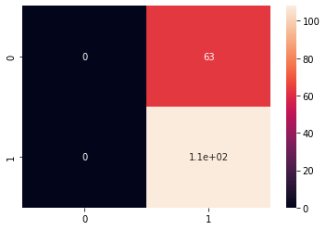

|  |  |  |  |  |
| --- | --- | --- | --- | --- |
|  | precision | recall | f1-score | support |
| 0 | 0.00 | 0.00 | 0.00 | 63 |
| 1 | 0.63 | 1.00 | 0.77 | 108 |
| accuracy |  |  | 0.63 | 171 |
| macro avg | 0.32 | 0.50 | 0.39 | 171 |
| weighted avg | 0.40 | 0.63 | 0.49 | 171 |

Accuracy Score of RBF kernel 0.631578947368421

/usr/local/lib/python3.7/dist-packages/sklearn/metrics/_classification.py:1272: Undefined MetricWarning: Precision and F-score are ill-defined and being set to 0.0 in labels with no predicted samples. Use `zero_division` parameter to control this behavior.

_warn_prf(average, modifier, msg_start, len(result))

In [129]:



sns.heatmap(cf_matrix, annot=True)

Out[129]:

<matplotlib.axes._subplots.AxesSubplot at 0x7fa14969c310>

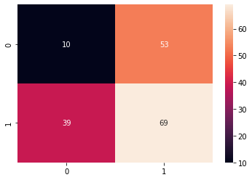

### train size : test size = 60% : 40%

In [130]:



X_train, X_test, y_train, y_test = train_test_split(X, y, test_size=0.4, random_state=0)

In [131]:



print(len(X_train)) print(len(y_test))

341

228

In [132]:



sigmoid_SVC_classifier.fit(X_train, y_train)

Out[132]:

SVC(C=0.9, break_ties=False, cache_size=200, class_weight=None, coef0=0.0, decision_function_shape='ovr', degree=3, gamma='scale', kernel='sigmoid', max_iter=-1, probability=False, random_state=None, shrinking=True, tol=0.001, verbose=False)

In [133]:



y_pred = sigmoid_SVC_classifier.predict(X_test) print(f"Accuracy: {100 * accuracy_score(y_test,y_pred)}%\n") cf_matrix = confusion_matrix(y_test,y_pred) print("Confusion Matrix:\n", cf_matrix) print("\nClassification Report:\n") print(classification_report(y_test,y_pred))

Accuracy: 47.80701754385965%

Confusion Matrix:

[[15 68]

[51 94]]

Classification Report:

|  |  |  |  |  |
| --- | --- | --- | --- | --- |
|  | precision | recall | f1-score | support |
| 0 | 0.23 | 0.18 | 0.20 | 83 |
| 1 | 0.58 | 0.65 | 0.61 | 145 |
| accuracy |  |  | 0.48 | 228 |
| macro avg | 0.40 | 0.41 | 0.41 | 228 |
| weighted avg | 0.45 | 0.48 | 0.46 | 228 |

In [134]:



sns.heatmap(cf_matrix, annot=True)

Out[134]:

<matplotlib.axes._subplots.AxesSubplot at 0x7fa149633390>

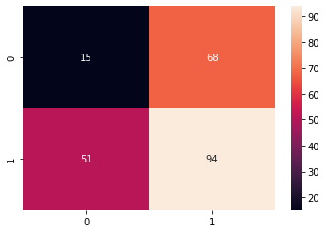



### train size : test size = 50% : 50%

In [135]:



X_train, X_test, y_train, y_test = train_test_split(X, y, test_size=0.5, random_state=0)

In [136]:



print(len(X_train)) print(len(y_test))

284

285

In [137]:



sigmoid_SVC_classifier.fit(X_train, y_train)

Out[137]:

SVC(C=0.9, break_ties=False, cache_size=200, class_weight=None, coef0=0.0, decision_function_shape='ovr', degree=3, gamma='scale', kernel='sigmoid', max_iter=-1, probability=False, random_state=None, shrinking=True, tol=0.001, verbose=False)

In [138]:



y_pred = sigmoid_SVC_classifier.predict(X_test) print(f"Accuracy: {100 * accuracy_score(y_test,y_pred)}%\n") cf_matrix = confusion_matrix(y_test,y_pred) print("Confusion Matrix:\n", cf_matrix) print("\nClassification Report:\n") print(classification_report(y_test,y_pred))

Accuracy: 46.666666666666664%

Confusion Matrix:

[[ 24 77]

[ 75 109]]

Classification Report:

|  |  |  |  |  |
| --- | --- | --- | --- | --- |
|  | precision | recall | f1-score | support |
| 0 | 0.24 | 0.24 | 0.24 | 101 |
| 1 | 0.59 | 0.59 | 0.59 | 184 |
| accuracy |  |  | 0.47 | 285 |
| macro avg | 0.41 | 0.42 | 0.41 | 285 |
| weighted avg | 0.46 | 0.47 | 0.47 | 285 |

In [139]:



sns.heatmap(cf_matrix, annot=True)

Out[139]:

<matplotlib.axes._subplots.AxesSubplot at 0x7fa14956a250>

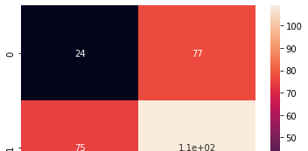

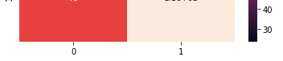

### train size : test size = 40% : 60%

In [140]:



X_train, X_test, y_train, y_test = train_test_split(X, y, test_size=0.6, random_state=0)

In [141]:



print(len(X_train)) print(len(y_test))

227

342

In [142]:



sigmoid_SVC_classifier.fit(X_train, y_train)

Out[142]:

SVC(C=0.9, break_ties=False, cache_size=200, class_weight=None, coef0=0.0, decision_function_shape='ovr', degree=3, gamma='scale', kernel='sigmoid', max_iter=-1, probability=False, random_state=None, shrinking=True, tol=0.001, verbose=False)

In [143]:



y_pred = sigmoid_SVC_classifier.predict(X_test) print(f"Accuracy: {100 * accuracy_score(y_test,y_pred)}%\n") cf_matrix = confusion_matrix(y_test,y_pred) print("Confusion Matrix:\n", cf_matrix) print("\nClassification Report:\n") print(classification_report(y_test,y_pred))

Accuracy: 50.29239766081871%

Confusion Matrix:

[[ 36 87]

[ 83 136]]

Classification Report:

|  |  |  |  |  |
| --- | --- | --- | --- | --- |
|  | precision | recall | f1-score | support |
| 0 | 0.30 | 0.29 | 0.30 | 123 |
| 1 | 0.61 | 0.62 | 0.62 | 219 |
| accuracy |  |  | 0.50 | 342 |
| macro avg | 0.46 | 0.46 | 0.46 | 342 |
| weighted avg | 0.50 | 0.50 | 0.50 | 342 |

In [144]:



sns.heatmap(cf_matrix, annot=True)

Out[144]:

<matplotlib.axes._subplots.AxesSubplot at 0x7fa1494df550>

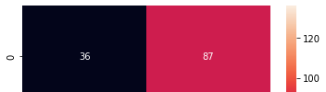

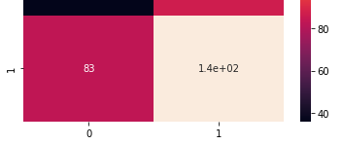

### train size : test size = 30% : 70%

In [145]:



X_train, X_test, y_train, y_test = train_test_split(X, y, test_size=0.7, random_state=0)

In [146]:



print(len(X_train)) print(len(y_test))

170

399

In [147]:



sigmoid_SVC_classifier.fit(X_train, y_train)

Out[147]:

SVC(C=0.9, break_ties=False, cache_size=200, class_weight=None, coef0=0.0, decision_function_shape='ovr', degree=3, gamma='scale', kernel='sigmoid', max_iter=-1, probability=False, random_state=None, shrinking=True, tol=0.001, verbose=False)

In [148]:



y_pred = sigmoid_SVC_classifier.predict(X_test) print(f"Accuracy: {100 * accuracy_score(y_test,y_pred)}%\n") cf_matrix = confusion_matrix(y_test,y_pred) print("Confusion Matrix:\n", cf_matrix) print("\nClassification Report:\n") print(classification_report(y_test,y_pred))

Accuracy: 50.37593984962406%

Confusion Matrix:

[[ 43 103]

[ 95 158]]

Classification Report:

|  |  |  |  |  |
| --- | --- | --- | --- | --- |
|  | precision | recall | f1-score | support |
| 0 | 0.31 | 0.29 | 0.30 | 146 |
| 1 | 0.61 | 0.62 | 0.61 | 253 |
| accuracy |  |  | 0.50 | 399 |
| macro avg | 0.46 | 0.46 | 0.46 | 399 |
| weighted avg | 0.50 | 0.50 | 0.50 | 399 |

In [149]:



sns.heatmap(cf_matrix, annot=True)

Out[149]:

<matplotlib.axes._subplots.AxesSubplot at 0x7fa149c649d0>



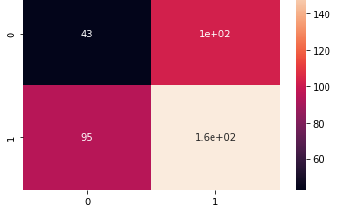

# MLP Classifier

In [150]:



mlp_classifier = MLPClassifier(learning_rate='constant', max_iter=600) mlp_classifier

Out[150]:

MLPClassifier(activation='relu', alpha=0.0001, batch_size='auto', beta_1=0.9, beta_2=0.999, early_stopping=False, epsilon=1e-08, hidden_layer_sizes=(100,), learning_rate='constant', learning_rate_init=0.001, max_fun=15000, max_iter=600, momentum=0.9, n_iter_no_change=10, nesterovs_momentum=True, power_t=0.5, random_state=None, shuffle=True, solver='adam', tol=0.0001, validation_fraction=0.1, verbose=False, warm_start=False)

### train size : test size = 70% : 30%

In [151]:



X_train, X_test, y_train, y_test = train_test_split(X, y, test_size=0.3, random_state=0)

# 70% training data, 30% testing data

In [152]:



print(len(X_train)) print(len(y_test))

398

171

In [153]:



mlp_classifier.fit(X_train, y_train)

Out[153]:

MLPClassifier(activation='relu', alpha=0.0001, batch_size='auto', beta_1=0.9, beta_2=0.999, early_stopping=False, epsilon=1e-08, hidden_layer_sizes=(100,), learning_rate='constant', learning_rate_init=0.001, max_fun=15000, max_iter=600, momentum=0.9, n_iter_no_change=10, nesterovs_momentum=True, power_t=0.5, random_state=None, shuffle=True, solver='adam', tol=0.0001, validation_fraction=0.1, verbose=False, warm_start=False)

In [154]:



y_pred = mlp_classifier.predict(X_test)

print(f"Accuracy: {100 * accuracy_score(y_test,y_pred)}%\n") cf_matrix = confusion_matrix(y_test,y_pred) print("Confusion Matrix:\n")





print(cf_matrix) print("\nClassification Report:\n")

print(classification_report(y_test,y_pred))

Accuracy: 63.74269005847953%

Confusion Matrix:

[[46 17]

[45 63]]

Classification Report:

|  |  |  |  |  |
| --- | --- | --- | --- | --- |
|  | precision | recall | f1-score | support |
| 0 | 0.51 | 0.73 | 0.60 | 63 |
| 1 | 0.79 | 0.58 | 0.67 | 108 |
| accuracy |  |  | 0.64 | 171 |
| macro avg | 0.65 | 0.66 | 0.63 | 171 |
| weighted avg | 0.68 | 0.64 | 0.64 | 171 |

In [155]:



sns.heatmap(cf_matrix, annot=True)

Out[155]:

<matplotlib.axes._subplots.AxesSubplot at 0x7fa149765c50>

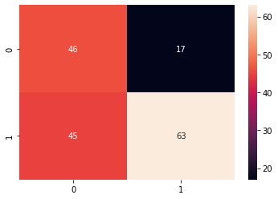

### train size : test size = 60% : 40%

In [156]:



X_train, X_test, y_train, y_test = train_test_split(X, y, test_size=0.4, random_state=0)

# 60% training data, 40% testing data

In [157]:



print(len(X_train)) print(len(y_test))

341

228

In [158]:



mlp_classifier.fit(X_train, y_train)

Out[158]:

MLPClassifier(activation='relu', alpha=0.0001, batch_size='auto', beta_1=0.9, beta_2=0.999, early_stopping=False, epsilon=1e-08, hidden_layer_sizes=(100,), learning_rate='constant', learning_rate_init=0.001, max_fun=15000, max_iter=600,

In [159]:

momentum=0.9, n_iter_no_change=10, nesterovs_momentum=True, power_t=0.5, random_state=None, shuffle=True, solver='adam', tol=0.0001, validation_fraction=0.1, verbose=False, warm_start=False)





y_pred = mlp_classifier.predict(X_test)

print(f"Accuracy: {100 * accuracy_score(y_test,y_pred)}%\n") cf_matrix = confusion_matrix(y_test,y_pred) print("Confusion Matrix:")

print(cf_matrix) print("\nClassification Report:\n")

print(classification_report(y_test,y_pred))

Accuracy: 87.28070175438597%

Confusion Matrix:

[[ 78 5]

[ 24 121]]

Classification Report:

|  |  |  |  |  |
| --- | --- | --- | --- | --- |
|  | precision | recall | f1-score | support |
| 0 | 0.76 | 0.94 | 0.84 | 83 |
| 1 | 0.96 | 0.83 | 0.89 | 145 |
| accuracy |  |  | 0.87 | 228 |
| macro avg | 0.86 | 0.89 | 0.87 | 228 |
| weighted avg | 0.89 | 0.87 | 0.87 | 228 |

In [160]:



sns.heatmap(cf_matrix, annot=True)

Out[160]:

<matplotlib.axes._subplots.AxesSubplot at 0x7fa149407290>

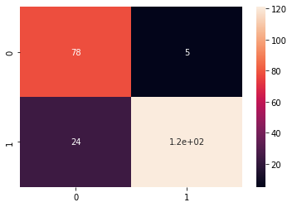

### train size : test size = 50% : 50%

In [161]:



X_train, X_test, y_train, y_test = train_test_split(X, y, test_size=0.5, random_state=0)

# 50% training data, 50% testing data

In [162]:



print(len(X_train)) print(len(y_test))

284

285



In [163]:



mlp_classifier.fit(X_train, y_train)

Out[163]:

MLPClassifier(activation='relu', alpha=0.0001, batch_size='auto', beta_1=0.9, beta_2=0.999, early_stopping=False, epsilon=1e-08, hidden_layer_sizes=(100,), learning_rate='constant', learning_rate_init=0.001, max_fun=15000, max_iter=600, momentum=0.9, n_iter_no_change=10, nesterovs_momentum=True, power_t=0.5, random_state=None, shuffle=True, solver='adam', tol=0.0001, validation_fraction=0.1, verbose=False, warm_start=False)

In [164]:



y_pred = mlp_classifier.predict(X_test)

print(f"Accuracy: {100 * accuracy_score(y_test,y_pred)}%\n") cf_matrix = confusion_matrix(y_test,y_pred) print("Confusion Matrix:")

print(cf_matrix) print("\nClassification Report:\n")

print(classification_report(y_test,y_pred))

Accuracy: 93.6842105263158%

Confusion Matrix:

[[ 93 8]

[ 10 174]]

Classification Report:

|  |  |  |  |  |
| --- | --- | --- | --- | --- |
|  | precision | recall | f1-score | support |
| 0 | 0.90 | 0.92 | 0.91 | 101 |
| 1 | 0.96 | 0.95 | 0.95 | 184 |
| accuracy |  |  | 0.94 | 285 |
| macro avg | 0.93 | 0.93 | 0.93 | 285 |
| weighted avg | 0.94 | 0.94 | 0.94 | 285 |

In [165]:



sns.heatmap(cf_matrix, annot=True)

Out[165]:

<matplotlib.axes._subplots.AxesSubplot at 0x7fa149347a10>

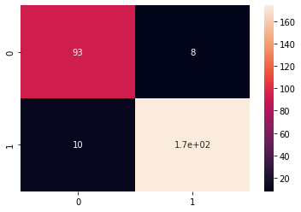

### train size : test size = 40% : 60%

In [166]:





X_train, X_test, y_train, y_test = train_test_split(X, y, test_size=0.6, random_state=0)

In [167]:



print(len(X_train)) print(len(y_test))

227

342

In [168]:



mlp_classifier.fit(X_train, y_train)

Out[168]:

MLPClassifier(activation='relu', alpha=0.0001, batch_size='auto', beta_1=0.9, beta_2=0.999, early_stopping=False, epsilon=1e-08, hidden_layer_sizes=(100,), learning_rate='constant', learning_rate_init=0.001, max_fun=15000, max_iter=600, momentum=0.9, n_iter_no_change=10, nesterovs_momentum=True, power_t=0.5, random_state=None, shuffle=True, solver='adam', tol=0.0001, validation_fraction=0.1, verbose=False, warm_start=False)

In [169]:



y_pred = mlp_classifier.predict(X_test)

print(f"Accuracy: {100 * accuracy_score(y_test,y_pred)}%\n") cf_matrix = confusion_matrix(y_test,y_pred) print("Confusion Matrix:\n")

print(cf_matrix) print("\nClassification Report:\n")

print(classification_report(y_test,y_pred))

Accuracy: 90.35087719298247%

Confusion Matrix:

[[112 11]

[ 22 197]]

Classification Report:

|  |  |  |  |  |
| --- | --- | --- | --- | --- |
|  | precision | recall | f1-score | support |
| 0 | 0.84 | 0.91 | 0.87 | 123 |
| 1 | 0.95 | 0.90 | 0.92 | 219 |
| accuracy |  |  | 0.90 | 342 |
| macro avg | 0.89 | 0.91 | 0.90 | 342 |
| weighted avg | 0.91 | 0.90 | 0.90 | 342 |

In [170]:



sns.heatmap(cf_matrix, annot=True)

Out[170]:

<matplotlib.axes._subplots.AxesSubplot at 0x7fa149277710>

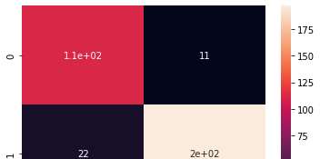

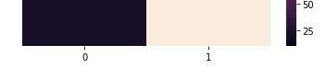

### train size : test size = 30% : 70%

In [171]:



X_train, X_test, y_train, y_test = train_test_split(X, y, test_size=0.7, random_state=0)

In [172]:



print(len(X_train)) print(len(y_test))

170

399

In [173]:



mlp_classifier.fit(X_train, y_train)

Out[173]:

MLPClassifier(activation='relu', alpha=0.0001, batch_size='auto', beta_1=0.9, beta_2=0.999, early_stopping=False, epsilon=1e-08, hidden_layer_sizes=(100,), learning_rate='constant', learning_rate_init=0.001, max_fun=15000, max_iter=600, momentum=0.9, n_iter_no_change=10, nesterovs_momentum=True, power_t=0.5, random_state=None, shuffle=True, solver='adam', tol=0.0001, validation_fraction=0.1, verbose=False, warm_start=False)

In [174]:



y_pred = mlp_classifier.predict(X_test)

print(f"Accuracy: {100 * accuracy_score(y_test,y_pred)}%\n") cf_matrix = confusion_matrix(y_test,y_pred) print("Confusion Matrix:\n")

print(cf_matrix) print("\nClassification Report:\n")

print(classification_report(y_test,y_pred))

Accuracy: 66.41604010025063%

Confusion Matrix:

[[130 16]

[118 135]]

Classification Report:

|  |  |  |  |  |
| --- | --- | --- | --- | --- |
|  | precision | recall | f1-score | support |
| 0 | 0.52 | 0.89 | 0.66 | 146 |
| 1 | 0.89 | 0.53 | 0.67 | 253 |
| accuracy |  |  | 0.66 | 399 |
| macro avg | 0.71 | 0.71 | 0.66 | 399 |
| weighted avg | 0.76 | 0.66 | 0.67 | 399 |

In [175]:



sns.heatmap(cf_matrix, annot=True)

Out[175]:

<matplotlib.axes._subplots.AxesSubplot at 0x7fa149212910>



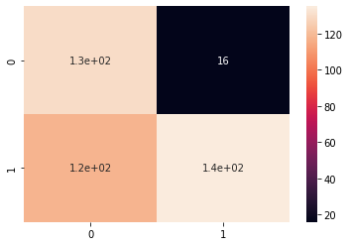

# Random Forest Classifier

In [176]:



rfc_classifier = RandomForestClassifier(n_estimators=20) rfc_classifier

Out[176]:

RandomForestClassifier(bootstrap=True, ccp_alpha=0.0, class_weight=None,

criterion='gini', max_depth=None, max_features='auto', max_leaf_nodes=None, max_samples=None, min_impurity_decrease=0.0, min_impurity_split=None, min_samples_leaf=1, min_samples_split=2, min_weight_fraction_leaf=0.0, n_estimators=20, n_jobs=None, oob_score=False, random_state=None, verbose=0, warm_start=False)

### train size : test size = 70% : 30%

In [177]:



X_train, X_test, y_train, y_test = train_test_split(X, y, test_size=0.3, random_state=0)

# 70% training data, 30% testing data

In [178]:



print(len(X_train)) print(len(y_test))

398

171

In [179]:



rfc_classifier.fit(X_train, y_train)

Out[179]:

RandomForestClassifier(bootstrap=True, ccp_alpha=0.0, class_weight=None,

criterion='gini', max_depth=None, max_features='auto', max_leaf_nodes=None, max_samples=None, min_impurity_decrease=0.0, min_impurity_split=None, min_samples_leaf=1, min_samples_split=2, min_weight_fraction_leaf=0.0, n_estimators=20, n_jobs=None, oob_score=False, random_state=None, verbose=0, warm_start=False)

In [180]:



y_pred = rfc_classifier.predict(X_test)

print(f"Accuracy: {100 * accuracy_score(y_test,y_pred)}%\n") cf_matrix = confusion_matrix(y_test,y_pred)





print("Confusion Matrix:\n") print(cf_matrix) print("\nClassification Report:\n")

print(classification_report(y_test,y_pred))

Accuracy: 95.90643274853801%

Confusion Matrix:

[[ 59 4]

[ 3 105]]

Classification Report:

|  |  |  |  |  |
| --- | --- | --- | --- | --- |
|  | precision | recall | f1-score | support |
| 0 | 0.95 | 0.94 | 0.94 | 63 |
| 1 | 0.96 | 0.97 | 0.97 | 108 |
| accuracy |  |  | 0.96 | 171 |
| macro avg | 0.96 | 0.95 | 0.96 | 171 |
| weighted avg | 0.96 | 0.96 | 0.96 | 171 |

In [181]:



sns.heatmap(cf_matrix, annot=True)

Out[181]:

<matplotlib.axes._subplots.AxesSubplot at 0x7fa149140f50>

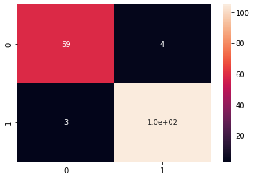

### train size : test size = 60% : 40%

In [182]:



X_train, X_test, y_train, y_test = train_test_split(X, y, test_size=0.4, random_state=0)

# 60% training data, 40% testing data

In [183]:



print(len(X_train)) print(len(y_test))

341

228

In [184]:



rfc_classifier.fit(X_train, y_train)

Out[184]:

RandomForestClassifier(bootstrap=True, ccp_alpha=0.0, class_weight=None,

criterion='gini', max_depth=None, max_features='auto', max_leaf_nodes=None, max_samples=None,

In [185]:

min_impurity_decrease=0.0, min_impurity_split=None, min_samples_leaf=1, min_samples_split=2, min_weight_fraction_leaf=0.0, n_estimators=20, n_jobs=None, oob_score=False, random_state=None, verbose=0, warm_start=False)





y_pred = rfc_classifier.predict(X_test)

print(f"Accuracy: {100 * accuracy_score(y_test,y_pred)}%\n") cf_matrix = confusion_matrix(y_test,y_pred) print("Confusion Matrix:")

print(cf_matrix) print("\nClassification Report:\n")

print(classification_report(y_test,y_pred))

Accuracy: 94.2982456140351%

Confusion Matrix:

[[ 73 10]

[ 3 142]]

Classification Report:

|  |  |  |  |  |
| --- | --- | --- | --- | --- |
|  | precision | recall | f1-score | support |
| 0 | 0.96 | 0.88 | 0.92 | 83 |
| 1 | 0.93 | 0.98 | 0.96 | 145 |
| accuracy |  |  | 0.94 | 228 |
| macro avg | 0.95 | 0.93 | 0.94 | 228 |
| weighted avg | 0.94 | 0.94 | 0.94 | 228 |

In [186]:



sns.heatmap(cf_matrix, annot=True)

Out[186]:

<matplotlib.axes._subplots.AxesSubplot at 0x7fa1490cca90>

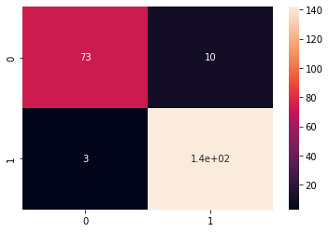

### train size : test size = 50% : 50%

In [187]:



X_train, X_test, y_train, y_test = train_test_split(X, y, test_size=0.5, random_state=0)

# 50% training data, 50% testing data

In [188]:



print(len(X_train)) print(len(y_test))

284

285

In [189]:



rfc_classifier.fit(X_train, y_train)

Out[189]:

RandomForestClassifier(bootstrap=True, ccp_alpha=0.0, class_weight=None,

criterion='gini', max_depth=None, max_features='auto', max_leaf_nodes=None, max_samples=None, min_impurity_decrease=0.0, min_impurity_split=None, min_samples_leaf=1, min_samples_split=2, min_weight_fraction_leaf=0.0, n_estimators=20, n_jobs=None, oob_score=False, random_state=None, verbose=0, warm_start=False)

In [190]:



y_pred = rfc_classifier.predict(X_test)

print(f"Accuracy: {100 * accuracy_score(y_test,y_pred)}%\n") cf_matrix = confusion_matrix(y_test,y_pred) print("Confusion Matrix:")

print(cf_matrix) print("\nClassification Report:\n")

print(classification_report(y_test,y_pred))

Accuracy: 94.38596491228071%

Confusion Matrix:

[[ 94 7]

[ 9 175]]

Classification Report:

|  |  |  |  |  |
| --- | --- | --- | --- | --- |
|  | precision | recall | f1-score | support |
| 0 | 0.91 | 0.93 | 0.92 | 101 |
| 1 | 0.96 | 0.95 | 0.96 | 184 |
| accuracy |  |  | 0.94 | 285 |
| macro avg | 0.94 | 0.94 | 0.94 | 285 |
| weighted avg | 0.94 | 0.94 | 0.94 | 285 |

In [191]:



sns.heatmap(cf_matrix, annot=True)

Out[191]:

<matplotlib.axes._subplots.AxesSubplot at 0x7fa14900e710>

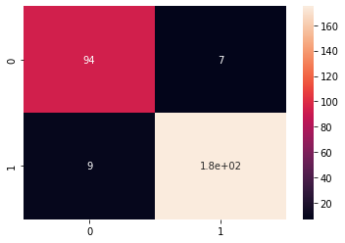

### train size : test size = 40% : 60%

In [192]:



X_train, X_test, y_train, y_test = train_test_split(X, y, test_size=0.6, random_state=0)

In [193]:



print(len(X_train)) print(len(y_test))

227

342

In [194]:



rfc_classifier.fit(X_train, y_train)

Out[194]:

RandomForestClassifier(bootstrap=True, ccp_alpha=0.0, class_weight=None,

criterion='gini', max_depth=None, max_features='auto', max_leaf_nodes=None, max_samples=None, min_impurity_decrease=0.0, min_impurity_split=None, min_samples_leaf=1, min_samples_split=2, min_weight_fraction_leaf=0.0, n_estimators=20, n_jobs=None, oob_score=False, random_state=None, verbose=0, warm_start=False)

In [195]:



y_pred = rfc_classifier.predict(X_test)

print(f"Accuracy: {100 * accuracy_score(y_test,y_pred)}%\n") cf_matrix = confusion_matrix(y_test,y_pred) print("Confusion Matrix:\n")

print(cf_matrix) print("\nClassification Report:\n")

print(classification_report(y_test,y_pred))

Accuracy: 93.56725146198829%

Confusion Matrix:

[[111 12]

[ 10 209]]

Classification Report:

|  |  |  |  |  |
| --- | --- | --- | --- | --- |
|  | precision | recall | f1-score | support |
| 0 | 0.92 | 0.90 | 0.91 | 123 |
| 1 | 0.95 | 0.95 | 0.95 | 219 |
| accuracy |  |  | 0.94 | 342 |
| macro avg | 0.93 | 0.93 | 0.93 | 342 |
| weighted avg | 0.94 | 0.94 | 0.94 | 342 |

In [196]:



sns.heatmap(cf_matrix, annot=True)

Out[196]:

<matplotlib.axes._subplots.AxesSubplot at 0x7fa148f90c50>

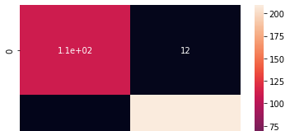

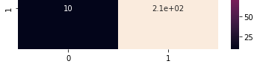

### train size : test size = 30% : 70%

In [197]:



X_train, X_test, y_train, y_test = train_test_split(X, y, test_size=0.7, random_state=0)

In [198]:



print(len(X_train)) print(len(y_test))

170

399

In [199]:



rfc_classifier.fit(X_train, y_train)

Out[199]:

RandomForestClassifier(bootstrap=True, ccp_alpha=0.0, class_weight=None,

criterion='gini', max_depth=None, max_features='auto', max_leaf_nodes=None, max_samples=None, min_impurity_decrease=0.0, min_impurity_split=None, min_samples_leaf=1, min_samples_split=2, min_weight_fraction_leaf=0.0, n_estimators=20, n_jobs=None, oob_score=False, random_state=None, verbose=0, warm_start=False)

In [200]:



y_pred = rfc_classifier.predict(X_test)

print(f"Accuracy: {100 * accuracy_score(y_test,y_pred)}%\n") cf_matrix = confusion_matrix(y_test,y_pred) print("Confusion Matrix:\n")

print(cf_matrix) print("\nClassification Report:\n")

print(classification_report(y_test,y_pred))

Accuracy: 94.23558897243107%

Confusion Matrix:

[[135 11]

[ 12 241]]

Classification Report:

|  |  |  |  |  |
| --- | --- | --- | --- | --- |
|  | precision | recall | f1-score | support |
| 0 | 0.92 | 0.92 | 0.92 | 146 |
| 1 | 0.96 | 0.95 | 0.95 | 253 |
| accuracy |  |  | 0.94 | 399 |
| macro avg | 0.94 | 0.94 | 0.94 | 399 |
| weighted avg | 0.94 | 0.94 | 0.94 | 399 |

In [201]:



sns.heatmap(cf_matrix, annot=True)

Out[201]:

<matplotlib.axes._subplots.AxesSubplot at 0x7fa148ea6350>

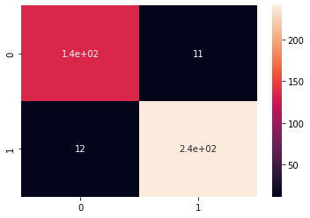

Name : Anmol Raj



Roll no : 001811001069

***IONOSPHERE***

# Import required modules

In [ ]:

import numpy as np import pandas as pd

from sklearn import datasets

from sklearn.metrics import accuracy_score, classification_report, confusion_matrix from sklearn.model_selection import train_test_split

from sklearn.svm import SVC import seaborn as sns

from sklearn.neural_network import MLPClassifier from sklearn.ensemble import RandomForestClassifier

# Load Dataset

In [ ]:

df = pd.read_csv('/content/ionosphere_data.csv') df.head()

Out[ ]:

|  |  |  |  |  |  |  |  |  |  |  |  |
| --- | --- | --- | --- | --- | --- | --- | --- | --- | --- | --- | --- |
| **column_a** | **column_b** | **column_c** | **column_d** | **column_e** | **column_f** | **column_g** | **column_h** | **column_i** | **column_j** | **column_k** | **colu** |
| **0** True | False | 0.99539 | -0.05889 | 0.85243 | 0.02306 | 0.83398 | -0.37708 | 1.00000 | 0.03760 | 0.85243 | -0.1 |
| **1** True | False | 1.00000 | -0.18829 | 0.93035 | -0.36156 | -0.10868 | -0.93597 | 1.00000 | -0.04549 | 0.50874 | -0.6 |
| **2** True | False | 1.00000 | -0.03365 | 1.00000 | 0.00485 | 1.00000 | -0.12062 | 0.88965 | 0.01198 | 0.73082 | 0.0 |
| **3** True | False | 1.00000 | -0.45161 | 1.00000 | 1.00000 | 0.71216 | -1.00000 | 0.00000 | 0.00000 | 0.00000 | 0.0 |
| **4** True | False | 1.00000 | -0.02401 | 0.94140 | 0.06531 | 0.92106 | -0.23255 | 0.77152 | -0.16399 | 0.52798 | -0.2 |

In [ ]:

df.column_ai.value_counts() Out[ ]:

g 225

b 126

Name: column_ai, dtype: int64

# DataFrame ready to perform

In [ ]:

len(df) Out[ ]: 351

In [ ]:

X = df.drop(["column_ai"], axis="columns")

y = df.column_ai print(X.head())



print(y.head())

column_a column_b column_c ... column_af column_ag column_ah 0 True False 0.99539 ... -0.54487 0.18641 -0.45300

1 True False 1.00000 ... -0.06288 -0.13738 -0.02447

2 True False 1.00000 ... -0.24180 0.56045 -0.38238

3 True False 1.00000 ... 1.00000 -0.32382 1.00000

4 True False 1.00000 ... -0.59573 -0.04608 -0.65697

|  |  |  |
| --- | --- | --- |
| [5 | rows x 34 | columns] |
| 0 | g |  |
| 1 | b |  |
| 2 | g |  |
| 3 | b |  |
| 4 | g |  |

Name: column_ai, dtype: object

# SVC Classfier

## Linear SVC Classifier

In [ ]:

linear_SVC_classifier = SVC(kernel='linear') linear_SVC_classifier

Out[ ]:

SVC(C=1.0, break_ties=False, cache_size=200, class_weight=None, coef0=0.0, decision_function_shape='ovr', degree=3, gamma='scale', kernel='linear', max_iter=-1, probability=False, random_state=None, shrinking=True, tol=0.001, verbose=False)

### train size : test size = 70% : 30%

In [ ]:

X_train, X_test, y_train, y_test = train_test_split(X, y, test_size=0.3, random_state=0)

#### # 70% training data, 30% testing data

In [ ]:

print(len(X_train)) print(len(y_test))

245

106

In [ ]:

linear_SVC_classifier.fit(X_train, y_train) Out[ ]:

SVC(C=1.0, break_ties=False, cache_size=200, class_weight=None, coef0=0.0, decision_function_shape='ovr', degree=3, gamma='scale', kernel='linear', max_iter=-1, probability=False, random_state=None, shrinking=True, tol=0.001, verbose=False)

In [ ]:

y_pred = linear_SVC_classifier.predict(X_test) print(f"Accuracy: {100 * accuracy_score(y_test,y_pred)}%\n") cf_matrix = confusion_matrix(y_test,y_pred) print("Confusion Matrix:\n")

print(cf_matrix) print("\nClassification Report:\n")

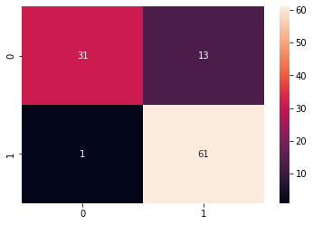

print(classification_report(y_test,y_pred)) Accuracy: 86.79245283018868%

Confusion Matrix:

[[31 13]

[ 1 61]]

Classification Report:

|  |  |  |  |  |
| --- | --- | --- | --- | --- |
|  | precision | recall | f1-score | support |
| b | 0.97 | 0.70 | 0.82 | 44 |
| g | 0.82 | 0.98 | 0.90 | 62 |
| accuracy |  |  | 0.87 | 106 |
| macro avg | 0.90 | 0.84 | 0.86 | 106 |
| weighted avg | 0.88 | 0.87 | 0.86 | 106 |

In [ ]:

sns.heatmap(cf_matrix, annot=True) Out[ ]:

<matplotlib.axes._subplots.AxesSubplot at 0x7f0fd4a58650>

### train size : test size = 60% : 40%

In [ ]:

X_train, X_test, y_train, y_test = train_test_split(X, y, test_size=0.4, random_state=0)

#### # 60% training data, 40% testing data

In [ ]:

print(len(X_train)) print(len(y_test))

210

141

In [ ]:

linear_SVC_classifier.fit(X_train, y_train) Out[ ]:

SVC(C=1.0, break_ties=False, cache_size=200, class_weight=None, coef0=0.0, decision_function_shape='ovr', degree=3, gamma='scale', kernel='linear', max_iter=-1, probability=False, random_state=None, shrinking=True, tol=0.001, verbose=False)

In [ ]:

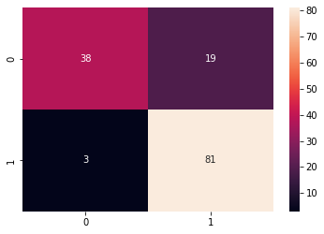

y_pred = linear_SVC_classifier.predict(X_test) print(f"Accuracy: {100 * accuracy_score(y_test,y_pred)}%\n") cf_matrix = confusion_matrix(y_test,y_pred) print("Confusion Matrix:")

print(cf_matrix) print("\nClassification Report:\n")

print(classification_report(y_test,y_pred)) Accuracy: 84.39716312056737%

Confusion Matrix:

[[38 19]

[ 3 81]]

Classification Report:

|  |  |  |  |  |
| --- | --- | --- | --- | --- |
|  | precision | recall | f1-score | support |
| b | 0.93 | 0.67 | 0.78 | 57 |
| g | 0.81 | 0.96 | 0.88 | 84 |
| accuracy |  |  | 0.84 | 141 |
| macro avg | 0.87 | 0.82 | 0.83 | 141 |
| weighted avg | 0.86 | 0.84 | 0.84 | 141 |

In [ ]:

sns.heatmap(cf_matrix, annot=True) Out[ ]:

<matplotlib.axes._subplots.AxesSubplot at 0x7f0fca484750>

### train size : test size = 50% : 50%

In [ ]:

X_train, X_test, y_train, y_test = train_test_split(X, y, test_size=0.5, random_state=0)

#### # 50% training data, 50% testing data

In [ ]:

print(len(X_train)) print(len(y_test))

175

176

In [ ]:

linear_SVC_classifier.fit(X_train, y_train)

Out[ ]:

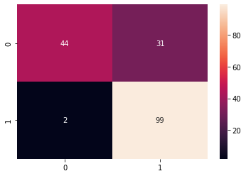

SVC(C=1.0, break_ties=False, cache_size=200, class_weight=None, coef0=0.0, decision_function_shape='ovr', degree=3, gamma='scale', kernel='linear', max_iter=-1, probability=False, random_state=None, shrinking=True, tol=0.001, verbose=False)

In [ ]:

y_pred = linear_SVC_classifier.predict(X_test) print(f"Accuracy: {100 * accuracy_score(y_test,y_pred)}%\n") cf_matrix = confusion_matrix(y_test,y_pred) print("Confusion Matrix:")

print(cf_matrix) print("\nClassification Report:\n")

print(classification_report(y_test,y_pred)) Accuracy: 81.25%

Confusion Matrix:

[[44 31]

[ 2 99]]

Classification Report:

|  |  |  |  |  |
| --- | --- | --- | --- | --- |
|  | precision | recall | f1-score | support |
| b | 0.96 | 0.59 | 0.73 | 75 |
| g | 0.76 | 0.98 | 0.86 | 101 |
| accuracy |  |  | 0.81 | 176 |
| macro avg | 0.86 | 0.78 | 0.79 | 176 |
| weighted avg | 0.84 | 0.81 | 0.80 | 176 |

In [ ]:

sns.heatmap(cf_matrix, annot=True) Out[ ]:

<matplotlib.axes._subplots.AxesSubplot at 0x7f0fc9f5da90>

### train size : test size = 40% : 60%

In [ ]:

X_train, X_test, y_train, y_test = train_test_split(X, y, test_size=0.6, random_state=0)

In [ ]:

print(len(X_train)) print(len(y_test))

140

211

In [ ]:



linear_SVC_classifier.fit(X_train, y_train)

Out[ ]:

SVC(C=1.0, break_ties=False, cache_size=200, class_weight=None, coef0=0.0, decision_function_shape='ovr', degree=3, gamma='scale', kernel='linear', max_iter=-1, probability=False, random_state=None, shrinking=True, tol=0.001, verbose=False)

In [ ]:



y_pred = linear_SVC_classifier.predict(X_test) print(f"Accuracy: {100 * accuracy_score(y_test,y_pred)}%\n") cf_matrix = confusion_matrix(y_test,y_pred) print("Confusion Matrix:\n")

print(cf_matrix) print("\nClassification Report:\n")

print(classification_report(y_test,y_pred))

Accuracy: 79.14691943127961%

Confusion Matrix:

[[ 45 43]

[ 1 122]]

Classification Report:

|  |  |  |  |  |
| --- | --- | --- | --- | --- |
|  | precision | recall | f1-score | support |
| b | 0.98 | 0.51 | 0.67 | 88 |
| g | 0.74 | 0.99 | 0.85 | 123 |
| accuracy |  |  | 0.79 | 211 |
| macro avg | 0.86 | 0.75 | 0.76 | 211 |
| weighted avg | 0.84 | 0.79 | 0.77 | 211 |

In [ ]:



sns.heatmap(cf_matrix, annot=True)

Out[ ]:

<matplotlib.axes._subplots.AxesSubplot at 0x7f0fc9e95450>

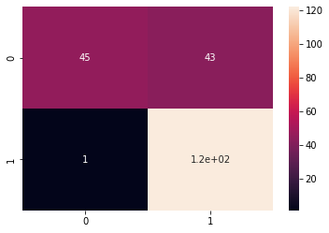

### train size : test size = 30% : 70%

In [ ]:



X_train, X_test, y_train, y_test = train_test_split(X, y, test_size=0.7, random_state=0)

In [ ]:

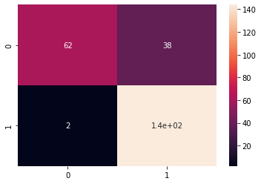

print(len(X_train)) print(len(y_test))

105

246

In [ ]:

linear_SVC_classifier.fit(X_train, y_train) Out[ ]:

SVC(C=1.0, break_ties=False, cache_size=200, class_weight=None, coef0=0.0, decision_function_shape='ovr', degree=3, gamma='scale', kernel='linear', max_iter=-1, probability=False, random_state=None, shrinking=True, tol=0.001, verbose=False)

In [ ]:

y_pred = linear_SVC_classifier.predict(X_test) print(f"Accuracy: {100 * accuracy_score(y_test,y_pred)}%\n") cf_matrix = confusion_matrix(y_test,y_pred) print("Confusion Matrix:\n")

print(cf_matrix) print("\nClassification Report:\n")

print(classification_report(y_test,y_pred)) Accuracy: 83.73983739837398%

Confusion Matrix:

[[ 62 38]

[ 2 144]]

Classification Report:

|  |  |  |  |  |
| --- | --- | --- | --- | --- |
|  | precision | recall | f1-score | support |
| b | 0.97 | 0.62 | 0.76 | 100 |
| g | 0.79 | 0.99 | 0.88 | 146 |
| accuracy |  |  | 0.84 | 246 |
| macro avg | 0.88 | 0.80 | 0.82 | 246 |
| weighted avg | 0.86 | 0.84 | 0.83 | 246 |

In [ ]:

sns.heatmap(cf_matrix, annot=True) Out[ ]:

<matplotlib.axes._subplots.AxesSubplot at 0x7f0fc9f65a50>

## Polynomial SVC Classifier



In [ ]:

poly_SVC_classifier = SVC(kernel='poly') poly_SVC_classifier

Out[ ]:

SVC(C=1.0, break_ties=False, cache_size=200, class_weight=None, coef0=0.0, decision_function_shape='ovr', degree=3, gamma='scale', kernel='poly', max_iter=-1, probability=False, random_state=None, shrinking=True, tol=0.001, verbose=False)

### train size : test size = 70% : 30%

In [ ]:

X_train, X_test, y_train, y_test = train_test_split(X, y, test_size=0.3, random_state=0)

In [ ]:

print(len(X_train)) print(len(y_test))

245

106

In [ ]:

poly_SVC_classifier.fit(X_train, y_train) Out[ ]:

SVC(C=1.0, break_ties=False, cache_size=200, class_weight=None, coef0=0.0, decision_function_shape='ovr', degree=3, gamma='scale', kernel='poly', max_iter=-1, probability=False, random_state=None, shrinking=True, tol=0.001, verbose=False)

In [ ]:

y_pred = poly_SVC_classifier.predict(X_test) print(f"Accuracy: {100 * accuracy_score(y_test,y_pred)}%\n") cf_matrix = confusion_matrix(y_test,y_pred) print("Confusion Matrix:\n", cf_matrix) print("\nClassification Report:\n") print(classification_report(y_test,y_pred))

Accuracy: 92.45283018867924%

Confusion Matrix:

[[38 6]

[ 2 60]]

Classification Report:

|  |  |  |  |  |
| --- | --- | --- | --- | --- |
|  | precision | recall | f1-score | support |
| b | 0.95 | 0.86 | 0.90 | 44 |
| g | 0.91 | 0.97 | 0.94 | 62 |
| accuracy |  |  | 0.92 | 106 |
| macro avg | 0.93 | 0.92 | 0.92 | 106 |
| weighted avg | 0.93 | 0.92 | 0.92 | 106 |

In [ ]:

sns.heatmap(cf_matrix, annot=True)

Out[ ]:

<matplotlib.axes._subplots.AxesSubplot at 0x7f0fc9d7b0d0>

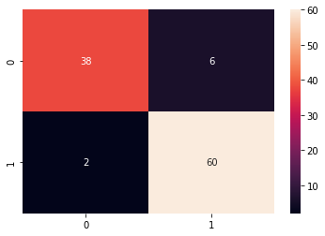

### train size : test size = 60% : 40%

In [ ]:



X_train, X_test, y_train, y_test = train_test_split(X, y, test_size=0.4, random_state=0)

In [ ]:



print(len(X_train)) print(len(y_test))

210

141

In [ ]:



poly_SVC_classifier.fit(X_train, y_train)

Out[ ]:

SVC(C=1.0, break_ties=False, cache_size=200, class_weight=None, coef0=0.0, decision_function_shape='ovr', degree=3, gamma='scale', kernel='poly', max_iter=-1, probability=False, random_state=None, shrinking=True, tol=0.001, verbose=False)

In [ ]:



y_pred = poly_SVC_classifier.predict(X_test) print(f"Accuracy: {100 * accuracy_score(y_test,y_pred)}%\n") cf_matrix = confusion_matrix(y_test,y_pred) print("Confusion Matrix:\n", cf_matrix) print("\nClassification Report:\n") print(classification_report(y_test,y_pred))

Accuracy: 75.88652482269504%

Confusion Matrix: [[23 34]

[ 0 84]]

Classification Report:

|  |  |  |  |  |
| --- | --- | --- | --- | --- |
|  | precision | recall | f1-score | support |
| b | 1.00 | 0.40 | 0.57 | 57 |
| g | 0.71 | 1.00 | 0.83 | 84 |
| accuracy |  |  | 0.76 | 141 |
| macro avg | 0.86 | 0.70 | 0.70 | 141 |
| weighted avg | 0.83 | 0.76 | 0.73 | 141 |

In [ ]:

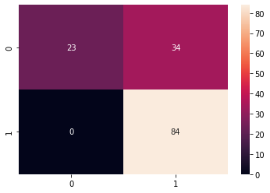

sns.heatmap(cf_matrix, annot=True) Out[ ]:

<matplotlib.axes._subplots.AxesSubplot at 0x7f0fc9d0a3d0>

### train size : test size = 50% : 50%

In [ ]:

X_train, X_test, y_train, y_test = train_test_split(X, y, test_size=0.5, random_state=0)

In [ ]:

print(len(X_train)) print(len(y_test))

175

176

In [ ]:

poly_SVC_classifier.fit(X_train, y_train) Out[ ]:

SVC(C=1.0, break_ties=False, cache_size=200, class_weight=None, coef0=0.0, decision_function_shape='ovr', degree=3, gamma='scale', kernel='poly', max_iter=-1, probability=False, random_state=None, shrinking=True, tol=0.001, verbose=False)

In [ ]:

y_pred = poly_SVC_classifier.predict(X_test) print(f"Accuracy: {100 * accuracy_score(y_test,y_pred)}%\n") cf_matrix = confusion_matrix(y_test,y_pred) print("Confusion Matrix:\n", cf_matrix) print("\nClassification Report:\n") print(classification_report(y_test,y_pred))

Accuracy: 65.3409090909091%

Confusion Matrix:

[[ 14 61]

[ 0 101]]

Classification Report:

precision recall f1-score support

|  |  |  |  |  |
| --- | --- | --- | --- | --- |
| b | 1.00 | 0.19 | 0.31 | 75 |
| g | 0.62 | 1.00 | 0.77 | 101 |

|  |  |  |  |  |
| --- | --- | --- | --- | --- |
| accuracy |  |  | 0.65 | 176 |
| macro avg | 0.81 | 0.59 | 0.54 | 176 |
| weighted avg | 0.78 | 0.65 | 0.57 | 176 |

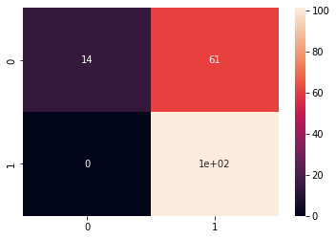

In [ ]:

sns.heatmap(cf_matrix, annot=True) Out[ ]:

<matplotlib.axes._subplots.AxesSubplot at 0x7f0fc9c31bd0>

### train size : test size = 40% : 60%

In [ ]:

X_train, X_test, y_train, y_test = train_test_split(X, y, test_size=0.6, random_state=0)

In [ ]:

print(len(X_train)) print(len(y_test))

140

211

In [ ]:

poly_SVC_classifier.fit(X_train, y_train) Out[ ]:

SVC(C=1.0, break_ties=False, cache_size=200, class_weight=None, coef0=0.0, decision_function_shape='ovr', degree=3, gamma='scale', kernel='poly', max_iter=-1, probability=False, random_state=None, shrinking=True, tol=0.001, verbose=False)

In [ ]:

y_pred = poly_SVC_classifier.predict(X_test) print(f"Accuracy: {100 * accuracy_score(y_test,y_pred)}%\n") cf_matrix = confusion_matrix(y_test,y_pred) print("Confusion Matrix:\n", cf_matrix) print("\nClassification Report:\n") print(classification_report(y_test,y_pred))

Accuracy: 63.507109004739334%

Confusion Matrix: [[ 11 77]

[ 0 123]]

Classification Report:

|  |  |  |  |  |
| --- | --- | --- | --- | --- |
|  | precision | recall | f1-score | support |
| b | 1.00 | 0.12 | 0.22 | 88 |
| g | 0.61 | 1.00 | 0.76 | 123 |
| accuracy |  |  | 0.64 | 211 |
| macro avg | 0.81 | 0.56 | 0.49 | 211 |
| weighted avg | 0.78 | 0.64 | 0.54 | 211 |



In [ ]:



sns.heatmap(cf_matrix, annot=True)

Out[ ]:

<matplotlib.axes._subplots.AxesSubplot at 0x7f0fc9c8f610>

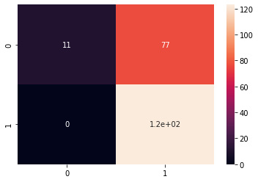

### train size : test size = 30% : 70%

In [ ]:



X_train, X_test, y_train, y_test = train_test_split(X, y, test_size=0.7, random_state=0)

In [ ]:



print(len(X_train)) print(len(y_test))

105

246

In [ ]:



poly_SVC_classifier.fit(X_train, y_train)

Out[ ]:

SVC(C=1.0, break_ties=False, cache_size=200, class_weight=None, coef0=0.0, decision_function_shape='ovr', degree=3, gamma='scale', kernel='poly', max_iter=-1, probability=False, random_state=None, shrinking=True, tol=0.001, verbose=False)

In [ ]:



y_pred = poly_SVC_classifier.predict(X_test) print(f"Accuracy: {100 * accuracy_score(y_test,y_pred)}%\n") cf_matrix = confusion_matrix(y_test,y_pred) print("Confusion Matrix:\n", cf_matrix) print("\nClassification Report:\n") print(classification_report(y_test,y_pred))

Accuracy: 63.82113821138211%

Confusion Matrix: [[ 11 89]

[ 0 146]]

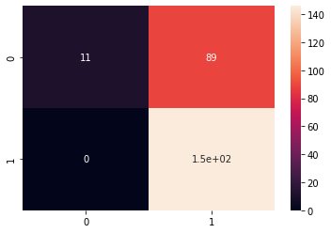

Classification Report:

|  |  |  |  |  |
| --- | --- | --- | --- | --- |
|  | precision | recall | f1-score | support |
| b | 1.00 | 0.11 | 0.20 | 100 |
| g | 0.62 | 1.00 | 0.77 | 146 |
| accuracy |  |  | 0.64 | 246 |
| macro avg | 0.81 | 0.56 | 0.48 | 246 |
| weighted avg | 0.78 | 0.64 | 0.54 | 246 |

In [ ]:

sns.heatmap(cf_matrix, annot=True) Out[ ]:

<matplotlib.axes._subplots.AxesSubplot at 0x7f0fc9b11050>

## Gaussain SVC Classifier

In [ ]:

gaussain_SVC_classifier = SVC(kernel='rbf') gaussain_SVC_classifier

Out[ ]:

SVC(C=1.0, break_ties=False, cache_size=200, class_weight=None, coef0=0.0, decision_function_shape='ovr', degree=3, gamma='scale', kernel='rbf', max_iter=-1, probability=False, random_state=None, shrinking=True, tol=0.001, verbose=False)

### train size : test size = 70% : 30%

In [ ]:

X_train, X_test, y_train, y_test = train_test_split(X, y, test_size=0.3, random_state=0)

In [ ]:

print(len(X_train)) print(len(y_test))

245

106

In [ ]:

gaussain_SVC_classifier.fit(X_train, y_train)

Out[ ]:

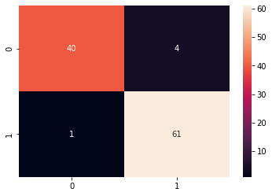

SVC(C=1.0, break_ties=False, cache_size=200, class_weight=None, coef0=0.0, decision_function_shape='ovr', degree=3, gamma='scale', kernel='rbf', max_iter=-1, probability=False, random_state=None, shrinking=True, tol=0.001, verbose=False)

In [ ]:

y_pred = gaussain_SVC_classifier.predict(X_test) print(f"Accuracy: {100 * accuracy_score(y_test,y_pred)}%\n") cf_matrix = confusion_matrix(y_test,y_pred) print("Confusion Matrix:\n", cf_matrix) print("\nClassification Report:\n") print(classification_report(y_test,y_pred))

Accuracy: 95.28301886792453%

Confusion Matrix:

[[40 4]

[ 1 61]]

Classification Report:

|  |  |  |  |  |
| --- | --- | --- | --- | --- |
|  | precision | recall | f1-score | support |
| b | 0.98 | 0.91 | 0.94 | 44 |
| g | 0.94 | 0.98 | 0.96 | 62 |
| accuracy |  |  | 0.95 | 106 |
| macro avg | 0.96 | 0.95 | 0.95 | 106 |
| weighted avg | 0.95 | 0.95 | 0.95 | 106 |

In [ ]:

sns.heatmap(cf_matrix, annot=True) Out[ ]:

<matplotlib.axes._subplots.AxesSubplot at 0x7f0fc9a3d310>

### train size : test size = 60% : 40%

In [ ]:

X_train, X_test, y_train, y_test = train_test_split(X, y, test_size=0.4, random_state=0)

In [ ]:

print(len(X_train)) print(len(y_test))

210

141

In [ ]:

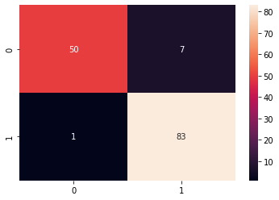

gaussain_SVC_classifier.fit(X_train, y_train) Out[ ]:

SVC(C=1.0, break_ties=False, cache_size=200, class_weight=None, coef0=0.0, decision_function_shape='ovr', degree=3, gamma='scale', kernel='rbf', max_iter=-1, probability=False, random_state=None, shrinking=True, tol=0.001, verbose=False)

In [ ]:

y_pred = gaussain_SVC_classifier.predict(X_test) print(f"Accuracy: {100 * accuracy_score(y_test,y_pred)}%\n") cf_matrix = confusion_matrix(y_test,y_pred) print("Confusion Matrix:\n", cf_matrix) print("\nClassification Report:\n") print(classification_report(y_test,y_pred))

Accuracy: 94.32624113475178%

Confusion Matrix:

[[50 7]

[ 1 83]]

Classification Report:

|  |  |  |  |  |
| --- | --- | --- | --- | --- |
|  | precision | recall | f1-score | support |
| b | 0.98 | 0.88 | 0.93 | 57 |
| g | 0.92 | 0.99 | 0.95 | 84 |
| accuracy |  |  | 0.94 | 141 |
| macro avg | 0.95 | 0.93 | 0.94 | 141 |
| weighted avg | 0.95 | 0.94 | 0.94 | 141 |

In [ ]:

sns.heatmap(cf_matrix, annot=True) Out[ ]:

<matplotlib.axes._subplots.AxesSubplot at 0x7f0fc995f510>

### train size : test size = 50% : 50%

In [ ]:

X_train, X_test, y_train, y_test = train_test_split(X, y, test_size=0.5, random_state=0)

In [ ]:

print(len(X_train))

print(len(y_test))

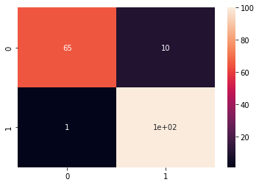

175

176

In [ ]:

gaussain_SVC_classifier.fit(X_train, y_train) Out[ ]:

SVC(C=1.0, break_ties=False, cache_size=200, class_weight=None, coef0=0.0, decision_function_shape='ovr', degree=3, gamma='scale', kernel='rbf', max_iter=-1, probability=False, random_state=None, shrinking=True, tol=0.001, verbose=False)

In [ ]:

y_pred = gaussain_SVC_classifier.predict(X_test) print(f"Accuracy: {100 * accuracy_score(y_test,y_pred)}%\n") cf_matrix = confusion_matrix(y_test,y_pred) print("Confusion Matrix:\n", cf_matrix) print("\nClassification Report:\n") print(classification_report(y_test,y_pred))

Accuracy: 93.75%

Confusion Matrix:

[[ 65 10]

[ 1 100]]

Classification Report:

|  |  |  |  |  |
| --- | --- | --- | --- | --- |
|  | precision | recall | f1-score | support |
| b | 0.98 | 0.87 | 0.92 | 75 |
| g | 0.91 | 0.99 | 0.95 | 101 |
| accuracy |  |  | 0.94 | 176 |
| macro avg | 0.95 | 0.93 | 0.93 | 176 |
| weighted avg | 0.94 | 0.94 | 0.94 | 176 |

In [ ]:

sns.heatmap(cf_matrix, annot=True) Out[ ]:

<matplotlib.axes._subplots.AxesSubplot at 0x7f0fc9908110>

### train size : test size = 40% : 60%

In [ ]:

X_train, X_test, y_train, y_test = train_test_split(X, y, test_size=0.6, random_state=0)

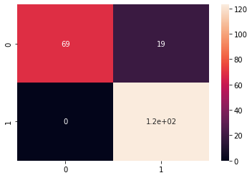

In [ ]:

print(len(X_train)) print(len(y_test))

140

211

In [ ]:

gaussain_SVC_classifier.fit(X_train, y_train) Out[ ]:

SVC(C=1.0, break_ties=False, cache_size=200, class_weight=None, coef0=0.0, decision_function_shape='ovr', degree=3, gamma='scale', kernel='rbf', max_iter=-1, probability=False, random_state=None, shrinking=True, tol=0.001, verbose=False)

In [ ]:

y_pred = gaussain_SVC_classifier.predict(X_test) print(f"Accuracy: {100 * accuracy_score(y_test,y_pred)}%\n") cf_matrix = confusion_matrix(y_test,y_pred) print("Confusion Matrix:\n", cf_matrix) print("\nClassification Report:\n") print(classification_report(y_test,y_pred))

Accuracy: 90.99526066350711%

Confusion Matrix:

[[ 69 19]

[ 0 123]]

Classification Report:

|  |  |  |  |  |
| --- | --- | --- | --- | --- |
|  | precision | recall | f1-score | support |
| b | 1.00 | 0.78 | 0.88 | 88 |
| g | 0.87 | 1.00 | 0.93 | 123 |
| accuracy |  |  | 0.91 | 211 |
| macro avg | 0.93 | 0.89 | 0.90 | 211 |
| weighted avg | 0.92 | 0.91 | 0.91 | 211 |

In [ ]:

sns.heatmap(cf_matrix, annot=True) Out[ ]:

<matplotlib.axes._subplots.AxesSubplot at 0x7f0fc9cea990>

### train size : test size = 30% : 70%

In [ ]:



X_train, X_test, y_train, y_test = train_test_split(X, y, test_size=0.7, random_state=0)

In [ ]:



print(len(X_train)) print(len(y_test))

105

246

In [ ]:



gaussain_SVC_classifier.fit(X_train, y_train)

Out[ ]:

SVC(C=1.0, break_ties=False, cache_size=200, class_weight=None, coef0=0.0, decision_function_shape='ovr', degree=3, gamma='scale', kernel='rbf', max_iter=-1, probability=False, random_state=None, shrinking=True, tol=0.001, verbose=False)

In [ ]:



y_pred = gaussain_SVC_classifier.predict(X_test) print(f"Accuracy: {100 * accuracy_score(y_test,y_pred)}%\n") cf_matrix = confusion_matrix(y_test,y_pred) print("Confusion Matrix:\n", cf_matrix) print("\nClassification Report:\n") print(classification_report(y_test,y_pred))

Accuracy: 90.2439024390244%

Confusion Matrix:

[[ 76 24]

[ 0 146]]

Classification Report:

|  |  |  |  |  |
| --- | --- | --- | --- | --- |
|  | precision | recall | f1-score | support |
| b | 1.00 | 0.76 | 0.86 | 100 |
| g | 0.86 | 1.00 | 0.92 | 146 |
| accuracy |  |  | 0.90 | 246 |
| macro avg | 0.93 | 0.88 | 0.89 | 246 |
| weighted avg | 0.92 | 0.90 | 0.90 | 246 |

In [ ]:



sns.heatmap(cf_matrix, annot=True)

Out[ ]:

<matplotlib.axes._subplots.AxesSubplot at 0x7f0fc97ad810>

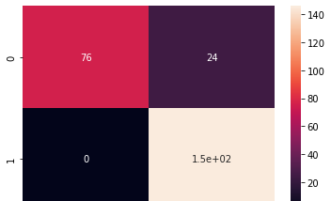

## Sigmoid SVC Classifier



In [ ]:

sigmoid_SVC_classifier = SVC(kernel='sigmoid') sigmoid_SVC_classifier

Out[ ]:

SVC(C=1.0, break_ties=False, cache_size=200, class_weight=None, coef0=0.0, decision_function_shape='ovr', degree=3, gamma='scale', kernel='sigmoid', max_iter=-1, probability=False, random_state=None, shrinking=True, tol=0.001, verbose=False)

### train size : test size = 70% : 30%

In [ ]:

X_train, X_test, y_train, y_test = train_test_split(X, y, test_size=0.3, random_state=0)

In [ ]:

print(len(X_train)) print(len(y_test))

245

106

In [ ]:

sigmoid_SVC_classifier.fit(X_train, y_train) Out[ ]:

SVC(C=1.0, break_ties=False, cache_size=200, class_weight=None, coef0=0.0, decision_function_shape='ovr', degree=3, gamma='scale', kernel='sigmoid', max_iter=-1, probability=False, random_state=None, shrinking=True, tol=0.001, verbose=False)

In [ ]:

y_pred = sigmoid_SVC_classifier.predict(X_test) print(f"Accuracy: {100 * accuracy_score(y_test,y_pred)}%\n") cf_matrix = confusion_matrix(y_test,y_pred) print("Confusion Matrix:\n", cf_matrix) print("\nClassification Report:\n") print(classification_report(y_test,y_pred))

Accuracy: 84.90566037735849%

Confusion Matrix: [[29 15]

[ 1 61]]

Classification Report:

|  |  |  |  |  |
| --- | --- | --- | --- | --- |
|  | precision | recall | f1-score | support |
| b | 0.97 | 0.66 | 0.78 | 44 |
| g | 0.80 | 0.98 | 0.88 | 62 |
| accuracy |  |  | 0.85 | 106 |
| macro avg | 0.88 | 0.82 | 0.83 | 106 |
| weighted avg | 0.87 | 0.85 | 0.84 | 106 |

In [ ]:



sns.heatmap(cf_matrix, annot=True)

Out[ ]:

<matplotlib.axes._subplots.AxesSubplot at 0x7f0fc96dcdd0>

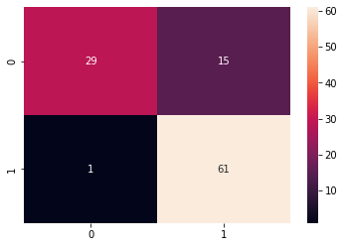

### train size : test size = 60% : 40%

In [ ]:



X_train, X_test, y_train, y_test = train_test_split(X, y, test_size=0.4, random_state=0)

In [ ]:



print(len(X_train)) print(len(y_test))

210

141

In [ ]:



sigmoid_SVC_classifier.fit(X_train, y_train)

Out[ ]:

SVC(C=1.0, break_ties=False, cache_size=200, class_weight=None, coef0=0.0, decision_function_shape='ovr', degree=3, gamma='scale', kernel='sigmoid', max_iter=-1, probability=False, random_state=None, shrinking=True, tol=0.001, verbose=False)

In [ ]:



y_pred = sigmoid_SVC_classifier.predict(X_test) print(f"Accuracy: {100 * accuracy_score(y_test,y_pred)}%\n") cf_matrix = confusion_matrix(y_test,y_pred) print("Confusion Matrix:\n", cf_matrix) print("\nClassification Report:\n") print(classification_report(y_test,y_pred))

Accuracy: 82.97872340425532%

Confusion Matrix: [[34 23]

[ 1 83]]

Classification Report:

|  |  |  |  |  |
| --- | --- | --- | --- | --- |
|  | precision | recall | f1-score | support |
| b | 0.97 | 0.60 | 0.74 | 57 |
| g | 0.78 | 0.99 | 0.87 | 84 |
| accuracy |  |  | 0.83 | 141 |

|  |  |  |  |  |
| --- | --- | --- | --- | --- |
| macro avg | 0.88 | 0.79 | 0.81 | 141 |
| weighted avg | 0.86 | 0.83 | 0.82 | 141 |



In [ ]:



sns.heatmap(cf_matrix, annot=True)

Out[ ]:

<matplotlib.axes._subplots.AxesSubplot at 0x7f0fc9673850>

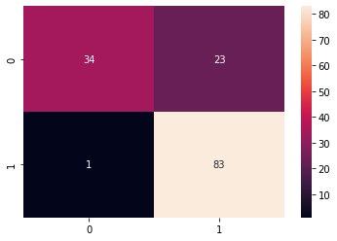

### train size : test size = 50% : 50%

In [ ]:



X_train, X_test, y_train, y_test = train_test_split(X, y, test_size=0.5, random_state=0)

In [ ]:



print(len(X_train)) print(len(y_test))

175

176

In [ ]:



sigmoid_SVC_classifier.fit(X_train, y_train)

Out[ ]:

SVC(C=1.0, break_ties=False, cache_size=200, class_weight=None, coef0=0.0, decision_function_shape='ovr', degree=3, gamma='scale', kernel='sigmoid', max_iter=-1, probability=False, random_state=None, shrinking=True, tol=0.001, verbose=False)

In [ ]:



y_pred = sigmoid_SVC_classifier.predict(X_test) print(f"Accuracy: {100 * accuracy_score(y_test,y_pred)}%\n") cf_matrix = confusion_matrix(y_test,y_pred) print("Confusion Matrix:\n", cf_matrix) print("\nClassification Report:\n") print(classification_report(y_test,y_pred))

Accuracy: 83.52272727272727%

Confusion Matrix:

[[48 27]

[ 2 99]]

Classification Report:

precision recall f1-score support



|  |  |  |  |  |
| --- | --- | --- | --- | --- |
| b | 0.96 | 0.64 | 0.77 | 75 |
| g | 0.79 | 0.98 | 0.87 | 101 |
| accuracy |  |  | 0.84 | 176 |
| macro avg | 0.87 | 0.81 | 0.82 | 176 |
| weighted avg | 0.86 | 0.84 | 0.83 | 176 |

In [ ]:



sns.heatmap(cf_matrix, annot=True)

Out[ ]:

<matplotlib.axes._subplots.AxesSubplot at 0x7f0fc95aa290>

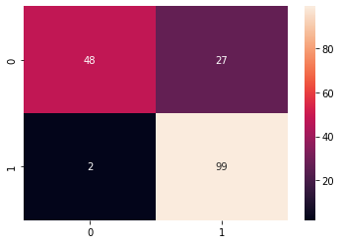

### train size : test size = 40% : 60%

In [ ]:



X_train, X_test, y_train, y_test = train_test_split(X, y, test_size=0.6, random_state=0)

In [ ]:



print(len(X_train)) print(len(y_test))

140

211

In [ ]:



sigmoid_SVC_classifier.fit(X_train, y_train)

Out[ ]:

SVC(C=1.0, break_ties=False, cache_size=200, class_weight=None, coef0=0.0, decision_function_shape='ovr', degree=3, gamma='scale', kernel='sigmoid', max_iter=-1, probability=False, random_state=None, shrinking=True, tol=0.001, verbose=False)

In [ ]:



y_pred = sigmoid_SVC_classifier.predict(X_test) print(f"Accuracy: {100 * accuracy_score(y_test,y_pred)}%\n") cf_matrix = confusion_matrix(y_test,y_pred) print("Confusion Matrix:\n", cf_matrix) print("\nClassification Report:\n") print(classification_report(y_test,y_pred))

Accuracy: 81.99052132701422%

Confusion Matrix: [[ 51 37]

[ 1 122]]

Classification Report:

|  |  |  |  |  |
| --- | --- | --- | --- | --- |
|  | precision | recall | f1-score | support |
| b | 0.98 | 0.58 | 0.73 | 88 |
| g | 0.77 | 0.99 | 0.87 | 123 |
| accuracy |  |  | 0.82 | 211 |
| macro avg | 0.87 | 0.79 | 0.80 | 211 |
| weighted avg | 0.86 | 0.82 | 0.81 | 211 |

In [ ]:



sns.heatmap(cf_matrix, annot=True)

Out[ ]:

<matplotlib.axes._subplots.AxesSubplot at 0x7f0fc94da4d0>

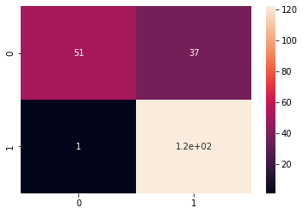

### train size : test size = 30% : 70%

In [ ]:



X_train, X_test, y_train, y_test = train_test_split(X, y, test_size=0.7, random_state=0)

In [ ]:



print(len(X_train)) print(len(y_test))

105

246

In [ ]:



sigmoid_SVC_classifier.fit(X_train, y_train)

Out[ ]:

SVC(C=1.0, break_ties=False, cache_size=200, class_weight=None, coef0=0.0, decision_function_shape='ovr', degree=3, gamma='scale', kernel='sigmoid', max_iter=-1, probability=False, random_state=None, shrinking=True, tol=0.001, verbose=False)

In [ ]:



y_pred = sigmoid_SVC_classifier.predict(X_test) print(f"Accuracy: {100 * accuracy_score(y_test,y_pred)}%\n") cf_matrix = confusion_matrix(y_test,y_pred) print("Confusion Matrix:\n", cf_matrix) print("\nClassification Report:\n") print(classification_report(y_test,y_pred))

Accuracy: 82.11382113821138%



Confusion Matrix:

[[ 56 44]

[ 0 146]]

Classification Report:

|  |  |  |  |  |
| --- | --- | --- | --- | --- |
|  | precision | recall | f1-score | support |
| b | 1.00 | 0.56 | 0.72 | 100 |
| g | 0.77 | 1.00 | 0.87 | 146 |
| accuracy |  |  | 0.82 | 246 |
| macro avg | 0.88 | 0.78 | 0.79 | 246 |
| weighted avg | 0.86 | 0.82 | 0.81 | 246 |

In [ ]:



sns.heatmap(cf_matrix, annot=True)

Out[ ]:

<matplotlib.axes._subplots.AxesSubplot at 0x7f0fc9476dd0>

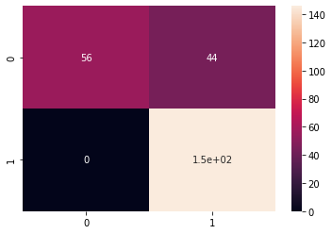

# MLP Classifier

In [ ]:



mlp_classifier = MLPClassifier(learning_rate='constant', max_iter=600) mlp_classifier

Out[ ]:

MLPClassifier(activation='relu', alpha=0.0001, batch_size='auto', beta_1=0.9, beta_2=0.999, early_stopping=False, epsilon=1e-08, hidden_layer_sizes=(100,), learning_rate='constant', learning_rate_init=0.001, max_fun=15000, max_iter=600, momentum=0.9, n_iter_no_change=10, nesterovs_momentum=True, power_t=0.5, random_state=None, shuffle=True, solver='adam', tol=0.0001, validation_fraction=0.1, verbose=False, warm_start=False)

### train size : test size = 70% : 30%

In [ ]:



X_train, X_test, y_train, y_test = train_test_split(X, y, test_size=0.3, random_state=0)

# 70% training data, 30% testing data

In [ ]:



print(len(X_train))





print(len(y_test))

245

106

In [ ]:



mlp_classifier.fit(X_train, y_train)

Out[ ]:

MLPClassifier(activation='relu', alpha=0.0001, batch_size='auto', beta_1=0.9, beta_2=0.999, early_stopping=False, epsilon=1e-08, hidden_layer_sizes=(100,), learning_rate='constant', learning_rate_init=0.001, max_fun=15000, max_iter=600, momentum=0.9, n_iter_no_change=10, nesterovs_momentum=True, power_t=0.5, random_state=None, shuffle=True, solver='adam', tol=0.0001, validation_fraction=0.1, verbose=False, warm_start=False)

In [ ]:



y_pred = mlp_classifier.predict(X_test)

print(f"Accuracy: {100 * accuracy_score(y_test,y_pred)}%\n") cf_matrix = confusion_matrix(y_test,y_pred) print("Confusion Matrix:\n")

print(cf_matrix) print("\nClassification Report:\n")

print(classification_report(y_test,y_pred))

Accuracy: 93.39622641509435%

Confusion Matrix:

[[37 7]

[ 0 62]]

Classification Report:

|  |  |  |  |  |
| --- | --- | --- | --- | --- |
|  | precision | recall | f1-score | support |
| b | 1.00 | 0.84 | 0.91 | 44 |
| g | 0.90 | 1.00 | 0.95 | 62 |
| accuracy |  |  | 0.93 | 106 |
| macro avg | 0.95 | 0.92 | 0.93 | 106 |
| weighted avg | 0.94 | 0.93 | 0.93 | 106 |

In [ ]:



sns.heatmap(cf_matrix, annot=True)

Out[ ]:

<matplotlib.axes._subplots.AxesSubplot at 0x7f0fc93b3250>

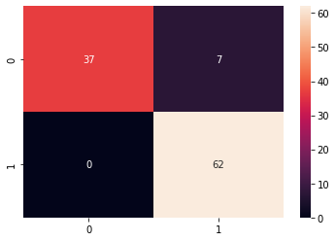



### train size : test size = 60% : 40%

In [ ]:



X_train, X_test, y_train, y_test = train_test_split(X, y, test_size=0.4, random_state=0)

# 60% training data, 40% testing data

In [ ]:



print(len(X_train)) print(len(y_test))

210

141

In [ ]:



mlp_classifier.fit(X_train, y_train)

Out[ ]:

MLPClassifier(activation='relu', alpha=0.0001, batch_size='auto', beta_1=0.9, beta_2=0.999, early_stopping=False, epsilon=1e-08, hidden_layer_sizes=(100,), learning_rate='constant', learning_rate_init=0.001, max_fun=15000, max_iter=600, momentum=0.9, n_iter_no_change=10, nesterovs_momentum=True, power_t=0.5, random_state=None, shuffle=True, solver='adam', tol=0.0001, validation_fraction=0.1, verbose=False, warm_start=False)

In [ ]:



y_pred = mlp_classifier.predict(X_test)

print(f"Accuracy: {100 * accuracy_score(y_test,y_pred)}%\n") cf_matrix = confusion_matrix(y_test,y_pred) print("Confusion Matrix:")

print(cf_matrix) print("\nClassification Report:\n")

print(classification_report(y_test,y_pred))

Accuracy: 90.0709219858156%

Confusion Matrix:

[[43 14]

[ 0 84]]

Classification Report:

|  |  |  |  |  |
| --- | --- | --- | --- | --- |
|  | precision | recall | f1-score | support |
| b | 1.00 | 0.75 | 0.86 | 57 |
| g | 0.86 | 1.00 | 0.92 | 84 |
| accuracy |  |  | 0.90 | 141 |
| macro avg | 0.93 | 0.88 | 0.89 | 141 |
| weighted avg | 0.91 | 0.90 | 0.90 | 141 |

In [ ]:



sns.heatmap(cf_matrix, annot=True)

Out[ ]:

<matplotlib.axes._subplots.AxesSubplot at 0x7f0fc9340950>

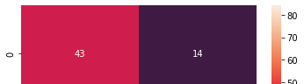

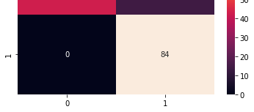

### train size : test size = 50% : 50%

In [ ]:



X_train, X_test, y_train, y_test = train_test_split(X, y, test_size=0.5, random_state=0)

# 50% training data, 50% testing data

In [ ]:



print(len(X_train)) print(len(y_test))

175

176

In [ ]:



mlp_classifier.fit(X_train, y_train)

Out[ ]:

MLPClassifier(activation='relu', alpha=0.0001, batch_size='auto', beta_1=0.9, beta_2=0.999, early_stopping=False, epsilon=1e-08, hidden_layer_sizes=(100,), learning_rate='constant', learning_rate_init=0.001, max_fun=15000, max_iter=600, momentum=0.9, n_iter_no_change=10, nesterovs_momentum=True, power_t=0.5, random_state=None, shuffle=True, solver='adam', tol=0.0001, validation_fraction=0.1, verbose=False, warm_start=False)

In [ ]:



y_pred = mlp_classifier.predict(X_test)

print(f"Accuracy: {100 * accuracy_score(y_test,y_pred)}%\n") cf_matrix = confusion_matrix(y_test,y_pred) print("Confusion Matrix:")

print(cf_matrix) print("\nClassification Report:\n")

print(classification_report(y_test,y_pred))

Accuracy: 85.79545454545455%

Confusion Matrix: [[ 50 25]

[ 0 101]]

Classification Report:

|  |  |  |  |  |
| --- | --- | --- | --- | --- |
|  | precision | recall | f1-score | support |
| b | 1.00 | 0.67 | 0.80 | 75 |
| g | 0.80 | 1.00 | 0.89 | 101 |
| accuracy |  |  | 0.86 | 176 |
| macro avg | 0.90 | 0.83 | 0.84 | 176 |
| weighted avg | 0.89 | 0.86 | 0.85 | 176 |

In [ ]:



sns.heatmap(cf_matrix, annot=True)



Out[ ]:

<matplotlib.axes._subplots.AxesSubplot at 0x7f0fc9277f50>

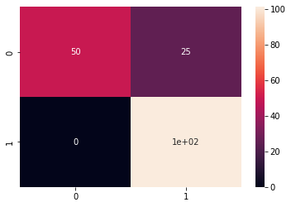

### train size : test size = 40% : 60%

In [ ]:



X_train, X_test, y_train, y_test = train_test_split(X, y, test_size=0.6, random_state=0)

In [ ]:



print(len(X_train)) print(len(y_test))

140

211

In [ ]:



mlp_classifier.fit(X_train, y_train)

Out[ ]:

MLPClassifier(activation='relu', alpha=0.0001, batch_size='auto', beta_1=0.9, beta_2=0.999, early_stopping=False, epsilon=1e-08, hidden_layer_sizes=(100,), learning_rate='constant', learning_rate_init=0.001, max_fun=15000, max_iter=600, momentum=0.9, n_iter_no_change=10, nesterovs_momentum=True, power_t=0.5, random_state=None, shuffle=True, solver='adam', tol=0.0001, validation_fraction=0.1, verbose=False, warm_start=False)

In [ ]:



y_pred = mlp_classifier.predict(X_test)

print(f"Accuracy: {100 * accuracy_score(y_test,y_pred)}%\n") cf_matrix = confusion_matrix(y_test,y_pred) print("Confusion Matrix:\n")

print(cf_matrix) print("\nClassification Report:\n")

print(classification_report(y_test,y_pred))

Accuracy: 84.36018957345972%

Confusion Matrix:

[[ 56 32]

[ 1 122]]

Classification Report:

precision recall f1-score support

|  |  |  |  |  |
| --- | --- | --- | --- | --- |
| b | 0.98 | 0.64 | 0.77 | 88 |
| g | 0.79 | 0.99 | 0.88 | 123 |
| accuracy |  |  | 0.84 | 211 |
| macro avg | 0.89 | 0.81 | 0.83 | 211 |
| weighted avg | 0.87 | 0.84 | 0.84 | 211 |



In [ ]:



sns.heatmap(cf_matrix, annot=True)

Out[ ]:

<matplotlib.axes._subplots.AxesSubplot at 0x7f0fc91ac8d0>

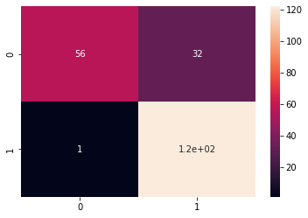

### train size : test size = 30% : 70%

In [ ]:



X_train, X_test, y_train, y_test = train_test_split(X, y, test_size=0.7, random_state=0)

In [ ]:



print(len(X_train)) print(len(y_test))

105

246

In [ ]:



mlp_classifier.fit(X_train, y_train)

Out[ ]:

MLPClassifier(activation='relu', alpha=0.0001, batch_size='auto', beta_1=0.9, beta_2=0.999, early_stopping=False, epsilon=1e-08, hidden_layer_sizes=(100,), learning_rate='constant', learning_rate_init=0.001, max_fun=15000, max_iter=600, momentum=0.9, n_iter_no_change=10, nesterovs_momentum=True, power_t=0.5, random_state=None, shuffle=True, solver='adam', tol=0.0001, validation_fraction=0.1, verbose=False, warm_start=False)

In [ ]:



y_pred = mlp_classifier.predict(X_test)

print(f"Accuracy: {100 * accuracy_score(y_test,y_pred)}%\n") cf_matrix = confusion_matrix(y_test,y_pred) print("Confusion Matrix:\n")

print(cf_matrix) print("\nClassification Report:\n")

print(classification_report(y_test,y_pred))

Accuracy: 84.5528455284553%



Confusion Matrix:

[[ 62 38]

[ 0 146]]

Classification Report:

|  |  |  |  |  |
| --- | --- | --- | --- | --- |
|  | precision | recall | f1-score | support |
| b | 1.00 | 0.62 | 0.77 | 100 |
| g | 0.79 | 1.00 | 0.88 | 146 |
| accuracy |  |  | 0.85 | 246 |
| macro avg | 0.90 | 0.81 | 0.83 | 246 |
| weighted avg | 0.88 | 0.85 | 0.84 | 246 |

In [ ]:



sns.heatmap(cf_matrix, annot=True)

Out[ ]:

<matplotlib.axes._subplots.AxesSubplot at 0x7f0fc90e4a50>

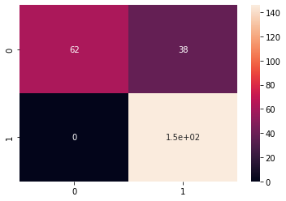

# Random Forest Classifier

In [ ]:



rfc_classifier = RandomForestClassifier(n_estimators=20) rfc_classifier

Out[ ]:

RandomForestClassifier(bootstrap=True, ccp_alpha=0.0, class_weight=None,

criterion='gini', max_depth=None, max_features='auto', max_leaf_nodes=None, max_samples=None, min_impurity_decrease=0.0, min_impurity_split=None, min_samples_leaf=1, min_samples_split=2, min_weight_fraction_leaf=0.0, n_estimators=20, n_jobs=None, oob_score=False, random_state=None, verbose=0, warm_start=False)

### train size : test size = 70% : 30%

In [ ]:



X_train, X_test, y_train, y_test = train_test_split(X, y, test_size=0.3, random_state=0)

# 70% training data, 30% testing data

In [ ]:





print(len(X_train)) print(len(y_test))

245

106

In [ ]:



rfc_classifier.fit(X_train, y_train)

Out[ ]:

RandomForestClassifier(bootstrap=True, ccp_alpha=0.0, class_weight=None,

criterion='gini', max_depth=None, max_features='auto', max_leaf_nodes=None, max_samples=None, min_impurity_decrease=0.0, min_impurity_split=None, min_samples_leaf=1, min_samples_split=2, min_weight_fraction_leaf=0.0, n_estimators=20, n_jobs=None, oob_score=False, random_state=None, verbose=0, warm_start=False)

In [ ]:



y_pred = rfc_classifier.predict(X_test)

print(f"Accuracy: {100 * accuracy_score(y_test,y_pred)}%\n") cf_matrix = confusion_matrix(y_test,y_pred) print("Confusion Matrix:\n")

print(cf_matrix) print("\nClassification Report:\n")

print(classification_report(y_test,y_pred))

Accuracy: 95.28301886792453%

Confusion Matrix:

[[41 3]

[ 2 60]]

Classification Report:

|  |  |  |  |  |
| --- | --- | --- | --- | --- |
|  | precision | recall | f1-score | support |
| b | 0.95 | 0.93 | 0.94 | 44 |
| g | 0.95 | 0.97 | 0.96 | 62 |
| accuracy |  |  | 0.95 | 106 |
| macro avg | 0.95 | 0.95 | 0.95 | 106 |
| weighted avg | 0.95 | 0.95 | 0.95 | 106 |

In [ ]:



sns.heatmap(cf_matrix, annot=True)

Out[ ]:

<matplotlib.axes._subplots.AxesSubplot at 0x7f0fc95aa750>

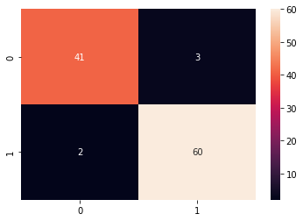



### train size : test size = 60% : 40%

In [ ]:



X_train, X_test, y_train, y_test = train_test_split(X, y, test_size=0.4, random_state=0)

# 60% training data, 40% testing data

In [ ]:



print(len(X_train)) print(len(y_test))

210

141

In [ ]:



rfc_classifier.fit(X_train, y_train)

Out[ ]:

RandomForestClassifier(bootstrap=True, ccp_alpha=0.0, class_weight=None,

criterion='gini', max_depth=None, max_features='auto', max_leaf_nodes=None, max_samples=None, min_impurity_decrease=0.0, min_impurity_split=None, min_samples_leaf=1, min_samples_split=2, min_weight_fraction_leaf=0.0, n_estimators=20, n_jobs=None, oob_score=False, random_state=None, verbose=0, warm_start=False)

In [ ]:



y_pred = rfc_classifier.predict(X_test)

print(f"Accuracy: {100 * accuracy_score(y_test,y_pred)}%\n") cf_matrix = confusion_matrix(y_test,y_pred) print("Confusion Matrix:")

print(cf_matrix) print("\nClassification Report:\n")

print(classification_report(y_test,y_pred))

Accuracy: 90.0709219858156%

Confusion Matrix:

[[45 12]

[ 2 82]]

Classification Report:

|  |  |  |  |  |
| --- | --- | --- | --- | --- |
|  | precision | recall | f1-score | support |
| b | 0.96 | 0.79 | 0.87 | 57 |
| g | 0.87 | 0.98 | 0.92 | 84 |
| accuracy |  |  | 0.90 | 141 |
| macro avg | 0.91 | 0.88 | 0.89 | 141 |
| weighted avg | 0.91 | 0.90 | 0.90 | 141 |

In [ ]:



sns.heatmap(cf_matrix, annot=True)

Out[ ]:

<matplotlib.axes._subplots.AxesSubplot at 0x7f0fc8f97410>

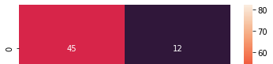

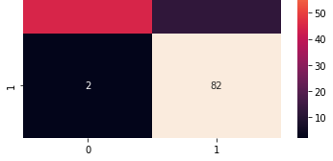

### train size : test size = 50% : 50%

In [ ]:



X_train, X_test, y_train, y_test = train_test_split(X, y, test_size=0.5, random_state=0)

# 50% training data, 50% testing data

In [ ]:



print(len(X_train)) print(len(y_test))

175

176

In [ ]:



rfc_classifier.fit(X_train, y_train)

Out[ ]:

RandomForestClassifier(bootstrap=True, ccp_alpha=0.0, class_weight=None,

criterion='gini', max_depth=None, max_features='auto', max_leaf_nodes=None, max_samples=None, min_impurity_decrease=0.0, min_impurity_split=None, min_samples_leaf=1, min_samples_split=2, min_weight_fraction_leaf=0.0, n_estimators=20, n_jobs=None, oob_score=False, random_state=None, verbose=0, warm_start=False)

In [ ]:



y_pred = rfc_classifier.predict(X_test)

print(f"Accuracy: {100 * accuracy_score(y_test,y_pred)}%\n") cf_matrix = confusion_matrix(y_test,y_pred) print("Confusion Matrix:")

print(cf_matrix) print("\nClassification Report:\n")

print(classification_report(y_test,y_pred))

Accuracy: 92.04545454545455%

Confusion Matrix: [[ 62 13]

[ 1 100]]

Classification Report:

|  |  |  |  |  |
| --- | --- | --- | --- | --- |
|  | precision | recall | f1-score | support |
| b | 0.98 | 0.83 | 0.90 | 75 |
| g | 0.88 | 0.99 | 0.93 | 101 |
| accuracy |  |  | 0.92 | 176 |
| macro avg | 0.93 | 0.91 | 0.92 | 176 |
| weighted avg | 0.93 | 0.92 | 0.92 | 176 |

In [ ]:





sns.heatmap(cf_matrix, annot=True)

Out[ ]:

<matplotlib.axes._subplots.AxesSubplot at 0x7f0fc8f42090>

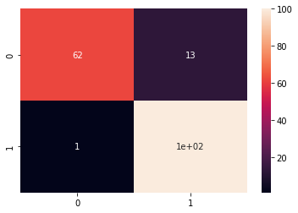

### train size : test size = 40% : 60%

In [ ]:



X_train, X_test, y_train, y_test = train_test_split(X, y, test_size=0.6, random_state=0)

In [ ]:



print(len(X_train)) print(len(y_test))

140

211

In [ ]:



rfc_classifier.fit(X_train, y_train)

Out[ ]:

RandomForestClassifier(bootstrap=True, ccp_alpha=0.0, class_weight=None,

criterion='gini', max_depth=None, max_features='auto', max_leaf_nodes=None, max_samples=None, min_impurity_decrease=0.0, min_impurity_split=None, min_samples_leaf=1, min_samples_split=2, min_weight_fraction_leaf=0.0, n_estimators=20, n_jobs=None, oob_score=False, random_state=None, verbose=0, warm_start=False)

In [ ]:



y_pred = rfc_classifier.predict(X_test)

print(f"Accuracy: {100 * accuracy_score(y_test,y_pred)}%\n") cf_matrix = confusion_matrix(y_test,y_pred) print("Confusion Matrix:\n")

print(cf_matrix) print("\nClassification Report:\n")

print(classification_report(y_test,y_pred))

Accuracy: 90.04739336492891%

Confusion Matrix:

[[ 75 13]

[ 8 115]]

Classification Report:

precision recall f1-score support



|  |  |  |  |  |
| --- | --- | --- | --- | --- |
| b | 0.90 | 0.85 | 0.88 | 88 |
| g | 0.90 | 0.93 | 0.92 | 123 |
| accuracy |  |  | 0.90 | 211 |
| macro avg | 0.90 | 0.89 | 0.90 | 211 |
| weighted avg | 0.90 | 0.90 | 0.90 | 211 |

In [ ]:



sns.heatmap(cf_matrix, annot=True)

Out[ ]:

<matplotlib.axes._subplots.AxesSubplot at 0x7f0fc8e6b350>

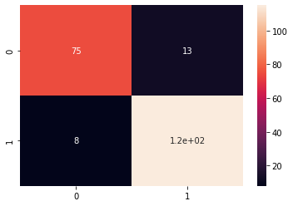

### train size : test size = 30% : 70%

In [ ]:



X_train, X_test, y_train, y_test = train_test_split(X, y, test_size=0.7, random_state=0)

In [ ]:



print(len(X_train)) print(len(y_test))

105

246

In [ ]:



rfc_classifier.fit(X_train, y_train)

Out[ ]:

RandomForestClassifier(bootstrap=True, ccp_alpha=0.0, class_weight=None,

criterion='gini', max_depth=None, max_features='auto', max_leaf_nodes=None, max_samples=None, min_impurity_decrease=0.0, min_impurity_split=None, min_samples_leaf=1, min_samples_split=2, min_weight_fraction_leaf=0.0, n_estimators=20, n_jobs=None, oob_score=False, random_state=None, verbose=0, warm_start=False)

In [ ]:



y_pred = rfc_classifier.predict(X_test)

print(f"Accuracy: {100 * accuracy_score(y_test,y_pred)}%\n") cf_matrix = confusion_matrix(y_test,y_pred) print("Confusion Matrix:\n")

print(cf_matrix) print("\nClassification Report:\n")

print(classification_report(y_test,y_pred))

Accuracy: 89.83739837398373%

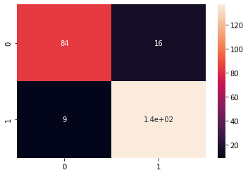

Confusion Matrix:

[[ 84 16]

[ 9 137]]

Classification Report:

|  |  |  |  |  |
| --- | --- | --- | --- | --- |
|  | precision | recall | f1-score | support |
| b | 0.90 | 0.84 | 0.87 | 100 |
| g | 0.90 | 0.94 | 0.92 | 146 |
| accuracy |  |  | 0.90 | 246 |
| macro avg | 0.90 | 0.89 | 0.89 | 246 |
| weighted avg | 0.90 | 0.90 | 0.90 | 246 |

In [ ]:

sns.heatmap(cf_matrix, annot=True) Out[ ]:

<matplotlib.axes._subplots.AxesSubplot at 0x7f0fc8df4810>

Name : Anmol Raj



Roll no : 001811001069

***WINE DATASET***

# Importing modules

In [1]:

import numpy as np import pandas as pd

from sklearn import datasets

from sklearn.metrics import accuracy_score, classification_report, confusion_matrix from sklearn.model_selection import train_test_split

from sklearn.svm import SVC import seaborn as sns

from sklearn.neural_network import MLPClassifier from sklearn.ensemble import RandomForestClassifier

# Load Dataset

In [2]:

wine = datasets.load_wine() # it's source is same as : https://archive.ics.uci.edu/ml/dat asets/wine

In [3]:

dir(wine) Out[3]:

['DESCR', 'data', 'feature_names', 'target', 'target_names']

|  |  |  |  |  |
| --- | --- | --- | --- | --- |
| In [4]: |  | | | |
| wine.data |
| Out[4]: |
| array([[1.423e+01, 1.710e+00, | 2.430e+00, | ..., | 1.040e+00, | 3.920e+00, |
| 1.065e+03], |  |  |  |  |
| [1.320e+01, 1.780e+00, | 2.140e+00, | ..., | 1.050e+00, | 3.400e+00, |
| 1.050e+03], |  |  |  |  |
| [1.316e+01, 2.360e+00, | 2.670e+00, | ..., | 1.030e+00, | 3.170e+00, |
| 1.185e+03], |  |  |  |  |
| ..., |  |  |  |  |
| [1.327e+01, 4.280e+00, | 2.260e+00, | ..., | 5.900e-01, | 1.560e+00, |
| 8.350e+02], |  |  |  |  |
| [1.317e+01, 2.590e+00, | 2.370e+00, | ..., | 6.000e-01, | 1.620e+00, |
| 8.400e+02], |  |  |  |  |
| [1.413e+01, 4.100e+00, | 2.740e+00, | ..., | 6.100e-01, | 1.600e+00, |
| 5.600e+02]]) |  |  |  |  |

In [5]:

print(wine.feature_names) print(wine.target_names) print(wine.target)

['alcohol', 'malic_acid', 'ash', 'alcalinity_of_ash', 'magnesium', 'total_phenols', 'flav anoids', 'nonflavanoid_phenols', 'proanthocyanins', 'color_intensity', 'hue', 'od280/od31 5_of_diluted_wines', 'proline']

['class_0' 'class_1' 'class_2']

[0 0 0 0 0 0 0 0 0 0 0 0 0 0 0 0 0 0 0 0 0 0 0 0 0 0 0 0 0 0 0 0 0 0 0 0 0

0 0 0 0 0 0 0 0 0 0 0 0 0 0 0 0 0 0 0 0 0 0 1 1 1 1 1 1 1 1 1 1 1 1 1 1 1

1 1 1 1 1 1 1 1 1 1 1 1 1 1 1 1 1 1 1 1 1 1 1 1 1 1 1 1 1 1 1 1 1 1 1 1 1

1 1 1 1 1 1 1 1 1 1 1 1 1 1 1 1 1 1 1 2 2 2 2 2 2 2 2 2 2 2 2 2 2 2 2 2 2

2 2 2 2 2 2 2 2 2 2 2 2 2 2 2 2 2 2 2 2 2 2 2 2 2 2 2 2 2 2]

In [6]:



df = pd.DataFrame(data=wine.data, columns=wine.feature_names) df.head()

Out[6]:

|  |  |  |  |  |  |  |  |  |  |
| --- | --- | --- | --- | --- | --- | --- | --- | --- | --- |
| **alcohol** | **malic_acid** | **ash** | **alcalinity_of_ash** | **magnesium** | **total_phenols** | **flavanoids** | **nonflavanoid_phenols** | **proanthocyanins** | c |
| **0** 14.23 | 1.71 | 2.43 | 15.6 | 127.0 | 2.80 | 3.06 | 0.28 | 2.29 |  |
| **1** 13.20 | 1.78 | 2.14 | 11.2 | 100.0 | 2.65 | 2.76 | 0.26 | 1.28 |  |
| **2** 13.16 | 2.36 | 2.67 | 18.6 | 101.0 | 2.80 | 3.24 | 0.30 | 2.81 |  |
| **3** 14.37 | 1.95 | 2.50 | 16.8 | 113.0 | 3.85 | 3.49 | 0.24 | 2.18 |  |
| **4** 13.24 | 2.59 | 2.87 | 21.0 | 118.0 | 2.80 | 2.69 | 0.39 | 1.82 |  |

|  |  |  |
| --- | --- | --- |
|  |  |  |

In [7]:



df["target"] = wine.target df.head()

Out[7]:

|  |  |  |  |  |  |  |  |  |  |
| --- | --- | --- | --- | --- | --- | --- | --- | --- | --- |
| **alcohol** | **malic_acid** | **ash** | **alcalinity_of_ash** | **magnesium** | **total_phenols** | **flavanoids** | **nonflavanoid_phenols** | **proanthocyanins** | c |
| **0** 14.23 | 1.71 | 2.43 | 15.6 | 127.0 | 2.80 | 3.06 | 0.28 | 2.29 |  |
| **1** 13.20 | 1.78 | 2.14 | 11.2 | 100.0 | 2.65 | 2.76 | 0.26 | 1.28 |  |
| **2** 13.16 | 2.36 | 2.67 | 18.6 | 101.0 | 2.80 | 3.24 | 0.30 | 2.81 |  |
| **3** 14.37 | 1.95 | 2.50 | 16.8 | 113.0 | 3.85 | 3.49 | 0.24 | 2.18 |  |
| **4** 13.24 | 2.59 | 2.87 | 21.0 | 118.0 | 2.80 | 2.69 | 0.39 | 1.82 |  |

|  |  |  |
| --- | --- | --- |
|  |  |  |

In [8]:



wine.target_names

Out[8]:

array(['class_0', 'class_1', 'class_2'], dtype='<U7')

# DataFrame ready to perform

In [9]:



len(df)

Out[9]: 178

In [10]:



X = df.drop(["target"], axis="columns") y = df.target

print(X.head())

print(y.head())

|  |  |  |  |
| --- | --- | --- | --- |
| alcohol | malic_acid ash ... hue | od280/od315_of_diluted_wines | proline |
| 0 14.23 | 1.71 2.43 ... 1.04 | 3.92 | 1065.0 |
| 1 13.20 | 1.78 2.14 ... 1.05 | 3.40 | 1050.0 |
| 2 13.16 | 2.36 2.67 ... 1.03 | 3.17 | 1185.0 |

|  |  |  |  |  |
| --- | --- | --- | --- | --- |
| 3 | 14.37 | 1.95 2.50 ... 0.86 | 3.45 | 1480.0 |
| 4 | 13.24 | 2.59 2.87 ... 1.04 | 2.93 | 735.0 |
| [5 | rows x 13 columns] | | | |
| 0 | 0 | | | |
| 1 | 0 | | | |
| 2 | 0 | | | |
| 3 | 0 | | | |
| 4 | 0 | | | |

Name: target, dtype: int64



# SVC Classfier

## Linear SVC Classifier

In [11]:

linear_SVC_classifier = SVC(kernel='linear') linear_SVC_classifier

Out[11]:

SVC(C=1.0, break_ties=False, cache_size=200, class_weight=None, coef0=0.0, decision_function_shape='ovr', degree=3, gamma='scale', kernel='linear', max_iter=-1, probability=False, random_state=None, shrinking=True, tol=0.001, verbose=False)

### train size : test size = 70% : 30%

In [12]:

X_train, X_test, y_train, y_test = train_test_split(X, y, test_size=0.3, random_state=0)

#### # 70% training data, 30% testing data

In [13]:

print(len(X_train)) print(len(y_test))

124

54

In [14]:

linear_SVC_classifier.fit(X_train, y_train) Out[14]:

SVC(C=1.0, break_ties=False, cache_size=200, class_weight=None, coef0=0.0, decision_function_shape='ovr', degree=3, gamma='scale', kernel='linear', max_iter=-1, probability=False, random_state=None, shrinking=True, tol=0.001, verbose=False)

In [15]:

y_pred = linear_SVC_classifier.predict(X_test) print(f"Accuracy: {100 * accuracy_score(y_test,y_pred)}%\n") cf_matrix = confusion_matrix(y_test,y_pred) print("Confusion Matrix:\n")

print(cf_matrix) print("\nClassification Report:\n")

print(classification_report(y_test,y_pred)) Accuracy: 98.14814814814815%

Confusion Matrix:

[[19 0 0]

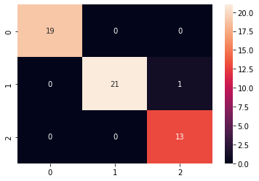

[ 0 21 1]

[ 0 0 13]]

Classification Report:

|  |  |  |  |  |
| --- | --- | --- | --- | --- |
|  | precision | recall | f1-score | support |
| 0 | 1.00 | 1.00 | 1.00 | 19 |
| 1 | 1.00 | 0.95 | 0.98 | 22 |
| 2 | 0.93 | 1.00 | 0.96 | 13 |
| accuracy |  |  | 0.98 | 54 |
| macro avg | 0.98 | 0.98 | 0.98 | 54 |
| weighted avg | 0.98 | 0.98 | 0.98 | 54 |

In [16]:

sns.heatmap(cf_matrix, annot=True) Out[16]:

<matplotlib.axes._subplots.AxesSubplot at 0x7f5e43120550>

### train size : test size = 60% : 40%

In [17]:

X_train, X_test, y_train, y_test = train_test_split(X, y, test_size=0.4, random_state=0)

#### # 60% training data, 40% testing data

In [18]:

print(len(X_train)) print(len(y_test))

106

72

In [19]:

linear_SVC_classifier.fit(X_train, y_train) Out[19]:

SVC(C=1.0, break_ties=False, cache_size=200, class_weight=None, coef0=0.0, decision_function_shape='ovr', degree=3, gamma='scale', kernel='linear', max_iter=-1, probability=False, random_state=None, shrinking=True, tol=0.001, verbose=False)

In [20]:

y_pred = linear_SVC_classifier.predict(X_test) print(f"Accuracy: {100 * accuracy_score(y_test,y_pred)}%\n")





cf_matrix = confusion_matrix(y_test,y_pred) print("Confusion Matrix:")

print(cf_matrix) print("\nClassification Report:\n")

print(classification_report(y_test,y_pred))

Accuracy: 95.83333333333334%

Confusion Matrix:

[[22 0 0]

[ 0 28 3]

[ 0 0 19]]

Classification Report:

|  |  |  |  |  |
| --- | --- | --- | --- | --- |
|  | precision | recall | f1-score | support |
| 0 | 1.00 | 1.00 | 1.00 | 22 |
| 1 | 1.00 | 0.90 | 0.95 | 31 |
| 2 | 0.86 | 1.00 | 0.93 | 19 |
| accuracy |  |  | 0.96 | 72 |
| macro avg | 0.95 | 0.97 | 0.96 | 72 |
| weighted avg | 0.96 | 0.96 | 0.96 | 72 |

In [21]:



sns.heatmap(cf_matrix, annot=True)

Out[21]:

<matplotlib.axes._subplots.AxesSubplot at 0x7f5e20c82a50>

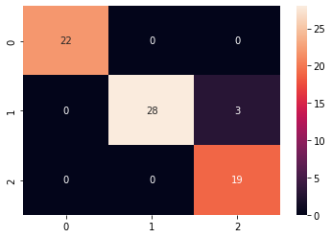

### train size : test size = 50% : 50%

In [22]:



X_train, X_test, y_train, y_test = train_test_split(X, y, test_size=0.5, random_state=0)

# 50% training data, 50% testing data

In [23]:



print(len(X_train)) print(len(y_test))

89

89

In [24]:



linear_SVC_classifier.fit(X_train, y_train)

Out[24]:

SVC(C=1.0, break_ties=False, cache_size=200, class_weight=None, coef0=0.0,

decision_function_shape='ovr', degree=3, gamma='scale', kernel='linear', max_iter=-1, probability=False, random_state=None, shrinking=True, tol=0.001, verbose=False)

In [25]:



y_pred = linear_SVC_classifier.predict(X_test) print(f"Accuracy: {100 * accuracy_score(y_test,y_pred)}%\n") cf_matrix = confusion_matrix(y_test,y_pred) print("Confusion Matrix:")

print(cf_matrix) print("\nClassification Report:\n")

print(classification_report(y_test,y_pred))

Accuracy: 92.13483146067416%

Confusion Matrix:

[[25 0 0]

[ 3 34 3]

[ 1 0 23]]

Classification Report:

|  |  |  |  |  |
| --- | --- | --- | --- | --- |
|  | precision | recall | f1-score | support |
| 0 | 0.86 | 1.00 | 0.93 | 25 |
| 1 | 1.00 | 0.85 | 0.92 | 40 |
| 2 | 0.88 | 0.96 | 0.92 | 24 |
| accuracy |  |  | 0.92 | 89 |
| macro avg | 0.92 | 0.94 | 0.92 | 89 |
| weighted avg | 0.93 | 0.92 | 0.92 | 89 |

In [26]:



sns.heatmap(cf_matrix, annot=True)

Out[26]:

<matplotlib.axes._subplots.AxesSubplot at 0x7f5e20c2b590>

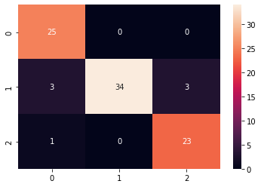

### train size : test size = 40% : 60%

In [27]:



X_train, X_test, y_train, y_test = train_test_split(X, y, test_size=0.6, random_state=0)

In [28]:



print(len(X_train)) print(len(y_test))

71

107

In [29]:

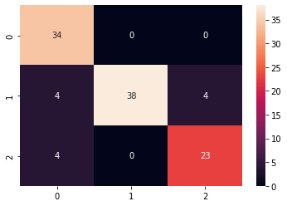

linear_SVC_classifier.fit(X_train, y_train) Out[29]:

SVC(C=1.0, break_ties=False, cache_size=200, class_weight=None, coef0=0.0, decision_function_shape='ovr', degree=3, gamma='scale', kernel='linear', max_iter=-1, probability=False, random_state=None, shrinking=True, tol=0.001, verbose=False)

In [30]:

y_pred = linear_SVC_classifier.predict(X_test) print(f"Accuracy: {100 * accuracy_score(y_test,y_pred)}%\n") cf_matrix = confusion_matrix(y_test,y_pred) print("Confusion Matrix:\n")

print(cf_matrix) print("\nClassification Report:\n")

print(classification_report(y_test,y_pred)) Accuracy: 88.78504672897196%

Confusion Matrix:

[[34 0 0]

[ 4 38 4]

[ 4 0 23]]

Classification Report:

|  |  |  |  |  |
| --- | --- | --- | --- | --- |
|  | precision | recall | f1-score | support |
| 0 | 0.81 | 1.00 | 0.89 | 34 |
| 1 | 1.00 | 0.83 | 0.90 | 46 |
| 2 | 0.85 | 0.85 | 0.85 | 27 |
| accuracy |  |  | 0.89 | 107 |
| macro avg | 0.89 | 0.89 | 0.88 | 107 |
| weighted avg | 0.90 | 0.89 | 0.89 | 107 |

In [31]:

sns.heatmap(cf_matrix, annot=True) Out[31]:

<matplotlib.axes._subplots.AxesSubplot at 0x7f5e20b034d0>

### train size : test size = 30% : 70%

In [32]:

X_train, X_test, y_train, y_test = train_test_split(X, y, test_size=0.7, random_state=0)

In [33]:

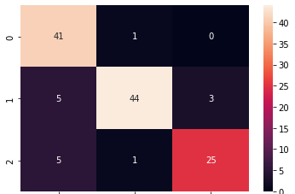

print(len(X_train)) print(len(y_test))

53

125

In [34]:

linear_SVC_classifier.fit(X_train, y_train) Out[34]:

SVC(C=1.0, break_ties=False, cache_size=200, class_weight=None, coef0=0.0, decision_function_shape='ovr', degree=3, gamma='scale', kernel='linear', max_iter=-1, probability=False, random_state=None, shrinking=True, tol=0.001, verbose=False)

In [35]:

y_pred = linear_SVC_classifier.predict(X_test) print(f"Accuracy: {100 * accuracy_score(y_test,y_pred)}%\n") cf_matrix = confusion_matrix(y_test,y_pred) print("Confusion Matrix:\n")

print(cf_matrix) print("\nClassification Report:\n")

print(classification_report(y_test,y_pred)) Accuracy: 88.0%

Confusion Matrix:

[[41 1 0]

[ 5 44 3]

[ 5 1 25]]

Classification Report:

|  |  |  |  |  |
| --- | --- | --- | --- | --- |
|  | precision | recall | f1-score | support |
| 0 | 0.80 | 0.98 | 0.88 | 42 |
| 1 | 0.96 | 0.85 | 0.90 | 52 |
| 2 | 0.89 | 0.81 | 0.85 | 31 |
| accuracy |  |  | 0.88 | 125 |
| macro avg | 0.88 | 0.88 | 0.88 | 125 |
| weighted avg | 0.89 | 0.88 | 0.88 | 125 |

In [36]:

sns.heatmap(cf_matrix, annot=True) Out[36]:

<matplotlib.axes._subplots.AxesSubplot at 0x7f5e20a402d0>



## Polynomial SVC Classifier

In [37]:



poly_SVC_classifier = SVC(kernel='poly') poly_SVC_classifier

Out[37]:

SVC(C=1.0, break_ties=False, cache_size=200, class_weight=None, coef0=0.0, decision_function_shape='ovr', degree=3, gamma='scale', kernel='poly', max_iter=-1, probability=False, random_state=None, shrinking=True, tol=0.001, verbose=False)

### train size : test size = 70% : 30%

In [38]:



X_train, X_test, y_train, y_test = train_test_split(X, y, test_size=0.3, random_state=0)

In [39]:



print(len(X_train)) print(len(y_test))

124

54

In [40]:



poly_SVC_classifier.fit(X_train, y_train)

Out[40]:

SVC(C=1.0, break_ties=False, cache_size=200, class_weight=None, coef0=0.0, decision_function_shape='ovr', degree=3, gamma='scale', kernel='poly', max_iter=-1, probability=False, random_state=None, shrinking=True, tol=0.001, verbose=False)

In [41]:



y_pred = poly_SVC_classifier.predict(X_test) print(f"Accuracy: {100 * accuracy_score(y_test,y_pred)}%\n") cf_matrix = confusion_matrix(y_test,y_pred) print("Confusion Matrix:\n", cf_matrix) print("\nClassification Report:\n") print(classification_report(y_test,y_pred))

Accuracy: 74.07407407407408%

Confusion Matrix: [[15 1 3]

[ 1 21 0]

[ 0 9 4]]

Classification Report:

|  |  |  |  |  |
| --- | --- | --- | --- | --- |
|  | precision | recall | f1-score | support |
| 0 | 0.94 | 0.79 | 0.86 | 19 |
| 1 | 0.68 | 0.95 | 0.79 | 22 |
| 2 | 0.57 | 0.31 | 0.40 | 13 |
| accuracy |  |  | 0.74 | 54 |
| macro avg | 0.73 | 0.68 | 0.68 | 54 |
| weighted avg | 0.74 | 0.74 | 0.72 | 54 |

In [42]:

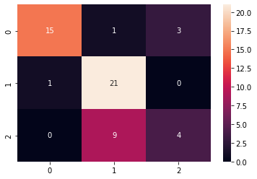

sns.heatmap(cf_matrix, annot=True) Out[42]:

<matplotlib.axes._subplots.AxesSubplot at 0x7f5e209ea350>

### train size : test size = 60% : 40%

In [43]:

X_train, X_test, y_train, y_test = train_test_split(X, y, test_size=0.4, random_state=0)

In [44]:

print(len(X_train)) print(len(y_test))

106

72

In [45]:

poly_SVC_classifier.fit(X_train, y_train) Out[45]:

SVC(C=1.0, break_ties=False, cache_size=200, class_weight=None, coef0=0.0, decision_function_shape='ovr', degree=3, gamma='scale', kernel='poly', max_iter=-1, probability=False, random_state=None, shrinking=True, tol=0.001, verbose=False)

In [46]:

y_pred = poly_SVC_classifier.predict(X_test) print(f"Accuracy: {100 * accuracy_score(y_test,y_pred)}%\n") cf_matrix = confusion_matrix(y_test,y_pred) print("Confusion Matrix:\n", cf_matrix) print("\nClassification Report:\n") print(classification_report(y_test,y_pred))

Accuracy: 65.27777777777779%

Confusion Matrix: [[18 4 0]

[ 2 29 0]

[ 0 19 0]]

Classification Report:

|  |  |  |  |  |
| --- | --- | --- | --- | --- |
|  | precision | recall | f1-score | support |
| 0 | 0.90 | 0.82 | 0.86 | 22 |
| 1 | 0.56 | 0.94 | 0.70 | 31 |

|  |  |  |  |  |
| --- | --- | --- | --- | --- |
| 2 | 0.00 | 0.00 | 0.00 | 19 |
| accuracy |  |  | 0.65 | 72 |
| macro avg | 0.49 | 0.58 | 0.52 | 72 |
| weighted avg | 0.52 | 0.65 | 0.56 | 72 |



/usr/local/lib/python3.7/dist-packages/sklearn/metrics/_classification.py:1272: Undefined MetricWarning: Precision and F-score are ill-defined and being set to 0.0 in labels with no predicted samples. Use `zero_division` parameter to control this behavior.

_warn_prf(average, modifier, msg_start, len(result))

In [47]:



sns.heatmap(cf_matrix, annot=True)

Out[47]:

<matplotlib.axes._subplots.AxesSubplot at 0x7f5e208806d0>

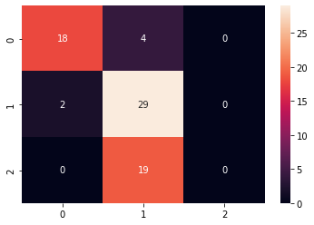

### train size : test size = 50% : 50%

In [48]:



X_train, X_test, y_train, y_test = train_test_split(X, y, test_size=0.5, random_state=0)

In [49]:



print(len(X_train)) print(len(y_test))

89

89

In [50]:



poly_SVC_classifier.fit(X_train, y_train)

Out[50]:

SVC(C=1.0, break_ties=False, cache_size=200, class_weight=None, coef0=0.0, decision_function_shape='ovr', degree=3, gamma='scale', kernel='poly', max_iter=-1, probability=False, random_state=None, shrinking=True, tol=0.001, verbose=False)

In [51]:



y_pred = poly_SVC_classifier.predict(X_test) print(f"Accuracy: {100 * accuracy_score(y_test,y_pred)}%\n") cf_matrix = confusion_matrix(y_test,y_pred) print("Confusion Matrix:\n", cf_matrix) print("\nClassification Report:\n") print(classification_report(y_test,y_pred))

Accuracy: 70.78651685393258%

Confusion Matrix:

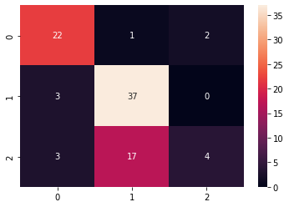

[[22 1 2]

[ 3 37 0]

[ 3 17 4]]

Classification Report:

|  |  |  |  |  |
| --- | --- | --- | --- | --- |
|  | precision | recall | f1-score | support |
| 0 | 0.79 | 0.88 | 0.83 | 25 |
| 1 | 0.67 | 0.93 | 0.78 | 40 |
| 2 | 0.67 | 0.17 | 0.27 | 24 |
| accuracy |  |  | 0.71 | 89 |
| macro avg | 0.71 | 0.66 | 0.63 | 89 |
| weighted avg | 0.70 | 0.71 | 0.66 | 89 |

In [52]:

sns.heatmap(cf_matrix, annot=True) Out[52]:

<matplotlib.axes._subplots.AxesSubplot at 0x7f5e20828dd0>

### train size : test size = 40% : 60%

In [53]:

X_train, X_test, y_train, y_test = train_test_split(X, y, test_size=0.6, random_state=0)

In [54]:

print(len(X_train)) print(len(y_test))

71

107

In [55]:

poly_SVC_classifier.fit(X_train, y_train) Out[55]:

SVC(C=1.0, break_ties=False, cache_size=200, class_weight=None, coef0=0.0, decision_function_shape='ovr', degree=3, gamma='scale', kernel='poly', max_iter=-1, probability=False, random_state=None, shrinking=True, tol=0.001, verbose=False)

In [56]:

y_pred = poly_SVC_classifier.predict(X_test) print(f"Accuracy: {100 * accuracy_score(y_test,y_pred)}%\n")

cf_matrix = confusion_matrix(y_test,y_pred) print("Confusion Matrix:\n", cf_matrix) print("\nClassification Report:\n") print(classification_report(y_test,y_pred))

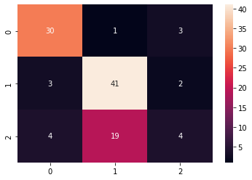

Accuracy: 70.09345794392523%

Confusion Matrix:

[[30 1 3]

[ 3 41 2]

[ 4 19 4]]

Classification Report:

|  |  |  |  |  |
| --- | --- | --- | --- | --- |
|  | precision | recall | f1-score | support |
| 0 | 0.81 | 0.88 | 0.85 | 34 |
| 1 | 0.67 | 0.89 | 0.77 | 46 |
| 2 | 0.44 | 0.15 | 0.22 | 27 |
| accuracy |  |  | 0.70 | 107 |
| macro avg | 0.64 | 0.64 | 0.61 | 107 |
| weighted avg | 0.66 | 0.70 | 0.65 | 107 |

In [57]:

sns.heatmap(cf_matrix, annot=True) Out[57]:

<matplotlib.axes._subplots.AxesSubplot at 0x7f5e20763e10>

### train size : test size = 30% : 70%

In [58]:

X_train, X_test, y_train, y_test = train_test_split(X, y, test_size=0.7, random_state=0)

In [59]:

print(len(X_train)) print(len(y_test))

53

125

In [60]:

poly_SVC_classifier.fit(X_train, y_train) Out[60]:

SVC(C=1.0, break_ties=False, cache_size=200, class_weight=None, coef0=0.0, decision_function_shape='ovr', degree=3, gamma='scale', kernel='poly', max_iter=-1, probability=False, random_state=None, shrinking=True,

tol=0.001, verbose=False)

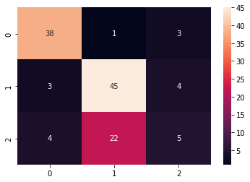

In [61]:

y_pred = poly_SVC_classifier.predict(X_test) print(f"Accuracy: {100 * accuracy_score(y_test,y_pred)}%\n") cf_matrix = confusion_matrix(y_test,y_pred) print("Confusion Matrix:\n", cf_matrix) print("\nClassification Report:\n") print(classification_report(y_test,y_pred))

Accuracy: 70.39999999999999%

Confusion Matrix:

[[38 1 3]

[ 3 45 4]

[ 4 22 5]]

Classification Report:

|  |  |  |  |  |
| --- | --- | --- | --- | --- |
|  | precision | recall | f1-score | support |
| 0 | 0.84 | 0.90 | 0.87 | 42 |
| 1 | 0.66 | 0.87 | 0.75 | 52 |
| 2 | 0.42 | 0.16 | 0.23 | 31 |
| accuracy |  |  | 0.70 | 125 |
| macro avg | 0.64 | 0.64 | 0.62 | 125 |
| weighted avg | 0.66 | 0.70 | 0.66 | 125 |

In [62]:

sns.heatmap(cf_matrix, annot=True) Out[62]:

<matplotlib.axes._subplots.AxesSubplot at 0x7f5e2069f6d0>

## Gaussain SVC Classifier

In [63]:

gaussain_SVC_classifier = SVC(kernel='rbf') gaussain_SVC_classifier

Out[63]:

SVC(C=1.0, break_ties=False, cache_size=200, class_weight=None, coef0=0.0, decision_function_shape='ovr', degree=3, gamma='scale', kernel='rbf', max_iter=-1, probability=False, random_state=None, shrinking=True, tol=0.001, verbose=False)

### train size : test size = 70% : 30%



In [64]:



X_train, X_test, y_train, y_test = train_test_split(X, y, test_size=0.3, random_state=0)

In [65]:



print(len(X_train)) print(len(y_test))

124

54

In [66]:



gaussain_SVC_classifier.fit(X_train, y_train)

Out[66]:

SVC(C=1.0, break_ties=False, cache_size=200, class_weight=None, coef0=0.0, decision_function_shape='ovr', degree=3, gamma='scale', kernel='rbf', max_iter=-1, probability=False, random_state=None, shrinking=True, tol=0.001, verbose=False)

In [67]:



y_pred = gaussain_SVC_classifier.predict(X_test) print(f"Accuracy: {100 * accuracy_score(y_test,y_pred)}%\n") cf_matrix = confusion_matrix(y_test,y_pred) print("Confusion Matrix:\n", cf_matrix) print("\nClassification Report:\n") print(classification_report(y_test,y_pred))

Accuracy: 77.77777777777779%

Confusion Matrix:

[[17 0 2]

[ 1 20 1]

[ 1 7 5]]

Classification Report:

|  |  |  |  |  |
| --- | --- | --- | --- | --- |
|  | precision | recall | f1-score | support |
| 0 | 0.89 | 0.89 | 0.89 | 19 |
| 1 | 0.74 | 0.91 | 0.82 | 22 |
| 2 | 0.62 | 0.38 | 0.48 | 13 |
| accuracy |  |  | 0.78 | 54 |
| macro avg | 0.75 | 0.73 | 0.73 | 54 |
| weighted avg | 0.77 | 0.78 | 0.76 | 54 |

In [68]:



sns.heatmap(cf_matrix, annot=True)

Out[68]:

<matplotlib.axes._subplots.AxesSubplot at 0x7f5e205db9d0>

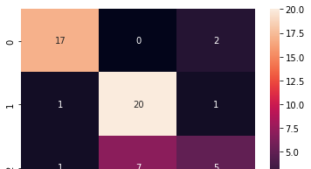

### train size : test size = 60% : 40%



In [69]:

X_train, X_test, y_train, y_test = train_test_split(X, y, test_size=0.4, random_state=0)

In [70]:

print(len(X_train)) print(len(y_test))

106

72

In [71]:

gaussain_SVC_classifier.fit(X_train, y_train) Out[71]:

SVC(C=1.0, break_ties=False, cache_size=200, class_weight=None, coef0=0.0, decision_function_shape='ovr', degree=3, gamma='scale', kernel='rbf', max_iter=-1, probability=False, random_state=None, shrinking=True, tol=0.001, verbose=False)

In [72]:

y_pred = gaussain_SVC_classifier.predict(X_test) print(f"Accuracy: {100 * accuracy_score(y_test,y_pred)}%\n") cf_matrix = confusion_matrix(y_test,y_pred) print("Confusion Matrix:\n", cf_matrix) print("\nClassification Report:\n") print(classification_report(y_test,y_pred))

Accuracy: 68.05555555555556%

Confusion Matrix:

[[20 2 0]

[ 2 29 0]

[ 3 16 0]]

Classification Report:

|  |  |  |  |  |
| --- | --- | --- | --- | --- |
|  | precision | recall | f1-score | support |
| 0 | 0.80 | 0.91 | 0.85 | 22 |
| 1 | 0.62 | 0.94 | 0.74 | 31 |
| 2 | 0.00 | 0.00 | 0.00 | 19 |
| accuracy |  |  | 0.68 | 72 |
| macro avg | 0.47 | 0.61 | 0.53 | 72 |
| weighted avg | 0.51 | 0.68 | 0.58 | 72 |

/usr/local/lib/python3.7/dist-packages/sklearn/metrics/_classification.py:1272: Undefined MetricWarning: Precision and F-score are ill-defined and being set to 0.0 in labels with no predicted samples. Use `zero_division` parameter to control this behavior.

_warn_prf(average, modifier, msg_start, len(result))

In [73]:

sns.heatmap(cf_matrix, annot=True) Out[73]:

<matplotlib.axes._subplots.AxesSubplot at 0x7f5e2051e450>

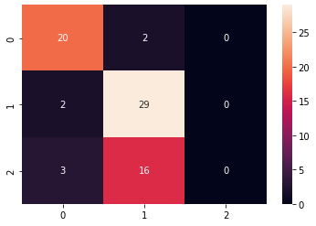

### train size : test size = 50% : 50%

In [74]:

X_train, X_test, y_train, y_test = train_test_split(X, y, test_size=0.5, random_state=0)

In [75]:

print(len(X_train)) print(len(y_test))

89

89

In [76]:

gaussain_SVC_classifier.fit(X_train, y_train) Out[76]:

SVC(C=1.0, break_ties=False, cache_size=200, class_weight=None, coef0=0.0, decision_function_shape='ovr', degree=3, gamma='scale', kernel='rbf', max_iter=-1, probability=False, random_state=None, shrinking=True, tol=0.001, verbose=False)

In [77]:

y_pred = gaussain_SVC_classifier.predict(X_test) print(f"Accuracy: {100 * accuracy_score(y_test,y_pred)}%\n") cf_matrix = confusion_matrix(y_test,y_pred) print("Confusion Matrix:\n", cf_matrix) print("\nClassification Report:\n") print(classification_report(y_test,y_pred))

Accuracy: 67.41573033707866%

Confusion Matrix: [[22 2 1]

[ 3 37 0]

[ 3 20 1]]

Classification Report:

|  |  |  |  |  |
| --- | --- | --- | --- | --- |
|  | precision | recall | f1-score | support |
| 0 | 0.79 | 0.88 | 0.83 | 25 |
| 1 | 0.63 | 0.93 | 0.75 | 40 |
| 2 | 0.50 | 0.04 | 0.08 | 24 |
| accuracy |  |  | 0.67 | 89 |
| macro avg | 0.64 | 0.62 | 0.55 | 89 |
| weighted avg | 0.64 | 0.67 | 0.59 | 89 |

In [78]:

sns.heatmap(cf_matrix, annot=True) Out[78]:

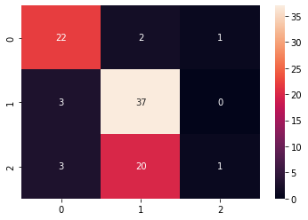

<matplotlib.axes._subplots.AxesSubplot at 0x7f5e205651d0>

### train size : test size = 40% : 60%

In [79]:

X_train, X_test, y_train, y_test = train_test_split(X, y, test_size=0.6, random_state=0)

In [80]:

print(len(X_train)) print(len(y_test))

71

107

In [81]:

gaussain_SVC_classifier.fit(X_train, y_train) Out[81]:

SVC(C=1.0, break_ties=False, cache_size=200, class_weight=None, coef0=0.0, decision_function_shape='ovr', degree=3, gamma='scale', kernel='rbf', max_iter=-1, probability=False, random_state=None, shrinking=True, tol=0.001, verbose=False)

In [82]:

y_pred = gaussain_SVC_classifier.predict(X_test) print(f"Accuracy: {100 * accuracy_score(y_test,y_pred)}%\n") cf_matrix = confusion_matrix(y_test,y_pred) print("Confusion Matrix:\n", cf_matrix) print("\nClassification Report:\n") print(classification_report(y_test,y_pred))

Accuracy: 71.96261682242991%

Confusion Matrix:

[[30 0 4]

[ 3 36 7]

[ 4 12 11]]

Classification Report:

precision recall f1-score support

|  |  |  |  |  |
| --- | --- | --- | --- | --- |
| 0 | 0.81 | 0.88 | 0.85 | 34 |
| 1 | 0.75 | 0.78 | 0.77 | 46 |
| 2 | 0.50 | 0.41 | 0.45 | 27 |



|  |  |  |  |  |
| --- | --- | --- | --- | --- |
| accuracy |  |  | 0.72 | 107 |
| macro avg | 0.69 | 0.69 | 0.69 | 107 |
| weighted avg | 0.71 | 0.72 | 0.71 | 107 |

In [83]:



sns.heatmap(cf_matrix, annot=True)

Out[83]:

<matplotlib.axes._subplots.AxesSubplot at 0x7f5e20900d90>

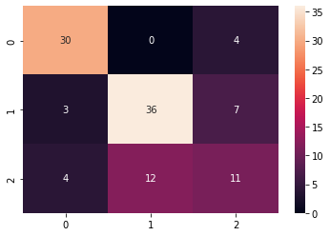

### train size : test size = 30% : 70%

In [84]:



X_train, X_test, y_train, y_test = train_test_split(X, y, test_size=0.7, random_state=0)

In [85]:



print(len(X_train)) print(len(y_test))

53

125

In [86]:



gaussain_SVC_classifier.fit(X_train, y_train)

Out[86]:

SVC(C=1.0, break_ties=False, cache_size=200, class_weight=None, coef0=0.0, decision_function_shape='ovr', degree=3, gamma='scale', kernel='rbf', max_iter=-1, probability=False, random_state=None, shrinking=True, tol=0.001, verbose=False)

In [87]:



y_pred = gaussain_SVC_classifier.predict(X_test) print(f"Accuracy: {100 * accuracy_score(y_test,y_pred)}%\n") cf_matrix = confusion_matrix(y_test,y_pred) print("Confusion Matrix:\n", cf_matrix) print("\nClassification Report:\n") print(classification_report(y_test,y_pred))

Accuracy: 72.0% Confusion Matrix:

[[38 0 4]

[ 3 36 13]

[ 4 11 16]]

Classification Report:



|  |  |  |  |  |
| --- | --- | --- | --- | --- |
|  | precision | recall | f1-score | support |
| 0 | 0.84 | 0.90 | 0.87 | 42 |
| 1 | 0.77 | 0.69 | 0.73 | 52 |
| 2 | 0.48 | 0.52 | 0.50 | 31 |
| accuracy |  |  | 0.72 | 125 |
| macro avg | 0.70 | 0.70 | 0.70 | 125 |
| weighted avg | 0.72 | 0.72 | 0.72 | 125 |

In [88]:



sns.heatmap(cf_matrix, annot=True)

Out[88]:

<matplotlib.axes._subplots.AxesSubplot at 0x7f5e2030e2d0>

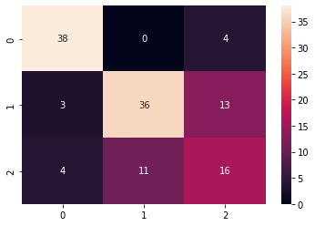

## Sigmoid SVC Classifier

In [89]:



sigmoid_SVC_classifier = SVC(kernel='sigmoid') sigmoid_SVC_classifier

Out[89]:

SVC(C=1.0, break_ties=False, cache_size=200, class_weight=None, coef0=0.0, decision_function_shape='ovr', degree=3, gamma='scale', kernel='sigmoid', max_iter=-1, probability=False, random_state=None, shrinking=True, tol=0.001, verbose=False)

### train size : test size = 70% : 30%

In [90]:



X_train, X_test, y_train, y_test = train_test_split(X, y, test_size=0.3, random_state=0)

In [91]:



print(len(X_train)) print(len(y_test))

124

54

In [92]:



sigmoid_SVC_classifier.fit(X_train, y_train)

Out[92]:

SVC(C=1.0, break_ties=False, cache_size=200, class_weight=None, coef0=0.0,

decision_function_shape='ovr', degree=3, gamma='scale', kernel='sigmoid', max_iter=-1, probability=False, random_state=None, shrinking=True, tol=0.001, verbose=False)

In [93]:



y_pred = sigmoid_SVC_classifier.predict(X_test) print(f"Accuracy: {100 * accuracy_score(y_test,y_pred)}%\n") cf_matrix = confusion_matrix(y_test,y_pred) print("Confusion Matrix:\n", cf_matrix) print("\nClassification Report:\n") print(classification_report(y_test,y_pred))

Accuracy: 20.37037037037037%

Confusion Matrix:

[[ 0 19 0]

[11 11 0]

[ 8 5 0]]

Classification Report:

|  |  |  |  |  |
| --- | --- | --- | --- | --- |
|  | precision | recall | f1-score | support |
| 0 | 0.00 | 0.00 | 0.00 | 19 |
| 1 | 0.31 | 0.50 | 0.39 | 22 |
| 2 | 0.00 | 0.00 | 0.00 | 13 |
| accuracy |  |  | 0.20 | 54 |
| macro avg | 0.10 | 0.17 | 0.13 | 54 |
| weighted avg | 0.13 | 0.20 | 0.16 | 54 |

/usr/local/lib/python3.7/dist-packages/sklearn/metrics/_classification.py:1272: Undefined MetricWarning: Precision and F-score are ill-defined and being set to 0.0 in labels with no predicted samples. Use `zero_division` parameter to control this behavior.

_warn_prf(average, modifier, msg_start, len(result))

In [94]:



sns.heatmap(cf_matrix, annot=True)

Out[94]:

<matplotlib.axes._subplots.AxesSubplot at 0x7f5e20256410>

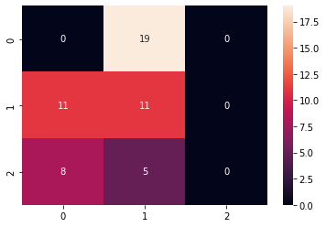

### train size : test size = 60% : 40%

In [95]:



X_train, X_test, y_train, y_test = train_test_split(X, y, test_size=0.4, random_state=0)

In [96]:



print(len(X_train))





print(len(y_test))

106

72

In [97]:



sigmoid_SVC_classifier.fit(X_train, y_train)

Out[97]:

SVC(C=1.0, break_ties=False, cache_size=200, class_weight=None, coef0=0.0, decision_function_shape='ovr', degree=3, gamma='scale', kernel='sigmoid', max_iter=-1, probability=False, random_state=None, shrinking=True, tol=0.001, verbose=False)

In [98]:



y_pred = sigmoid_SVC_classifier.predict(X_test) print(f"Accuracy: {100 * accuracy_score(y_test,y_pred)}%\n") cf_matrix = confusion_matrix(y_test,y_pred) print("Confusion Matrix:\n", cf_matrix) print("\nClassification Report:\n") print(classification_report(y_test,y_pred))

|  |  |
| --- | --- |
| Accuracy:  Confusion | 18.055555555555554%  Matrix: |
| [[ 2 20 | 0] |
| [20 11 | 0] |
| [15 4 | 0]] |

Classification Report:

|  |  |  |  |  |
| --- | --- | --- | --- | --- |
|  | precision | recall | f1-score | support |
| 0 | 0.05 | 0.09 | 0.07 | 22 |
| 1 | 0.31 | 0.35 | 0.33 | 31 |
| 2 | 0.00 | 0.00 | 0.00 | 19 |
| accuracy |  |  | 0.18 | 72 |
| macro avg | 0.12 | 0.15 | 0.13 | 72 |
| weighted avg | 0.15 | 0.18 | 0.16 | 72 |

/usr/local/lib/python3.7/dist-packages/sklearn/metrics/_classification.py:1272: Undefined MetricWarning: Precision and F-score are ill-defined and being set to 0.0 in labels with no predicted samples. Use `zero_division` parameter to control this behavior.

_warn_prf(average, modifier, msg_start, len(result))

In [99]:



sns.heatmap(cf_matrix, annot=True)

Out[99]:

<matplotlib.axes._subplots.AxesSubplot at 0x7f5e201a1550>

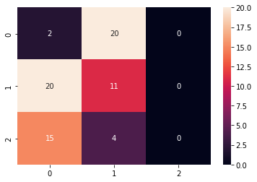



### train size : test size = 50% : 50%

In [100]:



X_train, X_test, y_train, y_test = train_test_split(X, y, test_size=0.5, random_state=0)

In [101]:



print(len(X_train)) print(len(y_test))

89

89

In [102]:



sigmoid_SVC_classifier.fit(X_train, y_train)

Out[102]:

SVC(C=1.0, break_ties=False, cache_size=200, class_weight=None, coef0=0.0, decision_function_shape='ovr', degree=3, gamma='scale', kernel='sigmoid', max_iter=-1, probability=False, random_state=None, shrinking=True, tol=0.001, verbose=False)

In [103]:



y_pred = sigmoid_SVC_classifier.predict(X_test) print(f"Accuracy: {100 * accuracy_score(y_test,y_pred)}%\n") cf_matrix = confusion_matrix(y_test,y_pred) print("Confusion Matrix:\n", cf_matrix) print("\nClassification Report:\n") print(classification_report(y_test,y_pred))

Accuracy: 17.97752808988764%

Confusion Matrix:

[[ 7 18 0]

[31 9 0]

[24 0 0]]

Classification Report:

|  |  |  |  |  |
| --- | --- | --- | --- | --- |
|  | precision | recall | f1-score | support |
| 0 | 0.11 | 0.28 | 0.16 | 25 |
| 1 | 0.33 | 0.23 | 0.27 | 40 |
| 2 | 0.00 | 0.00 | 0.00 | 24 |
| accuracy |  |  | 0.18 | 89 |
| macro avg | 0.15 | 0.17 | 0.14 | 89 |
| weighted avg | 0.18 | 0.18 | 0.17 | 89 |

/usr/local/lib/python3.7/dist-packages/sklearn/metrics/_classification.py:1272: Undefined MetricWarning: Precision and F-score are ill-defined and being set to 0.0 in labels with no predicted samples. Use `zero_division` parameter to control this behavior.

_warn_prf(average, modifier, msg_start, len(result))

In [104]:



sns.heatmap(cf_matrix, annot=True)

Out[104]:

<matplotlib.axes._subplots.AxesSubplot at 0x7f5e200d1a50>

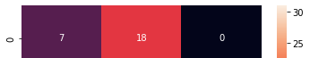

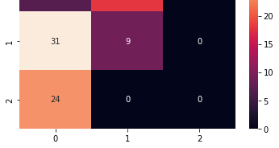

### train size : test size = 40% : 60%

In [105]:



X_train, X_test, y_train, y_test = train_test_split(X, y, test_size=0.6, random_state=0)

In [106]:



print(len(X_train)) print(len(y_test))

71

107

In [107]:



sigmoid_SVC_classifier.fit(X_train, y_train)

Out[107]:

SVC(C=1.0, break_ties=False, cache_size=200, class_weight=None, coef0=0.0, decision_function_shape='ovr', degree=3, gamma='scale', kernel='sigmoid', max_iter=-1, probability=False, random_state=None, shrinking=True, tol=0.001, verbose=False)

In [108]:



y_pred = sigmoid_SVC_classifier.predict(X_test) print(f"Accuracy: {100 * accuracy_score(y_test,y_pred)}%\n") cf_matrix = confusion_matrix(y_test,y_pred) print("Confusion Matrix:\n", cf_matrix) print("\nClassification Report:\n") print(classification_report(y_test,y_pred))

Accuracy: 15.887850467289718%

Confusion Matrix: [[ 7 27 0]

[36 10 0]

[27 0 0]]

Classification Report:

|  |  |  |  |  |
| --- | --- | --- | --- | --- |
|  | precision | recall | f1-score | support |
| 0 | 0.10 | 0.21 | 0.13 | 34 |
| 1 | 0.27 | 0.22 | 0.24 | 46 |
| 2 | 0.00 | 0.00 | 0.00 | 27 |
| accuracy |  |  | 0.16 | 107 |
| macro avg | 0.12 | 0.14 | 0.13 | 107 |
| weighted avg | 0.15 | 0.16 | 0.15 | 107 |

/usr/local/lib/python3.7/dist-packages/sklearn/metrics/_classification.py:1272: Undefined MetricWarning: Precision and F-score are ill-defined and being set to 0.0 in labels with no predicted samples. Use `zero_division` parameter to control this behavior.

_warn_prf(average, modifier, msg_start, len(result))

In [109]:



sns.heatmap(cf_matrix, annot=True)

Out[109]:

<matplotlib.axes._subplots.AxesSubplot at 0x7f5e20016910>

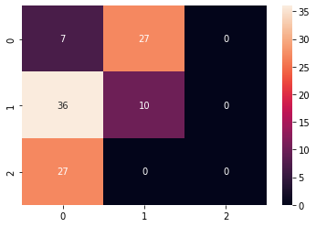

### train size : test size = 30% : 70%

In [110]:



X_train, X_test, y_train, y_test = train_test_split(X, y, test_size=0.7, random_state=0)

In [111]:



print(len(X_train)) print(len(y_test))

53

125

In [112]:



sigmoid_SVC_classifier.fit(X_train, y_train)

Out[112]:

SVC(C=1.0, break_ties=False, cache_size=200, class_weight=None, coef0=0.0, decision_function_shape='ovr', degree=3, gamma='scale', kernel='sigmoid', max_iter=-1, probability=False, random_state=None, shrinking=True, tol=0.001, verbose=False)

In [113]:



y_pred = sigmoid_SVC_classifier.predict(X_test) print(f"Accuracy: {100 * accuracy_score(y_test,y_pred)}%\n") cf_matrix = confusion_matrix(y_test,y_pred) print("Confusion Matrix:\n", cf_matrix) print("\nClassification Report:\n") print(classification_report(y_test,y_pred))

Accuracy: 41.6% Confusion Matrix:

[[ 0 42 0]

[ 0 52 0]

[ 0 31 0]]

Classification Report:

|  |  |  |  |  |
| --- | --- | --- | --- | --- |
|  | precision | recall | f1-score | support |
| 0 | 0.00 | 0.00 | 0.00 | 42 |
| 1 | 0.42 | 1.00 | 0.59 | 52 |
| 2 | 0.00 | 0.00 | 0.00 | 31 |



|  |  |  |  |  |
| --- | --- | --- | --- | --- |
| accuracy |  |  | 0.42 | 125 |
| macro avg | 0.14 | 0.33 | 0.20 | 125 |
| weighted avg | 0.17 | 0.42 | 0.24 | 125 |

/usr/local/lib/python3.7/dist-packages/sklearn/metrics/_classification.py:1272: Undefined MetricWarning: Precision and F-score are ill-defined and being set to 0.0 in labels with no predicted samples. Use `zero_division` parameter to control this behavior.

_warn_prf(average, modifier, msg_start, len(result))

In [114]:



sns.heatmap(cf_matrix, annot=True)

Out[114]:

<matplotlib.axes._subplots.AxesSubplot at 0x7f5e1ff59190>

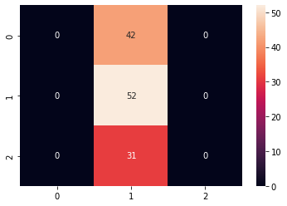

# MLP Classifier

In [115]:



mlp_classifier = MLPClassifier(learning_rate='constant', max_iter=600) mlp_classifier

Out[115]:

MLPClassifier(activation='relu', alpha=0.0001, batch_size='auto', beta_1=0.9, beta_2=0.999, early_stopping=False, epsilon=1e-08, hidden_layer_sizes=(100,), learning_rate='constant', learning_rate_init=0.001, max_fun=15000, max_iter=600, momentum=0.9, n_iter_no_change=10, nesterovs_momentum=True, power_t=0.5, random_state=None, shuffle=True, solver='adam', tol=0.0001, validation_fraction=0.1, verbose=False, warm_start=False)

### train size : test size = 70% : 30%

In [116]:



X_train, X_test, y_train, y_test = train_test_split(X, y, test_size=0.3, random_state=0)

# 70% training data, 30% testing data

In [117]:



print(len(X_train)) print(len(y_test))

124

54

In [118]:





mlp_classifier.fit(X_train, y_train)

Out[118]:

MLPClassifier(activation='relu', alpha=0.0001, batch_size='auto', beta_1=0.9, beta_2=0.999, early_stopping=False, epsilon=1e-08, hidden_layer_sizes=(100,), learning_rate='constant', learning_rate_init=0.001, max_fun=15000, max_iter=600, momentum=0.9, n_iter_no_change=10, nesterovs_momentum=True, power_t=0.5, random_state=None, shuffle=True, solver='adam', tol=0.0001, validation_fraction=0.1, verbose=False, warm_start=False)

In [119]:



y_pred = mlp_classifier.predict(X_test)

print(f"Accuracy: {100 * accuracy_score(y_test,y_pred)}%\n") cf_matrix = confusion_matrix(y_test,y_pred) print("Confusion Matrix:\n")

print(cf_matrix) print("\nClassification Report:\n")

print(classification_report(y_test,y_pred))

Accuracy: 70.37037037037037%

Confusion Matrix:

|  |  |
| --- | --- |
| [[17 | 1 1] |
| [ 4 | 17 1] |
| [ 5 | 4 4]] |

Classification Report:

|  |  |  |  |  |
| --- | --- | --- | --- | --- |
|  | precision | recall | f1-score | support |
| 0 | 0.65 | 0.89 | 0.76 | 19 |
| 1 | 0.77 | 0.77 | 0.77 | 22 |
| 2 | 0.67 | 0.31 | 0.42 | 13 |
| accuracy |  |  | 0.70 | 54 |
| macro avg | 0.70 | 0.66 | 0.65 | 54 |
| weighted avg | 0.71 | 0.70 | 0.68 | 54 |

In [120]:



sns.heatmap(cf_matrix, annot=True)

Out[120]:

<matplotlib.axes._subplots.AxesSubplot at 0x7f5e208b7cd0>

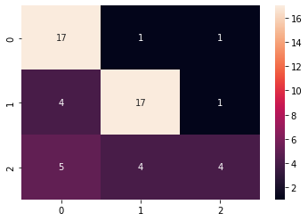

### train size : test size = 60% : 40%

In [121]:





X_train, X_test, y_train, y_test = train_test_split(X, y, test_size=0.4, random_state=0)

# 60% training data, 40% testing data

In [122]:



print(len(X_train)) print(len(y_test))

106

72

In [123]:



mlp_classifier.fit(X_train, y_train)

/usr/local/lib/python3.7/dist-packages/sklearn/neural_network/_multilayer_perceptron.py:5 71: ConvergenceWarning: Stochastic Optimizer: Maximum iterations (600) reached and the op timization hasn't converged yet.

% self.max_iter, ConvergenceWarning)

Out[123]:

MLPClassifier(activation='relu', alpha=0.0001, batch_size='auto', beta_1=0.9, beta_2=0.999, early_stopping=False, epsilon=1e-08, hidden_layer_sizes=(100,), learning_rate='constant', learning_rate_init=0.001, max_fun=15000, max_iter=600, momentum=0.9, n_iter_no_change=10, nesterovs_momentum=True, power_t=0.5, random_state=None, shuffle=True, solver='adam', tol=0.0001, validation_fraction=0.1, verbose=False, warm_start=False)

In [124]:



y_pred = mlp_classifier.predict(X_test)

print(f"Accuracy: {100 * accuracy_score(y_test,y_pred)}%\n") cf_matrix = confusion_matrix(y_test,y_pred) print("Confusion Matrix:")

print(cf_matrix) print("\nClassification Report:\n")

print(classification_report(y_test,y_pred))

Accuracy: 94.44444444444444%

Confusion Matrix:

[[20 2 0]

[ 0 29 2]

[ 0 0 19]]

Classification Report:

|  |  |  |  |  |
| --- | --- | --- | --- | --- |
|  | precision | recall | f1-score | support |
| 0 | 1.00 | 0.91 | 0.95 | 22 |
| 1 | 0.94 | 0.94 | 0.94 | 31 |
| 2 | 0.90 | 1.00 | 0.95 | 19 |
| accuracy |  |  | 0.94 | 72 |
| macro avg | 0.95 | 0.95 | 0.95 | 72 |
| weighted avg | 0.95 | 0.94 | 0.94 | 72 |

In [125]:



sns.heatmap(cf_matrix, annot=True)

Out[125]:

<matplotlib.axes._subplots.AxesSubplot at 0x7f5e1fdcea10>



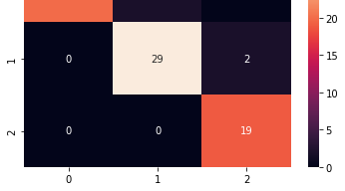

### train size : test size = 50% : 50%

In [126]:



X_train, X_test, y_train, y_test = train_test_split(X, y, test_size=0.5, random_state=0)

# 50% training data, 50% testing data

In [127]:



print(len(X_train)) print(len(y_test))

89

89

In [128]:



mlp_classifier.fit(X_train, y_train)

Out[128]:

MLPClassifier(activation='relu', alpha=0.0001, batch_size='auto', beta_1=0.9, beta_2=0.999, early_stopping=False, epsilon=1e-08, hidden_layer_sizes=(100,), learning_rate='constant', learning_rate_init=0.001, max_fun=15000, max_iter=600, momentum=0.9, n_iter_no_change=10, nesterovs_momentum=True, power_t=0.5, random_state=None, shuffle=True, solver='adam', tol=0.0001, validation_fraction=0.1, verbose=False, warm_start=False)

In [129]:



y_pred = mlp_classifier.predict(X_test)

print(f"Accuracy: {100 * accuracy_score(y_test,y_pred)}%\n") cf_matrix = confusion_matrix(y_test,y_pred) print("Confusion Matrix:")

print(cf_matrix) print("\nClassification Report:\n")

print(classification_report(y_test,y_pred))

Accuracy: 26.96629213483146%

Confusion Matrix: [[ 0 0 25]

[ 0 0 40]

[ 0 0 24]]

Classification Report:

|  |  |  |  |  |
| --- | --- | --- | --- | --- |
|  | precision | recall | f1-score | support |
| 0 | 0.00 | 0.00 | 0.00 | 25 |
| 1 | 0.00 | 0.00 | 0.00 | 40 |
| 2 | 0.27 | 1.00 | 0.42 | 24 |
| accuracy |  |  | 0.27 | 89 |
| macro avg | 0.09 | 0.33 | 0.14 | 89 |
| weighted avg | 0.07 | 0.27 | 0.11 | 89 |



/usr/local/lib/python3.7/dist-packages/sklearn/metrics/_classification.py:1272: Undefined MetricWarning: Precision and F-score are ill-defined and being set to 0.0 in labels with no predicted samples. Use `zero_division` parameter to control this behavior.

_warn_prf(average, modifier, msg_start, len(result))

In [130]:



sns.heatmap(cf_matrix, annot=True)

Out[130]:

<matplotlib.axes._subplots.AxesSubplot at 0x7f5e1fd5ae90>

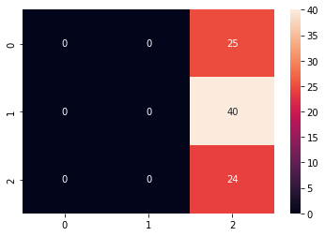

### train size : test size = 40% : 60%

In [131]:



X_train, X_test, y_train, y_test = train_test_split(X, y, test_size=0.6, random_state=0)

In [132]:



print(len(X_train)) print(len(y_test))

71

107

In [133]:



mlp_classifier.fit(X_train, y_train)

Out[133]:

MLPClassifier(activation='relu', alpha=0.0001, batch_size='auto', beta_1=0.9, beta_2=0.999, early_stopping=False, epsilon=1e-08, hidden_layer_sizes=(100,), learning_rate='constant', learning_rate_init=0.001, max_fun=15000, max_iter=600, momentum=0.9, n_iter_no_change=10, nesterovs_momentum=True, power_t=0.5, random_state=None, shuffle=True, solver='adam', tol=0.0001, validation_fraction=0.1, verbose=False, warm_start=False)

In [134]:



y_pred = mlp_classifier.predict(X_test)

print(f"Accuracy: {100 * accuracy_score(y_test,y_pred)}%\n") cf_matrix = confusion_matrix(y_test,y_pred) print("Confusion Matrix:\n")

print(cf_matrix) print("\nClassification Report:\n")

print(classification_report(y_test,y_pred))

Accuracy: 40.18691588785047%

Confusion Matrix:

[[34 0 0]

[19 0 27]

[18 0 9]]

Classification Report:

|  |  |  |  |  |
| --- | --- | --- | --- | --- |
|  | precision | recall | f1-score | support |
| 0 | 0.48 | 1.00 | 0.65 | 34 |
| 1 | 0.00 | 0.00 | 0.00 | 46 |
| 2 | 0.25 | 0.33 | 0.29 | 27 |
| accuracy |  |  | 0.40 | 107 |
| macro avg | 0.24 | 0.44 | 0.31 | 107 |
| weighted avg | 0.22 | 0.40 | 0.28 | 107 |

/usr/local/lib/python3.7/dist-packages/sklearn/metrics/_classification.py:1272: Undefined MetricWarning: Precision and F-score are ill-defined and being set to 0.0 in labels with no predicted samples. Use `zero_division` parameter to control this behavior.

_warn_prf(average, modifier, msg_start, len(result))

In [135]:



sns.heatmap(cf_matrix, annot=True)

Out[135]:

<matplotlib.axes._subplots.AxesSubplot at 0x7f5e1fcf5790>

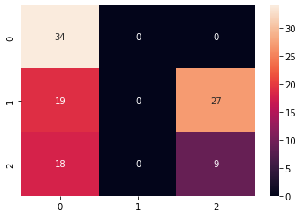

### train size : test size = 30% : 70%

In [136]:



X_train, X_test, y_train, y_test = train_test_split(X, y, test_size=0.7, random_state=0)

In [137]:



print(len(X_train)) print(len(y_test))

53

125

In [138]:



mlp_classifier.fit(X_train, y_train)

Out[138]:

MLPClassifier(activation='relu', alpha=0.0001, batch_size='auto', beta_1=0.9, beta_2=0.999, early_stopping=False, epsilon=1e-08, hidden_layer_sizes=(100,), learning_rate='constant', learning_rate_init=0.001, max_fun=15000, max_iter=600,

In [139]:

momentum=0.9, n_iter_no_change=10, nesterovs_momentum=True, power_t=0.5, random_state=None, shuffle=True, solver='adam', tol=0.0001, validation_fraction=0.1, verbose=False, warm_start=False)





y_pred = mlp_classifier.predict(X_test)

print(f"Accuracy: {100 * accuracy_score(y_test,y_pred)}%\n") cf_matrix = confusion_matrix(y_test,y_pred) print("Confusion Matrix:\n")

print(cf_matrix) print("\nClassification Report:\n")

print(classification_report(y_test,y_pred))

Accuracy: 15.2% Confusion Matrix:

[[ 2 40 0]

[35 17 0]

[14 17 0]]

Classification Report:

|  |  |  |  |  |
| --- | --- | --- | --- | --- |
|  | precision | recall | f1-score | support |
| 0 | 0.04 | 0.05 | 0.04 | 42 |
| 1 | 0.23 | 0.33 | 0.27 | 52 |
| 2 | 0.00 | 0.00 | 0.00 | 31 |
| accuracy |  |  | 0.15 | 125 |
| macro avg | 0.09 | 0.12 | 0.10 | 125 |
| weighted avg | 0.11 | 0.15 | 0.13 | 125 |

/usr/local/lib/python3.7/dist-packages/sklearn/metrics/_classification.py:1272: Undefined MetricWarning: Precision and F-score are ill-defined and being set to 0.0 in labels with no predicted samples. Use `zero_division` parameter to control this behavior.

_warn_prf(average, modifier, msg_start, len(result))

In [140]:



sns.heatmap(cf_matrix, annot=True)

Out[140]:

<matplotlib.axes._subplots.AxesSubplot at 0x7f5e200c8810>

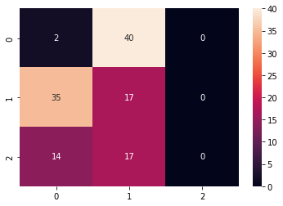

# Random Forest Classifier

In [141]:



rfc_classifier = RandomForestClassifier(n_estimators=20)





rfc_classifier

Out[141]:

RandomForestClassifier(bootstrap=True, ccp_alpha=0.0, class_weight=None,

criterion='gini', max_depth=None, max_features='auto', max_leaf_nodes=None, max_samples=None, min_impurity_decrease=0.0, min_impurity_split=None, min_samples_leaf=1, min_samples_split=2, min_weight_fraction_leaf=0.0, n_estimators=20, n_jobs=None, oob_score=False, random_state=None, verbose=0, warm_start=False)

### train size : test size = 70% : 30%

In [142]:



X_train, X_test, y_train, y_test = train_test_split(X, y, test_size=0.3, random_state=0)

# 70% training data, 30% testing data

In [143]:



print(len(X_train)) print(len(y_test))

124

54

In [144]:



rfc_classifier.fit(X_train, y_train)

Out[144]:

RandomForestClassifier(bootstrap=True, ccp_alpha=0.0, class_weight=None,

criterion='gini', max_depth=None, max_features='auto', max_leaf_nodes=None, max_samples=None, min_impurity_decrease=0.0, min_impurity_split=None, min_samples_leaf=1, min_samples_split=2, min_weight_fraction_leaf=0.0, n_estimators=20, n_jobs=None, oob_score=False, random_state=None, verbose=0, warm_start=False)

In [145]:



y_pred = rfc_classifier.predict(X_test)

print(f"Accuracy: {100 * accuracy_score(y_test,y_pred)}%\n") cf_matrix = confusion_matrix(y_test,y_pred) print("Confusion Matrix:\n")

print(cf_matrix) print("\nClassification Report:\n")

print(classification_report(y_test,y_pred))

Accuracy: 96.29629629629629%

Confusion Matrix:

|  |  |
| --- | --- |
| [[19 0 | 0] |
| [ 1 20 | 1] |
| [ 0 0 | 13]] |

Classification Report:

|  |  |  |  |  |
| --- | --- | --- | --- | --- |
|  | precision | recall | f1-score | support |
| 0 | 0.95 | 1.00 | 0.97 | 19 |
| 1 | 1.00 | 0.91 | 0.95 | 22 |
| 2 | 0.93 | 1.00 | 0.96 | 13 |
| accuracy |  |  | 0.96 | 54 |
| macro avg | 0.96 | 0.97 | 0.96 | 54 |

weighted avg 0.97 0.96 0.96 54

In [146]:



sns.heatmap(cf_matrix, annot=True)

Out[146]:

<matplotlib.axes._subplots.AxesSubplot at 0x7f5e1fcb77d0>

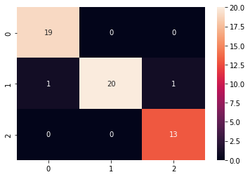

### train size : test size = 60% : 40%

In [147]:



X_train, X_test, y_train, y_test = train_test_split(X, y, test_size=0.4, random_state=0)

# 60% training data, 40% testing data

In [148]:



print(len(X_train)) print(len(y_test))

106

72

In [149]:



rfc_classifier.fit(X_train, y_train)

Out[149]:

RandomForestClassifier(bootstrap=True, ccp_alpha=0.0, class_weight=None,

criterion='gini', max_depth=None, max_features='auto', max_leaf_nodes=None, max_samples=None, min_impurity_decrease=0.0, min_impurity_split=None, min_samples_leaf=1, min_samples_split=2, min_weight_fraction_leaf=0.0, n_estimators=20, n_jobs=None, oob_score=False, random_state=None, verbose=0, warm_start=False)

In [150]:



y_pred = rfc_classifier.predict(X_test)

print(f"Accuracy: {100 * accuracy_score(y_test,y_pred)}%\n") cf_matrix = confusion_matrix(y_test,y_pred) print("Confusion Matrix:")

print(cf_matrix) print("\nClassification Report:\n")

print(classification_report(y_test,y_pred))

Accuracy: 97.22222222222221%

Confusion Matrix: [[22 0 0]

[ 0 29 2]

[ 0 0 19]]

Classification Report:

|  |  |  |  |  |
| --- | --- | --- | --- | --- |
|  | precision | recall | f1-score | support |
| 0 | 1.00 | 1.00 | 1.00 | 22 |
| 1 | 1.00 | 0.94 | 0.97 | 31 |
| 2 | 0.90 | 1.00 | 0.95 | 19 |
| accuracy |  |  | 0.97 | 72 |
| macro avg | 0.97 | 0.98 | 0.97 | 72 |
| weighted avg | 0.97 | 0.97 | 0.97 | 72 |

In [151]:



sns.heatmap(cf_matrix, annot=True)

Out[151]:

<matplotlib.axes._subplots.AxesSubplot at 0x7f5e1faabc10>

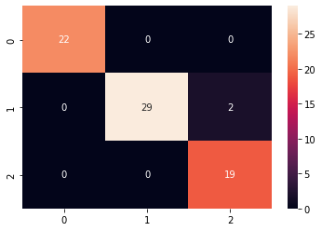

### train size : test size = 50% : 50%

In [152]:



X_train, X_test, y_train, y_test = train_test_split(X, y, test_size=0.5, random_state=0)

# 50% training data, 50% testing data

In [153]:



print(len(X_train)) print(len(y_test))

89

89

In [154]:



rfc_classifier.fit(X_train, y_train)

Out[154]:

RandomForestClassifier(bootstrap=True, ccp_alpha=0.0, class_weight=None,

criterion='gini', max_depth=None, max_features='auto', max_leaf_nodes=None, max_samples=None, min_impurity_decrease=0.0, min_impurity_split=None, min_samples_leaf=1, min_samples_split=2, min_weight_fraction_leaf=0.0, n_estimators=20, n_jobs=None, oob_score=False, random_state=None, verbose=0, warm_start=False)

In [155]:





y_pred = rfc_classifier.predict(X_test)

print(f"Accuracy: {100 * accuracy_score(y_test,y_pred)}%\n") cf_matrix = confusion_matrix(y_test,y_pred) print("Confusion Matrix:")

print(cf_matrix) print("\nClassification Report:\n")

print(classification_report(y_test,y_pred))

Accuracy: 95.50561797752809%

Confusion Matrix:

[[25 0 0]

[ 1 36 3]

[ 0 0 24]]

Classification Report:

|  |  |  |  |  |
| --- | --- | --- | --- | --- |
|  | precision | recall | f1-score | support |
| 0 | 0.96 | 1.00 | 0.98 | 25 |
| 1 | 1.00 | 0.90 | 0.95 | 40 |
| 2 | 0.89 | 1.00 | 0.94 | 24 |
| accuracy |  |  | 0.96 | 89 |
| macro avg | 0.95 | 0.97 | 0.96 | 89 |
| weighted avg | 0.96 | 0.96 | 0.95 | 89 |

In [156]:



sns.heatmap(cf_matrix, annot=True)

Out[156]:

<matplotlib.axes._subplots.AxesSubplot at 0x7f5e1f9ece10>

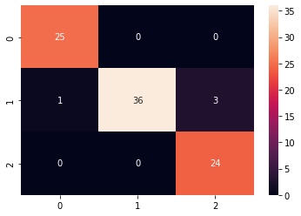

### train size : test size = 40% : 60%

In [157]:



X_train, X_test, y_train, y_test = train_test_split(X, y, test_size=0.6, random_state=0)

In [158]:



print(len(X_train)) print(len(y_test))

71

107

In [159]:



rfc_classifier.fit(X_train, y_train)

Out[159]:

RandomForestClassifier(bootstrap=True, ccp_alpha=0.0, class_weight=None,

criterion='gini', max_depth=None, max_features='auto', max_leaf_nodes=None, max_samples=None, min_impurity_decrease=0.0, min_impurity_split=None, min_samples_leaf=1, min_samples_split=2, min_weight_fraction_leaf=0.0, n_estimators=20, n_jobs=None, oob_score=False, random_state=None, verbose=0, warm_start=False)

In [160]:



y_pred = rfc_classifier.predict(X_test)

print(f"Accuracy: {100 * accuracy_score(y_test,y_pred)}%\n") cf_matrix = confusion_matrix(y_test,y_pred) print("Confusion Matrix:\n")

print(cf_matrix) print("\nClassification Report:\n")

print(classification_report(y_test,y_pred))

Accuracy: 94.39252336448598%

Confusion Matrix:

|  |  |
| --- | --- |
| [[33 1 | 0] |
| [ 2 42 | 2] |
| [ 0 1 | 26]] |

Classification Report:

|  |  |  |  |  |
| --- | --- | --- | --- | --- |
|  | precision | recall | f1-score | support |
| 0 | 0.94 | 0.97 | 0.96 | 34 |
| 1 | 0.95 | 0.91 | 0.93 | 46 |
| 2 | 0.93 | 0.96 | 0.95 | 27 |
| accuracy |  |  | 0.94 | 107 |
| macro avg | 0.94 | 0.95 | 0.95 | 107 |
| weighted avg | 0.94 | 0.94 | 0.94 | 107 |

In [161]:



sns.heatmap(cf_matrix, annot=True)

Out[161]:

<matplotlib.axes._subplots.AxesSubplot at 0x7f5e1f92a690>

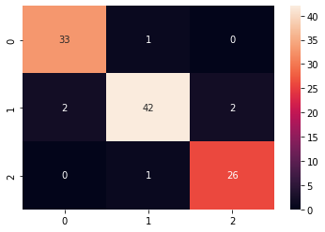

### train size : test size = 30% : 70%

In [162]:



X_train, X_test, y_train, y_test = train_test_split(X, y, test_size=0.7, random_state=0)

In [163]:





print(len(X_train)) print(len(y_test))

53

125

In [164]:



rfc_classifier.fit(X_train, y_train)

Out[164]:

RandomForestClassifier(bootstrap=True, ccp_alpha=0.0, class_weight=None,

criterion='gini', max_depth=None, max_features='auto', max_leaf_nodes=None, max_samples=None, min_impurity_decrease=0.0, min_impurity_split=None, min_samples_leaf=1, min_samples_split=2, min_weight_fraction_leaf=0.0, n_estimators=20, n_jobs=None, oob_score=False, random_state=None, verbose=0, warm_start=False)

In [165]:



y_pred = rfc_classifier.predict(X_test)

print(f"Accuracy: {100 * accuracy_score(y_test,y_pred)}%\n") cf_matrix = confusion_matrix(y_test,y_pred) print("Confusion Matrix:\n")

print(cf_matrix) print("\nClassification Report:\n")

print(classification_report(y_test,y_pred))

Accuracy: 92.80000000000001%

Confusion Matrix:

|  |  |
| --- | --- |
| [[42 0 | 0] |
| [ 2 43 | 7] |
| [ 0 0 | 31]] |

Classification Report:

|  |  |  |  |  |
| --- | --- | --- | --- | --- |
|  | precision | recall | f1-score | support |
| 0 | 0.95 | 1.00 | 0.98 | 42 |
| 1 | 1.00 | 0.83 | 0.91 | 52 |
| 2 | 0.82 | 1.00 | 0.90 | 31 |
| accuracy |  |  | 0.93 | 125 |
| macro avg | 0.92 | 0.94 | 0.93 | 125 |
| weighted avg | 0.94 | 0.93 | 0.93 | 125 |

In [166]:



sns.heatmap(cf_matrix, annot=True)

Out[166]:

<matplotlib.axes._subplots.AxesSubplot at 0x7f5e1f867f50>

