**Machine Learning Lab**

**Assignment 3**

***Name – Anmol Raj***

***Roll - 001811001069***

***Semester - 7***

***Year - 4***

***Department - Information Technology(IT)***

***Wine Dataset***

***Importing the Dataset :-***

**import** **pandas** **as** **pd**

**import** **numpy** **as** **np**

df = pd.read_csv("wine.data",header=**None**)

col_name = ['Class','Alcohol','Malic acid','Ash','Alcalinity of ash','Magnesium','Total phenols','Flavanoids',

'Nonflavanoid phenols','Proanthocyanins','Color intensity','Hue','OD280/OD315 of diluted wines','Proline']

df.columns = col_name

X = df.drop(['Class'], axis=1)

y = df['Class']

***GaussianHMM Without Tuning(70-30 Split)* :-**

**from** **sklearn.model_selection** **import** train_test_split

X_train, X_test, y_train, y_test = train_test_split(X,y,train_size=0.7,test_size=0.3,random_state=10)

**from** **sklearn.preprocessing** **import** StandardScaler

sc = StandardScaler()

X_train = sc.fit_transform(X_train)

X_test = sc.transform(X_test)

**from** **hmmlearn** **import** hmm

classifier = hmm.GaussianHMM(n_components=3, covariance_type="full")

classifier.fit(X_train)

y_pred = classifier.predict(X_test)

size = len(y_pred)

strings = np.empty(size, np.unicode_)

**for** i **in** range (size):

**if** y_pred[i] == 0:

strings[i] = 1

**elif** y_pred[i] == 1:

strings[i] = 2

**else**:

strings[i] = 3

strings = strings.astype(np.int)

**from** **sklearn.metrics** **import** classification_report, confusion_matrix, accuracy_score

print("Confusion Matrix:")

print(confusion_matrix(y_test, strings))

print("--------------------------------------------------")

print("--------------------------------------------------")

print("Performance Evaluation")

print(classification_report(y_test, strings))

print("--------------------------------------------------")

print("--------------------------------------------------")

print("Accuracy:")

print(accuracy_score(y_test, strings))

**import** **matplotlib.pyplot** **as** **plt**

**import** **seaborn** **as** **sns**

cm = confusion_matrix(y_test, strings)

sns.heatmap(cm, annot=**True**, fmt="d",cmap='Blues')

plt.show()

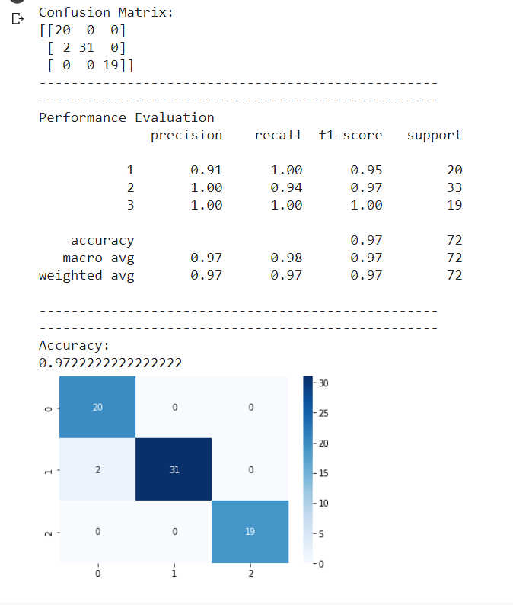

***GaussianHMM With Tuning(70-30 Split)* :-**

**from** **sklearn.model_selection** **import** train_test_split

X_train, X_test, y_train, y_test = train_test_split(X,y,train_size=0.7,test_size=0.3,random_state=10)

**from** **sklearn.preprocessing** **import** StandardScaler

sc = StandardScaler()

X_train = sc.fit_transform(X_train)

X_test = sc.transform(X_test)

**from** **hmmlearn** **import** hmm

classifier = hmm.GaussianHMM(n_components=3, covariance_type="full", n_iter=5,algorithm='viterbi',verbose=**False**

)

classifier.fit(X_train)

y_pred = classifier.predict(X_test)

size = len(y_pred)

strings = np.empty(size, np.unicode_)

**for** i **in** range (size):

**if** y_pred[i] == 0:

strings[i] = 1

**elif** y_pred[i] == 1:

strings[i] = 2

**else**:

strings[i] = 3

strings = strings.astype(np.int)

**from** **sklearn.metrics** **import** classification_report, confusion_matrix, accuracy_score

print("Confusion Matrix:")

print(confusion_matrix(y_test, strings))

print("--------------------------------------------------")

print("--------------------------------------------------")

print("Performance Evaluation")

print(classification_report(y_test, strings))

print("--------------------------------------------------")

print("--------------------------------------------------")

print("Accuracy:")

print(accuracy_score(y_test, strings))

**import** **matplotlib.pyplot** **as** **plt**

**import** **seaborn** **as** **sns**

cm = confusion_matrix(y_test, strings)

sns.heatmap(cm, annot=**True**, fmt="d",cmap='Blues')

plt.show()

Confusion Matrix:

[[ 0 15 0]

[ 2 2 23]

[12 0 0]]

--------------------------------------------------

--------------------------------------------------

Performance Evaluation

precision recall f1-score support

1 0.00 0.00 0.00 15

2 0.12 0.07 0.09 27

3 0.00 0.00 0.00 12

accuracy 0.04 54

macro avg 0.04 0.02 0.03 54

weighted avg 0.06 0.04 0.05 54

--------------------------------------------------

--------------------------------------------------

Accuracy:

0.037037037037037035

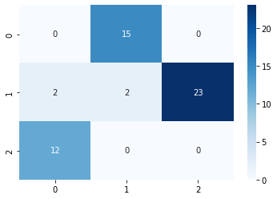

***GMMHMM Without Tuning(70-30 Split)* :-**

**from** **sklearn.model_selection** **import** train_test_split

X_train, X_test, y_train, y_test = train_test_split(X,y,train_size=0.7,test_size=0.3,random_state=10)

**from** **sklearn.preprocessing** **import** StandardScaler

sc = StandardScaler()

X_train = sc.fit_transform(X_train)

X_test = sc.transform(X_test)

**import** **hmmlearn**

classifier = hmmlearn.hmm.GMMHMM(n_components=3, random_state=10,covariance_type='full',algorithm='viterbi',n_iter=10)

classifier.fit(X_train)

y_pred = classifier.predict(X_test)

size = len(y_pred)

strings = np.empty(size, np.unicode_)

**for** i **in** range (size):

**if** y_pred[i] == 0:

strings[i] = 3

**elif** y_pred[i] == 1:

strings[i] = 2

**else**:

strings[i] = 1

strings = strings.astype(np.int)

**from** **sklearn.metrics** **import** classification_report, confusion_matrix, accuracy_score

print("Confusion Matrix:")

print(confusion_matrix(y_test, strings))

print("--------------------------------------------------")

print("--------------------------------------------------")

print("Performance Evaluation")

print(classification_report(y_test, strings))

print("--------------------------------------------------")

print("--------------------------------------------------")

print("Accuracy:")

print(accuracy_score(y_test, strings))

**import** **matplotlib.pyplot** **as** **plt**

**import** **seaborn** **as** **sns**

cm = confusion_matrix(y_test, strings)

sns.heatmap(cm, annot=**True**, fmt="d",cmap='Blues')

plt.show()

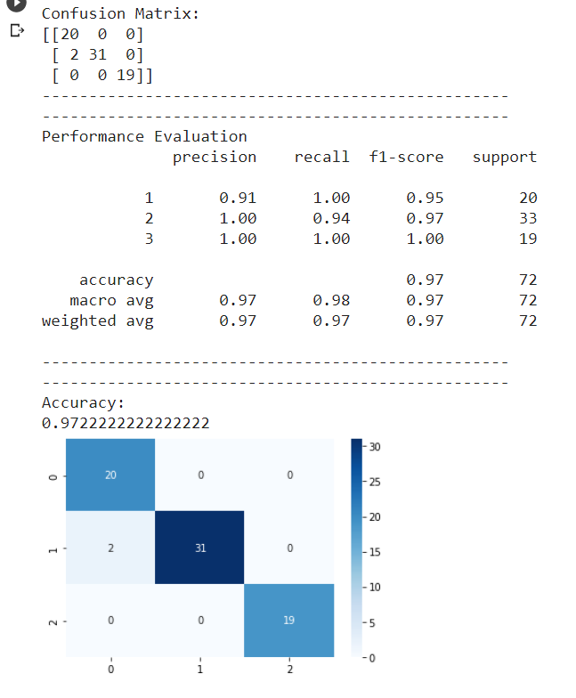

***GMMHMM With Tuning(30-70)* :-**

**from** **sklearn.model_selection** **import** train_test_split

X_train, X_test, y_train, y_test = train_test_split(X,y,train_size=0.3,test_size=0.7,random_state=10)

**from** **sklearn.preprocessing** **import** StandardScaler

sc = StandardScaler()

X_train = sc.fit_transform(X_train)

X_test = sc.transform(X_test)

**from** **hmmlearn** **import** hmm

classifier = hmm.GaussianHMM(n_components=3, covariance_type="full", n_iter=5,algorithm='viterbi',verbose=**False**

)

classifier.fit(X_train)

y_pred = classifier.predict(X_test)

size = len(y_pred)

strings = np.empty(size, np.unicode_)

**for** i **in** range (size):

**if** y_pred[i] == 0:

strings[i] = 1

**elif** y_pred[i] == 1:

strings[i] = 2

**else**:

strings[i] = 3

strings = strings.astype(np.int)

**from** **sklearn.metrics** **import** classification_report, confusion_matrix, accuracy_score

print("Confusion Matrix:")

print(confusion_matrix(y_test, strings))

print("--------------------------------------------------")

print("--------------------------------------------------")

print("Performance Evaluation")

print(classification_report(y_test, strings))

print("--------------------------------------------------")

print("--------------------------------------------------")

print("Accuracy:")

print(accuracy_score(y_test, strings))

**import** **matplotlib.pyplot** **as** **plt**

**import** **seaborn** **as** **sns**

cm = confusion_matrix(y_test, strings)

sns.heatmap(cm, annot=**True**, fmt="d",cmap='Blues')

plt.show()

Confusion Matrix:

[[39 0 2]

[ 5 0 44]

[ 3 24 8]]

--------------------------------------------------

--------------------------------------------------

Performance Evaluation

precision recall f1-score support

1 0.83 0.95 0.89 41

2 0.00 0.00 0.00 49

3 0.15 0.23 0.18 35

accuracy 0.38 125

macro avg 0.33 0.39 0.36 125

weighted avg 0.31 0.38 0.34 125

--------------------------------------------------

--------------------------------------------------

Accuracy:

0.376

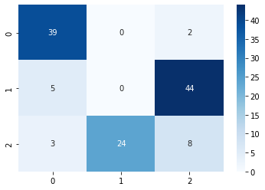

***MultinomialHMM With Tuning(70-30 Split)* :-**

**from** **sklearn.model_selection** **import** train_test_split

X_train, X_test, y_train, y_test = train_test_split(X,y,train_size=0.7,test_size=0.3,random_state=10)

**from** **sklearn.preprocessing** **import** StandardScaler

sc = StandardScaler()

X_train = sc.fit_transform(X_train)

X_test = sc.transform(X_test)

**import** **hmmlearn**

classifier = hmmlearn.hmm.MultinomialHMM(n_components=4, random_state=15,n_iter=10,algorithm='viterbi',params='ste')

**import** **math**

row = len(X_train)

col = len(X_train[0])

new = [1] * 33

**for** i **in** range(row):

**for** j **in** range(col):

X_train[i][j] = X_train[i][j]*10

X_train[i][j] = math.floor(X_train[i][j])

x = X_train[i].astype(np.int)

new = np.vstack([new,x])

y = new

y = np.absolute(y)

X_train = y

**import** **math**

row = len(X_test)

col = len(X_test[0])

new

**for** i **in** range(row):

**for** j **in** range(col):

X_test[i][j] = X_test[i][j]*10

X_test[i][j] = math.floor(X_test[i][j])

x = X_test[i].astype(np.int)

new = np.vstack([new,x])

y = new

y = np.absolute(y)

X_test = y

classifier.fit(X_train)

y_pred = classifier.predict(X_test)

size = len(y_pred)

strings = np.empty(size, np.unicode_)

**for** i **in** range (size):

**if** y_pred[i] == 1:

strings[i] = ("b")

**else**:

strings[i] = ("g")

strings

strings = strings[0:246]

**from** **sklearn.metrics** **import** classification_report, confusion_matrix, accuracy_score

print("Confusion Matrix:")

print(confusion_matrix(y_test, strings))

print("--------------------------------------------------")

print("--------------------------------------------------")

print("Performance Evaluation")

print(classification_report(y_test, strings))

print("--------------------------------------------------")

print("--------------------------------------------------")

print("Accuracy:")

print(accuracy_score(y_test, strings))

**import** **matplotlib.pyplot** **as** **plt**

**import** **seaborn** **as** **sns**

cm = confusion_matrix(y_test, strings)

sns.heatmap(cm, annot=**True**, fmt="d",cmap='Blues')

plt.show()

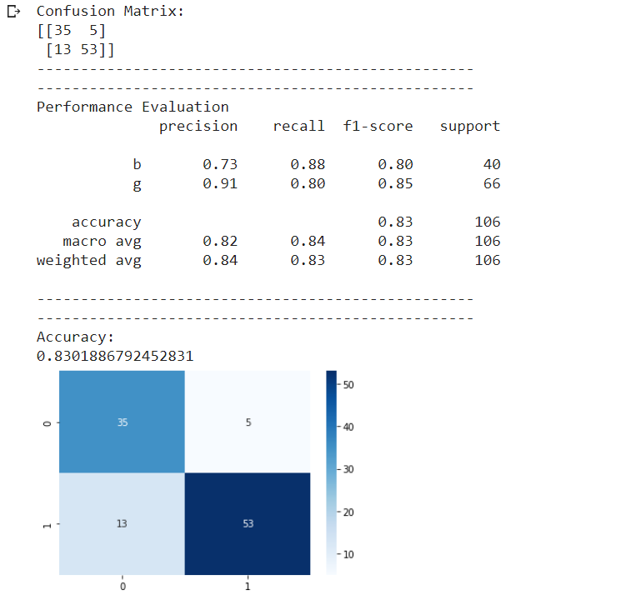

**The maximum accuracy was achieved when the Train-Test split ratio was 70:30, which was achieved by using the Gaussian Model. The maximum range of accuracies was achieved by the Gaussian Model, followed by the GMMHMM model, which is followed by the MultinomialHMM model.**

**2) Ionosphere Dataset**

***Importing the dataset***

**import** **pandas** **as** **pd**

**import** **numpy** **as** **np**

*# Dataset Preparation*

df = pd.read_csv("ionosphere.data",header=**None**)

col_name = ['1','2','3','4','5','6','7','8','9','10','11','12','13','14','15','16','17','18','19'

,'20','21','22','23','24','25','26','27','28','29','30','31','32','33','34','Class']

df.columns = col_name

X = df.drop(['1','2','Class'], axis=1)

y = df['Class']

***GaussianHMM Without Tuning(70-30 Split)* :-**

**from** **sklearn.model_selection** **import** train_test_split

X_train, X_test, y_train, y_test = train_test_split(X,y,train_size=0.7,test_size=0.3,random_state=10)

**from** **sklearn.preprocessing** **import** StandardScaler

sc = StandardScaler()

X_train = sc.fit_transform(X_train)

X_test = sc.transform(X_test)

**from** **hmmlearn** **import** hmm

classifier = hmm.GaussianHMM(n_components=2, covariance_type="full")

classifier.fit(X_train)

y_pred = classifier.predict(X_test)

size = len(y_pred)

strings = np.empty(size, np.unicode_)

**for** i **in** range (size):

**if** y_pred[i] == 1:

strings[i] = ("g")

**else**:

strings[i] = ("b")

strings

**from** **sklearn.metrics** **import** classification_report, confusion_matrix, accuracy_score

print("Confusion Matrix:")

print(confusion_matrix(y_test, strings))

print("--------------------------------------------------")

print("--------------------------------------------------")

print("Performance Evaluation")

print(classification_report(y_test, strings))

print("--------------------------------------------------")

print("--------------------------------------------------")

print("Accuracy:")

print(accuracy_score(y_test, strings))

**import** **matplotlib.pyplot** **as** **plt**

**import** **seaborn** **as** **sns**

cm = confusion_matrix(y_test, strings)

sns.heatmap(cm, annot=**True**, fmt="d",cmap='Blues')

plt.show()



***GaussianHMM With Tuning(70-30 Split)* :-**

**from** **sklearn.model_selection** **import** train_test_split

X_train, X_test, y_train, y_test = train_test_split(X,y,train_size=0.7,test_size=0.3,random_state=10)

**from** **sklearn.preprocessing** **import** StandardScaler

sc = StandardScaler()

X_train = sc.fit_transform(X_train)

X_test = sc.transform(X_test)

**from** **hmmlearn** **import** hmm

classifier = hmm.GaussianHMM(n_components=2, covariance_type="full",n_iter=5,algorithm='viterbi',verbose=**False**)

classifier.fit(X_train)

y_pred = classifier.predict(X_test)

size = len(y_pred)

strings = np.empty(size, np.unicode_)

**for** i **in** range (size):

**if** y_pred[i] == 1:

strings[i] = ("g")

**else**:

strings[i] = ("b")

strings

**from** **sklearn.metrics** **import** classification_report, confusion_matrix, accuracy_score

print("Confusion Matrix:")

print(confusion_matrix(y_test, strings))

print("--------------------------------------------------")

print("--------------------------------------------------")

print("Performance Evaluation")

print(classification_report(y_test, strings))

print("--------------------------------------------------")

print("--------------------------------------------------")

print("Accuracy:")

print(accuracy_score(y_test, strings))

**import** **matplotlib.pyplot** **as** **plt**

**import** **seaborn** **as** **sns**

cm = confusion_matrix(y_test, strings)

sns.heatmap(cm, annot=**True**, fmt="d",cmap='Blues')

plt.show()



***GMMHMM Without Tuning(70-30 Split)* :-**

**from** **sklearn.model_selection** **import** train_test_split

X_train, X_test, y_train, y_test = train_test_split(X,y,train_size=0.7,test_size=0.3,random_state=10)

**from** **sklearn.preprocessing** **import** StandardScaler

sc = StandardScaler()

X_train = sc.fit_transform(X_train)

X_test = sc.transform(X_test)

**import** **hmmlearn**

classifier = hmmlearn.hmm.GMMHMM(n_components=2, random_state=10,covariance_type='full',algorithm='viterbi',n_iter=10)

classifier.fit(X_train)

y_pred = classifier.predict(X_test)

size = len(y_pred)

strings = np.empty(size, np.unicode_)

**for** i **in** range (size):

**if** y_pred[i] == 1:

strings[i] = ("g")

**else**:

strings[i] = ("b")

strings

**from** **sklearn.metrics** **import** classification_report, confusion_matrix, accuracy_score

print("Confusion Matrix:")

print(confusion_matrix(y_test, strings))

print("--------------------------------------------------")

print("--------------------------------------------------")

print("Performance Evaluation")

print(classification_report(y_test, strings))

print("--------------------------------------------------")

print("--------------------------------------------------")

print("Accuracy:")

print(accuracy_score(y_test, strings))

**import** **matplotlib.pyplot** **as** **plt**

**import** **seaborn** **as** **sns**

cm = confusion_matrix(y_test, strings)

sns.heatmap(cm, annot=**True**, fmt="d",cmap='Blues')

plt.show()



***GMMHMM With Tuning(70-30 Split)* :-**

**from** **sklearn.model_selection** **import** train_test_split

X_train, X_test, y_train, y_test = train_test_split(X,y,train_size=0.7,test_size=0.3,random_state=10)

**from** **sklearn.preprocessing** **import** StandardScaler

sc = StandardScaler()

X_train = sc.fit_transform(X_train)

X_test = sc.transform(X_test)

**import** **hmmlearn**

classifier = hmmlearn.hmm.GMMHMM(n_components=2, random_state=10,covariance_type='full',algorithm='viterbi',n_iter=10)

classifier.fit(X_train)

y_pred = classifier.predict(X_test)

size = len(y_pred)

strings = np.empty(size, np.unicode_)

**for** i **in** range (size):

**if** y_pred[i] == 1:

strings[i] = ("g")

**else**:

strings[i] = ("b")

strings

**from** **sklearn.metrics** **import** classification_report, confusion_matrix, accuracy_score

print("Confusion Matrix:")

print(confusion_matrix(y_test, strings))

print("--------------------------------------------------")

print("--------------------------------------------------")

print("Performance Evaluation")

print(classification_report(y_test, strings))

print("--------------------------------------------------")

print("--------------------------------------------------")

print("Accuracy:")

print(accuracy_score(y_test, strings))

**import** **matplotlib.pyplot** **as** **plt**

**import** **seaborn** **as** **sns**

cm = confusion_matrix(y_test, strings)

sns.heatmap(cm, annot=**True**, fmt="d",cmap='Blues')

plt.show()



***MultinomialHMM With Tuning(70-30 split)* :-**

**from** **sklearn.model_selection** **import** train_test_split

X_train, X_test, y_train, y_test = train_test_split(X,y,train_size=0.7,test_size=0.3,random_state=10)

**from** **sklearn.preprocessing** **import** StandardScaler

sc = StandardScaler()

X_train = sc.fit_transform(X_train)

X_test = sc.transform(X_test)

**import** **hmmlearn**

classifier = hmmlearn.hmm.MultinomialHMM(n_components=4, random_state=15,n_iter=10,algorithm='viterbi',params='ste')

**import** **math**

row = len(X_train)

col = len(X_train[0])

new = [1] * 33

**for** i **in** range(row):

**for** j **in** range(col):

X_train[i][j] = X_train[i][j]*10

X_train[i][j] = math.floor(X_train[i][j])

x = X_train[i].astype(np.int)

new = np.vstack([new,x])

y = new

y = np.absolute(y)

X_train = y

**import** **math**

row = len(X_test)

col = len(X_test[0])

new

**for** i **in** range(row):

**for** j **in** range(col):

X_test[i][j] = X_test[i][j]*10

X_test[i][j] = math.floor(X_test[i][j])

x = X_test[i].astype(np.int)

new = np.vstack([new,x])

y = new

y = np.absolute(y)

X_test = y

classifier.fit(X_train)

y_pred = classifier.predict(X_test)

size = len(y_pred)

strings = np.empty(size, np.unicode_)

**for** i **in** range (size):

**if** y_pred[i] == 1:

strings[i] = ("g")

**else**:

strings[i] = ("b")

strings

strings = strings[0:106]

**from** **sklearn.metrics** **import** classification_report, confusion_matrix, accuracy_score

print("Confusion Matrix:")

print(confusion_matrix(y_test, strings))

print("--------------------------------------------------")

print("--------------------------------------------------")

print("Performance Evaluation")

print(classification_report(y_test, strings))

print("--------------------------------------------------")

print("--------------------------------------------------")

print("Accuracy:")

print(accuracy_score(y_test, strings))

**import** **matplotlib.pyplot** **as** **plt**

**import** **seaborn** **as** **sns**

cm = confusion_matrix(y_test, strings)

sns.heatmap(cm, annot=**True**, fmt="d",cmap='Blues')

plt.show()

Confusion Matrix:

[[34 6]

[52 14]]

--------------------------------------------------

--------------------------------------------------

Performance Evaluation

precision recall f1-score support

b 0.40 0.85 0.54 40

g 0.70 0.21 0.33 66

accuracy 0.45 106

macro avg 0.55 0.53 0.43 106

weighted avg 0.59 0.45 0.41 106

--------------------------------------------------

--------------------------------------------------

Accuracy:

0.4528301886792453

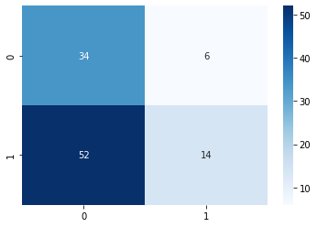

***MultinomialHMM With Tuning(30-70 Split)* :-**

**from** **sklearn.model_selection** **import** train_test_split

X_train, X_test, y_train, y_test = train_test_split(X,y,train_size=0.3,test_size=0.7,random_state=10)

**from** **sklearn.preprocessing** **import** StandardScaler

sc = StandardScaler()

X_train = sc.fit_transform(X_train)

X_test = sc.transform(X_test)

**import** **hmmlearn**

classifier = hmmlearn.hmm.MultinomialHMM(n_components=4, random_state=15,n_iter=10,algorithm='viterbi',params='ste')

**import** **math**

row = len(X_train)

col = len(X_train[0])

new = [1] * 33

**for** i **in** range(row):

**for** j **in** range(col):

X_train[i][j] = X_train[i][j]*10

X_train[i][j] = math.floor(X_train[i][j])

x = X_train[i].astype(np.int)

new = np.vstack([new,x])

y = new

y = np.absolute(y)

X_train = y

**import** **math**

row = len(X_test)

col = len(X_test[0])

new

**for** i **in** range(row):

**for** j **in** range(col):

X_test[i][j] = X_test[i][j]*10

X_test[i][j] = math.floor(X_test[i][j])

x = X_test[i].astype(np.int)

new = np.vstack([new,x])

y = new

y = np.absolute(y)

X_test = y

classifier.fit(X_train)

y_pred = classifier.predict(X_test)

size = len(y_pred)

strings = np.empty(size, np.unicode_)

**for** i **in** range (size):

**if** y_pred[i] == 1:

strings[i] = ("g")

**else**:

strings[i] = ("b")

strings

strings = strings[0:106]

**from** **sklearn.metrics** **import** classification_report, confusion_matrix, accuracy_score

print("Confusion Matrix:")

print(confusion_matrix(y_test, strings))

print("--------------------------------------------------")

print("--------------------------------------------------")

print("Performance Evaluation")

print(classification_report(y_test, strings))

print("--------------------------------------------------")

print("--------------------------------------------------")

print("Accuracy:")

print(accuracy_score(y_test, strings))

**import** **matplotlib.pyplot** **as** **plt**

**import** **seaborn** **as** **sns**

cm = confusion_matrix(y_test, strings)

sns.heatmap(cm, annot=**True**, fmt="d",cmap='Blues')

plt.show()

Confusion Matrix:

[[ 17 67]

[ 31 131]]

--------------------------------------------------

--------------------------------------------------

Performance Evaluation

precision recall f1-score support

b 0.35 0.20 0.26 84

g 0.66 0.81 0.73 162

accuracy 0.60 246

macro avg 0.51 0.51 0.49 246

weighted avg 0.56 0.60 0.57 246

--------------------------------------------------

--------------------------------------------------

Accuracy:

0.6016260162601627

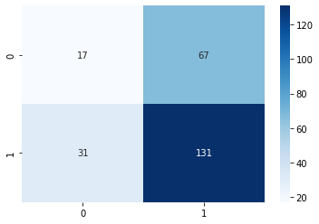

**The maximum accuracy was achieved when the Train-Test split ratio was 70:30, which was achieved by using the Gaussian Model. The maximum range of accuracies was achieved by the Gaussian Model, followed by the GMMHMM model, which is followed by the MultinomialHMM model.**

**3) Breast Cancer Dataset**

***Importing the Dataset***

**import** **pandas** **as** **pd**

**import** **numpy** **as** **np**

*# Dataset Preparation*

df = pd.read_csv("wdbc.data",header=**None**)

col_name = ['1','Class','3','4','5','6','7','8','9','10','11','12','13','14','15','16','17','18','19'

,'20','21','22','23','24','25','26','27','28','29','30','31','32']

df.columns = col_name

X = df.drop(['1','Class'], axis=1)

y = df['Class']

***GaussianHMM Without Tuning(70-30 Split)* :-**

**from** **sklearn.model_selection** **import** train_test_split

X_train, X_test, y_train, y_test = train_test_split(X,y,train_size=0.7,test_size=0.3,random_state=10)

**from** **sklearn.preprocessing** **import** StandardScaler

sc = StandardScaler()

X_train = sc.fit_transform(X_train)

X_test = sc.transform(X_test)

**from** **hmmlearn** **import** hmm

classifier = hmm.GaussianHMM(n_components=2, covariance_type="full")

classifier.fit(X_train)

y_pred = classifier.predict(X_test)

size = len(y_pred)

strings = np.empty(size, np.unicode_)

**for** i **in** range (size):

**if** y_pred[i] == 1:

strings[i] = ("M")

**else**:

strings[i] = ("B")

strings

**from** **sklearn.metrics** **import** classification_report, confusion_matrix, accuracy_score

print("Confusion Matrix:")

print(confusion_matrix(y_test, strings))

print("--------------------------------------------------")

print("--------------------------------------------------")

print("Performance Evaluation")

print(classification_report(y_test, strings))

print("--------------------------------------------------")

print("--------------------------------------------------")

print("Accuracy:")

print(accuracy_score(y_test, strings))

**import** **matplotlib.pyplot** **as** **plt**

**import** **seaborn** **as** **sns**

cm = confusion_matrix(y_test, strings)

sns.heatmap(cm, annot=**True**, fmt="d",cmap='Blues')

plt.show()

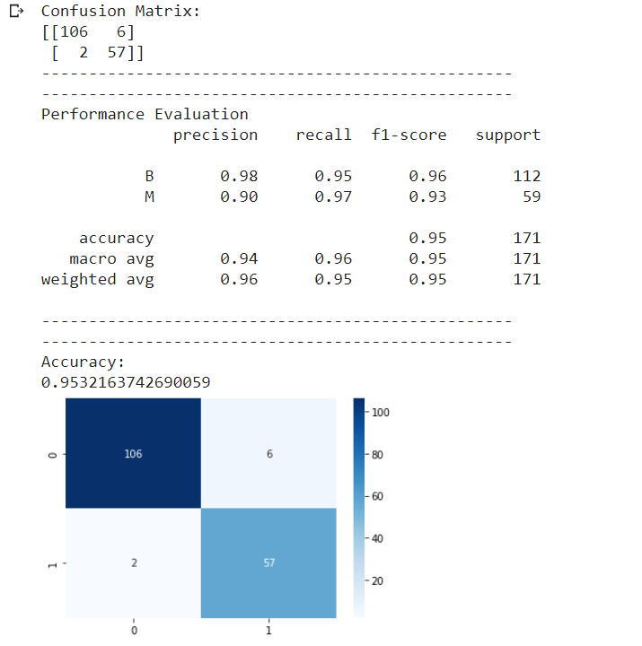

***GaussianHMM With Tuning(70-30 Split)* :-**

**from** **sklearn.model_selection** **import** train_test_split

X_train, X_test, y_train, y_test = train_test_split(X,y,train_size=0.7,test_size=0.3,random_state=10)

**from** **sklearn.preprocessing** **import** StandardScaler

sc = StandardScaler()

X_train = sc.fit_transform(X_train)

X_test = sc.transform(X_test)

**from** **hmmlearn** **import** hmm

classifier = hmm.GaussianHMM(n_components=2, covariance_type="full",n_iter=10,algorithm='viterbi',verbose=**False**)

classifier.fit(X_train)

y_pred = classifier.predict(X_test)

size = len(y_pred)

strings = np.empty(size, np.unicode_)

**for** i **in** range (size):

**if** y_pred[i] == 1:

strings[i] = ("M")

**else**:

strings[i] = ("B")

strings

**from** **sklearn.metrics** **import** classification_report, confusion_matrix, accuracy_score

print("Confusion Matrix:")

print(confusion_matrix(y_test, strings))

print("--------------------------------------------------")

print("--------------------------------------------------")

print("Performance Evaluation")

print(classification_report(y_test, strings))

print("--------------------------------------------------")

print("--------------------------------------------------")

print("Accuracy:")

print(accuracy_score(y_test, strings))

**import** **matplotlib.pyplot** **as** **plt**

**import** **seaborn** **as** **sns**

cm = confusion_matrix(y_test, strings)

sns.heatmap(cm, annot=**True**, fmt="d",cmap='Blues')

plt.show()

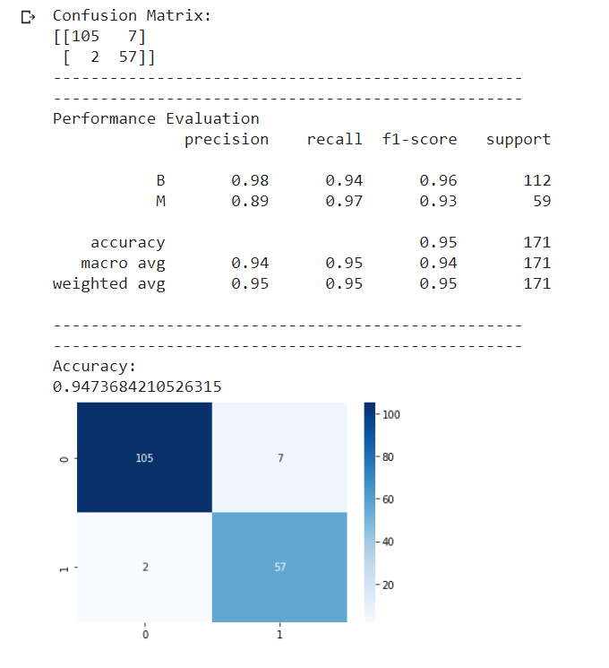

***GMMHMM Without Tuning(70-30 Split)* :-**

**from** **sklearn.model_selection** **import** train_test_split

X_train, X_test, y_train, y_test = train_test_split(X,y,train_size=0.7,test_size=0.3,random_state=10)

**from** **sklearn.preprocessing** **import** StandardScaler

sc = StandardScaler()

X_train = sc.fit_transform(X_train)

X_test = sc.transform(X_test)

**import** **hmmlearn**

classifier = hmmlearn.hmm.GMMHMM(n_components=2, random_state=10)

classifier.fit(X_train)

y_pred = classifier.predict(X_test)

size = len(y_pred)

strings = np.empty(size, np.unicode_)

**for** i **in** range (size):

**if** y_pred[i] == 1:

strings[i] = ("M")

**else**:

strings[i] = ("B")

strings

**from** **sklearn.metrics** **import** classification_report, confusion_matrix, accuracy_score

print("Confusion Matrix:")

print(confusion_matrix(y_test, strings))

print("--------------------------------------------------")

print("--------------------------------------------------")

print("Performance Evaluation")

print(classification_report(y_test, strings))

print("--------------------------------------------------")

print("--------------------------------------------------")

print("Accuracy:")

print(accuracy_score(y_test, strings))

**import** **matplotlib.pyplot** **as** **plt**

**import** **seaborn** **as** **sns**

cm = confusion_matrix(y_test, strings)

sns.heatmap(cm, annot=**True**, fmt="d",cmap='Blues')

plt.show()

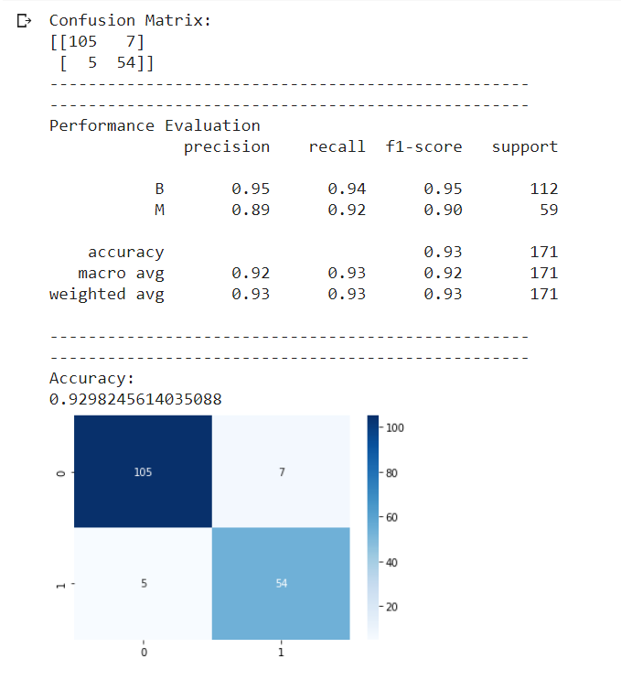

***GMMHMM With Tuning(70-30 Split)* :-**

**from** **sklearn.model_selection** **import** train_test_split

X_train, X_test, y_train, y_test = train_test_split(X,y,train_size=0.7,test_size=0.3,random_state=10)

**from** **sklearn.preprocessing** **import** StandardScaler

sc = StandardScaler()

X_train = sc.fit_transform(X_train)

X_test = sc.transform(X_test)

**import** **hmmlearn**

classifier = hmmlearn.hmm.GMMHMM(n_components=2, random_state=10,covariance_type='diag',algorithm='viterbi',n_iter=10)

classifier.fit(X_train)

y_pred = classifier.predict(X_test)

size = len(y_pred)

strings = np.empty(size, np.unicode_)

**for** i **in** range (size):

**if** y_pred[i] == 1:

strings[i] = ("M")

**else**:

strings[i] = ("B")

strings

**from** **sklearn.metrics** **import** classification_report, confusion_matrix, accuracy_score

print("Confusion Matrix:")

print(confusion_matrix(y_test, strings))

print("--------------------------------------------------")

print("--------------------------------------------------")

print("Performance Evaluation")

print(classification_report(y_test, strings))

print("--------------------------------------------------")

print("--------------------------------------------------")

print("Accuracy:")

print(accuracy_score(y_test, strings))

**import** **matplotlib.pyplot** **as** **plt**

**import** **seaborn** **as** **sns**

cm = confusion_matrix(y_test, strings)

sns.heatmap(cm, annot=**True**, fmt="d",cmap='Blues')

plt.show()



***MultinomialHMM With Tuning(70-30 Split)* :-**

**from** **sklearn.model_selection** **import** train_test_split

X_train, X_test, y_train, y_test = train_test_split(X,y,train_size=0.7,test_size=0.3,random_state=10)

**from** **sklearn.preprocessing** **import** StandardScaler

sc = StandardScaler()

X_train = sc.fit_transform(X_train)

X_test = sc.transform(X_test)

**import** **hmmlearn**

classifier = hmmlearn.hmm.MultinomialHMM(n_components=4, random_state=15,n_iter=10,algorithm='viterbi',params='ste')

**import** **math**

row = len(X_train)

col = len(X_train[0])

new

**for** i **in** range(row):

**for** j **in** range(col):

X_train[i][j] = X_train[i][j]*10

X_train[i][j] = math.floor(X_train[i][j])

x = X_train[i].astype(np.int)

new = np.vstack([new,x])

y = new

y = np.absolute(y)

X_train = y

**import** **math**

row = len(X_test)

col = len(X_test[0])

new

**for** i **in** range(row):

**for** j **in** range(col):

X_test[i][j] = X_test[i][j]*10

X_test[i][j] = math.floor(X_test[i][j])

x = X_test[i].astype(np.int)

new = np.vstack([new,x])

y = new

y = np.absolute(y)

X_test = y

classifier.fit(X_train)

y_pred = classifier.predict(X_test)

size = len(y_pred)

strings = np.empty(size, np.unicode_)

**for** i **in** range (size):

**if** y_pred[i] == 1:

strings[i] = ("M")

**else**:

strings[i] = ("B")

strings

strings = strings[0:171]

**from** **sklearn.metrics** **import** classification_report, confusion_matrix, accuracy_score

print("Confusion Matrix:")

print(confusion_matrix(y_test, strings))

print("--------------------------------------------------")

print("--------------------------------------------------")

print("Performance Evaluation")

print(classification_report(y_test, strings))

print("--------------------------------------------------")

print("--------------------------------------------------")

print("Accuracy:")

print(accuracy_score(y_test, strings))

**import** **matplotlib.pyplot** **as** **plt**

**import** **seaborn** **as** **sns**

cm = confusion_matrix(y_test, strings)

sns.heatmap(cm, annot=**True**, fmt="d",cmap='Blues')

plt.show()

Confusion Matrix:

[[79 33]

[40 19]]

--------------------------------------------------

--------------------------------------------------

Performance Evaluation

precision recall f1-score support

B 0.66 0.71 0.68 112

M 0.37 0.32 0.34 59

accuracy 0.57 171

macro avg 0.51 0.51 0.51 171

weighted avg 0.56 0.57 0.57 171

--------------------------------------------------

--------------------------------------------------

Accuracy:

0.5730994152046783

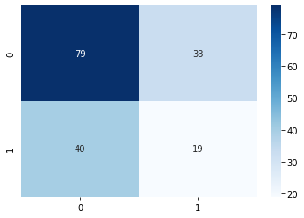

**The maximum accuracy was achieved when the Train-Test split ratio was 70:30, which was achieved by using the Gaussian Model. The maximum range of accuracies was achieved by the Gaussian Model, followed by the GMMHMM model, which is followed by the MultinomialHMM model.**

1. **CIFAR-10**

***Importing dataset* :-**

**import** **pandas** **as** **pd**

**import** **numpy** **as** **np**

**import** **matplotlib.pyplot** **as** **plt**

**import** **tensorflow** **as** **tf**

*# dataset preparation*

**from** **tensorflow.keras** **import** datasets,layers,models

(train_images,train_labels) , (test_images,test_labels) = datasets.cifar10.load_data()

*# Normalize pixel values to be within 0 , 1*

train_images , test_images = train_images/255.0 , test_images/255.0

input_shape = train_images[0].shape

model = models.Sequential()

model.add(layers.Conv2D(32,(3,3),activation='relu',input_shape=input_shape))

model.add(layers.MaxPool2D(2,2))

model.add(layers.Conv2D(64,(3,3),activation='relu'))

model.add(layers.MaxPool2D(2,2))

model.add(layers.Conv2D(64,(3,3),activation='relu'))

model.add(layers.Flatten())

model.add(layers.Dense(64,activation='relu'))

model.add(layers.Dense(10))

model.summary()

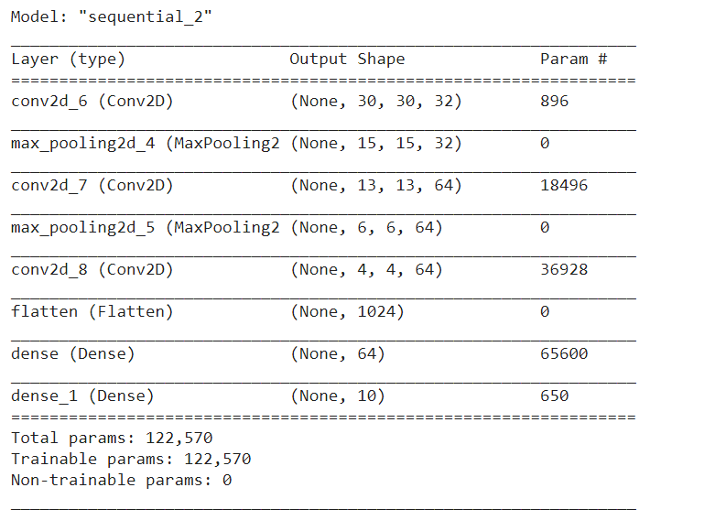

model.compile(optimizer='adam',loss=tf.keras.losses.SparseCategoricalCrossentropy(from_logits=**True**),metrics=['accuracy'])

history = model.fit(train_images,train_labels,epochs=20,validation_data=(test_images,test_labels))

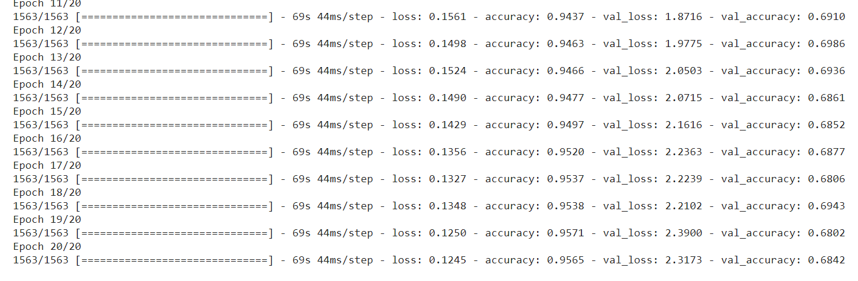

plt.plot(history.history['accuracy'],label='accuracy')

plt.plot(history.history['val_accuracy'],label='val_accuracy')

plt.xlabel('epoch')

plt.ylabel('accuracy')

plt.ylim([0.5,1])

plt.legend(loc='lower right')

plt.show()

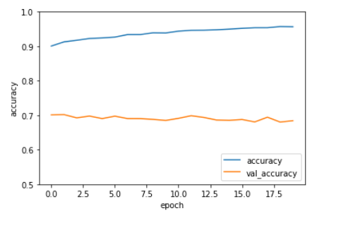

test_loss , test_acc = model.evaluate(test_images,test_labels,verbose=2)

313/313 - 3s - loss: 2.3173 - accuracy: 0.6842

**2) MNIST**

***Importing the Dataset :-***

**import** **pandas** **as** **pd**

**import** **numpy** **as** **np**

**import** **matplotlib.pyplot** **as** **plt**

**import** **tensorflow** **as** **tf**

*# dataset preparation*

**from** **tensorflow.keras** **import** datasets,layers,models

(train_images,train_labels) , (test_images,test_labels) = datasets.mnist.load_data()

*# Normalize pixel values to be within 0 , 1*

train_images , test_images = train_images/255.0 , test_images/255.0

train_images = np.reshape(train_images, train_images.shape + (1,))

test_images = np.reshape(test_images, test_images.shape + (1,))

train_images[0].shape

model = models.Sequential()

model.add(layers.Conv2D(32,(3,3),activation='relu',input_shape=(28,28,1)))

model.add(layers.MaxPool2D(2,2))

model.add(layers.Conv2D(64,(3,3),activation='relu'))

model.add(layers.MaxPool2D(2,2))

model.add(layers.Conv2D(64,(3,3),activation='relu'))

model.add(layers.Flatten())

model.add(layers.Dense(64,activation='relu'))

model.add(layers.Dense(10))

model.summary()

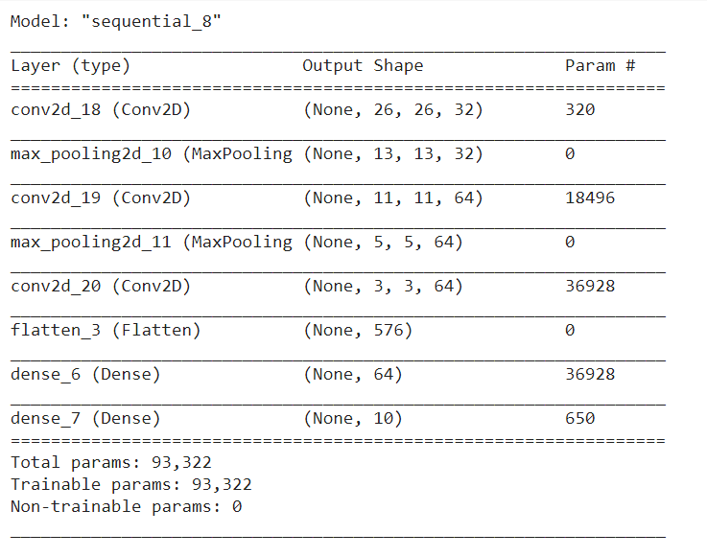

model.compile(optimizer='adam',loss=tf.keras.losses.SparseCategoricalCrossentropy(from_logits=**True**),metrics=['accuracy'])

history = model.fit(train_images,train_labels,epochs=20,validation_data=(test_images,test_labels))

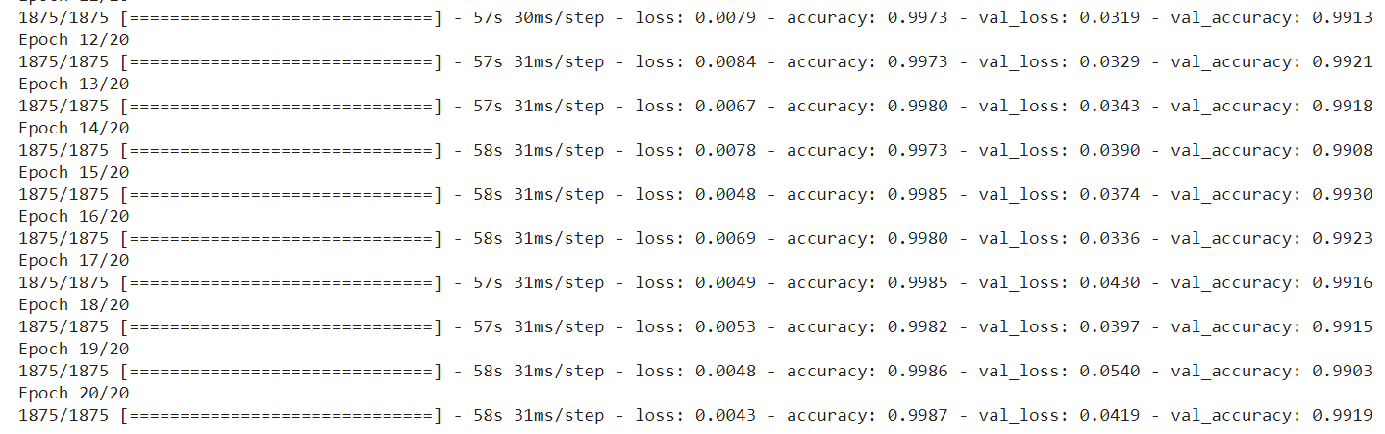

plt.plot(history.history['accuracy'],label='accuracy')

plt.plot(history.history['val_accuracy'],label='val_accuracy')

plt.xlabel('epoch')

plt.ylabel('accuracy')

plt.ylim([0.5,1])

plt.legend(loc='lower right')

plt.show()

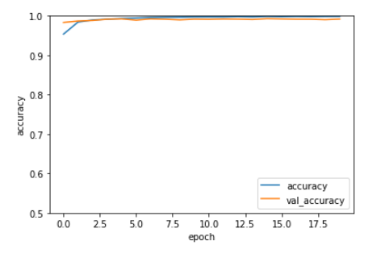

test_loss , test_acc = model.evaluate(test_images,test_labels,verbose=2)

313/313 - 3s - loss: 0.0419 - accuracy: 0.9919

**3) SAVEE**

***Importing the Dataset :-***

!unzip "/content/drive/MyDrive/SaveeDataset.zip"

**import** **librosa**

**import** **numpy** **as** **np**

input_length = 16000*5

batch_size = 32

n_mels = 320

**def** preprocess_audio_mel_T(audio, sample_rate=16000, window_size=20, *#log_specgram*

step_size=10, eps=1e-10):

mel_spec = librosa.feature.melspectrogram(y=audio, sr=sample_rate, n_mels= n_mels)

mel_db = (librosa.power_to_db(mel_spec, ref=np.max) + 40)/40

**return** mel_db.T

**def** load_audio_file(file_path, input_length=input_length):

data = librosa.core.load(file_path, sr=16000)[0] *#, sr=16000*

**if** len(data)>input_length:

max_offset = len(data)-input_length

offset = np.random.randint(max_offset)

data = data[offset:(input_length+offset)]

**else**:

**if** input_length > len(data):

max_offset = input_length - len(data)

offset = np.random.randint(max_offset)

**else**:

offset = 0

data = np.pad(data, (offset, input_length - len(data) - offset), "constant")

data = preprocess_audio_mel_T(data)

**return** data

**import** **os**

**from** **scipy.io** **import** wavfile

**import** **librosa**

**import** **matplotlib.pyplot** **as** **plt**

**import** **numpy** **as** **np**

rootDirectory = "/content/AudioData/"

personNames = ["DC","JE","JK","KL"]

classes = ["a" , "d" , "f", "h", "n", "sa" , "su" ]

X = list()

y = list()

**for** person **in** personNames:

directory = os.path.join(rootDirectory,person)

**for** filename **in** os.listdir(directory):

filePath = os.path.join(directory, filename)

data = load_audio_file(file_path=filePath)

data = np.reshape(data, data.shape + (1,))

**if**(filename[0:1] **in** classes):

X.append(data)

y.append(classes.index(filename[0:1]))

**elif**(filename[0:2] **in** classes):

X.append(data)

y.append(classes.index(filename[0:2]))

X = np.asarray(X, dtype=np.float32)

y = np.asarray(y, dtype=np.float32)

**import** **pandas** **as** **pd**

**import** **numpy** **as** **np**

**import** **matplotlib.pyplot** **as** **plt**

**import** **tensorflow** **as** **tf**

*# dataset preparation*

**from** **tensorflow.keras** **import** datasets,layers,models

**from** **sklearn.model_selection** **import** train_test_split

X_train, X_test, y_train, y_test = train_test_split(X, y, test_size=0.3, train_size= 0.7 ,random_state=10)

model = models.Sequential()

model.add(layers.Conv2D(32,(3,3),activation='relu',input_shape=(157,320,1)))

model.add(layers.MaxPool2D(2,2))

model.add(layers.Conv2D(64,(3,3),activation='relu'))

model.add(layers.MaxPool2D(2,2))

model.add(layers.Conv2D(64,(3,3),activation='relu'))

model.add(layers.Flatten())

model.add(layers.Dense(64,activation='relu'))

model.add(layers.Dense(10))

model.summary()

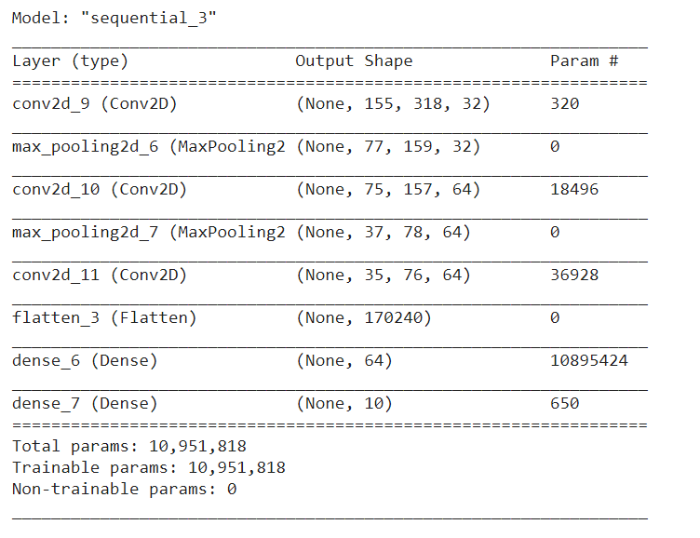

model.compile(optimizer='adam',loss=tf.keras.losses.SparseCategoricalCrossentropy(from_logits=**True**),metrics=['accuracy'])

history = model.fit(X_train,y_train,epochs=30,validation_data=(X_test,y_test))

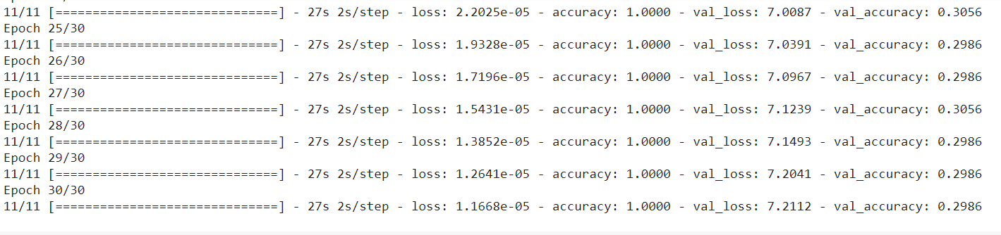

plt.plot(history.history['accuracy'],label='accuracy')

plt.plot(history.history['val_accuracy'],label='val_accuracy')

plt.xlabel('epoch')

plt.ylabel('accuracy')

plt.ylim([0.5,1])

plt.legend(loc='lower right')

plt.show()

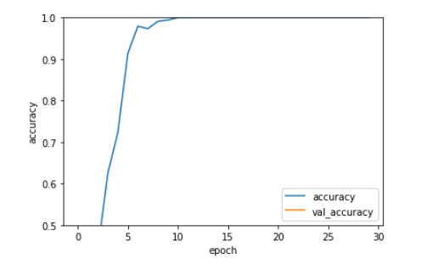

test_loss , test_acc = model.evaluate(X_test,y_test,verbose=2)

5/5 - 3s - loss: 7.2112 - accuracy: 0.2986

**4) EmoDB**

***Importing the Dataset :-***

!unzip "/content/drive/MyDrive/EmoDB.zip"

**import** **librosa**

**import** **numpy** **as** **np**

input_length = 16000*5

batch_size = 32

n_mels = 320

**def** preprocess_audio_mel_T(audio, sample_rate=16000, window_size=20, *#log_specgram*

step_size=10, eps=1e-10):

mel_spec = librosa.feature.melspectrogram(y=audio, sr=sample_rate, n_mels= n_mels)

mel_db = (librosa.power_to_db(mel_spec, ref=np.max) + 40)/40

**return** mel_db.T

**def** load_audio_file(file_path, input_length=input_length):

data = librosa.core.load(file_path, sr=16000)[0] *#, sr=16000*

**if** len(data)>input_length:

max_offset = len(data)-input_length

offset = np.random.randint(max_offset)

data = data[offset:(input_length+offset)]

**else**:

**if** input_length > len(data):

max_offset = input_length - len(data)

offset = np.random.randint(max_offset)

**else**:

offset = 0

data = np.pad(data, (offset, input_length - len(data) - offset), "constant")

data = preprocess_audio_mel_T(data)

**return** data

*# Preprocessing the dataset*

**import** **os**

**from** **scipy.io** **import** wavfile

**import** **librosa**

**import** **matplotlib.pyplot** **as** **plt**

**import** **numpy** **as** **np**

directory = "/content/wav/"

classes = ["W" ,"L" ,"E" ,"A" , "F" ,"T" ,"N" ]

X = list()

y = list()

**for** filename **in** os.listdir(directory):

filePath = os.path.join(directory, filename)

data = load_audio_file(file_path=filePath)

data = np.reshape(data, data.shape + (1,))

**if**(filename[5:6] **in** classes):

X.append(data)

y.append(classes.index(filename[5:6]))

X = np.asarray(X, dtype=np.float32)

y = np.asarray(y, dtype=np.float32)

**import** **pandas** **as** **pd**

**import** **numpy** **as** **np**

**import** **matplotlib.pyplot** **as** **plt**

**import** **tensorflow** **as** **tf**

*# dataset preparation*

**from** **tensorflow.keras** **import** datasets,layers,models

**from** **sklearn.model_selection** **import** train_test_split

X_train, X_test, y_train, y_test = train_test_split(X, y, test_size=0.3, train_size= 0.7 ,random_state=10)

model = models.Sequential()

model.add(layers.Conv2D(32,(3,3),activation='relu',input_shape=(157,320,1)))

model.add(layers.MaxPool2D(2,2))

model.add(layers.Conv2D(64,(3,3),activation='relu'))

model.add(layers.MaxPool2D(2,2))

model.add(layers.Conv2D(64,(3,3),activation='relu'))

model.add(layers.Flatten())

model.add(layers.Dense(64,activation='relu'))

model.add(layers.Dense(10))

model.summary()

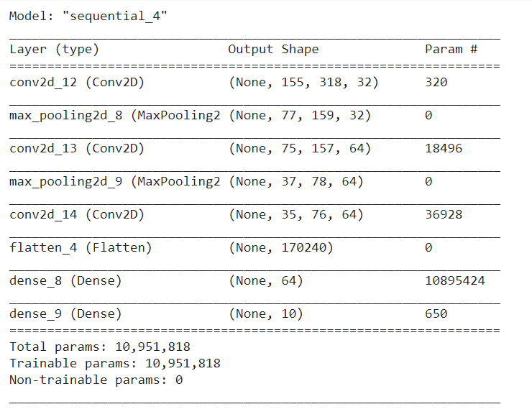

model.compile(optimizer='adam',loss=tf.keras.losses.SparseCategoricalCrossentropy(from_logits=**True**),metrics=['accuracy']) history = model.fit(X_train,y_train,epochs=20,validation_data=(X_test,y_test))

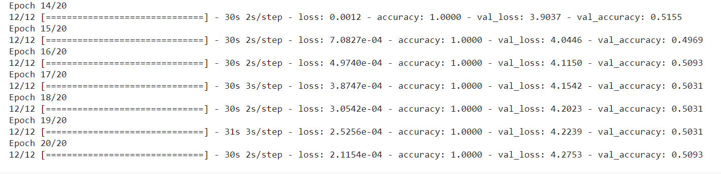

plt.plot(history.history['accuracy'],label='accuracy')

plt.plot(history.history['val_accuracy'],label='val_accuracy')

plt.xlabel('epoch')

plt.ylabel('accuracy')

plt.ylim([0,1])

plt.legend(loc='lower right')

plt.show()

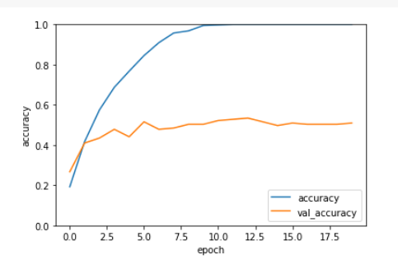

test_loss , test_acc = model.evaluate(X_test,y_test,verbose=2)

6/6 - 3s - loss: 4.2753 - accuracy: 0.5093

**It was observed that the more layers we add the higher accuracy we can achieve. At the same time, if we keep on adding more layers, the final accuracy will saturate. Also, the number of convolution and the pooling layers play an important role in training the model.**

1. **VGG-16**

**from** **google.colab** **import** drive drive.mount('/content/drive')

**import** **tensorflow** **as** **tf**

**from** **tensorflow** **import** keras

**import** **matplotlib.pyplot** **as** **plt**

%matplotlib inline

**import** **numpy** **as** **np**

**import** **skimage.transform**

**from** **__future__** **import** print_function

!pip install keras_applications

**import** **numpy** **as** **np**

**import** **warnings**

**from** **keras.models** **import** Model

**from** **keras.layers** **import** Flatten

**from** **keras.layers** **import** Dense

**from** **keras.layers** **import** Input

**from** **keras.layers** **import** Conv2D

**from** **keras.layers** **import** MaxPooling2D

**from** **keras.layers** **import** GlobalMaxPooling2D

**from** **keras.layers** **import** GlobalAveragePooling2D

**from** **keras.preprocessing** **import** image

**from** **keras.utils** **import** layer_utils

**from** **keras.utils.data_utils** **import** get_file

**from** **keras** **import** backend **as** K

**from** **keras.applications.imagenet_utils** **import** decode_predictions

**from** **keras.applications.imagenet_utils** **import** preprocess_input

**from** **keras_applications.imagenet_utils** **import** _obtain_input_shape

**from** **keras.utils.layer_utils** **import** get_source_inputs

**def** load_preprocess_training_batch(X_train):

new = []

**for** item **in** X_train:

tmpFeature = skimage.transform.resize(item, (224, 224), mode='constant')

new.append(tmpFeature)

**return** new

**def** preprocess_data(X_train):

**for** item **in** X_train:

item = np.expand_dims(item, axis=0)

item = preprocess_input(item)

**return** X_train

**And def VGG16 is also declared(which code is too long and can be available online) .**

**import** **tensorflow** **as** **tf**

**from** **tensorflow** **import** keras

**import** **matplotlib.pyplot** **as** **plt**

%matplotlib inline

**import** **numpy** **as** **np**

**import** **skimage.transform**

* 1. **CIFAR-10**

(X_train, y_train) , (X_test, y_test) = keras.datasets.cifar10.load_data()

X_train = X_train[0:2000]

y_train = y_train[0:2000]

X_test = X_test[0:2000]

y_test = y_test[0:2000]

X_train_resized = load_preprocess_training_batch(X_train)

X_test_resized = load_preprocess_training_batch(X_test)

X_train_resized = np.array(X_train_resized)

X_test_resized = np.array(X_test_resized)

X_train_resized = X_train_resized / 255

X_test_resized = X_test_resized / 255

X_train_resized = preprocess_data(X_train_resized)

X_test_resized = preprocess_data(X_test_resized)

model = VGG16(include_top=**True**, weights='imagenet')

model.compile(optimizer='SGD',

loss='sparse_categorical_crossentropy',

metrics=['accuracy'])

history = model.fit(X_train_resized, y_train, epochs=5)

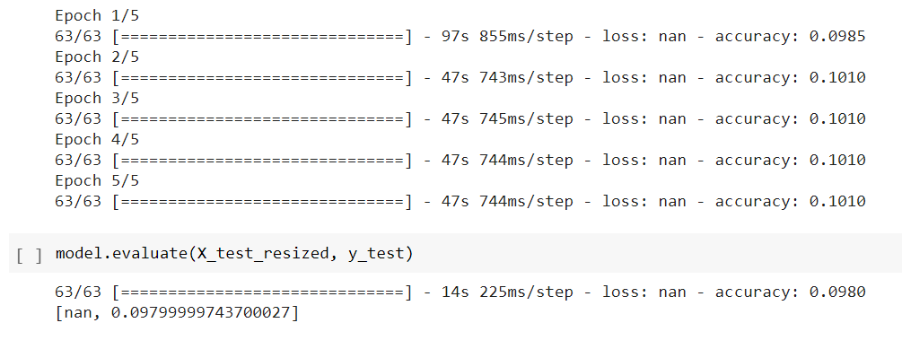

model.evaluate(X_test_resized, y_test)

[nan, 0.09799999743700027]

* 1. **MNIST**

(X_train, y_train) , (X_test, y_test) = keras.datasets.mnist.load_data()

X_train = X_train[0:2000]

y_train = y_train[0:2000]

X_test = X_test[0:2000]

y_test = y_test[0:2000]

X_train_resized = load_preprocess_training_batch(X_train)

X_test_resized = load_preprocess_training_batch(X_test)

X_train_resized = np.array(X_train_resized)

X_test_resized = np.array(X_test_resized)

X_train_resized = X_train_resized / 255.0

X_test_resized = X_test_resized / 255.0

X_train_resized = preprocess_data(X_train_resized)

X_test_resized = preprocess_data(X_test_resized)

**import** **cv2**

X_train_new = list()

**for** i **in** range(len(X_train_resized)):

g = X_train_resized[i]

X_train_new.append(cv2.merge([g,g,g]))

X_train_new = np.asarray(X_train_new,dtype=np.float32)

X_test_new = list()

**for** i **in** range(len(X_test_resized)):

g = X_test_resized[i]

X_test_new.append(cv2.merge([g,g,g]))

X_test_new = np.asarray(X_test_new,dtype=np.float32)

model = VGG16(include_top=**True**, weights='imagenet')

model.compile(optimizer='SGD',

loss='sparse_categorical_crossentropy',

metrics=['accuracy'])

history = model.fit(X_train_new, y_train, epochs=5)

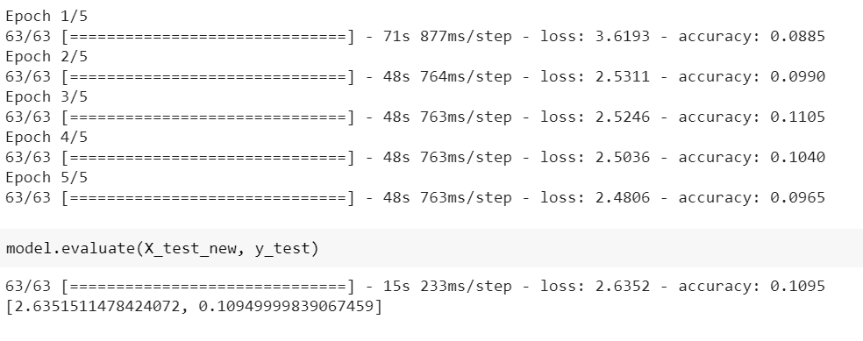

model.evaluate(X_test_new, y_test)

[2.6351511478424072, 0.10949999839067459]

* 1. **SAVEE**

!unzip "/content/drive/MyDrive/SaveeDataset.zip"

**import** **librosa**

**import** **numpy** **as** **np**

input_length = 16000*5

batch_size = 32

n_mels = 320

**def** preprocess_audio_mel_T(audio, sample_rate=16000, window_size=20, *#log_specgram*

step_size=10, eps=1e-10):

mel_spec = librosa.feature.melspectrogram(y=audio, sr=sample_rate, n_mels= n_mels)

mel_db = (librosa.power_to_db(mel_spec, ref=np.max) + 40)/40

**return** mel_db.T

**def** load_audio_file(file_path, input_length=input_length):

data = librosa.core.load(file_path, sr=16000)[0] *#, sr=16000*

**if** len(data)>input_length:

max_offset = len(data)-input_length

offset = np.random.randint(max_offset)

data = data[offset:(input_length+offset)]

**else**:

**if** input_length > len(data):

max_offset = input_length - len(data)

offset = np.random.randint(max_offset)

**else**:

offset = 0

data = np.pad(data, (offset, input_length - len(data) - offset), "constant")

data = preprocess_audio_mel_T(data)

**return** data

**import** **os**

**from** **scipy.io** **import** wavfile

**import** **librosa**

**import** **matplotlib.pyplot** **as** **plt**

**import** **numpy** **as** **np**

**import** **cv2**

rootDirectory = "/content/AudioData/"

personNames = ["DC","JE","JK","KL"]

classes = ["a" , "d" , "f", "h", "n", "sa" , "su" ]

X = list()

y = list()

**for** person **in** personNames:

directory = os.path.join(rootDirectory,person)

**for** filename **in** os.listdir(directory):

filePath = os.path.join(directory, filename)

a = load_audio_file(file_path=filePath)

data = cv2.merge([a,a,a])

*# data = np.reshape(data, data.shape + (1,))*

**if**(filename[0:1] **in** classes):

X.append(data)

y.append(classes.index(filename[0:1]))

**elif**(filename[0:2] **in** classes):

X.append(data)

y.append(classes.index(filename[0:2]))

X = np.asarray(X, dtype=np.float32)

y = np.asarray(y, dtype=np.float32)

**import** **pandas** **as** **pd**

**import** **numpy** **as** **np**

**import** **matplotlib.pyplot** **as** **plt**

**import** **tensorflow** **as** **tf**

*# dataset preparation*

**from** **tensorflow.keras** **import** datasets,layers,models

**from** **sklearn.model_selection** **import** train_test_split

X_train, X_test, y_train, y_test = train_test_split(X, y, test_size=0.5, train_size= 0.5 ,random_state=10)

X_train_resized = load_preprocess_training_batch(X_train)

X_test_resized = load_preprocess_training_batch(X_test)

X_train_resized = np.array(X_train_resized)

X_test_resized = np.array(X_test_resized)

X_train_resized = preprocess_data(X_train_resized)

X_test_resized = preprocess_data(X_test_resized)

model = VGG16(include_top=**True**, weights='imagenet')

model.compile(optimizer='SGD',

loss='sparse_categorical_crossentropy',

metrics=['accuracy'])

history = model.fit(X_train_resized, y_train, epochs=50)

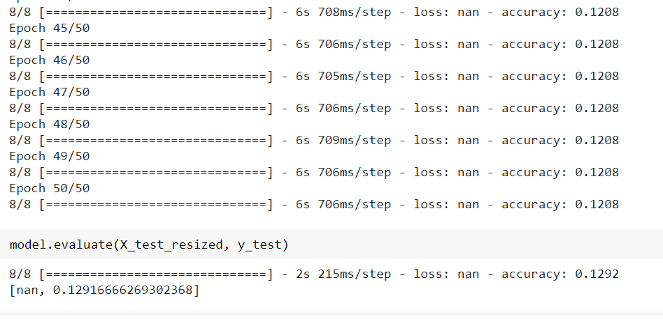

model.evaluate(X_test_resized, y_test)

[nan, 0.12916666269302368]

* 1. **EmoDB**

!unzip "/content/drive/MyDrive/EmoDB.zip"

**import** **librosa**

**import** **numpy** **as** **np**

input_length = 16000*5

batch_size = 32

n_mels = 320

**def** preprocess_audio_mel_T(audio, sample_rate=16000, window_size=20, *#log_specgram*

step_size=10, eps=1e-10):

mel_spec = librosa.feature.melspectrogram(y=audio, sr=sample_rate, n_mels= n_mels)

mel_db = (librosa.power_to_db(mel_spec, ref=np.max) + 40)/40

**return** mel_db.T

**def** load_audio_file(file_path, input_length=input_length):

data = librosa.core.load(file_path, sr=16000)[0] *#, sr=16000*

**if** len(data)>input_length:

max_offset = len(data)-input_length

offset = np.random.randint(max_offset)

data = data[offset:(input_length+offset)]

**else**:

**if** input_length > len(data):

max_offset = input_length - len(data)

offset = np.random.randint(max_offset)

**else**:

offset = 0

data = np.pad(data, (offset, input_length - len(data) - offset), "constant")

data = preprocess_audio_mel_T(data)

return data

**import** **os**

**from** **scipy.io** **import** wavfile

**import** **librosa**

**import** **matplotlib.pyplot** **as** **plt**

**import** **numpy** **as** **np**

**import** **cv2**

directory = "/content/wav/"

classes = ["W" ,"L" ,"E" ,"A" , "F" ,"T" ,"N" ]

X = list()

y = list()

**for** filename **in** os.listdir(directory):

filePath = os.path.join(directory, filename)

a = load_audio_file(file_path=filePath)

data = cv2.merge([a,a,a])

**if**(filename[5:6] **in** classes):

X.append(data)

y.append(classes.index(filename[5:6]))

X = np.asarray(X, dtype=np.float32)

y = np.asarray(y, dtype=np.float32)

**import** **pandas** **as** **pd**

**import** **numpy** **as** **np**

**import** **matplotlib.pyplot** **as** **plt**

**import** **tensorflow** **as** **tf**

*# dataset preparation*

**from** **tensorflow.keras** **import** datasets,layers,models

**from** **sklearn.model_selection** **import** train_test_split

X_train, X_test, y_train, y_test = train_test_split(X, y, test_size=0.5, train_size= 0.5 ,random_state=10)

X_train_resized = load_preprocess_training_batch(X_train)

X_test_resized = load_preprocess_training_batch(X_test)

X_train_resized = np.array(X_train_resized)

X_test_resized = np.array(X_test_resized)

X_train_resized = preprocess_data(X_train_resized)

X_test_resized = preprocess_data(X_test_resized)

model = VGG16(include_top=**True**, weights='imagenet')

model.compile(optimizer='SGD',

loss='sparse_categorical_crossentropy',

metrics=['accuracy'])

history = model.fit(X_train_resized, y_train, epochs=20)

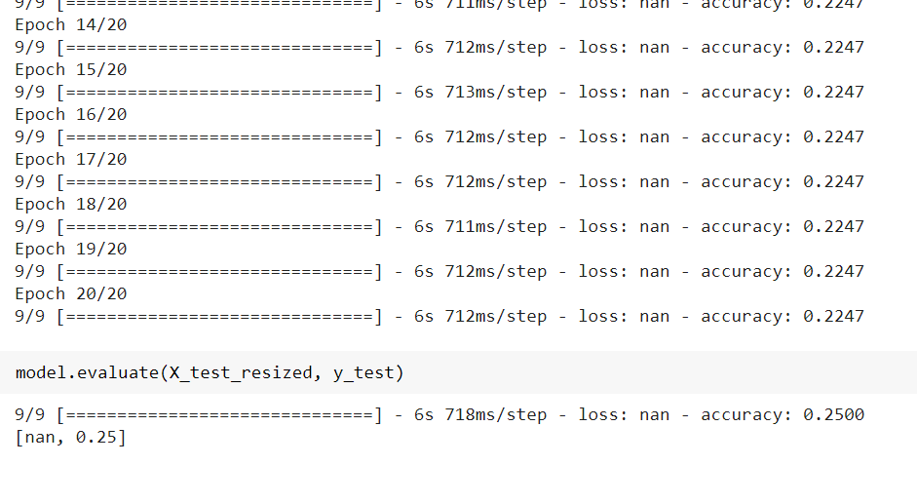

model.evaluate(X_test_resized, y_test)

[nan, 0.25]

**The entire model can be broken down into 5 blocks, where each block contains 3 convolution and 1 max-pooling layers.**

**Looking at the complexity of the model and the limitations of google colab, I have reduced the input size for the model,i.e., i have taken 2000 training data points and 2000 testing data points.**

1. **ResNet-50**
2. from google.colab import drive
3. drive.mount('/content/drive')
4. from __future__ import print_function
5. import numpy as np
6. import warnings
7. !pip install keras_applications
8. from keras.layers import Input
9. from keras import layers
10. from keras.layers import Dense
11. from keras.layers import Activation
12. from keras.layers import Flatten
13. from keras.layers import Conv2D
14. from keras.layers import MaxPooling2D
15. from keras.layers import GlobalMaxPooling2D
16. from keras.layers import ZeroPadding2D
17. from keras.layers import AveragePooling2D
18. from keras.layers import GlobalAveragePooling2D
19. from keras.layers import BatchNormalization
20. from keras.models import Model
21. from keras.preprocessing import image
22. import keras.backend as K
23. from keras.utils import layer_utils
24. from keras.utils.data_utils import get_file
25. from keras.applications.imagenet_utils import decode_predictions
26. from keras.applications.imagenet_utils import preprocess_input
27. from keras_applications.imagenet_utils import _obtain_input_shape
28. from keras.utils.layer_utils import get_source_inputs
29. import tensorflow as tf
30. from tensorflow import keras
31. import matplotlib.pyplot as plt
32. %matplotlib inline
33. import numpy as np
34. import skimage.transform

**And def ResNet50 is also declared(which code is too long and can be available online) .**

def load_preprocess_training_batch(X_train):

    new = []

    for item in X_train:

        tmpFeature = skimage.transform.resize(item, (224, 224), mode='constant')

        new.append(tmpFeature)

    return new

def preprocess_data(X_train):

    for item in X_train:

      item = np.expand_dims(item, axis=0)

      item = preprocess_input(item)

    return X_train

**2.1) CIFAR-10**

(X_train, y_train) , (X_test, y_test) = keras.datasets.cifar10.load_data()

X_train = X_train[0:2000]

y_train = y_train[0:2000]

X_test = X_test[0:2000]

y_test = y_test[0:2000]

X_train_resized = load_preprocess_training_batch(X_train)

X_test_resized = load_preprocess_training_batch(X_test)

X_train_resized = np.array(X_train_resized)

X_test_resized = np.array(X_test_resized)

X_train_resized = X_train_resized / 255

X_test_resized = X_test_resized / 255

X_train_resized = preprocess_data(X_train_resized)

X_test_resized = preprocess_data(X_test_resized)

model = ResNet50(include_top=True, weights='imagenet')

model.compile(optimizer='SGD',

              loss='sparse_categorical_crossentropy',

              metrics=['accuracy'])

history = model.fit(X_train_resized, y_train, epochs=5)

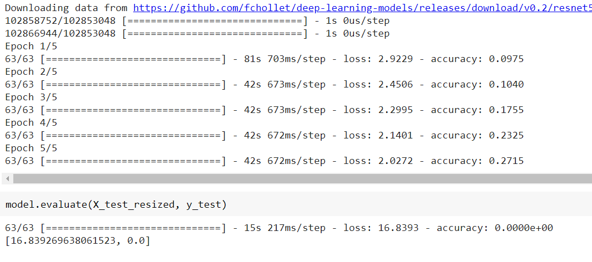

**2.2) MNIST**

(X_train, y_train) , (X_test, y_test) = keras.datasets.mnist.load_data()

X_train = X_train[0:2000]

y_train = y_train[0:2000]

X_test = X_test[0:2000]

y_test = y_test[0:2000]

X_train_resized = load_preprocess_training_batch(X_train)

X_test_resized = load_preprocess_training_batch(X_test)

X_train_resized = np.array(X_train_resized)

X_test_resized = np.array(X_test_resized)

X_train_resized = X_train_resized / 255.0

X_test_resized = X_test_resized / 255.0

X_train_resized = preprocess_data(X_train_resized)

X_test_resized = preprocess_data(X_test_resized)

import cv2

X_train_new = list()

for i in range(len(X_train_resized)):

  g  = X_train_resized[i]

  X_train_new.append(cv2.merge([g,g,g]))

X_train_new = np.asarray(X_train_new,dtype=np.float32)

X_test_new = list()

for i in range(len(X_test_resized)):

  g  = X_test_resized[i]

  X_test_new.append(cv2.merge([g,g,g]))

X_test_new = np.asarray(X_test_new,dtype=np.float32)

model = ResNet50(include_top=True, weights='imagenet')

model.compile(optimizer='SGD',

              loss='sparse_categorical_crossentropy',

              metrics=['accuracy'])

history = model.fit(X_train_new, y_train, epochs=10)

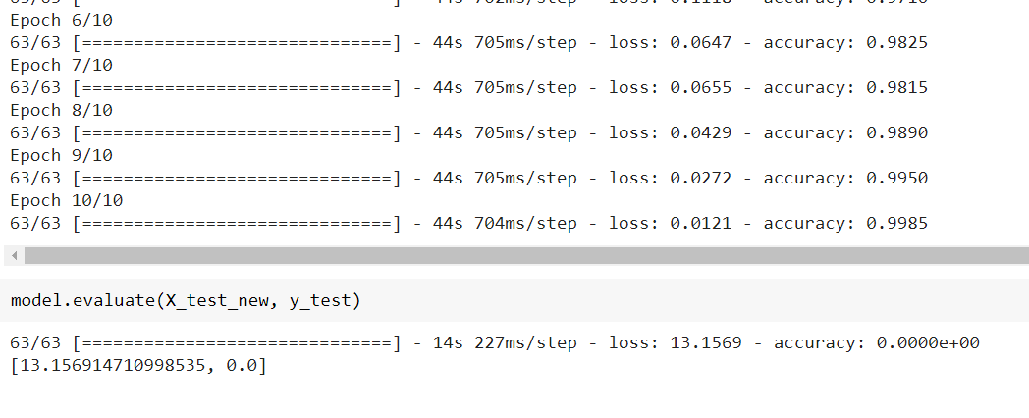

**2.3) SAVEE**

!unzip "/content/drive/MyDrive/SaveeDataset.zip"

import librosa

import numpy as np

input_length = 16000*5

batch_size = 32

n_mels = 320

def preprocess_audio_mel_T(audio, sample_rate=16000, window_size=20, #log_specgram

                 step_size=10, eps=1e-10):

    mel_spec = librosa.feature.melspectrogram(y=audio, sr=sample_rate, n_mels= n_mels)

    mel_db = (librosa.power_to_db(mel_spec, ref=np.max) + 40)/40

    return mel_db.T

def load_audio_file(file_path, input_length=input_length):

  data = librosa.core.load(file_path, sr=16000)[0] #, sr=16000

  if len(data)>input_length:

    max_offset = len(data)-input_length

    offset = np.random.randint(max_offset)

    data = data[offset:(input_length+offset)]

  else:

    if input_length > len(data):

      max_offset = input_length - len(data)

      offset = np.random.randint(max_offset)

    else:

      offset = 0

    data = np.pad(data, (offset, input_length - len(data) - offset), "constant")

  data = preprocess_audio_mel_T(data)

  return data

# Preprocessing the dataset

import os

from scipy.io import wavfile

import librosa

import matplotlib.pyplot as plt

import numpy as np

import cv2

rootDirectory = "/content/AudioData/"

personNames = ["DC","JE","JK","KL"]

classes = ["a" , "d" , "f", "h", "n", "sa" , "su" ]

X = list()

y = list()

for person in personNames:

  directory = os.path.join(rootDirectory,person)

  for filename in os.listdir(directory):

    filePath = os.path.join(directory, filename)

    a = load_audio_file(file_path=filePath)

    data = cv2.merge([a,a,a])

    # data = np.reshape(data, data.shape + (1,))

    if(filename[0:1] in classes):

      X.append(data)

      y.append(classes.index(filename[0:1]))

    elif(filename[0:2] in classes):

      X.append(data)

      y.append(classes.index(filename[0:2]))

X = np.asarray(X, dtype=np.float32)

y = np.asarray(y, dtype=np.float32)

import pandas as pd

import numpy as np

import matplotlib.pyplot as plt

import tensorflow as tf

# dataset preparation

from tensorflow.keras import datasets,layers,models

from sklearn.model_selection import train_test_split

X_train, X_test, y_train, y_test = train_test_split(X, y, test_size=0.5, train_size= 0.5 ,random_state=10)

X_train_resized = load_preprocess_training_batch(X_train)

X_test_resized = load_preprocess_training_batch(X_test)

X_train_resized = np.array(X_train_resized)

X_test_resized = np.array(X_test_resized)

X_train_resized = preprocess_data(X_train_resized)

X_test_resized = preprocess_data(X_test_resized)

model = ResNet50(include_top=True, weights='imagenet')

model.compile(optimizer='SGD',

              loss='sparse_categorical_crossentropy',

              metrics=['accuracy'])

history = model.fit(X_train_resized, y_train, epochs=10)

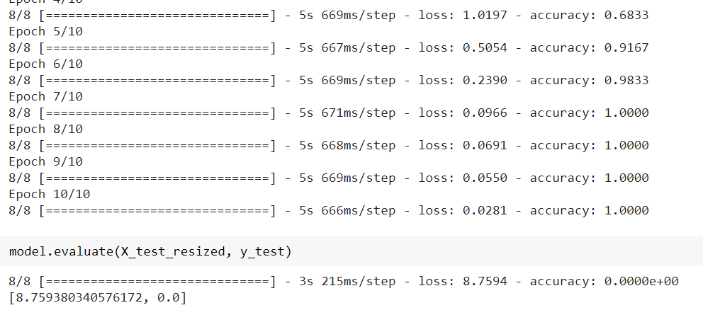

**2.4) EmoDB**

!unzip "/content/drive/MyDrive/EmoDB.zip"

import librosa

import numpy as np

input_length = 16000*5

batch_size = 32

n_mels = 320

def preprocess_audio_mel_T(audio, sample_rate=16000, window_size=20, #log_specgram

                 step_size=10, eps=1e-10):

    mel_spec = librosa.feature.melspectrogram(y=audio, sr=sample_rate, n_mels= n_mels)

    mel_db = (librosa.power_to_db(mel_spec, ref=np.max) + 40)/40

    return mel_db.T

def load_audio_file(file_path, input_length=input_length):

  data = librosa.core.load(file_path, sr=16000)[0] #, sr=16000

  if len(data)>input_length:

    max_offset = len(data)-input_length

    offset = np.random.randint(max_offset)

    data = data[offset:(input_length+offset)]

  else:

    if input_length > len(data):

      max_offset = input_length - len(data)

      offset = np.random.randint(max_offset)

    else:

      offset = 0

    data = np.pad(data, (offset, input_length - len(data) - offset), "constant")

  data = preprocess_audio_mel_T(data)

  return data

# Preprocessing the dataset

import os

from scipy.io import wavfile

import librosa

import matplotlib.pyplot as plt

import numpy as np

import cv2

directory = "/content/wav/"

classes = ["W" ,"L" ,"E" ,"A" , "F" ,"T" ,"N" ]

X = list()

y = list()

for filename in os.listdir(directory):

  filePath = os.path.join(directory, filename)

  a = load_audio_file(file_path=filePath)

  data = cv2.merge([a,a,a])

  if(filename[5:6] in classes):

    X.append(data)

    y.append(classes.index(filename[5:6]))

X = np.asarray(X, dtype=np.float32)

y = np.asarray(y, dtype=np.float32)

import pandas as pd

import numpy as np

import matplotlib.pyplot as plt

import tensorflow as tf

# dataset preparation

from tensorflow.keras import datasets,layers,models

from sklearn.model_selection import train_test_split

X_train, X_test, y_train, y_test = train_test_split(X, y, test_size=0.5, train_size= 0.5 ,random_state=10)

X_train_resized = load_preprocess_training_batch(X_train)

X_test_resized = load_preprocess_training_batch(X_test)

X_train_resized = np.array(X_train_resized)

X_test_resized = np.array(X_test_resized)

X_train_resized = preprocess_data(X_train_resized)

X_test_resized = preprocess_data(X_test_resized)

model = ResNet50(include_top=True, weights='imagenet')

model.compile(optimizer='SGD',

              loss='sparse_categorical_crossentropy',

              metrics=['accuracy'])

history = model.fit(X_train_resized, y_train, epochs=10)

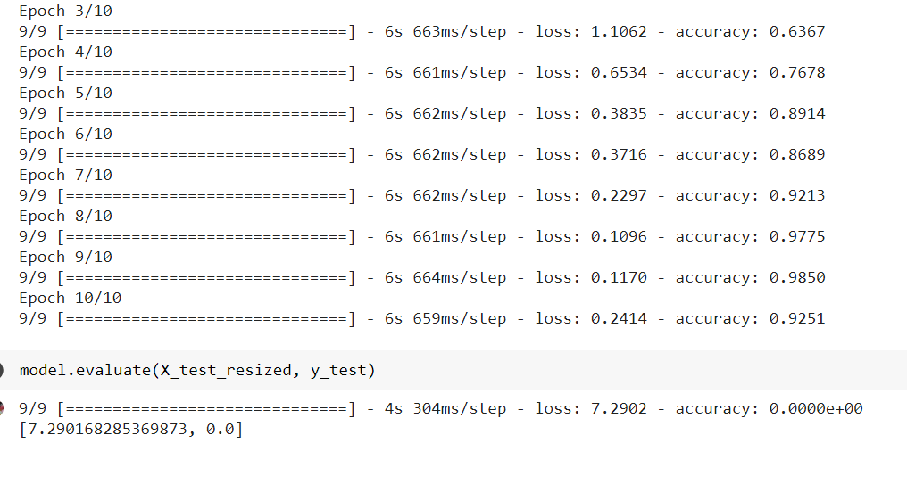

**Looking at the complexity of the model and the limitations of google colab, I have reduced the input size for the model,i.e., I have taken 2000 training data points and 2000 testing data points.**

1. **Recurrent Neural Networks (RNN)**

from google.colab import drive

drive.mount('/content/drive')

**3.1) CIFAR-10**

import os

import tensorflow as tf

import keras

from tensorflow.keras import layers

from tensorflow.keras import Model

from os import getcwd

cifar10 = tf.keras.datasets.cifar10

(training_images, training_labels), (test_images, test_labels) = cifar10.load_data()

training_images = training_images.reshape(50000, 1024, 3)

training_images = training_images[0:10000]

training_labels = training_labels[0:10000]

training_images = training_images/255.0

test_images = test_images.reshape(10000, 1024, 3)

test_images = test_images[0:5000]

test_labels = test_labels[0:5000]

test_images = test_images/255.0

model = tf.keras.models.Sequential([

    tf.keras.layers.Bidirectional(tf.keras.layers.LSTM(32, input_shape=(1024,3), return_sequences=True)),

    tf.keras.layers.Bidirectional(tf.keras.layers.LSTM(32)),

    tf.keras.layers.Flatten(),

    tf.keras.layers.Dense(64, activation='relu'),

    tf.keras.layers.Dense(10, activation='softmax')

    ])

model.compile(optimizer='adam',

              loss='sparse_categorical_crossentropy',

              metrics=['accuracy'])

history = model.fit(training_images, training_labels, batch_size = 50, epochs=10)

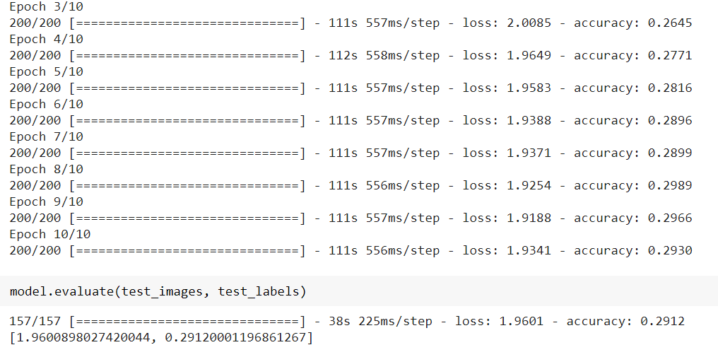

**3.2) MNIST**

import torch

# Device configuration

device = torch.device('cuda' if torch.cuda.is_available() else 'cpu')

device

from torchvision import datasets

from torchvision.transforms import ToTensor

train_data = datasets.MNIST(

    root = 'data',

    train = True,

    transform = ToTensor(),

    download = True,

)

test_data = datasets.MNIST(

    root = 'data',

    train = False,

    transform = ToTensor()

)

import matplotlib.pyplot as plt

plt.imshow(train_data.data[0], cmap='gray')

plt.title('%i' % train_data.targets[0])

plt.show()

figure = plt.figure(figsize=(10, 8))

cols, rows = 5, 5

for i in range(1, cols * rows + 1):

    sample_idx = torch.randint(len(train_data), size=(1,)).item()

    img, label = train_data[sample_idx]

    figure.add_subplot(rows, cols, i)

    plt.title(label)

    plt.axis("off")

    plt.imshow(img.squeeze(), cmap="gray")

plt.show()

from torch.utils.data import DataLoader

loaders = {

    'train' : torch.utils.data.DataLoader(train_data,

                                          batch_size=100,

                                          shuffle=True,

                                          num_workers=1),

    'test'  : torch.utils.data.DataLoader(test_data,

                                          batch_size=100,

                                          shuffle=True,

                                          num_workers=1),

}

loaders

from torch import nn

import torch.nn.functional as F

sequence_length = 28

input_size = 28

hidden_size = 128

num_layers = 2

num_classes = 10

batch_size = 100

num_epochs = 2

learning_rate = 0.01

class RNN(nn.Module):

    pass

model = RNN().to(device)

print(model)

class RNN(nn.Module):

    def __init__(self, input_size, hidden_size, num_layers, num_classes):

        super(RNN, self).__init__()

        self.hidden_size = hidden_size

        self.num_layers = num_layers

        self.lstm = nn.LSTM(input_size, hidden_size, num_layers, batch_first=True)

        self.fc = nn.Linear(hidden_size, num_classes)

        pass

    def forward(self, x):

        # Set initial hidden and cell states

        h0 = torch.zeros(self.num_layers, x.size(0), self.hidden_size).to(device)

        c0 = torch.zeros(self.num_layers, x.size(0), self.hidden_size).to(device)

        # Passing in the input and hidden state into the model and  obtaining outputs

        out, hidden = self.lstm(x, (h0, c0))  # out: tensor of shape (batch_size, seq_length, hidden_size)

        #Reshaping the outputs such that it can be fit into the fully connected layer

        out = self.fc(out[:, -1, :])

        return out

        pass

pass

model = RNN(input_size, hidden_size, num_layers, num_classes).to(device)

print(model)

loss_func = nn.CrossEntropyLoss()

loss_func

from torch import optim

optimizer = optim.Adam(model.parameters(), lr = 0.01)

optimizer

def train(num_epochs, model, loaders):

    # Train the model

    total_step = len(loaders['train'])

    for epoch in range(num_epochs):

        for i, (images, labels) in enumerate(loaders['train']):

            images = images.reshape(-1, sequence_length, input_size).to(device)

            labels = labels.to(device)

            # Forward pass

            outputs = model(images)

            loss = loss_func(outputs, labels)

            # Backward and optimize

            optimizer.zero_grad()

            loss.backward()

            optimizer.step()

            if (i+1) % 100 == 0:

                print ('Epoch [{}/{}], Step [{}/{}], Loss: {:.4f}'

                       .format(epoch + 1, num_epochs, i + 1, total_step, loss.item()))

                pass

        pass

    pass

train(num_epochs, model, loaders)

# Test the model

model.eval()

with torch.no_grad():

    correct = 0

    total = 0

    for images, labels in loaders['test']:

        images = images.reshape(-1, sequence_length, input_size).to(device)

        labels = labels.to(device)

        outputs = model(images)

        _, predicted = torch.max(outputs.data, 1)

        total = total + labels.size(0)

        correct = correct + (predicted == labels).sum().item()

print('Test Accuracy of the model on the 10000 test images: {} %'.format(100 * correct / total))



**3.3) SAVEE**

!unzip "/content/drive/MyDrive/SaveeDataset.zip"

import librosa

import numpy as np

input_length = 16000*5

batch_size = 32

n_mels = 320

def preprocess_audio_mel_T(audio, sample_rate=16000, window_size=20, #log_specgram

                 step_size=10, eps=1e-10):

    mel_spec = librosa.feature.melspectrogram(y=audio, sr=sample_rate, n_mels= n_mels)

    mel_db = (librosa.power_to_db(mel_spec, ref=np.max) + 40)/40

    return mel_db.T

def load_audio_file(file_path, input_length=input_length):

  data = librosa.core.load(file_path, sr=16000)[0] #, sr=16000

  if len(data)>input_length:

    max_offset = len(data)-input_length

    offset = np.random.randint(max_offset)

    data = data[offset:(input_length+offset)]

  else:

    if input_length > len(data):

      max_offset = input_length - len(data)

      offset = np.random.randint(max_offset)

    else:

      offset = 0

    data = np.pad(data, (offset, input_length - len(data) - offset), "constant")

  data = preprocess_audio_mel_T(data)

  return data

# Preprocessing the dataset

import os

from scipy.io import wavfile

import librosa

import matplotlib.pyplot as plt

import numpy as np

import cv2

rootDirectory = "/content/AudioData/"

personNames = ["DC","JE","JK","KL"]

classes = ["a" , "d" , "f", "h", "n", "sa" , "su" ]

X = list()

y = list()

for person in personNames:

  directory = os.path.join(rootDirectory,person)

  for filename in os.listdir(directory):

    filePath = os.path.join(directory, filename)

    data = load_audio_file(file_path=filePath)

    # data = cv2.merge([a,a,a])

    if(filename[0:1] in classes):

      X.append(data)

      y.append(classes.index(filename[0:1]))

    elif(filename[0:2] in classes):

      X.append(data)

      y.append(classes.index(filename[0:2]))

X = np.asarray(X, dtype=np.float32)

y = np.asarray(y, dtype=np.float32)

import pandas as pd

import numpy as np

import matplotlib.pyplot as plt

import tensorflow as tf

# dataset preparation

from tensorflow.keras import datasets,layers,models

from sklearn.model_selection import train_test_split

X_train, X_test, y_train, y_test = train_test_split(X, y, test_size=0.4, train_size= 0.6 ,random_state=10)

import os

import tensorflow as tf

import keras

from tensorflow.keras import layers

from tensorflow.keras import Model

from os import getcwd

model = tf.keras.models.Sequential([

    tf.keras.layers.Bidirectional(tf.keras.layers.LSTM(32, input_shape=(157,320), return_sequences=True)),

    tf.keras.layers.Bidirectional(tf.keras.layers.LSTM(32)),

    tf.keras.layers.Flatten(),

    tf.keras.layers.Dense(64, activation='relu'),

    tf.keras.layers.Dense(10, activation='softmax')

    ])

model.compile(optimizer='adam',

              loss='sparse_categorical_crossentropy',

              metrics=['accuracy'])

history = model.fit(X_train,y_train, batch_size = 50, epochs=50)

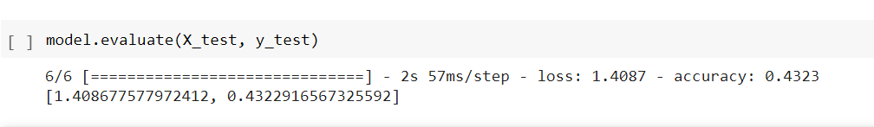

**3.4) EmoDB**

!unzip "/content/drive/MyDrive/EmoDB.zip"

import librosa

import numpy as np

input_length = 16000*5

batch_size = 32

n_mels = 320

def preprocess_audio_mel_T(audio, sample_rate=16000, window_size=20, #log_specgram

                 step_size=10, eps=1e-10):

    mel_spec = librosa.feature.melspectrogram(y=audio, sr=sample_rate, n_mels= n_mels)

    mel_db = (librosa.power_to_db(mel_spec, ref=np.max) + 40)/40

    return mel_db.T

def load_audio_file(file_path, input_length=input_length):

  data = librosa.core.load(file_path, sr=16000)[0] #, sr=16000

  if len(data)>input_length:

    max_offset = len(data)-input_length

    offset = np.random.randint(max_offset)

    data = data[offset:(input_length+offset)]

  else:

    if input_length > len(data):

      max_offset = input_length - len(data)

      offset = np.random.randint(max_offset)

    else:

      offset = 0

    data = np.pad(data, (offset, input_length - len(data) - offset), "constant")

  data = preprocess_audio_mel_T(data)

  return data

# Preprocessing the dataset

import os

from scipy.io import wavfile

import librosa

import matplotlib.pyplot as plt

import numpy as np

import cv2

directory = "/content/wav/"

classes = ["W" ,"L" ,"E" ,"A" , "F" ,"T" ,"N" ]

X = list()

y = list()

for filename in os.listdir(directory):

  filePath = os.path.join(directory, filename)

  data = load_audio_file(file_path=filePath)

  if(filename[5:6] in classes):

    X.append(data)

    y.append(classes.index(filename[5:6]))

X = np.asarray(X, dtype=np.float32)

y = np.asarray(y, dtype=np.float32)

import pandas as pd

import numpy as np

import matplotlib.pyplot as plt

import tensorflow as tf

# dataset preparation

from tensorflow.keras import datasets,layers,models

from sklearn.model_selection import train_test_split

X_train, X_test, y_train, y_test = train_test_split(X, y, test_size=0.3, train_size= 0.7 ,random_state=10)

model = tf.keras.models.Sequential([

    tf.keras.layers.Bidirectional(tf.keras.layers.LSTM(32, input_shape=(157,320), return_sequences=True)),

    tf.keras.layers.Bidirectional(tf.keras.layers.LSTM(32)),

    tf.keras.layers.Flatten(),

    tf.keras.layers.Dense(64, activation='relu'),

    tf.keras.layers.Dense(10, activation='softmax')

    ])

model.compile(optimizer='adam',

              loss='sparse_categorical_crossentropy',

              metrics=['accuracy'])

history = model.fit(X_train,y_train, batch_size = 50, epochs=50)

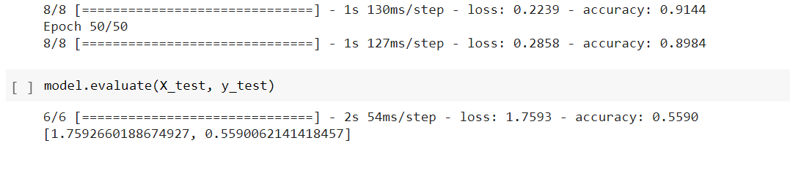

**Looking at the complexity of the model and the limitations of google colab, I have reduced the input size for the model,i.e., I have taken 2000 training data points and 2000 testing data points.**

1. **AlexNet**

from google.colab import drive

drive.mount('/content/drive')

# Import necessary packages

import argparse

# Import necessary components to build LeNet

from keras.models import Sequential

from keras.layers.core import Dense, Dropout, Activation, Flatten

from keras.layers.convolutional import Conv2D, MaxPooling2D, ZeroPadding2D

from keras.layers import BatchNormalization

from keras.regularizers import l2

import tensorflow as tf

from tensorflow import keras

import matplotlib.pyplot as plt

%matplotlib inline

import numpy as np

import skimage.transform

def alexnet_model(img_shape=(224, 224, 3), n_classes=10, l2_reg=0.,

    weights=None):

    # Initialize model

    alexnet = Sequential()

    # Layer 1

    alexnet.add(Conv2D(30, (11, 11), input_shape=img_shape,

        padding='same', kernel_regularizer=l2(l2_reg)))

    alexnet.add(BatchNormalization())

    alexnet.add(Activation('relu'))

    alexnet.add(MaxPooling2D(pool_size=(2, 2)))

    # Layer 2

    alexnet.add(Conv2D(30, (5, 5), padding='same'))

    alexnet.add(BatchNormalization())

    alexnet.add(Activation('relu'))

    alexnet.add(MaxPooling2D(pool_size=(2, 2)))

    # Layer 3

    alexnet.add(ZeroPadding2D((1, 1)))

    alexnet.add(Conv2D(30, (3, 3), padding='same'))

    alexnet.add(BatchNormalization())

    alexnet.add(Activation('relu'))

    alexnet.add(MaxPooling2D(pool_size=(2, 2)))

    # Layer 4

    alexnet.add(ZeroPadding2D((1, 1)))

    alexnet.add(Conv2D(30, (3, 3), padding='same'))

    alexnet.add(BatchNormalization())

    alexnet.add(Activation('relu'))

    # Layer 5

    alexnet.add(ZeroPadding2D((1, 1)))

    alexnet.add(Conv2D(30, (3, 3), padding='same'))

    alexnet.add(BatchNormalization())

    alexnet.add(Activation('relu'))

    alexnet.add(MaxPooling2D(pool_size=(2, 2)))

    # Layer 6

    alexnet.add(Flatten())

    alexnet.add(Dense(30))

    alexnet.add(BatchNormalization())

    alexnet.add(Activation('relu'))

    alexnet.add(Dropout(0.5))

    # Layer 7

    alexnet.add(Dense(30))

    alexnet.add(BatchNormalization())

    alexnet.add(Activation('relu'))

    alexnet.add(Dropout(0.5))

    # Layer 8

    alexnet.add(Dense(n_classes))

    alexnet.add(BatchNormalization())

    alexnet.add(Activation('softmax'))

    if weights is not None:

        alexnet.load_weights(weights)

    return alexnet

def parse_args():

    """

    Parse command line arguments.

    Parameters:

        None

    Returns:

        parser arguments

    """

    parser = argparse.ArgumentParser(description='AlexNet model')

    optional = parser._action_groups.pop()

    required = parser.add_argument_group('required arguments')

    optional.add_argument('--print_model',

        dest='print_model',

        help='Print AlexNet model',

        action='store_true')

    parser._action_groups.append(optional)

    return parser.parse_args()

def load_preprocess_training_batch(X_train):

    new = []

    for item in X_train:

        tmpFeature = skimage.transform.resize(item, (224, 224), mode='constant')

        new.append(tmpFeature)

    return new

**4.1) CIFAR-10**

model = alexnet_model()

(X_train, y_train) , (X_test, y_test) = keras.datasets.cifar10.load_data()

X_train = X_train[0:500]

y_train = y_train[0:500]

X_test = X_test[0:200]

y_test = y_test[0:200]

X_train_resized = load_preprocess_training_batch(X_train)

X_test_resized = load_preprocess_training_batch(X_test)

X_train_resized = np.array(X_train_resized)

X_test_resized = np.array(X_test_resized)

X_train_resized = X_train_resized / 255

X_test_resized = X_test_resized / 255

model.compile(optimizer='SGD',

              loss='sparse_categorical_crossentropy',

              metrics=['accuracy'])

history = model.fit(X_train_resized, y_train, epochs=5)

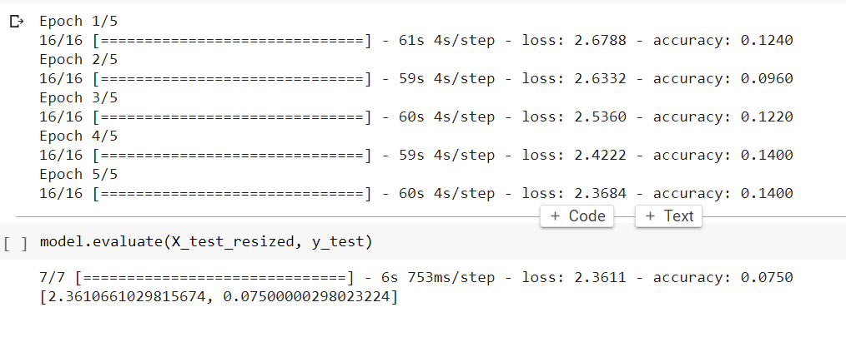

**4.2) MNIST**

(X_train, y_train) , (X_test, y_test) = keras.datasets.mnist.load_data()

X_train = X_train[0:2000]

y_train = y_train[0:2000]

X_test = X_test[0:2000]

y_test = y_test[0:2000]

X_train_resized = load_preprocess_training_batch(X_train)

X_test_resized = load_preprocess_training_batch(X_test)

X_train_resized = np.array(X_train_resized)

X_test_resized = np.array(X_test_resized)

X_train_resized = X_train_resized / 255.0

X_test_resized = X_test_resized / 255.0

import cv2

X_train_new = list()

for i in range(len(X_train_resized)):

  g  = X_train_resized[i]

  X_train_new.append(cv2.merge([g,g,g]))

X_train_new = np.asarray(X_train_new,dtype=np.float32)

X_test_new = list()

for i in range(len(X_test_resized)):

  g  = X_test_resized[i]

  X_test_new.append(cv2.merge([g,g,g]))

X_test_new = np.asarray(X_test_new,dtype=np.float32)

model = alexnet_model()

model.compile(optimizer='SGD',

              loss='sparse_categorical_crossentropy',

              metrics=['accuracy'])

history = model.fit(X_train_new, y_train, epochs=5)

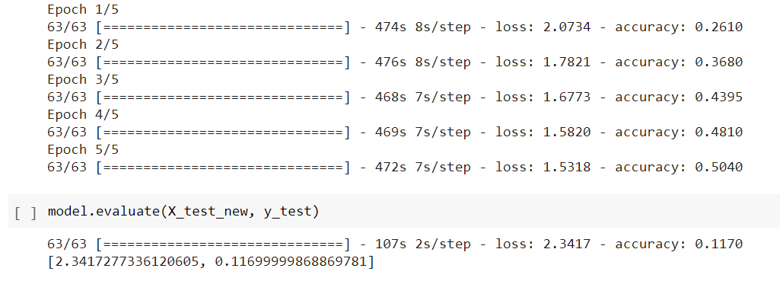

**4.3) SAVEE**

!unzip "/content/drive/MyDrive/SaveeDataset.zip"

import librosa

import numpy as np

input_length = 16000*5

batch_size = 32

n_mels = 320

def preprocess_audio_mel_T(audio, sample_rate=16000, window_size=20, #log_specgram

                 step_size=10, eps=1e-10):

    mel_spec = librosa.feature.melspectrogram(y=audio, sr=sample_rate, n_mels= n_mels)

    mel_db = (librosa.power_to_db(mel_spec, ref=np.max) + 40)/40

    return mel_db.T

def load_audio_file(file_path, input_length=input_length):

  data = librosa.core.load(file_path, sr=16000)[0] #, sr=16000

  if len(data)>input_length:

    max_offset = len(data)-input_length

    offset = np.random.randint(max_offset)

    data = data[offset:(input_length+offset)]

  else:

    if input_length > len(data):

      max_offset = input_length - len(data)

      offset = np.random.randint(max_offset)

    else:

      offset = 0

    data = np.pad(data, (offset, input_length - len(data) - offset), "constant")

  data = preprocess_audio_mel_T(data)

  return data

# Preprocessing the dataset

import os

from scipy.io import wavfile

import librosa

import matplotlib.pyplot as plt

import numpy as np

import cv2

rootDirectory = "/content/AudioData/"

personNames = ["DC","JE","JK","KL"]

classes = ["a" , "d" , "f", "h", "n", "sa" , "su" ]

X = list()

y = list()

for person in personNames:

  directory = os.path.join(rootDirectory,person)

  for filename in os.listdir(directory):

    filePath = os.path.join(directory, filename)

    a = load_audio_file(file_path=filePath)

    data = cv2.merge([a,a,a])

    if(filename[0:1] in classes):

      X.append(data)

      y.append(classes.index(filename[0:1]))

    elif(filename[0:2] in classes):

      X.append(data)

      y.append(classes.index(filename[0:2]))

X = np.asarray(X, dtype=np.float32)

y = np.asarray(y, dtype=np.float32)

import pandas as pd

import numpy as np

import matplotlib.pyplot as plt

import tensorflow as tf

# dataset preparation

from tensorflow.keras import datasets,layers,models

from sklearn.model_selection import train_test_split

X_train, X_test, y_train, y_test = train_test_split(X, y, test_size=0.5, train_size= 0.5 ,random_state=10)

X_train_resized = load_preprocess_training_batch(X_train)

X_test_resized = load_preprocess_training_batch(X_test)

X_train_resized = np.array(X_train_resized)

X_test_resized = np.array(X_test_resized)

model = alexnet_model()

model.compile(optimizer='SGD',

              loss='sparse_categorical_crossentropy',

              metrics=['accuracy'])

history = model.fit(X_train_resized, y_train, epochs=10)

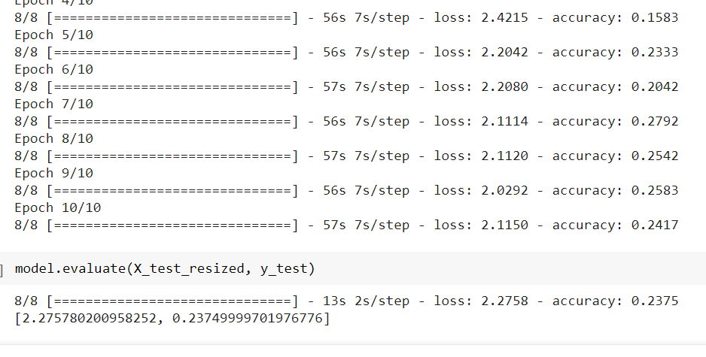

**4.4) EmoDB**

!unzip "/content/drive/MyDrive/EmoDB.zip"

import librosa

import numpy as np

input_length = 16000*5

batch_size = 32

n_mels = 320

def preprocess_audio_mel_T(audio, sample_rate=16000, window_size=20, #log_specgram

                 step_size=10, eps=1e-10):

    mel_spec = librosa.feature.melspectrogram(y=audio, sr=sample_rate, n_mels= n_mels)

    mel_db = (librosa.power_to_db(mel_spec, ref=np.max) + 40)/40

    return mel_db.T

def load_audio_file(file_path, input_length=input_length):

  data = librosa.core.load(file_path, sr=16000)[0] #, sr=16000

  if len(data)>input_length:

    max_offset = len(data)-input_length

    offset = np.random.randint(max_offset)

    data = data[offset:(input_length+offset)]

  else:

    if input_length > len(data):

      max_offset = input_length - len(data)

      offset = np.random.randint(max_offset)

    else:

      offset = 0

    data = np.pad(data, (offset, input_length - len(data) - offset), "constant")

  data = preprocess_audio_mel_T(data)

  return data

# Preprocessing the dataset

import os

from scipy.io import wavfile

import librosa

import matplotlib.pyplot as plt

import numpy as np

import cv2

directory = "/content/wav/"

classes = ["W" ,"L" ,"E" ,"A" , "F" ,"T" ,"N" ]

X = list()

y = list()

for filename in os.listdir(directory):

  filePath = os.path.join(directory, filename)

  a = load_audio_file(file_path=filePath)

  data = cv2.merge([a,a,a])

  if(filename[5:6] in classes):

    X.append(data)

    y.append(classes.index(filename[5:6]))

X = np.asarray(X, dtype=np.float32)

y = np.asarray(y, dtype=np.float32)

import pandas as pd

import numpy as np

import matplotlib.pyplot as plt

import tensorflow as tf

# dataset preparation

from tensorflow.keras import datasets,layers,models

from sklearn.model_selection import train_test_split

X_train, X_test, y_train, y_test = train_test_split(X, y, test_size=0.4, train_size= 0.6 ,random_state=10)

X_train_resized = load_preprocess_training_batch(X_train)

X_test_resized = load_preprocess_training_batch(X_test)

X_train_resized = np.array(X_train_resized)

X_test_resized = np.array(X_test_resized)

model = alexnet_model()

model.compile(optimizer='SGD',

              loss='sparse_categorical_crossentropy',

              metrics=['accuracy'])

history = model.fit(X_train_resized, y_train, epochs=10)

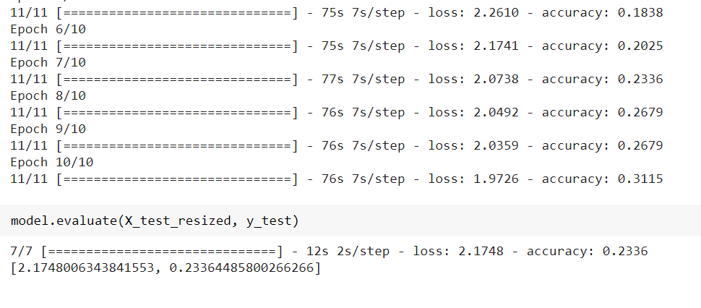

**Looking at the complexity of the model and the limitations of google colab, I have reduced the input size for the model,i.e., I have taken 2000 training data points and 2000 testing data points.**

1. **GoogLeNet**

from google.colab import drive

drive.mount('/content/drive')

**5.1) CIFAR-10**

def inception_module(x,

                     filters_1x1,

                     filters_3x3_reduce,

                     filters_3x3,

                     filters_5x5_reduce,

                     filters_5x5,

                     filters_pool_proj,

                     name=None):

    conv_1x1 = Conv2D(filters_1x1, (1, 1), padding='same', activation='relu', kernel_initializer=kernel_init, bias_initializer=bias_init)(x)

    conv_3x3 = Conv2D(filters_3x3_reduce, (1, 1), padding='same', activation='relu', kernel_initializer=kernel_init, bias_initializer=bias_init)(x)

    conv_3x3 = Conv2D(filters_3x3, (3, 3), padding='same', activation='relu', kernel_initializer=kernel_init, bias_initializer=bias_init)(conv_3x3)

    conv_5x5 = Conv2D(filters_5x5_reduce, (1, 1), padding='same', activation='relu', kernel_initializer=kernel_init, bias_initializer=bias_init)(x)

    conv_5x5 = Conv2D(filters_5x5, (5, 5), padding='same', activation='relu', kernel_initializer=kernel_init, bias_initializer=bias_init)(conv_5x5)

    pool_proj = MaxPool2D((3, 3), strides=(1, 1), padding='same')(x)

    pool_proj = Conv2D(filters_pool_proj, (1, 1), padding='same', activation='relu', kernel_initializer=kernel_init, bias_initializer=bias_init)(pool_proj)

    output = concatenate([conv_1x1, conv_3x3, conv_5x5, pool_proj], axis=3, name=name)

    return output

kernel_init = keras.initializers.glorot_uniform()

bias_init = keras.initializers.Constant(value=0.2)

input_layer = Input(shape=(224, 224, 3))

x = Conv2D(64, (7, 7), padding='same', strides=(2, 2), activation='relu', name='conv_1_7x7/2', kernel_initializer=kernel_init, bias_initializer=bias_init)(input_layer)

x = MaxPool2D((3, 3), padding='same', strides=(2, 2), name='max_pool_1_3x3/2')(x)

x = Conv2D(64, (1, 1), padding='same', strides=(1, 1), activation='relu', name='conv_2a_3x3/1')(x)

x = Conv2D(192, (3, 3), padding='same', strides=(1, 1), activation='relu', name='conv_2b_3x3/1')(x)

x = MaxPool2D((3, 3), padding='same', strides=(2, 2), name='max_pool_2_3x3/2')(x)

x = inception_module(x,

                     filters_1x1=64,

                     filters_3x3_reduce=96,

                     filters_3x3=128,

                     filters_5x5_reduce=16,

                     filters_5x5=32,

                     filters_pool_proj=32,

                     name='inception_3a')

x = inception_module(x,

                     filters_1x1=128,

                     filters_3x3_reduce=128,

                     filters_3x3=192,

                     filters_5x5_reduce=32,

                     filters_5x5=96,

                     filters_pool_proj=64,

                     name='inception_3b')

x = MaxPool2D((3, 3), padding='same', strides=(2, 2), name='max_pool_3_3x3/2')(x)

x = inception_module(x,

                     filters_1x1=192,

                     filters_3x3_reduce=96,

                     filters_3x3=208,

                     filters_5x5_reduce=16,

                     filters_5x5=48,

                     filters_pool_proj=64,

                     name='inception_4a')

x1 = AveragePooling2D((5, 5), strides=3)(x)

x1 = Conv2D(128, (1, 1), padding='same', activation='relu')(x1)

x1 = Flatten()(x1)

x1 = Dense(1024, activation='relu')(x1)

x1 = Dropout(0.7)(x1)

x1 = Dense(10, activation='softmax', name='auxilliary_output_1')(x1)

x = inception_module(x,

                     filters_1x1=160,

                     filters_3x3_reduce=112,

                     filters_3x3=224,

                     filters_5x5_reduce=24,

                     filters_5x5=64,

                     filters_pool_proj=64,

                     name='inception_4b')

x = inception_module(x,

                     filters_1x1=128,

                     filters_3x3_reduce=128,

                     filters_3x3=256,

                     filters_5x5_reduce=24,

                     filters_5x5=64,

                     filters_pool_proj=64,

                     name='inception_4c')

x = inception_module(x,

                     filters_1x1=112,

                     filters_3x3_reduce=144,

                     filters_3x3=288,

                     filters_5x5_reduce=32,

                     filters_5x5=64,

                     filters_pool_proj=64,

                     name='inception_4d')

x2 = AveragePooling2D((5, 5), strides=3)(x)

x2 = Conv2D(128, (1, 1), padding='same', activation='relu')(x2)

x2 = Flatten()(x2)

x2 = Dense(1024, activation='relu')(x2)

x2 = Dropout(0.7)(x2)

x2 = Dense(10, activation='softmax', name='auxilliary_output_2')(x2)

x = inception_module(x,

                     filters_1x1=256,

                     filters_3x3_reduce=160,

                     filters_3x3=320,

                     filters_5x5_reduce=32,

                     filters_5x5=128,

                     filters_pool_proj=128,

                     name='inception_4e')

x = MaxPool2D((3, 3), padding='same', strides=(2, 2), name='max_pool_4_3x3/2')(x)

x = inception_module(x,

                     filters_1x1=256,

                     filters_3x3_reduce=160,

                     filters_3x3=320,

                     filters_5x5_reduce=32,

                     filters_5x5=128,

                     filters_pool_proj=128,

                     name='inception_5a')

x = inception_module(x,

                     filters_1x1=384,

                     filters_3x3_reduce=192,

                     filters_3x3=384,

                     filters_5x5_reduce=48,

                     filters_5x5=128,

                     filters_pool_proj=128,

                     name='inception_5b')

x = GlobalAveragePooling2D(name='avg_pool_5_3x3/1')(x)

x = Dropout(0.4)(x)

x = Dense(10, activation='softmax', name='output')(x)

import keras

from keras.layers.core import Layer

import keras.backend as K

import tensorflow as tf

from keras.datasets import cifar10

from keras.models import Model

from keras.layers import Conv2D, MaxPool2D,  \

    Dropout, Dense, Input, concatenate,      \

    GlobalAveragePooling2D, AveragePooling2D,\

    Flatten

import cv2

import numpy as np

from keras.datasets import cifar10

from keras import backend as K

from keras.utils import np_utils

import math

from tensorflow.keras.optimizers import SGD

from keras.callbacks import LearningRateScheduler

num_classes = 10

def load_cifar10_data(img_rows, img_cols):

    # Load cifar10 training and validation sets

    (X_train, Y_train), (X_valid, Y_valid) = cifar10.load_data()

    X_train = X_train[0:5000]

    Y_train = Y_train[0:5000]

    X_valid = X_valid[0:2000]

    Y_valid = Y_valid[0:2000]

    # Resize training images

    X_train = np.array([cv2.resize(img, (img_rows,img_cols)) for img in X_train[:,:,:,:]])

    X_valid = np.array([cv2.resize(img, (img_rows,img_cols)) for img in X_valid[:,:,:,:]])

    # Transform targets to keras compatible format

    Y_train = np_utils.to_categorical(Y_train, num_classes)

    Y_valid = np_utils.to_categorical(Y_valid, num_classes)

    X_train = X_train.astype('float32')

    X_valid = X_valid.astype('float32')

    # preprocess data

    X_train = X_train / 255.0

    X_valid = X_valid / 255.0

    return X_train, Y_train, X_valid, Y_valid

X_train, y_train, X_test, y_test = load_cifar10_data(224, 224)

model = Model(input_layer, [x, x1, x2], name='inception_v1')

model.summary()

epochs = 10

initial_lrate = 0.01

def decay(epoch, steps=100):

    initial_lrate = 0.01

    drop = 0.96

    epochs_drop = 8

    lrate = initial_lrate * math.pow(drop, math.floor((1+epoch)/epochs_drop))

    return lrate

sgd = SGD(learning_rate=initial_lrate, momentum=0.9, nesterov=False)

lr_sc = LearningRateScheduler(decay, verbose=1)

model.compile(loss=['categorical_crossentropy', 'categorical_crossentropy', 'categorical_crossentropy'], loss_weights=[1, 0.3, 0.3], optimizer=sgd, metrics=['accuracy'])

history = model.fit(X_train, [y_train, y_train, y_train], validation_data=(X_test, [y_test, y_test, y_test]), epochs=epochs, batch_size=256, callbacks=[lr_sc])

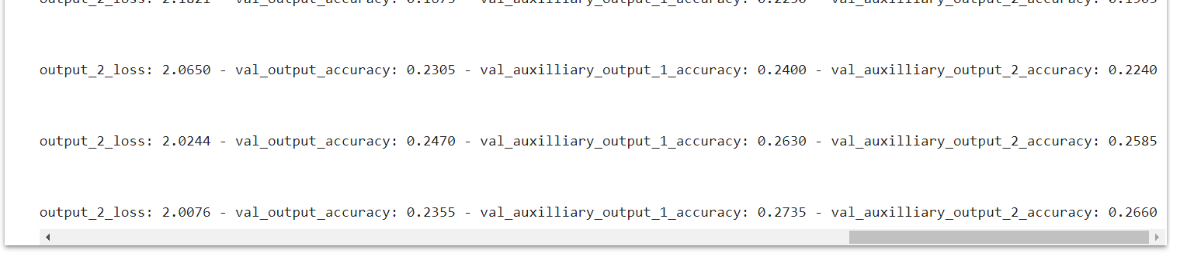

**5.2) MNIST**

import tensorflow as tf

import matplotlib.pyplot as plt

from tensorflow.keras import datasets, layers, models, losses, Model

(x_train, y_train), (x_test, y_test)=tf.keras.datasets.mnist.load_data()

x_train = tf.pad(x_train, [[0, 0], [2,2], [2,2]])/255

x_test = tf.pad(x_test, [[0, 0], [2,2], [2,2]])/255

x_train = tf.expand_dims(x_train, axis=3, name=None)

x_test = tf.expand_dims(x_test, axis=3, name=None)

x_train = tf.repeat(x_train, 3, axis=3)

x_test = tf.repeat(x_test, 3, axis=3)

x_val = x_train[-2000:,:,:]

y_val = y_train[-2000:]

x_train = x_train[:-2000,:,:]

y_train = y_train[:-2000]

def inception(x,

              filters_1x1,

              filters_3x3_reduce,

              filters_3x3,

              filters_5x5_reduce,

              filters_5x5,

              filters_pool):

  path1 = layers.Conv2D(filters_1x1, (1, 1), padding='same', activation='relu')(x)

  path2 = layers.Conv2D(filters_3x3_reduce, (1, 1), padding='same', activation='relu')(x)

  path2 = layers.Conv2D(filters_3x3, (1, 1), padding='same', activation='relu')(path2)

  path3 = layers.Conv2D(filters_5x5_reduce, (1, 1), padding='same', activation='relu')(x)

  path3 = layers.Conv2D(filters_5x5, (1, 1), padding='same', activation='relu')(path3)

  path4 = layers.MaxPool2D((3, 3), strides=(1, 1), padding='same')(x)

  path4 = layers.Conv2D(filters_pool, (1, 1), padding='same', activation='relu')(path4)

  return tf.concat([path1, path2, path3, path4], axis=3)

inp = layers.Input(shape=(32, 32, 3))

input_tensor = layers.experimental.preprocessing.Resizing(224, 224, interpolation="bilinear", input_shape=x_train.shape[1:])(inp)

x = layers.Conv2D(64, 7, strides=2, padding='same', activation='relu')(input_tensor)

x = layers.MaxPooling2D(3, strides=2)(x)

x = layers.Conv2D(64, 1, strides=1, padding='same', activation='relu')(x)

x = layers.Conv2D(192, 3, strides=1, padding='same', activation='relu')(x)

x = layers.MaxPooling2D(3, strides=2)(x)

x = inception(x,

              filters_1x1=64,

              filters_3x3_reduce=96,

              filters_3x3=128,

              filters_5x5_reduce=16,

              filters_5x5=32,

              filters_pool=32)

x = inception(x,

              filters_1x1=128,

              filters_3x3_reduce=128,

              filters_3x3=192,

              filters_5x5_reduce=32,

              filters_5x5=96,

              filters_pool=64)

x = layers.MaxPooling2D(3, strides=2)(x)

x = inception(x,

              filters_1x1=192,

              filters_3x3_reduce=96,

              filters_3x3=208,

              filters_5x5_reduce=16,

              filters_5x5=48,

              filters_pool=64)

aux1 = layers.AveragePooling2D((5, 5), strides=3)(x)

aux1 = layers.Conv2D(128, 1, padding='same', activation='relu')(aux1)

aux1 = layers.Flatten()(aux1)

aux1 = layers.Dense(1024, activation='relu')(aux1)

aux1 = layers.Dropout(0.7)(aux1)

aux1 = layers.Dense(10, activation='softmax')(aux1)

x = inception(x,

              filters_1x1=160,

              filters_3x3_reduce=112,

              filters_3x3=224,

              filters_5x5_reduce=24,

              filters_5x5=64,

              filters_pool=64)

x = inception(x,

              filters_1x1=128,

              filters_3x3_reduce=128,

              filters_3x3=256,

              filters_5x5_reduce=24,

              filters_5x5=64,

              filters_pool=64)

x = inception(x,

              filters_1x1=112,

              filters_3x3_reduce=144,

              filters_3x3=288,

              filters_5x5_reduce=32,

              filters_5x5=64,

              filters_pool=64)

aux2 = layers.AveragePooling2D((5, 5), strides=3)(x)

aux2 = layers.Conv2D(128, 1, padding='same', activation='relu')(aux2)

aux2 = layers.Flatten()(aux2)

aux2 = layers.Dense(1024, activation='relu')(aux2)

aux2 = layers.Dropout(0.7)(aux2)

aux2 = layers.Dense(10, activation='softmax')(aux2)

x = inception(x,

              filters_1x1=256,

              filters_3x3_reduce=160,

              filters_3x3=320,

              filters_5x5_reduce=32,

              filters_5x5=128,

              filters_pool=128)

x = layers.MaxPooling2D(3, strides=2)(x)

x = inception(x,

              filters_1x1=256,

              filters_3x3_reduce=160,

              filters_3x3=320,

              filters_5x5_reduce=32,

              filters_5x5=128,

              filters_pool=128)

x = inception(x,

              filters_1x1=384,

              filters_3x3_reduce=192,

              filters_3x3=384,

              filters_5x5_reduce=48,

              filters_5x5=128,

              filters_pool=128)

x = layers.GlobalAveragePooling2D()(x)

x = layers.Dropout(0.4)(x)

out = layers.Dense(10, activation='softmax')(x)

model = Model(inputs = inp, outputs = [out, aux1, aux2])

model.compile(optimizer='adam', loss=[losses.sparse_categorical_crossentropy, losses.sparse_categorical_crossentropy, losses.sparse_categorical_crossentropy], loss_weights=[1, 0.3, 0.3], metrics=['accuracy'])

history = model.fit(x_train, [y_train, y_train, y_train], validation_data=(x_val, [y_val, y_val, y_val]), batch_size=64, epochs=10)

fig, axs = plt.subplots(2, 1, figsize=(15,15))

axs[0].plot(history.history['loss'])

axs[0].plot(history.history['val_loss'])

axs[0].title.set_text('Training Loss vs Validation Loss')

axs[0].set_xlabel('Epochs')

axs[0].set_ylabel('Loss')

axs[0].legend(['Train','Val'])

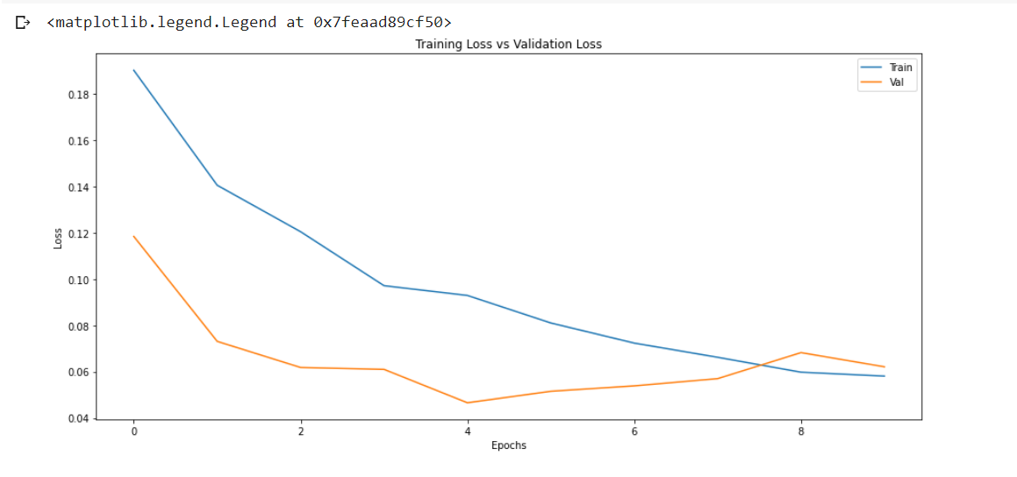

model.evaluate(x_test, y_test)

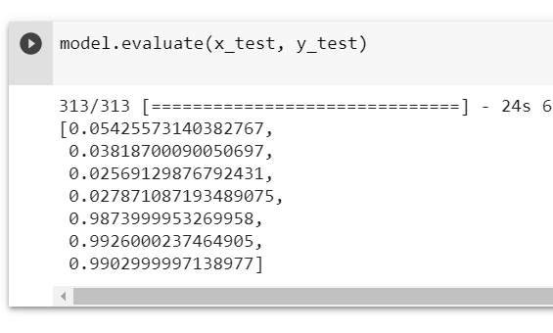

**5.3) SAVEE**

!unzip "/content/drive/MyDrive/SaveeDataset.zip"

import librosa

import numpy as np

input_length = 16000*5

batch_size = 32

n_mels = 320

def preprocess_audio_mel_T(audio, sample_rate=16000, window_size=20, #log_specgram

                 step_size=10, eps=1e-10):

    mel_spec = librosa.feature.melspectrogram(y=audio, sr=sample_rate, n_mels= n_mels)

    mel_db = (librosa.power_to_db(mel_spec, ref=np.max) + 40)/40

    return mel_db.T

def load_audio_file(file_path, input_length=input_length):

  data = librosa.core.load(file_path, sr=16000)[0] #, sr=16000

  if len(data)>input_length:

    max_offset = len(data)-input_length

    offset = np.random.randint(max_offset)

    data = data[offset:(input_length+offset)]

  else:

    if input_length > len(data):

      max_offset = input_length - len(data)

      offset = np.random.randint(max_offset)

    else:

      offset = 0

    data = np.pad(data, (offset, input_length - len(data) - offset), "constant")

  data = preprocess_audio_mel_T(data)

  return data

# Preprocessing the dataset

import os

from scipy.io import wavfile

import librosa

import matplotlib.pyplot as plt

import numpy as np

import cv2

rootDirectory = "/content/AudioData/"

personNames = ["DC","JE","JK","KL"]

classes = ["a" , "d" , "f", "h", "n", "sa" , "su" ]

X = list()

y = list()

for person in personNames:

  directory = os.path.join(rootDirectory,person)

  for filename in os.listdir(directory):

    filePath = os.path.join(directory, filename)

    a = load_audio_file(file_path=filePath)

    data = cv2.merge([a,a,a])

    if(filename[0:1] in classes):

      X.append(data)

      y.append(classes.index(filename[0:1]))

    elif(filename[0:2] in classes):

      X.append(data)

      y.append(classes.index(filename[0:2]))

X = np.asarray(X, dtype=np.float32)

y = np.asarray(y, dtype=np.float32)

import pandas as pd

import numpy as np

import matplotlib.pyplot as plt

import tensorflow as tf

# dataset preparation

from tensorflow.keras import datasets,layers,models

from sklearn.model_selection import train_test_split

X_train, X_test, y_train, y_test = train_test_split(X, y, test_size=0.4, train_size= 0.6 ,random_state=10)

import tensorflow as tf

import matplotlib.pyplot as plt

from tensorflow.keras import datasets, layers, models, losses, Model

def inception(x,

              filters_1x1,

              filters_3x3_reduce,

              filters_3x3,

              filters_5x5_reduce,

              filters_5x5,

              filters_pool):

  path1 = layers.Conv2D(filters_1x1, (1, 1), padding='same', activation='relu')(x)

  path2 = layers.Conv2D(filters_3x3_reduce, (1, 1), padding='same', activation='relu')(x)

  path2 = layers.Conv2D(filters_3x3, (1, 1), padding='same', activation='relu')(path2)

  path3 = layers.Conv2D(filters_5x5_reduce, (1, 1), padding='same', activation='relu')(x)

  path3 = layers.Conv2D(filters_5x5, (1, 1), padding='same', activation='relu')(path3)

  path4 = layers.MaxPool2D((3, 3), strides=(1, 1), padding='same')(x)

  path4 = layers.Conv2D(filters_pool, (1, 1), padding='same', activation='relu')(path4)

  return tf.concat([path1, path2, path3, path4], axis=3)

inp = layers.Input(shape=(157, 320, 3))

input_tensor = layers.experimental.preprocessing.Resizing(224, 224, interpolation="bilinear", input_shape=X_train.shape[1:])(inp)

x = layers.Conv2D(64, 7, strides=2, padding='same', activation='relu')(input_tensor)

x = layers.MaxPooling2D(3, strides=2)(x)

x = layers.Conv2D(64, 1, strides=1, padding='same', activation='relu')(x)

x = layers.Conv2D(192, 3, strides=1, padding='same', activation='relu')(x)

x = layers.MaxPooling2D(3, strides=2)(x)

x = inception(x,

              filters_1x1=64,

              filters_3x3_reduce=96,

              filters_3x3=128,

              filters_5x5_reduce=16,

              filters_5x5=32,

              filters_pool=32)

x = inception(x,

              filters_1x1=128,

              filters_3x3_reduce=128,

              filters_3x3=192,

              filters_5x5_reduce=32,

              filters_5x5=96,

              filters_pool=64)

x = layers.MaxPooling2D(3, strides=2)(x)

x = inception(x,

              filters_1x1=192,

              filters_3x3_reduce=96,

              filters_3x3=208,

              filters_5x5_reduce=16,

              filters_5x5=48,

              filters_pool=64)

aux1 = layers.AveragePooling2D((5, 5), strides=3)(x)

aux1 = layers.Conv2D(128, 1, padding='same', activation='relu')(aux1)

aux1 = layers.Flatten()(aux1)

aux1 = layers.Dense(1024, activation='relu')(aux1)

aux1 = layers.Dropout(0.7)(aux1)

aux1 = layers.Dense(10, activation='softmax')(aux1)

x = inception(x,

              filters_1x1=160,

              filters_3x3_reduce=112,

              filters_3x3=224,

              filters_5x5_reduce=24,

              filters_5x5=64,

              filters_pool=64)

x = inception(x,

              filters_1x1=128,

              filters_3x3_reduce=128,

              filters_3x3=256,

              filters_5x5_reduce=24,

              filters_5x5=64,

              filters_pool=64)

x = inception(x,

              filters_1x1=112,

              filters_3x3_reduce=144,

              filters_3x3=288,

              filters_5x5_reduce=32,

              filters_5x5=64,

              filters_pool=64)

aux2 = layers.AveragePooling2D((5, 5), strides=3)(x)

aux2 = layers.Conv2D(128, 1, padding='same', activation='relu')(aux2)

aux2 = layers.Flatten()(aux2)

aux2 = layers.Dense(1024, activation='relu')(aux2)

aux2 = layers.Dropout(0.7)(aux2)

aux2 = layers.Dense(10, activation='softmax')(aux2)

x = inception(x,

              filters_1x1=256,

              filters_3x3_reduce=160,

              filters_3x3=320,

              filters_5x5_reduce=32,

              filters_5x5=128,

              filters_pool=128)

x = layers.MaxPooling2D(3, strides=2)(x)

x = inception(x,

              filters_1x1=256,

              filters_3x3_reduce=160,

              filters_3x3=320,

              filters_5x5_reduce=32,

              filters_5x5=128,

              filters_pool=128)

x = inception(x,

              filters_1x1=384,

              filters_3x3_reduce=192,

              filters_3x3=384,

              filters_5x5_reduce=48,

              filters_5x5=128,

              filters_pool=128)

x = layers.GlobalAveragePooling2D()(x)

x = layers.Dropout(0.4)(x)

out = layers.Dense(10, activation='softmax')(x)

model = Model(inputs = inp, outputs = [out, aux1, aux2])

model.compile(optimizer='adam', loss=[losses.sparse_categorical_crossentropy, losses.sparse_categorical_crossentropy, losses.sparse_categorical_crossentropy], loss_weights=[1, 0.3, 0.3], metrics=['accuracy'])

history = model.fit(X_train, [y_train, y_train, y_train], validation_data=(X_test, [y_test, y_test, y_test]), batch_size=64, epochs=30)

fig, axs = plt.subplots(figsize=(12,8))

axs.plot(history.history['loss'])

axs.plot(history.history['val_loss'])

axs.title.set_text('Training Loss vs Validation Loss')

axs.set_xlabel('Epochs')

axs.set_ylabel('Loss')

axs.legend(['Train','Val'])

plt.show()

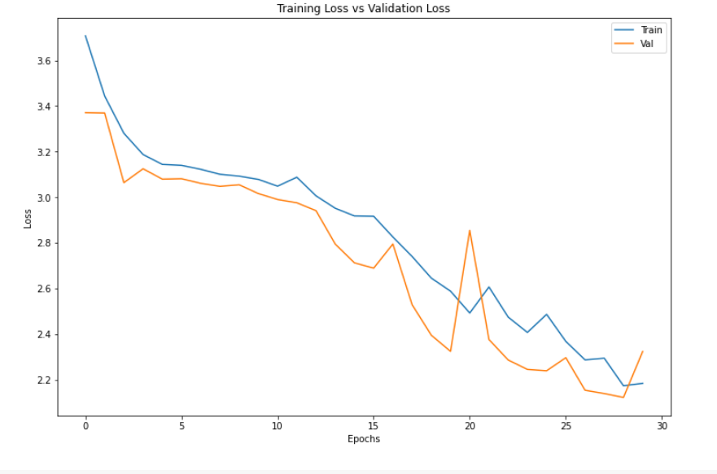

model.evaluate(X_test, y_test)

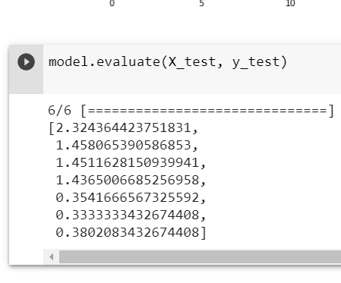

**5.4) EmoDB**

!unzip "/content/drive/MyDrive/EmoDB.zip"

import librosa

import numpy as np

input_length = 16000*5

batch_size = 32

n_mels = 320

def preprocess_audio_mel_T(audio, sample_rate=16000, window_size=20, #log_specgram

                 step_size=10, eps=1e-10):

    mel_spec = librosa.feature.melspectrogram(y=audio, sr=sample_rate, n_mels= n_mels)

    mel_db = (librosa.power_to_db(mel_spec, ref=np.max) + 40)/40

    return mel_db.T

def load_audio_file(file_path, input_length=input_length):

  data = librosa.core.load(file_path, sr=16000)[0] #, sr=16000

  if len(data)>input_length:

    max_offset = len(data)-input_length

    offset = np.random.randint(max_offset)

    data = data[offset:(input_length+offset)]

  else:

    if input_length > len(data):

      max_offset = input_length - len(data)

      offset = np.random.randint(max_offset)

    else:

      offset = 0

    data = np.pad(data, (offset, input_length - len(data) - offset), "constant")

  data = preprocess_audio_mel_T(data)

  return data

# Preprocessing the dataset

import os

from scipy.io import wavfile

import librosa

import matplotlib.pyplot as plt

import numpy as np

import cv2

directory = "/content/wav/"

classes = ["W" ,"L" ,"E" ,"A" , "F" ,"T" ,"N" ]

X = list()

y = list()

for filename in os.listdir(directory):

  filePath = os.path.join(directory, filename)

  a = load_audio_file(file_path=filePath)

  data = cv2.merge([a,a,a])

  if(filename[5:6] in classes):

    X.append(data)

    y.append(classes.index(filename[5:6]))

X = np.asarray(X, dtype=np.float32)

y = np.asarray(y, dtype=np.float32)

import pandas as pd

import numpy as np

import matplotlib.pyplot as plt

import tensorflow as tf

# dataset preparation

from tensorflow.keras import datasets,layers,models

from sklearn.model_selection import train_test_split

X_train, X_test, y_train, y_test = train_test_split(X, y, test_size=0.4, train_size= 0.6 ,random_state=10)

def inception(x,

              filters_1x1,

              filters_3x3_reduce,

              filters_3x3,

              filters_5x5_reduce,

              filters_5x5,

              filters_pool):

  path1 = layers.Conv2D(filters_1x1, (1, 1), padding='same', activation='relu')(x)

  path2 = layers.Conv2D(filters_3x3_reduce, (1, 1), padding='same', activation='relu')(x)

  path2 = layers.Conv2D(filters_3x3, (1, 1), padding='same', activation='relu')(path2)

  path3 = layers.Conv2D(filters_5x5_reduce, (1, 1), padding='same', activation='relu')(x)

  path3 = layers.Conv2D(filters_5x5, (1, 1), padding='same', activation='relu')(path3)

  path4 = layers.MaxPool2D((3, 3), strides=(1, 1), padding='same')(x)

  path4 = layers.Conv2D(filters_pool, (1, 1), padding='same', activation='relu')(path4)

  return tf.concat([path1, path2, path3, path4], axis=3)

inp = layers.Input(shape=(157, 320, 3))

input_tensor = layers.experimental.preprocessing.Resizing(224, 224, interpolation="bilinear", input_shape=X_train.shape[1:])(inp)

x = layers.Conv2D(64, 7, strides=2, padding='same', activation='relu')(input_tensor)

x = layers.MaxPooling2D(3, strides=2)(x)

x = layers.Conv2D(64, 1, strides=1, padding='same', activation='relu')(x)

x = layers.Conv2D(192, 3, strides=1, padding='same', activation='relu')(x)

x = layers.MaxPooling2D(3, strides=2)(x)

x = inception(x,

              filters_1x1=64,

              filters_3x3_reduce=96,

              filters_3x3=128,

              filters_5x5_reduce=16,

              filters_5x5=32,

              filters_pool=32)

x = inception(x,

              filters_1x1=128,

              filters_3x3_reduce=128,

              filters_3x3=192,

              filters_5x5_reduce=32,

              filters_5x5=96,

              filters_pool=64)

x = layers.MaxPooling2D(3, strides=2)(x)

x = inception(x,

              filters_1x1=192,

              filters_3x3_reduce=96,

              filters_3x3=208,

              filters_5x5_reduce=16,

              filters_5x5=48,

              filters_pool=64)

aux1 = layers.AveragePooling2D((5, 5), strides=3)(x)

aux1 = layers.Conv2D(128, 1, padding='same', activation='relu')(aux1)

aux1 = layers.Flatten()(aux1)

aux1 = layers.Dense(1024, activation='relu')(aux1)

aux1 = layers.Dropout(0.7)(aux1)

aux1 = layers.Dense(10, activation='softmax')(aux1)

x = inception(x,

              filters_1x1=160,

              filters_3x3_reduce=112,

              filters_3x3=224,

              filters_5x5_reduce=24,

              filters_5x5=64,

              filters_pool=64)

x = inception(x,

              filters_1x1=128,

              filters_3x3_reduce=128,

              filters_3x3=256,

              filters_5x5_reduce=24,

              filters_5x5=64,

              filters_pool=64)

x = inception(x,

              filters_1x1=112,

              filters_3x3_reduce=144,

              filters_3x3=288,

              filters_5x5_reduce=32,

              filters_5x5=64,

              filters_pool=64)

aux2 = layers.AveragePooling2D((5, 5), strides=3)(x)

aux2 = layers.Conv2D(128, 1, padding='same', activation='relu')(aux2)

aux2 = layers.Flatten()(aux2)

aux2 = layers.Dense(1024, activation='relu')(aux2)

aux2 = layers.Dropout(0.7)(aux2)

aux2 = layers.Dense(10, activation='softmax')(aux2)

x = inception(x,

              filters_1x1=256,

              filters_3x3_reduce=160,

              filters_3x3=320,

              filters_5x5_reduce=32,

              filters_5x5=128,

              filters_pool=128)

x = layers.MaxPooling2D(3, strides=2)(x)

x = inception(x,

              filters_1x1=256,

              filters_3x3_reduce=160,

              filters_3x3=320,

              filters_5x5_reduce=32,

              filters_5x5=128,

              filters_pool=128)

x = inception(x,

              filters_1x1=384,

              filters_3x3_reduce=192,

              filters_3x3=384,

              filters_5x5_reduce=48,

              filters_5x5=128,

              filters_pool=128)

x = layers.GlobalAveragePooling2D()(x)

x = layers.Dropout(0.4)(x)

out = layers.Dense(10, activation='softmax')(x)

model = Model(inputs = inp, outputs = [out, aux1, aux2])

model.compile(optimizer='adam', loss=[losses.sparse_categorical_crossentropy, losses.sparse_categorical_crossentropy, losses.sparse_categorical_crossentropy], loss_weights=[1, 0.3, 0.3], metrics=['accuracy'])

history = model.fit(X_train, [y_train, y_train, y_train], validation_data=(X_test, [y_test, y_test, y_test]), batch_size=64, epochs=30)

fig, axs = plt.subplots(figsize=(12,8))

axs.plot(history.history['loss'])

axs.plot(history.history['val_loss'])

axs.title.set_text('Training Loss vs Validation Loss')

axs.set_xlabel('Epochs')

axs.set_ylabel('Loss')

axs.legend(['Train','Val'])

plt.show()

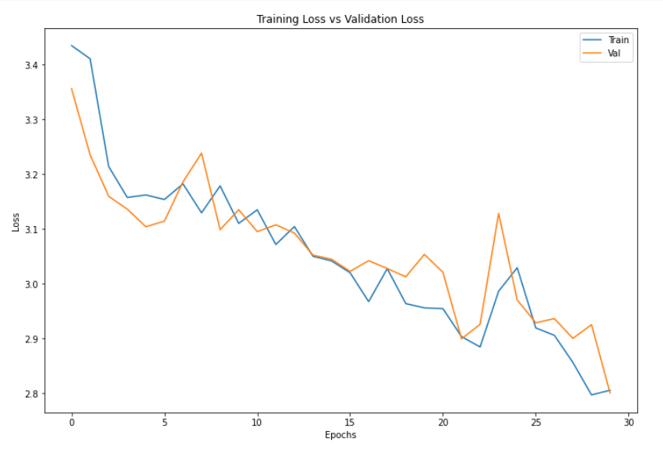

model.evaluate(X_test, y_test)

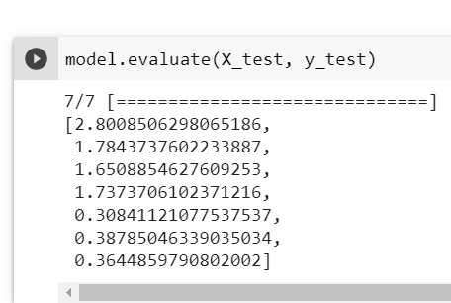

**Looking at the complexity of the model and the limitations of google colab, I have reduced the input size for the model,i.e., I have taken 2000 training data points and 2000 testing data points.**