# Manav Rachna International Institute of Research and Studies Bachelor's in computer applications

**Data Structures using C**



**Submitted by:** Anmol Prasad **Department:** School of Computer Applications **Course:** Bachelor's in computer applications

**Roll No:** 24/SCA/BCA/058

**Semester:** 2nd

**Subject:** Data Structures using C

# Experiment no: 1

**Program:**

#include<stdio.h> int main(){

int arr[10], n;

printf("Enter the number of elements you want.\n"); scanf("%d", &n);

printf("Enter the elements.\n"); for(int i=0; i<n; i++){

scanf("%d", &arr[i]);

}

printf("Elements inside array are:\n"); for(int i=0; i<n; i++){

printf("%d\t", arr[i]);

}

return 0;

}

# Output:

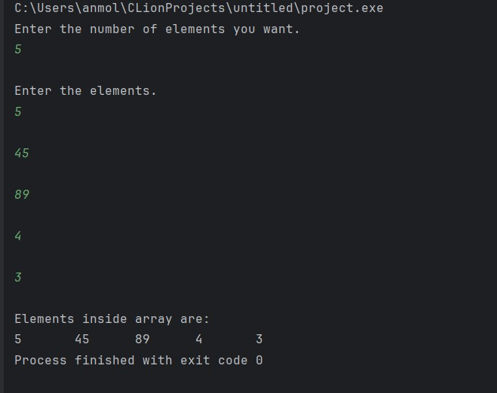

**Experiment no: 2**

**Aim:** To search for element inside of an array.

# Program:

#include<stdio.h> int main(){

int arr[7] = {1,5,3,7,6,4,9};

int n, count=0;

printf("Enter the element that you want to search.\n"); scanf("%d", &n);

for(int i=0; i<7; i++){ if(arr[i] == n){

printf("%d is present at %d position\n", n, i+1); count += 1;

}

}

if(count == 0){

printf("%d not found.\n");

} return 0; }

# Output:

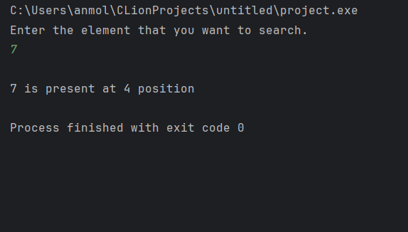

**Experiment no: 3**

**Aim:** To update element in an array.

# Program:

#include<stdio.h> int main(){

int arr[7] = {1,2,3,4,5,6,7};

int pos, n;

printf("Elements of array before updation.\n"); for(int i=0; i<7; i++){

printf("%d\t", arr[i]);

}

printf("\nEnter the position of element you want to update.\n"); scanf("%d", &pos);

printf("Enter the value you want to update.\n"); scanf("%d", &n);

arr[pos-1] = n; // Updating the element.

printf("Elements of array after updation.\n"); for(int i=0; i<7; i++){ printf("%d\t", arr[i]); } return 0; }

# Output:

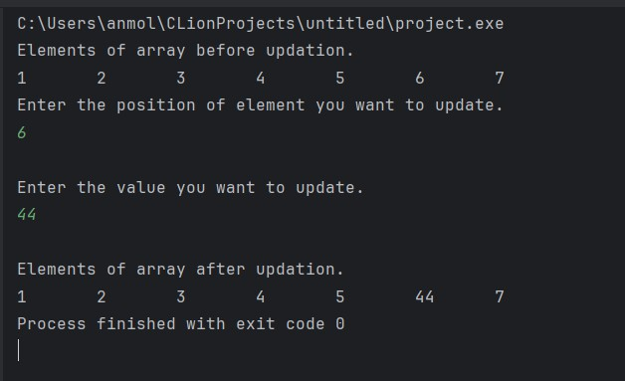

**Experiment no: 4 Aim:** To delete element from an array.

# Program:

#include<stdio.h> int main(){

int arr[7] = {1,2,3,4,5,6,7};

int n, count=0;

printf("Elements of array before deletion:\n"); for(int i=0; i<7; i++){

printf("%d\t", arr[i]);

}

printf("\nEnter the element that you want to delete.\n"); scanf("%d", &n);

for(int i=0; i<7; i++){ if(arr[i] == n){ count += 1;

for(int j=i; j<6; j++){ arr[j] = arr[j+1];

} } } if(count == 0){ printf("%d not found\n", n);

} else{

printf("Elements of array after deletion:\n"); for(int i=0; i<6; i++){

printf("%d\t", arr[i]);

}

}

return 0;

}

# Output:

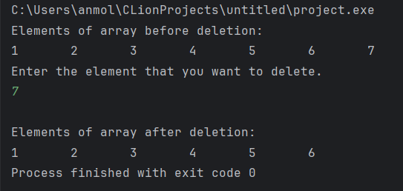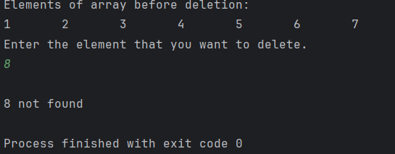

**Experiment no: 5 Aim:** To sort elements in an array.

# Program:

#include<stdio.h> int main(){

int arr[7] = {4,2,6,8,5,1,9};

int temp;

printf("Initial Array:\n"); for(int i=0; i<7; i++){ printf("%d\t", arr[i]);

}

printf("\nSorting in ascending order:\n");

for(int i=0; i<7; i++){ for(int j=0; j<6; j++){ if(arr[j] > arr[j+1]){ temp = arr[j];

arr[j] = arr[j+1]; arr[j+1] = temp;

}

}

}

for(int i=0; i<7; i++){ printf("%d\t", arr[i]);

}

printf("\nSorting in descending order:\n");

for(int i=0; i<7; i++){ for(int j=0; j<6; j++){ if(arr[j] < arr[j+1]){ temp = arr[j];

arr[j] = arr[j+1]; arr[j+1] = temp;

}

}

}

for(int i=0; i<7; i++){ printf("%d\t", arr[i]);

}

return 0;

}

**Output:**

