**Assignment – 1**

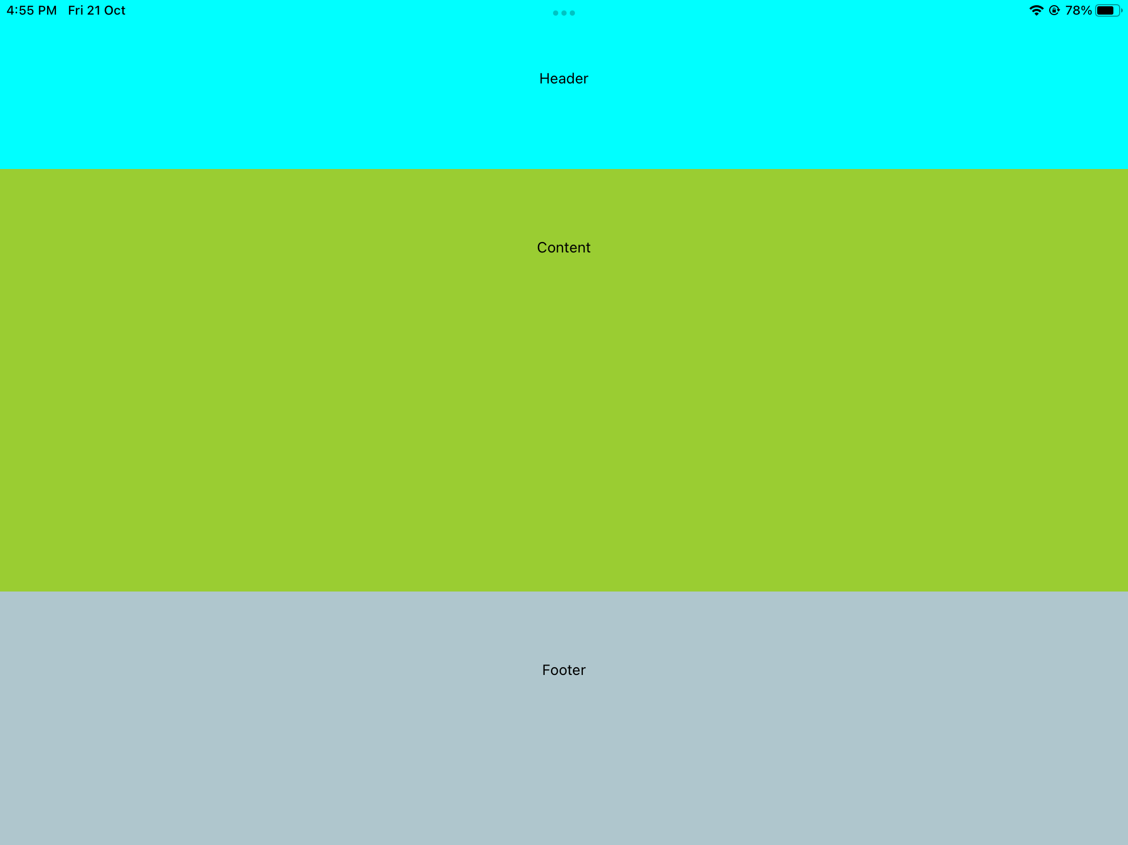

In assignment 1 flex is used in each section. For header the flex value is 2, for content flex value is 5 and for footer flex value is 3 . Flex direction not used because through flex we achieve all

**Assignment –2**

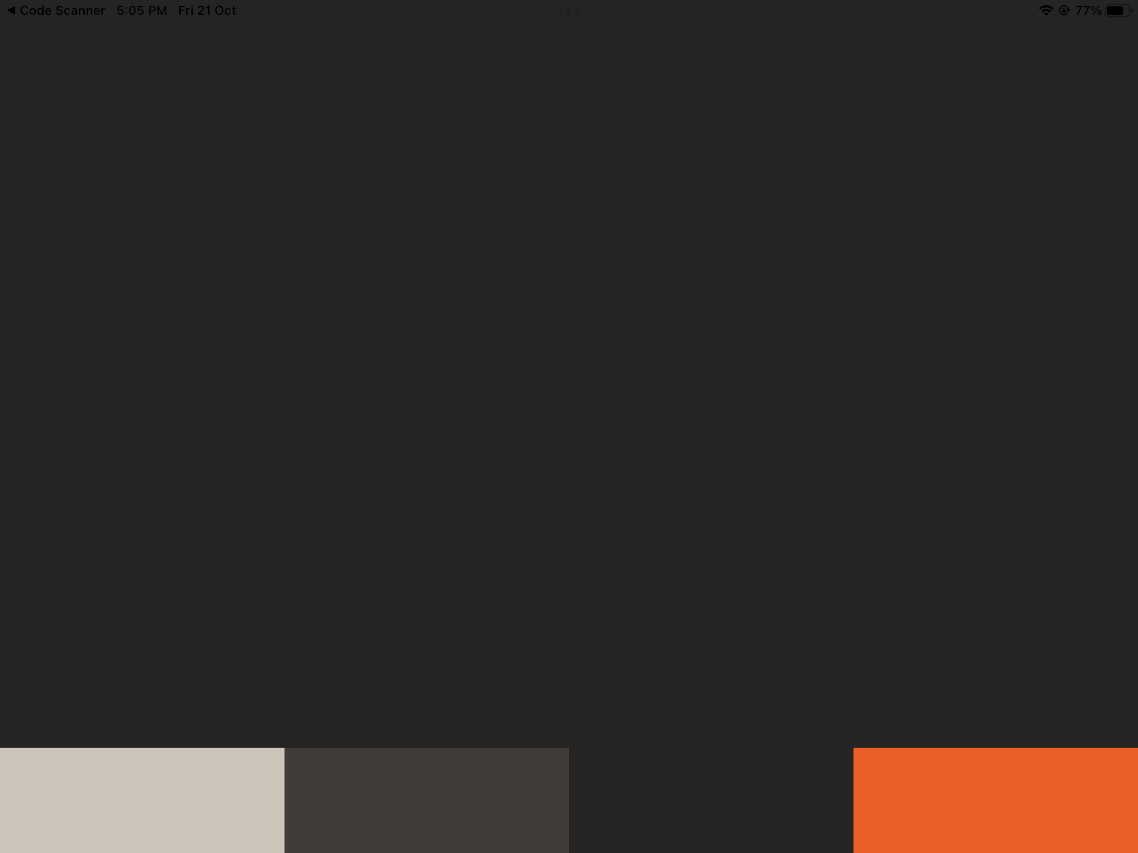

In this assignment 4 box-shaped Text are thier each has different color as soon as user click on any color it changes the whole background color

**Assignment-3**

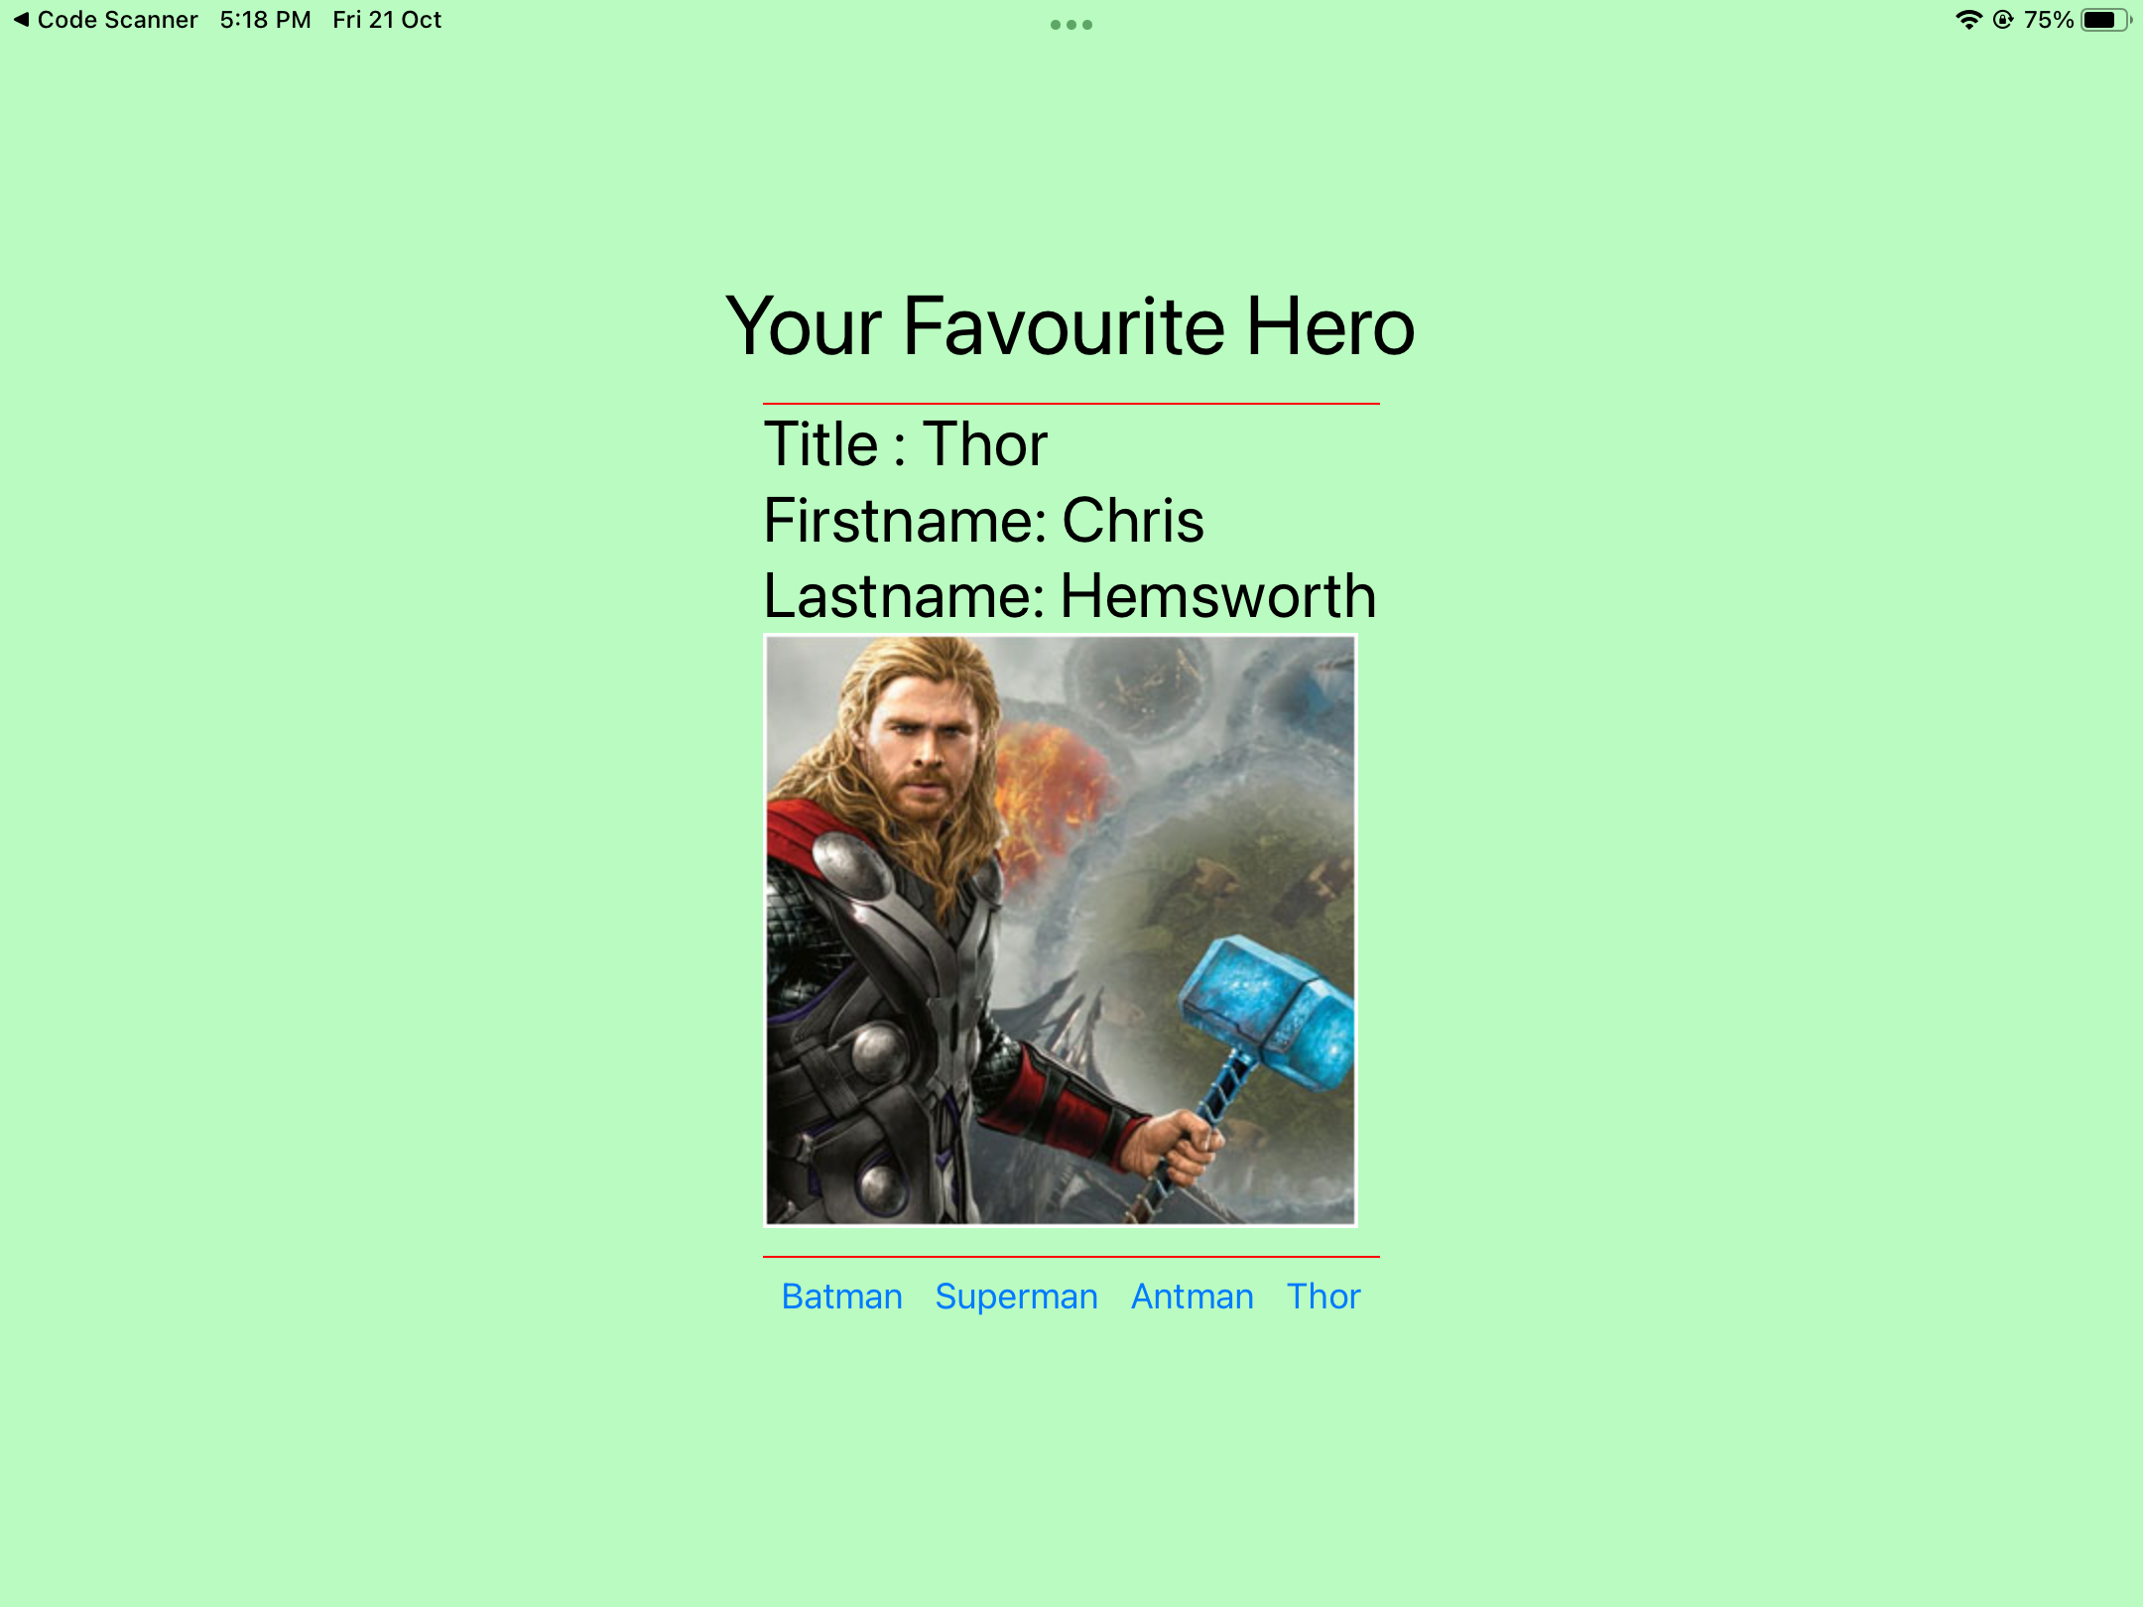

In this Assignment , on every click on each button it’s changing the image , title, firstname and lastname

UseState is used to change the state of each object on a click of button