High Low Casino
  - Game Design Document
Version 2 2
Prepared for Busy Gamers Studios
16 September 2026

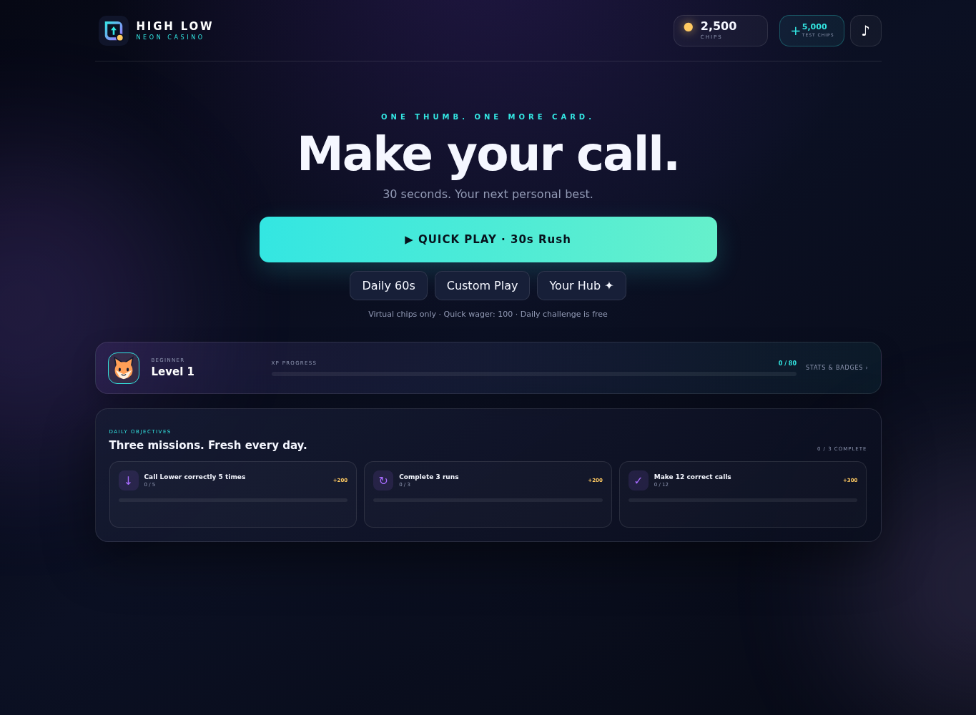
Current desktop menu from the tested HTML5 build

Document purpose
This document defines the current High Low Casino product, its implemented rules, complete Gen Z and hybrid casual engagement package, economy, interface, telemetry, quality requirements, and production roadmap. The working HTML5 build is the source of truth for current behavior. Items marked as production recommendations require backend, platform, art, legal, or live operations work beyond the present offline-first release.
Document field | Value
Genre | Hybrid casual higher or lower card prediction game
Current platform | Responsive HTML5 browser game and installable web app
Currency model | Virtual chips with no cash redemption
Primary session | 15 to 60 seconds per run
Core audience | Mobile-first casual and Gen Z players aged 13 and above subject to local ratings
Current build status | Playable and tested with local progression and optional Google Sheets event collection

Table of Contents
1 Executive Summary
2 Product Vision and Design Pillars
3 Audience Platforms and Positioning
4 Core Gameplay
5 Fairness and Probability
6 Game Modes
7 Controls and Interaction
8 Wagers Multipliers and Cash Out
9 Insurance and Boosters
10 Progression
11 Short Term Rewards
12 Daily Missions Achievements and Statistics
13 Return Systems
14 Cosmetics Identity and Collection
15 Social and Competitive Systems
16 Seasons Events and Pass
17 User Interface and Screen Flows
18 Visual Audio and Haptic Direction
19 Accessibility
20 Economy and Responsible Design
21 Onboarding
22 Save Data and Recovery
23 Analytics and Google Sheets
24 Technical Design Summary
25 Live Operations and Content Cadence
26 Quality Assurance
27 Metrics and Success Criteria
28 Production Roadmap
29 Risks and Mitigations
30 Acceptance Criteria
Appendix A Detailed Level Requirements
Appendix B Analytics Event Catalogue
Appendix C Current Implementation Limitations
Appendix D Glossary
Appendix E Gen Z Engagement Coverage

1 Executive Summary
High Low Casino is a one-thumb card prediction game in which the player decides whether the next rank will be higher or lower than the current card. A correct call builds a streak and increases the available cash-out multiplier. A wrong call ends a normal run unless a one-prediction shield is active. Ties preserve the streak. The player chooses when to stop, which creates the central tension between securing a known reward and risking it for a larger payout.
The current build combines a fast hypercasual first session with hybrid-casual progression. Quick Play starts a 30-second run without a menu sequence. Levels, ranks, missions, streak chests, achievements, cosmetics, weekly leagues, daily challenges, seasonal passes, shareable result cards, friend ghosts, and return rewards provide longer-term goals. All rewards use virtual currency or cosmetic inventory.
Revision 2 2 consolidates every approved Gen Z engagement requirement into one production specification. Appendix E provides a traceable coverage matrix and implementation order so design, engineering, art, analytics, and quality assurance can validate the same scope.
Card generation is intentionally independent of spending, balance, cosmetics, boosters, and previous results. Normal runs use independent rank and suit draws with replacement. The user interface displays the actual next-draw probabilities for the current rank. Daily and friend challenges use fixed replay sequences and identify themselves as fixed.

1 1 Product Goals
- Deliver an understandable first run within ten seconds of opening the game.
- Support satisfying 15 to 30 second sessions while allowing longer untimed runs.
- Make cash-out timing the main strategic choice rather than hiding or changing probability.
- Create visible short-term rewards every few correct calls and long-term identity goals across levels and seasons.
- Enable safe offline play with browser storage and optional append-only analytics delivery to Google Sheets.
- Keep the release virtual-currency-only and avoid pay-to-win probability changes.

1 2 Non Goals for the Current Release
- Real-money wagering, cash redemption, cryptocurrency, or transferable value.
- A server-authoritative global economy or anti-cheat-secured competitive leaderboard.
- Real-time multiplayer, chat, account login, cloud save, advertising SDKs, or in-app purchases.
- A physical-deck simulation in normal modes. Normal cards are independent draws with replacement.

2 Product Vision and Design Pillars
Pillar | Design requirement | Observable player experience
Instant clarity | Show one current card, two prediction actions, live odds, streak, and cash-out value. | The player understands the next decision without reading a tutorial page.
Fast restart | Quick Play, Play Again, remembered mode, and affordable auto wager remove repeated menu steps. | A failed run can restart in one tap.
Voluntary risk | The multiplier rises predictably and cash-out remains available after a correct call. | The player owns the decision to continue or secure value.
Fairness visibility | Use independent draws, show edge restrictions, label fixed replays, and never adjust odds using player data. | Losses feel attributable to known rules rather than hidden manipulation.
Expressive progression | Skins, avatars, frames, titles, emotes, badges, and share cards remain cosmetic. | Players can build identity without buying stronger odds.
Short and long goals | Combo feedback, chests, missions, ranks, leagues, and seasons operate at different time horizons. | Every session can advance at least one visible goal.
Resilient data | Save progress locally and queue analytics until acknowledged. | Temporary network loss does not stop play or silently discard queued records.

3 Audience Platforms and Positioning

3 1 Target Players
Segment | Need | Relevant systems
First-session casual player | Immediate interaction and low cognitive load | Quick Play, large prediction buttons, 30-second Rush, automatic wager
Gen Z mobile player | One-thumb controls, identity, reactions, social output | Swipe gestures, Byte dealer, emotes, shareable story card, seasonal cosmetics
Risk and strategy player | Transparent odds and meaningful stopping decisions | Live probabilities, cash out, insurance cost, Perfect Call
Progression player | Frequent goals and visible ownership | Levels, ranks, missions, chests, achievements, collection album
Competitive asynchronous player | Comparison without matchmaking delay | Local Top 10, weekly league, personal best, friend ghost codes

3 2 Platform Requirements
Platform | Current requirement | Production consideration
Mobile browser | Responsive portrait layout, pointer gestures, touch targets, no horizontal overflow | Test Safari and Chrome across common 360 to 430 pixel widths
Desktop browser | Mouse buttons, keyboard shortcuts, scalable central play area | Support 1280 by 720 and larger without excessive empty space
Installable web app | Manifest and versioned service-worker cache | Define update prompt and cache invalidation policy
Google Apps Script host | Single-file build with inline assets and script bridge | Suitable for internal tests and small audiences under Google quotas
Future Android and iOS | Not included in the current source | Wrap as PWA or port logic to Unity only after retention proves the concept

3 3 Product Positioning
The game is positioned as a neon hybrid-casual prediction game, not as simulated gambling with redeemable value. Casino-inspired tension supports the theme, while clear virtual-currency labels, transparent odds, free practice modes, and cosmetic-only progression protect player trust.

4 Core Gameplay
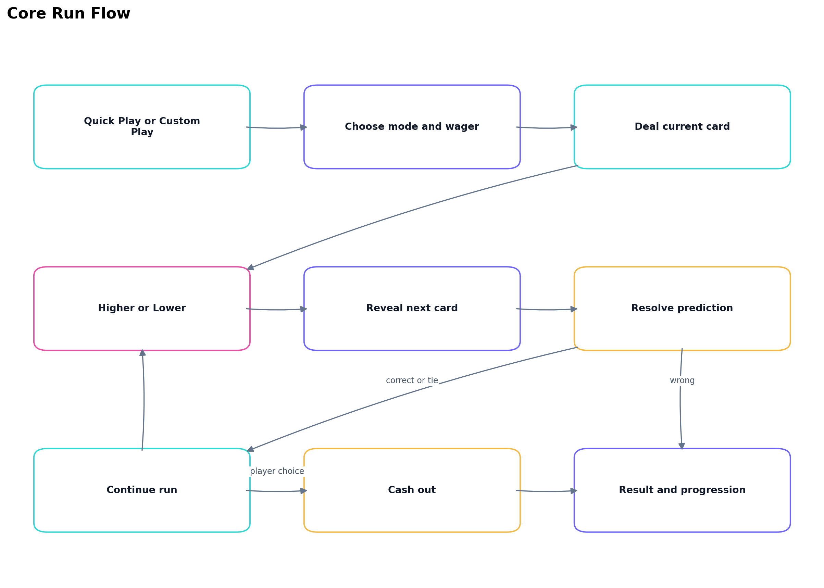
Figure 1 Core run flow

4 1 Core Loop
1. The player starts Quick Play or selects a mode, wager, card skin, and optional boosters.
2. A normal run deducts the selected wager. Daily and friend challenges are free practice modes.
3. The game deals a current card and asks for Higher or Lower.
4. The next card is generated and saved before the reveal animation resolves the prediction.
5. A correct call increases streak, updates the multiplier, grants XP, and may open a milestone chest.
6. A tie changes the current card but preserves the streak.
7. An incorrect call ends a normal run unless insurance or the shield booster protects that prediction.
8. After a correct call, the player continues or cashes out. Timed modes may settle automatically.
9. The result screen awards final XP, updates missions and statistics, records rankings, and offers immediate replay or sharing.

4 2 Card Ranking
Ranks use the order 2 through 10, Jack, Queen, King, Ace. Ace is highest and 2 is lowest. Suits have no effect on resolution. Higher is disabled on an Ace; Lower is disabled on a 2.

4 3 Resolution Rules
Condition | Result | Streak | Run state | Reward effect
Next rank is greater and Higher was selected | Correct | Increase by one | Continue | XP and multiplier update
Next rank is lower and Lower was selected | Correct | Increase by one | Continue | XP and multiplier update
Next rank equals current rank | Tie | No change | Continue | No correct-call XP
Direction is wrong with active protection | Protected loss | No change | Continue | Protection is consumed
Direction is wrong without protection in normal mode | Incorrect | Run ends | Loss | No cash-out reward
Direction is wrong in Daily or Friend mode | Incorrect | Reset to zero | Continue until timer ends | Challenge score continues

4 4 Input Locking
Prediction, insurance, cash-out, and navigation inputs are disabled while a reveal or result transition is resolving. Open modals also block gameplay input. This prevents duplicate predictions, repeated payouts, and state changes during animation.

5 Fairness and Probability

5 1 Normal Card Generation
Each normal draw independently selects one of 13 ranks and one of four suits with replacement. The implementation uses cryptographic random values with rejection sampling when the browser provides them. Math random is a compatibility fallback. Card generation does not receive chip balance, purchase history, previous losses, rank, selected skin, booster inventory, or account status.

5 2 Displayed Odds
For current rank r, the next-draw probabilities are calculated as follows. Higher equals 14 minus r divided by 13. Lower equals r minus 2 divided by 13. Tie equals 1 divided by 13. The interface rounds these values to whole percentages.
Current rank | Higher outcomes | Lower outcomes | Tie outcomes | Displayed strategic implication
2 | 12 of 13 | 0 of 13 | 1 of 13 | Only Higher is available
7 | 7 of 13 | 5 of 13 | 1 of 13 | Higher is more likely
8 | 6 of 13 | 6 of 13 | 1 of 13 | Directions are equally likely
10 | 4 of 13 | 8 of 13 | 1 of 13 | Lower is more likely
Ace | 0 of 13 | 12 of 13 | 1 of 13 | Only Lower is available

5 3 Perfect Call
A Perfect Call occurs when the player selects a direction with probability below 6 of 13 and the prediction succeeds. It grants 5 additional XP and can advance a Perfect Call mission. The bonus is calculated after the outcome and never changes the generated card.

5 4 Fixed Challenge Sequences
Daily and friend modes replay deterministic card sequences. The Daily sequence is derived from the UTC date so all attempts on the same date receive the same cards. Friend challenge codes may include the original card list, seed, score, and timed prediction trace. These modes show a fixed-replay label and disable boosters.

5 5 Trust Rules
- Never improve or reduce odds because of spending, purchases, balance, inactivity, previous wins, previous losses, or player identity.
- Never describe a fixed sequence as a fresh random draw.
- Never sell a skin, booster, insurance token, or pass tier that changes card probability.
- Show the insurance price before activation and consume only one protection per prediction.
- Keep virtual chips clearly labeled and unavailable for cash redemption.

6 Game Modes
Mode | Duration | Entry | Failure behavior | Primary purpose
Classic | Untimed | Selected wager | Wrong unprotected call ends run | Deliberate risk and cash-out decisions
Quick | Five seconds per decision | Selected wager | Timer or wrong call ends run | Fast reactions and repeated short runs
Rush | Thirty seconds total | Auto-selected affordable wager | Timer cashes out an active streak or ends at zero | Default instant play
Daily | Sixty seconds total | Free | Wrong call resets streak; play continues | Shared daily score challenge
Friend | Sixty seconds total | Free | Wrong call resets streak; play continues | Asynchronous ghost comparison
Personal best | Untimed | Auto-selected wager | Wrong unprotected call ends run | Beat saved best streak for one key
Weekend Sprint | Thirty seconds total | Auto-selected wager | Same settlement as Rush | Weekend key reward at streak five

6 1 Quick Play Selection
Quick Play remembers the previous eligible mode and uses the highest configured wager no greater than 100 chips and no greater than the current balance. If Weekend Sprint is remembered outside Saturday or Sunday UTC, the button falls back to Rush. If no configured tier fits the balance, the implementation falls back to 10 chips.

6 2 Timed Settlement
- Rush and Weekend Sprint automatically cash out when the total timer expires and the streak is at least one.
- Rush and Weekend Sprint end with no cash-out reward when the timer expires at streak zero.
- Daily and Friend challenges finish when sixty seconds expire and report total correct calls and best streak.
- Quick ends the run if the player does not submit a decision within five seconds.
- An accepted card reveal completes before timeout settlement so a submitted decision is never discarded mid-animation.

7 Controls and Interaction
Action | Touch gesture | Button | Keyboard | Guard
Higher | Swipe up at least 45 pixels | Higher | Up arrow | Disabled on Ace
Lower | Swipe down at least 45 pixels | Lower | Down arrow | Disabled on 2
Cash out | Swipe right at least 45 pixels | Cash Out | C | Requires streak at least one
Activate insurance | Hold card area for 600 milliseconds | Protect prediction | None | Normal mode, affordable, no active protection
Extra time | None | Add 3 seconds | None | Timed eligible run with booster
Close secondary panel | None | Close control | Escape | Only when modal is open

Buttons remain the accessible alternative to gestures. Other page areas retain normal scrolling, and a held or dragged pointer cannot submit multiple actions.

8 Wagers Multipliers and Cash Out

8 1 Wager Tiers
Tier | Wager chips | Tier | Wager chips
1 | 10 | 6 | 1,000
2 | 50 | 7 | 2,500
3 | 100 | 8 | 5,000
4 | 250 | 9 | 10,000
5 | 500 | 10 | 25,000

8 2 Streak Multipliers
Streak | Multiplier | Streak | Multiplier | Streak | Multiplier
1 | 1.25x | 2 | 1.65x | 3 | 2.20x
4 | 3.10x | 5 | 5.00x | 6 | 6.50x
7 | 8.50x | 8 | 11.00x | 9 | 14.00x
10 | 18.00x | 11 | 23.00x | 12 | 29.00x
13 | 36.00x | 14 | 44.00x | 15 | 55.00x

Cash-out value equals floor of wager multiplied by the configured streak multiplier. The entry wager is deducted at run start; the cash-out value is then credited on settlement. Milestone chest chips are separate immediate rewards. Multipliers remain capped at 55 times after streak 15.

8 3 Cash Out Requirements
- Cash Out becomes active after the first correct prediction in normal modes.
- The displayed amount updates after every correct prediction.
- The control remains disabled during a reveal, while a modal is open, and after settlement begins.
- A practice challenge uses End Challenge instead of a chip cash-out.
- Auto Cash-Out settles automatically at streak three when that booster is active.

9 Insurance and Boosters

9 1 Standard Insurance
Insurance is available after streak one in normal modes. Its price is the greater of 5 chips or 15 percent of the current cash-out value, rounded up. The cost is deducted immediately and the next prediction is protected. Protection expires after that prediction whether the result is correct, tie, or incorrect. On a protected wrong call, the streak remains unchanged and the newly revealed card becomes the current card.

9 2 Booster Rules
Booster | Effect | Consumption rule | Probability effect
Extra Time | Adds three seconds once | Consumed at eligible Rush, Quick, or Weekend run start | None
Shield | Protects the first prediction | Consumed at eligible casual run start | None
Auto Cash Out | Automatically secures value at streak three | Consumed at eligible casual run start | None
Double XP | Doubles XP associated with the run | Consumed at eligible casual run start | None
Mission Booster | Doubles additive mission progress | Consumed at eligible casual run start | None
Cosmetic Key | Opens one collection pack | Consumed only when an unopened item is available | None

Daily and Friend modes disable all boosters. The mission booster does not double maximum-streak objectives because those objectives record the highest achieved value rather than additive progress.

10 Progression

10 1 Experience and Level Formula
The game supports levels 1 through 50. XP required to move from level L to the next level equals 80 plus 28 multiplied by L minus 1. Total XP accumulates permanently in the browser save.
XP source | Base amount | Notes
Correct prediction | 3 XP | Awarded only for a non-tie correct call
Perfect Call | 5 XP additional | Awarded with correct-call XP
Run completion | 5 XP | All completed run types
Cash-out completion | 8 XP additional | Normal successful cash-out
Milestone chest | 12 to 150 XP | Granted at its streak milestone
Daily mission | 25 to 40 XP | Depends on rotating objective
All-time leaderboard placement | 50 to 200 XP | One-time local placement reward

10 2 Ranks
Rank | Minimum level | Total XP at level | Related unlock
Beginner | 1 | 0 | Neon at level 1
Player | 5 | 488 | Classic at level 5
Risk Taker | 10 | 1,728 | Royal at level 12
Card Expert | 18 | 4,984 | None at rank entry
High Roller | 27 | 11,180 | None at rank entry
Casino Master | 38 | 21,756 | None at rank entry
Prediction Legend | 50 | 36,848 | Maximum level

10 3 Card Skins
Skin | Unlock | Ownership | Gameplay impact
Neon | Level 1 | Standard | Cosmetic only
Classic | Level 5 | Standard | Cosmetic only
Royal | Level 12 | Standard | Cosmetic only
Cyber | Level 20 | Standard | Cosmetic only
Emerald | Level 30 | Standard | Cosmetic only
Aurora | Aurora season tier 10 | Permanent seasonal | Cosmetic only
Sunset | Sunset season tier 10 | Permanent seasonal | Cosmetic only
Cosmic | Cosmic season tier 10 | Permanent seasonal | Cosmetic only

11 Short Term Rewards

11 1 Streak Milestone Chests
Streak | Chip reward | XP reward | Presentation
3 | 40 | 12 | Basic chest and combo pulse
5 | 100 | 25 | Stronger particles and milestone reaction
8 | 250 | 45 | Gold effect tier
10 | 500 | 70 | High-intensity celebration
15 | 1,500 | 150 | Legendary celebration

Each chest can be collected once per run. Chip and XP rewards are committed before the celebration opens. Timed modes use a nonblocking notification so a modal cannot pause the timer.

11 2 Combo and Atmosphere
Streak | Visual and audio state
0 | Build Your Combo prompt and calm table
1 to 2 | Soft glow and basic positive feedback
3 to 4 | Card trails, combo pulse, and chest feedback
5 to 7 | Animated background and stronger music layer
8 to 10 | Screen pulse, gold effects, stronger particles
11 to 14 | Jackpot-style environment intensity
15 and above | Legend reaction; multiplier remains at configured cap after 15

11 3 Reactive Dealer
Byte is the current CSS-animated dealer. Reactions cover run start, correct call, Perfect Call, new record, comeback after protection, loss, tie, shield use, cash-out, chest, and legendary streak. Reactions must remain short enough to avoid delaying the next decision.

12 Daily Missions Achievements and Statistics

12 1 Daily Mission Pool
Mission | Target | Reward
Reach a five-card streak | Maximum streak 5 | 300 chips and 35 XP
Complete three runs | 3 completed runs | 200 chips and 25 XP
Cash out 1,000 chips | 1,000 cumulative chips | 400 chips and 40 XP
Make twelve correct calls | 12 cumulative correct calls | 300 chips and 35 XP
Make two Perfect Calls | 2 cumulative Perfect Calls | 250 chips and 40 XP
Call Lower correctly five times | 5 correct Lower calls | 200 chips and 30 XP

Three distinct missions are selected deterministically for each UTC day. Completion pays automatically once, and the save stores both progress and claim state.

12 2 Achievements
Badge | Requirement
First Fortune | Cash out the first run
Hot Hand | Reach streak 5
Untouchable | Reach streak 10
Big Winner | Cash out 5,000 chips
Table Regular | Complete 25 runs
Risk Taker | Reach level 10
Skin Collector | Reach level 30 and unlock all standard skins
Card Reader | Make 100 predictions

12 3 Player Statistics
Statistic | Definition
Win rate | Correct calls divided by correct plus incorrect calls; ties are excluded
Average streak | Total best streak across finished or abandoned runs divided by recorded runs
Highest reward | Largest secured cash-out reward; test-chip grants are excluded
Total predictions | All accepted prediction resolutions including ties and protected mistakes
Best streak | Highest saved streak across runs
Runs played | All completed run settlements

13 Return Systems

13 1 Seven Day Login Journey
Day | Chips | Additional inventory
1 | 100 | One key and one Extra Time
2 | 150 | One key and one Shield
3 | 200 | One key and one Auto Cash-Out
4 | 250 | One key and one Double XP
5 | 300 | One key and one Mission Booster
6 | 400 | Two keys
7 | 700 | Two keys

One login reward is available per UTC date. Consecutive days advance the journey; a missed day restarts it at day one.

13 2 Daily Drop and Comeback
- Daily Drop grants 500 chips once every 24 hours.
- After at least three days away, the comeback reward grants 300 chips and one cosmetic key once for that absence.
- Time-based systems use the device clock in the current build and therefore are not tamper resistant.

13 3 Weekly Achievement
Twenty correct calls within the UTC week unlock the Twenty Clean Calls badge and one cosmetic key. The weekly counter resets on Monday at 00:00 UTC.
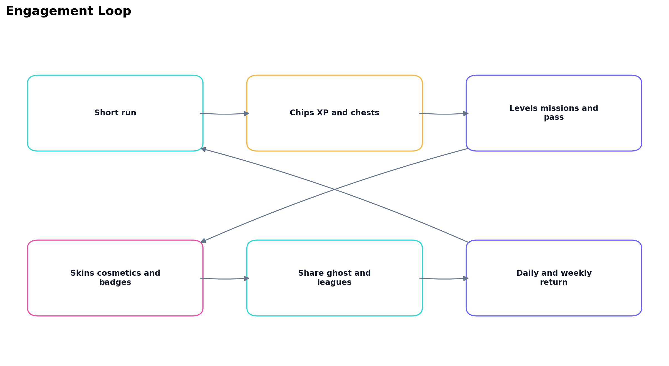
Figure 2 Engagement loop across sessions

14 Cosmetics Identity and Collection

14 1 Identity Slots
Slot | Current options | Default
Avatar | Neon Fox, Byte Bot, Cosmic Cat, Ghost, Visitor, Panda | Neon Fox
Frame | Electric, Golden, Candy, Orbit | Electric
Title | Fresh Deck, Card Reader, Main Character, Chill Dealer | Fresh Deck
Emote | Good Game, On Fire, Wow, Cool | Good Game

14 2 Cosmetic Packs
The collection album contains 18 items. One key opens one pack and selects uniformly from unowned items. Duplicate items are impossible. If the album is complete, the key is retained. Pack items and card skins never change probability, rewards, multipliers, timers, or insurance prices.

14 3 Player Hub
The Player Hub contains Challenges, Locker, Collection, Pass, League, Journey, and Settings tabs. It is the main destination for identity changes, booster preparation, event progress, and social challenge setup.
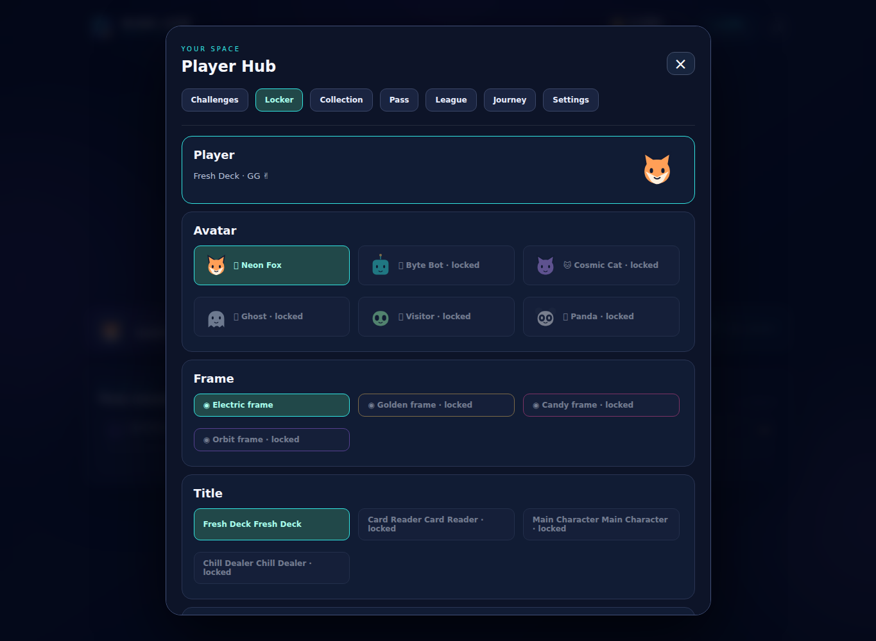
Figure 3 Current Locker screen and identity equipment

15 Social and Competitive Systems

15 1 Local All Time Leaderboard
The current all-time Top 10 is stored in the browser. Entries rank by streak, then secured reward, then earlier completion time. Four labeled demonstration entries provide initial context. Player names are sanitized and limited to 16 characters.
Place | One-time chips | One-time XP
1 | 1,500 | 200
2 | 750 | 100
3 | 400 | 50

The current implementation claims each all-time placement tier only once per browser save. It is not a global, server-verified competition.

15 2 Weekly League
League | Weekly correct-call threshold
Bronze | 0 to 19
Silver | 20 to 49
Gold | 50 to 99
Diamond | 100 or more

The weekly board keeps the best score for each display name and settles once on the first visit after a new UTC week begins. The player receives 1,500 chips for first, 750 for second, or 400 for third. Demonstration scores do not enter the weekly board.

15 3 Friend Challenges and Ghosts
- A completed run can be encoded as an HL1 challenge string containing version, seed, player name, score, timed trace, and up to 1,001 cards.
- Imported traces are validated for direction, order, duration, and numeric range before play.
- A hosted challenge link can prefill the Friend panel.
- Imported results are unverified practice comparisons and never become authoritative opponents or economy transactions.

15 4 Shareable Result Cards
The game generates a 1080 by 1920 portrait PNG containing player name, avatar, title, final streak, secured chips, level, rank, card skin, mode, and a Can You Beat My Streak message. The interface supports native device sharing, download, caption copy, and text links for WhatsApp, Telegram, and X. Instagram Stories and Discord use the native share sheet or manual upload.
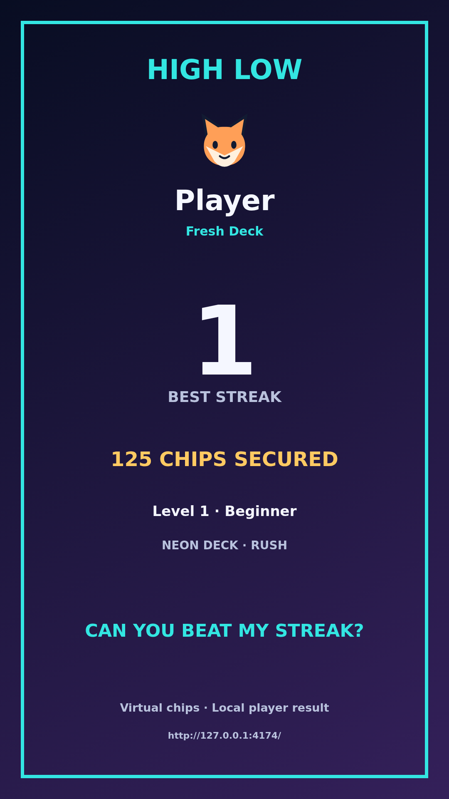
Figure 4 Current shareable portrait result card

16 Seasons Events and Pass

16 1 Monthly Themes
Theme | Rotation | Tier 10 reward
Aurora Nights | Month index rotation | Aurora card skin
Sunset Arcade | Month index rotation | Sunset card skin
Cosmic Club | Month index rotation | Cosmic card skin

16 2 Free Cosmetic Pass
The pass contains ten tiers and resets on the first UTC day of each month. Every 15 points unlocks one tier. Correct calls grant one point. A completed cash-out adds three points; another completed run adds one point. Tiers 1 through 9 award one cosmetic key each. Tier 10 awards the current permanent seasonal card skin.

16 3 Weekend Sprint
Weekend Sprint is available on Saturday and Sunday UTC. It runs for 30 seconds, uses a normal wager, and grants one extra cosmetic key when the completed run reaches streak five or higher.

17 User Interface and Screen Flows

17 1 Screen Inventory
Screen or panel | Purpose | Required primary actions
Main menu | Immediate entry and daily overview | Quick Play, Daily 60s, Custom Play, Hub, test chips
Custom Play | Configure a normal run | Wager, Classic or Quick, skin, deal
Gameplay | Make predictions and manage risk | Higher, Lower, insurance, cash out, emote
Result | Explain settlement and continue | Play Again, leaderboard, home, share
Player profile | Review progress | Statistics, badges, test XP
Leaderboard | Compare local scores | Name edit, ranking review, close
Player Hub | Manage meta systems | Challenges, locker, collection, pass, league, journey, settings
Chest | Celebrate milestone | Collect and continue
Data panel | Review analytics status | Sync, export, import

17 2 Gameplay HUD
Area | Content
Top left | Wager
Top center | Current streak and multiplier
Top right | Cash-out value
Upper play area | Byte reaction and run timer
Center | Current card and hidden next card
Below cards | Higher and Lower with labels
Lower play area | Live odds and fairness label
Bottom | Insurance, Cash Out, gesture hint, emote

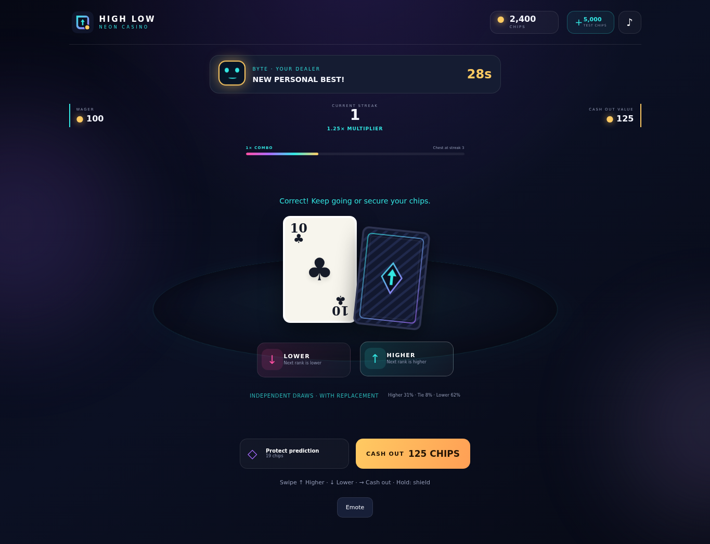
Figure 5 Current Rush gameplay screen

17 3 Feedback Priorities
- Prediction controls must be the most visually prominent interactive elements during decision time.
- Cash Out must become more prominent as the secured value grows.
- The current card, next-card state, streak, multiplier, and timer must remain readable without scrolling on common phones.
- Celebrations must never conceal a required decision or consume decision time unfairly.
- Every color-coded result must also use text, motion, icon, or shape.

18 Visual Audio and Haptic Direction

18 1 Visual Language
The current direction uses a dark navy table with cyan, violet, pink, and gold accents. Cards use large rank and suit marks. Glass panels organize the menu and hub. Cosmetics may change card backs, avatars, frames, titles, and event atmosphere, but card fronts must retain consistent contrast and rank readability.

18 2 Animation
Event | Required response
Deal | Short card arrival and stable final position
Reveal | Single coordinated flip before resolution
Correct | Glow, combo pulse, positive particles, dealer reaction
Perfect Call | Distinct text and stronger celebration
Wrong | Shake or loss effect without flashing hazards
Tie | Neutral pulse and streak-safe message
Chest | Gold particles and reward count
Cash out | Secured-value burst and transition to result

18 3 Audio and Haptics
The web build synthesizes optional adaptive music and tones. Production assets should include deal, flip, Higher, Lower, correct, wrong, tie, cash-out, insurance, chest, chip, achievement, and button sounds. Music intensity should follow streak atmosphere and reset immediately after settlement. Haptic mappings are recommended for native ports, with an independent toggle.

19 Accessibility
Requirement | Current or target behavior
Color independence | Higher and Lower use arrows and text; results include words and motion
Touch size | Primary controls sized for one-thumb use
Keyboard access | Up, Down, C, and Escape shortcuts
Reduced motion | Motion setting reduces optional animation intensity
Sound independence | Game rules and results never require audio
High contrast | Card fronts and rank marks maintain readable contrast
Screen reader support | Semantic labels for key controls; continue auditing dynamic announcements
Timer alternatives | Classic mode remains untimed
Large text resilience | Avoid clipped labels at browser zoom and narrow widths

Production accessibility testing should include keyboard-only navigation, 200 percent zoom, reduced-motion preference, common color-vision simulations, and VoiceOver or TalkBack review.

20 Economy and Responsible Design

20 1 Currency Sources and Sinks
Type | Sources | Sinks
Chips | Starting balance, cash-out, chests, missions, login, daily drop, comeback, leaderboard, test button | Run entry and insurance
XP | Correct calls, Perfect Calls, completion, cash-out, chests, missions, leaderboard | No spending; progression only
Cosmetic keys | Login, streak three or more, personal best, weekly badge, Weekend Sprint, pass | Cosmetic packs

20 2 Current Economy Defaults
Parameter | Value
Starting chips | 2,500
Test chip grant | 5,000
Test XP grant | 250
Daily drop | 500 chips per 24 hours
Comeback reward | 300 chips and one key after three days
Insurance cost | Maximum of 5 chips or 15 percent of cash-out value
Starting booster inventory | Two of each booster and two cosmetic keys

20 3 Responsible Design Requirements
- Virtual currency has no redemption, withdrawal, transfer, or promised monetary value.
- Purchases, if introduced later, must not improve probability or conceal true prices.
- Rewarded advertising must remain optional and cannot interrupt a prediction or cash-out decision.
- Time reminders, spending controls, age ratings, privacy disclosures, and parental controls must follow the launch market.
- A real-money version is a separate regulated product requiring legal review, licensing, identity verification, geofencing, responsible-gaming controls, audited RNG, and server-authoritative transactions.

21 Onboarding

21 1 First Minute
1. Open on the main menu with Quick Play as the primary action.
2. Start a 30-second Rush using an affordable automatic wager.
3. Highlight the current card and Higher and Lower controls.
4. After the first correct call, animate the multiplier and Cash Out value.
5. Explain that one wrong unprotected call ends a normal run.
6. After the first normal loss, introduce insurance in a short contextual message.
7. Return to Play Again without forcing the player through Custom Play.

21 2 Tutorial Rules
- Keep instruction text to one sentence per step.
- Do not stop the timer while a player reads optional progression information.
- Do not manipulate the result of a normal wagered run. A guaranteed tutorial outcome must be explicitly free and labeled as a tutorial.
- Allow experienced players to skip repeat explanations.

22 Save Data and Recovery

22 1 Browser Save
Progress is stored under the key high-low-casino-save-v1. The save includes chips, profile, XP, statistics, achievements, rankings, daily mission state, skin, hybrid progression, inventory, login journey, weekly scores, seasonal progress, history, challenge bests, and settings.

22 2 Persistence Rules
- Persist after every chip transaction, reward, completed prediction resolution, equipment change, mission completion, and settlement.
- Migrate older saves by merging known fields with defaults.
- If browser storage is unavailable, continue the session in memory and tell the player that progress will not survive closure.
- Export and import controls support progress migration between ordinary hosting and the Apps Script deployment.
- The current build does not resume an interrupted active run. The entry remains spent and already-awarded rewards remain saved.

22 3 Production Cloud Save Recommendation
A production account system should assign a server player ID, maintain versioned save documents, use compare-and-swap updates, keep an economy transaction ledger, and resolve conflicts by transaction identity rather than replacing the entire save. This is a roadmap item, not current behavior.

23 Analytics and Google Sheets
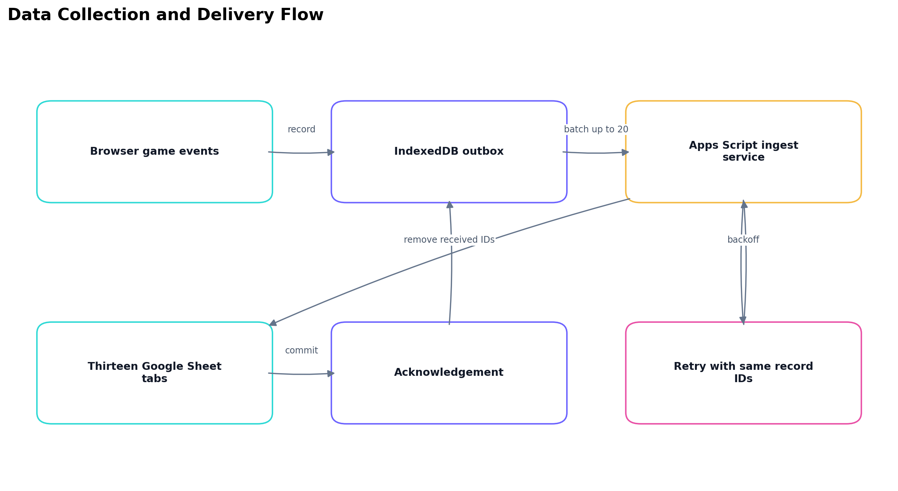
Figure 6 Telemetry queue and Google Sheets delivery

23 1 Analytics Objectives
- Measure whether players understand predictions, insurance, and cash-out.
- Find the streaks and modes where players stop, fail, or replay.
- Balance chip sources, sinks, mission rewards, and booster use.
- Evaluate retention loops without using analytics to change card outcomes.
- Diagnose errors, storage failures, and interrupted sessions.

23 2 Event Categories
Google Sheet tab | Event examples | Decision supported
Players | Latest snapshot by player ID | Current player state and progression
Events | Canonical chunk receipts | Deduplication and audit
Sessions | Start, heartbeat, visibility, online status, page hide | Session duration and interruption
Runs | Start, complete, abandon | Mode performance and run outcomes
Predictions | Selected and resolved | Direction, odds, result, streak
Economy | Entry, cash-out, insurance, rewards, test grants | Source and sink balance
Snapshots | Complete save and active run | State reconstruction and support
Progression | XP, level, login, resets, boosters | Progression pacing
Missions | Progress and completion | Objective performance
Achievements | Badge unlock | Milestone frequency
Cosmetics | Pack, equip, skin, pass claim | Collection engagement
UI | Button and gesture action | Control usage
Errors | Browser and save errors | Reliability

23 3 Delivery Rules
- Record identifiers combine session, sequence, and chunk index so retries are idempotent.
- Payloads longer than 20,000 characters are split into ordered chunks.
- The client sends at most 20 records per request and removes only acknowledged record IDs.
- IndexedDB is the primary outbox. Local storage and memory are fallbacks.
- Failed delivery retries with exponential delay and keeps records available for export.
- The Apps Script collector validates size, identity, timestamp, type, and scalar summaries.
- Category rows are written before canonical Event receipts. A retry checks each destination, completing a partial write without duplicating committed rows.
- Formula-looking strings are stored as text to prevent spreadsheet formula injection.

23 4 Data Boundaries
The logger uses a generated browser player ID and session ID. It records the player-selected display name because that name is part of the game state. It does not request Google email, contacts, precise location, payment information, unrelated browser storage, or raw keystrokes. Client-submitted scores remain unverified.

23 5 Deployment Constraint
Automatic upload operates only from the Google Apps Script web-app URL because it uses the authenticated google script bridge. The spreadsheet owner must run setup and authorize the deployment. The standalone index file records and exports logs but cannot automatically write to Google Sheets from unrelated hosting.

24 Technical Design Summary

24 1 Runtime Architecture
Component | Responsibility
index.html | Semantic screen and modal structure
styles.css | Core visual presentation
hybrid.css | Mobile-first hub, mascot, engagement, season, and social styling
config.js | Economy, XP, ranks, skins, chests, missions, achievements, wagers, multipliers
game.js | Run state, RNG, prediction resolution, transactions, saves, UI bridge
hybrid-model.js | Calendar systems, cosmetics, boosters, season, league, challenge code
hybrid-ui.js | Hub, gestures, dealer, share canvas, music, challenge interface
telemetry.js | Event capture, chunking, outbox, retries, export and import
service-worker.js | Versioned offline asset cache
INSTALL.gs | Single-file Apps Script game and Sheets collector

24 2 Gameplay State Model
State | Allowed input | Exit condition
Menu | Mode, wager, skin, hub, daily reward | Start run
Waiting for prediction | Higher, Lower, insurance, cash out | Accepted action or timer
Revealing | None | Reveal delay completes
Resolving | None | Tie, correct, protected loss, or terminal loss
Waiting for continuation | Prediction, insurance, cash out | Next action
Run settled | Result actions | Replay or home
Modal open | Modal-specific controls | Close or confirm

24 3 Security Boundaries
The current browser is authoritative for its own chips, XP, and scores. Local storage and client scripts can be modified by a determined user. Google Sheets telemetry improves observability but does not validate outcomes. Any paid, competitive, or shared economy requires server-generated run IDs, server-side random outcomes, signed responses, idempotent transactions, rate limits, and receipt validation.

25 Live Operations and Content Cadence
Cadence | Content | Owner tasks
Daily | Three missions, 60-second challenge, login reward | Review mission completion and challenge participation
Weekend | Weekend Sprint | Confirm UTC availability and reward behavior
Weekly | League settlement and clean-calls badge | Review payout frequency and board quality
Monthly | Theme and ten-tier cosmetic pass | Prepare theme art, exclusive skin, copy, and QA
Seasonal campaign | Limited visuals and social challenge | Plan asset set, event calendar, and communication

Remote configuration is recommended before live operations scale. It should control wager tiers, multipliers, reward values, timers, insurance, mission pool, season dates, and feature availability with schema validation and bundled fallback values.

26 Quality Assurance

26 1 Functional Test Matrix
Area | Required tests
Prediction | Higher, Lower, tie, Ace restriction, 2 restriction, correct card replacement
Settlement | Loss, cash-out, timeout, challenge finish, duplicate input, duplicate reward guard
Insurance | Cost rounding, insufficient chips, tie consumption, correct consumption, protected wrong call
Timers | Quick expiry, Rush settlement, accepted reveal at deadline, extra time once
Progression | XP formula, level boundaries, rank changes, skin unlocks, double XP
Rewards | Chest once per run, mission once per day, login cadence, comeback once, pass claim once
Social | Challenge encode and decode, invalid code rejection, PNG export, native share fallback
Persistence | Legacy migration, unavailable storage, reload, export and import
Telemetry | Chunk reconstruction, lost acknowledgement, partial Sheets write, deduplication, offline retry
Responsive UI | Desktop, narrow phone, tall phone, browser zoom, no horizontal overflow

26 2 Current Automated Validation
- Eleven progression model tests cover login cadence, comeback rewards, cosmetics, boosters, season pass, weekly payouts, duplicate completion, mission rotation, deterministic cards, and challenge codes.
- Real DOM tests cover migration, wagers, cash-out, timers, replay, navigation safety, insurance, gestures, packs, pass claims, and telemetry emission.
- Collector tests cover recoverable partial writes, retry deduplication, validation, formula-safe text, latest-player projection, and lock release.
- Chromium tests cover mobile layout, IndexedDB persistence, lost-acknowledgement recovery, the inline Apps Script build, and 1080 by 1920 PNG export.

26 3 Device Test Targets
- Android Chrome on low-memory and mid-range hardware.
- iPhone Safari with safe-area insets.
- Desktop Chrome, Edge, Firefox, and Safari.
- Offline reload after one successful hosted load.
- Slow and unstable network during telemetry delivery.
- Private browsing and storage-disabled conditions.

27 Metrics and Success Criteria
Metric | Initial target | Interpretation
Tutorial completion | Above 80 percent | First-run instructions are understandable
First decision time | Below 10 seconds | Quick Play removes setup friction
Average run duration | 15 to 60 seconds by mode | Matches short-session positioning
Runs per session | At least 3 | Replay loop is functioning
Cash-out rate by streak | Tracked by streak 1 to 15 | Risk curve and multiplier tuning
Daily mission completion | 20 to 40 percent per mission | Objectives are achievable without becoming automatic
Day 1 retention | Measure before target lock | Validate return systems after acquisition source is known
Crash-free sessions | Above 99 percent | Technical stability
Unsent telemetry backlog | Near zero for connected sessions | Collector and quota health

Targets for retention, monetization, and lifetime value should be set only after enough external-player data exists. Test-button activity and internal sessions must be excluded from production KPI reporting.

28 Production Roadmap
Phase | Scope | Exit criteria
Phase 1 Current MVP | Playable HTML5 game, full local progression, share cards, telemetry queue, Google Sheets collector | Automated tests pass and owner deploys Apps Script
Phase 2 Pilot | Remote configuration, consent copy, analytics dashboard, device QA, content tuning | Stable small-audience sessions and balanced source-sink economy
Phase 3 Online foundation | Accounts, cloud save, server economy ledger, global leagues, verified challenges | Idempotent transactions and authoritative score validation
Phase 4 Monetization | Rewarded ads, remove ads, cosmetic shop, receipts, regional privacy controls | No probability benefits; completed legal and store review
Phase 5 Live operations | Content pipeline, seasonal calendar, segmentation for content only, experiments | Safe rollback, configuration validation, event monitoring
Phase 6 Native expansion | Android and iOS package or Unity port, haptics, platform services | Device performance, store compliance, restore purchases

29 Risks and Mitigations
Risk | Current exposure | Mitigation
Player distrust of casino theme | Medium | Show virtual-only label, live odds, fair RNG explanation, and no cash redemption
Local save manipulation | High for competitive use | Keep current board casual; move economy and scores to server before global competition
Device clock manipulation | Medium | Use server time for live events and rewards in an online release
Sheets quota or scale limits | Medium after public launch | Use database ingestion and export reports to Sheets
Telemetry privacy | Medium | Minimize fields, publish notice, avoid verified identity unless required, set retention policy
Economy inflation | Medium | Separate test grants, monitor sources and sinks, tune through validated remote config
Celebration fatigue | Low to medium | Scale effects by streak and honor reduced motion
Session interruption | Medium | Add active-run recovery with pre-generated saved next card
Challenge cheating | High for prizes | Treat current codes as practice; sign server challenges before rewarding competition

30 Acceptance Criteria
1. A new player can start Quick Play and make a valid prediction without opening Custom Play.
2. Higher and Lower resolve correctly for every rank, and impossible edge choices are disabled.
3. Ties preserve streak and continue the run.
4. Normal card generation does not read balance, purchases, cosmetics, previous outcomes, or player status.
5. The multiplier and cash-out value match the configured table and integer rounding rule.
6. Cash-out and every other chip transaction apply once.
7. Insurance shows its price, protects one prediction, and expires after that prediction.
8. Classic, Quick, Rush, Daily, Friend, Personal Best, and Weekend modes follow their timer and settlement rules.
9. XP, levels, ranks, skins, missions, chests, achievements, and statistics persist across reload.
10. The Top 3 rewards cannot be claimed repeatedly for the same saved placement.
11. Cosmetic packs cannot grant duplicates and cannot change card outcomes.
12. Swipe, button, and keyboard controls respect busy and modal states.
13. The 1080 by 1920 result card exports with the current player identity and run result.
14. Telemetry queues offline, retries failed delivery, removes only acknowledged records, and deduplicates destination rows.
15. The interface remains readable at supported desktop and mobile widths without horizontal overflow.
16. All virtual-currency, fairness, fixed-replay, and local-ranking labels remain visible where relevant.

Appendix A Detailed Level Requirements
Level | Total XP at level | XP to next | Rank
1 | 0 | 80 | Beginner
2 | 80 | 108 | Beginner
3 | 188 | 136 | Beginner
4 | 324 | 164 | Beginner
5 | 488 | 192 | Player
6 | 680 | 220 | Player
7 | 900 | 248 | Player
8 | 1,148 | 276 | Player
9 | 1,424 | 304 | Player
10 | 1,728 | 332 | Risk Taker
11 | 2,060 | 360 | Risk Taker
12 | 2,420 | 388 | Risk Taker
13 | 2,808 | 416 | Risk Taker
14 | 3,224 | 444 | Risk Taker
15 | 3,668 | 472 | Risk Taker
16 | 4,140 | 500 | Risk Taker
17 | 4,640 | 528 | Risk Taker
18 | 5,168 | 556 | Card Expert
19 | 5,724 | 584 | Card Expert
20 | 6,308 | 612 | Card Expert
21 | 6,920 | 640 | Card Expert
22 | 7,560 | 668 | Card Expert
23 | 8,228 | 696 | Card Expert
24 | 8,924 | 724 | Card Expert
25 | 9,648 | 752 | Card Expert
26 | 10,400 | 780 | Card Expert
27 | 11,180 | 808 | High Roller
28 | 11,988 | 836 | High Roller
29 | 12,824 | 864 | High Roller
30 | 13,688 | 892 | High Roller
31 | 14,580 | 920 | High Roller
32 | 15,500 | 948 | High Roller
33 | 16,448 | 976 | High Roller
34 | 17,424 | 1,004 | High Roller
35 | 18,428 | 1,032 | High Roller
36 | 19,460 | 1,060 | High Roller
37 | 20,520 | 1,088 | High Roller
38 | 21,608 | 1,116 | Casino Master
39 | 22,724 | 1,144 | Casino Master
40 | 23,868 | 1,172 | Casino Master
41 | 25,040 | 1,200 | Casino Master
42 | 26,240 | 1,228 | Casino Master
43 | 27,468 | 1,256 | Casino Master
44 | 28,724 | 1,284 | Casino Master
45 | 30,008 | 1,312 | Casino Master
46 | 31,320 | 1,340 | Casino Master
47 | 32,660 | 1,368 | Casino Master
48 | 34,028 | 1,396 | Casino Master
49 | 35,424 | 1,424 | Casino Master
50 | 36,848 | Maximum | Prediction Legend

Appendix B Analytics Event Catalogue
Event | Primary payload
game_loaded | Build configuration and save schema
session_start | New browser session
session_heartbeat | Elapsed and visible time
session_visibility | Foreground or background
session_pagehide | Best-effort page exit
network_online | Connectivity restored
network_offline | Connectivity lost
ui_click | Named interface control
gesture_action | Higher, Lower, cash-out, or insurance gesture
run_started | Mode, wager, initial card, seed, boosters
prediction_selected | Direction, current and next card, streak
prediction_resolved | Result, prior and next card, streak transition, shield
run_completed | Final result, duration, rewards, trace
run_abandoned | Navigation ended active run
economy_transaction | Reason, amount, before and after balance
insurance_activated | Cost and streak
chest_claimed | Milestone and reward
xp_granted | XP amount and total
level_up | Old level, new level, rank
mission_progress | Objective progress
mission_completed | Mission rewards
achievement_unlocked | Badge identity
login_reward | Journey day and chips
comeback_reward | Return reward
weekly_reset | Placement and payout
season_reset | Old and new season
boosters_consumed | Run booster list
booster_used | Extra-time activation
pack_opened | Cosmetic item and remaining keys
cosmetic_equipped | Item and slot
pass_claimed | Season and tier
player_snapshot | Complete saved state
browser_error | Unhandled runtime error
save_error | Browser persistence failure

Appendix C Current Implementation Limitations
- The all-time and weekly leaderboards are local to one browser and are not cheat resistant.
- Google Sheets records client-supplied data and does not validate the card result or wallet.
- The current active run does not resume after page closure.
- Browser storage clearing removes local progress unless the player exported it.
- Device time controls daily, weekly, monthly, and comeback schedules.
- The static build has no advertising, purchases, login, cloud save, chat, or global matchmaking.
- Apps Script delivery requires owner authorization and is intended for testing or a small audience.
- Daily and friend replays are fixed sequences and are explicitly labeled as such.

Appendix D Glossary
Term | Definition
Cash out | End a normal run and credit the displayed secured value
Correct call | A non-tie card whose rank matches the chosen direction
Fixed replay | A deterministic card sequence used for comparable challenges
Ghost | An asynchronous record of another run used for practice comparison
Perfect Call | A correct choice of a direction with probability below 6 of 13
Protection | Insurance or Shield that preserves streak on one wrong prediction
Streak | Consecutive correct non-tie predictions in the active run
Virtual chips | Nonredeemable game currency used for entries and insurance

Appendix E Gen Z Engagement Coverage
This matrix is the scope checklist for the complete Gen Z and hybrid casual package. Implemented items describe the current HTML5 build. Production items identify the additional backend, content, art, or platform work required before a public competitive release.
Area | Requirement | Current specification | Production requirement
Testing | Add more coins on button click | A visible test control grants 5,000 chips and is tagged as test activity. | Exclude test grants and related sessions from production KPIs; remove or protect the control in release builds.
Progression | Levels 1 through 50 and seven ranks | XP requirements, level boundaries, rank names, and related unlocks are defined. | Tune thresholds using cohort data without changing outcome probability.
Cosmetics | Card skins and unlock levels | Neon, Classic, Royal, Cyber, and Emerald unlock through level progression; seasonal skins are permanent rewards. | Maintain readable card fronts and a repeat-safe collection inventory.
Rewards | Streak chests at 3, 5, 8, 10, and 15 | Each milestone has configured chips and XP and can be claimed once per run. | Balance values through validated remote configuration.
Goals | Three daily missions | Three objectives rotate daily from a six-mission pool with chips and XP rewards. | Use server time and signed claims when accounts are added.
Mastery | Achievements and badges | Eight achievements track streak, wins, cash-outs, Perfect Calls, and progression. | Add content-driven badge sets without power benefits.
Feedback | Animated combo and enhanced results | Combo scale, card trails, pulses, particles, win glow, loss shake, comeback, and legendary celebration intensify by streak. | Provide reduced-motion equivalents and profile low-end devices.
Profile | Player statistics | Win rate, average streak, best streak, highest reward, calls, runs, and secured chips are saved. | Define authoritative calculations before cross-device comparison.
Competition | Leaderboard and Top 3 rewards | A local Top 10 awards 1,500, 750, and 400 chips plus XP to the Top 3 once. | Use server-validated scores, weekly reset IDs, and idempotent reward claims for global competition.
Persistence | Browser progress save | Profile, wallet, XP, missions, cosmetics, rankings, statistics, settings, and progression persist in browser storage. | Add account cloud save, conflict resolution, migration, and recovery.
Access | Instant Quick Play | Quick Play remembers an eligible mode, chooses an affordable wager, deals immediately, and supports one-tap replay. | Measure first-decision time and protect against accidental repeated wagers.
Controls | One-thumb gestures | Swipe up selects Higher, swipe down selects Lower, swipe right cashes out, and a 600 millisecond hold activates insurance. Buttons and keyboard remain available. | Tune gesture thresholds by device and retain accessible alternatives.
Sessions | 15 to 30 second mini-runs | Rush and Weekend Sprint use a 30-second total timer; Quick uses five-second decisions. | Tune timer values only through transparent mode configuration.
Personality | Reactive dealer mascot | Byte reacts to starts, correct calls, Perfect Calls, records, ties, protection, loss, cash-out, chests, and legendary streaks. | Expand reaction content while keeping it short, optional, and localizable.
Delight | Perfect Call and comeback moments | Less-likely successful calls grant 5 bonus XP and distinct feedback; protected losses trigger comeback feedback. | Keep bonuses cosmetic or progression-based and resolve them only after the card outcome.
Daily play | Daily 60-second challenge | A free, fixed daily replay runs for sixty seconds and compares score without risking chips. | Use a signed server sequence for verified shared competition.
Sharing | Portrait result cards | A 1080 by 1920 card includes identity, streak, secured chips, rank, level, skin, mode, and challenge message. | Support native sharing and privacy-safe attribution without forced posting.
Leagues | Weekly competition | A local weekly league records score, resets by UTC week, and grants placement rewards once. | Move standings and payouts to an authoritative service for public leagues.
Collection | Collectible card packs and album | Cosmetic keys open duplicate-safe packs and the hub shows collection ownership. | Add themed pack tables, pity rules if needed, and clear cosmetic-only labels.
Identity | Avatar frame title and emotes | Selectable avatars, frames, titles, and emotes appear in profile and social surfaces. | Moderate any future custom text and preserve child-safe defaults.
Social | Friend challenges and ghost runs | Shareable codes reproduce fixed sequences and prediction traces for asynchronous comparison. | Sign codes and validate rewards before attaching competitive value.
Live content | Seasonal themes and events | Monthly cosmetic seasons, a ten-tier free pass, limited visuals, and Weekend Sprint provide cadence. | Operate through a versioned content calendar with rollback and time-zone rules.
Retention | Login journey and comeback | Seven-day rewards, daily drop, personal-best challenge, weekly achievement, comeback reward, and weekend goal cover return loops. | Use server time, claim IDs, and notification consent in an online release.
Boosters | Fair non-pay-to-win utility | Extra Time, Shield, Auto Cash Out, Double XP, Mission Booster, and Cosmetic Key do not affect card generation. | Disclose duration and consumption before use; never sell improved odds.
Fairness | No hidden probability manipulation | Normal draws ignore balance, spending, cosmetics, prior losses, and status; live probabilities are displayed. | Keep RNG and economy audits independent and publish mode rules.
Analytics | Google Sheets including session logs | Game, economy, progression, social, error, session start, heartbeat, visibility, network, and page-hide events queue and batch to Sheets. | Add consent and retention controls, exclude internal tests, and migrate ingestion beyond Apps Script at scale.

Appendix E 1 Recommended Implementation Order
1. Instant Quick Play, one-tap replay, swipe controls, and protected input states.
2. Reactive Byte dealer, combo meter, comeback feedback, Perfect Call celebration, and streak atmosphere.
3. Shareable portrait result cards with download, native share, and copied caption.
4. Daily 60-second challenge with fixed replay labeling and comparable scoring.
5. Avatars, frames, titles, emotes, card skins, collection album, and duplicate-safe packs.
6. Weekly leagues, Top 3 rewards, reset identifiers, and idempotent claims.
7. Friend challenges and ghost runs with signed codes before valuable rewards are attached.
8. Seasonal themes, Weekend Sprint, login journey, comeback rewards, and cosmetic-only progression pass.
9. Production account, cloud save, server-authoritative economy, score validation, and scalable analytics ingestion.
10. Continuous accessibility, performance, economy, fairness, privacy, and retention validation.

