Subject Name: **Source Code Management**

Subject Code: **CS181**

Cluster: **Beta**

Department: **DCSE**



|  |  |  |
| --- | --- | --- |
| **Submitted By:**  Amol  2110990165  G3-A |  | **Submitted To:**  Mr. Deepak Thakur |
|  |  |  |

* **What is GIT and why is it used?**

Git is a DevOps tool used for source code management. Git is software for tracking changes in any set of files. It is a free and open-source version control system used to handle small to very large projects efficiently.

Git is used to tracking changes in the source code, enabling multiple developers to work together on non-linear development

Git is an example of a DVCS (hence Distributed Version Control System).

* **What is GITHUB?**

GitHub is a code hosting platform for version control and collaboration. It lets you and others work together on projects from anywhere.

* **What is the difference between GIT and GITHUB?**

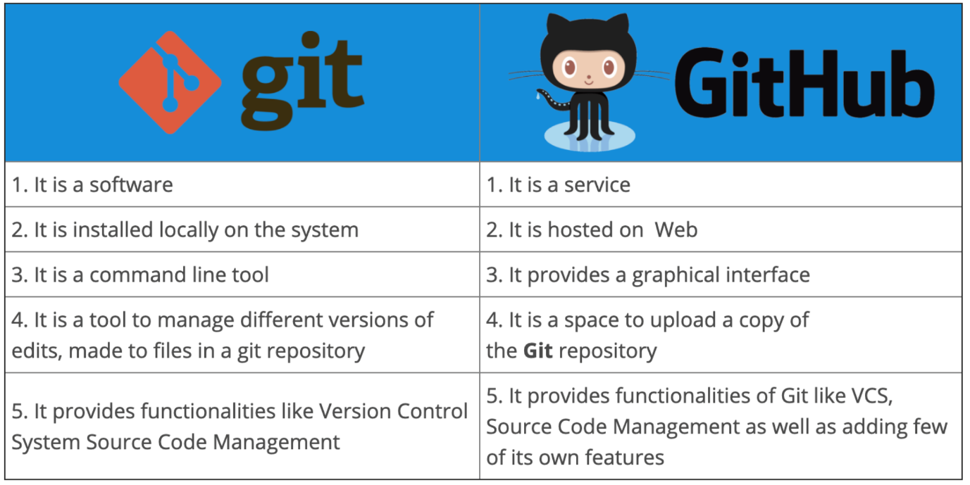

* **What is Repository?**

A repository contains all of your project's files and each file's revision history. You can discuss and manage your project's work within the repository. A Git repository is the .git/ folder inside a project. This repository tracks all changes made to files in your project, building a history over time. Meaning, if you delete the .git/ folder, then you delete your project’s history.

* **What is Version Control System (VCS)?**

Version Control Systems are the software tools for tracking/managing all the changes made to the source code during the project development. It keeps a record of every single change made to the code. It also allows us to turn back to the previous version of the code if any mistake is made in the current version. Without a VCS in place, it would not be possible to monitor the development of the project.

## Types of VCS

## The three types of VCS are:

1. Local Version Control System
2. Centralized Version Control System
3. Distributed Version Control System

#### **Local Version Control System:** Local Version Control System is located in your local machine. If the local machine crashes, it would not be possible to retrieve the files, and all the information will be lost. If anything happens to a single version, all the versions made after that will be lost.

#### **Centralized Version Control System:** In the Centralized Version Control Systems, there will be a single central server that contains all the files related to the project, and many collaborators checkout files from this single server (you will only have a working copy). The problem with the Centralized Version Control Systems is if the central server crashes, almost everything related to the project will be lost.

#### **Distributed Version Control System:** In a distributed version control system,  there will be one or more servers and many collaborators similar to the centralized system. But the difference is, not only do they check out the latest version, but each collaborator will have an exact copy of the main repository on their local machines.

#### Each user has their own repository and a working copy. This is very useful because even if the server crashes we would not lose everything as several copies are residing in several other computers.

## Installation of Git

Visit the provided link for the installation of git in your system.

<https://git-scm.com/downloads>

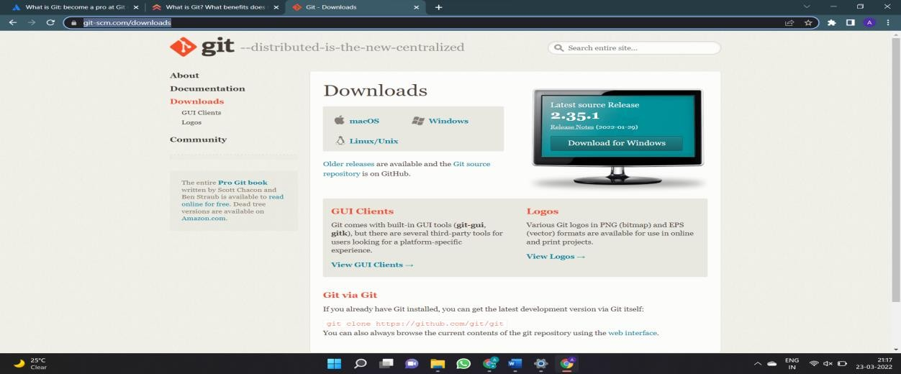

After opening this site, you have to select your operating system by clicking on it. Here I will show you the steps for the Windows operating system.

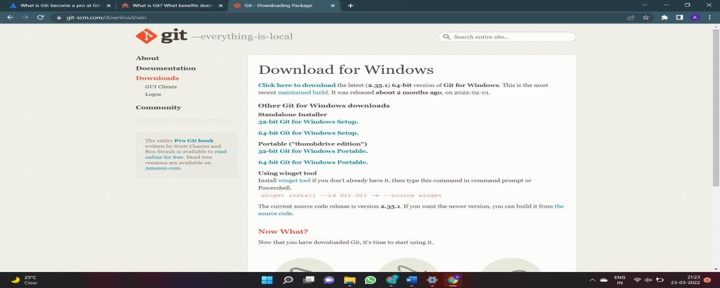

Now select the processor of the system you have. (Most of the system are now of 64-bits) After selecting the processor your download will start.

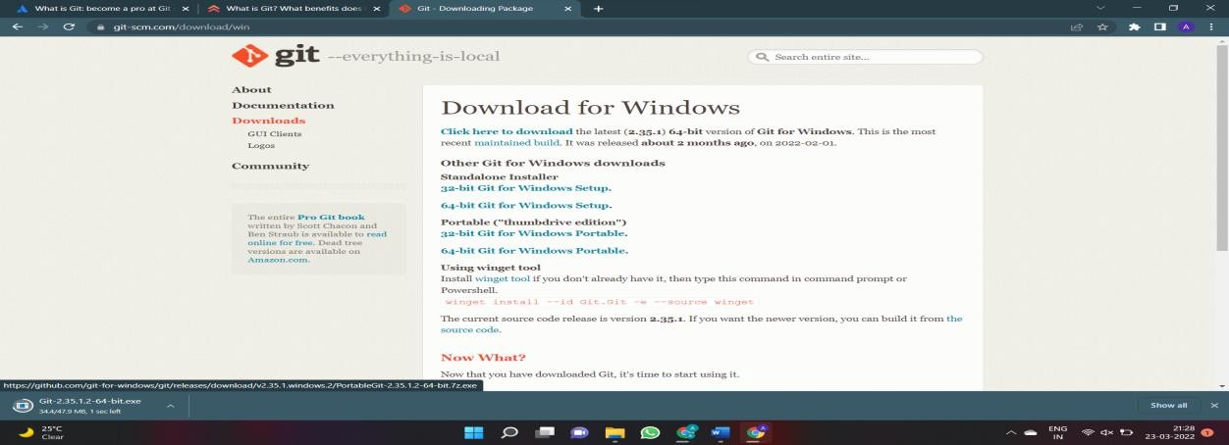

Now you have to open this folder.

After opening you will given a notification “Do you want to allow this app to make changes in your PC”

Click YES

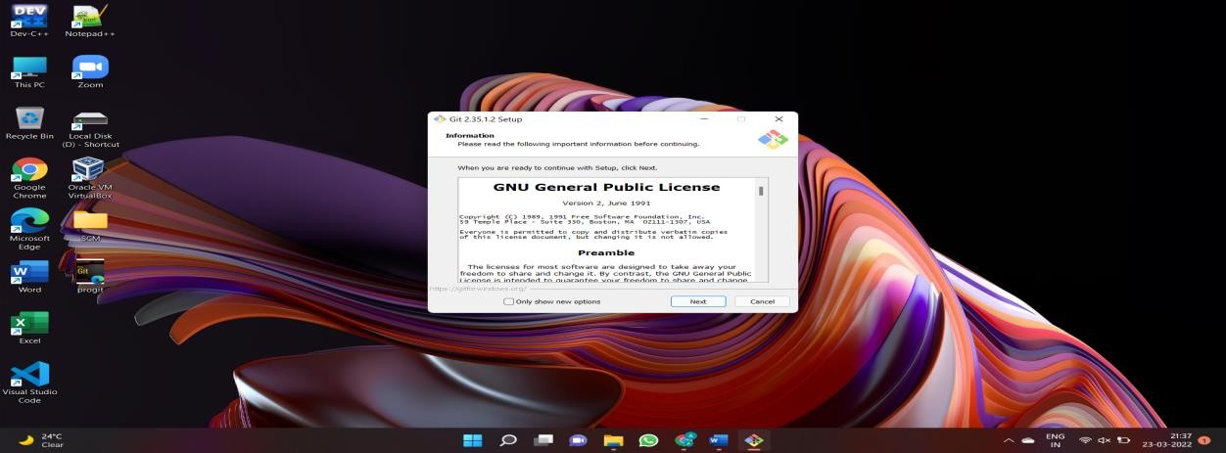

Click on Next

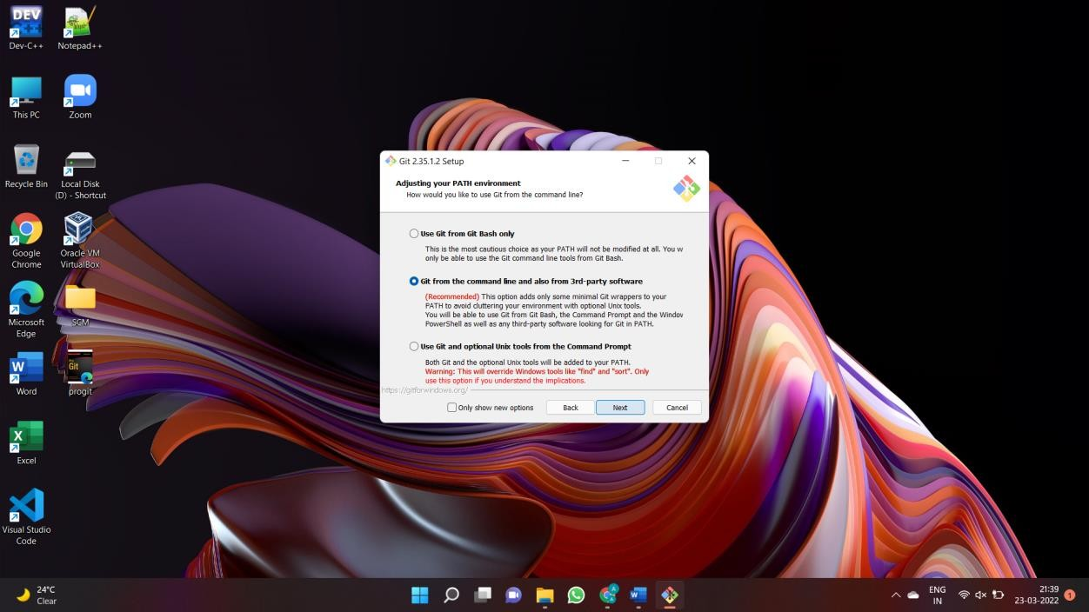

Continue clicking on next few times more

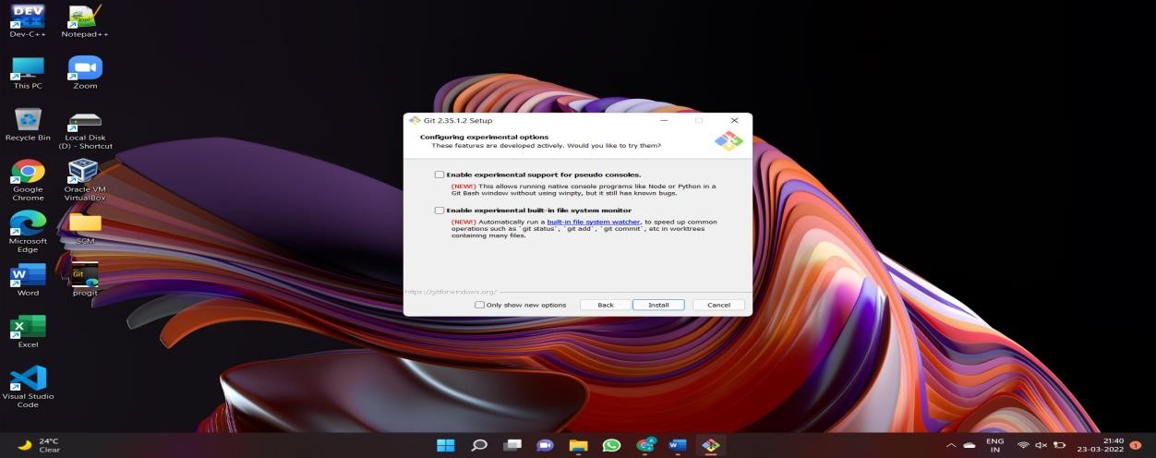

Now select the Install option.

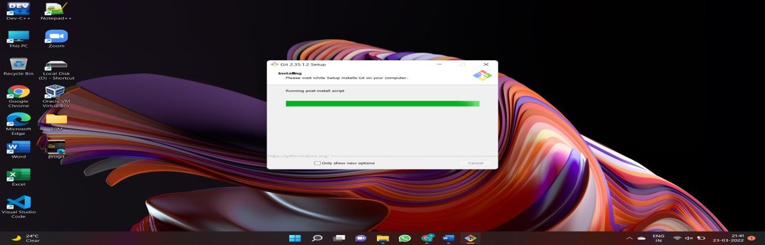

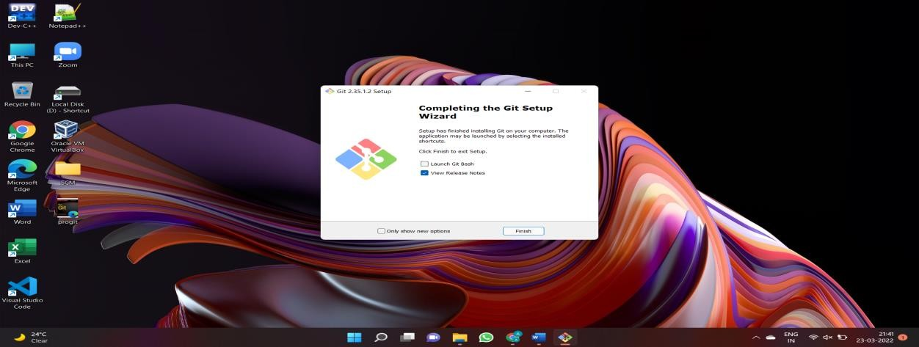

Click on Finish after the installation is finished.

The installation of the git is finished and now we have to setup git client and GitHub account.

# **Setting Up GitHub account**

Open your web browser search GitHub login.

Click on Create an account if you are a new user or if you have already an account, please login.

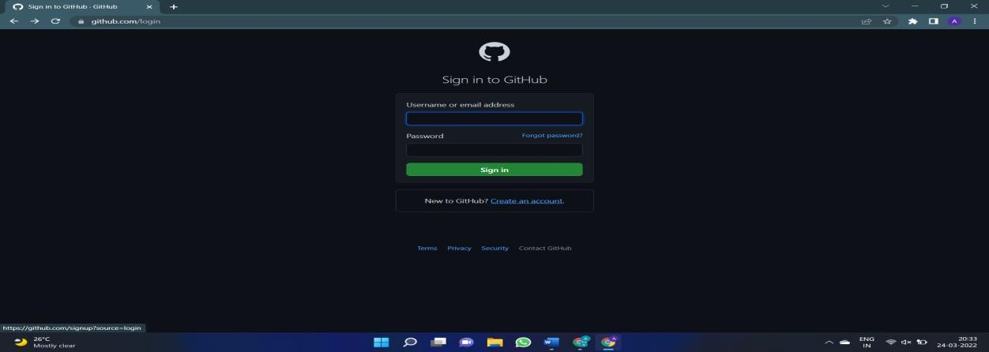

After Clicking on create a new account you will be redirected to a new page where you have to enter your email id which you want to use for your account. Now enter your password you want to create for your GitHub account. After that you will be asked to enter your username .

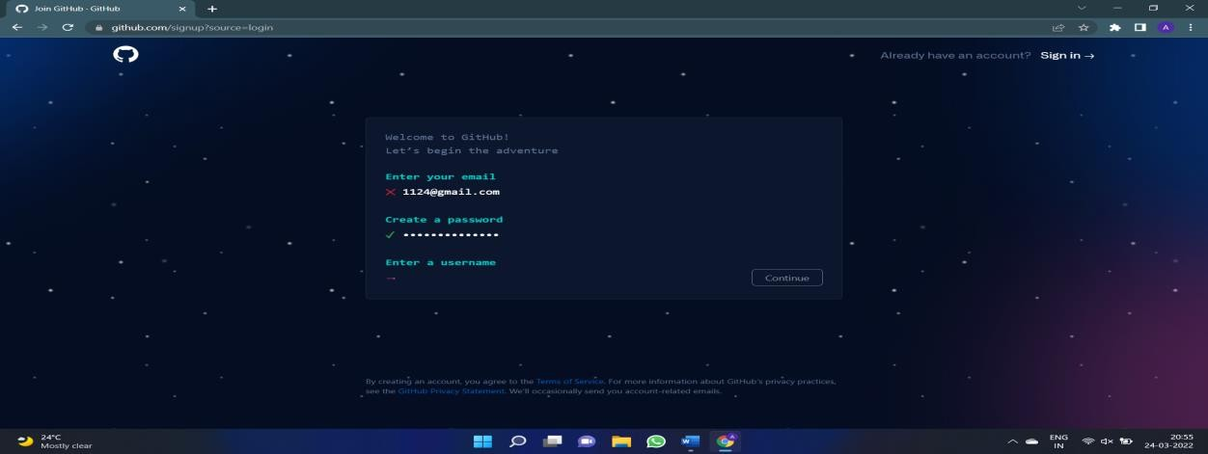

Now Click on Create Account.

Verify it from your email and you are all set to go.

# **Stages in GIT Life Cycle:**

Now let’s understand the three-stage architecture of Git:

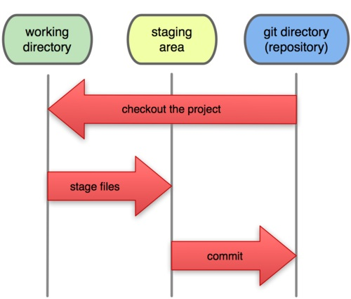

* **Working Directory:** *This is the directory that we’ve initialized, and here all the changes are made to commit on GitHub*.
* **Staging Area:** *This is where we first put out code or files of the working repository. The command that we use to stage code is, “git add --a”, “git add FileName” or “git add -A”.*

*In simple terms, staging means telling Git what files we want to commit (new untracked files, modified files, or deleted files).*

* **Git directory(repository):** *This is where all the commits are stored whenever we make a commit. We can revert to an older version of or project using the “git checkout” command from this directory*.

## Git operations and commands:

## First of all, Create a local repository using Git. For this, you have to make a folder in your device, right click and select “Git Bash Here”. This opens the Git terminal. To create a new local repository, use the command “git init” and it creates a folder .git.

## 

* When we use GIT for the first time, we have to give the user name and email so that if I am going to change in project, it will be visible to all.

For this, we use command 🡪

**“git config --global user.name *Name*”**

**“git config --global user.email *email*”**

For verifying the user’s name and email, we use 🡪

**“git config --global user.name”**

**“git config --global user.email”**

**Some Important Commands:**

* **ls 🡪** It gives the file names in the folder.
* **ls -lart 🡪** Gives the hidden files also.
* **git status 🡪**  Displays the state of the working directory and the staged snapshot.
* **touch filename 🡪** This command creates a new file in the repository.
* **Clear 🡪**  It clears the terminal.
* **rm -rf .git 🡪** It removes the repository.
* **git log 🡪** displays all of the commits in a repository's history
* **git diff 🡪** It compares my working tree to staging area.

Now, we have to create some files in the repository. Suppose we created *index.html*. Now type *git status:*

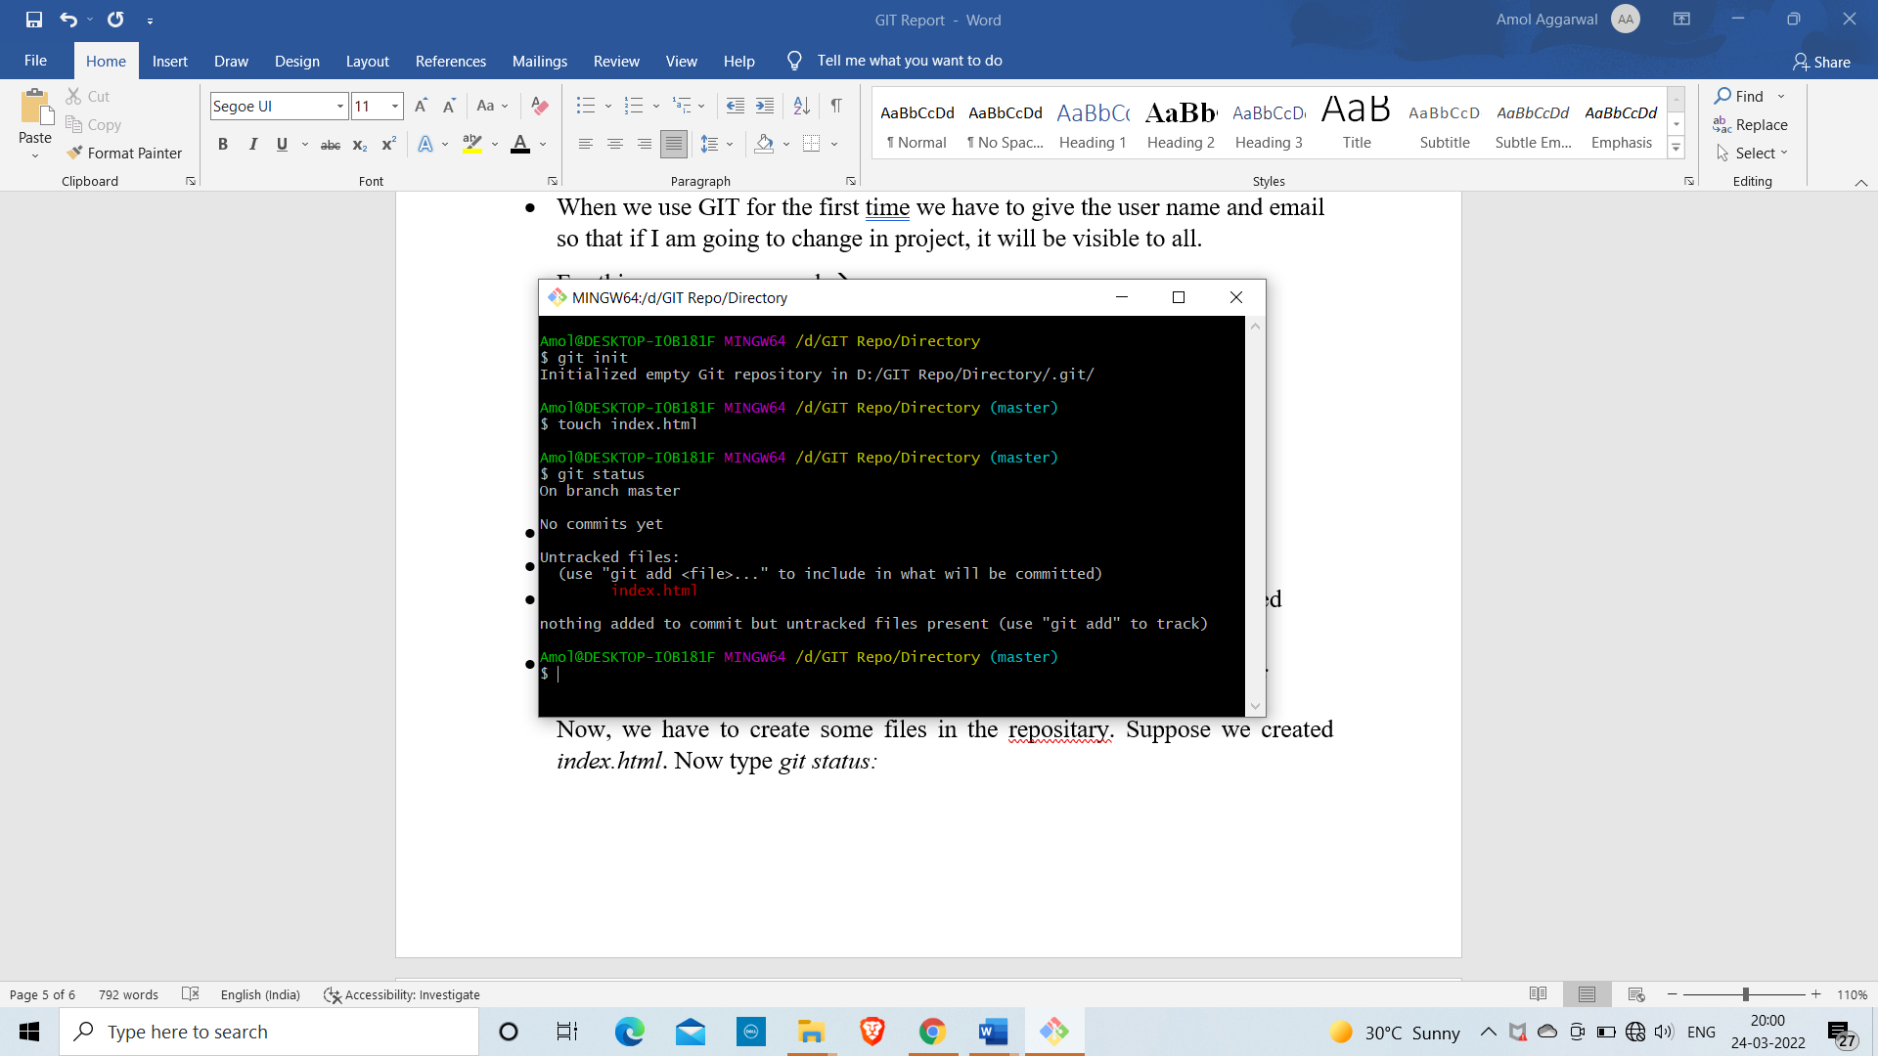

You can see that *index.html* is in red colour that means it is an untracked file.

Now firstly add the file in staging area and then commit the file.

For this, use command 🡪

**git add -A [** For add all the files in staging area. **]**

**git commit -m “write any message” [** For commit the file **]**

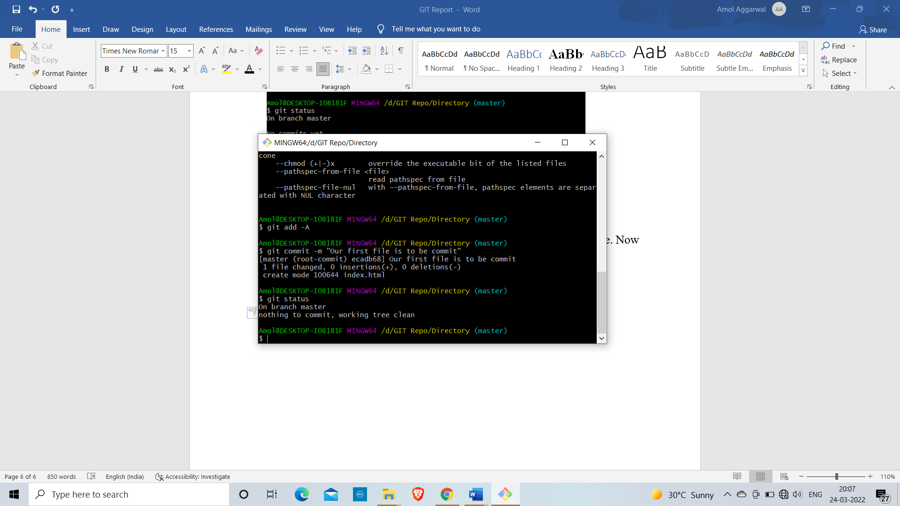

* **git log:** The git log command displays a record of the commits in a Git repository. By default, the git log command displays a commit hash, the commit message, and other commit metadata.

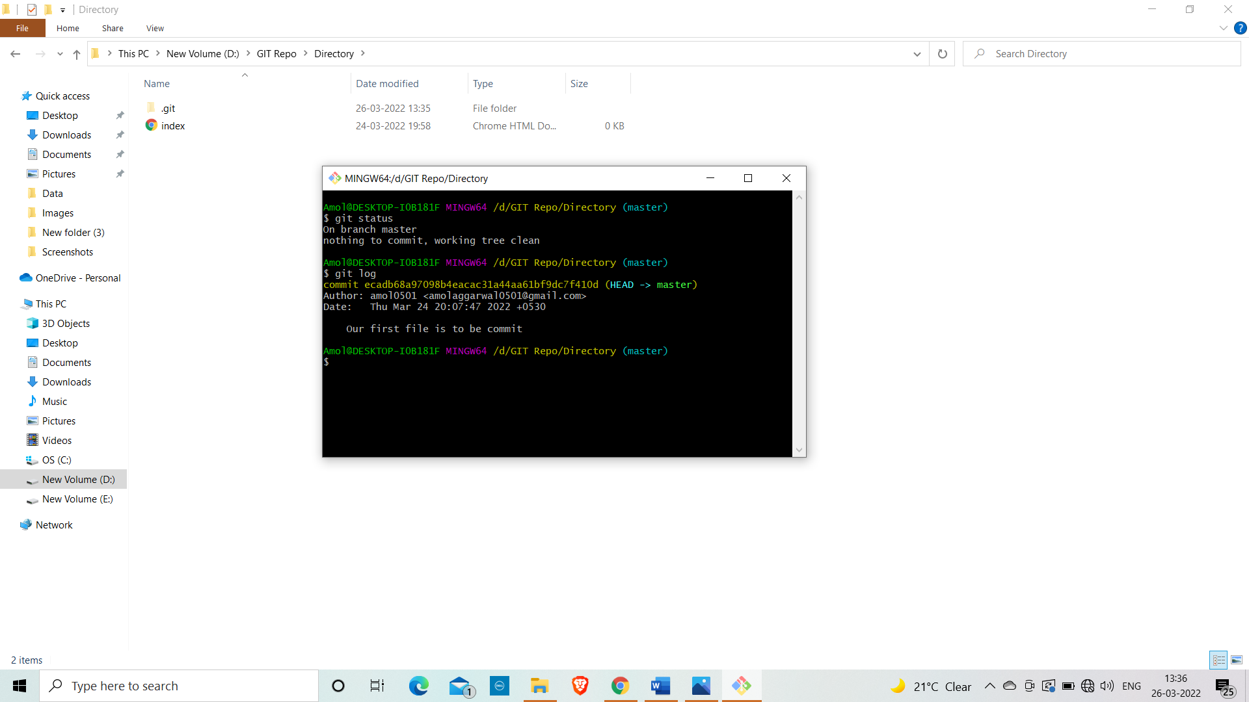

* **Branching:** A branch in Git is an independent line of work(a pointer to a specific commit). It allows users to create a branch from the original code (master branch) and isolate their work. Branches allow you to work on different parts of a project without impacting the main branch.

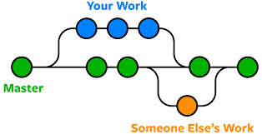

Let us see the command of it:

Firstly, add a new branch, let us suppose the branch name is activity1.

For this use command 🡪

**git branch name [**adding new branch**]**

**git branch [**use to see the branch’s names**]**

**git checkout *branch name* [**use to switch to the given branch**]**

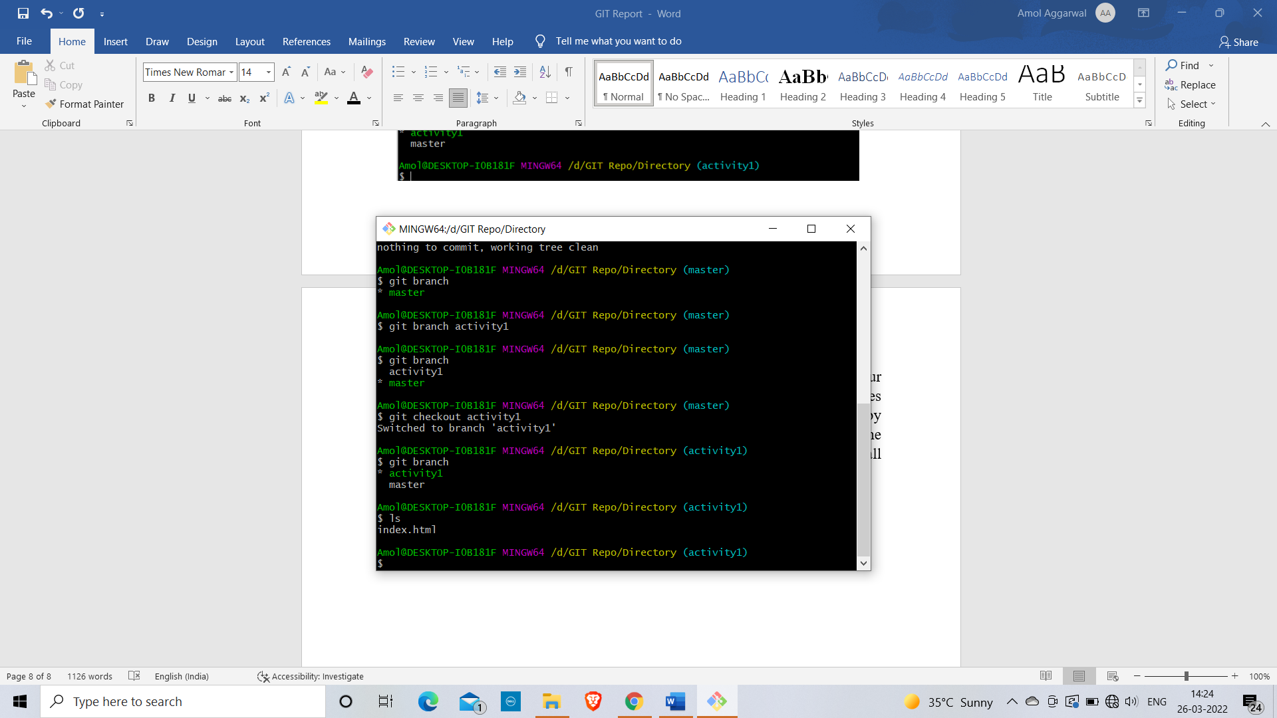

In this you can see that firstly ‘git branch’ shows only one branch in green colour but when we add a new branch using ‘git branch activity1’, it shows 2 branches but the green colour and star is on master. So, we have to switch to activity1 by using ‘git checkout activity1’. If we use ‘git branch’, now you can see that the green colour and star is on activity1. It means you are in activity1 branch and all the data of master branch is also on activity1 branch. Use “ls” to see the files.

Now add a new file in activity1 branch, do some changes in file and commit the file.

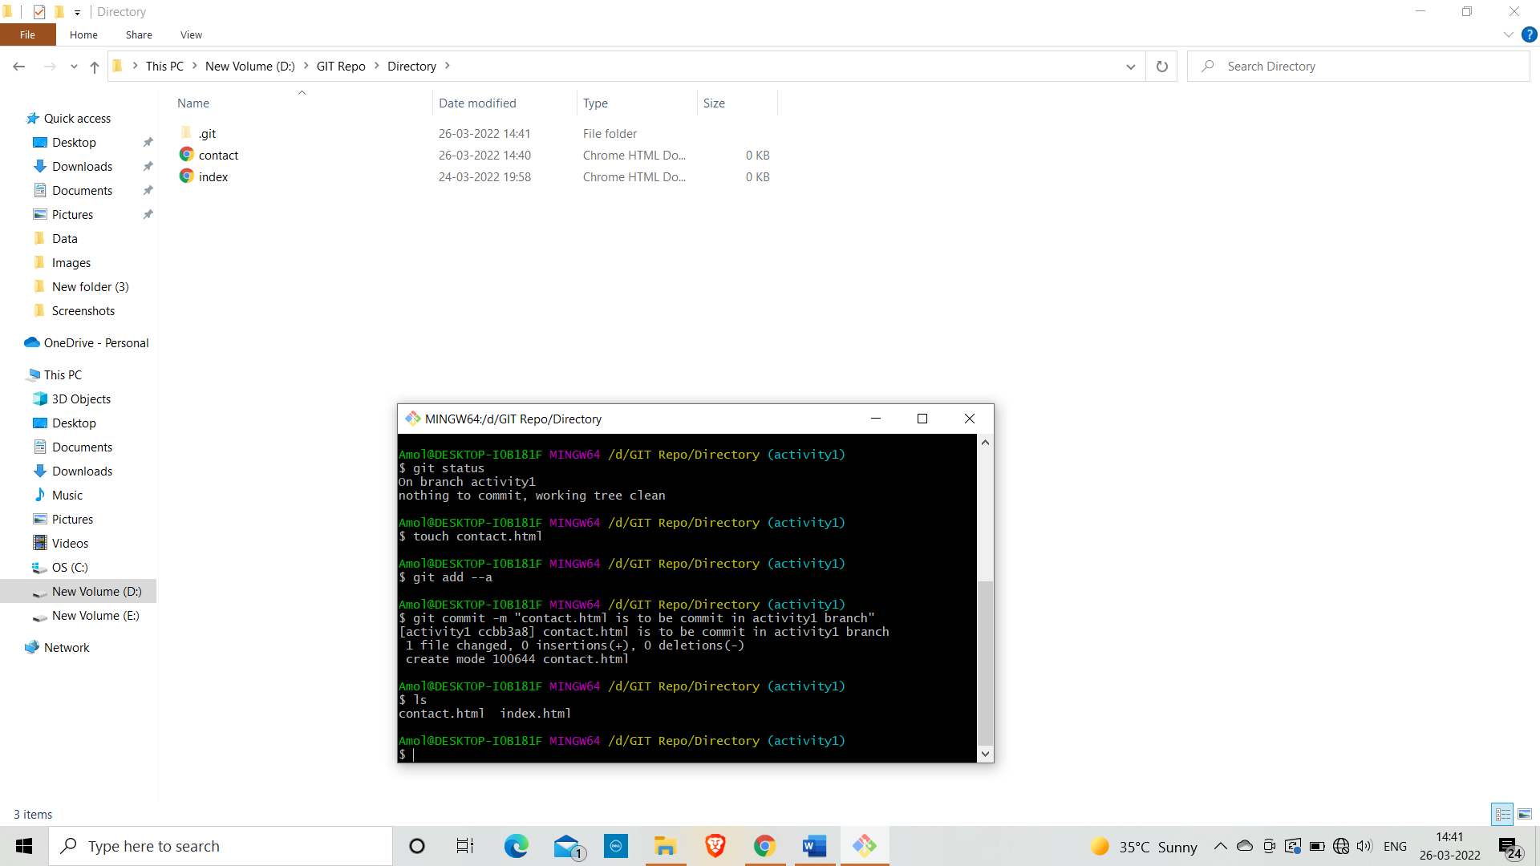

If we switched to master branch, ‘contact.html’ file is not there. But he file is in activity1 branch.

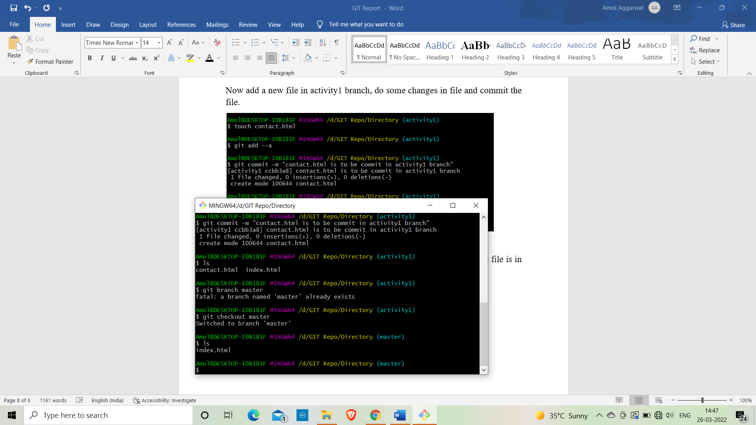

* To add these files in master branch, we have to do merging. For this firstly switch to master branch and then use command 🡪

**git merge branchna**a**me [**use to merge branch**]**

