NAME – ANMOL
REG. NO. - 19BCE0891

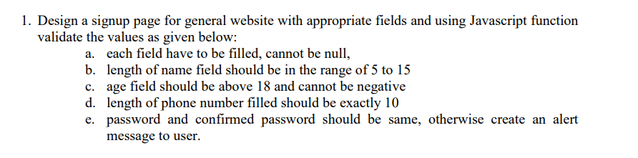

CODE -
<html>
<head>
<title>ANMOL - 19BCE0891</title>
</head>
<body>
<form>
Name : <input type="text" id="name" /> <br /><br />
Age : <input type="number" id="age" /> <br /><br />
Phone number : <input type="text" id="phno" /> <br /><br />
Password : <input type="password" id="pass" /> <br /><br />
Confirm Password : <input type="password" id="cpass" /> <br /><br />

<button onclick="validate()">Validate</button>
</form>
</body>
<script>
function validate() {
name = document.getElementById("name").value;
age = document.getElementById("age").value;
phno = document.getElementById("phno").value;
pass = document.getElementById("pass").value;
cpass = document.getElementById("cpass").value;

if (name == "" || age == "" || phno == "" || pass == "" || cpass == "") {
alert("Empty fields not allowed!!");
return false;
}

if (name.length < 5 || name.length > 15) {
alert("Name length should be in 5 to 15 range");
return false;
}

if (age < 18) {
alert("Age should >18 and non-negative");
return false;
}

if (phno.length != 10) {
alert("Phone no. should be of 10 digits");
return false;
}

if (pass !== cpass) {
alert("Password not confirmed");
return false;
}
}
</script>
<script></script>
</html>

OUTPUT -

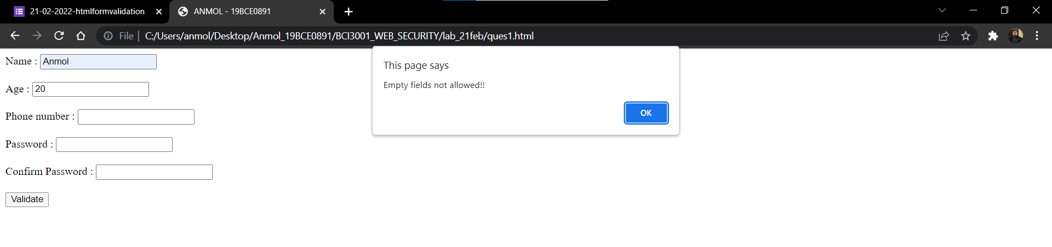
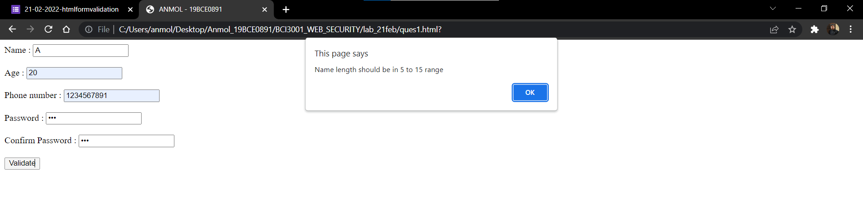
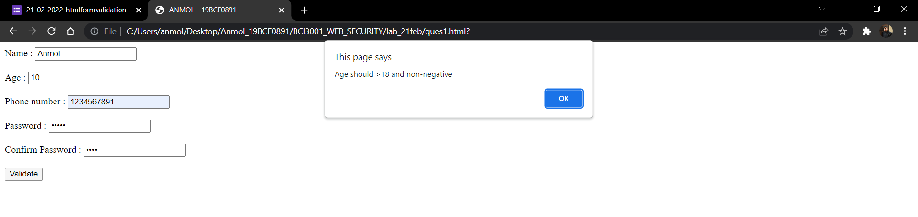
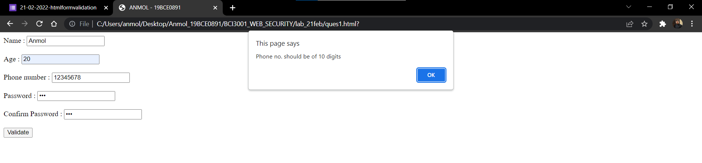
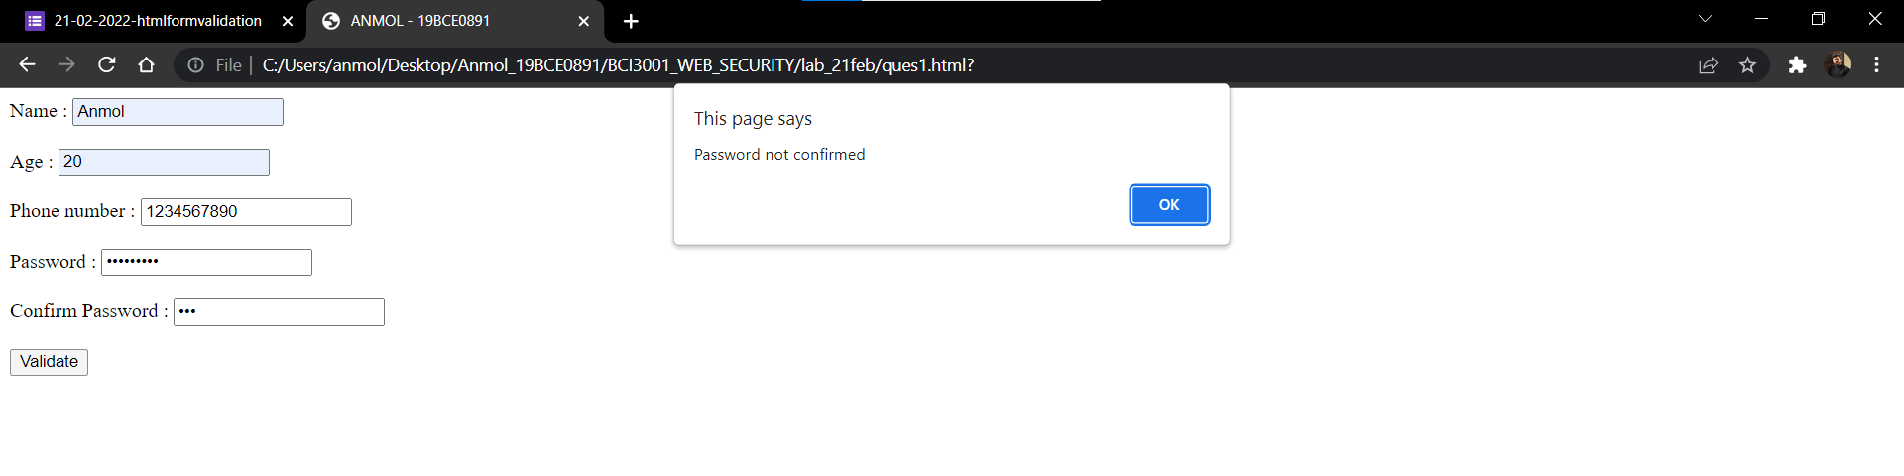

-----------------------------------------------------------------------------------------------------------------------

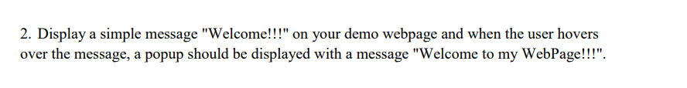
CODE -

<html>
<head>
<title>ANMOL - 19BCE0891</title>
</head>

<body>
<h1 onmouseover="alertMsg()">Welcome</h1>
</body>

<script type="text/javascript">
function alertMsg() {
alert("Welcome to my WebPage!!!");
}
</script>
</html>

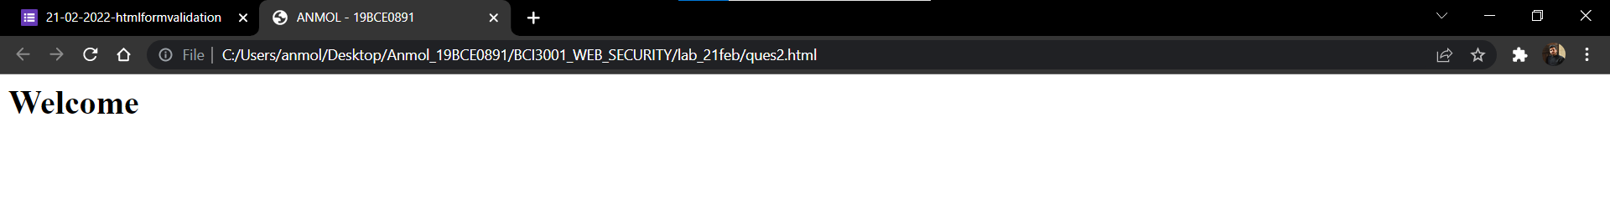

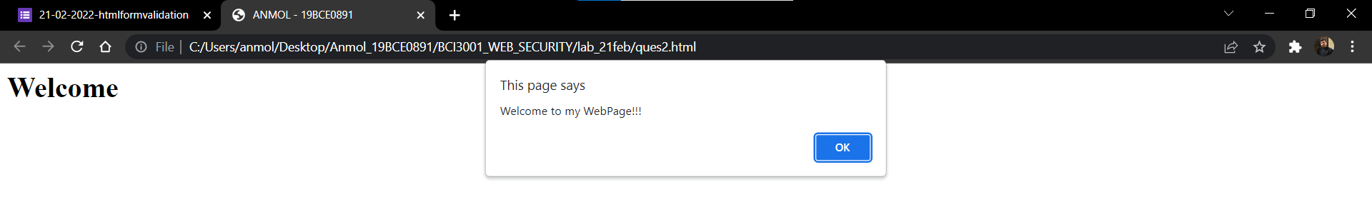

------------------------------------------------------------------------------------------------------------------------



CODE -

<html>
<head>
<title>ANMOL - 19BCE0891</title>
</head>
<body>
<h1>Sum of numbers</h1>
Enter num1 :
<input type="number" id="val1" />
<br /><br />

Enter num2 :
<input type="number" id="val2" />
<br /><br />

<button onclick="findSum()">Add</button>
<input type="text" id="output" />
</body>

<script>
function findSum() {
var num1 = parseInt(document.getElementById("val1").value);
var num2 = parseInt(document.getElementById("val2").value);

var sum = num1 + num2;

document.getElementById("output").value = sum;
}
</script>
</html>

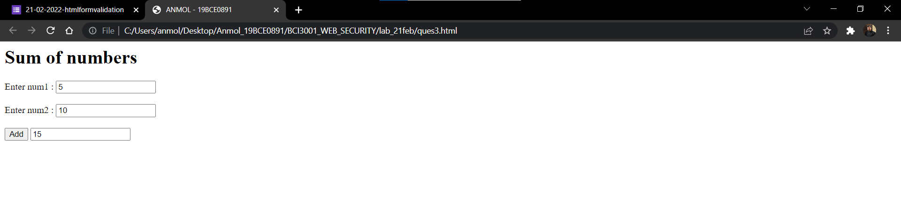

CODE -

<html>
<head>
<title>ANMOL - 19BCE0891</title>
</head>
<body>
<h1>Factorial of number</h1>
Enter num :
<input type="number" id="val" />
<br /><br />

<button onclick="findFact()">factorial !</button>

<h2 id="output" style="color: green"></h2>
</body>

<script>
function findFact() {
var num = document.getElementById("val").value;

var fact = 1;
for (var i = 1; i <= num; i++) {
fact = fact * i;
}

document.getElementById("output").innerHTML =
"Factorial of " + num + " is : " + fact;
}
</script>
</html>

