NAME – ANMOL
REG NO – 19BCE0891

1.Write a JavaScript program to find the biggest among three numbers

CODE -

<html>
<head>
<title>ANMOL - 19BCE0891</title>
</head>
<body>
<h1>Maximum of three Numbers</h1>
Enter 1st num :
<input type="number" id="val1" />
<br /><br />

Enter 2nd num :
<input type="number" id="val2" />
<br /><br />

Enter 3rd num :
<input type="number" id="val3" />
<br /><br />

<button onclick="findMax()">Max num</button>

<h3 id="output" style="color: red"></h3>
</body>

<script>
function findMax() {
const num1 = parseInt(document.getElementById("val1").value);
const num2 = parseInt(document.getElementById("val2").value);
const num3 = parseInt(document.getElementById("val3").value);

let max;
if (num1 >= num2 && num1 >= num3) {
max = num1;
} else if (num2 >= num1 && num2 >= num3) {
max = num2;
} else {
max = num3;
}
document.getElementById("output").innerHTML = max + " is greatest";
}
</script>
</html>

OUTPUT -

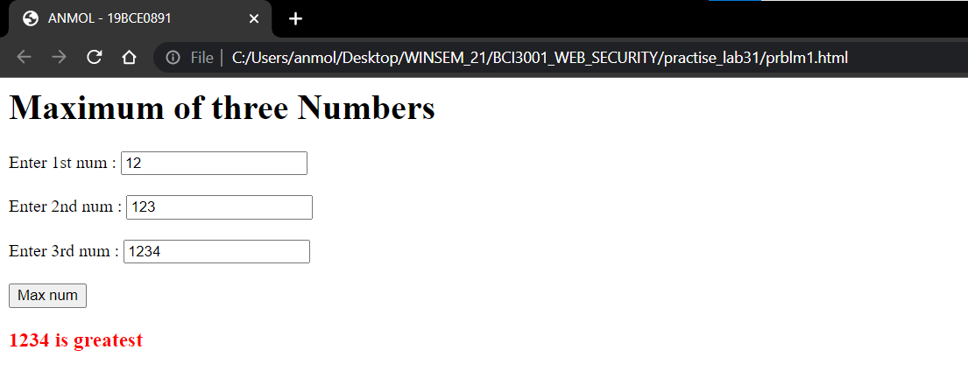

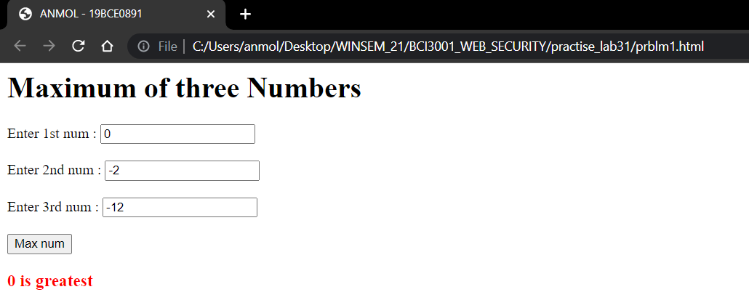

2.To find a given number is even or odd.//if -else

<html>
<head>
<title>ANMOL - 19BCE0891</title>
</head>
<body>
<h1>Odd/Even</h1>
Enter num :
<input type="number" id="val" />
<br /><br />

<button onclick="check()">check</button>

<h2 id="output" style="color: green"></h2>
</body>

<script>
function check() {
var num = document.getElementById("val").value;

if (num % 2 == 0) {
document.getElementById("output").innerHTML = num + " is Even";
} else {
document.getElementById("output").innerHTML = num + " is Odd";
}
}
</script>
</html>

OUTPUT -

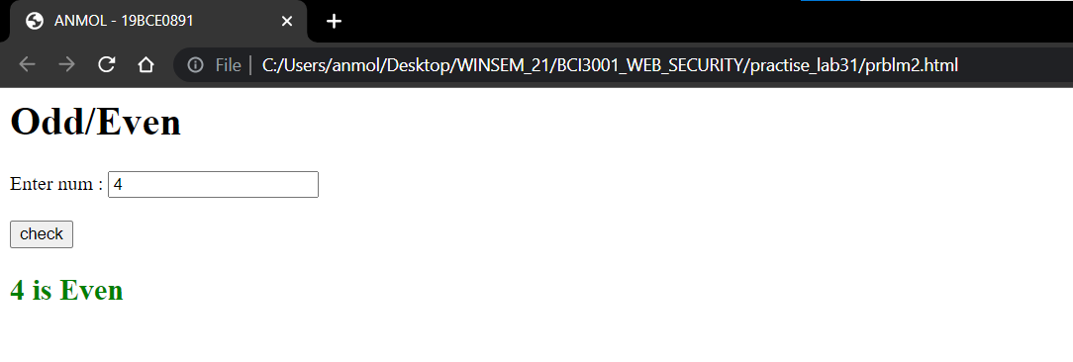

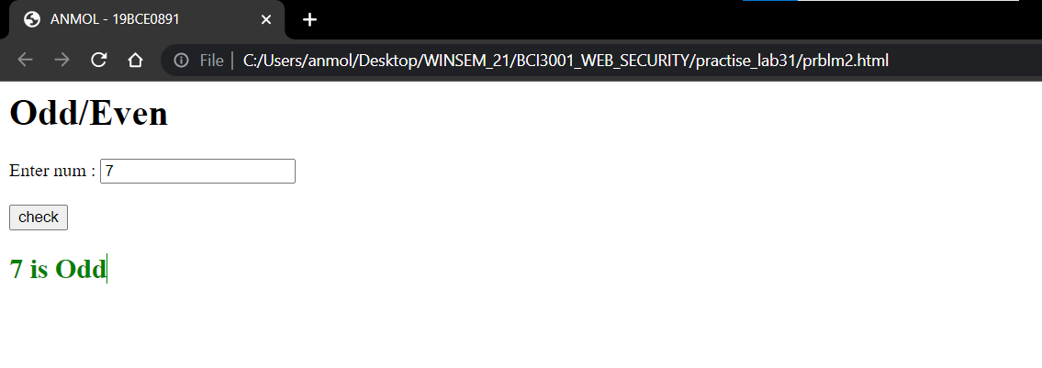

3.Program to find the sum of first n numbers.//for loop or while loop.

<html>
<head>
<title>ANMOL - 19BCE0891</title>
</head>
<body>
<h1>Sum of n numbers</h1>
Enter num :
<input type="number" id="val" />
<br /><br />

<button onclick="findSum()">find sum</button>

<h2 id="output" style="color: blue"></h2>
</body>

<script>
function findSum() {
var num = document.getElementById("val").value;

var sum = 0;
for (var i = 1; i <= num; i++) {
sum += i;
}

document.getElementById("output").innerHTML =
"Sum of " + num + " numbers is : " + sum;
}
</script>
</html>

OUTPUT -

