NAME – ANMOL
REG NO – 19BCE0891

ASSIGNMENT – 1

Q1 – BASIC HTML TAGS (ANY 10)

1. <b> tag is used to to make a portion of the text bold.
<u> tag in HTML is used to underline the text enclosed within the <u> tag.
<i> tag in HTML is used to display the content in italic style.

CODE -

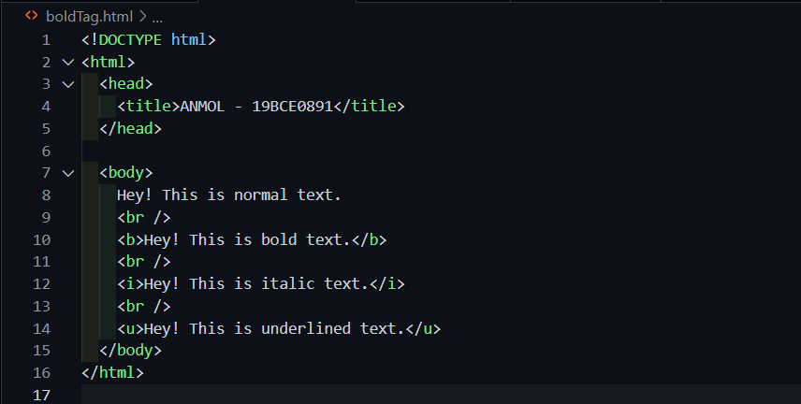

OUTPUT -

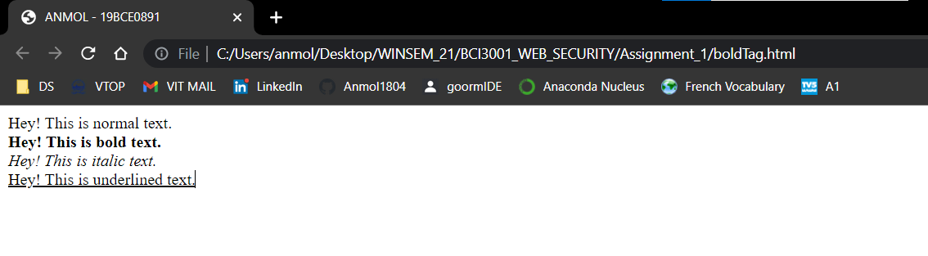

2. <p> defines a paragraph. Browsers automatically add a single blank line before and after each <p> element.

CODE -

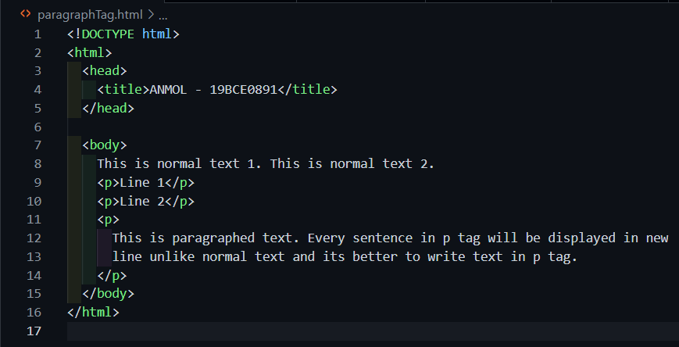

OUTPUT -

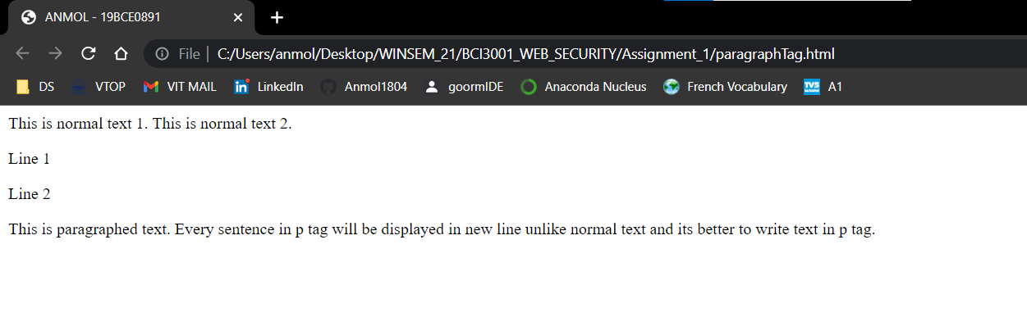

3. <img> tag is used to embed an image in an HTML page.

CODE -

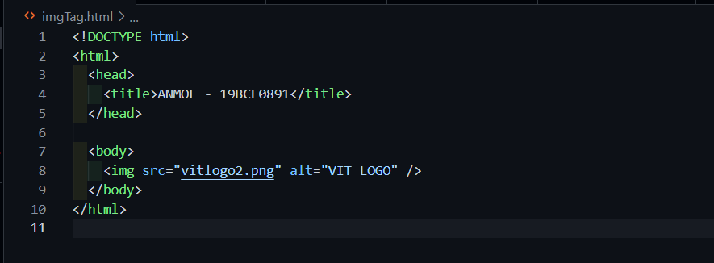

OUTPUT -

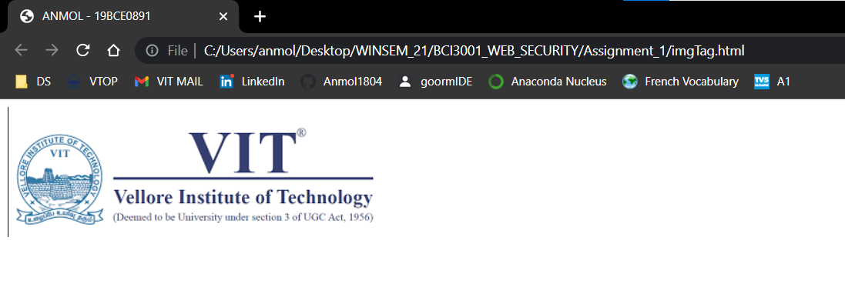

4. <button> tag is used to create a clickable button within HTML form on your webpage. You can put content like text or image within the <button>

CODE -

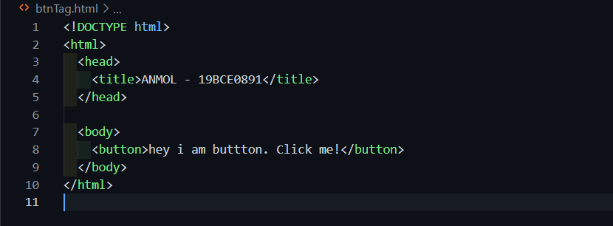

OUTPUT -

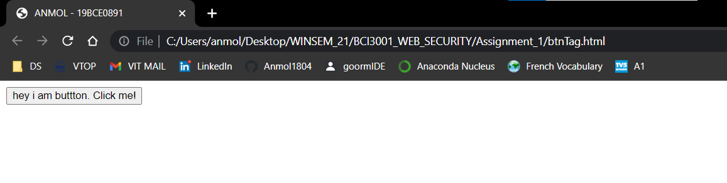

5. <a> tag defines a hyperlink, which is used to link from one page to another, href attribute, which indicates the link's destination.

CODE -

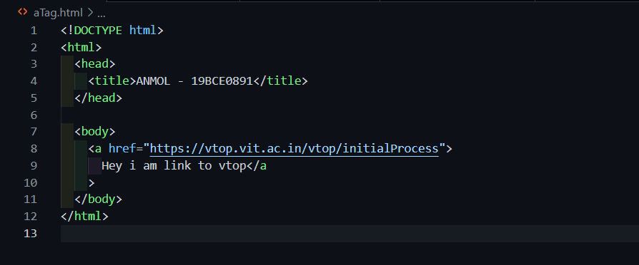

OUTPUT -

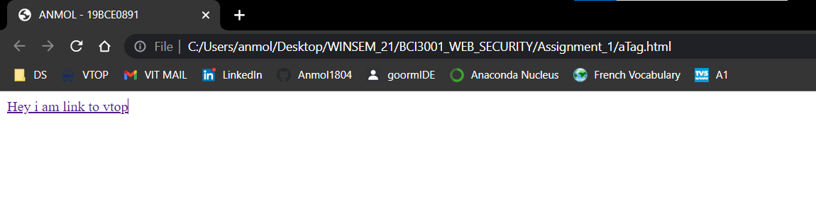

6. <input> tag specifies an input field where the user can enter data. Some of types mostly used are text, email, password, radio, checkbox etc.
<br> tag inserts a single line break.
CODE -

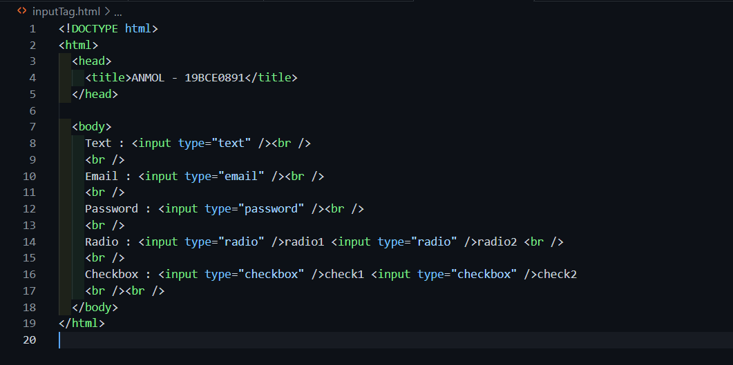

OUTPUT -

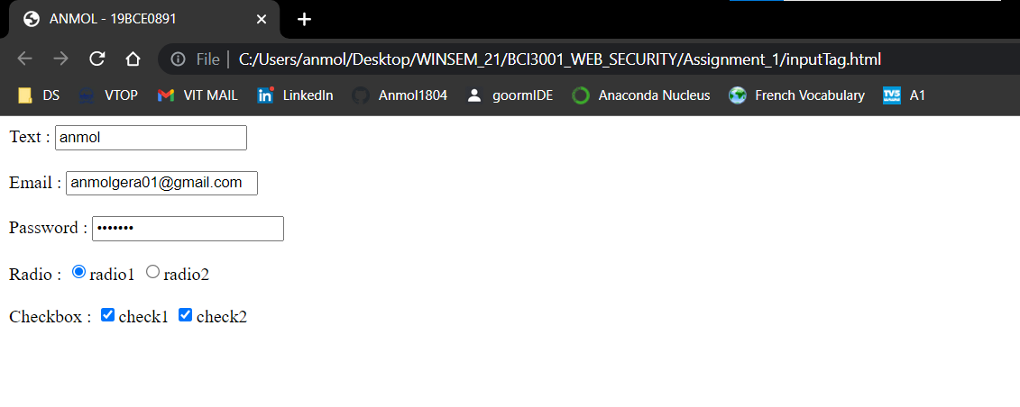

7. <iframe> tag specifies an inline frame. iframe is used to embed another document within the current HTML document.

CODE -

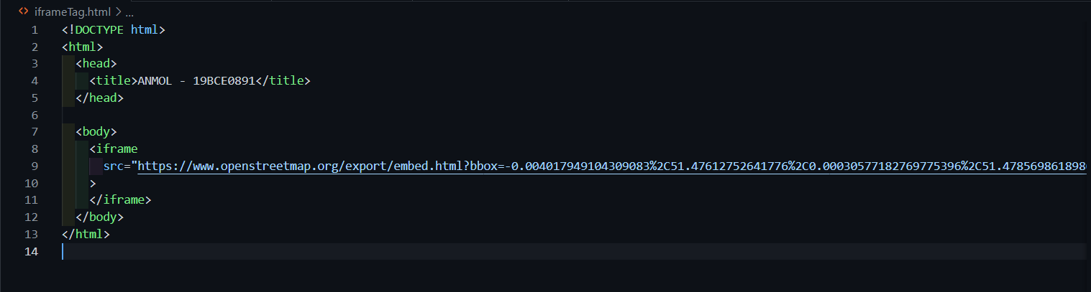

OUTPUT -

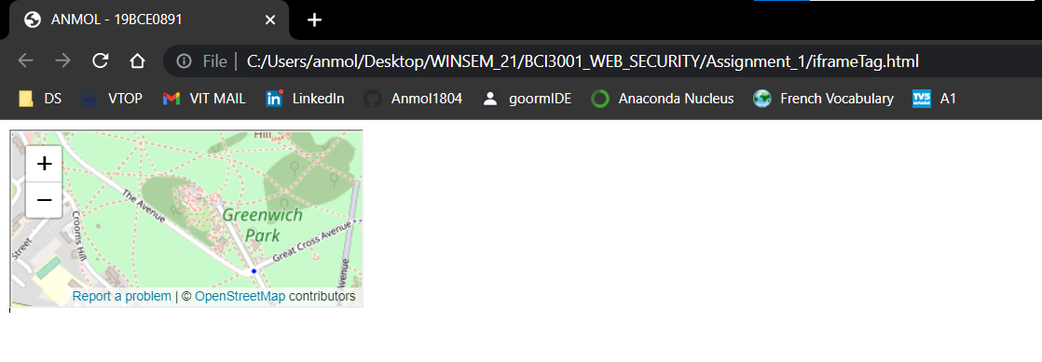

8. HTML headings are titles or subtitles that you want to display on a webpage.
<h1> headings should be used for main headings, followed by <h2> headings, then the less important <h3>, and so on.

CODE -
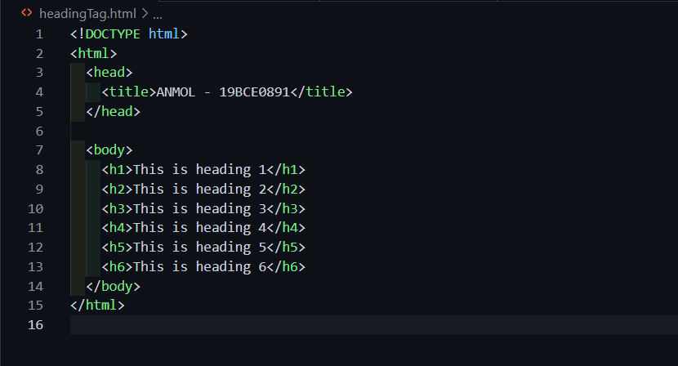

OUTPUT -

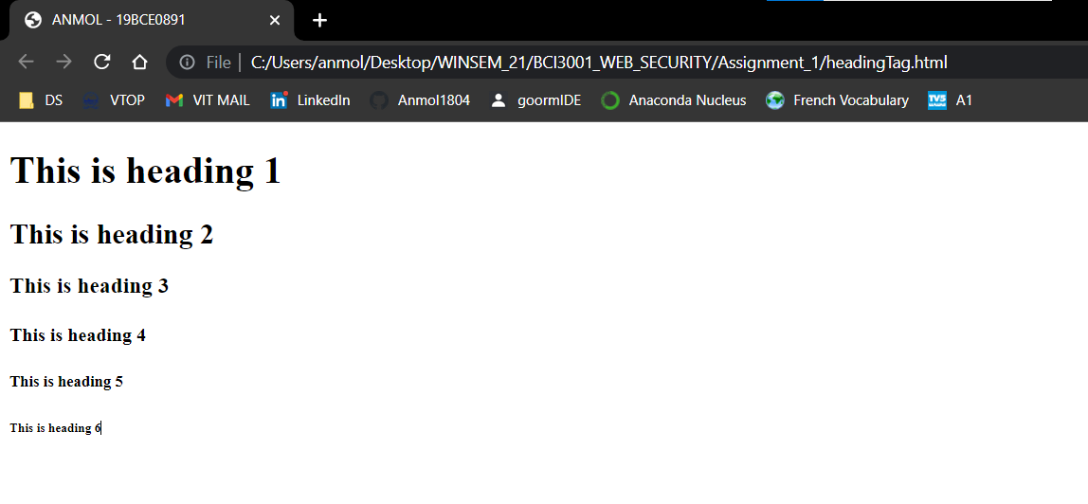

9. <ul> defines Unordered List element. The <ul> HTML element represents an unordered list of items, typically rendered as a bulleted list. The <li> tag is used to define each list item.

CODE -

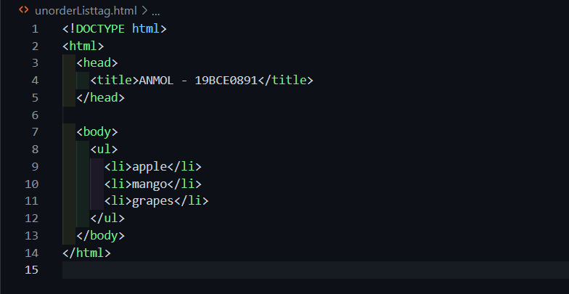

OUTPUT -

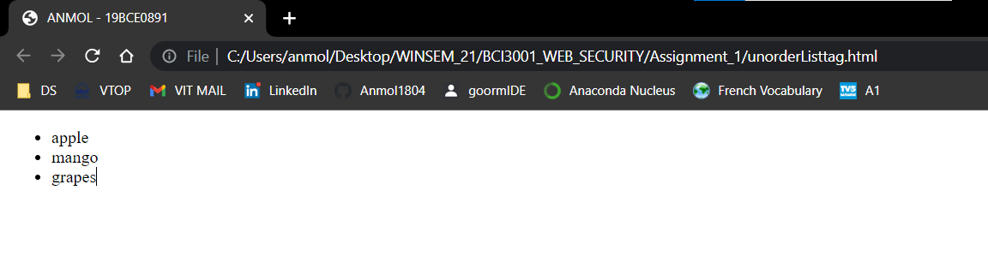

10. <ol> tag defines an ordered list. An ordered list can be numerical or alphabetical. The <li> tag is used to define each list item.

CODE -

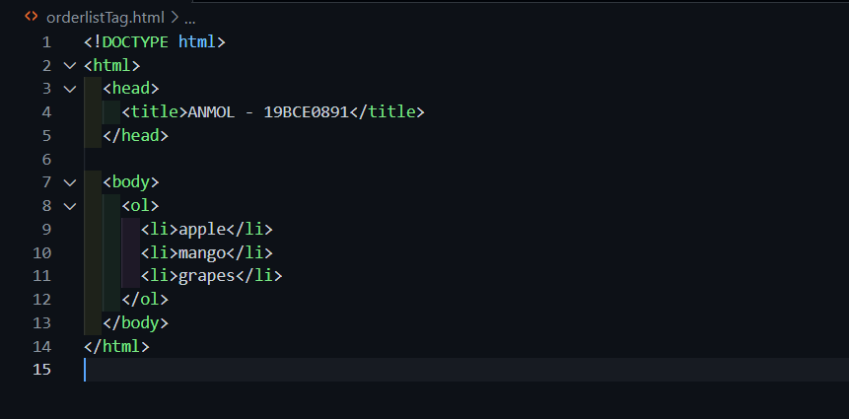

OUTPUT -

