NAME – ANMOL
REG NO – 19BCE0891

ASSIGNMENT – 2

1. Consider an application that allows the user to enter a list of integers as long as the values are unique. If the user tends to enter a value which is already in the list, then the user is not allowed to enter the values further with an error message stating that “Duplicate”. Otherwise the message “Unique” is displayed. Write a JavaScript for given problem.

CODE -

<html>
<head>
<title>ANMOL - 19BCE0891</title>
</head>

<body>
<center>
<form action="#">
<h1>DUPLICACY IN LIST</h1>
Input a number :
<input type="number" name="" id="num" />
<br /><br />

<button onclick="check()">check number</button>
<br /><br />

<h3 style="color: blue" id="out">List :</h3>

<h1 style="color: green" id="status"></h1>
</form>
</center>
</body>
<script>
var inpNums = [];

function check() {
var inp = parseInt(document.getElementById("num").value);

if (inpNums.includes(inp)) {
document.getElementById("status").innerHTML = "DUPLICATE";
document.getElementById("status").style.color = "red";

document.getElementById("num").disabled = true;
} else {
inpNums.push(inp);

let text = inpNums.toString();
document.getElementById("out").innerHTML = "List : " + inpNums;
document.getElementById("status").innerHTML = "UNIQUE";
}
}
</script>
</html>

CODE SNIPPETS -

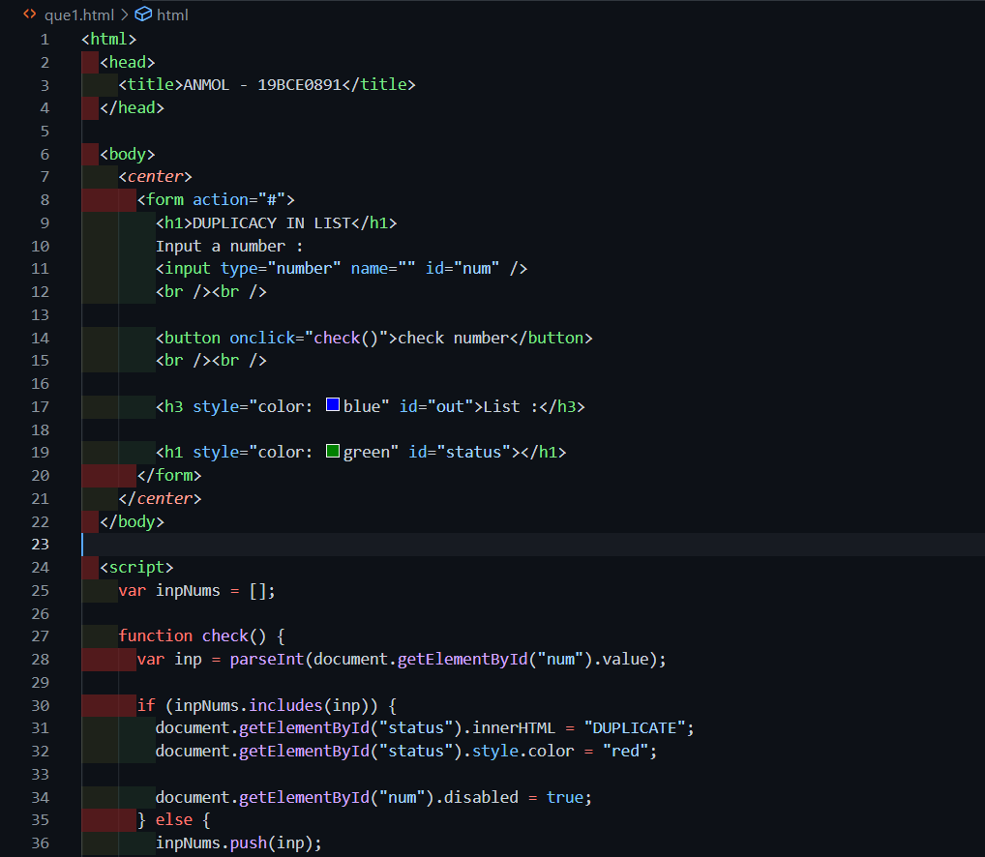
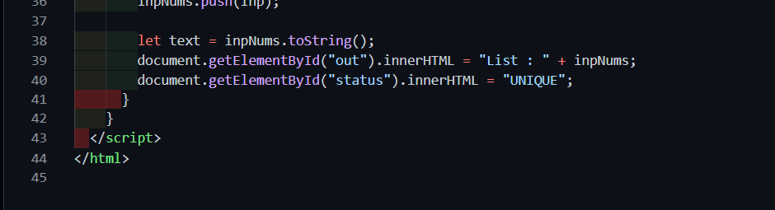

OUTPUT -

Initially :
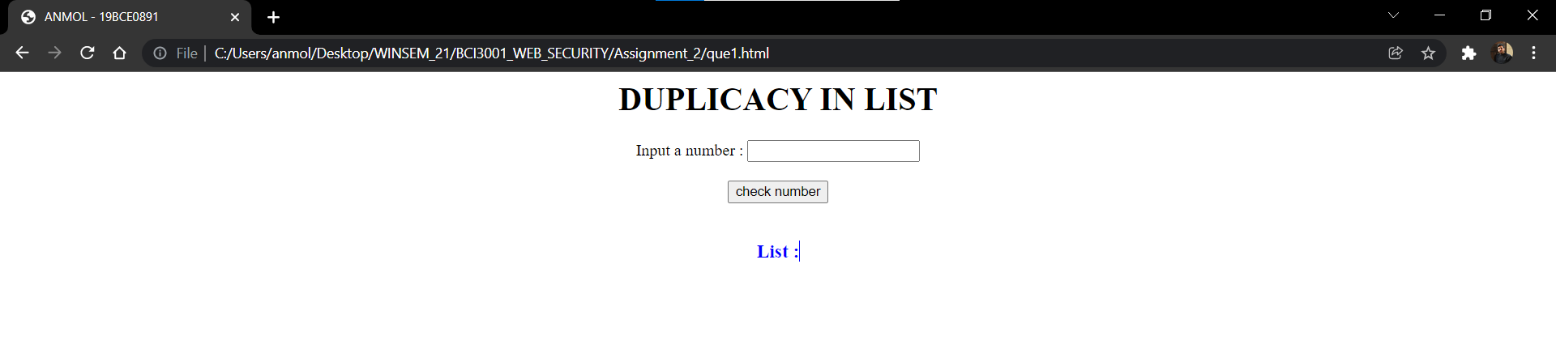

Entering Some Unique values: (list updated on input values)
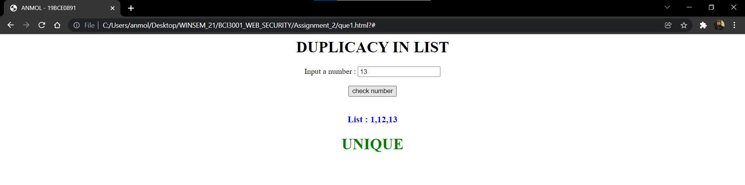
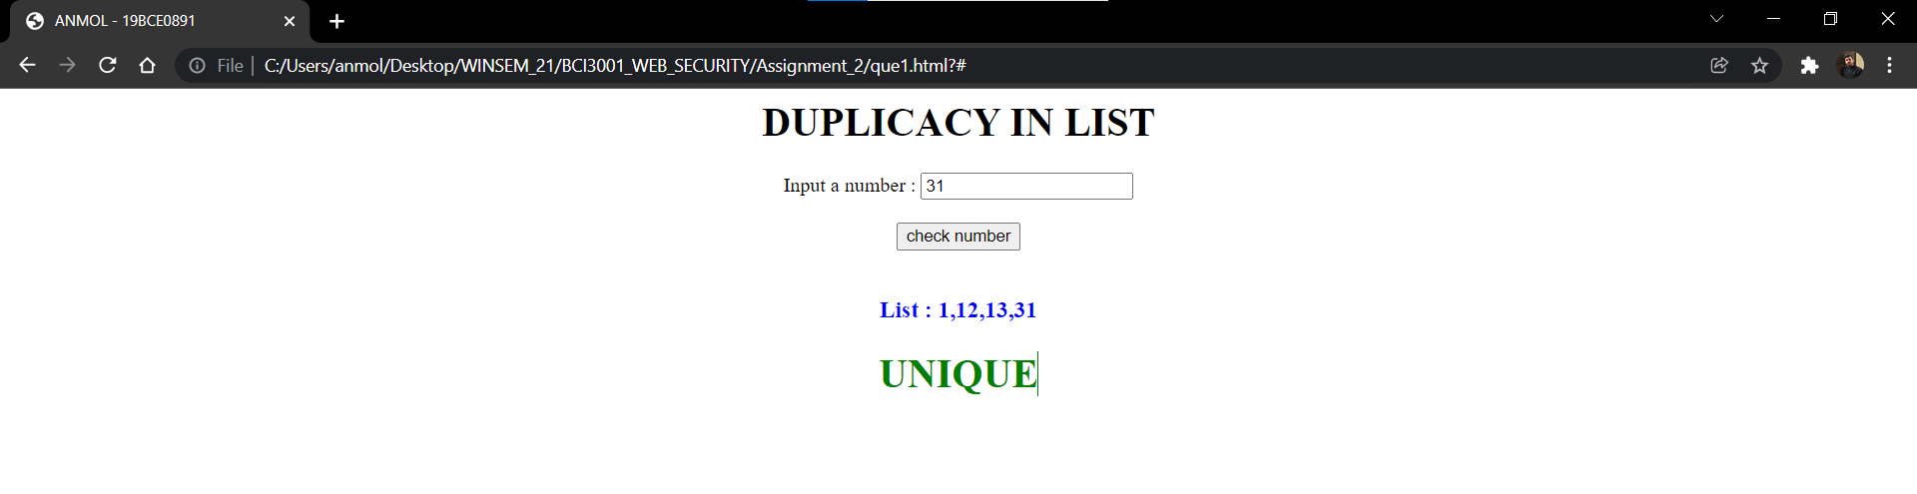

Entering Duplicate Value :
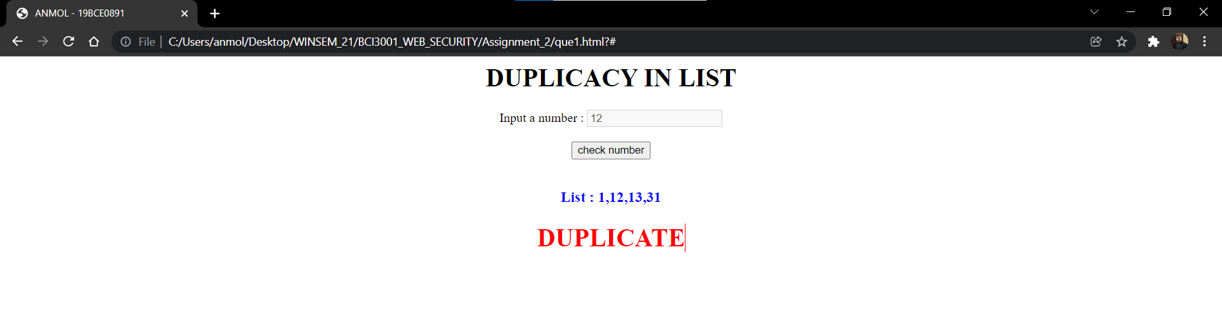
(inputing field get disabled)
3. BMI Body Mass Index (BMI) is a measure of health on weight. It can be calculated by taking your weight in kilograms and dividing by the square of your height in meters. The interpretation of BMI for people 16 years or older is as follows :
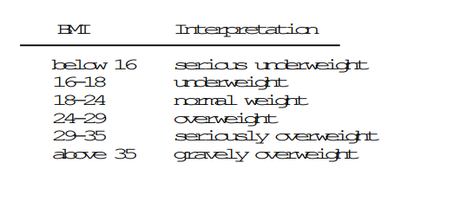
CODE -

<html>
<head>
<title>ANMOL - 19BCE0901</title>
</head>
<body>
<center>
<h1>BMI Calculator</h1>

<form action="#">
ENTER HEIGHT :
<input type="text" placeholder="in cm" id="ht" />
<br /><br />

ENTER WEIGHT :
<input type="text" placeholder="in kg" id="wt" />
<br /><br />

<button onclick="bmi()" id="btn">Calculate</button>
<h3 id="bmiVal" style="color: blue"></h3>
<h2 id="status" style="color: red"></h2>
</form>
</center>
</body>

<script>
function bmi() {
var ht = Number(document.getElementById("ht").value);
var wt = Number(document.getElementById("wt").value);
var bmi = (wt / ((ht * ht) / 10000)).toFixed(2);
document.getElementById("bmiVal").innerHTML = "BMI is : " + bmi;
if (bmi < 16) {
document.getElementById("status").innerHTML = "SERIOULSY UNDERWEIGHT";
document.getElementById("status").style.color = "red";
} else if (bmi >= 16 && bmi < 18) {
document.getElementById("status").innerHTML = "UNDERWEIGHT";
document.getElementById("status").style.color = "red";
} else if (bmi >= 18 && bmi < 24) {
document.getElementById("status").innerHTML = "NORMAL WEIGHT";
document.getElementById("status").style.color = "green";
} else if (bmi >= 24 && bmi < 29) {
document.getElementById("status").innerHTML = "OVERWEIGHT";
document.getElementById("status").style.color = "red";
} else if (bmi >= 29 && bmi < 35) {
document.getElementById("status").innerHTML = "SERIOULSY OVERWEIGHT";
document.getElementById("status").style.color = "red";
} else if (bmi >= 35) {
document.getElementById("status").innerHTML = "GRAVELY OVERWEIGHT";
document.getElementById("status").style.color = "red";
}
}
</script>
</html>

CODE SNIPPETS -
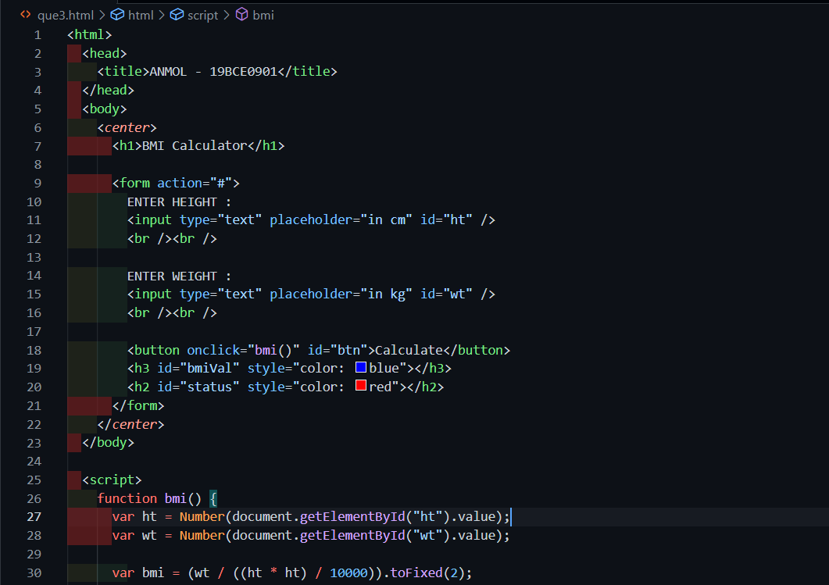
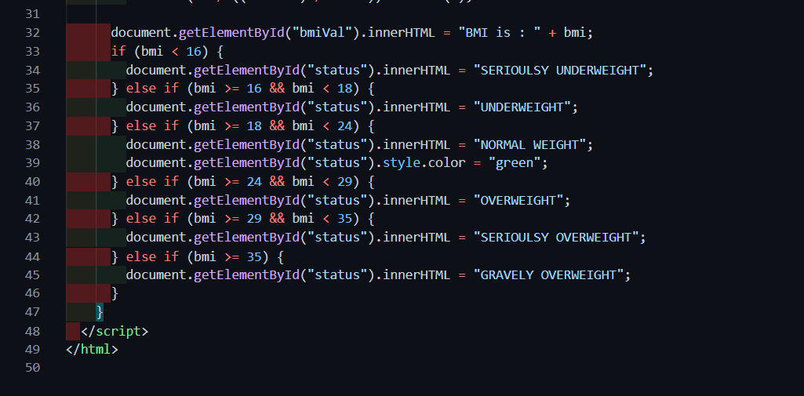
OUTPUT -

