NAME – ANMOL
REG NO – 19BCE0891

ASSIGNMENT – 4

1.Check input number is prime or not. If prime then display it on same page but if not prime write it into another page.

CODE -

<!DOCTYPE html>
<html>
<head>
<title>Anmol - 19BCE0891</title>

<script type="text/javascript">
function checkPrime() {
var n,
i,
prime = true;
n = document.myform.n.value;
n = parseInt(n);
for (i = 2; i * i <= n; i++)
if (n % i == 0) {
prime = false;
break;
}

// we know 1 is also not prime
if (prime == true && n != 1) {
alert(n + " is Prime");
} else {
document.write(n + " is Not Prime");
}
}
</script>
</head>

<body>
<h2>Is Prime?</h2>
<form name="myform">
Enter the number:
<input type="text" name="n" value="" />
<br /><br />
<input type="button" value="Check" onClick="checkPrime()" />
<br />
</form>
</body>
</html>

CODE Snippet :

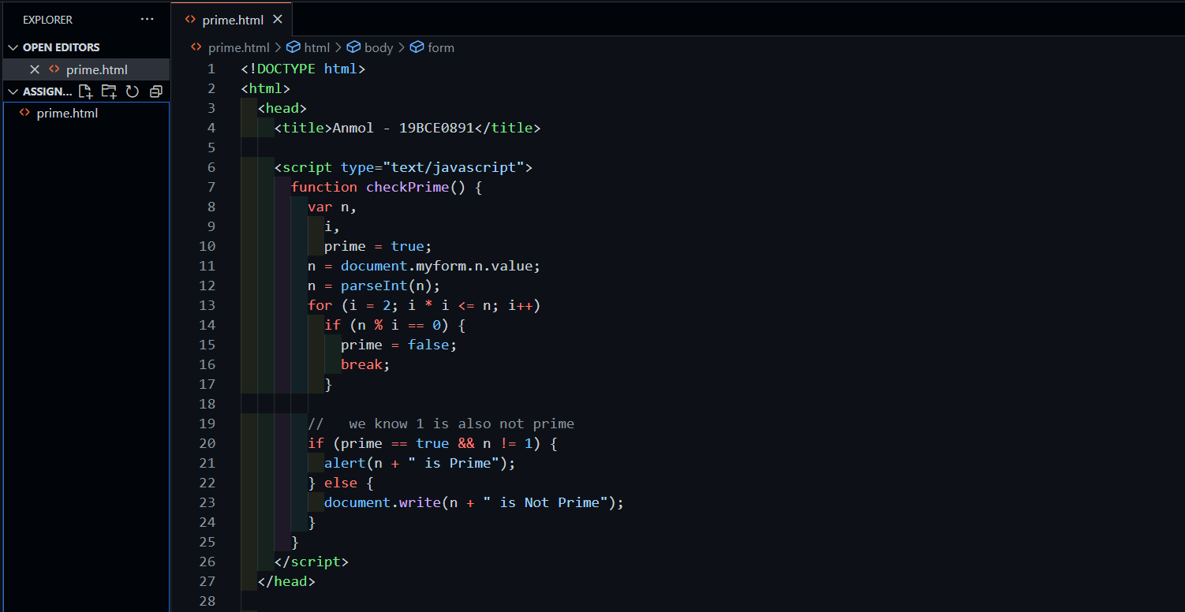

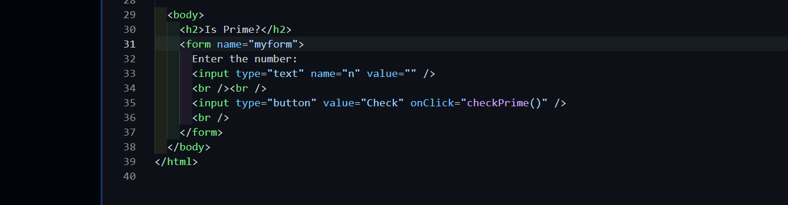

OUTPUT :

Alerting Prime no. :

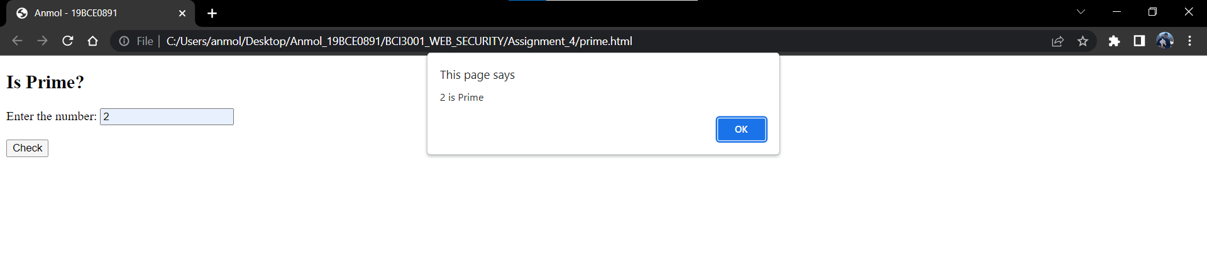

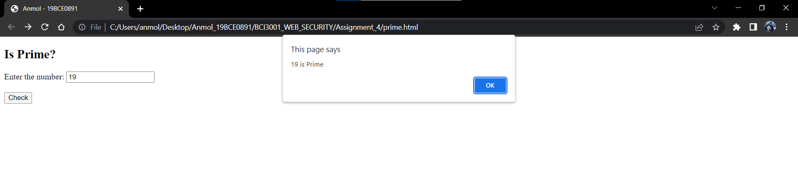
Not prime written on another page :

checking 1:
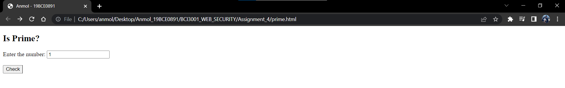
(new page)
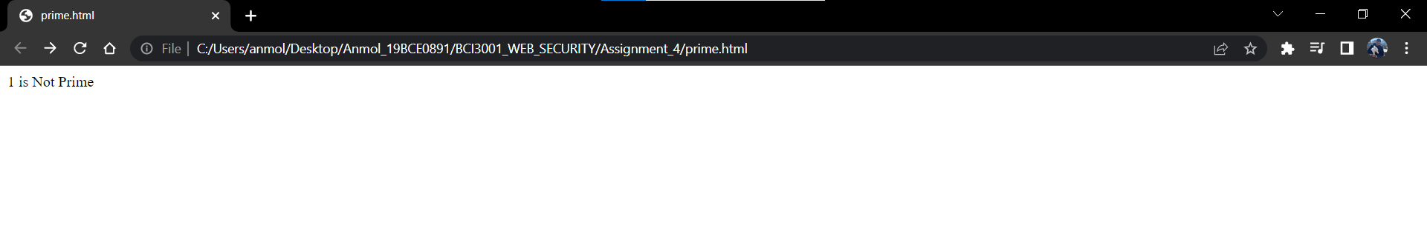

checking 200:
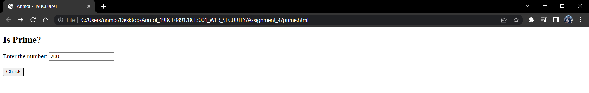
(new page)

