NAME – ANMOL
REG. NO. - 19BCE0891

DIGITAL ASSIGNMENT – 1

NETWORK TOPOLOGY

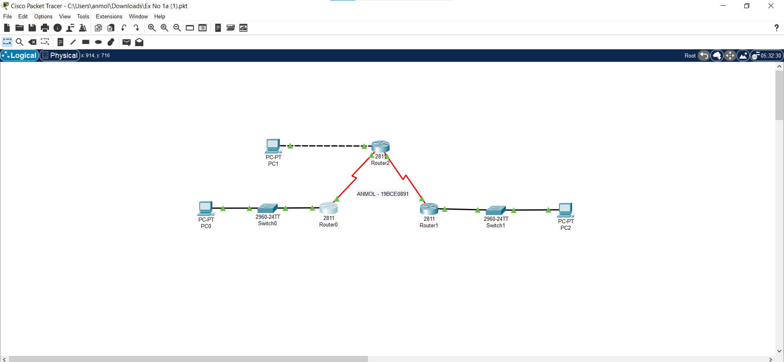

PC0 CONFIG

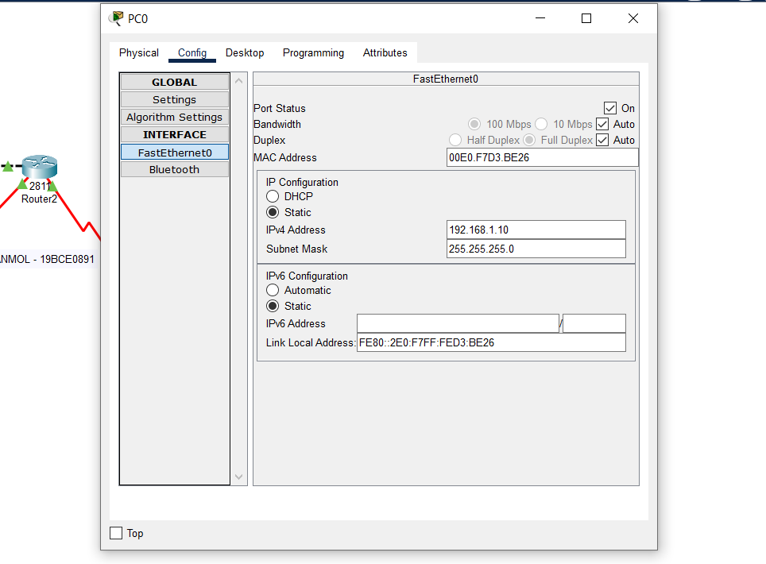

PC1 CONFIG

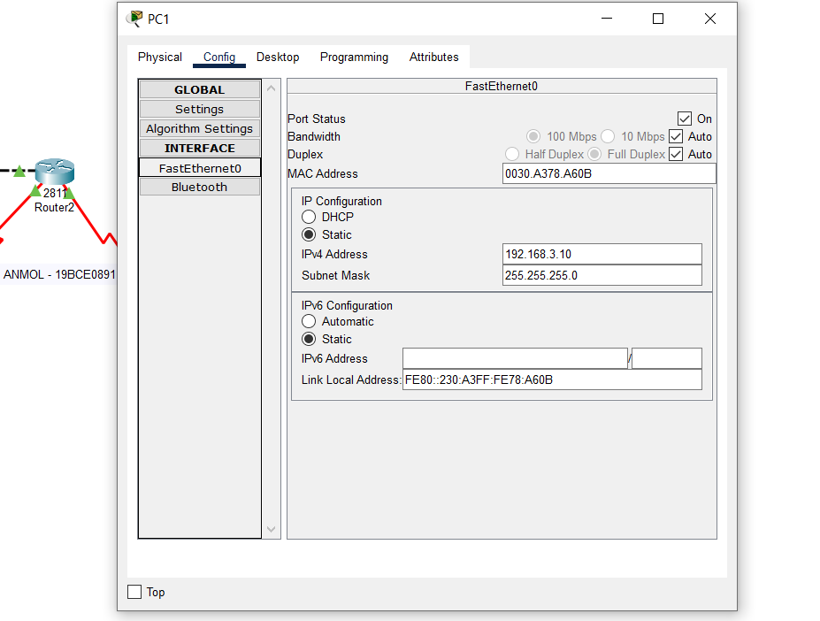

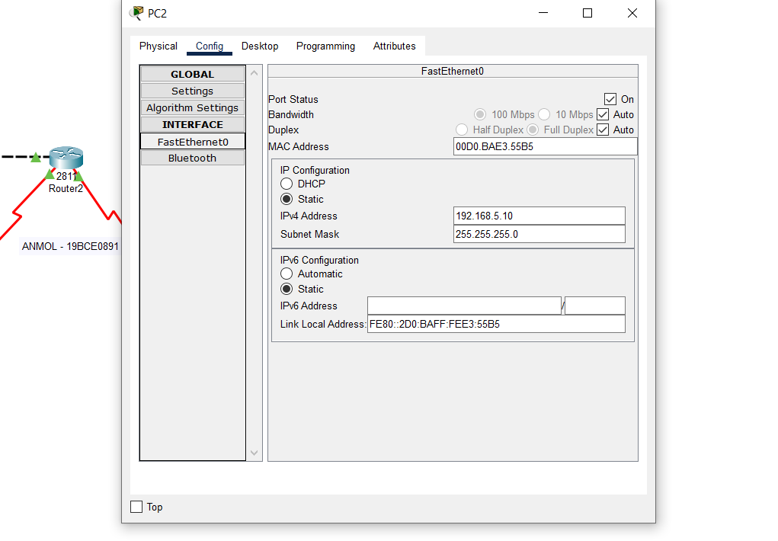

PC2 CONFIG

ROUTER 0 CONFIG

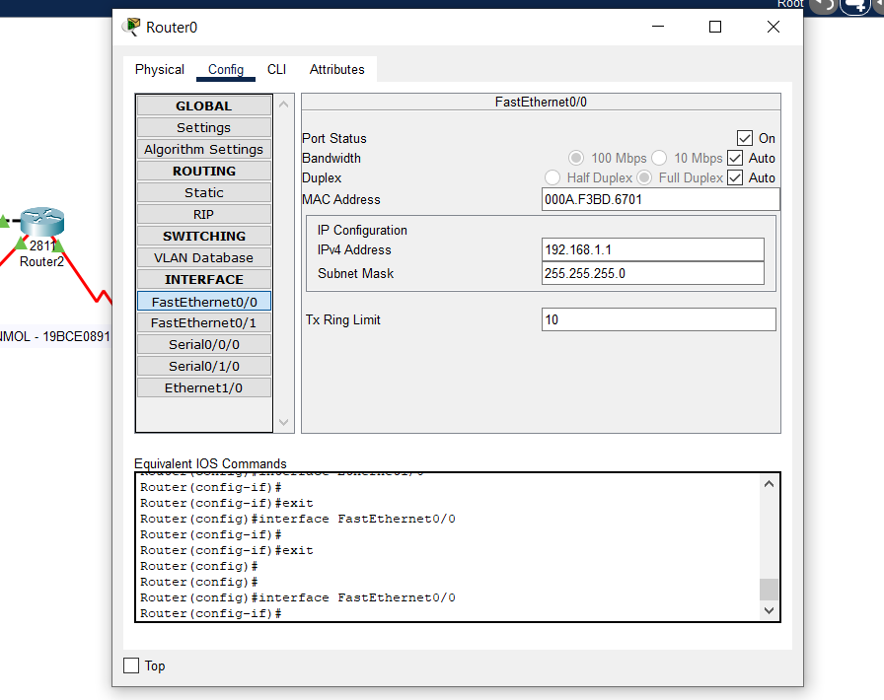

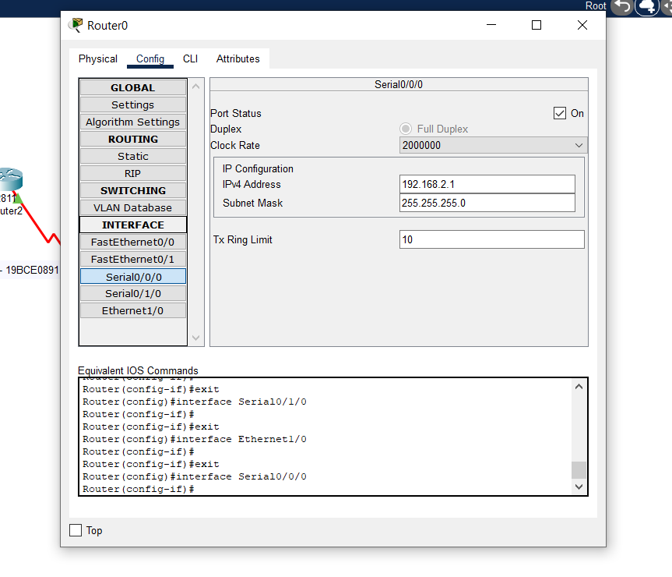

ROUTER 2 CONFIG

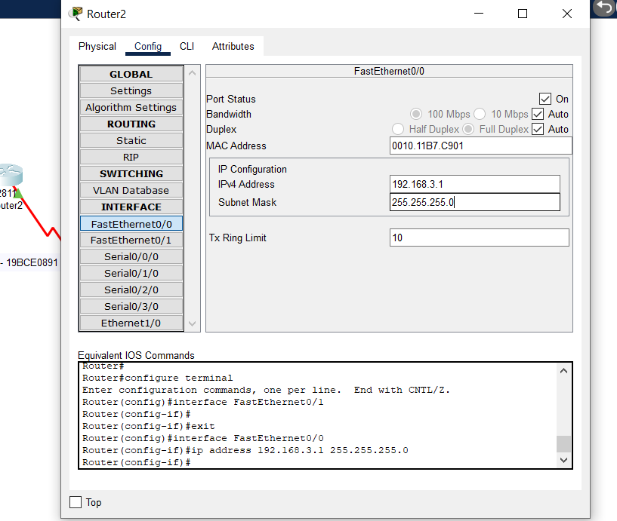

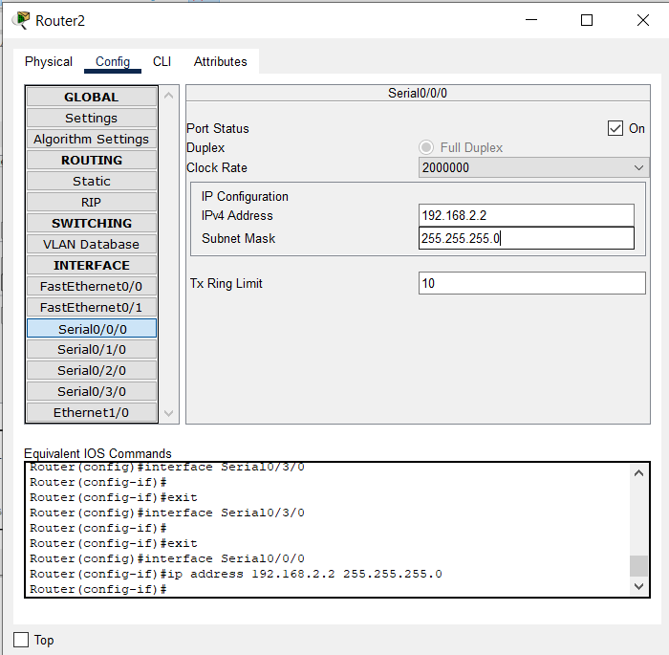

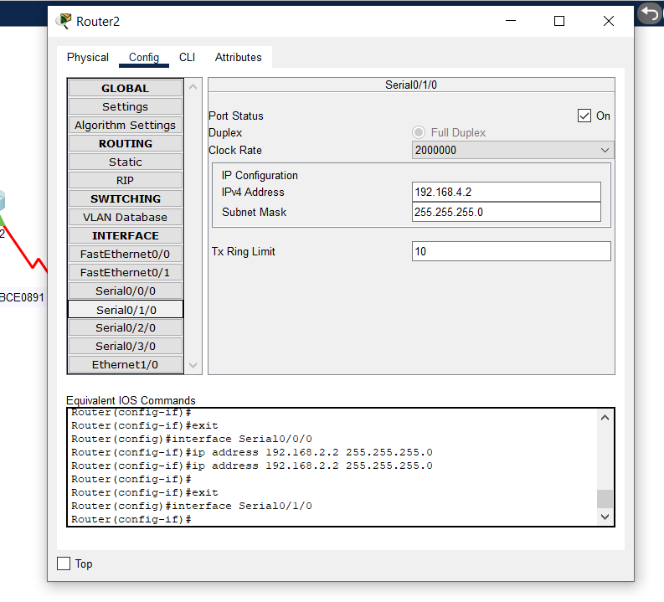

ROUTER 1 CONFIG

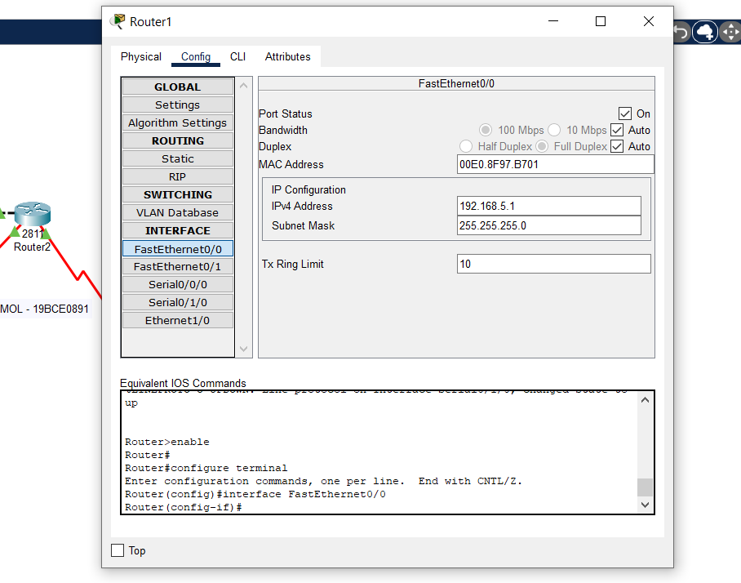

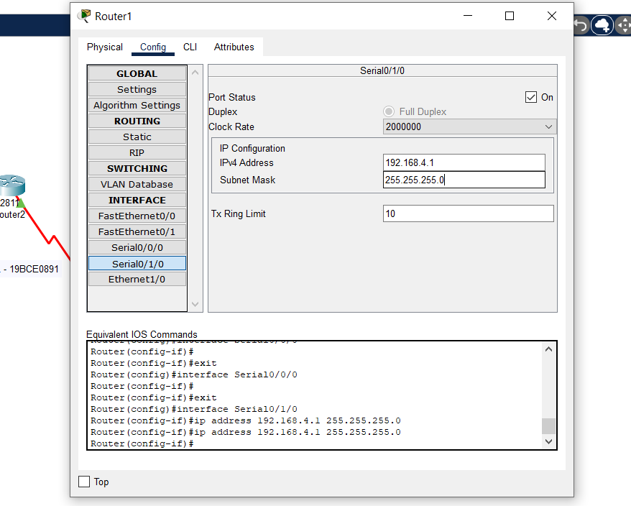

ADDING RIP TO ROUTER 1 (similarily to all routers)

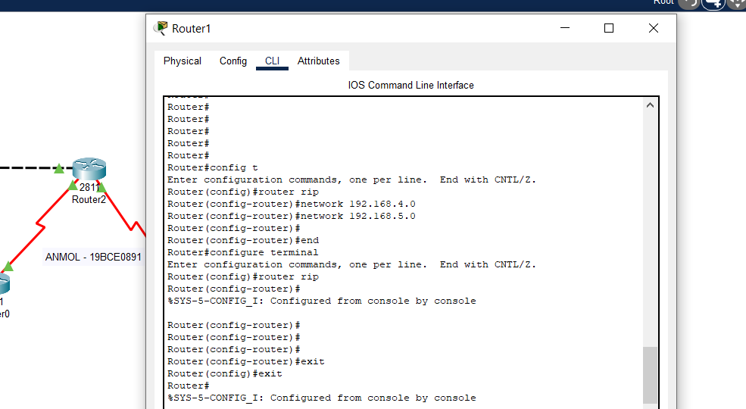

RIP CAN ALSO BE ADDED USING GUI (ADDED NETWORKS CAN BE SEEN)

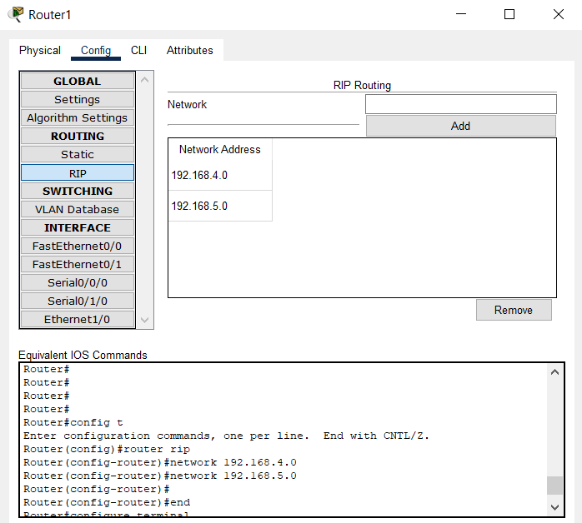

PINGING PC0 TO PC2
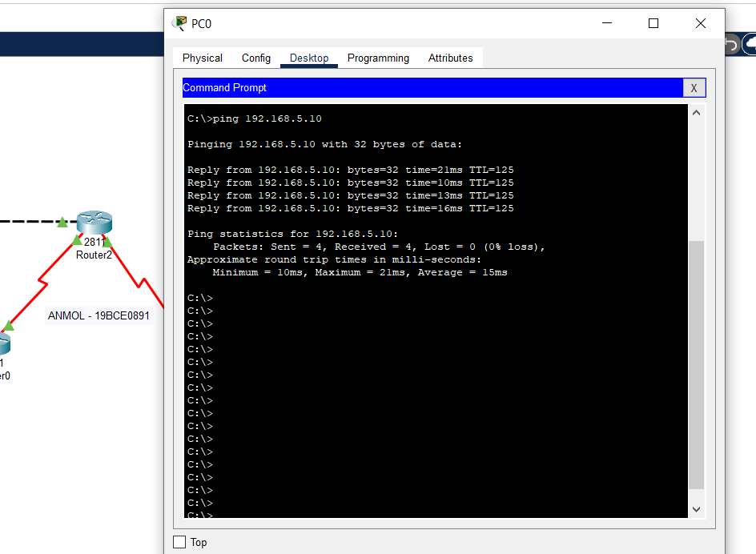

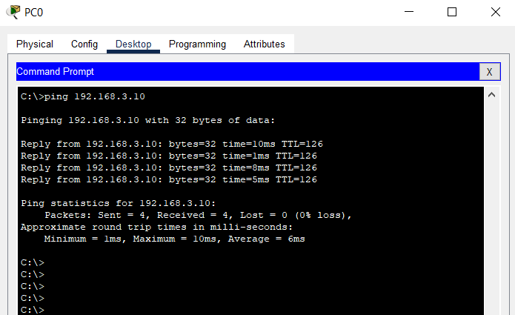
PINGING PC0 TO PC1

NOTE : ALL IP’S AND ROUTER CONFIGURATIONS CAN BE ADDED THROUGH GUI AS WELL AS CMD PROMPT

FOR COMMAND LINE INTERFACE (BELOW ARE like COMMANDS)

router 0

Router>enable
Router#config t
Router(config)#int fa0/0
Router(config-if)#ip address 192.168.1.1 255.255.255.0
Router(config)#int s0/0/0
Router(config-if)#ip address 192.168.2.1 255.255.255.0
Router(config-if)#exit
Router(config)#exit

Router(config)#router rip
Router(config-router)#network 192.168.1.0
Router(config-router)#network 192.168.2.0
Router(config-router)#exit
Router(config)#exit

(similarily for all routers with respectively ip addresses and networks)

