NAME – ANMOL
REG. NO. - 19BCE0891

DIGITAL ASSIGNMENT – 2

NETWORK TOPOLOGY

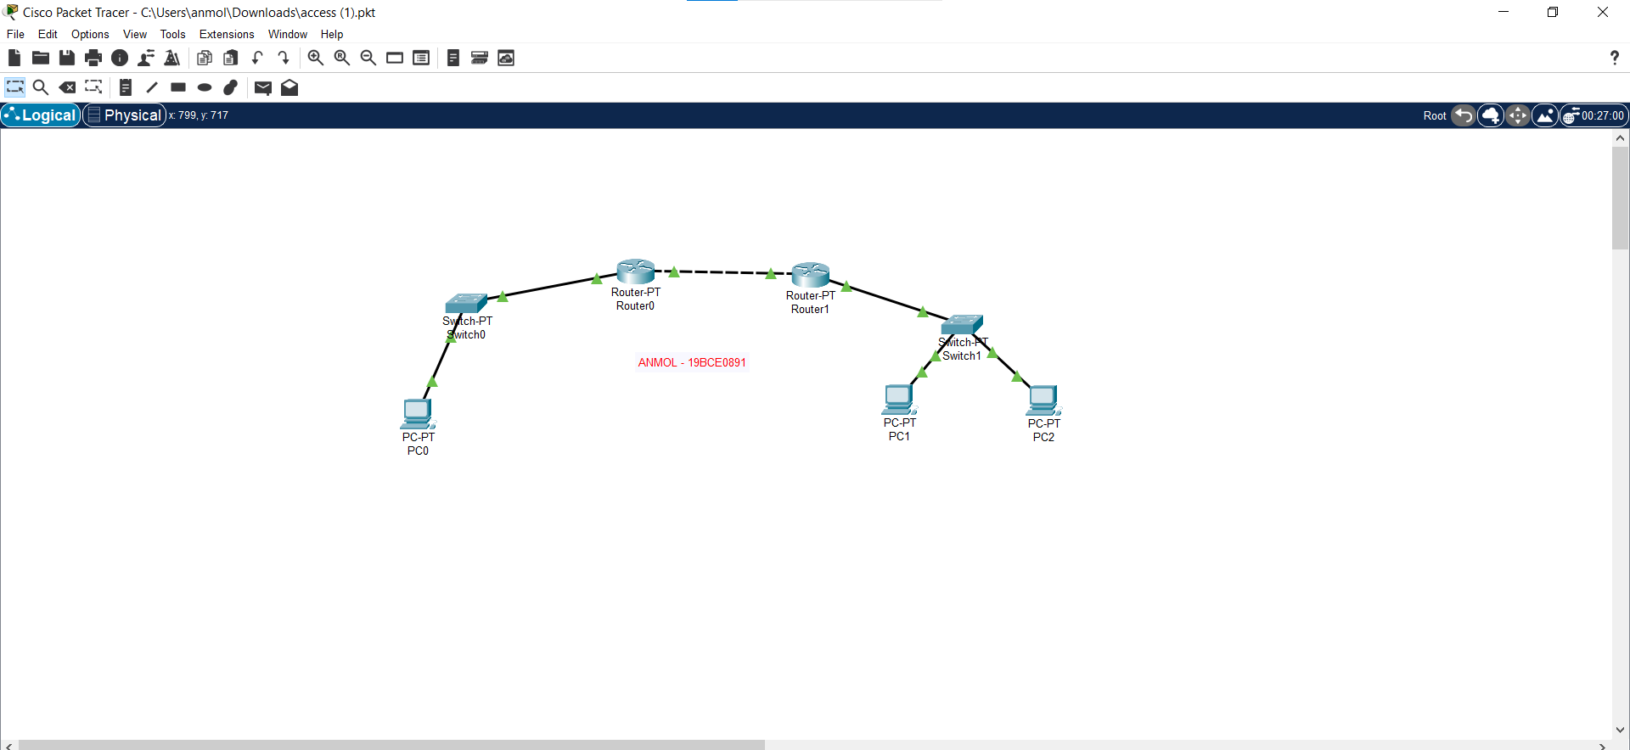

PC0 CONFIGURATIONS

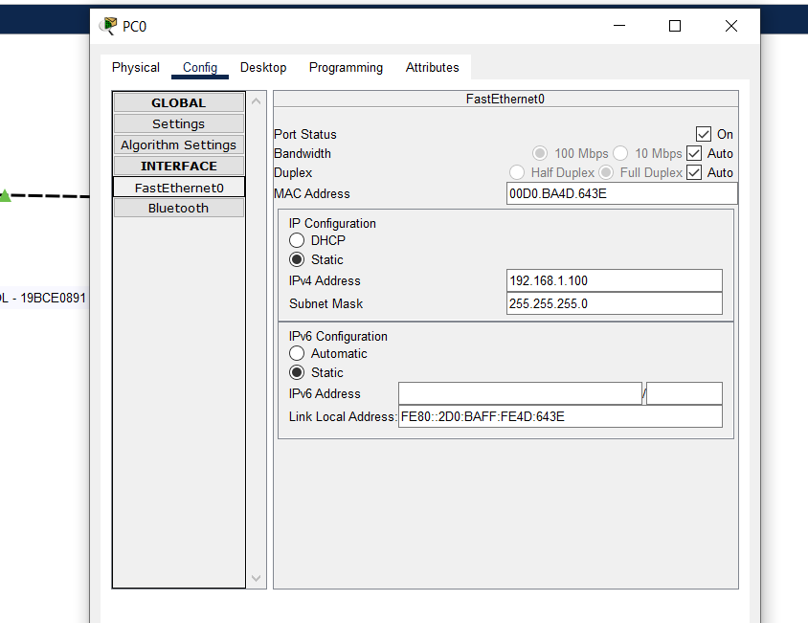

PC1 CONFIGURATIONS

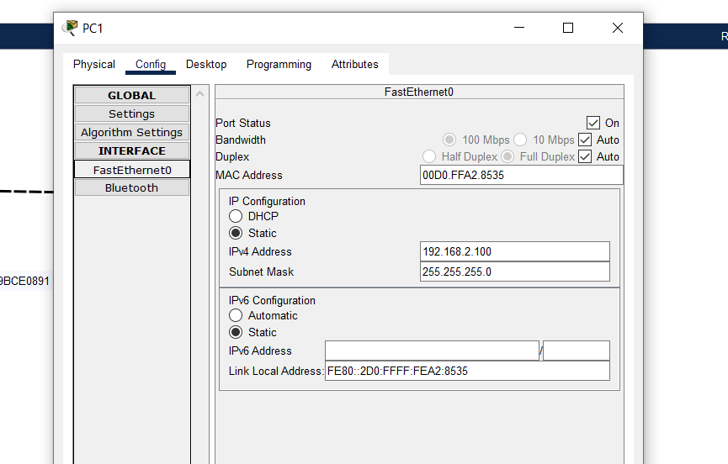

PC2 CONFIGURATIONS

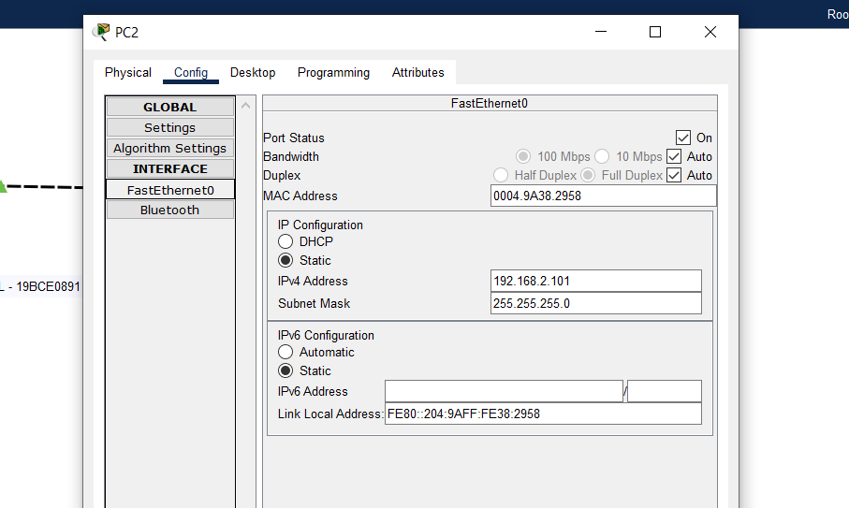

ROUTER 0 CONFIGURATIONS

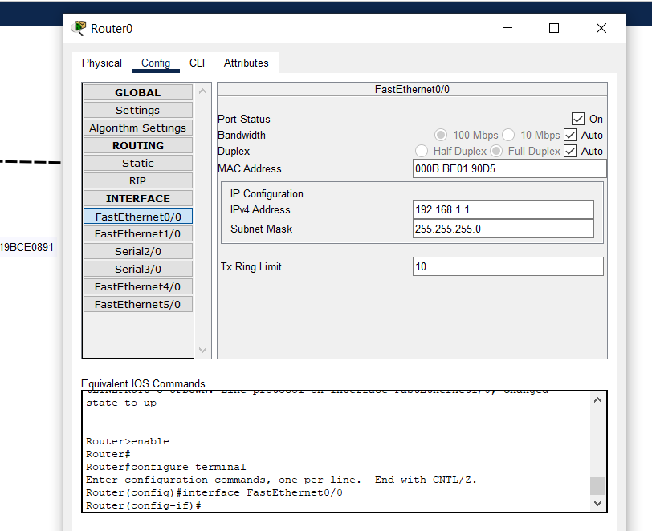

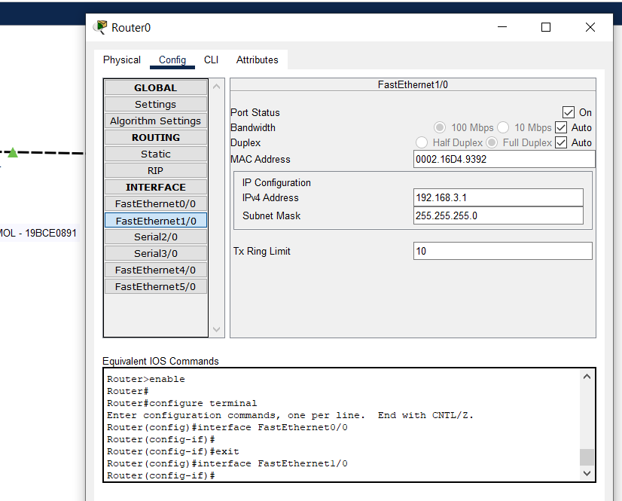

ROUTER 1 CONFIGURATIONS

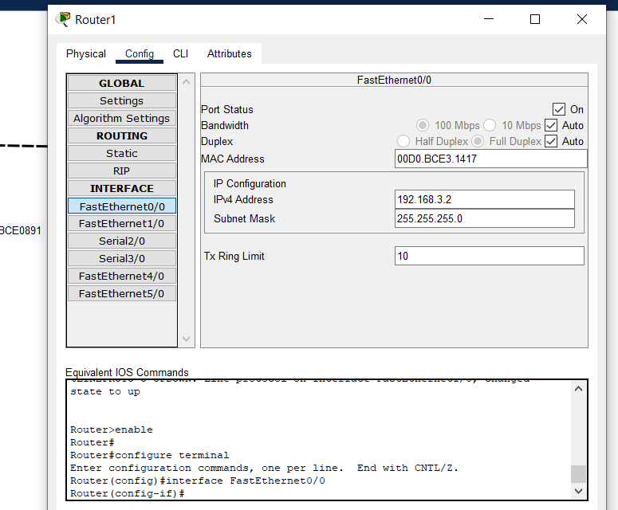

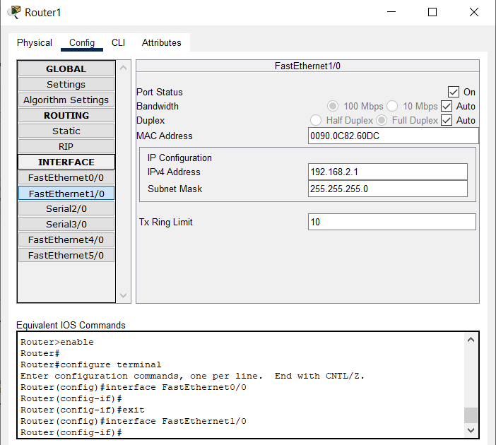

ROUTER 0 – ACCESS LIST

(denying service for pc2)

Router>
Router>enable
Router#config t
Enter configuration commands, one per line. End with CNTL/Z.
Router(config)#access-list 1 deny 192.168.2.101 0.0.0.0
Router(config)#access-list 1 permit any
Router(config)#int f0/0
Router(config-if)#ip access-group 1 out
Router(config-if)#

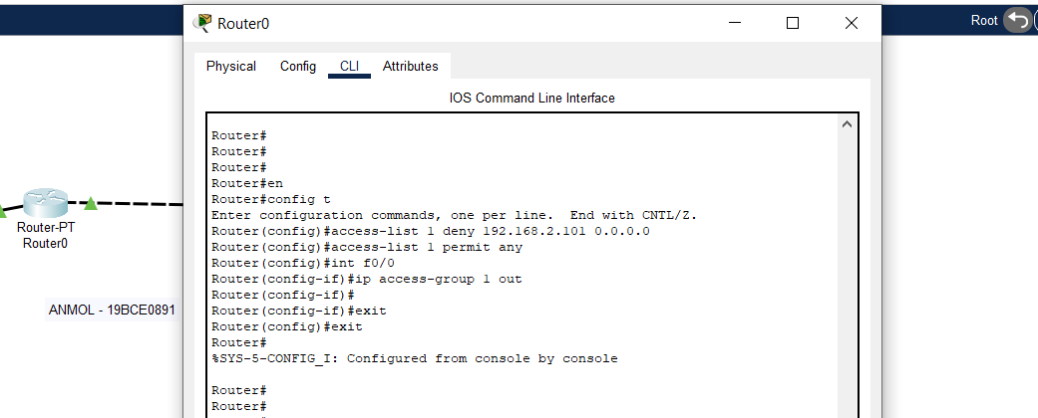

PC1 and PC2 BELONGS TO SAME NETWORK, BUT PC1 CAN PING PC0 and PC2 CAN’T PING PC1

PC1 pinging PC0 (SUCCESSFUL)

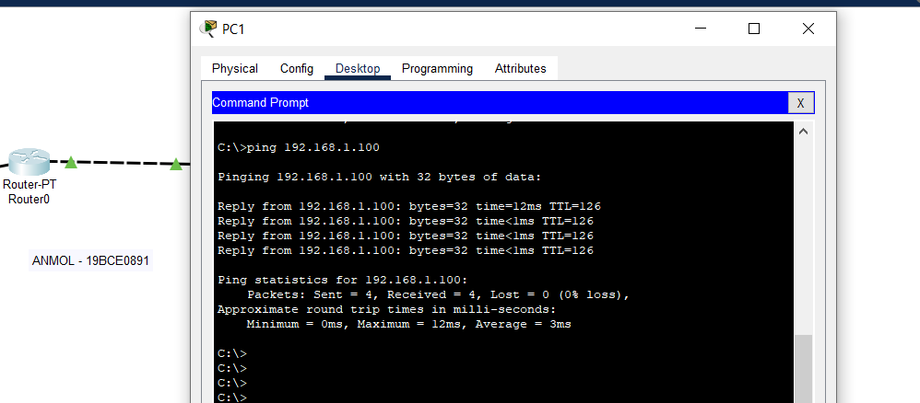

PC2 pinging PC0 (failure – Destination host unreachable)

