NAME – ANMOL
REG. NO. - 19BCE0891

DIGITAL ASSIGNMENT – 3

NETWORK TOPOLOGY

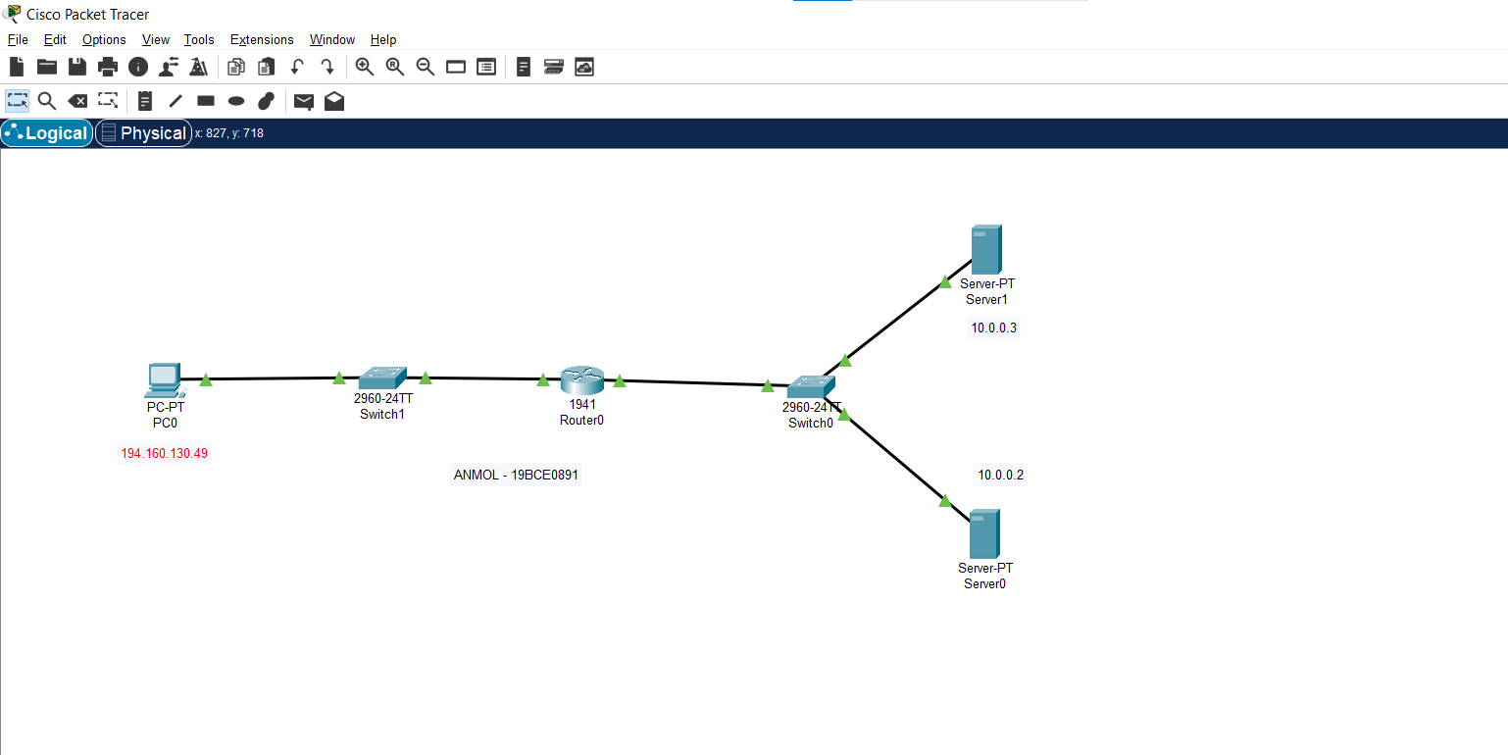

PC0 CONFIGURATION
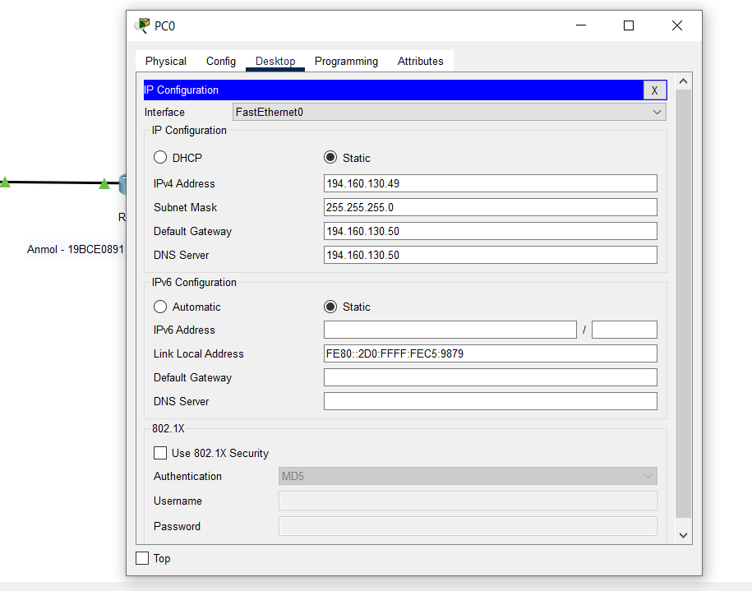

SERVER 0 CONFIGURATION

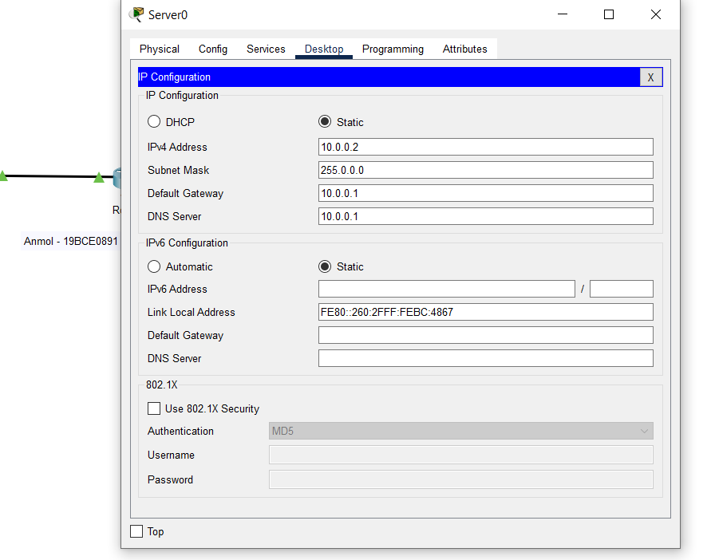

SERVER 1 CONFIGURATION
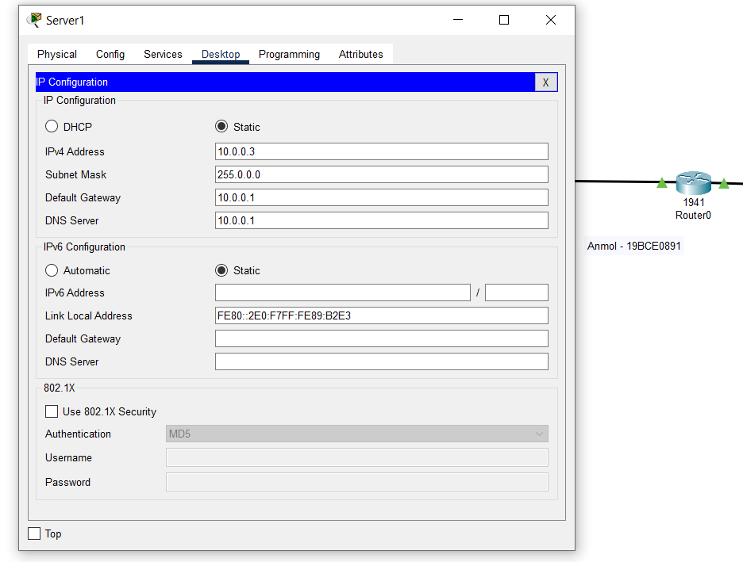
ROUTER 0 CONFIGURATION

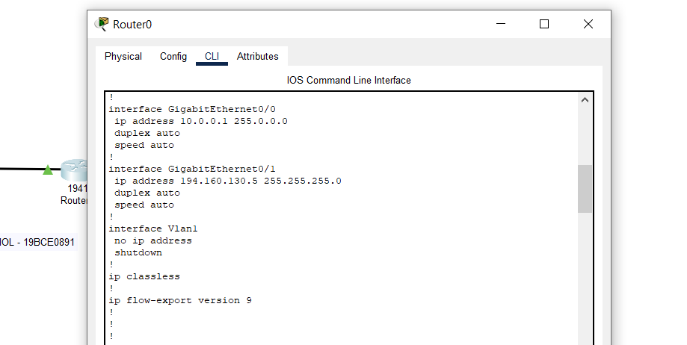

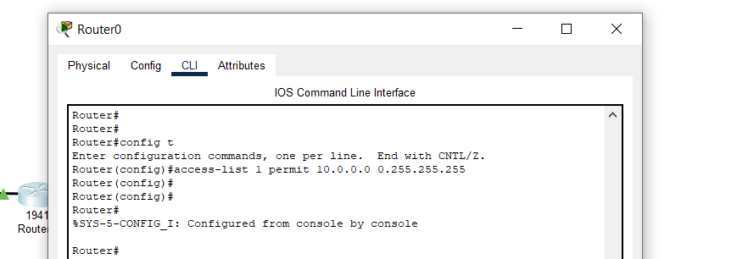
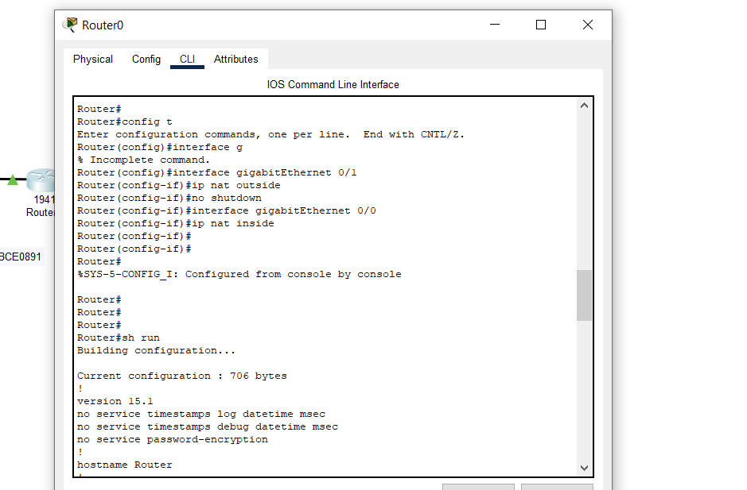
SH RUN
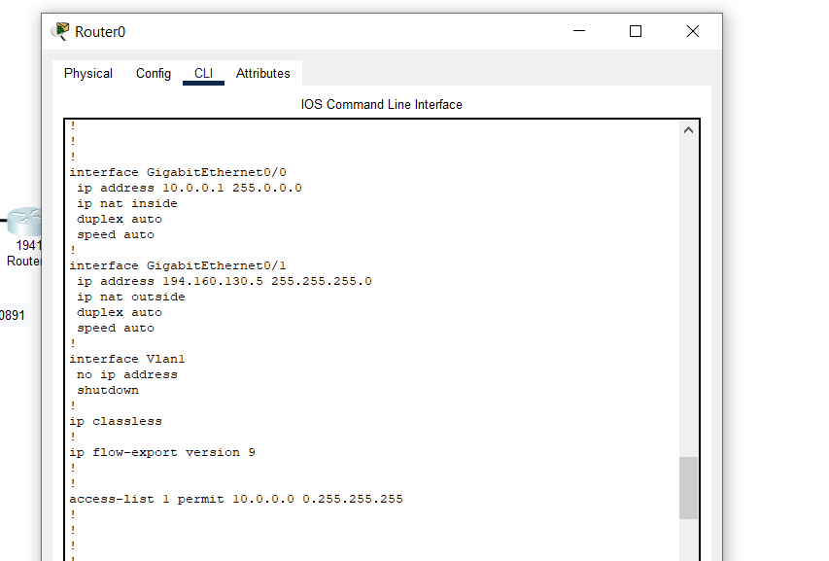

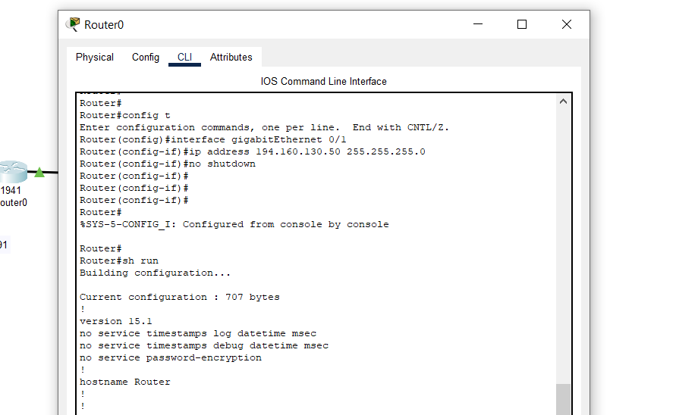

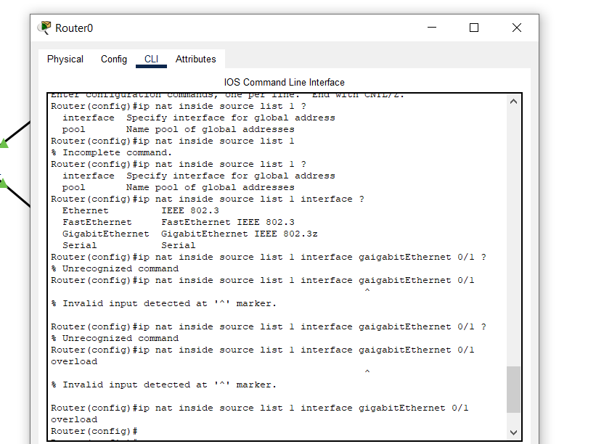

SH RUN

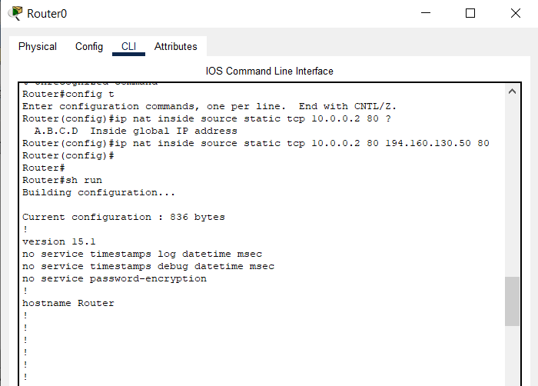

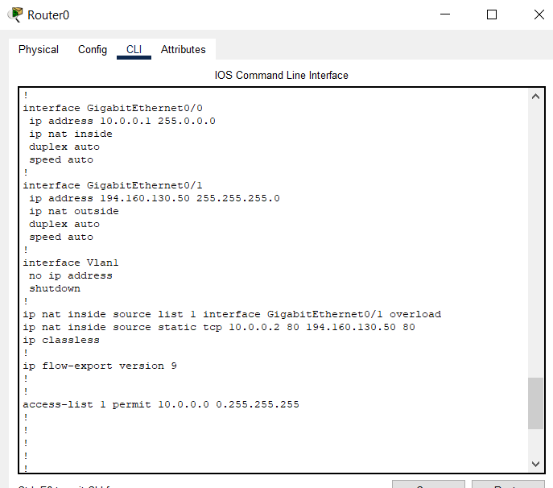

COMMANDS (ROUTER 0)

Router>enable
Router#config t
Enter configuration commands, one per line. End with CNTL/Z.
Router(config)#access-list 1 permit 10.0.0.0 0.255.255.255
Router(config)#interface GigabitEthernet0/1
Router(config-if)#ip nat outside
Router(config-if)#no shutdown
Router(config-if)#exit

Router(config)#interface GigabitEthernet0/0
Router(config-if)#ip nat inside
Router(config-if)#no shutdown
Router(config-if)#exit
Router(config)#exit

Router#config t
Enter configuration commands, one per line. End with CNTL/Z.
Router(config)#ip nat inside source list 1 interface
GigabitEthernet0/1 overload
Router(config)#ip nat inside source static tcp 10.0.0.2 80
194.160.130.50 80
Router(config)#ip nat inside source static tcp 10.0.0.3 21
194.160.130.50 21

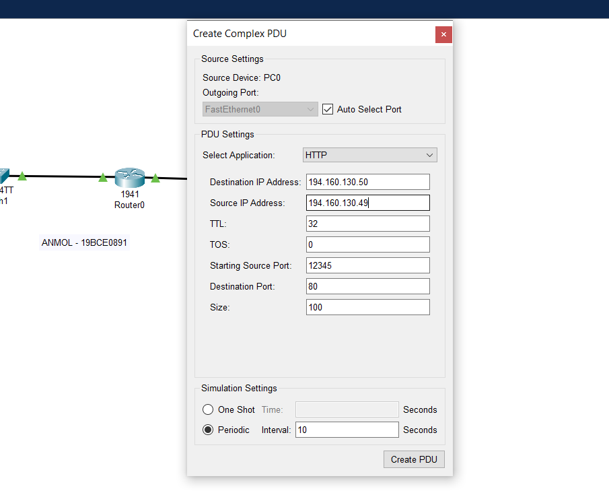
CREATING COMPLEX PDU

SENDING PDU VIA PC0

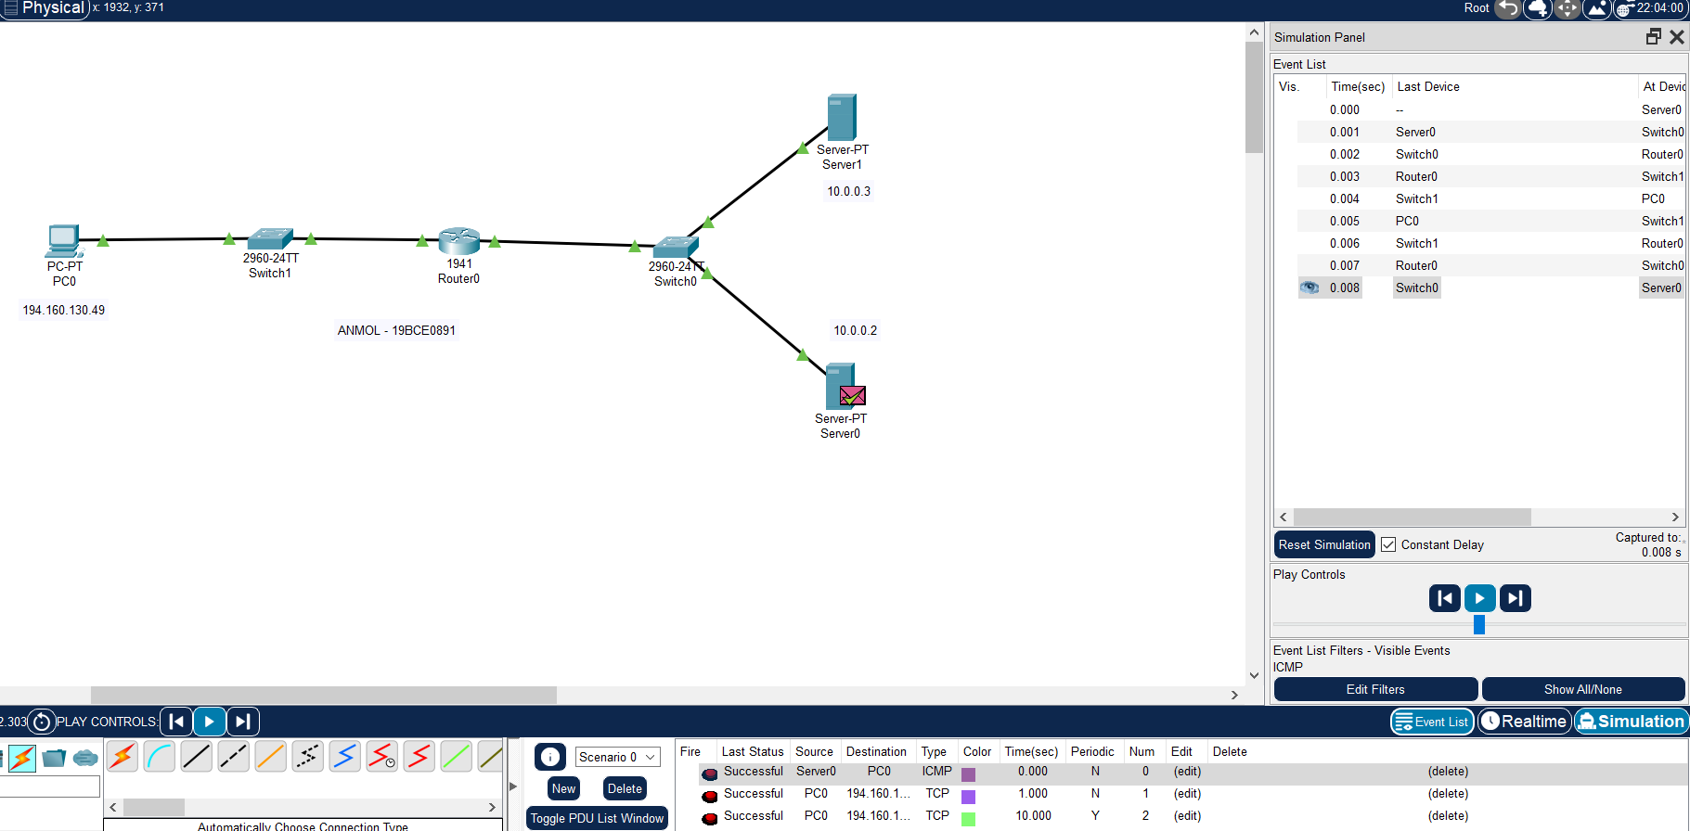

CREATING COMPLEX PDU

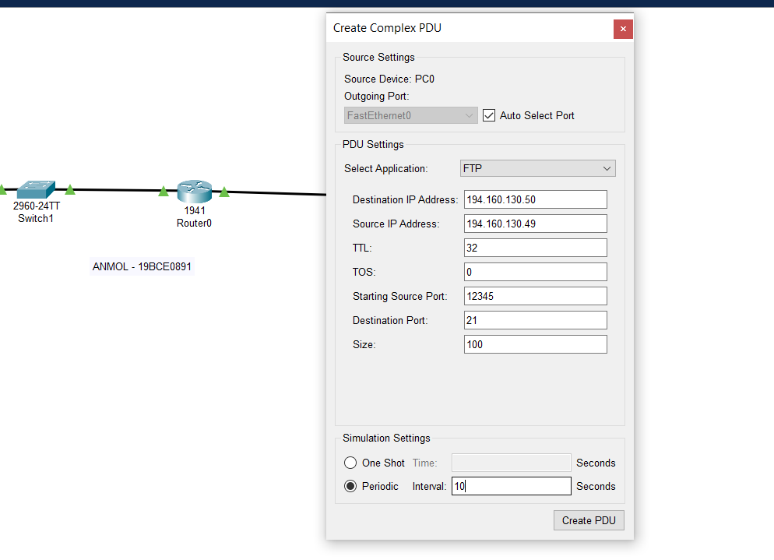
SENDING PDU VIA PC0
