NAME – ANMOL
REG. NO. - 19BCE0891

DIGITAL ASSIGNMENT – 4

NETWORK TOPOLOGY

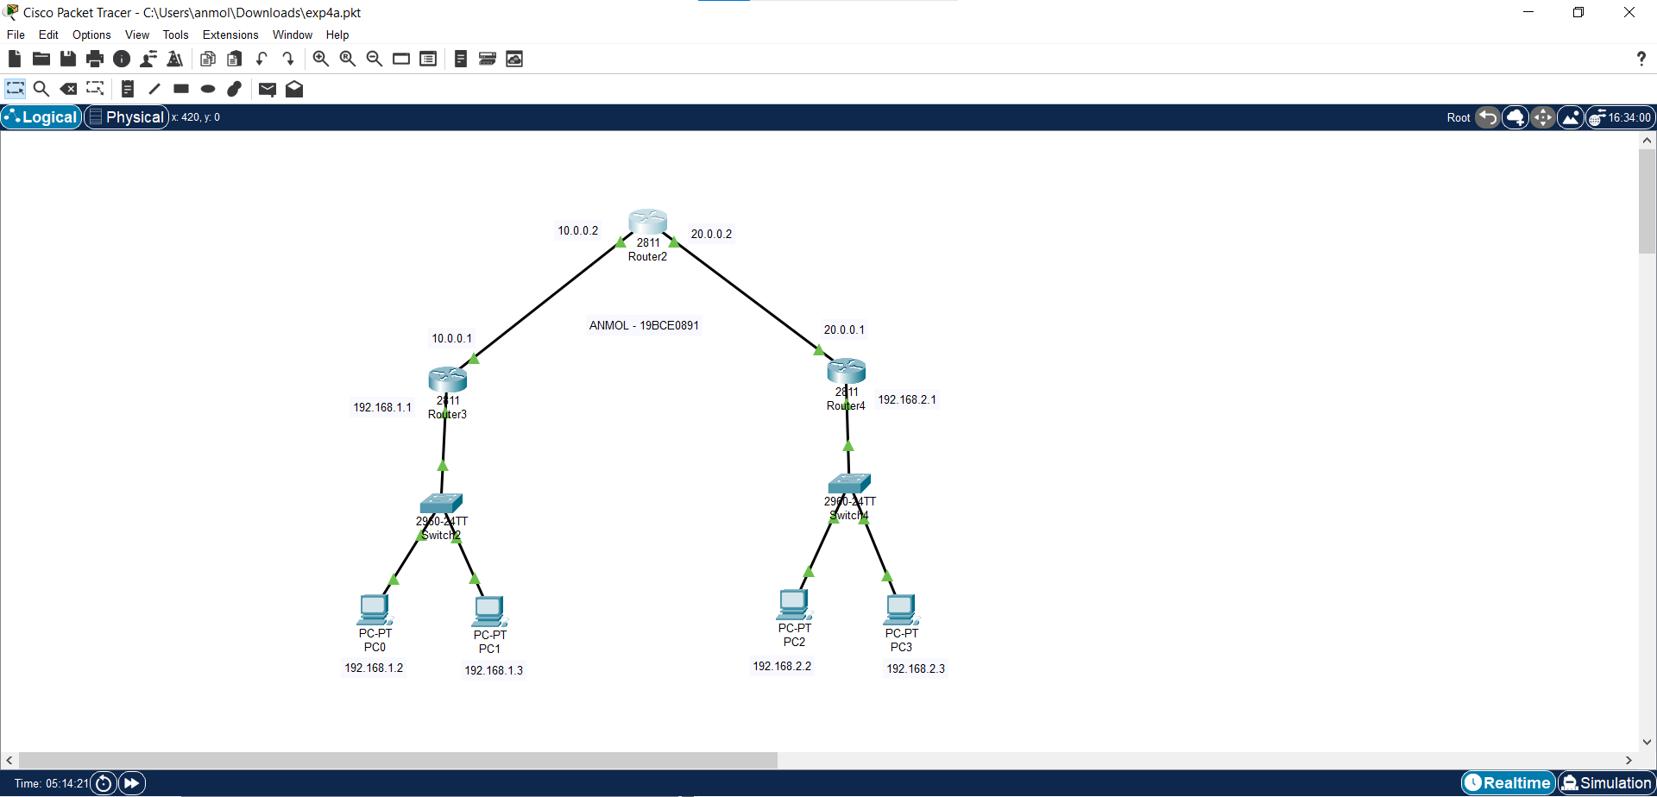

PC Configurations

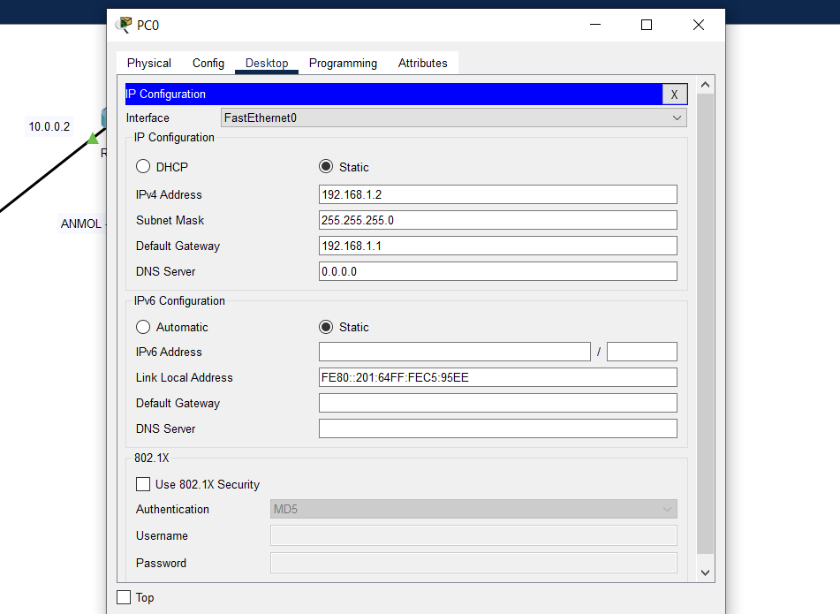

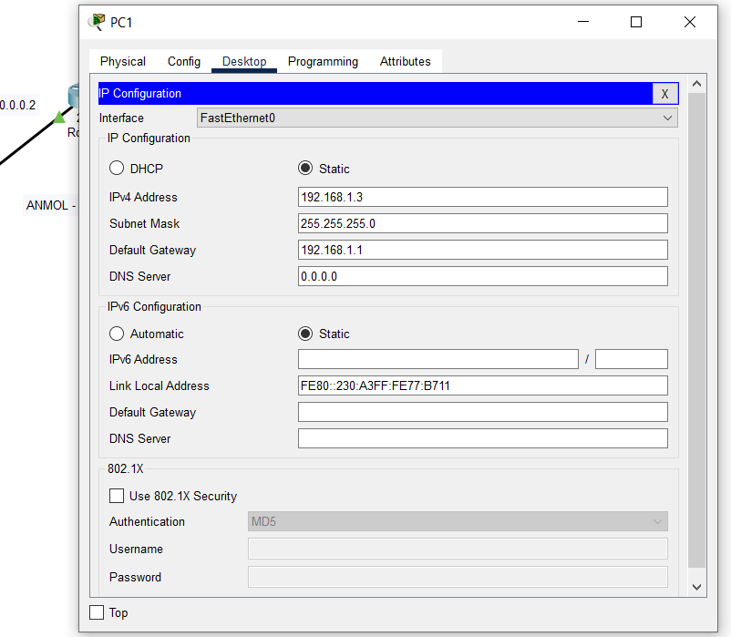

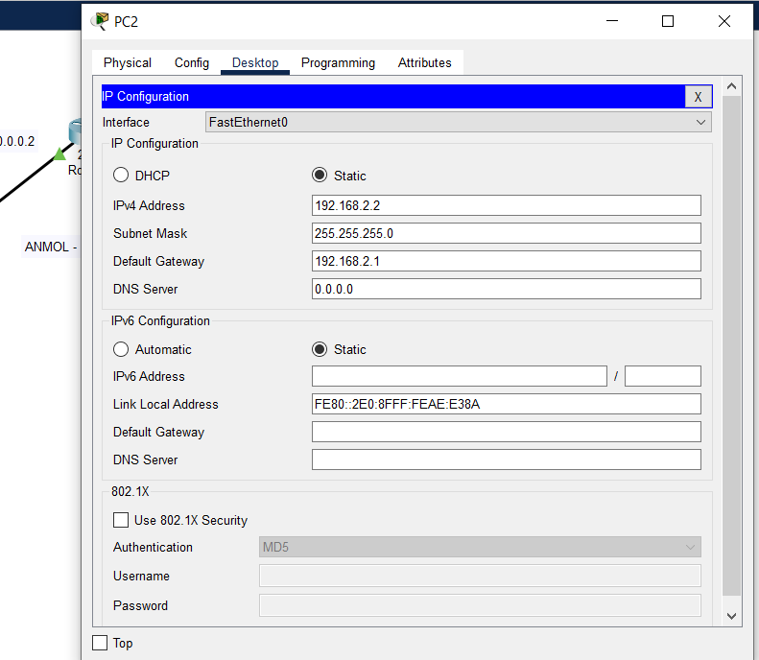

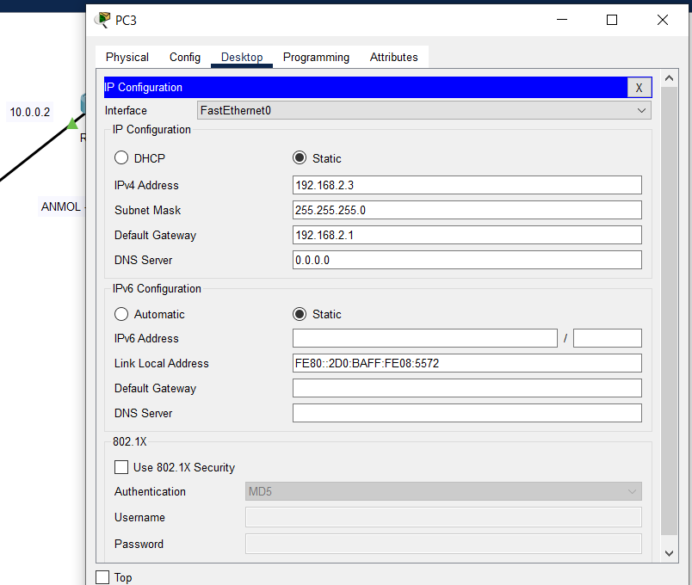

Router 3 Configuration

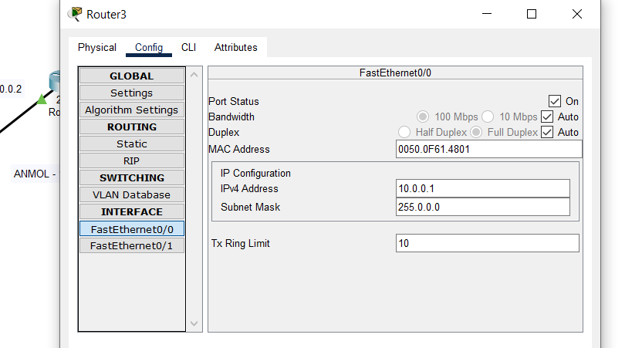

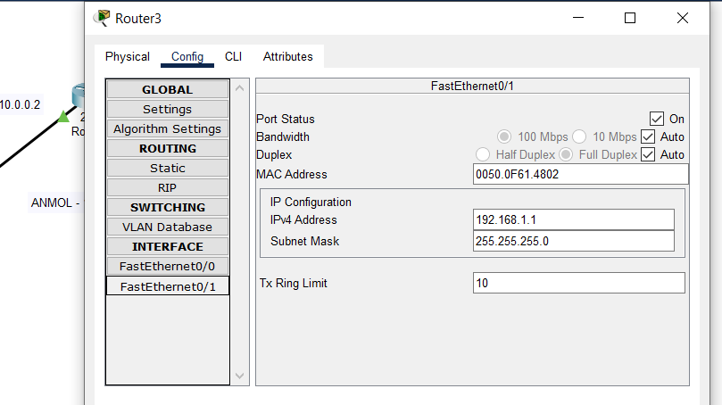

Router 4 Configuration

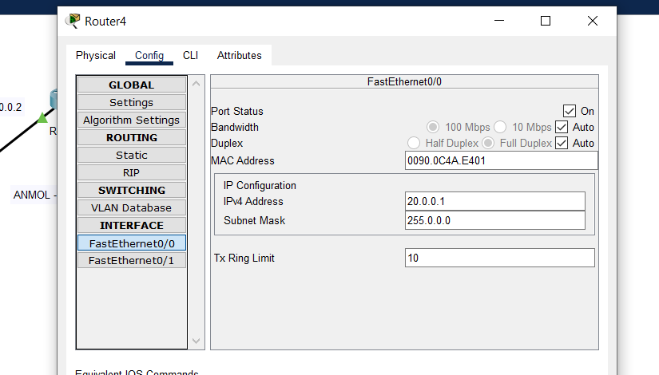

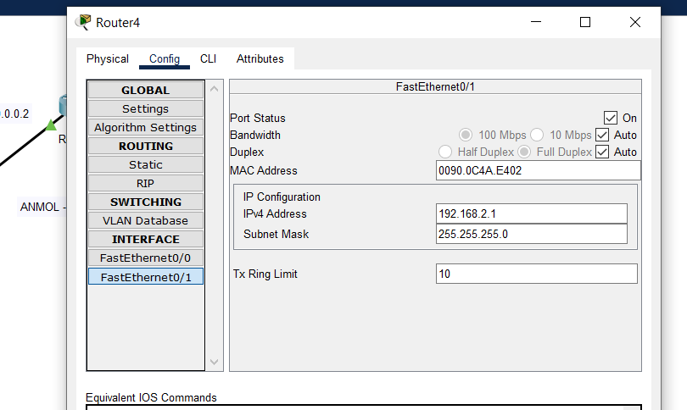

Router 2 Configuration

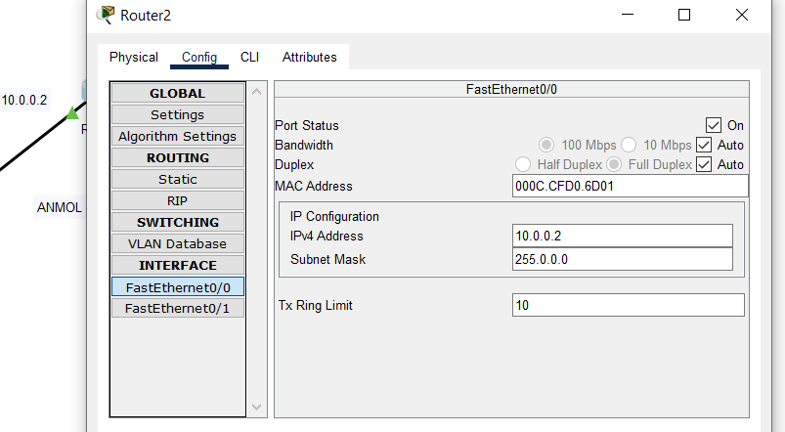

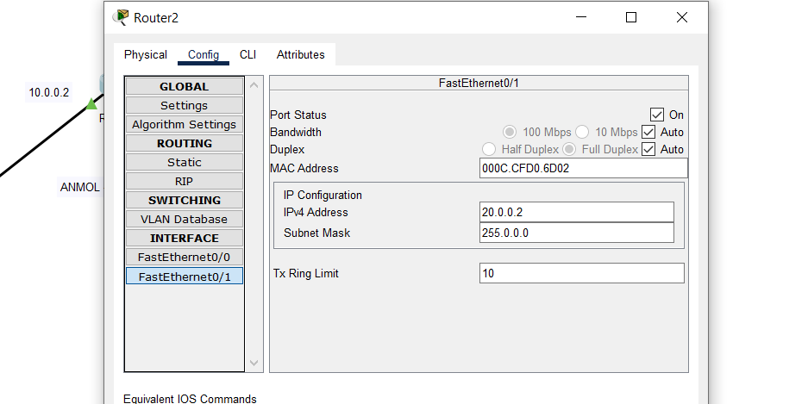

COMMANDS USED FOR THIS EXPERIMENT:

Router 3
Router#config t
Enter configuration commands, one per line. End with CNTL/Z.
Router(config)#router rip
Router(config-router)#network 192.168.1.0
Router(config-router)#network 10.0.0.0

Router 2
Router#config t
Enter configuration commands, one per line. End with CNTL/Z.
Router(config)#router rip
Router(config-router)#network 10.0.0.0
Router(config-router)#network 20.0.0.0

Router 4
Router(config)#
Router(config)#router rip
Router(config-router)#network 20.0.0.0
Router(config-router)#network 192.168.2.0

OUTPUT (Before Tunnel)

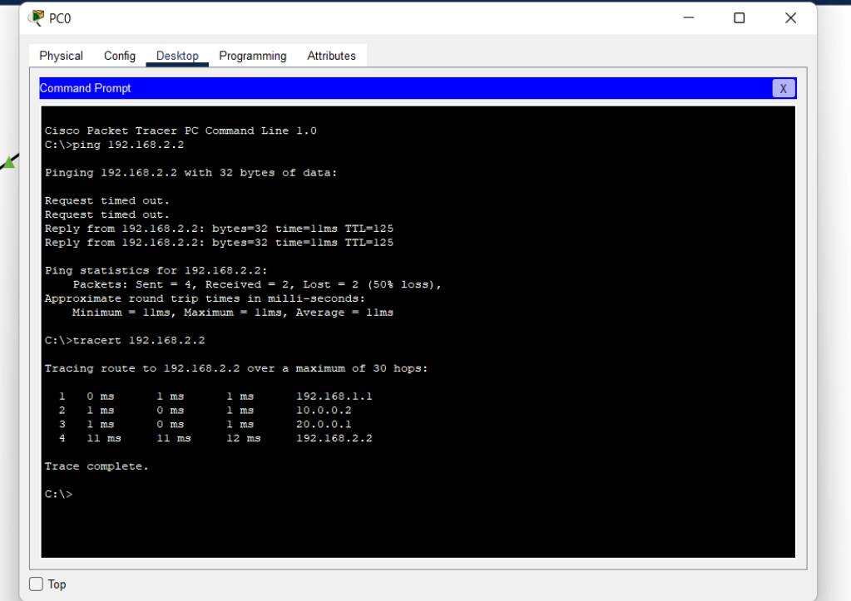
Tunnel Configuration:

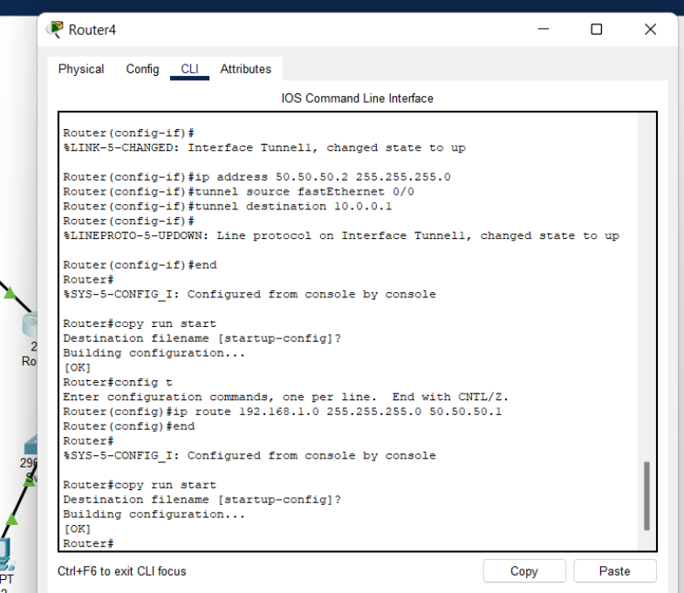

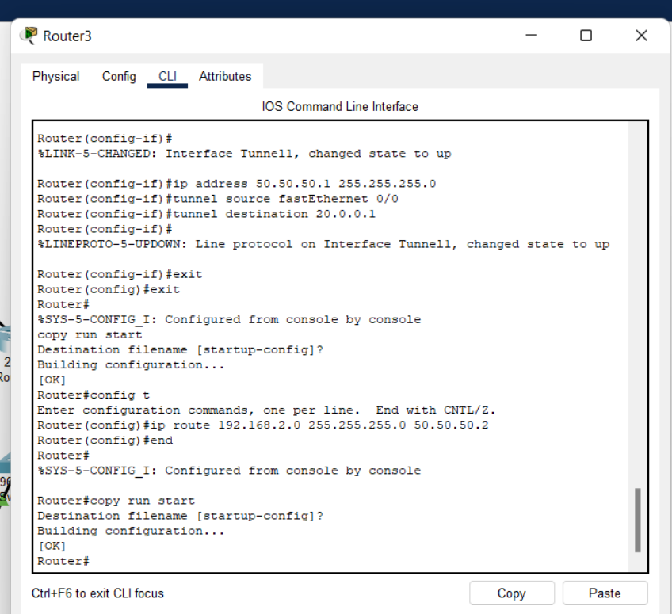

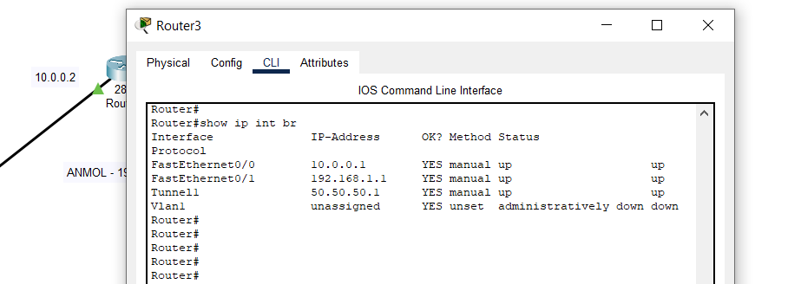

OUTPUT (After Tunnel):

