NAME – ANMOL
REG. NO. - 19BCE0891

DIGITAL ASSIGNMENT – 5

NETWORK TOPOLOGY

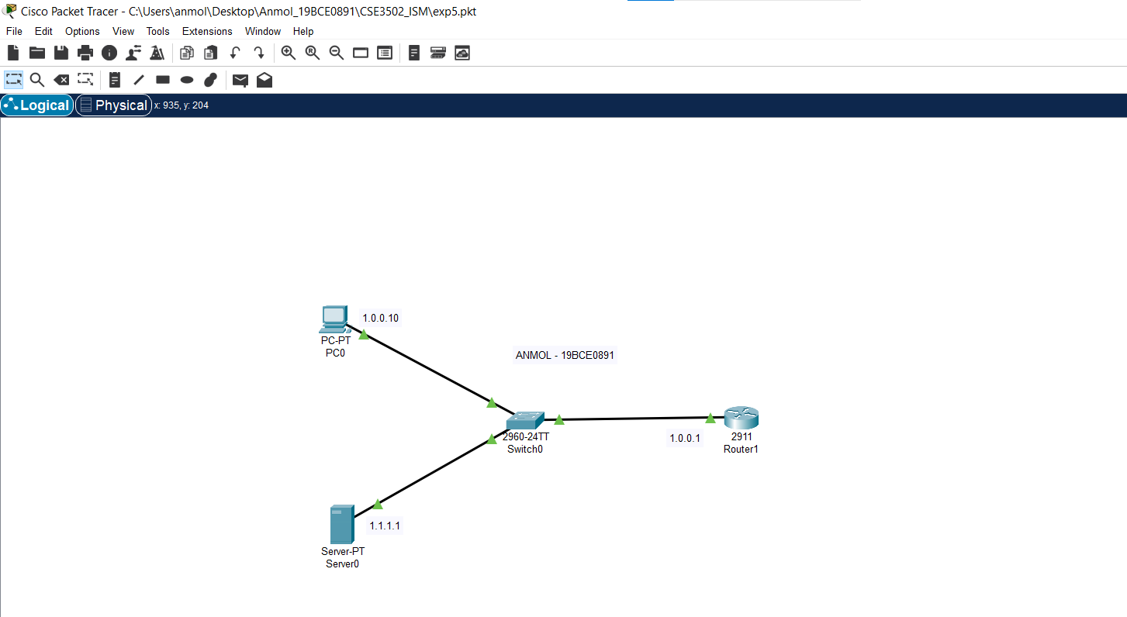
PC CONFIGURATION

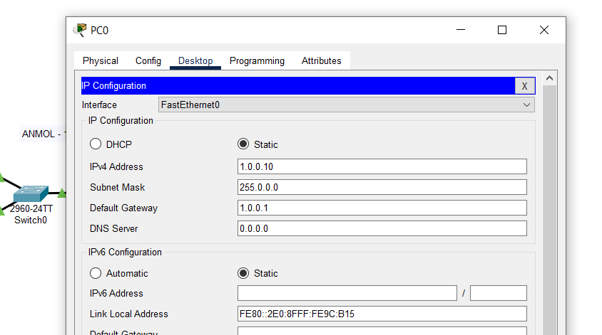

ROUTER CONFIGURATION

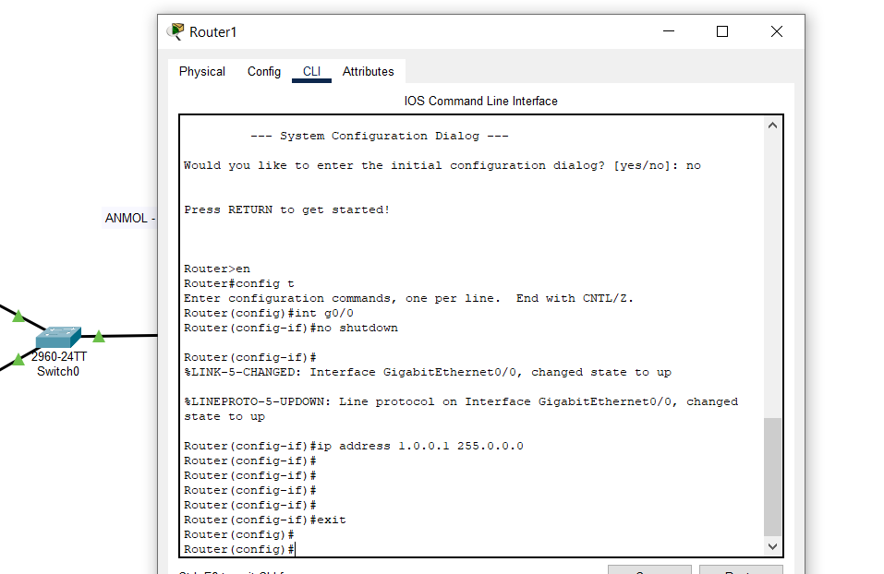

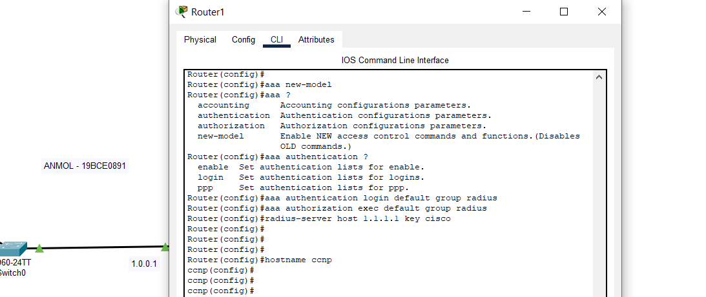

COMMANDS :

Router>en
Router#config t
Router(config)#int g0/0
Router(config-if)#no shutdown

Router(config-if)#ip address 1.0.0.1 255.0.0.0
Router(config-if)#exit
Router(config)#
Router(config)#aaa new-model

Router(config)#aaa authentication login default group radius
Router(config)#aaa authorization exec default group radius
Router(config)#radius-server host 1.1.1.1 key cisco
Router(config)#hostname ccnp

SERVER CONFIGURATION

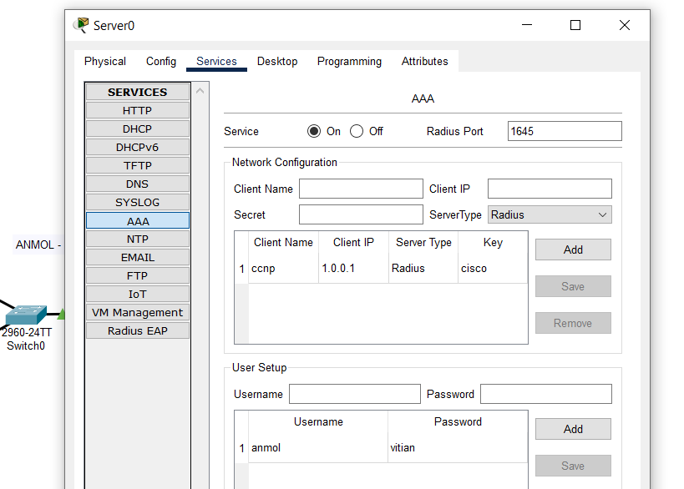

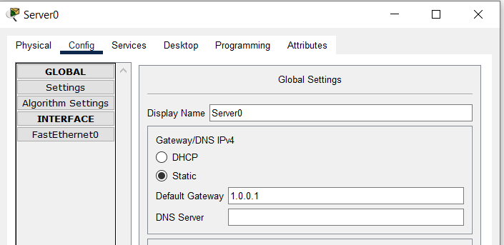

OUTPUT :

