NAME – ANMOL
REG. NO. - 19BCE0891

DIGITAL ASSIGNMENT – 6

#6a - DCHP SNOOPING

NETWORK TOPOLOGY

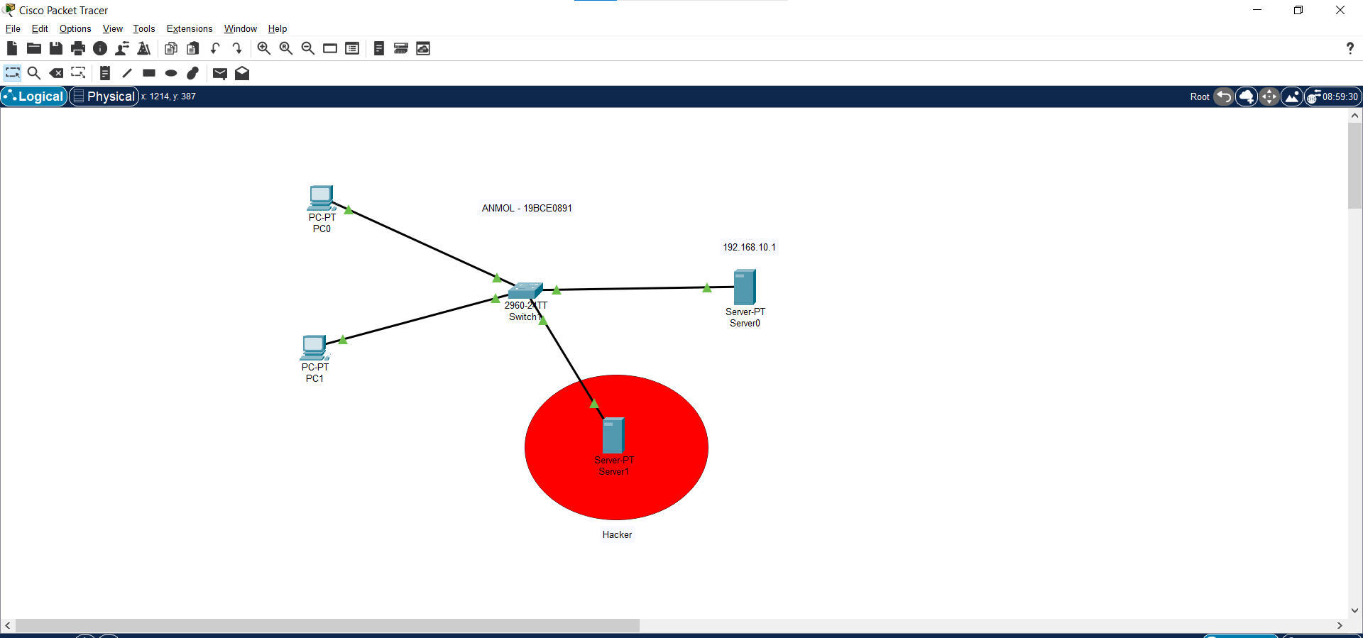

Server0 configuration

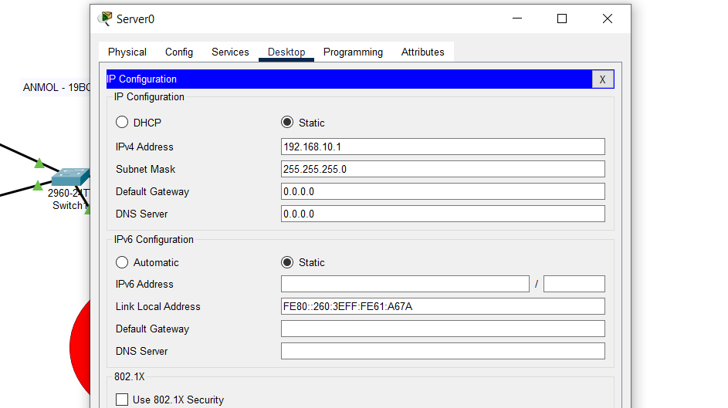

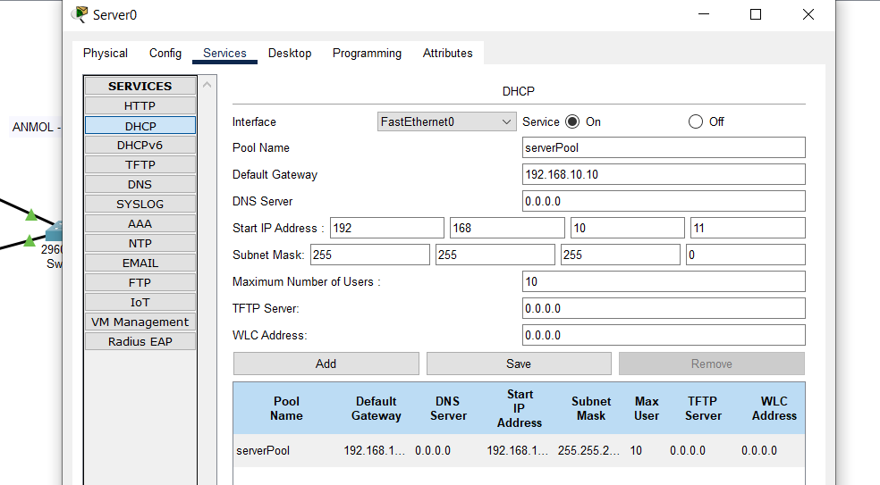

Server1 configuration (hacker)

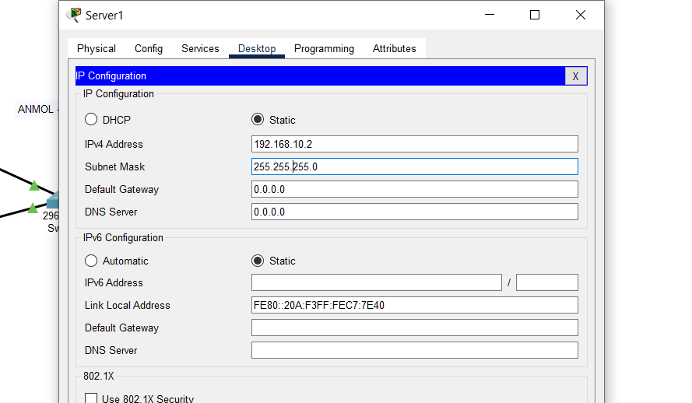

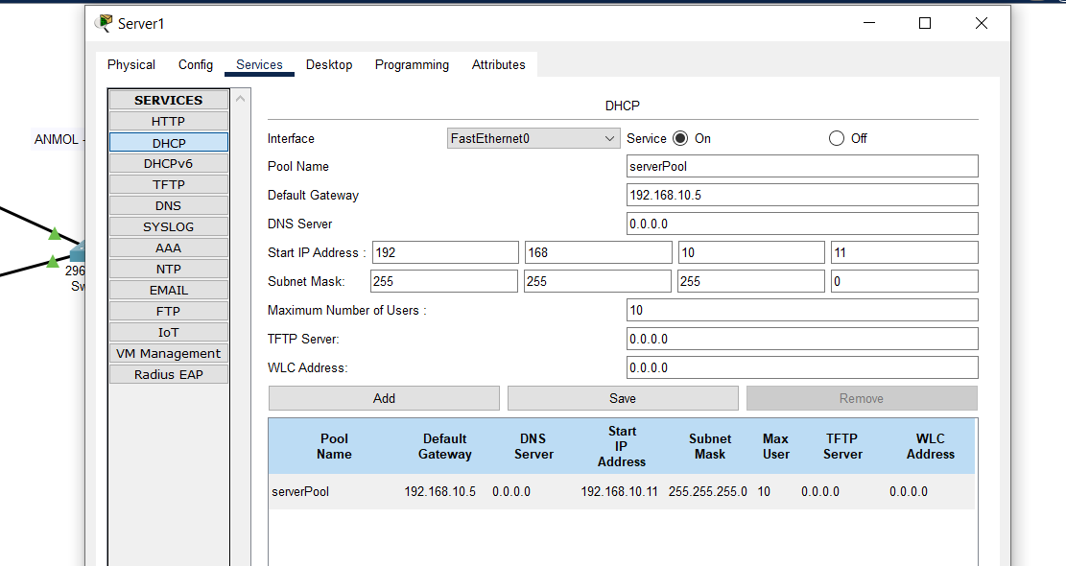

Before snooping PC’s connect with hacker server

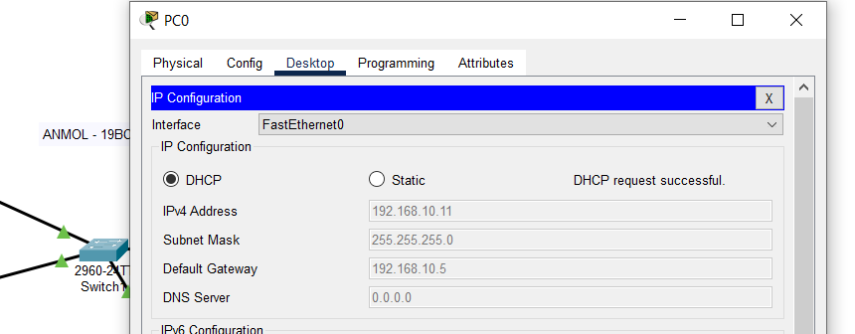
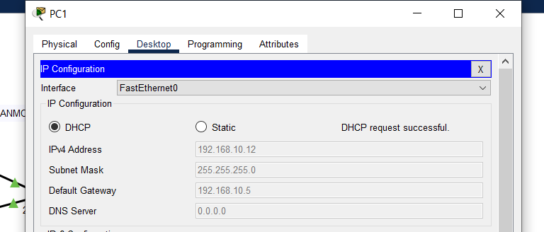

Commands to untrust all

Switch>
Switch>en
Switch#config t
Enter configuration commands, one per line. End with CNTL/Z.
Switch(config)#ip dhcp snooping
Switch(config)#

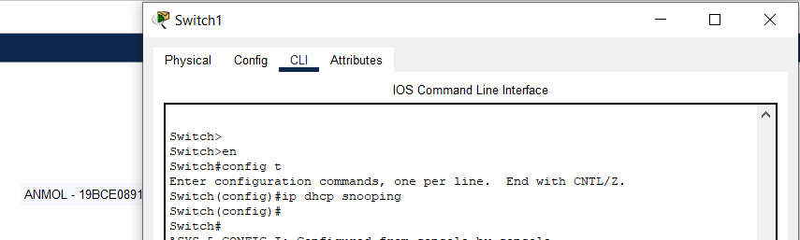

(all untrusted )
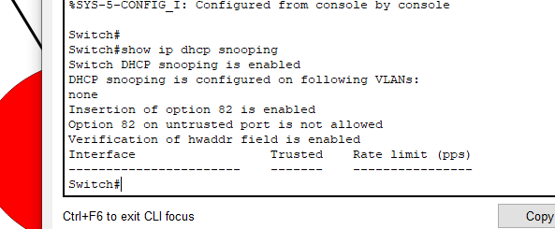

(All untrusted causes DHCP failure)

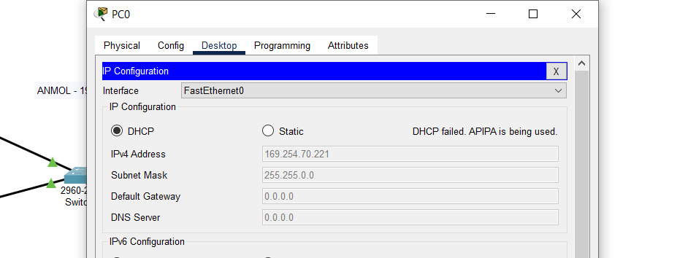
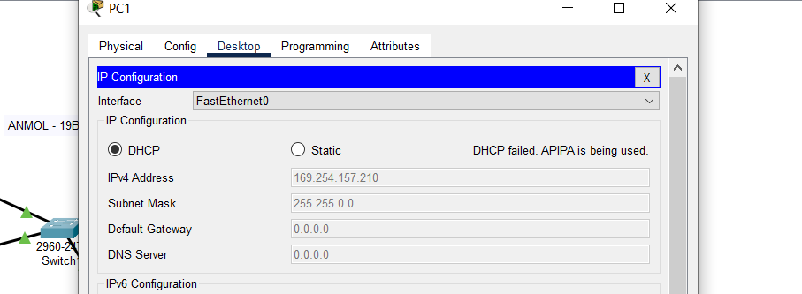

(Trusting server0 for DHCP and remaining all as untrusted)

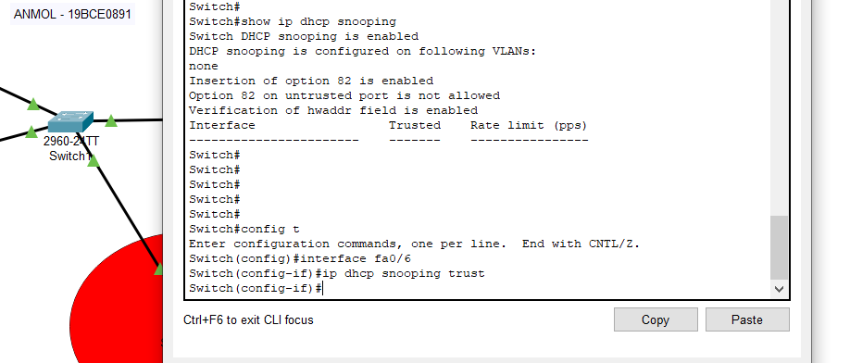

Commands for enabling trusted server

Switch#config t
Enter configuration commands, one per line. End with CNTL/Z.
Switch(config)#interface fa0/6
Switch(config-if)#ip dhcp snooping trust

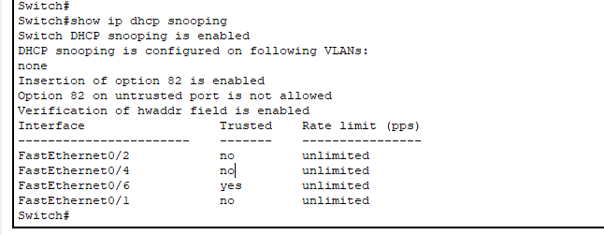

(DHCP using trusted server)

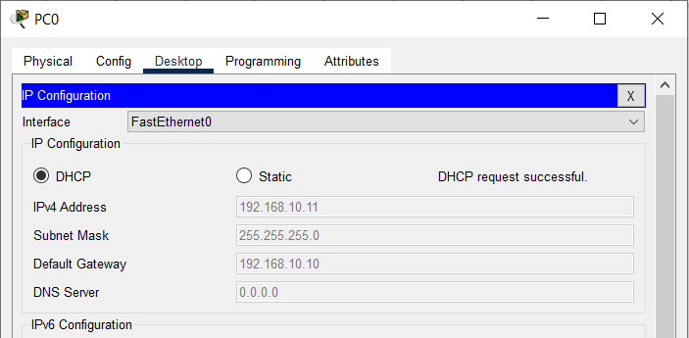
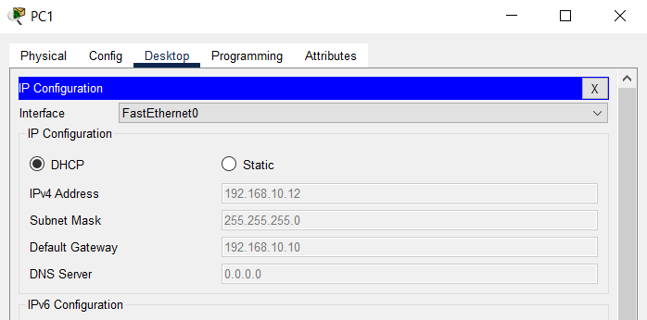

(Mac address of PC’s getting ip address using dhcp by trusted server)

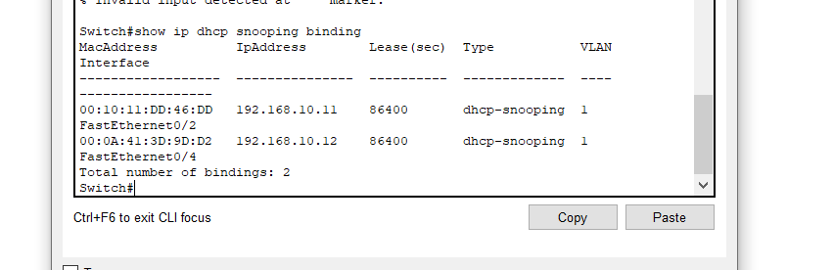

(pc0 mac)
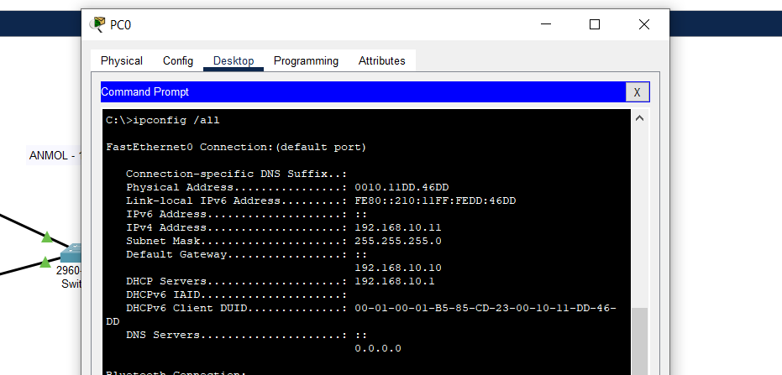
(pc1 mac)

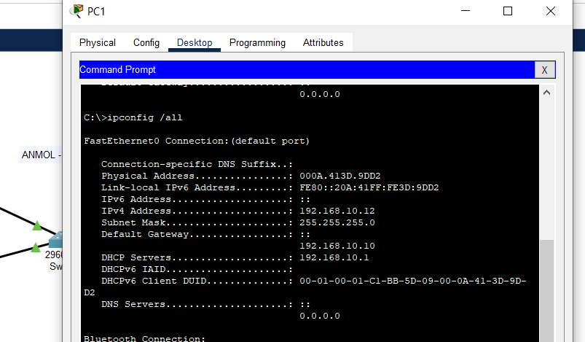

----------------------------------------------------------------------------------------------------------------------

#6b – PYTHON CODE FOR FILTERING PACKETS (using size, protocol, keywords)

Algorithm :

1. Start Wireshark and browse anything and capture packets and stop it. Export the generated values to CSV.
2. Read CSV and store it in pandas dataframe.
3. Input Size, keywords and Protocol and filter using below code.

CODE :
import pandas as pd

df = pd.DataFrame(pd.read_csv("data.csv"))
print(df)

# protocol filtering
inpPrtcl = str(input("Enter Protocol to filter : "))
protocol_filtered = df.loc[df['Protocol'] == inpPrtcl]
print(protocol_filtered)

# size(len) filtering
inpSize = int(input("Enter size (length) to filter : "))
size_filtered = df.loc[df["Length"] == inpSize]
print(size_filtered)

# keywords filter
inpKeyword = str(input("Enter Keyword to filter : "))
keyword_filtered = df.loc[df['Info'].str.contains(inpKeyword)]
print(keyword_filtered)

OUTPUT -

