|  |  |
| --- | --- |
| Python 2 | Python 3 |
| Support till 2020 only | * Not upgraded version of Python 2 but completely new * No guarantee on backward compatibility |

Certainly! The choice between using shell scripting and Python in DevOps depends on the specific task or problem you're trying to solve. Both have their strengths and are suitable for different scenarios. Here are some guidelines to help you decide when to use each:

**Use Shell Scripting When:**

1. **System Administration Tasks:** Shell scripting is excellent for automating routine system administration tasks like managing files, directories, and processes. You can use shell scripts for tasks like starting/stopping services, managing users, and basic file manipulation.
2. **Command Line Interactions:** If your task primarily involves running command line tools and utilities, shell scripting can be more efficient. It's easy to call and control these utilities from a shell script.
3. **Rapid Prototyping:** If you need to quickly prototype a solution or perform one-off tasks, shell scripting is usually faster to write and execute. It's great for ad-hoc tasks.
4. **Text Processing:** Shell scripting is well-suited for tasks that involve text manipulation, such as parsing log files, searching and replacing text, or extracting data from text-based sources.
5. **Environment Variables and Configuration:** Shell scripts are useful for managing environment variables and configuring your system.

**Use Python When:**

1. **Complex Logic:** Python is a full-fledged programming language and is well-suited for tasks that involve complex logic, data structures, and algorithms. If your task requires extensive data manipulation, Python can be a more powerful choice.
2. **Cross-Platform Compatibility:** Python is more platform-independent than shell scripting, making it a better choice for tasks that need to run on different operating systems.
3. **API Integration:** Python has extensive libraries and modules for interacting with APIs, databases, and web services. If your task involves working with APIs, Python may be a better choice.
4. **Reusable Code:** If you plan to reuse your code or build larger applications, Python's structure and modularity make it easier to manage and maintain.
5. **Error Handling:** Python provides better error handling and debugging capabilities, which can be valuable in DevOps where reliability is crucial.
6. **Advanced Data Processing:** If your task involves advanced data processing, data analysis, or machine learning, Python's rich ecosystem of libraries (e.g., Pandas, NumPy, SciPy) makes it a more suitable choice.

**REPL Tool: Read, Evaluate, Print, Loop**

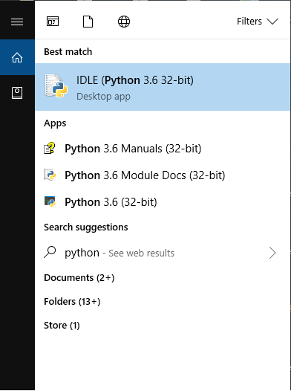

**REPL Editor:**

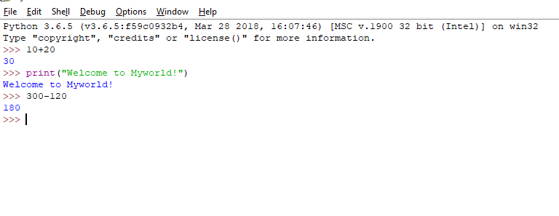

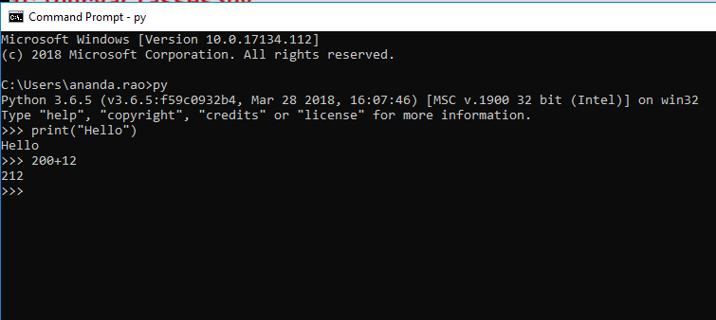

**Language Features:**

* Python is general purpose high level language [*directly communicates with machine; can be understood by programmer like Java, C#*]
* Guido Van Rossum, 1989 [National Research Institute, Netherlands], Officially made available to public on Feb 20th , 1991



<https://en.wikipedia.org/wiki/Guido_van_Rossum>

* Dynamically Typed Programming (C, Java is Static Typed )

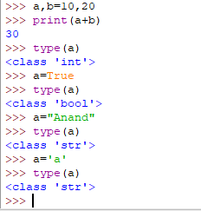

* Name because of popular BBC TV shows called Monty Python’s Circus 1969-74
* Features borrowed from other language
* Functional programming from **C**
* OOP from **C++** (not from Java since Java was not present at that time, 1995)
* Scripting language features from **Perl & Shell** script
* Modular programming features from **Modula-3** [*programs are divided into modules*]
* Syntax borrowed from C language & ABC language
* Where we can use python?
* Desktop applications
* Web applications [Django, Flask, Pyramid frameworks provides]
* Database applications
* Networking applications
* Games
* Data Analytics
* Machine learning
* AI
* IOT
* Features of Python
* 30 keywords in Python [53 in Java]; more readability & less coding effort
* Free ware and Open source [Free ware; no licensing cost] [You can able to see the source code and customize as per your requirement and can implement you can release your version]
* High level programming language
* Platform independent [write once and run anywhere]
* Portability [migration from one machine to another machine without any changes]
* **Dynamically Typed programming** [no need to declare type for variable]
* Support for both Procedure oriented and Object oriented [procedure oriented: without class we can manage with global variables and functions][***In java lambda expressions are introduced in version 8 to support procedure oriented***]
* Interpreted programming language
* **Python is extensible** [***we can use other programming languages code in python***]
* *Native language support is there in python*
* *We can improve the performance of application by opting other language programs but at the cost of platform independence*
* Embedded [*Python code can be embedded in other language codes (inter-operability)*]
* Rich library support is present in python [***Extensive Library***]
* Limitations of python
* Performance is not up to the mark since it is interpreted language
* Not suited for mobile application development
* Flavours of Python
* CPython [*standard python and can work with apps developed on C*]
* Jython or JPython
* IronPython [C#]
* Pypy [***Python for Speed****, inside Python VM, JIT compiler will be there*]
* RubyPython
* AnacondaPython [***To handle large data sets (Big Data)*]**
* Stackless [***Python for concurrency***]
* Python Versions
* Version 1.0 in 1994
* Version 2.0 in October 2000
* Version 3.0 in December 2008
* Version 3.6.3 in 2016
* No backward compatability
* **Identifiers**
* A name in python program is called Identifier
* It can be variable name or function name or class name …etc.
* Rules to define Identifiers:

1. Alphabet symbols (both upper & lower case), Digits (0-9), underscore (_)
2. Identifiers should not start with digit
3. Python identifiers are case sensitive [total =10 & TOTAL=100 are not same ]
4. Keywords are not allowed to use as identifiers [x=10 & def=20]
5. There is no length limit for python identifier
6. If identifier starts with _ symbol then it is Private
7. If identifier starts with __ symbol then it is Strongly Private
8. If identifier starts with __ symbol and ends with __ then it is language specific identifier

* **Reserved words**
* Words to represent some functionality
* 33 keywords
* True, False, None [3]
* and, or, not, is [4]
* if, else, elif [3] (no switch statement)
* while, for, break, continue, return, in, yield [7]
* try, except [catch block], finally, raise, assert [5]
* import, from, as, class, def, pass, global, nonlocal, lambda[anonymous functions], del, with [11]
* **Data Types**

1. Int [*decimal, binary, octal and hexadecimal*]
2. Float [*exponential form is allowed*]
3. Complex [*a.real, b.imag*]
4. Bool [*True, False*]
5. Str [*multi line strings,’’’* *; s[start:end:step], slice operator*] [*+ index & - index* ] *[*] [len(s)]*
6. Bytes
7. Bytearray
8. Range
9. List
10. Tuple
11. Set
12. Frozenset
13. Dict
14. None

***Everything in python is an object***

* **Base Conversions**
* Bin()
* Oct()
* Hex()
* **Type Casting**
* Int()
* *Int(123.56) ==> 123*
* *Int(10+20j) ==> can’t convert*
* *Int(True) ==>> 1*
* *Int(“10”) ==> 10*
* *Int(“10.5”) ==> Type Error, base 10 only allowed*
* Float()
* Complex()
* *Complex(x) ==>> x+0j*
* *Complex(x,y) ==>> x+yj*
* *Complex(True) ==> 1+0j*
* *Complex(“10.5”, “20”) ==>> 10.5 + 20j*
* Str()
* *Str(10) ==>> ‘10’*
* *Str(10+20j) ==> ‘10+20j’*
* Bool()
* *Bool(0) ==>> False*
* *Bool(1) ==>> True*
* *Bool(10) ==>> True ; any non-zero number is True*
* *Bool(0.0)==>> False*
* *Bool(0.1)==>> True*
* *Bool(0+0j) ==>> False*
* *Bool(0+1j) ==>> True ; at least real or imaginary is non-zero then True*
* *Bool(“”) ==> False; empty string case*
* *Bool(“A”)==>> True; any other string even space as string*
* **Immutable Vs Fundamental Data Types**
* Everything in python is object
* All fundamental data types are immutable
* Object creation is not costlier than checking for value in memory
* Memory utilization
* Performance
* **Reusing same object is defined in the following ranges**
* Int ---- 0 to 256
* Bool---always
* Str-----always
* Float---never
* Complex ---never

**At the time python interpreter starts or PVM starts:**

* From 0 to 256 objects will be created at the beginning
* Otherwise python start up becomes very late
* String literal at the time of execution or run time only
* For float, the range is infinite between 0 and 1 only [most commonly used]
* 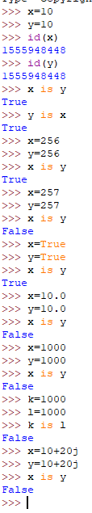
* **Bytes**
* It represents group of byte numbers just like array
* Values in bytes data type the range of values is 0 to 256

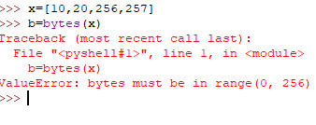

* Bytes objects are immutable and does not support item assignment

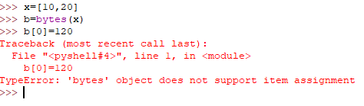

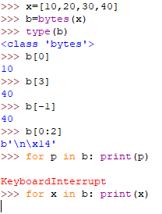

* **Bytearray**
* It represents group of byte numbers just like array
* Values in bytes data type the range of values is 0 to 256
* Bytearray is mutable and supports item assignment

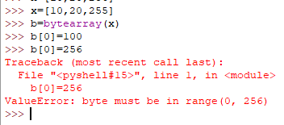

* **List**
* Group of values where insertion order is preserved and duplicates are allowed
* Repeat operator is also allowed [**S*2**]
* Not immutable
* 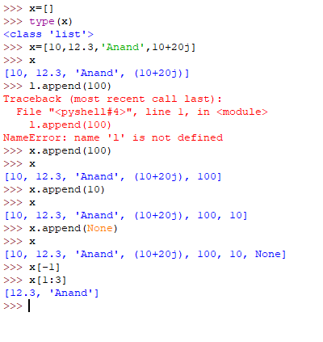
* **Tuple**
* Tuple is same as List in every feature but it is immutable
* 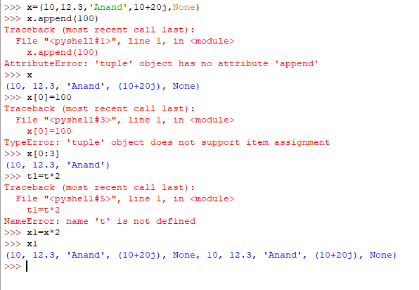
* **Range**
* Represents a sequence of values
* Elements present inside a Range is always immutable
* It represents values from 0 to end-1 [range(end)]
* Range(from,end-1) [range(10,30) …10 to 29]
* Range(from,end,step) [range(10,30,5) …10,15,20,25]
* Float objects are not allowed since it accepts only integer
* 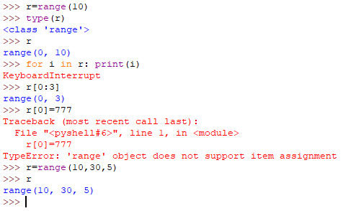
* **Set**
* No duplicates and no order of insertion of elements
* Curly braces for set, parenthesis for Tuple and brackets for List
* Index slicing is not applicable for set since no preserved order of elements
* Set is immutable
* 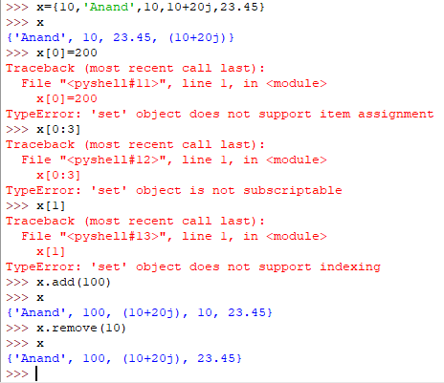
* **Frozenset**
* Immutable and same like set
* 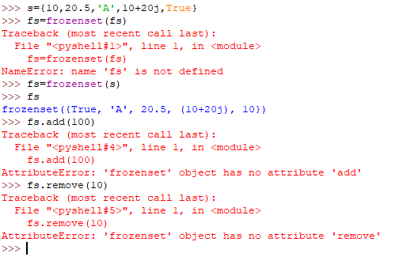
* **Dict**
* Key-value pairs
* Key can be any type of object and Value can be any type of object
* Empty with curly braces will be dictionary only; for empty set **s=set()**

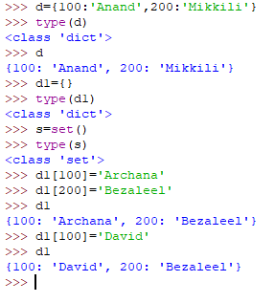

* **None**
* To handle no value, None is introduced
* **Escape Characters**
* **\n,\t[**horizontal tab**], \r [**go to first position**], \b,\f,\’,\”,\\,\v [**vertical tab**]**
* “Anand\”Mikkili” is good”
* ‘Anand “Mikkili” is good’
* “Anand ‘Mikkili’ is good”
* ‘’’Anand ‘Mikkili’ is “good” but honest’’’
* “””Anand ‘Mikkili’ is “good” but honest”””
* 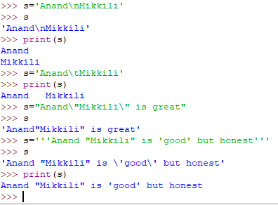
* **Constants**
* There is no way that we can assign a value as constant. So constant concept but developer only has to take care of it. At language level there is no concept
* **Operators**

1. Arithmetic Operators

* +, -, *, /, %, // [floor division], ** [exponential or power]
* 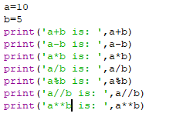
* 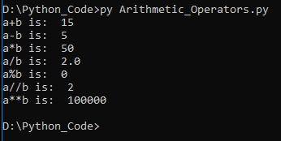
* + Operator for String then both the arguments must be string
* * Operator for String then String multiplication
* 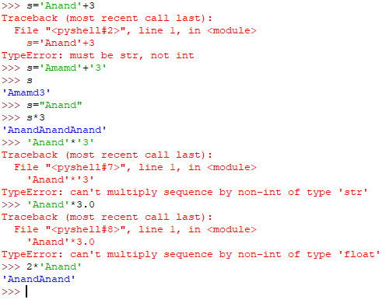
* x/0 or x%0 or x//0; Zero division error

1. Relational Operators or Comparison operators

* >, >=, <, <=, ==, !=
* 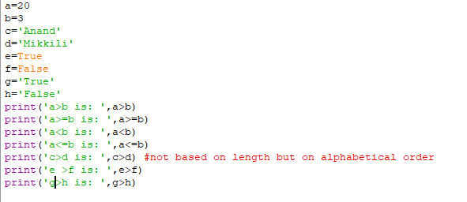
* 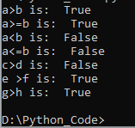
* Chaining of relational operators is possible
* If all the comparisons are True then final answer is True [**10<20<30 ….True**]
* If one of the comparison is False; then the result is False for whole chain [**10>20<30<40<50…False**]
* == is content comparison whereas is keyword is address comparison
* Chaining of relation is applicable for ==
* A

1. Logical Operators

* and, or, not
* Apply on Boolean type result is True or False
* Non-Boolean Type:
* [x and y]; If x evaluates to False then result is x otherwise return y
* [x and y]; If x evaluates to False then return y otherwise return x
* 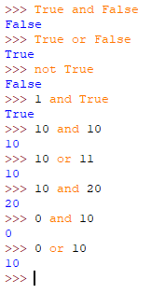

1. Bitwise Operators

* &, |, ^[**xor**], ~[**bit wise compliment**], << [left shift], >> [right shift]
* Bitwise operators are only applicable for boolean and integer data types
* If both the bits are 1 then 1 otherwise 0 [&]
* If at least one bit is 1 then 1 otherwise 0 [ | ]
* If both arguments are same then 0 otherwise 1 [ ^ ]
* ~
* Positive numbers will be represented normally
* Negative numbers represent in 2’s complement form
* Replace 0’s with 1 and 1’s with 0 to achieve 1’s complement form
* Add 1 to least significant bit to achieve 2’s complement form

~4

0000..100

1111...011 --negative number so convert into 2’s complement form

0000..100

1

0000...101 -🡪 -5

* A
* 1 ==>0 and 0 ==> 1
* Bitwise left shift [<<]
* Bitwise right shift [ >>]
* 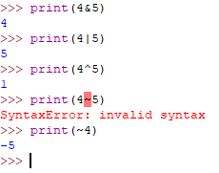

1. Assignment Operators

* x, y=10,20.5
* compound assignment operator x **+=**10
* ++x and x++ are not available in python [increment and decrement]

1. Special Operators

* Identity Operators
* ***Is*** [a is b; if a and b are pointing to same object then True]
* ***Is not***
* Membership Operators
* Whether the object is member of specified user defined data type or not
* ***In*** and ***not in*** are keywords for membership check

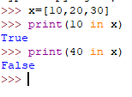

1. Operator precedence

* Highest priority goes to parenthesis ( ***( )*** )
* ***\*\**** operator will get next highest priority
* Unary operator will get next highest priority [ **Ex: ~x, -x unary minus**]
* Binary operators will get next highest priority [**\*, /, %, //, +, -** ; **x+y** ]
* Ternary operators will get next highest priority [**<<, >>, &, ^, |, >, >=, <, <=, ==, !=, =, +=, -=, *=, is, is not, in, not in, not, and, or**]
* Assignment will get least priority
* **Module**
* Module is a low level component which contains a group of functions, variables and classes [***ex: math module; like in java math class***]
* Library is high level component which contains modules
* Aliasing is available in python for modules are libraries [***import math as m***]; Once aliasing is done you should not refer the original name
* Import directly the function instead of module in python [***from math import sqrt; from math import \****]
* **Input & Output Statements**

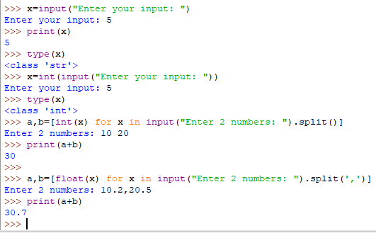

* **Command Line Arguments**

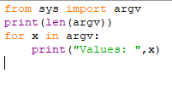

* **Eval()**

Command line arguments without type casting

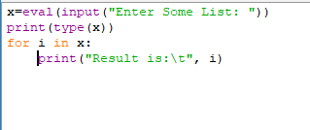

* **Flow Control**

1. Conditional Statements/Selection Statements
2. If
3. If-else
4. If-elif-else

Note:

* **Else is always optional**

1. Iterative Statements
2. For [for-else is also possible]

* For-else: only when loop executes without break and after loop completes then else block will be executed

1. While [while-else is also possible]
2. Transfer Statements
3. Break

* Break the loop and come out

1. Continue

* Skip current iteration and go for next iteration
* We’ll use continue only inside loops

1. Pass

* Wherever an empty block is required in if condition or elif condition or else then we use pass statement which do not perform anything
* Empty statement or Null statement or nothing. This is just to support syntactic existence
* This can be used in **conditional statements** and **functions**

1. Del keyword

x=10

del x

* del vs None
* del: I do not need both object reference and also object
* None: I do not need object but might need reference for future use
* A

1. A

* **A**