**PRACTICE SET OOPS & SE**

**Level 5**

**Session 2022-23**

**Question One**

1. The algorithm of a selection sort divides an input list into two parts: a sub-list of items which have already been sorted at the front, and a sub-list of items remaining to be sorted at the end. Initially, the entire list is unsorted, and the sorted sub-list is empty. To sort in ascending sequence:

• The element with the lowest value is selected and swaps position with the one at the first position on a list. Now, the 1st element of the list is sorted, the rest of the elements are unsorted.

• For rest of the list, the element with the smallest value in the remaining elements is found and placed at the second position. Now the two elements at the front of the list are sorted, the rest of the elements are unsorted.

• This process is repeated until all elements of the unsorted sub-list are selected and put into the sorted sub-list.

For a given list of A= {8, 5, 3, 19, 1} to be sorted ascendingly by the selection sort, what is the state of the list after each of the following steps?

Step 1) The list has one element sorted

Step 2) The list has two elements sorted

Step 3) The list has three elements sorted

Step 4) The list has four elements sorted

1. Complete the C# code given below to implement a selection sort.

void sort(int a[])

{ // a[] array of a list of elements

…. }

**Question Two**

1. The C# BackgroundWorker class executes a time-consuming operation on a separated thread asynchronously. Which of the following descriptions is accurate for the model behind the BackgroundWorker?

• Synchronous Single Threaded

• Synchronous Multi-Threaded

• Asynchronous Single Threaded

• Asynchronous Multi-Threaded

1. What is the difference between the synchronous programming model and the asynchronous programming model?
2. BackgroundWorker uses the DoWork event to start an asynchronous operation at background. This code example below is part of a larger example provided for the BackgroundWorker class. Can you access its foreground operation, such as the controls in a GUI, directly from the DoWork function? Explain your reason and provide a solution if direct access to the foreground operation is not feasible.

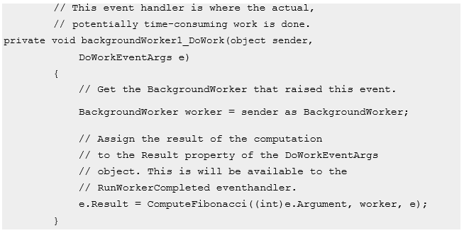

**Question Three**

Unit testing and integration testing are two testing strategies and regression testing is a kind of integration testing. What does a unit testing do? What does a regression testing do?

Briefly discuss the purpose and indicate why it is important to have integration testing.

**Question Four**

Formal Technical Reviews (FTRs) are usually used to assess the quality of a software design. Assume you are a member of a software team. How would you and your team use FTRs to assess the quality of a software design generally? Provide a brief explanation and analysis.

**SECTION B:**

**Question Five**

**A)** Describe the main characteristics of the Agile Scrum Methodology?

1. Provide four responsibilities that are undertaken by the Scrum Master?

**C)** What is the purpose of a Sprint Review Meeting?

1. Provide two advantages and two drawbacks of the Scrum Methodology.

**Question Six – Mini Case Study**

An e- Shop using Drupal has been set up on an Amazon Elastic Compute Cloud (Amazon EC2) instance. The instance is based on ubuntu 18.04 and contains an apache web server and a MySQL database server. After a few weeks, you realise that the system needs to be scaled up to handle significantly more users than initial planned for as soon as possible.

What is a scalable system?

Propose three solutions to improve the scalability of a system.

Elaborate how to realize cloud architecture behind the potential solutions on the server side .

Solutions:

**Formal Technical Review (FTR)** is a software quality control activity performed by software engineers.

**Objectives of formal technical review (FTR):** Some of these are:

Useful to uncover error in logic, function and implementation for any representation of the software.

The purpose of FTR is to verify that the software meets specified requirements.

To ensure that software is represented according to predefined standards.

It helps to review the uniformity in software that is development in a uniform manner.

To makes the project more manageable.

In addition, the purpose of FTR is to enable junior engineer to observer the analysis, design, coding and testing approach more closely. FTR also works to promote back up and continuity become familiar with parts of software they might not have seen otherwise. Actually, FTR is a class of reviews that include walkthroughs, inspections, round robin reviews and other small group technical assessments of software. Each FTR is conducted as meeting and is considered successful only if it is properly planned, controlled and attended.

**The review meeting:**

* Each review meeting should be held considering the following constraints- Involvement of people:
* Between 3, 4 and 5 people should be involve in the review.
* Advance preparation should occur but it should be very short that is at the most 2 hours of work for every person.
* The short duration of the review meeting should be less than two hour. Gives these constraints, it should be clear that an FTR focuses on specific (and small) part of the overall software.
* At the end of the review, all attendees of FTR must decide what to do.
* Accept the product without any modification.
* Reject the project due to serious error (Once corrected, another app need to be reviewed), or
* Accept the product provisional (minor errors are encountered and should be corrected, but no additional review will be required).

The decision was made, with all FTR attendees completing a sign-of indicating their participation in the review and their agreement with the findings of the review team.

**Review reporting and record keeping :-**

During the FTR, the reviewer actively records all issues that have been raised.

At the end of the meeting all these issues raised are consolidated and a review list is prepared.

Finally, a formal technical review summary report is prepared.

**It answers three questions :-**

* What was reviewed ?
* Who reviewed it ?
* What were the findings and conclusions ?

**Review guidelines :-**

Guidelines for the conducting of formal technical reviews should be established in advance. These guidelines must be distributed to all reviewers, agreed upon, and then followed. A review that is unregistered can often be worse than a review that does not minimum set of guidelines for FTR.

Review the product, not the manufacture (producer).

Take written notes (record purpose)

Limit the number of participants and insists upon advance preparation.

Develop a checklist for each product that is likely to be reviewed.

Allocate resources and time schedule for FTRs in order to maintain time schedule.

Conduct meaningful training for all reviewers in order to make reviews effective.

Reviews earlier reviews which serve as the base for the current review being conducted.

Set an agenda and maintain it.

Separate the problem areas, but do not attempt to solve every problem notes.

Limit debate and rebuttal.