**Part 1: Sales**

Question 1 (worth 5 marks)

Create a class diagram that supports the scenario.

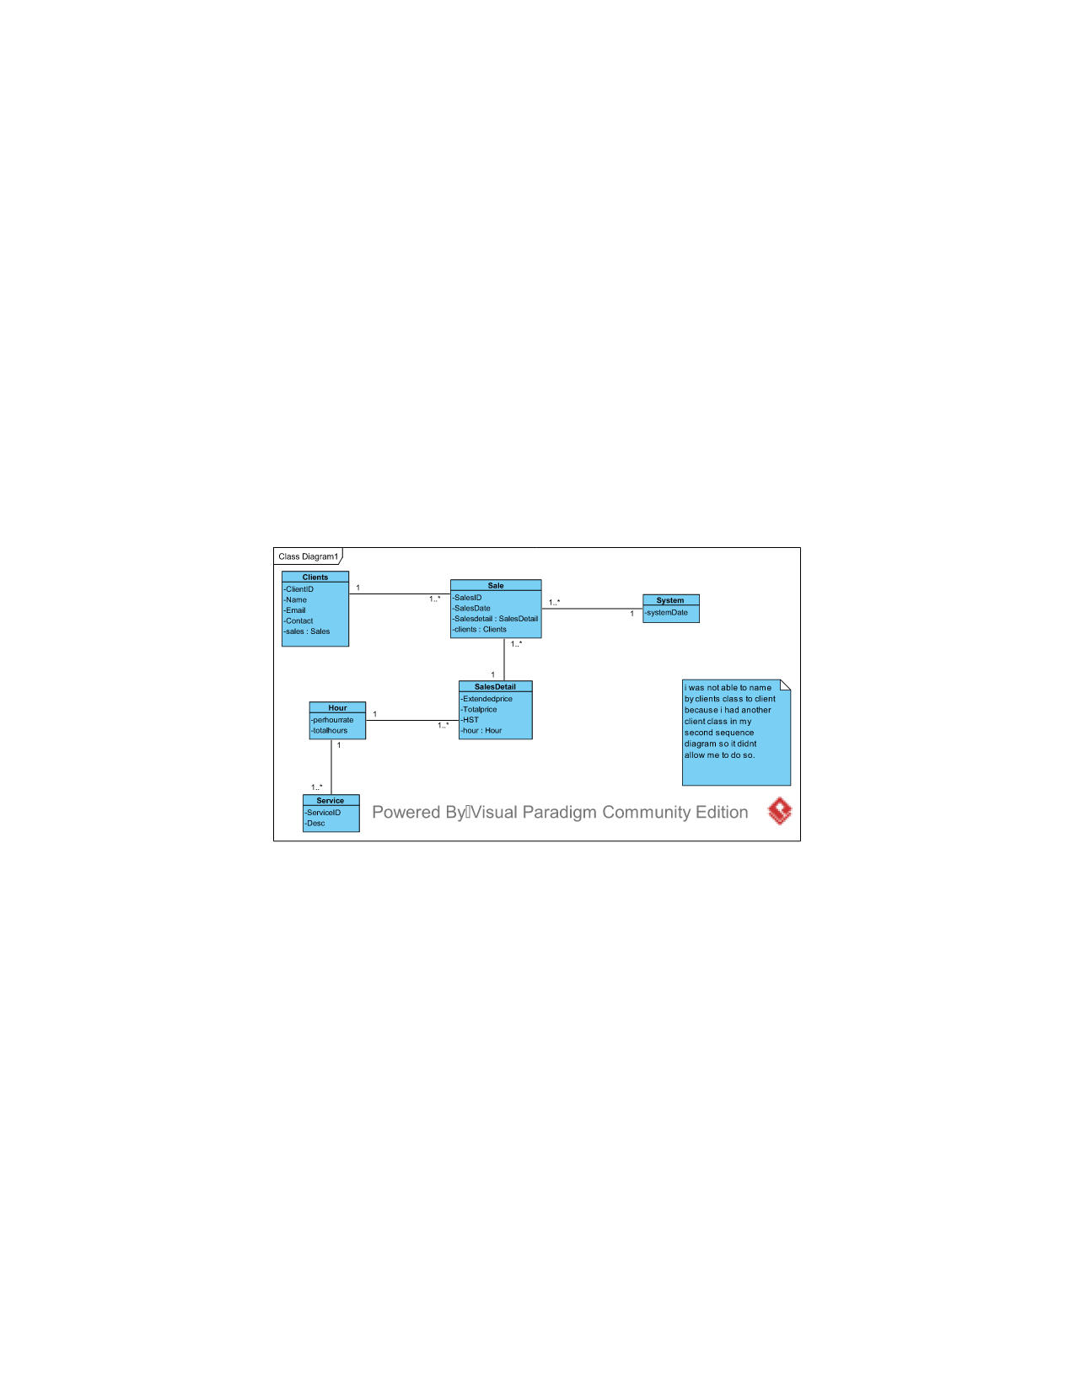

Question 2 (worth 10 marks)

Complete sequence diagrams to support the above scenario.

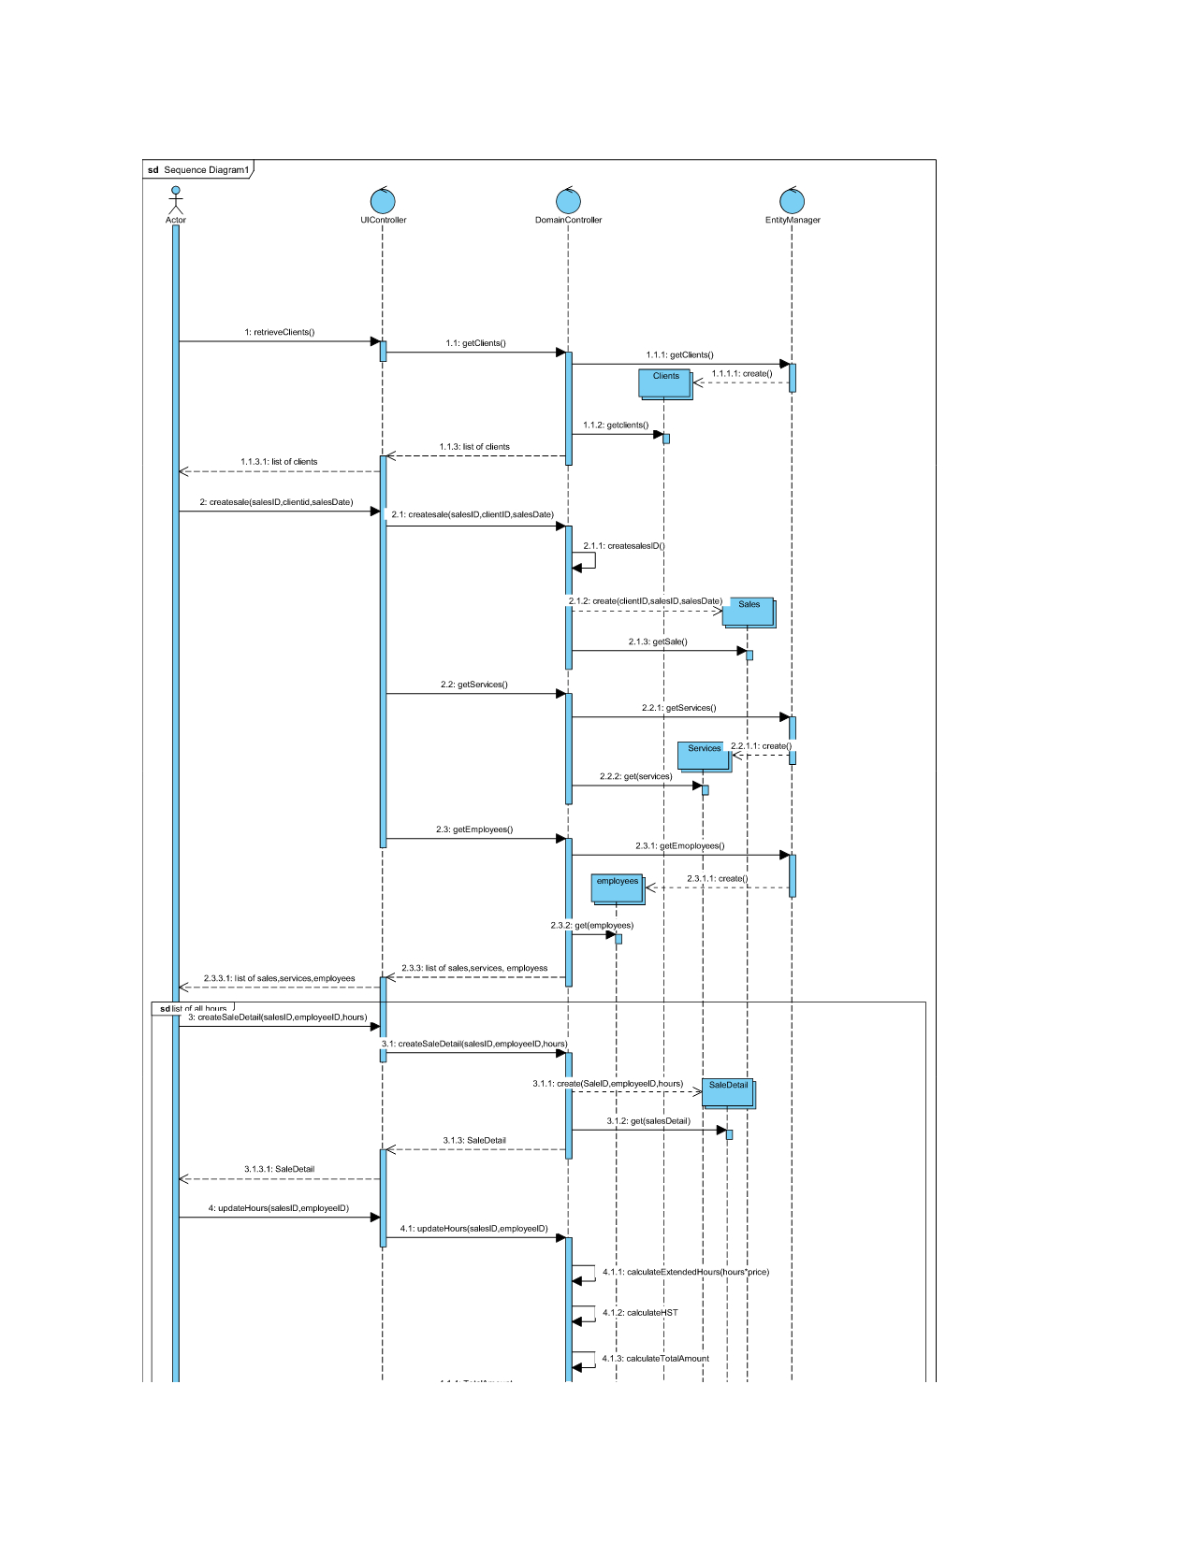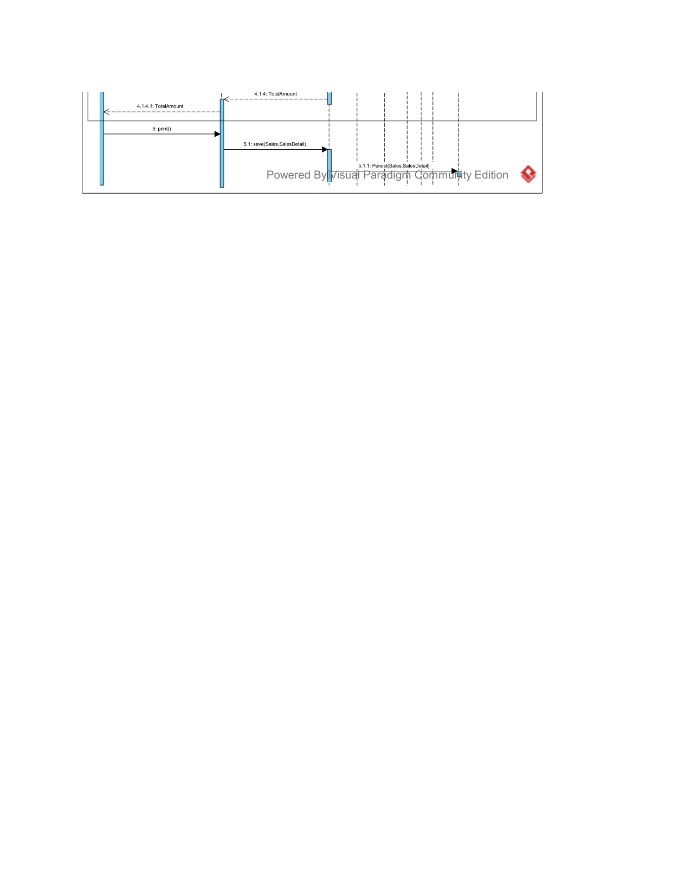

Question 3 (worth 2 marks)

The above scenario assumes that the cost/hour is the same irregardless of the products that are used in the service. CJ’s Styles is thinking of offering pricing for a service based on the quality of the products used in the service. Does your model support this? If not, how would your change your model? Please describe in English.

So if we are determined to charge the hourly fee based on the service the client is getting if need to add another class named servicetype. We will add type attribute in this class. Because the current model doesn’t differentiate between the services you are getting. So after implementing the new servicetype the client will select what type of service he wants and he will be charged accordingly.

Question 4 (worth 2 marks)

*CJ’s Styles* is thinking of offering a loyalty program. If a client purchases 10 of the same services, the 11th service is free. Does your model support this? If not, how would your change your model? Please describe in English.

No the current model doesn’t support this system. If we want to incorporate the loyalty we will need to add a class at the end after the customer finsihes selecting his services, schedule. This class will have an attribut called points. After wvery service the client will get 10 points and when it reaches 100 they will get a service free of their choice.

**Part 2: Scheduling**

You participated in a scheduling activity as part of week 9. Please use that activity in it’s entirety as the case study for this part of the test.

Question 5 – Class Diagram (worth 10 marks)

Your task is to create a class diagram to support the activity in it’s entirety and the scenario

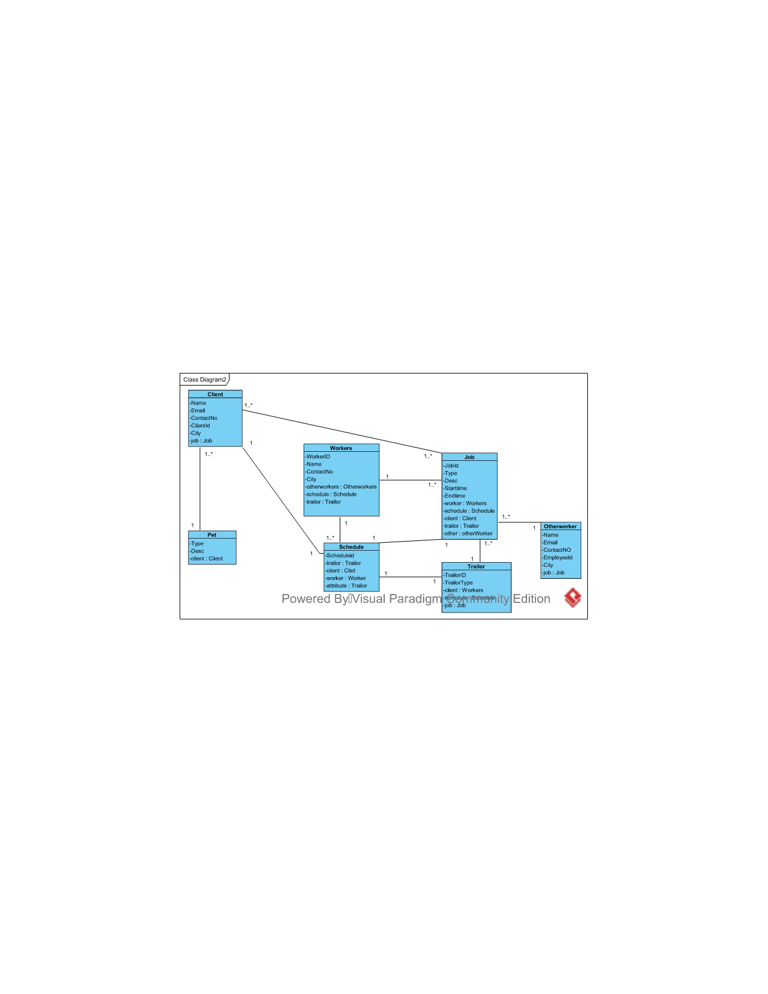

Question 6 – Sequence diagram (worth 5 marks)

Please complete an object level sequence diagram to support the above scenario.

