TECHNICAL REPORT · EMBEDDED SENSING & DATA ANALYSIS
Why Is One Room Colder?
Measuring a house's heat loss with two ESP32 sensor nodes, weather data and an RC thermal model

Author | Anmol Bhandohal, BSc Electrical Engineering (Co-op), University of Alberta
Date | October 2026 (Revision 1: Room A baseline)
Hardware | ESP32 · BME280 (temperature, humidity, pressure) · BH1750 (light)
Software | Arduino C++ firmware · Python (pandas, scikit-learn) · Microsoft Excel
Companion files | EnvMonitor_Analysis.xlsx (data, formulas, charts) · project slide deck

Status of this revision
Sections 1 to 5 use real measured data from the first overnight run in Room A (Oct 3 to 4, 2026).
The two-room comparison (Section 6) is planned and fully set up but not yet measured. Every amber cell, table entry and chart marked PENDING fills in from the second sensor node's logs; the Excel workbook already contains the formulas.

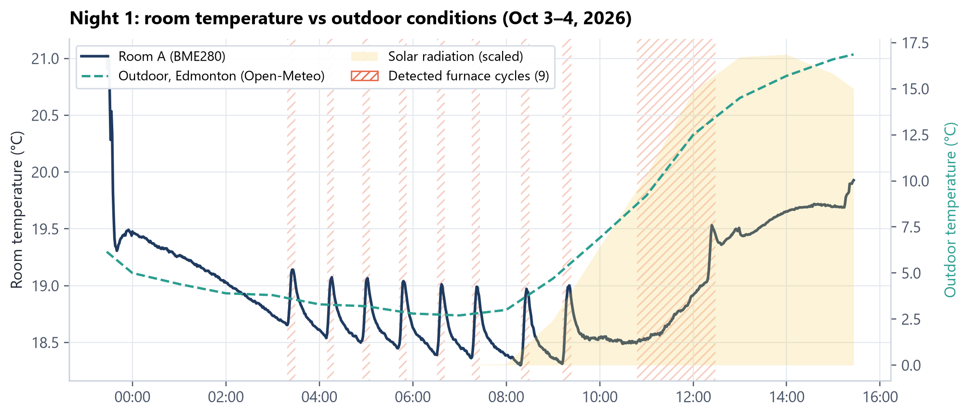
Room A, first overnight run: room temperature (navy), outdoor temperature (teal) and detected furnace cycles.
Contents
Summary 3
1. Objective and hypotheses 3
2. Theory 3
2.1 The room as an RC circuit 3
2.2 Dew point 4
3. Apparatus and method 5
3.1 Procedure 5
4. Results: Room A baseline (measured) 6
4.1 Furnace cycles 6
4.2 Humidity and dew point 7
4.3 Can the room's temperature be forecast? 7
5. Interpreting the baseline 8
6. Results: two-room comparison (pending) 8
7. How the result will be read 10
8. Sources of error and limitations 10
9. Conclusions and next steps 10
Appendix A. Workbook guide 11

Summary
One bedroom in our house is noticeably colder than the rest. The usual guesses are that it gets less sun, that its walls and window leak heat, or that its heating vent delivers less. Each one has a different fix and a different cost, so it is worth knowing which is true before spending money on it.
This study answers the question with measurements instead of guesses. A low-cost ESP32 sensor node logs temperature, humidity, pressure and light every 10 seconds. The logs are joined with hourly Edmonton weather data, and each room is modelled as an RC circuit: walls and air leaks act as a thermal resistance R and the room's contents as a thermal capacitance C. The time constant τ = RC gives a single number per room that captures how fast it loses heat.
960  minutes analysed (Room A) | 9  furnace cycles detected | 0.48 °C  average rise per cycle | 23.9 h  Room A time constant τ (RC fit) | PENDING  Room B / Room A heat-loss ratio

The Room A baseline is complete. Over 16 hours the room averaged 18.9 °C while it went from 2.7 to 16.9 °C outside. The furnace cycled every 56 minutes, and once each cycle ended the room drifted back down. A fitted RC model gives Room A a time constant of about 24 hours. The verdict on which explanation is right (sun, envelope or heating) needs the matching Room B data, which is being collected now.

1. Objective and hypotheses
Objective: determine the dominant cause of the temperature difference between the cold room (Room B) and a reference room (Room A), using only measured data and public weather records.
Table 1. Competing explanations and the measurement that separates them.
Hypothesis | Physical mechanism | What the data would show | Typical fix
H1: Less solar gain | Window faces away from the sun | Room gap appears in daytime only and disappears at night; light curve peaks at a different time of day | Window film or curtains (cheap); accept
H2: Envelope losses | Poor insulation or air leaks (low R) | Room B has a clearly smaller τ: it cools faster after each furnace cycle, at night too | Weatherstripping, caulking, insulation
H3: Weak heat delivery | Partly closed damper, long or leaky duct | Room B rises less per furnace cycle even though τ is similar | Open or balance dampers, seal ducts

2. Theory

2.1 The room as an RC circuit
Heat flow through a wall behaves like current through a resistor: it is proportional to the temperature difference across it. The air and furniture in a room store heat like a capacitor stores charge. Writing an energy balance on the room gives a first-order differential equation identical in form to an RC circuit charged from a source:
C · dT/dt = (Tout − T) / R + a · Psolar + b · Pfurnace | (1)

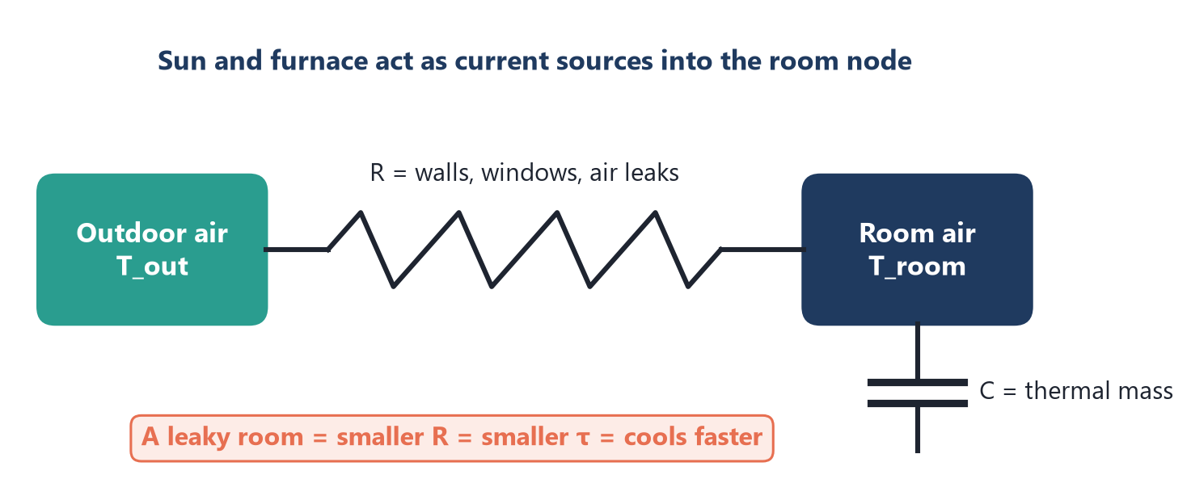
Figure 1. Electrical analogy for the room. Outdoor temperature is the source voltage; walls, windows and air leaks are the resistor; the room's thermal mass is the capacitor. Sun and furnace inject heat like current sources.
With the furnace off and no sun, Equation 1 reduces to natural cooling with time constant τ:
dT/dt = −(T − Tout) / τ , τ = R · C | (2)

A room with leakier walls has a smaller R, so a smaller τ, so it cools faster for the same temperature difference. Comparing τ between two rooms therefore isolates the envelope (H2) from the other two hypotheses. τ is estimated two independent ways: a least-squares fit of the full Equation 1 in Python, and a through-origin fit of Equation 2 to furnace-off minutes in Excel (cooling rate vs ΔT), which the reader can recompute from the workbook.

2.2 Dew point
Relative humidity alone does not say whether condensation will form on a cold window. The dew point does. It is computed from temperature T (°C) and relative humidity RH (%) with the Magnus approximation (a = 17.625, b = 243.04 °C), implemented as an Excel formula in column G of each room sheet:
γ = ln(RH/100) + aT/(b + T) , Tdew = b·γ / (a − γ) | (3)

3. Apparatus and method
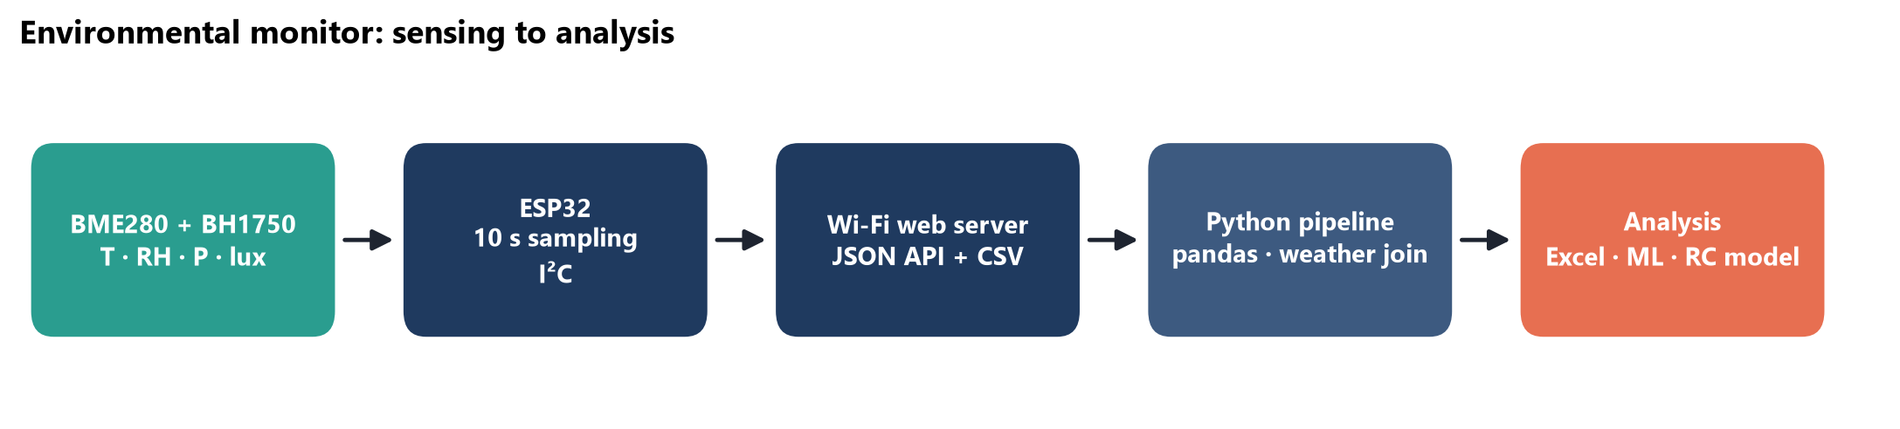
Figure 2. Measurement chain, from sensor to analysis.
Table 2. Equipment and data sources.
Component | Role | Key specification
ESP32 dev board | Microcontroller, Wi-Fi web server, logging | Samples every 10 s; serves live readings and a JSON history API
Bosch BME280 (I²C) | Temperature, humidity, pressure | ±1 °C, ±3 % RH absolute (datasheet); 0.01 °C resolution; forced mode to limit self-heating
ROHM BH1750 (I²C) | Ambient light (lux) | Shows when sunlight reaches the room, and from that the window orientation
Open-Meteo API | Outdoor temperature, solar radiation, wind | Hourly, Edmonton 53.55 N, 113.49 W; interpolated to 1 min
Python pipeline | Cleaning, resampling, weather join, models | pandas resample to 1 min; gaps over 5 min left unfilled
Excel workbook | Transparent analysis layer | All derived quantities as live formulas; native charts

3.1 Procedure
Table 3. Experimental phases.
Phase | What happens | Duration | Status
0. Calibration | Both nodes side by side, 10 cm apart, away from vents. Offsets (B − A) measured and subtracted from all later data. Pass if within ±0.2 °C and ±2 % RH after correction. | 24 h | PENDING
1. Baseline | Node A logs Room A alone: daily cycle, furnace sawtooth, light curve. Used to build and test the analysis pipeline. | 1 night | Done (Oct 3 to 4)
2. Two-room run | Nodes at 1.2 m height in each room, away from vents, windows and electronics. Event notes kept (doors, windows, absences). | 2 to 3 weeks | PENDING
3. Analysis | Heat-loss signature, furnace-cycle comparison, RC fit, sunny vs overcast days, wind dependence. | 1 week | Pipeline ready

The calibration step matters because the BME280's absolute accuracy (±1 °C) is larger than the effect being measured. Two sensors can easily disagree by half a degree out of the box. Measuring them side by side first turns that unknown into a known offset, which is subtracted.

4. Results: Room A baseline (measured)
Figure 3. Room A over the first overnight run (960 one-minute samples from 5,747 raw readings). The room is held near 19 °C by the thermostat while the outdoor temperature falls to 2.7 °C before sunrise and climbs to 16.9 °C in the afternoon. Hatched bands mark detected heating phases.
Table 4. Room A summary statistics, night 1. All values recompute live in the Summary sheet of the workbook.
Quantity | Room A | Method (Excel)
Mean temperature | 18.95 °C | AVERAGE
Range | 18.30 to 21.03 °C | MIN / MAX
Temperature variability (SD) | 0.46 °C | STDEV.S
Relative humidity range | 40 to 58 % | MIN / MAX
Mean dew point | 9.2 °C | Magnus formula, Eq. 3
Mean indoor − outdoor ΔT | 11.95 °C | AVERAGE of B − E
Share of minutes heating | 10.2 % | COUNTIF on phase column
Cooling rate per °C of ΔT (furnace off) | 0.063 h⁻¹ (τ ≈ 15.9 h) | SUMPRODUCT / SUMSQ, Eq. 2
Time constant τ, full RC fit | 23.9 h | Python least squares, Eq. 1

4.1 Furnace cycles
The heating system shows up clearly as a sawtooth. Cycles were detected automatically: the temperature is smoothed over 5 minutes, and a cycle starts where the slope dT/dt turns positive and ends where it turns negative again. Only rises of at least 0.15 °C count, which rejects sensor noise (one count is 0.01 °C). 9 cycles were found, on average 56 minutes apart, each lasting about 20 minutes and raising the room by 0.48 °C (about 2.2 °C per hour while running).
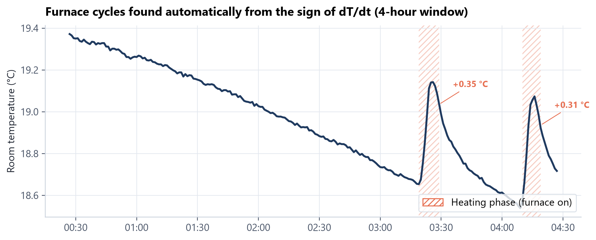
Figure 4. Four-hour detail of the heating sawtooth with the detected rise of each cycle. In the two-room comparison, a smaller rise per cycle in Room B would point to weak heat delivery (H3).

4.2 Humidity and dew point
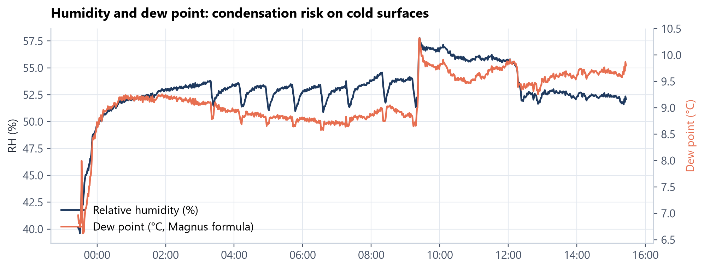
Figure 5. Relative humidity ranged from 40 % to 58 %; the dew point averaged 9.2 °C. Any surface colder than the dew point (for example a single-pane window frame on a −20 °C night) collects condensation, a known cause of mould on cold exterior walls.

4.3 Can the room's temperature be forecast?
As an extension, I trained models to predict the room temperature 30 minutes ahead from recent temperature changes, the indoor–outdoor gap and solar radiation (scikit-learn). Each model was scored against the simplest possible forecast, persistence ("in 30 minutes it will be the same as now"), using 5-fold time-series cross-validation so the model is never tested on data from before its training period.
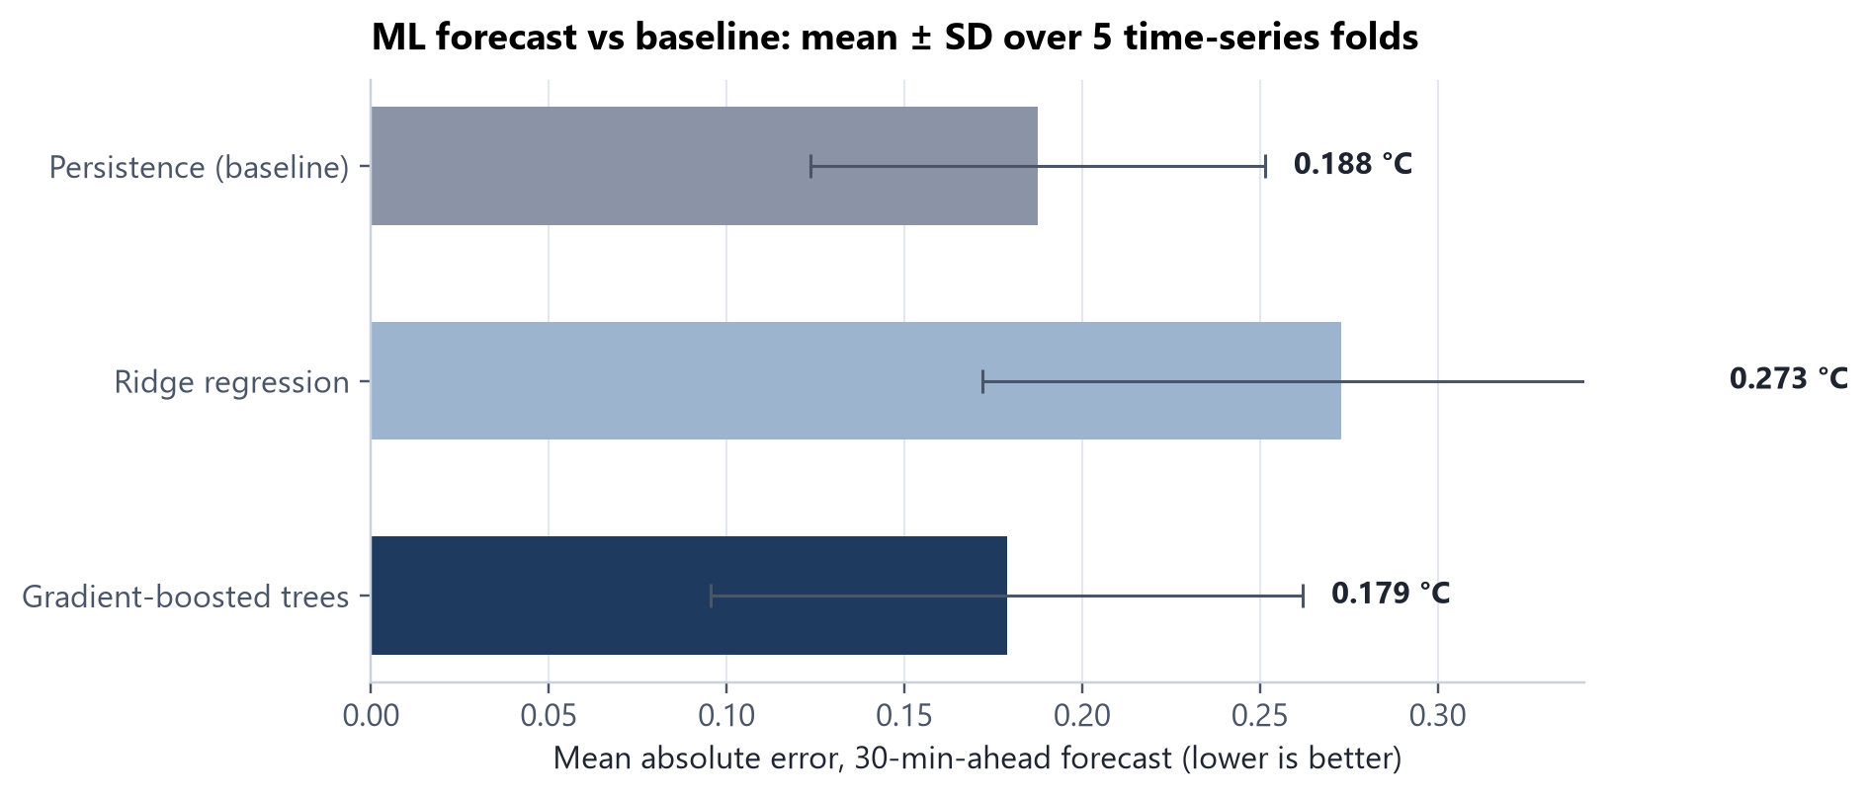
Figure 6. Mean absolute error of the 30-minute forecast. Error bars show the spread across the five folds.
Honest reading of the forecast result
Gradient-boosted trees beat persistence by only 4.7 % on average (0.179 vs 0.188 °C), and on a single chronological hold-out split they did worse (0.214 vs 0.141 °C). The fold-to-fold spread is larger than the improvement.
This is the expected result for one night of data: the furnace cycle dominates, and 16 hours contain only 9 examples of it. The conclusion is that the model needs weeks of data, not that ML fails here. The same script reruns on the Phase 2 data.

5. Interpreting the baseline
A 24-hour time constant means that if the furnace failed when it was 19 °C inside and 0 °C outside, Room A would lose roughly 0.8 °C in the first hour (19 °C ÷ 24 h) and fall about two-thirds of the way to outdoor temperature in a day. The two τ estimates differ (15.9 h vs 23.9 h). The simple Excel method uses only the minutes right after each furnace cycle, when warm air is still mixing out of the room, so it overstates the cooling rate. The full RC fit accounts for furnace and solar heat directly. For comparing rooms, what matters is applying the same method to both rooms; the absolute value is secondary.

6. Results: two-room comparison (pending)
This section is set up and waiting for data
The figures below are placeholders with final axes and titles. When the Room B logs and calibration run arrive, they are pasted into the RoomB_Pending and Calibration_Pending sheets; the Summary table, dashboard charts and these figures regenerate from the same scripts.

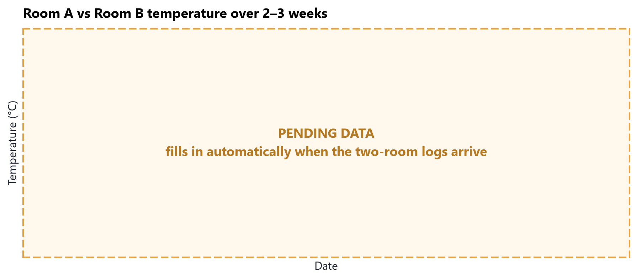
Figure 7. Room A and Room B temperatures over the 2 to 3 week run, with outdoor temperature. (PENDING)
Table 5. Comparison table. Room A night-1 values are real; the full run will replace them.
Quantity | Room A | Room B | B vs A | Supports
Mean temperature (°C) | 18.95 (night 1) | PENDING | PENDING | size of the problem
Mean ΔT to outdoor (°C) | 11.95 (night 1) | PENDING | PENDING | size of the problem
Rise per furnace cycle (°C) | 0.48 | PENDING | PENDING | H3 if B much smaller
Cooling rate per °C ΔT (h⁻¹) | 0.063 | PENDING | PENDING | H2 if B much larger
Time constant τ, RC fit (h) | 23.9 | PENDING | PENDING | H2 if B much smaller
Daytime minus night-time gap (°C) | PENDING | PENDING | PENDING | H1 if large
Gap vs wind speed (slope) | PENDING | PENDING | PENDING | air leaks (H2)

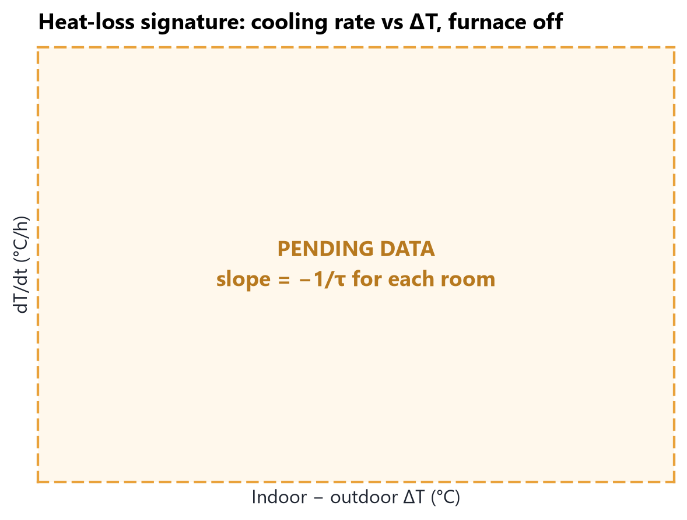 | 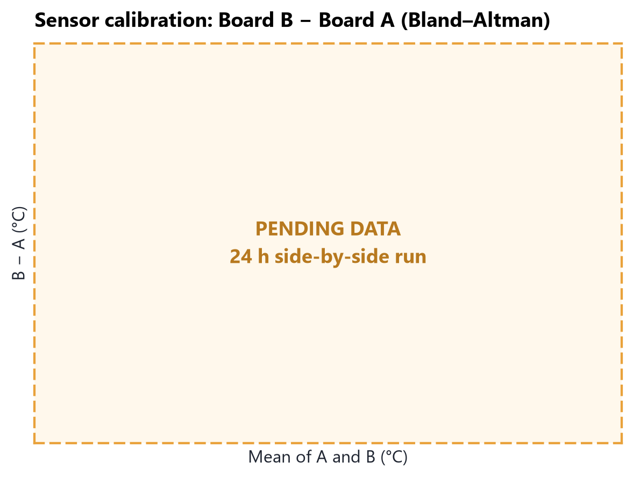
Figure 8. Heat-loss signature: cooling rate vs ΔT with the furnace off. Slope = −1/τ; the steeper room loses heat faster. (PENDING) | Figure 9. Calibration (Bland–Altman): sensor B − A against their mean over 24 h side by side. Passes if within ±0.2 °C. (PENDING)

7. How the result will be read
Table 6. Decision table: written before the data arrives so the result cannot be fitted to a preferred story.
If the data shows… | Then the cause is… | Recommended action
τ(B) at least 25 % smaller than τ(A), at night as well as in daytime | Envelope losses (H2) | Weatherstrip window and door; check outlet and switch boxes on exterior walls for drafts
Similar τ, but Room B rises clearly less per furnace cycle | Weak heat delivery (H3) | Check that the damper is fully open; balance the dampers to other rooms; inspect the duct run
Gap mostly in daytime, small at night; Room B light curve peaks late or stays low | Less solar gain (H1) | Accept, or use thermal curtains at night; no envelope work justified
Gap grows with wind speed | Infiltration (air leaks, part of H2) | Air-seal first; it is the cheapest envelope fix

8. Sources of error and limitations
- Sensor accuracy: ±1 °C absolute per BME280; handled by the Phase 0 side-by-side calibration, so only the relative offset matters.
- Self-heating: the ESP32 warms its own board. Sensors run in forced mode, and the first 10 minutes are compared with hour 2 to quantify it.
- Placement: readings depend on height and distance from vents and windows. Both nodes go at 1.2 m, away from vents, with photos of each location.
- Weather data resolution: Open-Meteo is a gridded hourly product, not a station on our roof. It is cross-checked against Environment Canada (Edmonton Blatchford).
- Occupancy: doors, laundry and people add heat. Event notes are logged and those periods can be excluded.
- Short baseline: one night supports pipeline testing, not conclusions. Section 6 is the actual experiment.

9. Conclusions and next steps
- A complete measurement chain (sensor → ESP32 → Wi-Fi → Python → Excel) was built and validated on 16 hours of real data from Room A.
- The heating system and the room's thermal response are clearly visible: 9 furnace cycles, about 0.5 °C rise per cycle, τ ≈ 24 h for Room A.
- The analysis, including the decision rules, is fixed before the comparison data exists, which keeps the conclusion honest.
- Next: build the second node, run the 24-hour calibration, then log both rooms for 2 to 3 weeks and fill in Sections 6 and 7.

Appendix A. Workbook guide
Table 7. Structure of EnvMonitor_Analysis.xlsx.
Sheet | Contents | Key formulas
Overview | Question, status legend, live key results | Cell links to Summary
Summary | Room A vs Room B metrics | AVERAGE, STDEV.S, SUMPRODUCT/SUMSQ, COUNTIF, IFERROR
Dashboard | Native Excel charts | Scatter with time axis, heat-loss scatter, model and cycle bars
RoomA_Night1 | 960 one-minute rows (real) | Magnus dew point, centred dT/dt, phase classification
RoomB_Pending | Same structure, 2,000 rows pre-wired | Same formulas, blank until data is pasted
Calibration_Pending | Side-by-side offsets with PASS/FAIL | AVERAGE, STDEV.S, conditional formatting
Furnace_Cycles | Detected cycles (real) | Duration, heating rate, period
ML_Forecast | Cross-validation folds (real) | Mean, SD, improvement vs baseline

