TEST REPORT · POWER ELECTRONICS & CONTROL
Adaptive LED Lamp
PWM dimming that is measured, verified linear, and held at a set brightness by closed-loop feedback

Author | Anmol Bhandohal, BSc Electrical Engineering (Co-op), University of Alberta
Date | September 2026
Hardware | ESP32 · IRLZ44N logic-level MOSFET (low side) · 12 V 2835 LED strip · BH1750 light sensor · 12 V 2 A adapter
Firmware | Arduino C++: 13-bit PWM at 5 kHz, serial command interface, integral brightness controller
Companion file | LED_Lamp_Characterization.xlsx (raw data, fits, step metrics, charts)

Summary
This lamp dims a 12 V LED strip with a MOSFET driven by PWM from an ESP32, and uses a light sensor to close the loop. Two questions were tested on the bench: is light output proportional to PWM duty cycle, and can the lamp hold a chosen brightness on its own?
0.99991  R², light output vs duty | 0.51 %  worst deviation from linear (of full scale) | 3.5 s  settling time, 11 lx step | 0.21 lx  overshoot, 11 lx step

The answer to both is yes. Light output follows 2.602 lux per % duty with R² = 0.99991; no point deviates by more than 0.51 % of full scale. An integral controller then holds 11 lx and 3 lx targets, settling in 3.5 to 4.5 s with under 0.25 lx overshoot. The steady-state ripple is about one sensor count.

1. Design
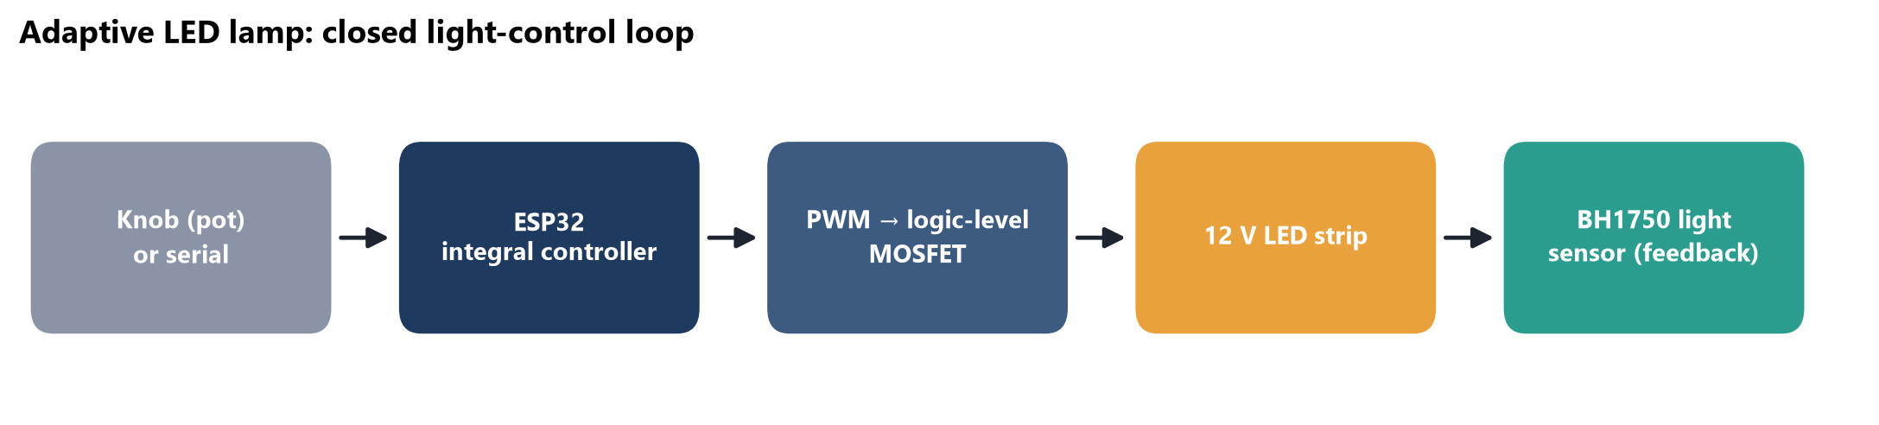
Figure 1. Signal path. The ESP32 sets a PWM duty cycle; a logic-level MOSFET on the low side switches the strip's return current; the BH1750 measures the result and feeds it back.
Table 1. Main components.
Part | Function | Why this part
ESP32 | PWM generation, control loop, serial interface | Hardware PWM (LEDC) up to 14-bit at 5 kHz; used at 13-bit
IRLZ44N N-channel MOSFET | Low-side switch for the strip | Logic-level gate: fully on at the ESP32's 3.3 V drive (a standard IRF540 needs about 10 V). 100 Ω gate resistor damps ringing; 100 kΩ pull-down keeps it off during boot
12 V 2835 LED strip (daylight) | Light source | Strip has built-in current-limiting resistors, so it runs from constant voltage
BH1750 (GY-302 module) | Light measurement and feedback | Digital lux output over I²C; resolution configurable
12 V 2 A adapter | Supply | The wall adapter does the AC to DC conversion; the board only switches DC

2. Test B3: is the lamp linear?

2.1 A first attempt that failed, and why
The first sweep looked flat: output barely changed from 0 to 100 % duty. Two problems were behind it. First, the room lights were on, so the sensor saw 14.2 lx of ambient light and the lamp added only about 1.6 lx at the sensor's position. Second, the readings only ever took three values (14.2, 15.0 and 15.8 lx), steps of exactly 0.83 lx. That is one count at the sensor's default sensitivity, so the measurement was mostly rounding.
Fixes applied before re-testing
Resolution: sensor measurement time register raised from 69 to 254 and switched to high-resolution mode 2, giving (1/1.2)·(69/254)/2 = 0.113 lx per count, about 7× finer.
Ambient: a dark-room control test read 0.0 lx for all 33 samples, which confirmed the sensor's zero. A tare command subtracts any remaining ambient light (0.11 lx on the final run).
Geometry: sensor placed 12.7 cm straight on from the strip, under a cover.

2.2 Method and result
Duty was stepped from 0 to 100 % in 10 % steps, 4 seconds per step, entirely over the serial link so no hand touched the setup during the run. The first sample after each step is discarded as settling, and each plateau is averaged over its 7 remaining samples. In the workbook this is an AVERAGEIFS on a "settled" flag column, followed by SLOPE, INTERCEPT and RSQ.
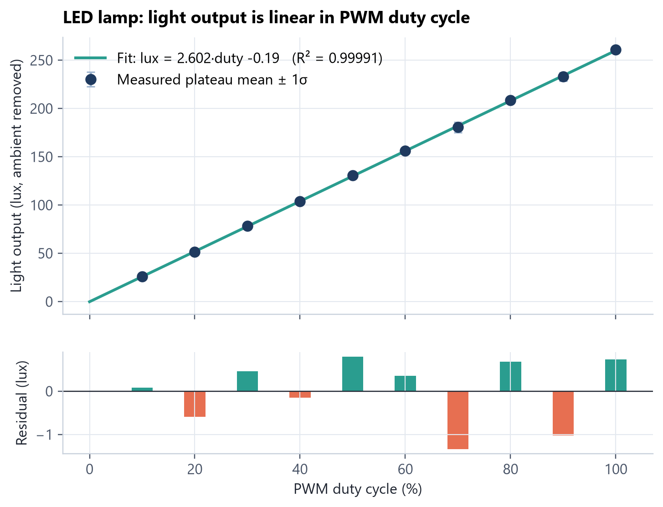
Figure 2. Light output against duty cycle with a least-squares line, and residuals below. Error bars (±1 SD within each plateau) are smaller than the markers.
Table 2. Plateau means and fit: lux = 2.602·duty -0.19.
Duty (%) | Mean (lx) | Fit (lx) | Residual (lx) | Residual (% FS)
10 | 25.90 | 25.83 | +0.08 | +0.03
20 | 51.26 | 51.85 | -0.59 | -0.23
30 | 78.33 | 77.87 | +0.46 | +0.18
40 | 103.73 | 103.89 | -0.16 | -0.06
50 | 130.70 | 129.90 | +0.79 | +0.30
60 | 156.28 | 155.92 | +0.36 | +0.14
70 | 180.60 | 181.94 | -1.34 | -0.51
80 | 208.64 | 207.96 | +0.68 | +0.26
90 | 232.96 | 233.98 | -1.02 | -0.39
100 | 260.74 | 260.00 | +0.74 | +0.28

Linear output means duty cycle maps directly to light. It does not map to perceived brightness, because the eye responds roughly logarithmically. The knob input therefore goes through a gamma curve (exponent 2.5), so that equal turns of the knob look like equal steps.

3. Test T4: closed-loop constant light
The controller is integral-only: each update it nudges the duty by a fraction of the error, scaled by the plant gain K (lux per % duty).
u[k+1] = u[k] + (G / K) · (setpoint − measured) , G = 0.35 | (1)

K depends on where the sensor sits relative to the strip, so the firmware measures it (a duty step from 20 % to 60 %) instead of hard-coding it. At the test geometry K = 0.141 lx/%, far below the 2.60 lx/% of the linearity test, because the sensor sat beside the diffuser rather than in front of it. Before running on hardware, the loop was simulated against the measured B3 plant and stayed stable with no overshoot even with K wrong by 2× in either direction. Each update is capped at 8 % to avoid visible jumps.
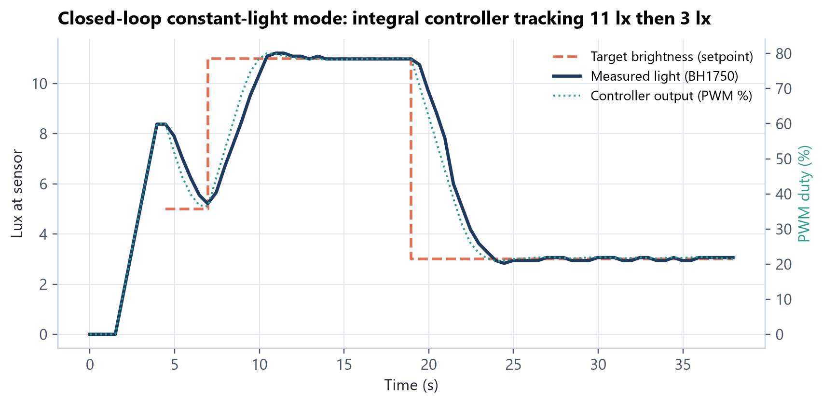
Figure 3. Step response: target 11 lx, then 3 lx. Measured light follows the setpoint within seconds; the controller output (dotted, right axis) settles at the duty needed for each level.
Table 3. Step-response metrics (T4_ClosedLoop sheet).
Metric | 11 lx step | 3 lx step
Settling time | 3.5 s | 4.5 s
Overshoot past target | 0.21 lx | 0.17 lx
Settled value | 10.98 lx | 3.01 lx
Steady-state ripple | ±0.1 lx (≈ 1 count) | ±0.1 lx

A first run (targets 60, 150 and 40 lx) was invalid: every target was above the 14 lx this geometry can reach, so the duty sat pinned at 100 %. The firmware now warns when a target is unreachable instead of failing silently.

4. Music-reactive mode
The same lamp can follow music. A Python engine on the PC captures whatever is playing through Windows' loopback interface. That is the digital stream sent to the speakers or AirPods, not a microphone, so room noise never reaches it. The engine turns each frame into a brightness at 60 updates per second and sends it to the ESP32 over serial.
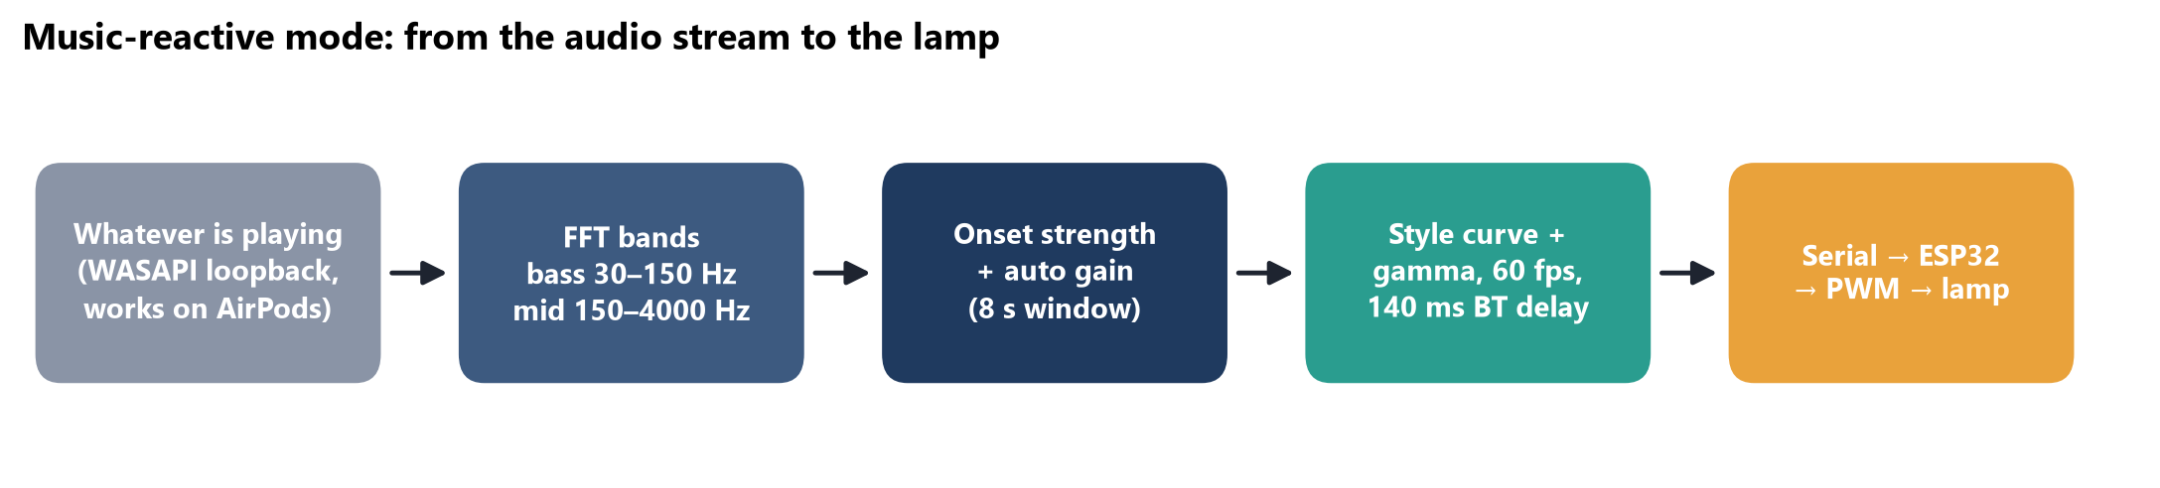
Figure 4. Signal chain of the music-reactive mode. The 140 ms Bluetooth output delay of the AirPods was measured and is subtracted so flashes line up with what is heard.

4.1 Four versions, and what each one taught
Table 4. Version history, from the project log.
Version | Idea | What testing showed
v1 | Map volume (dBFS) straight to brightness | Brightness only swung 50 to 70 %, and it followed the system volume knob instead of the music
v2 | Automatic gain: map between this song's quiet and loud parts over the last 8 s | Works at any volume. Two real bugs fixed on the way: an audio backlog that grew into lag, and a bass filter that never actually filtered
v3 | Separate kick / snare / hi-hat detectors, tuned on a synthetic test track | On real songs it caught only 0.12 to 0.33 kicks per beat, so the lamp mostly showed a slow glow
v4 | Continuous bass and mid onset strength instead of yes/no kick detection | 1.0 to 1.5 hits per beat and 5.8× the beat contrast on the same song

Judging a light show by eye is unreliable, so each version was scored against an independent referee: librosa, a standard open-source music-analysis library, found the beats in two recorded songs, and a script measured how well each lighting style lined up with them. Two numbers capture the trade-off: beat contrast (how far brightness jumps on a beat) and brightness left on between beats (how lit the room stays).
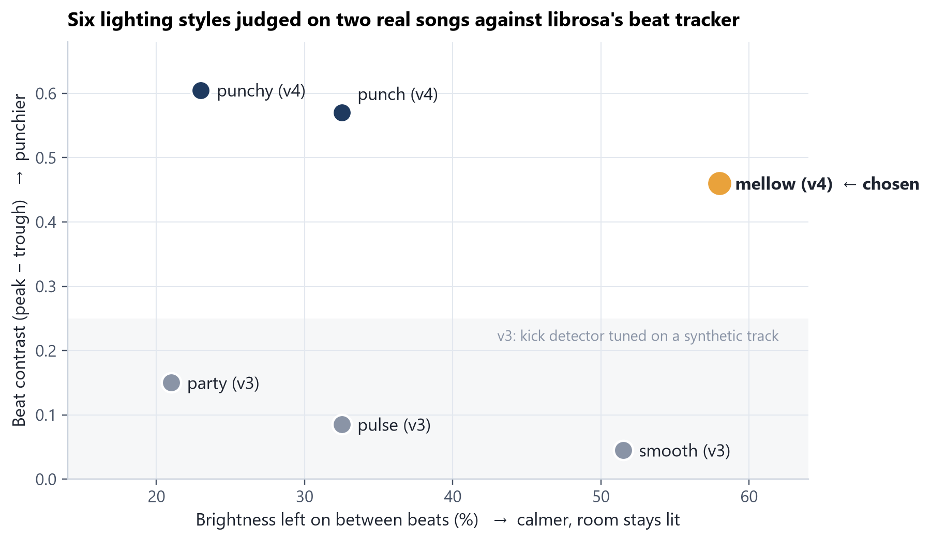
Figure 5. All six styles on the same two songs. The v3 styles cluster at low contrast; v4 moved every style up. Among v4 styles, more contrast costs a darker room between beats.
The final pick was made by rendering all three v4 styles side by side on the same 30 seconds of music (video linked below) and watching them. Mellow was chosen. It is not the highest-contrast option (punchy is), but it keeps the room at about 58 % between beats while still landing the beats with 0.46 average contrast, about 5× the v3 default. The metrics did not make the decision; they made the trade-off visible so the decision could be made deliberately.
Video
Real lamp reacting to music, and the side-by-side style comparison: anmol-portfolio-omega.vercel.app/docs

5. Design review findings
The schematic was reviewed net by net before layout. One finding: the bulk capacitors were connected across the LED (12 V to LED−) instead of from 12 V to ground, so each MOSFET turn-on would dump 100 µF through the transistor's on-resistance. The breadboard build places the capacitor from 12 V to ground, and the PCB layout is to be corrected in Altium before ordering boards.

6. Conclusions
- Output is linear in duty cycle (R² = 0.99991, worst residual 0.51 % FS) once the measurement itself is fixed.
- A self-calibrating integral controller holds a set brightness within about one sensor count and recovers from a step in under 5 s.
- A music-reactive mode went through four versions; judged against an independent beat tracker, v4 delivers 5.8× the beat contrast of v3 on the same song.
- The most useful result came from a failed test: it showed the measurement itself (ambient light and sensor quantisation) has to be checked before the device under test.

