SFU Degree Progression Tree

I choose this tree specifically for course requirements. This tree will help me in the future in regards to my own degree. I will be transferring to SFU in the fall after spending a bit excess of two years at KPU. This shows what courses needed to be taken in order to progress in the SFU Computer Science degree Bsc. Some optional courses are excluded because those are not what I will be taking and this is the best core path to complete the requirements for SFU Computer Science first and second year. I did not include 3rd and 4th year classes due to the sheer number of them and multiple options and the requirements become a lot more difficult to just put onto a tree. The courses follow a path of prerequisites. The courses on the very right can only be taken if the parent classes have been completed as they are children of the parents.

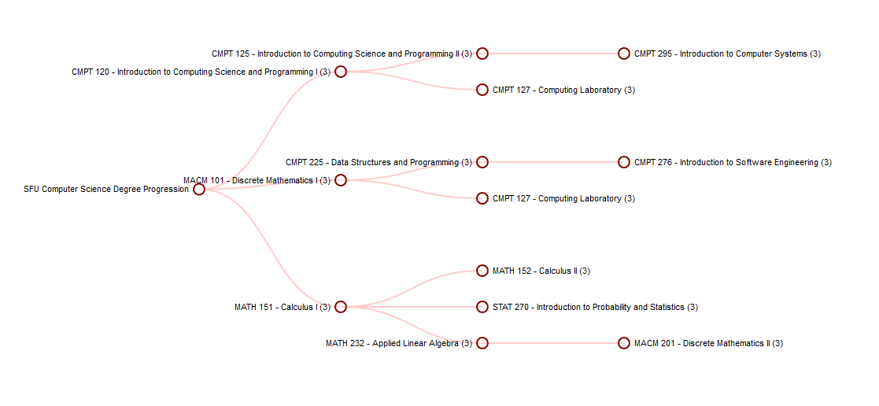

Based on official SFU Degree site <http://www.sfu.ca/students/calendar/2017/fall/programs/computing-science/major/bachelor-of-science-or-bachelor-of-arts.html>

Computer Information Systems: Diploma

Follows the same dynamic as the SFU Tree. This is for people in Computer Information Systems trying to complete the diploma. The classes on the very right cannot be taken unless classes on the left have been completed.

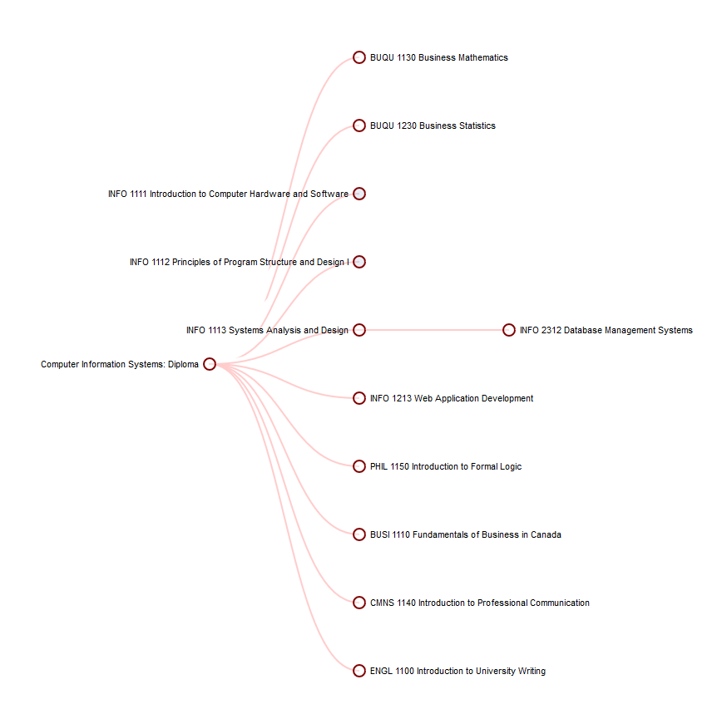

Course Requirements from

<https://www.kpu.ca/calendar/2016-17/business/computerinformationsystems/computerinformationsystems-dip.html>

Note: Has 4 Sublevels just not expanded!