Problem

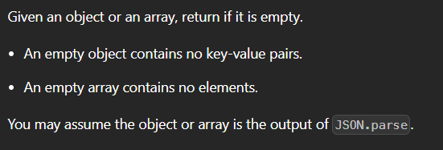

Solution

/**

 * @anmol{Object|Array} obj

 * @return {boolean}

 */

var isEmpty = function(obj) {

    for (const _ in obj) return false;

    return true;

};