**Exp-4**

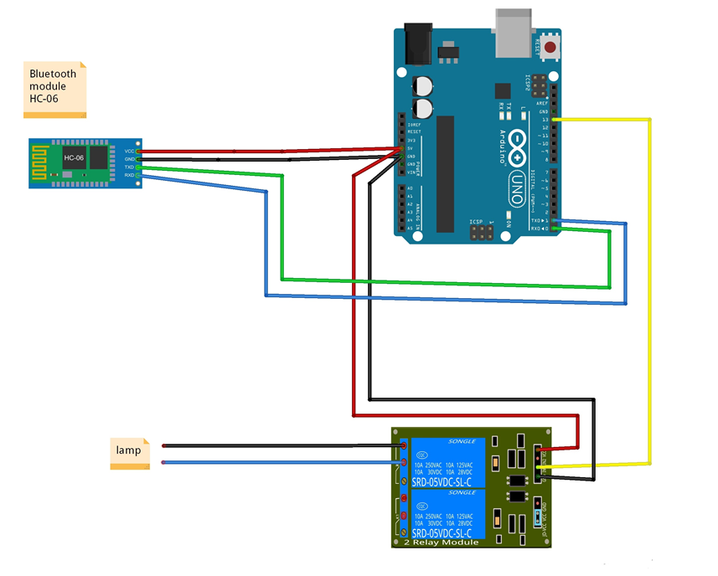

**Design a smartphone controlled light system**

**Concept Used:-**

**1.**In this experiment the concept of Bluetooth and LED Flasher has been used.

2.We connect the Arduino and the Bluetooth accordingly:-

* The Tx port of Bluetooth is connected to 0 pin of the arduino.
* The Ground of Bluetooth is connected to the ground of arduino.
* VCC that is high voltage is connected to the 5V of arduino.

**Learning and Observations : -**

1. From this experiment I have learned the concept and the working of Bluetooth device along with Arduino.
2. Whenever we pass signal from our phone to the Bluetooth to swich on the led the led glows and vice versa.

**Problems and Troubleshooting:**

1.There was a slight confusion in understanding the transmission and receiving of data and then making the required connections.

2.Some minor errors were there, which were trouble shooted by the correcting the code.

3.The Bluetooth was not getting connected to the smartphone previously.

**Precautions**

1. One should be careful of the Tx and Rx pins.

2. The coding needs to be correct for the proper functioning of the experiment.

3.The connections made on the pins of the Arduino must coincide with the codes written on the software.

**Learning Outcomes**

Following are some of the learning outcomes-

1.The concept and connections of Bluetooth and Arduino Board.

2.Having the knowledge of of Tx and Rx.

3.Improving the knowledge of the Arduino.