**Exp-5 Design an automatic night lamp**

**CIRCUIT DIAGRAM:-**

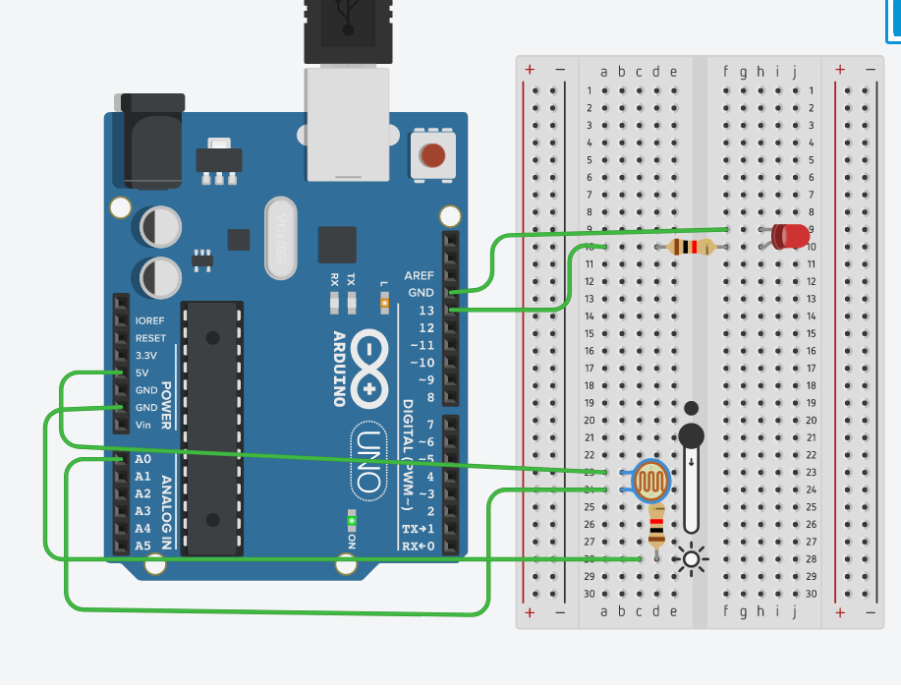

**Concept Used**

1.Light dependent resistors(LDRs) or photoresistors are devices that are used to detect the intensity of light.

2.The Arduino board has ~ sign in Digital pin side which is also known as Pulse Width Modulation (PWM)**.**

These pins help in getting Analog signals with digital means.

3.When the intensity of the light rays fall on the LDR increases, the resistance of the LDR decreases.

**Learning and Observations**

1. I have learned how to make a circuit using breadboard, Arduino and LDR.
2. I have learned the concept and working of LDR.

3.Whenever it is day or enough light, the resistance of the LDR decreases. This in turn will not allow the LED to glow.

If there is darkness or light intensity is less than a particular value, the resistance of the LDR increases significantly. This will make the LED glow.

**Problems and Troubleshooting**

1.There was a slight confusion in understanding the transmission and receiving of data and then making the required connections.

2.Some minor errors were there, which were trouble shooted by the correcting the code.

**Precautions**

1.The connections must be correct.

2. All the equipment must be in working condition.

3.The connections made on the pins of the Arduino must coincide with the codes written on the software.

**Learning Outcomes: –**

1. The concepts and working of LDR (Light Dependent Resistor).

2. Usage of LDR, LEDs and Arduino to design different circuits.

3. Improved my knowledge of the Arduino.