**Exp-6 Design an obstacle detector and distance measuring device.**

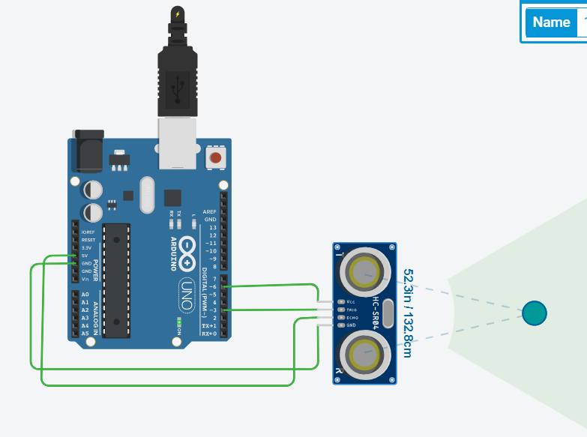

**Concept Used**

1.The obstacle detector works on the principle of transmitting and receiving the Ultrasonic signal, and calculating the distance between the obstacle and the sensor by measuring the time between transmitting and receiving of the signal.

2.The VCC terminal of the ultrasonic sensor is connected to the 5V supply. The TRIG pin is connected to the digital pin 9 and it sends out an ultrasonic wave.

3.ECHO pin is connected to the digital pin 10 and it receives the wave which is reflected back.

4.If the distance between the obstacle and the sensor is greater than 20cm, then the LED glows.

**Learning and Observations**

1. We made the connection between the arduino and the Ultrasonic signal transmitter HC-SR04.

2. Method to calculate the distance between the obstacle and the sensor, on the basis of signal transmission and receiving.

3. Making the circuits using Arduino and other electrical equipment.

4. The working of the Ultrasonic Signal Transmitter IC.

**Problems and Troubleshooting**

1.There was a slight confusion in understanding the transmission and receiving of data and then making the required connections.

**Precautions**

1.The connections must be correct.

2. All the equipment must be in working condition.

3.The connections made on the pins of the Arduino must coincide with the codes written on the software. Port selection for Arduino.

**Learning and Outcomes**

1.Using Arduino and other electrical equipment to make circuits.

2.I learnt to perform other experiments similar to this one.

3.The working of the ultrasonic sensor and improvised the learnings and my concepts of Arduino.